


Graduation Project Report

Department of Software Engineering
Faculty of Information Technology
Al-Ahliyya Amman University

RukhsTy

A project submitted
in partial fulfillment of the requirements for the degree of
Bachelor in Software Engineering

by:
Hatm Sinjlawi | 202110267
Salma Daghistani | 202220327
Omar Albow | 202411843
Shahd Taha | 202421114

Supervised by:
Dr. Ahmad Shubita

Month, Year
Undertaking
This is to declare that the project entitled “Project Title” is an original work done by undersigned, in partial fulfillment of the requirements for the degree “Bachelor in Software Engineering” at Software Engineering Department, Faculty of Information Technology, Al-Ahliyya Amman University. All the analysis, design and system development have been accomplished by the undersigned. Moreover, this project has not been submitted to any other college or university.

Name and Signature:………………………………….……………… Date: …………………
Name and Signature:………………………………….……………… Date: …………………
Name and Signature:………………………………….……………… Date: …………………
Name and Signature:………………………………….……………… Date: …………………

Rukhsty — Acknowledgement

We begin by praising and thanking Allah (SWT) for granting us the ability, patience, and determination to complete this graduation project. We would like to express our sincere gratitude to Al-Ahliyya Amman University, the Faculty of Information Technology, and the Department of Software Engineering for providing an academic environment that encouraged learning, research, and practical application of software engineering principles. We are deeply thankful to our supervisor for their continuous guidance, constructive feedback, and professional support throughout all phases of this work, from early planning and analysis to implementation and documentation. We also extend our appreciation to the Traffic Department of Jordan and related stakeholders for sharing valuable domain knowledge and insights that helped us understand real-world procedures and translate them into functional system requirements for RukhsaTech. Finally, we are sincerely grateful to our families and friends for their encouragement, understanding, and support during the project period; their motivation and patience played a significant role in helping us overcome challenges and complete this work successfully

RukhsTy-Abstract
RukhsTy is a full-stack web platform proposed to modernize and automate the driving license process in Jordan, which is widely experienced as manual, slow, paper-based, and dependent on multiple in-person visits that create physical queues, repeated document handling, and limited visibility into application progress. The project addresses these challenges by providing an end-to-end digital workflow that enables citizens to complete key steps online, starting from account registration and identity verification, through document submission, appointment booking, testing coordination, and status follow-up, up to final approval and preparation for license issuance.
The system was engineered using contemporary web development methods and technologies. The front end was implemented with React and Tailwind CSS to deliver a responsive, user-friendly interface, while the back end was developed using Node.js and Express to expose secure APIs and orchestrate business processes. PostgreSQL was used as the primary relational database for storing users, applications, schedules, and audit records. Authentication and authorization were handled using JWT tokens, location-aware services were supported through the Google Maps API, and real-time notifications and updates were delivered using Firebase.
RukhsTy provides a citizen portal for application submission and document upload, appointment booking for vision and theory tests, real-time application tracking, and bilingual operation in Arabic and English. In parallel, certified driving centers can manage test scheduling and availability, while a multi-level administrative dashboard supports approvals, center management, and operational oversight .The expected outcome is a significant reduction in processing time and administrative effort, fewer in-person visits, and improved transparency for applicants and service providers.
Table of Contents
Chapter 1: Introduction 1
1.1 Overview 1
1.2 Project Motivation 1
1.3 Review of Related Literature and Systems 2
1.4 Problem Statement (limitation of current systems) 3
1.5 Project Objectives 3
1.6 Project Plan 3
Chapter 2: The Development Process 4
Chapter 3: Requirements Engineering and Analysis 5
3.1 Stakeholders 5
3.2 Functional Requirements 5
3.3 Non-Functional Requirements 5
3.4 Use Case Diagram 5
3.5 Use Cases Descriptions 5
Chapter 4: Architecture and Design 6
4.1 Software Architecture 6
4.2 Software Design 6
4.2.1 Sequence Diagrams 6
4.2.2 Class Diagram 6
4.2.3 State Transition Diagram (If any) 6
4.2.4 ER Diagram (If any) 6
4.2.5 Activity Diagram (or any other related diagram, if necessary) 6
4.3 User Interface Design 6
Chapter 5: System Implementation 6
5.1 Overview 6
5.2 Tools and Technologies Used 6
5.3 Important Code Fragments 7
Chapter 6: Testing and Validation 7
6.1 Black-Box 7
6.2 White-Box 7
6.3 Testing Automation 7
Chapter 7: Conclusion and Future Work 7
References 8
Appendix 8

List of Figures

Figure 1. Smart room use cases 5

List of Tables
Table 1. Test Table 7

List of Abbreviations

Abbreviation | Stands For

Chapter 1: Introduction

Overview
Jordan has experienced steady population growth over recent decades, accompanied by a noticeable increase in urbanization, mobility needs, and private vehicle ownership. As more citizens rely on personal transportation for work, education, and daily life, obtaining a driving license becomes a high-demand public service that directly impacts a wide segment of society. However, despite improvements in many sectors, the driving license process in Jordan is still largely dependent on manual, paper-based procedures that require applicants to move between multiple service points and complete sequential steps in-person.
At the Department of Traffic, applicants typically face repeated visits for registration, file opening, document submission, test scheduling, and follow-up. These visits often involve long waiting times, limited appointment availability, and inconsistent access to information about the current status of the application. Manual verification and paperwork can also introduce errors, duplicated data entry, lost documents, and delays caused by the need for physical signatures and stamping. From a service delivery perspective, this approach leads to overcrowded branches, pressure on staff, and reduced transparency for citizens.
With Jordan’s national focus on digital transformation and improved citizen services, there is a clear need for modern e-government solutions that provide accessibility, efficiency, and accountability. RukhsTy addresses this need by offering a full-stack web-based platform that automates the driving license workflow from online registration and document upload to appointment booking, test coordination, and real-time status tracking. By digitizing communication and approvals, the platform reduces unnecessary visits, improves scheduling efficiency, and enables applicants to receive timely notifications and clear progress updates.
The scope of RukhsTy is a web application designed for Jordanian citizens applying for a license, as well as certified driving centers that support vision and theory test scheduling and management, in addition to authorized administrative users who oversee approvals, centers, and operational policies.

Project Motivation
Q1: What is the reasons behind your choice to develop this project?
Q2. Why your project is important?
Q3. What is the new idea that have been proposed by this project?

This project was selected because the driving license journey in Jordan is a widely shared experience that often includes long queues, hours of waiting, and multiple required visits to complete routine steps that could be handled digitally. As students and future software engineers, we have personally encountered the frustrations of a process with no unified online booking, heavy reliance on paperwork, and frequent repetition of data entry. These challenges motivated us to study the problem closely and propose a solution that improves the experience for both citizens and service providers.
The importance of the project comes from the fact that obtaining a driving license affects a large portion of the Jordanian population. It is not a niche service; it is a national requirement for mobility and employment in many fields. In addition, Jordan Vision 2025 emphasizes the adoption of digital government services that enhance service quality, reduce administrative waste, and increase transparency. A well-designed digital platform can also reduce opportunities for corruption and favoritism that may appear in manual, face-to-face processes by enforcing consistent rules, audit trails, and traceable approvals.
The new idea in RukhsTy is the delivery of a comprehensive end-to-end automation platform tailored for Jordan’s driving license workflow, combining real-time application tracking with certified center integration for scheduling and availability management. Instead of fragmented steps across different offices and paper files, the platform provides a single digital journey supported by secure authentication, online appointments, notifications, and clear operational oversight.

Review of Related Literature and Systems
Several countries have accelerated digital government services by introducing integrated portals and specialized transportation platforms that reduce in-person visits and increase transparency. In Saudi Arabia, the Absher platform provides citizens with a unified gateway to a range of government services, including driving license-related functions such as viewing license details, renewing licenses, paying violations, and in some cases reserving appointments through connected channels. Absher’s strengths include strong national identity integration, consistent user authentication, and a single sign-on experience that connects multiple agencies. However, the platform is still primarily oriented around service consumption (e.g., renewals and information retrieval) rather than a fully guided end-to-end “application journey” that covers document validation, test scheduling logistics, and third-party training-center coordination in one workflow.
The UAE’s RTA digital services represent a more transportation-focused model. RTA platforms generally offer comprehensive online transactions, clear service catalogs, and user-friendly mobile-first experiences, with appointment bookings and digital payments embedded in many processes. Their strengths are process maturity, high usability, and strong integration with related services. The remaining gap, from a Jordan context, is that such solutions depend on a high level of institutional data integration, standardized procedures across centers, and strong operational governance—elements that are not yet fully present in Jordan’s current licensing environment.
In contrast, Jordan’s existing Traffic Department website is comparatively minimal in terms of transactional functionality. It may provide informational pages and basic guidance, but it does not offer a unified online booking flow for vision/theory tests, nor does it provide transparent status tracking for applications. This creates a service gap where citizens are forced to rely on physical visits, phone calls, or informal channels to learn about next steps.
From a global perspective, services such as the UK’s DVLA provide highly structured digital journeys for common tasks like license renewal, address changes, and vehicle-related services, emphasizing clarity of requirements and predictable processing. Germany’s online Führerschein-related portals are typically more decentralized and tied to local authorities, but they increasingly provide online forms, appointment scheduling, and guidance as part of broader e-government efforts. These models highlight best practices such as standardized eligibility checks, reliable appointment systems, and clear communication of service stages.
RukhsTy fills these gaps specifically for Jordan by focusing on a complete driving-license workflow tailored to local procedures: online registration, document upload and verification workflows, appointment booking for vision and theory tests, certified center availability management, bilingual Arabic/English support, and real-time status tracking with notifications—reducing uncertainty, queues, and repetitive visits.

Problem Statement
The driving license process in Jordan remains heavily dependent on in-person procedures, which creates significant time and effort costs for citizens and operational pressure on the Department of Traffic. Applicants often need to visit traffic offices multiple times to open a file, submit documents, confirm eligibility, schedule tests, and follow up on approvals. Since there is no unified online appointment system, scheduling is frequently handled manually, leading to long queues, unpredictable waiting times, and inefficient use of resources for both citizens and staff.
Manual document verification and paper-based records introduce delays and increase the likelihood of errors such as missing forms, inconsistent data entry, and duplicated submissions. In addition, applicants do not have reliable real-time tracking of their application status; they must depend on physical follow-up or informal communication to know whether their application is pending, approved, or requires additional action. The absence of a well-designed bilingual interface further limits accessibility for users who prefer Arabic or English service content. Finally, paper records are inherently vulnerable to loss, damage, and fraud, which negatively affects transparency and trust in the process.

Project Objectives
The following objectives are defined as SMART goals (specific, measurable, achievable, relevant, and time-bound) for the RukhsTy platform:
- Develop an online citizen registration module that enables account creation and secure document upload to complete initial application submission digitally.
- Implement an online appointment booking feature for vision and theory tests that allows users to select available time slots and receive confirmation immediately.
- Build real-time application status tracking with automated notifications so applicants can monitor progress and required actions without visiting traffic offices.
- Create a multi-role administrative dashboard that supports officials in reviewing applications, approving/rejecting requests, and managing operational permissions.
- Integrate Google Maps to display certified driving center locations and provide accurate navigation and proximity-based discovery for users.
- Implement Firebase push notifications to deliver timely updates for appointment reminders, status changes, and requested corrections.
- Provide full bilingual support (Arabic and English) across the citizen portal and administrative interfaces to improve accessibility and inclusivity.
- Deploy a secure JWT-based authentication and authorization mechanism to protect user accounts, enforce role-based access, and support secure API communication.???????

Project Plan

The RukhsTy project follows a structured development plan organized into key phases:
• Phase 1: Requirements Analysis and System Design Define detailed functional and non-functional requirements, create wireframes and user flow diagrams using Figma, and design the database schema.
• Phase 2: Frontend Development Build responsive user interfaces using React.js and Tailwind CSS for citizen and administrator portals, with emphasis on bilingual support and accessibility.
• Phase 3: Backend Development Implement RESTful APIs using Node.js and Express.js, configure PostgreSQL database with secure JWT authentication, and develop document processing workflows.
• Phase 4: Integration and Testing Integrate Google Maps API for certified center localization, implement Firebase notifications, conduct unit testing, integration testing, and user acceptance testing.
• Phase 5: Deployment and Documentation Deploy the application on Replit platform, establish GitHub repository for version control, create comprehensive technical and user documentation.
• Phase 6: Maintenance and Optimization Monitor system performance, gather user feedback, implement enhancements, and conduct security audits.
The entire project development timeline is designed to be completed within the academic semester, with periodic milestones and review checkpoints to ensure quality and timeline adherence.

Chapter 2: The Development Process

RukhsTy was developed using an Agile methodology, specifically the Scrum framework, to ensure that the project progressed in a structured but adaptable manner throughout the 3-month development period. Because the project touches multiple stakeholders (citizens, certified driving centers, and government-side administrators) and includes integration points such as maps and notifications, we expected requirements to evolve as our understanding of the domain improved. Scrum was selected because it supports incremental delivery, frequent inspection of progress, and continuous improvement through regular planning and feedback cycles.
The work was organized into two-week sprints across the thress months, resulting in a sequence of planned iterations where each sprint produced a demonstrable increment of the system. At the start of each sprint, the team defined sprint goals and prioritized tasks based on overall project objectives and dependencies. During development, tasks were tracked and updated continuously, and progress was validated by integrating and testing features as they were completed rather than postponing testing to the end of the project.
Sprint 1 focused on establishing the technical foundation of the platform. This included project setup, repository initialization, base environment configuration, and the initial PostgreSQL database schema design. The sprint also delivered the authentication and authorization baseline using JWT, ensuring that role-based access could be applied consistently across later modules. Sprint 2 targeted the core citizen onboarding flow by implementing citizen registration, profile data capture, and the document upload mechanism required for application submission and validation. Sprint 3 delivered the appointment booking subsystem, enabling applicants to reserve vision and theory test time slots, while also establishing the scheduling logic required for capacity and availability.
Sprint 4 expanded the system to support operational control through an administrative dashboard. This sprint implemented multi-role administration features such as application review, approval or rejection decisions, and management of certified driving centers and system policies. Sprint 5 then focused on user experience and service automation by integrating Firebase-based notifications and Google Maps functionality to display certified center locations and assist citizens in selecting appropriate centers. Finally, Sprint 6 concentrated on stabilization activities including comprehensive testing, bug fixing, performance and security checks, and deployment on Replit along with final packaging and report documentation.
Throughout the project, the team held weekly meetings with the supervisor to review sprint outcomes, validate assumptions, and receive guidance on both technical decisions and documentation quality. GitHub was used for version control and collaboration, enabling parallel development through branching, pull requests, and code reviews. In addition, Figma supported UI/UX design iterations by allowing the team to prototype screens, refine user flows, and align the implementation with consistent visual standards.

Chapter 3: Requirements Engineering and Analysis

3.1 Stakeholders

Jordanian citizens applying for a driving license: The primary end users of the platform. They need a clear, accessible online journey to register, submit required documents, book vision/theory tests, track progress, and receive notifications without repeated visits to traffic offices.

Traffic Department officials (administrative users): Government-side users responsible for verifying documents, validating eligibility, approving/rejecting applications, monitoring operational performance, and ensuring that procedures are applied consistently and transparently.

Certified driving centers (test centers): Authorized centers that provide vision and theory testing services. They require tools to manage availability, publish appointment slots, confirm attendance, and record test outcomes (pass/fail) within a controlled workflow.

System administrators (super admin / technical admins): Users responsible for platform configuration and governance, such as managing roles and permissions, onboarding/managing centers, enforcing security policies, monitoring logs, and maintaining system continuity.

Accredited medical centers and approved eye clinics are also key stakeholders in the RukhsTy system. These entities are responsible for conducting the mandatory vision tests required for driver's license applicants. These tests are only permitted to be performed by accredited and licensed medical providers to ensure compliance with national road safety regulations.

System administrators and developers are internal stakeholders responsible for maintaining, updating, and ensuring the security and performance of the platform.

3.2 Functional Requirements

ID | Requirement | Priority | ID | Requirement | Priority
FR01 | The system shall allow users to register and log in using their national ID and password. | High | FR02 | The system shall send an OTP to verify the citizen’s email before activating the account. | High
FR03 | The system shall allow users to submit a driving license application. | High | FR04 | The system shall allow users to track the status of their application. | High
FR05 | The system shall allow users to receive notifications regarding their application status. | High | FR06 | The system shall allow users to book appointments for vision and theory tests at certified centers. | High
FR07 | The system shall allow administrators to review submitted applications. | High | FR08 | The system shall allow administrators to approve or reject applications. | Medium
FR09 | The system shall store and manage user and application data. | High | FR10 | The system shall allow administrators to update application status. | Medium

3.3 Non-Functional Requirements

ID | Requirement | Priority | ID | Requirement | Priority
NFR01 | Performance: Key pages shall load in under 3 seconds under normal network conditions. | High | NFR02 | Accessibility: The system shall support both Arabic and English languages. | High
NFR03 | Security: The system shall secure user authentication using JWT tokens with expiration and revocation mechanisms, and all passwords shall be salted and hashed using bcrypt. | High | NFR04 | Availability: The system shall achieve at least 99.5% uptime (excluding planned maintenance). | Medium
NFR05 | Scalability: The system shall support at least 1000 concurrent users with acceptable response times. | Medium | NFR06 | Usability: A new user shall be able to complete registration and submit an application within 10 minutes. | High
NFR07 | Maintainability: The system shall follow a modular architecture with well-documented code. | High | NFR8 | Data integrity: The system shall ensure atomic database operations and maintain audit logs for critical actions. | High

3.4 Use Case Diagram

Use Case Diagram 01:

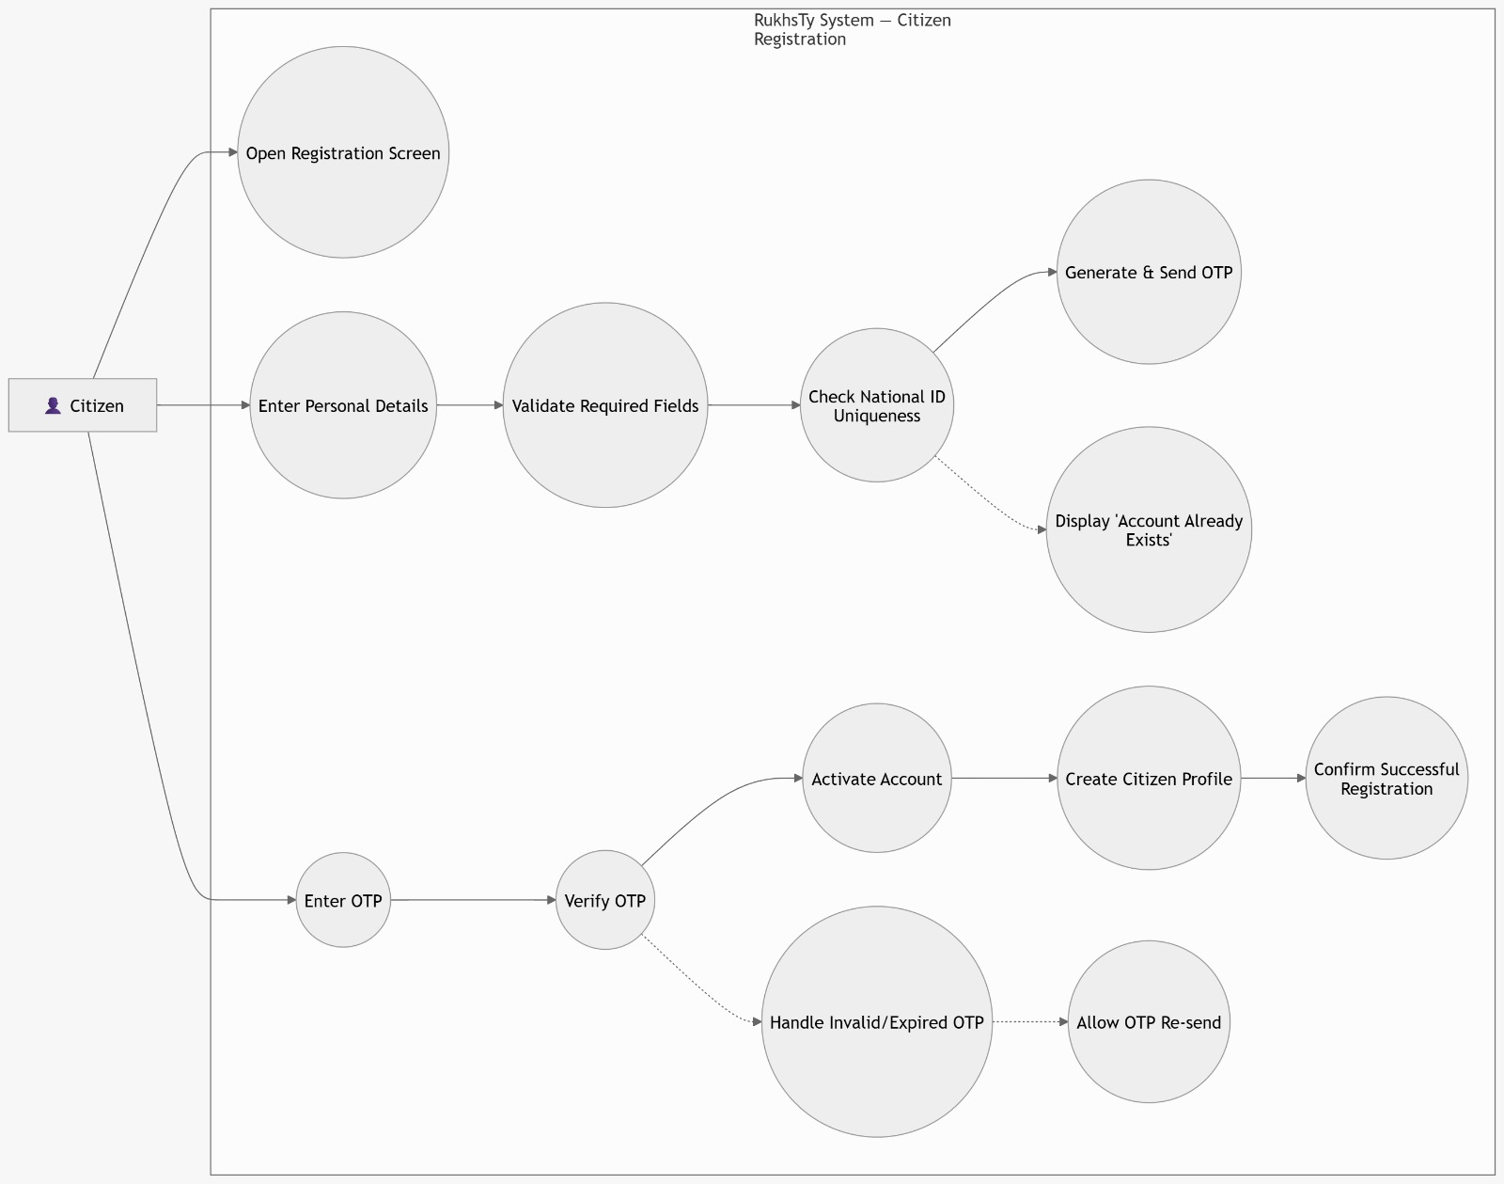

Use Case Diagram 02: 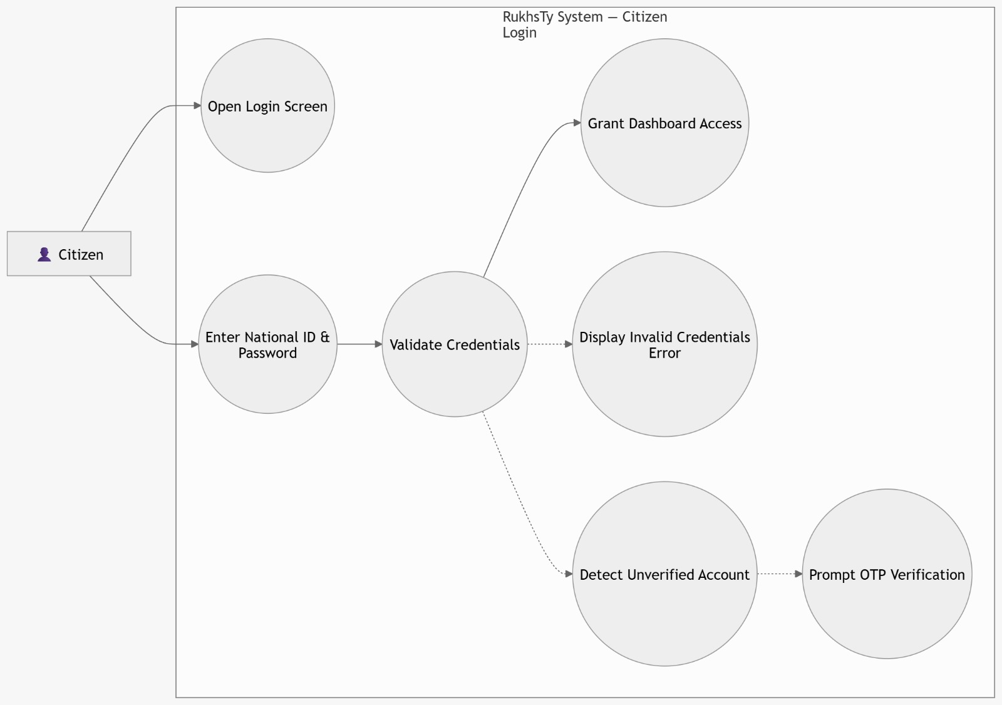

Use Case Diagram 03:

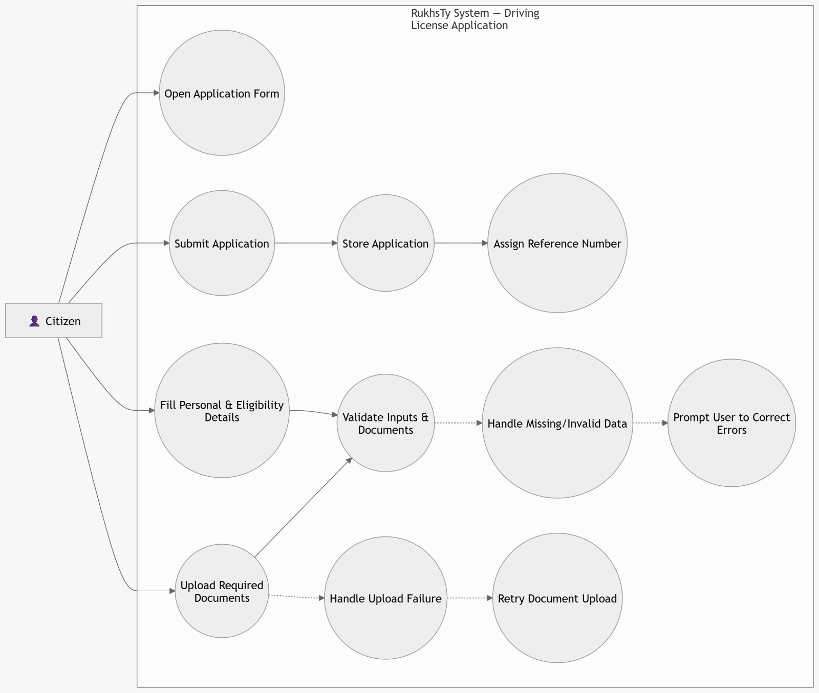

Use Case Diagram 04:

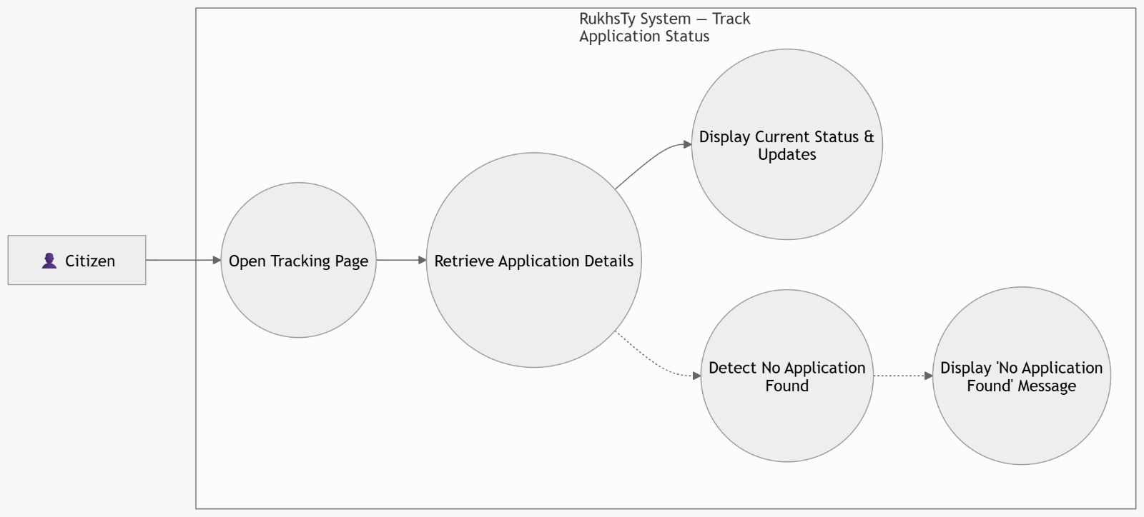

Use Case Diagram 05:

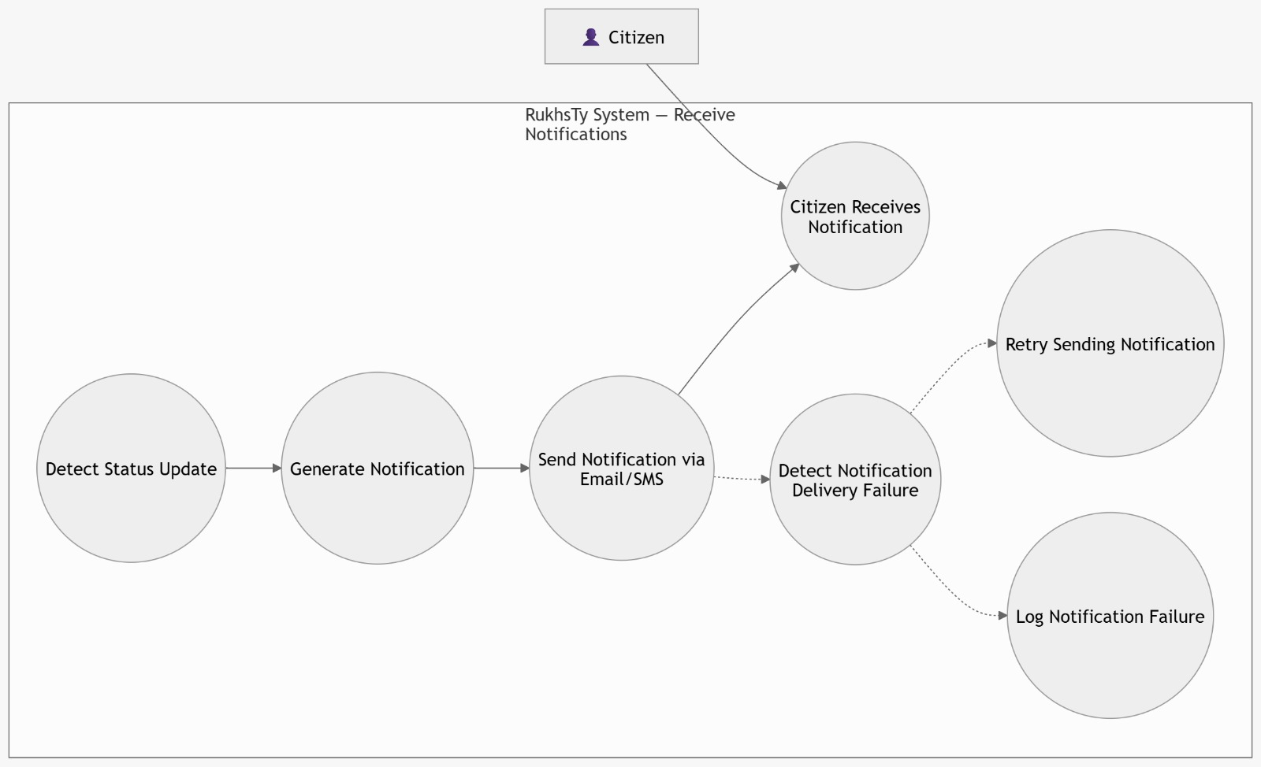

Use Case Diagram 06:

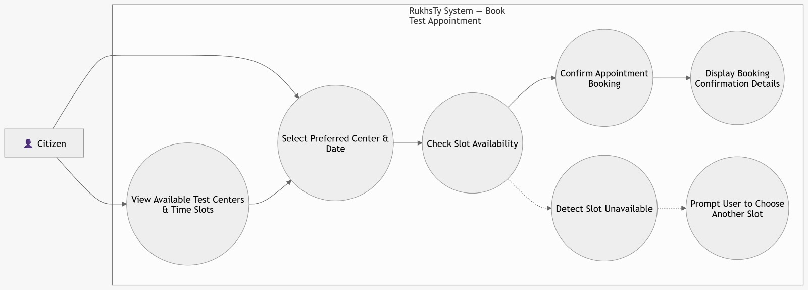

Use Case Diagram 07:

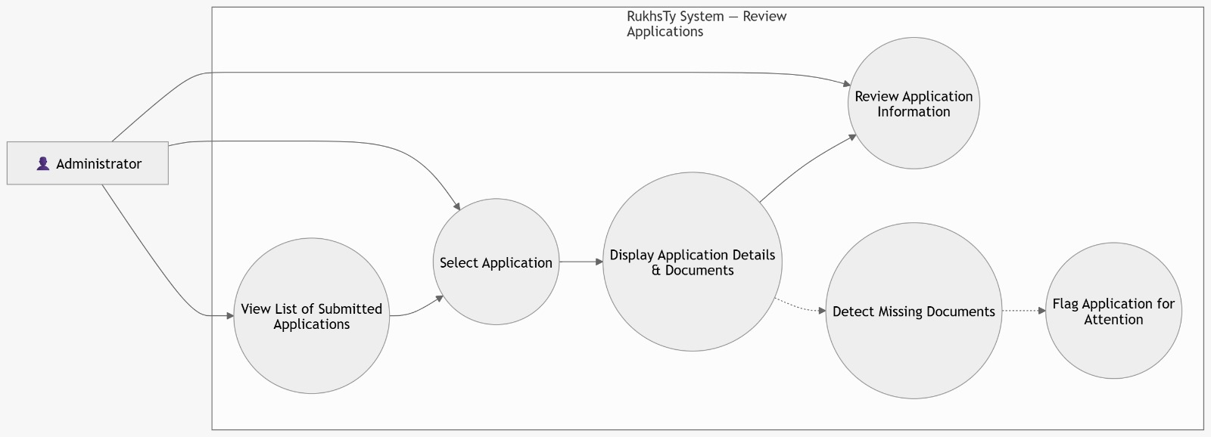

Use Case Diagram 08:

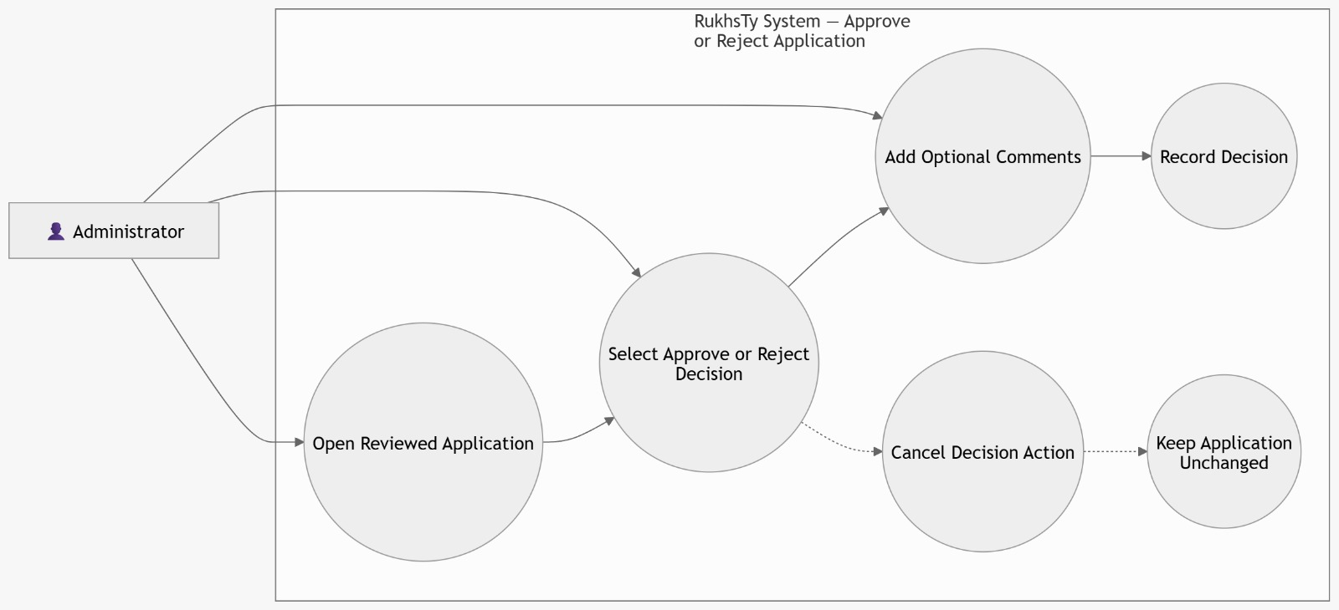

Use Case Diagram 09:

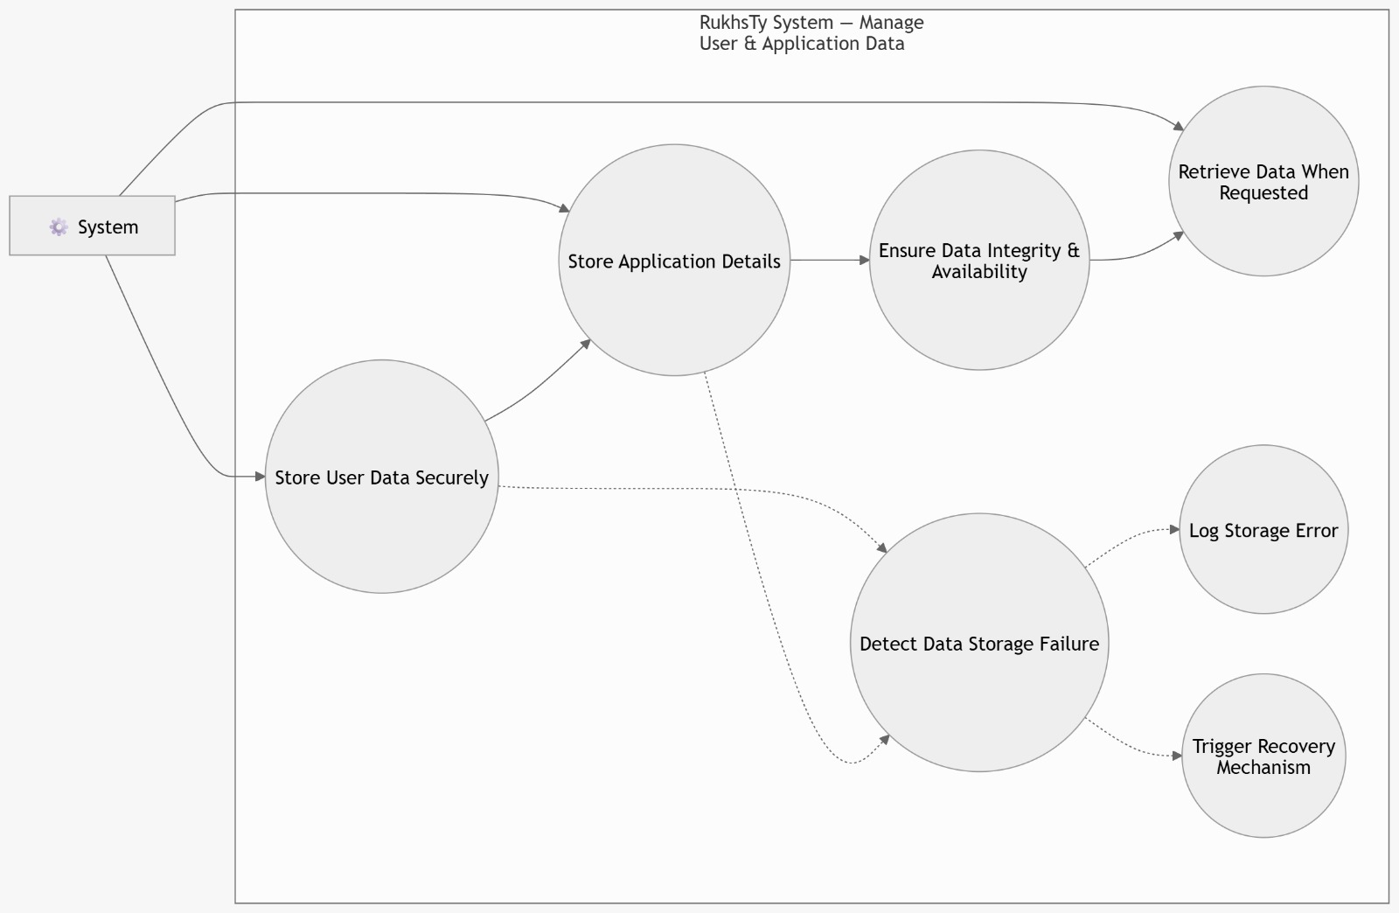

Use Case Diagram 10:

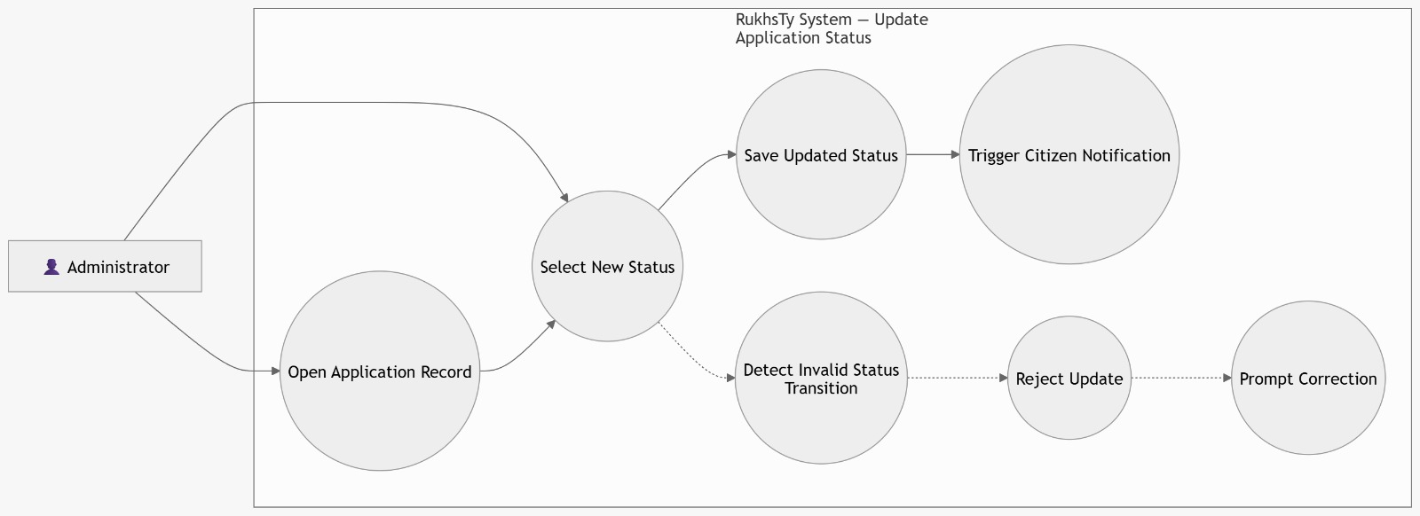
Fully System Use Case Diagram:

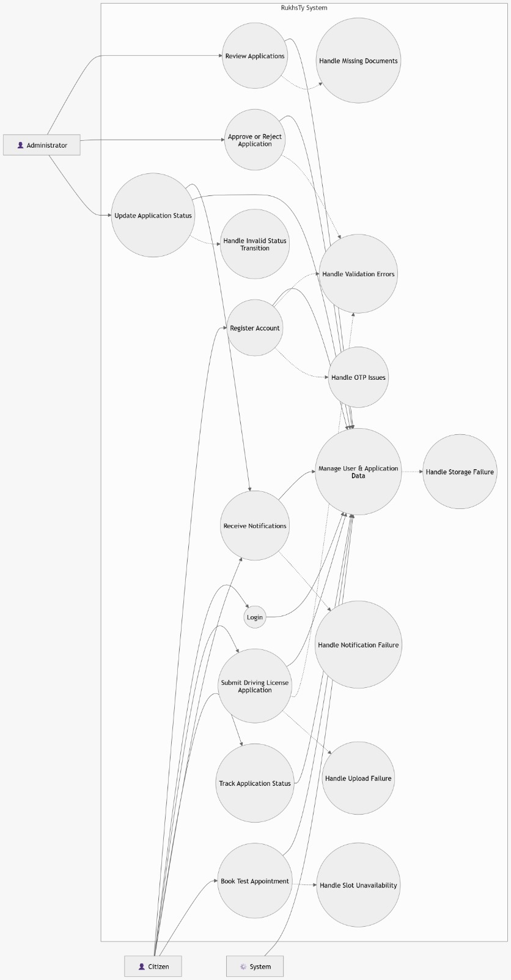

3.5 Use Cases Descriptions

UC01 — Citizen Registration

- Primary Actor: Citizen
- Goal: Create a verified citizen account to use RukhsTy services.
- Preconditions: Citizen has a valid Jordanian national ID and access to email/phone.
- Trigger: Citizen selects “Create Account / Register”.
- Basic Flow:
  - Citizen opens the registration screen.
  - Citizen enters full name, national ID, email, phone number, and password.
  - System validates required fields and checks national ID uniqueness.
  - System generates an OTP and sends it to the citizen’s email (and/or phone as configured).
  - Citizen enters the received OTP.
  - System verifies the OTP and activates the account.
  - System creates the citizen profile and confirms successful registration.
- Alternative / Exception Flows:
  - A1: National ID already registered
    - System detects an existing account for the entered national ID.
    - System displays: “Account already exists” and suggests login/password recovery.
  - A2: Invalid/expired OTP
    - Citizen enters an incorrect or expired OTP.
    - System displays an error and allows OTP re-send within policy limits.
- Postconditions: A verified citizen account exists and can be used to login and submit applications.

UC02 — Citizen Login
• Primary Actor: Citizen
• Goal: Access the system securely using credentials.
• Preconditions: Citizen has a registered and verified account.
• Trigger: Citizen selects “Login”.
• Basic Flow:
- Citizen opens the login screen.
- Citizen enters national ID and password.
- System validates credentials.
- System grants access to the dashboard.
• Alternative / Exception Flows:
- A1: Invalid credentials
  - Citizen enters incorrect national ID or password.
  - System displays error and prompts retry.
- A2: Account not activated
  - System detects unverified account.
  - System prompts OTP verification.
• Postconditions: Citizen is authenticated and can access services.

UC03 — Submit Driving License Application
• Primary Actor: Citizen
• Goal: Apply for a driving license online.
• Preconditions: Citizen is logged in.
• Trigger: Citizen selects “Apply for Driving License”.
• Basic Flow:
- Citizen opens application form.
- Citizen fills required personal and eligibility details.
- Citizen uploads required documents.
- System validates inputs and documents.
- Citizen submits the application.
- System stores the application and assigns a reference number.
• Alternative / Exception Flows:
- A1: Missing/invalid data
  - System detects incomplete or invalid fields.
  - System prompts user to correct errors.
- A2: Upload failure
  - Document upload fails.
  - System asks user to retry upload.
• Postconditions: Application is successfully submitted and stored.

UC04 — Track Application Status
• Primary Actor: Citizen
• Goal: View the current status of an application.
• Preconditions: Citizen has submitted an application.
• Trigger: Citizen selects “Track Application”.
• Basic Flow:
- Citizen opens tracking page.
- System retrieves application details.
- System displays current status and updates.
• Alternative / Exception Flows:
- A1: No application found
  - System cannot find application.
  - System displays “No application found”.
• Postconditions: Citizen is informed about application status.

UC05 — Receive Notifications
• Primary Actor: Citizen
• Goal: Stay informed about application updates.
• Preconditions: Application exists.
• Trigger: Application status changes.
• Basic Flow:
- System detects a status update.
- System generates a notification.
- System sends notification via email/SMS.
- Citizen receives the notification.
• Alternative / Exception Flows:
- A1: Notification delivery failure
  - Message fails to send.
  - System retries or logs failure.
• Postconditions: Citizen is notified of updates.

UC06 — Book Test Appointment
• Primary Actor: Citizen
• Goal: Schedule vision and theory test appointments.
• Preconditions: Citizen is eligible for booking.
• Trigger: Citizen selects “Book Appointment”.
• Basic Flow:
- Citizen views available test centers and time slots.
- Citizen selects preferred center and date.
- System checks availability.
- System confirms booking.
- System displays confirmation details.
• Alternative / Exception Flows:
- A1: Slot unavailable
  - Selected slot is already booked.
  - System prompts user to choose another slot.
• Postconditions: Appointment is successfully scheduled.

UC07 — Review Applications (Admin)
• Primary Actor: Administrator
• Goal: Examine submitted applications.
• Preconditions: Admin is logged in.
• Trigger: Admin selects “View Applications”.
• Basic Flow:
- Admin views list of submitted applications.
- Admin selects an application.
- System displays application details and documents.
- Admin reviews the information.
• Alternative / Exception Flows:
- A1: Missing documents
  - Required documents are not available.
  - System flags application for attention.
• Postconditions: Application is reviewed and ready for decision.

UC08 — Approve or Reject Application
• Primary Actor: Administrator
• Goal: Decide on application approval.
• Preconditions: Application has been reviewed.
• Trigger: Admin selects decision option.
• Basic Flow:
- Admin opens reviewed application.
- Admin selects approve or reject.
- Admin adds optional comments.
- System records the decision.
• Alternative / Exception Flows:
- A1: Decision not confirmed
  - Admin cancels action.
  - System keeps application unchanged.
• Postconditions: Application is approved or rejected.

UC09 — Manage User & Application Data
• Primary Actor: System
• Goal: Store and manage system data securely.
• Preconditions: Data is generated by user or admin actions.
• Trigger: Data is created or updated.
• Basic Flow:
- System stores user data securely.
- System stores application details.
- System ensures data integrity and availability.
- System retrieves data when requested.
• Alternative / Exception Flows:
- A1: Data storage failure
  - System encounters storage issue.
  - System logs error and triggers recovery mechanism.
• Postconditions: Data is securely stored and accessible.

UC10 — Update Application Status
• Primary Actor: Administrator
• Goal: Update the progress of an application.
• Preconditions: Application exists.
• Trigger: Admin selects “Update Status”.
• Basic Flow:
- Admin opens application record.
- Admin selects new status (e.g., pending, approved, rejected).
- System saves updated status.
- System triggers notification to citizen.
• Alternative / Exception Flows:
- A1: Invalid status update
  - System detects invalid transition.
  - System rejects update and prompts correction.
• Postconditions: Application status is updated and visible to the citizen.

Chapter 4: Architecture and Design

4.1 Software Architecture

4.2 Software Design

4.2.1 Sequence Diagrams
Provide UML sequence diagram for each use case scenario. You should show concurrent objects and the messages type (i.e. synchronous or asynchronous). A sequence diagram is a type of interaction diagram because it describes how—and in what order—a group of objects works together.

4.2.2 Class Diagram
In software engineering, a class diagram is a type of static structure diagram that describes the structure of a system by showing the system's classes, their attributes, operations (or methods), and the relationships among objects.

4.2.3 State Transition Diagram (If any)
Provide state transition diagram of the system and if needed for some
components/classes.

4.2.4 ER Diagram (If any)
Entity relationship diagram displays the relationships of entity set stored in a database.

4.2.5 Activity Diagram (or any other related diagram, if necessary)

4.3 User Interface Design
Provide snapshots for the graphical user interface screens of the system.

Chapter 5: System Implementation

5.1 Overview
Describes how the system will be deployed, installed and transitioned into an operational system. It contains a brief description of the major tasks and components involved in the implementation, the overall resources needed to support the implementation effort (such as hardware, software, facilities, materials, and personnel), and any site-specific implementation requirements.

5.2 Tools and Technologies Used
Describe any state of the art tools and technologies you used in the project. It is important that you describe how the tools and technologies are being applied to the project you have completed. You should include some discussions on evaluation of alternate tools and techniques, provide comparisons and state rationale for choosing the ones you did.

5.3 Important Code Fragments
Show important codes of your implemented system.

Chapter 6: Testing and Validation
Describe the scope, approach, resources and schedule of intended test activities.
It identifies amongst others test items, the features to be tested, test coverage, the test environment, and the test design techniques.

6.1 Black-Box
Provide the black-box techniques that are used to test this project including test
cases.
Table 1. Test Table
Test Case ID | Test Scenario | Test Steps | Test Data | Expected Results | Actual Results | Pass/ Fail
01 | Check Customer Login with valid Data | - Go to Site www.exam  - Enter UserId  - Enter Password  - Click Submit | Userid = Test123 Password = pass123 | User should Login into an application | As Expected | Pass

6.2 White-Box
Provide the white-box techniques that are used to test this project including test
cases (test case if code is available).

6.3 Testing Automation
This section should provide information about what test cases to automate and the automation tools that have been used to control the execution of tests and the comparison of actual outcomes with predicted outcomes.

Chapter 7: Conclusion and Future Work
It should drive the reader to see that you accomplish your objectives and you should state recommendations on how you might want to improve the work in future.

References
Citations are numbered consecutively inside brackets. In writing the references, we
follow American Psychological Association (APA) style. The references below show
examples of how to include a book with 3 authors [1], a project report [2], an article in a journal [3], an article in Wikipedia [4], and a website [5].
[1] Alred, G.J., Brusaw, C.T. & Oliu, W.E. Handbook of Technical Writing. Bedford/St. Martin's, 2006.
[2] Al-Naim M. & Al-Mudara N. Electronic Court. King Faisal University College of Computer Sciences and Information Technology, 2012.
[3] Al-Eid, A. (2012). The Changes in GUI. Journal of Computer Explosion,
27(10), 1327-33.
[4] Plagiarism. (n.d.). In Wikipedia. Retrieved January 10, 2013, from http://en.wikipedia.org/wiki/Plagiarism
[5] Sebastian, B. (2010, July 25). Programming Style. PCPrograms.com.
Retrieved July 25, 2010, from http://www.pcprograms.com.

Appendix
Any additional information or data that supports or extends the main document or report.

