Contents
1. Introduction 2
2. Definitions, Abbreviations, and Acronyms 2
3. System Architecture 3
4. Hardware Components 4
5. Bluetooth Low Energy 4
5.1 BLE Architecture 5
5.2 MOTOR CONTROL SERVICE 8
5.2.1 Services and Profiles (GATT) 10
5.2.2 Assigning UUIDs 12
5.2.3 The Motor State Characteristic 13
5.2.4 Constructing Motor Control Service 13
5.2.5 Controlling The Motor 13

LIST OF FIGURES

Figure 1: voice control robot architecture diagram ……………………………………. 5

Introduction

IoT (Internet of Things) connects small devices to the Internet. Below is basic architecture of IoT infrastructure.

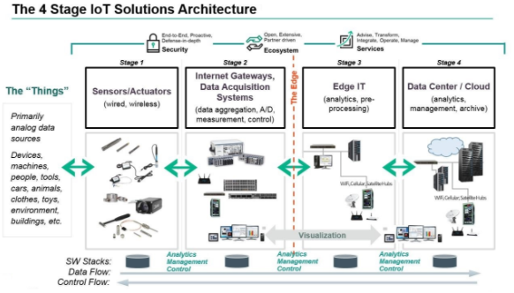

In Voice Controlled Robot using Android Things, we are exploring the first stage of the above architecture. Here actuators are L6206 controlled brush DC motors. We have two of them. We control the motion of these motors individually with voice commands issues by the user.

Definitions, Abbreviations, and Acronyms

IoT | Internet of Things
BLE | Bluetooth Low Energy
GAP | Generic Access Protocol
GATT | Generic Attribute Profile
ATT | Attribute profiles
APK | Android Package file
DC | Direct Current

System Architecture

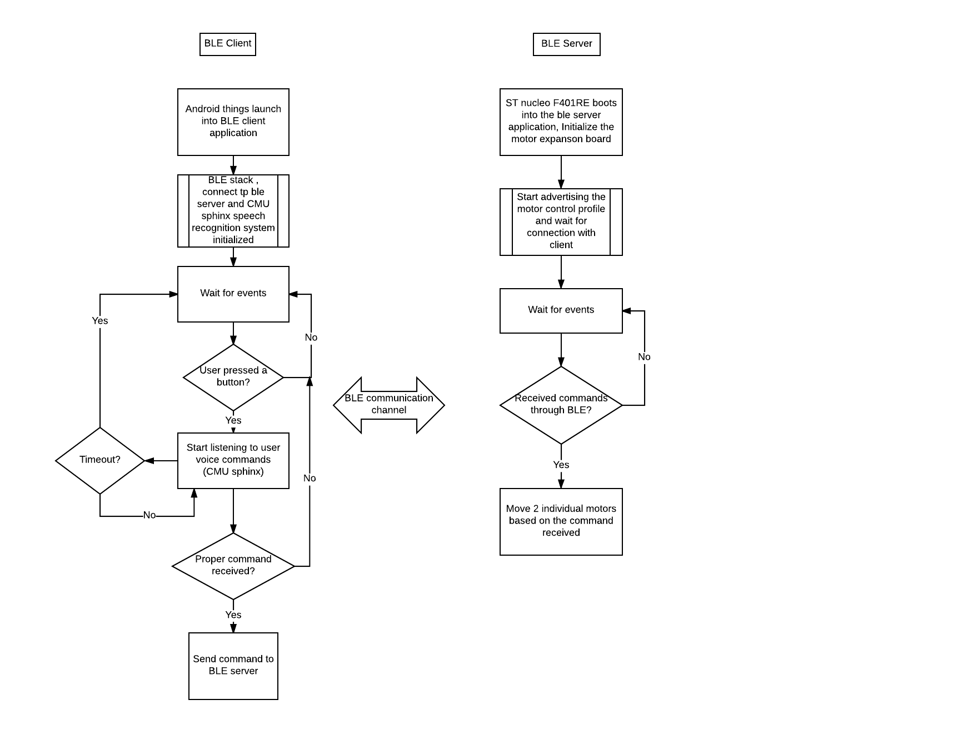

Figure 1: voice control robot architecture diagram

In this demo we are exploring android things on a raspberry pi as BLE client. We use open source speech recognition framework CMUspinx for processing the voice commands. In this demo we recognize four basic voice commands namely left, right, forward and reverse. We provide an optional speaker output of the command we input, to make the user satisfied that the speech recognition framework identified the command properly.

Hardware Components

The hardware components used in this project is listed below,

- Raspberry Pi3 Model B
- DIY basic robotic starter kit (2 brush DC motors, wheels etc)
- ST Nucleo F401RE
- X-Nucleo-IDB05A1 (BLE expansion board)
- X-Nucleo-IHM04A1 (Dual brush DC motor driver)

Bluetooth Low Energy

BLE is a short range wireless communication technology. BLE is designed with following basic goals in mind.

- Low power requirement (operating on a coin cell for longer periods of time)
- Low cost
- Industry standard wireless protocol, which can be easily adopted.

BLE is a method of transferring small amount of data of any type. I have used mbed online platform for developing the GATT server part of the project. Mbed supports cloud based online compiler (https://os.mbed.com/compiler). Developing a BLE application need an APP support (BLE client). The combined system is well explained by the following figure.

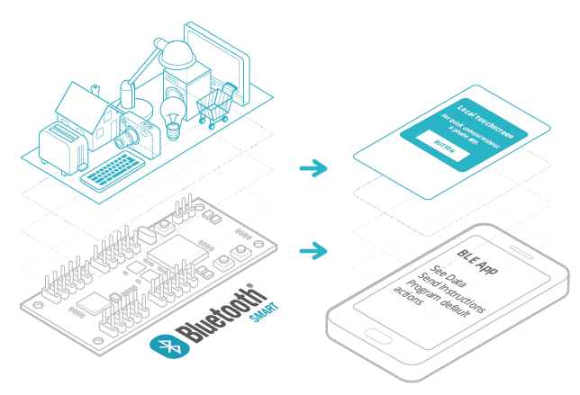

Figure 2: A BLE setup (from https://docs.mbed.com/docs/ble-intros/en/latest/Introduction/BeginnersIntro/)

BLE Architecture
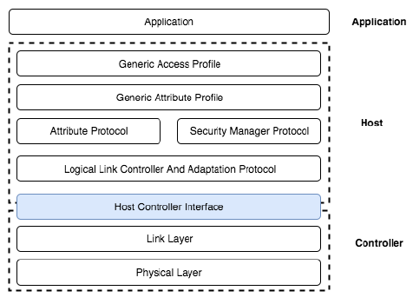

Figure3: BLE architecture

The architecture of BLE is divided into three important layers,
- Application
- Host
- Controller

- Application Layer

This layer will contain user interface, application logic and overall application architecture. In this project, in this layer we have motor controlling logic based on the commands received over the BLE connection.

- Host Layer

Host Layer has following sub layers,
- Generic Access Profile (GAP)
- Generic Attribute Profile (GATT)
- Attribute Protocol (ATT)
- Security Manager Protocol
- Logical Link Controller and Adaptation Protocol (L2CAP)

Generic Access Profile (GAP)

This defines how BLE devices access and communicate with each other. GAP identifies two roles for the communicating devices,
- Broadcaster/Peripheral: In this role BLE device will broadcast / advertise information packets.
- Observer/Central: In this role, BLE device listens for the packets. Then it decides to initiate a connection or not depending on the use case.

Generic Attribute Profile (GATT)

This defines how data or attributes are formatted, packaged and sent across connected devices. Like GAP, the interacting devices are given the flexibility to adopt some roles.
- Client: The client can read and/or write attribute/data found on the server.
- Server: Main role of the server is to store attribute/data. Once client make the request, server must make the attribute/data available.

Attribute Protocol

This defines rules for accessing attribute/data on a device. A GATT profile is built on top of the attribute protocol. This protocol defines the fact that data on the server will be arranged in the form of attributes which will have following format,
- A 16-bit attribute handle
- A UUID
- A set of permissions
- A value
Attribute protocol also defines read and write operations for attributes (ATT operations). These are listed as below,

- Read operations
- Write Operations ( Write requests with response, signed writes, Write without response)
- Indications: These are asynchronous notification operations initiated by the server for the clients who have registered for such notifications. Once client receive notification, it sends back acknowledgements.
- Notifications: These are also asynchronous but there will be no acknowledgements from the client.

Security Manager Protocol

This defines rules regarding authentication processes such as pairing.

Logical Link Controller and Adaptation Protocol (L2CAP)

This defines the following rules,

- Fragmentation and defragmentation of application data
- Multiplexing and DE multiplexing of multiple channels over a shared logical link.

- Controller Layer

Controller is the Bluetooth radio chip. It facilitates the transmission and reception of Bluetooth signals. This layer consists of a Link Layer and Physical Layer. Physical layer consists of the analogue circuits, which transmit and receive digital data over the air. Link layer is responsible for scanning, advertising, creating and maintaining link between devices. Following figure give a better picture of the states maintained in the Link Layer in the controller,

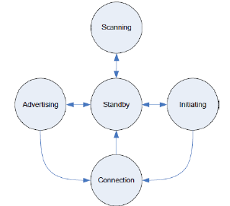

Figure 4: Controller layer state diagram

Above discussion gave a brief introduction to the BLE architecture. Now let us discuss some more details of creating a motor control service.

MOTOR CONTROL SERVICE

The use case is that the phone application will connect to the mbed application and set the motor control state variable. In non-connected state, the application simply advertises its ability to provide a motor control service.

The client server role can be better understood with following figure.

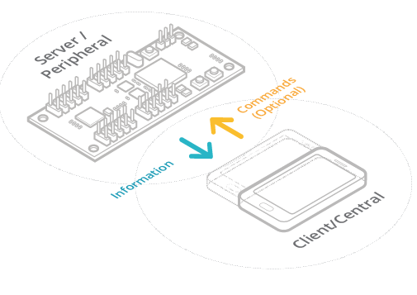

Figure 5: mbed board as peripheral and phones/tablets as Central devices

We use X-NUCLEO-IDB05A1 expansion board from ST Micro for the BLE communication. This evaluation board is based on SPBTLE-RF BlueNRG-MS RF module. The X-NUCLEO-IDB05A1 is compatible with the ST Morpho and Arduino UNO R3 connector layout. The X-NUCLEO-IDB05A1 interfaces with STM32 microcontroller via the SPI pin.

The pin connectivity is as in below figure,

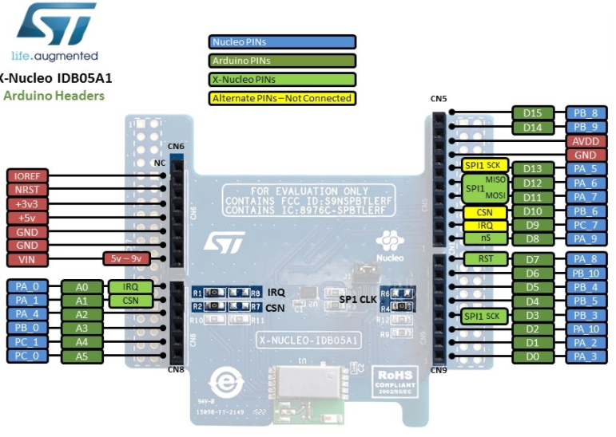

Figure 6: X-NUCLEO-IDB05A1 PinOut diagram (from https://os.mbed.com/components/X-NUCLEO-IDB05A1-Bluetooth-Low-Energy/)

BLE uses two modes,
- Advertising mode: The peripheral sends out a bit of information that any device in the area can pick up. This is how central devices know that there are peripherals around.
- Connected mode: The peripheral and a central device establish a one to one connection. This is how they can exchange complex information.

The code advertises “motor control” as a device name through the advertisement payload. We can configure the kind of BLE communication we want by deciding what to go in the advertisement packet. We will make the application discoverable with LE_GENERAL_DISCOVERABLE and connectable with ADV_CONNECTABLE_UNDIRECTED. Our application provides only GAP and GATT services. If connection get lost, we have registered a callback function with BLE API onDisconnection. In this call back we will restart the advertisement.

Advertisements are very limited in size.

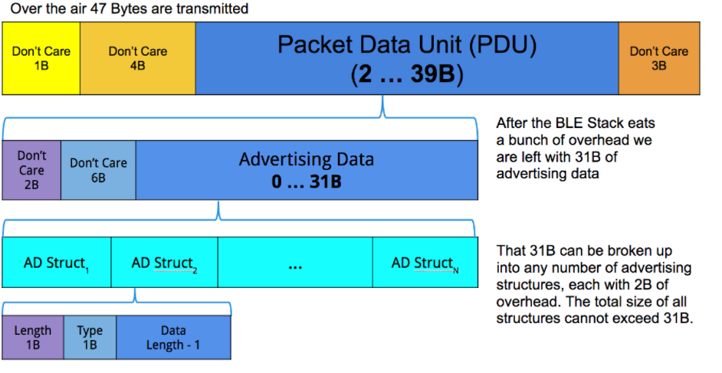

Figure 7: BLE GAP broadcast data (from https://docs.mbed.com/docs/ble-intros/en/latest/Introduction/BLEInDepth/)

- The BLE stack require 8 bytes (1 + 4 + 3) for its own purposes.
- The advertising packet data unit (PDU) therefore has at maximum 39 bytes. But the BLE stack once again requires some overhead, taking up 8 bytes (2 + 6).
- The PDU’s advertising data field has 31 bytes left, divided into advertising data (AD) structures. Then:
- The GAP broadcast must contain flags that tell the device about the type of advertisement we’re sending. The flag structure uses three bytes in total (one for data length, one for data type and one for the data itself). The reason we need the first two bytes - the data length and type indications - is to help the parser work correctly with our flag information. We have 28 bytes left.
- Now we’re finally sending our own data in its own data structure - but it, too, requires an indication of length and type (two bytes in total), so we have 26 bytes left.
All of which means that we have only 26B to use for the data we want to send over GAP.

We use this 26 bytes to configure the BLE advertisement parameters. A peripheral broadcasts this advertisement periodically to any central device within range, regardless of authentication.

Services and Profiles (GATT)

To make a conversation in the connected mode, BLE specification imposes a particular structure to the way data is exchanged in the connected mode. This relies on the ability of the BLE peripheral to maintain a database of state variables.
In our application we maintain single byte variable “motorControl” to hold the control value. We create a motor control service around this state variable. In BLE terms, we call this state variable, characteristic. So a service holds one or more characteristics. Characteristics can be associated with a small description by means of a descriptor.
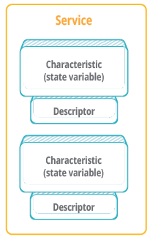
Figure 8: A BLE service ( from https://docs.mbed.com/docs/ble-intros/en/latest/Introduction/BLEInDepth/)

We can bundle several services together into a BLE profile. Profile is a description of what the BLE device is capable to do.

One of principle in design of a ble service is that, the characteristics should be mapped to only one thing. So an application requirement can be broken down into several characteristics and we can bundle them together into a service. Such services can be bundled together to a profile. In our case, we need only one characteristic to control the motor rotations. So we create the motor control service around this single characteristic.

A characteristic is fully defined by its declaration, value and descriptor:
- The declaration contains data about the characteristic, such as its universally unique identifier (UUID).
- The value is the “interesting” part of the characteristic: it’s the value that contains the data you’re viewing and reacting to.
- The descriptor is not mandatory; you can use it to provide more information about a characteristic or to control its behavior. For example, descriptors are used when working with notifications.

The characteristic can be read only, write only or read/write. These modes can be set by the mbed ble apis. Read/Write mode is useful when the peripheral device can set itself, or can receive the values from the client.

Our motor control BLE service is created as below,

bool initialValueForMOTORCharacteristic = false;
motorServicePtr = new MOTORService(ble, initialValueForMOTORCharacteristic);

Where MOTORService is the class designed as below,

class MOTORService {
public:
const static uint16_t MOTOR_SERVICE_UUID = 0xA000;
const static uint16_t MOTOR_CONTROL_CHARACTERISTIC_UUID = 0xA001;

MOTORService (BLEDevice &_ble, bool initialValueForMOTORCharacteristic) :
ble(_ble), motorControl(MOTOR_CONTROL_CHARACTERISTIC_UUID, &initialValueForMOTORCharacteristic)
{
GattCharacteristic *charTable[] = {&motorControl};
GattService motorService(MOTOR_SERVICE_UUID, charTable, sizeof(charTable) / sizeof(GattCharacteristic *));

ble.addService(motorService);
}

GattAttribute::Handle_t getValueHandle() const {
return motorControl.getValueHandle();
}

private:
BLEDevice &ble;
ReadWriteGattCharacteristic<bool> motorControl;
};

    - Assigning UUIDs

The motor control service has a single write only characteristic. We hold the motor control variable in this value. Bluetooth smart or BLE requires the use of UUIDs to identify the types of all involved entities.

In our application we will need two UUIDs, One each for motor control service and motor control characteristic.

We have chosen custom UUID space for our motor control service. This avoids collision with standard UUIDs.

const static uint16_t MOTOR_SERVICE_UUID = 0xA000;
const static uint16_t MOTOR_CONTROL_CHARACTERISTIC_UUID = 0xA001;

static const uint16_t uuid16_list[] = {MOTORService::MOTOR_SERVICE_UUID};

ble.gap().accumulateAdvertisingPayload(GapAdvertisingData::COMPLETE_LIST_16BIT_SERVICE_IDS, (uint8_t *)uuid16_list, sizeof(uuid16_list));

    - The Motor State Characteristic

Here we go into details of using the BLE_API provided by the mbed. It provides abstractions to create a BLE service. A GattService class contains one or more GattCharacteristics. The GattCharacteristics represents state variables exposed by the service. Every GattCharacteristic implicitly contains at least one GattAttribute to hold the value. It may be have more than oneGattAttribute, but that is uncommon. So the application needs to set up one or more GattCharacteristics and compose them into a GattService.

ReadWriteGattCharacteristic<bool> motorControl;
GattCharacteristic *charTable[] = {&motorControl};
GattService motorService(MOTOR_SERVICE_UUID, charTable, sizeof(charTable) / sizeof(GattCharacteristic *));

    - Constructing Motor Control Service

We can use the motorControl characteristic to construct a GATT service called motorService. We use a bit of C/C++ syntax to create a one-element array, using an initialiser list of pointers to GattCharacteristics.
We can then add this service to the BLE stack using BLEDevice::addService ():

GattCharacteristic *charTable[] = {&motorControl};
GattService motorService (MOTOR_SERVICE_UUID, charTable, sizeof (charTable) / sizeof (GattCharacteristic *));
ble.addService (motorService);

    - Controlling The Motor

I have used X-Nucleo IHM04A1 dual brush DC motor driver expansion board for this purpose. This dual brush driver expansion board is based on L6026 (DMOS dual full bridge driver) to drive dual bipolar DC or quad unipolar DC motors. In our project we configure the board to drive two dual brush DC motors. The X-NUCLEO-IHM04A1 is compatible with the Arduino UNO R3 connector, and supports the addition of other expansion boards with a single STM32 Nucleo board. The user can also mount the ST Morpho connector.

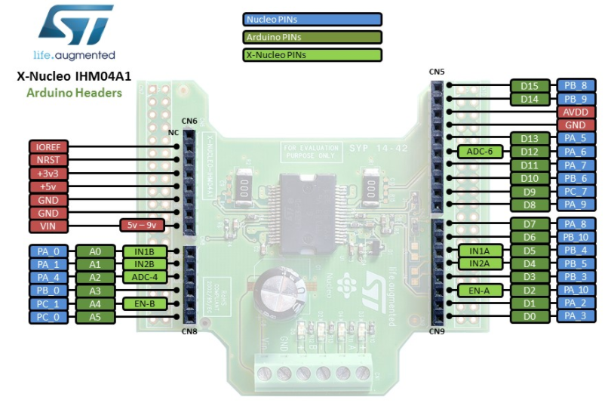
Figure 9: X-Nucleo IHM04A1 PinOut

Key features this evaluation board provides is listed below,
- Voltage range from 8 V to 50 V max.
- Phase current up to 2.8 A r.m.s.
- Direct output driving
- Mounting position for shunt resistors available
- Undervoltage lockout
- Programmable high side overcurrent protection
- Thermal protection shutdown
- Compatible with Arduino UNO R3 connector
- Compatible with STM32 Nucleo boards
- RoHS compliant

- Details of Work done

- Made proper understanding on mbed BLE support. Tried how to use mbed platform to rapid prototyping the IoT ideas.
- Tested BLE advertising of the ble peripheral (NUCLEO-IDB05A1). Tested the central BLE with the android APK provided by ST micro.
- Tested the X-NUCLEO-IHM04A1 with code samples in mbed for motor driving functionality.

- Details of Work to be done

- Create BLE central device APK. This APK has to scan for the presence of BLE peripheral, make one to one connection with it.
- Integrate voice assistant to the above APK developed for the Android things platform.
- Implement the command interface where user can issue voice commands which the central device will convert to text and will send appropriate commands to the peripheral device.
- Integrate the BLE peripheral and motor driver together.
- Based on the commands received from the central device, design an algorithm to move the two brushed dc motors independently.

- Plan of Work

Modules | Description | From | To | Status
Development Environment | - Mbed compiler environment  - Android studio for developing Android thing application  - ST Nucleo development tools | 01 Aug 2017 | 15 Aug 2017 | Done
BLE peripheral | - Setup and program for X-NUCLEO-IDB05A1 BLE expansion board  - Setup and program for X-NUCLEO-IHM04A1 DC motor expansion board. | 16 Aug 2017 | 31 Aug 2017 | Done
BLE central | - Android things on raspberry pi 3  - Develop a BLE central IoT app using Evo studio | 01 Sep 2017 | 15 Sep 2017 | Partially done
Google Assistant | - Integrate google assistant to the BLE central app. | 16 Sep 2017 | 30 Sep 2017 | Not started
Integration and Final test and documentation | - Integration test and project documentation | 01 Oct 2017 | 20 Oct 2017 | Not started

- Bibliography and References

- https://developer.android.com/things/index.html
- https://os.mbed.com/teams/Bluetooth-Low-Energy/
- https://os.mbed.com/platforms/ST-Nucleo-F401RE/
- https://os.mbed.com/components/X-NUCLEO-IDB05A1-Bluetooth-Low-Energy/
- https://os.mbed.com/components/X-NUCLEO-IHM04A1/

