TABLE OF CONTENTS

- Introduction ……………………………………………………………………………………………… 4
- Definitions, Abbreviations, and Acronyms ……………………………………………… 4
- System Architecture ………………………………………………………………………………… 5
- Module Design …………………………………………………………………………………………. 6
- Details of Work done ………………………………………………………………………………. 6
- Details of Work to be done ……………………………………………………………………… 6
- Plan of Work ……………………………………………………………………………………………. 7
- Bibliography and References ………………………………………………………………….. 7

LIST OF FIGURES

Figure 1: voice control robot architecture diagram ……………………………………. 5

- Introduction

IoT (Internet of Things) connects small devices to the Internet. Below is basic architecture of IoT infrastructure.

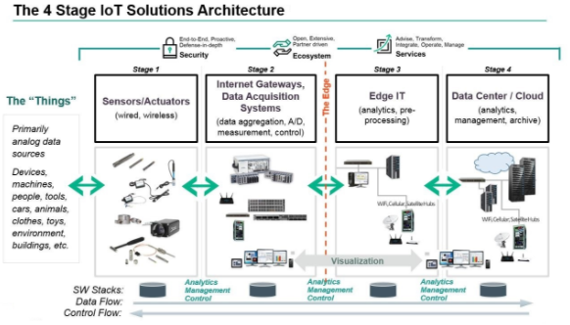

In Voice Controlled Robot using Android Things, we are exploring the first stage of the above architecture. Here actuators are L6206 controlled brush DC motors. We have two of them. We control the motion of these motors individually with voice commands issues by the user.

- Definitions, Abbreviations, and Acronyms

IoT | Internet of Things
BLE | Bluetooth Low Energy
GAP | Generic Access Protocol
GATT | Generic Attribute Profile
ATT | Attribute profiles
APK | Android Package file
DC | Direct Current

- System Architecture

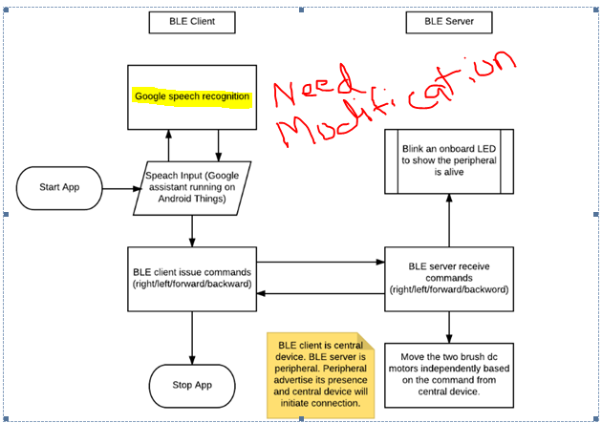

Figure 1: voice control robot architecture diagram

In this demo we are exploring android things on a raspberry pi as BLE client. We use open source speech recognition framework CMUspinx for processing the voice commands. In this demo we recognize four basic voice commands namely left, right, forward and reverse. We provide an optional speaker output of the command we input, to make the user satisfied that the speech recognition framework identified the command properly.

- Hardware Components

The hardware components used in this project is listed below,

- Raspberry Pi3 Model B
- DIY basic robotic starter kit (2 brush DC motors, wheels etc)
- ST Nucleo F401RE
- X-Nucleo-IDB05A1 (BLE expansion board)
- X-Nucleo-IHM04A1 (Dual brush DC motor driver)

- Bluetooth Low Energy

Bluetooth Low Energy (BLE) is part of WPAN (Wireless Personal Area
Network) communication technologies. BLE is designed with following
basic goals in mind.
- Low power requirement (operating on a coin cell for longer periods of time)
- Low cost
- Industry standard wireless protocol, which can be easily adopted.

  - BLE Architecture
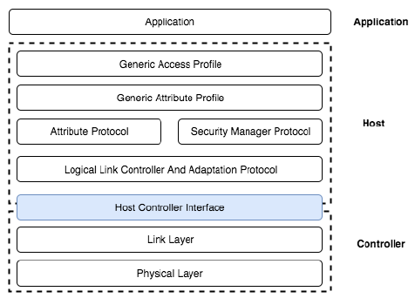
The architecture of BLE is divided into three important layers,
- Application
- Host
- Controller

- Application Layer

This layer will contain user interface, application logic and overall application architecture. In this project, in this layer we have motor controlling logic based on the commands received over the BLE connection.

- Host Layer

Host Layer has following sub layers,
- Generic Access Profile (GAP)
- Generic Attribute Profile (GATT)
- Attribute Protocol (ATT)
- Security Manager Protocol
- Logical Link Controller and Adaptation Protocol (L2CAP)

Generic Access Profile (GAP)

This defines how BLE devices access and communicate with each other. GAP identifies two roles for the communicating devices,
- Broadcaster/Peripheral: In this role BLE device will broadcast / advertise information packets.
- Observer/Central: In this role, BLE device listens for the packets. Then it decides to initiate a connection or not depending on the use case.

Generic Attribute Profile (GATT)

This defines how data or attributes are formatted, packaged and sent across connected devices. Like GAP, the interacting devices are given the flexibility to adopt some roles.
- Client: The client can read and/or write attribute/data found on the server.
- Server: Main role of the server is to store attribute/data. Once client make the request, server must make the attribute/data available.

Attribute Protocol

This defines rules for accessing attribute/data on a device. A GATT profile is built on top of the attribute protocol. This protocol defines the fact that data on the server will be arranged in the form of attributes which will have following format,
- A 16-bit attribute handle
- A UUID
- A set of permissions
- A value
Attribute protocol also defines read and write operations for attributes (ATT operations). These are listed as below,

- Read operations
- Write Operations ( Write requests with response, signed writes, Write without response)
- Indications: These are asynchronous notification operations initiated by the server for the clients who have registered for such notifications. Once client receive notification, it sends back acknowledgements.
- Notifications: These are also asynchronous but there will be no acknowledgements from the client.

Security Manager Protocol

This defines rules regarding authentication processes such as pairing.

Logical Link Controller and Adaptation Protocol (L2CAP)

This defines the following rules,

- Fragmentation and defragmentation of application data
- Multiplexing and DE multiplexing of multiple channels over a shared logical link.

- Controller Layer

Controller is the Bluetooth radio chip. It facilitates the transmission and reception of Bluetooth signals. This layer consists of a Link Layer and Physical Layer. Physical layer consists of the analogue circuits, which transmit and receive digital data over the air. Link layer is responsible for scanning, advertising, creating and maintaining link between devices. Following figure give a better picture of the states maintained in the Link Layer in the controller,

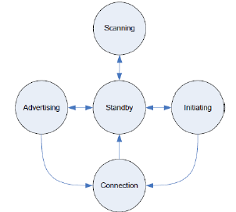

- Details of Work done

- Made proper understanding on mbed BLE support. Tried how to use mbed platform to rapid prototyping the IoT ideas.
- Tested BLE advertising of the ble peripheral (NUCLEO-IDB05A1). Tested the central BLE with the android APK provided by ST micro.
- Tested the X-NUCLEO-IHM04A1 with code samples in mbed for motor driving functionality.

- Details of Work to be done

- Create BLE central device APK. This APK has to scan for the presence of BLE peripheral, make one to one connection with it.
- Integrate voice assistant to the above APK developed for the Android things platform.
- Implement the command interface where user can issue voice commands which the central device will convert to text and will send appropriate commands to the peripheral device.
- Integrate the BLE peripheral and motor driver together.
- Based on the commands received from the central device, design an algorithm to move the two brushed dc motors independently.

- Plan of Work

Modules | Description | From | To | Status
Development Environment | - Mbed compiler environment  - Android studio for developing Android thing application  - ST Nucleo development tools | 01 Aug 2017 | 15 Aug 2017 | Done
BLE peripheral | - Setup and program for X-NUCLEO-IDB05A1 BLE expansion board  - Setup and program for X-NUCLEO-IHM04A1 DC motor expansion board. | 16 Aug 2017 | 31 Aug 2017 | Done
BLE central | - Android things on raspberry pi 3  - Develop a BLE central IoT app using Evo studio | 01 Sep 2017 | 15 Sep 2017 | Partially done
Google Assistant | - Integrate google assistant to the BLE central app. | 16 Sep 2017 | 30 Sep 2017 | Not started
Integration and Final test and documentation | - Integration test and project documentation | 01 Oct 2017 | 20 Oct 2017 | Not started

- Bibliography and References

- https://developer.android.com/things/index.html
- https://os.mbed.com/teams/Bluetooth-Low-Energy/
- https://os.mbed.com/platforms/ST-Nucleo-F401RE/
- https://os.mbed.com/components/X-NUCLEO-IDB05A1-Bluetooth-Low-Energy/
- https://os.mbed.com/components/X-NUCLEO-IHM04A1/

