Image Processing – HW1 (03/16/2021)

Instructions – Follow these carefully:

1. Please upload your work to Moodle. In the zip file, it must have the source code and a PDF report where you explain and display the outputs for each problem.
2. You can use either Python or Matlab to do the work.
3. Please feel free to read related materials available in the official Matlab/Python documentation.
4. The due date is 3/31 before 5:00pm.

Assignment:

1. (10%) Create a program that combines two perfectly aligned pictures (laptop_left.png and laptop_right.png). The output should be:

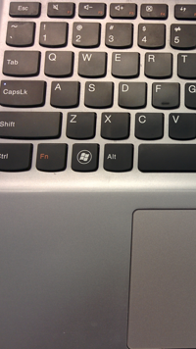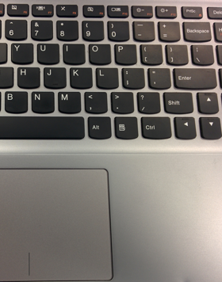

1. (20%) Following Q1, please rotate the combined image by 30 degrees clockwise (using an off-the-shelf function gets 10%, while implementing it by yourself gets the full credit)
2. (20%) Implement a program (not using any off-the-shelf functions) to flip the image “lena_flipped.bmp.”
3. (25%) Please overlay the image “graveler.bmp” without the white background onto the flipped lena image.
4. (25%, 25%)   
   (a) Please use a watermarking technique to embed “graveler.bmp” into the flipped lena image. You need to demonstrate how to embed and retrieve “graveler.bmp” from the image with the watermark.

(b) Please use the JPEG standard to encode the image with the watermark using different compression ratios (at least 3 different ratios), and decode it. Please check whether you can retrieve the watermark from the decoded image using the objective quality metric, PSNR.