How to Configure Your SVN Project to Automatically Trigger Hudson Builds Using Eclipse

The following instructions demonstrate how to configure your project in the SVN Repository so that when you commit changes, it will automatically trigger the appropriate Hudson build. For demonstration purposes, this document will use the Conveyance Estimator project located in the svn://cvs/test_svnroot test repository.

The Conveyance Estimator project consists of several components: bin item selector, bin packer, ref data, service, solution, retriever, and thin client. Two of these components have corresponding jobs in Hudson (binItemSelector -> CE_binitemselector_test and binpacker-> CE_binpacker_test). This document demonstrates how to configure the project so that any changes made to the bin item selector component will trigger the Hudson CE_binitemselector_test job to run.

Before configuring your SVN project, you must already have a build job configured in Hudson. Setting up Hudson jobs are beyond the scope of this document. Contact a member of the Development Support Team for help setting up Hudson jobs.

Before beginning, you must know the name of the Hudson build you wish to trigger. For this document’s example, you will first visit Hudson to find the appropriate name.

Visiting Hudson
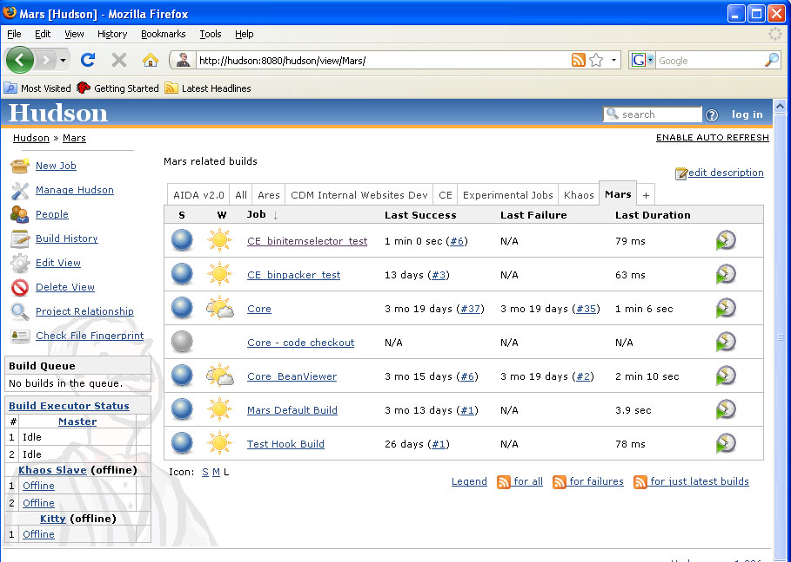
- Open Hudson in your browser (http://hudson:8080/hudson) and navigate to the Hudson job you wish to trigger. This document’s example is located in the Mars tab, and the name is CE_binitemselector_test. Clicking on this job will open its corresponding Hudson page.
Note: The URL for this page will be needed shortly, so leave the page open, or copy and paste the URL into a temporary location.

To Check-Out a Project
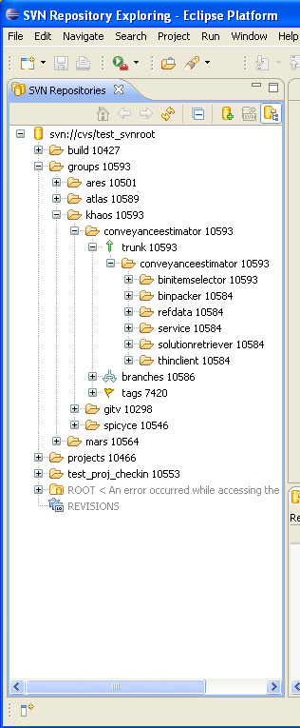
If you have not already done so, you will now check out the project or component from the SVN repository.

- Open Eclipse. In the SVN Repositories, navigate to, and expand, the svn://cvs/test_svnroot repository.
Note: If you do not see the repository svn://cvs/test_svnroot, you must add a new repository. Right-click in the SVN Repositories tab. Select New, then Repository Location. In the New Repository Location window, type svn://cvs/test_svnroot into the URL dialog box, then press Enter. In the same window, fill in your username and password in the appropriate dialog boxes. Check the box next to “Save Password.” Then click Finish.
- In the SVN Repositories tab, expand groups, expand khaos, expand coveyanceestimator, expand trunk, and then expand conveyanceestimator.

- Right-click on binitemselector (in Eclipse) and select Find/Check Out As….
- In the Check Out As window, select the Check out as a project with the name specified option. Click Finish.

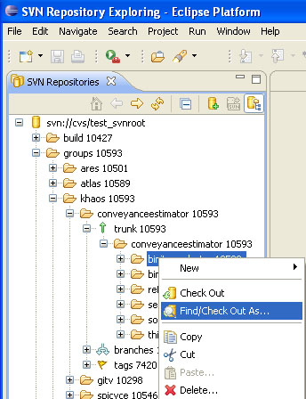

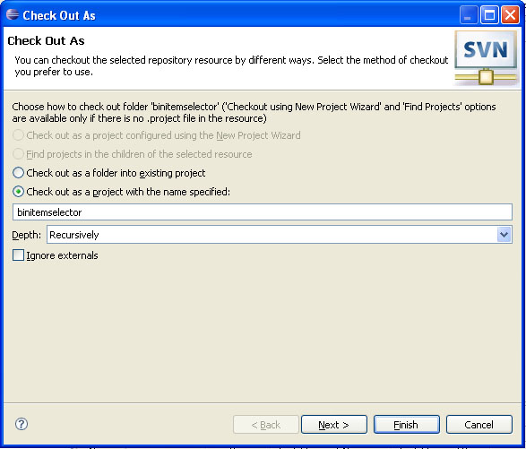

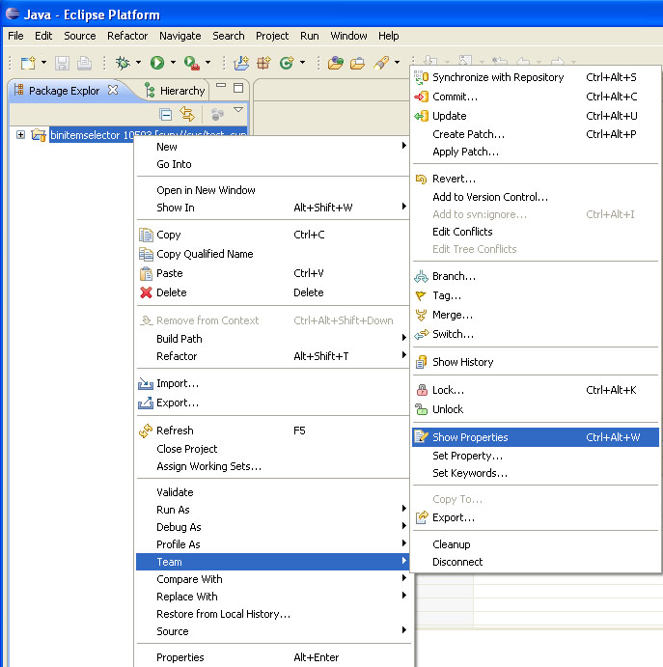
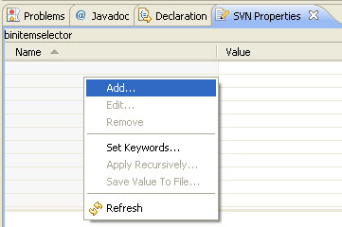
To Set the SVN Property to Identify Which Hudson Job to Trigger
This step lets Hudson know which job to build. Hudson will search through the children to the parent directories to find which job has been set to trigger.

- Click on the Java tab to view the newly checked out project.
Note: The Java tab can be viewed by clicking on the double arrows found in the upper right corner of the Eclipse window, then click Java.
- Right-click the binitemselector item in the Package Explorer tab. Select Team, then Show Properties. Notice the binitemselector appears in the SVN Properties tab.
- In the SVN Properties tab, right-click and select Add.

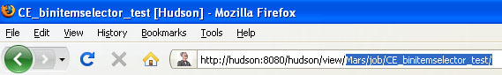
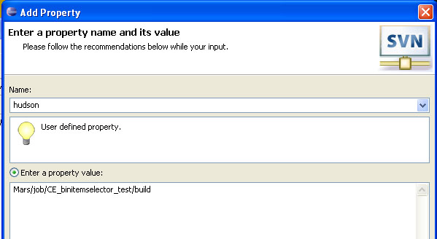
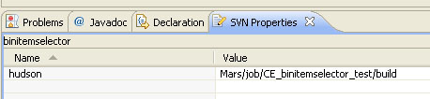
- In the Add Property window, type hudson into the Name dialog box.
- To know what property value to add in the Add Property window, click on the corresponding build in Hudson and, in the web address, copy the text after view. Paste that part of the address into the property value box and type /build on the end.
- Click OK. Notice that name and value are now filled-in in the SVN Properties tab.

To Commit the Property
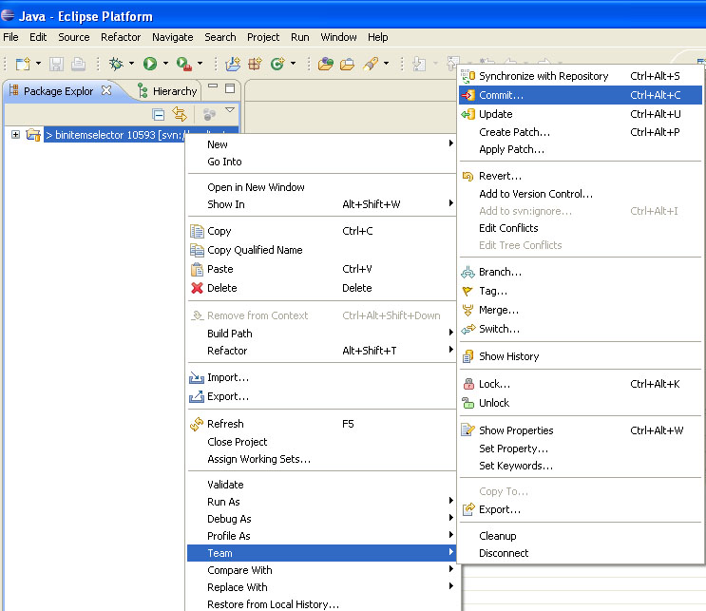
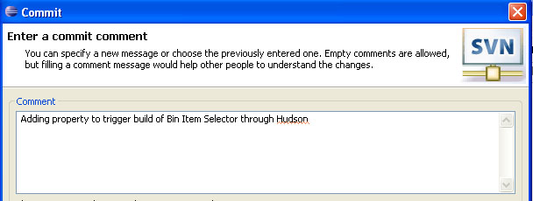
1. Right-click on the binitemselector folder in the Package Explorer tab. Select Team, then click on Commit.
2. In the Commit window, add a comment about the property. For example: “Adding property to trigger build of Bin Item Selector through Hudson.” Click OK.
Note: Now, for any changes made to that committed folder, Hudson will create a build.
Note: You cannot commit a comment if there has not been a change to the repository. It is possible this change has already been made by someone completing this demo.

Invoking Jobs Not on the Default Hudson Server
The default handling of the SVN ‘hudson’ values, will prefix the given property value with
“http:// hudson.im.calpoly.edu:8080/hudson/view/”.

If your job is on a different server, simply provide the entire URL. For example, an appropriate value could be:
http://im143. im.calpoly.edu/hudson/job/atlas_test_hudson_job/build

Changing the Default Hudson Server
SVN administrators can configure the Post Commit Hook Script to use a different default server prefix by editing the hudson_base property located in <path to repo root>/hooks/tools/post-commit/lib/postCommitHook.properties.
Handling jobs on Hudson with Authentication
To trigger builds on Hudson servers which require authentication, you must include an authentication token as part of your job URL. To get the authentication token:
- Go to the configuration page of the hudson job.
- Select the “Trigger builds remotely” check box and provide an authentication token string in the text field. For consistency it’s recommended that you use “SVNTriggeredBuild” (without the quotes).
- This token must now be appended onto your build URL. The format for the complete job URL is
HUDSON_URL/job/JOB_NAME/build?token=TOKEN_NAME
For example,
http://im143. im.calpoly.edu/hudson/job/atlas_test_hudson_job/build?token=SVNTriggeredBuild
-- or --
Mars/job/CE_binpacker_test/build?token=SVNTriggeredBuild

