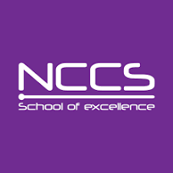

**National College Of Computer Studies (NCCS)**

**Paknajol,Kathmandu**

**Signature**

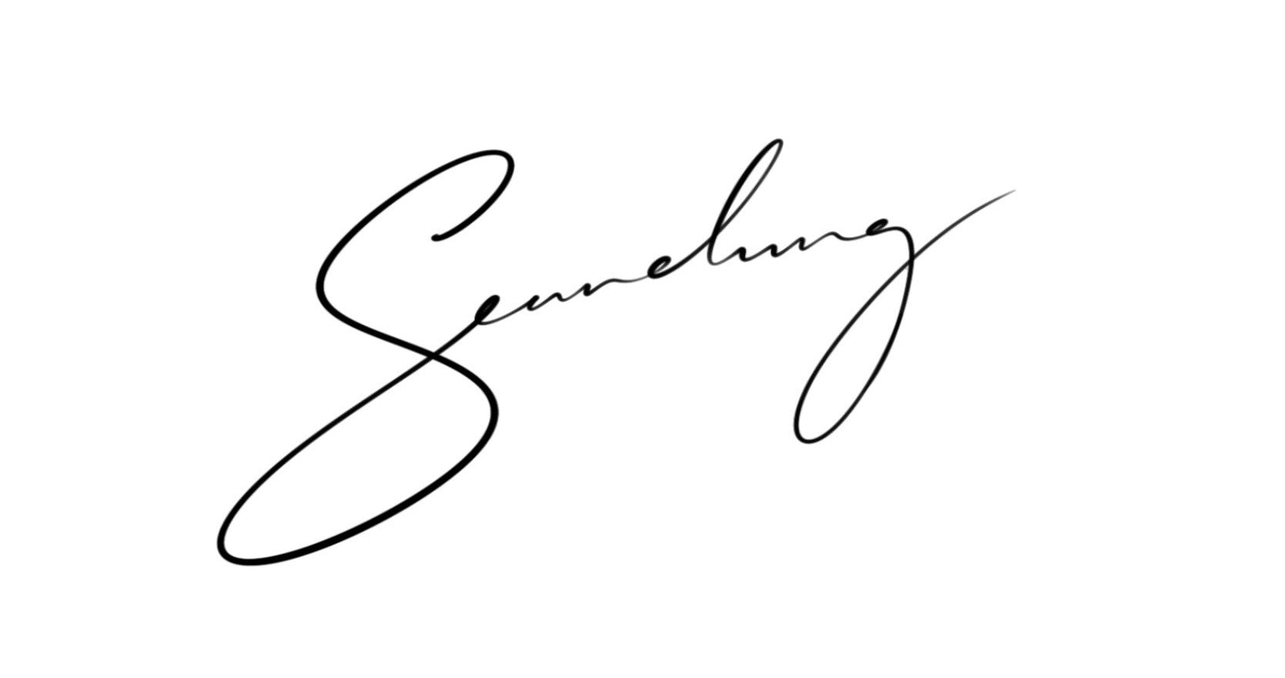



**Contact No: 01-4345678**

**Name: Raju Gurung**

**Address: Balaju,Kathmandu**

**Fathers Name: Aaitaman Gurung**

**Phone No: 98080808**

**Email:** [**raj1234@gmail.com**](mailto:raj1234@gmail.com)

**Semester: 1ST Semester**

**Faculty: BIM**

**STUDENT ID CARD**