Communic-aid
Learning How Much Evidence to Ask For in Gaze-Based Messaging on a Commodity iPhone
Vandya Bisaria
Indian Institute of Technology Gandhinagar, India
Mansie Singh
Indian Institute of Technology Gandhinagar, India
Sinngam Khaidem
Indian Institute of Technology Gandhinagar, India
Gaze is often the most reliable input left to people with severe motor impairments, but gaze interfaces force one trade off on every action: a long dwell is slow, a short dwell selects things by mistake, and a fixed confirmation step is either too weak for a call or too tedious for a letter. Communic-aid is a working hands-free messaging prototype whose only sensor is an iPhone with a TrueDepth camera. The phone streams gaze, head pose, blinks, eyebrow raises and a spoken confirmation word to a laptop that runs a chat app with messages, calls and a gaze keyboard. Its central idea is that the interface learns how much evidence to ask for before it acts, per person, per context and per level of risk. Every action belongs to one of four risk tiers with an accident cost; a dwell learner sets the dwell from implicit feedback, and a contextual bandit chooses which confirmation signal, if any, to ask for on risky actions. In a controlled usability test with two able-bodied participants, the learner shortened the dwell from 1500 ms to about 1200 ms within one session, with two accidents in 146 selections, both on undoable letters and none on risky actions; the router adapted its choice of signal to each participant; and a grouped keyboard with large targets was 1.5 to 2.8 times faster than QWERTY. Three more participants, including one person with a motor impairment, are scheduled.
CCS CONCEPTS • Human-centered computing → Accessibility technologies • Human-centered computing → Interaction techniques
Additional Keywords and Phrases: gaze interaction, adaptive dwell time, multimodal confirmation, contextual bandit, motor impairment, high-fidelity prototype, usability evaluation
ACM Reference Format:
Vandya Bisaria, Mansie Singh, and Sinngam Khaidem. 2026. Communic-aid: Learning How Much Evidence to Ask For in Gaze-Based Messaging on a Commodity iPhone. CS 435 Human-Computer Interaction, Group Course Project, IIT Gandhinagar, November 2026.

1 System Design and Architecture
Goal. For many people with ALS, muscular dystrophy, cerebral palsy or spinal cord injury, the eyes remain controllable long after the hands. Gaze interfaces suffer from the Midas touch problem [3]: the eyes are always looking at something, so the interface cannot tell “do this” from “I am reading”. The usual remedy is a dwell time: a button is selected only after the eyes have stayed on it long enough. Adaptive dwell methods tune one such threshold for all actions [5, 7, 9], and multimodal methods add a fixed second signal [2, 8]. Our earlier reports identified three gaps: confirmation does not scale with the cost of an error, dwell adaptation rarely learns from implicit signals, and no system chooses the confirmation modality from experience. Communic-aid addresses all three with one question: how much evidence should the interface ask for before it acts?
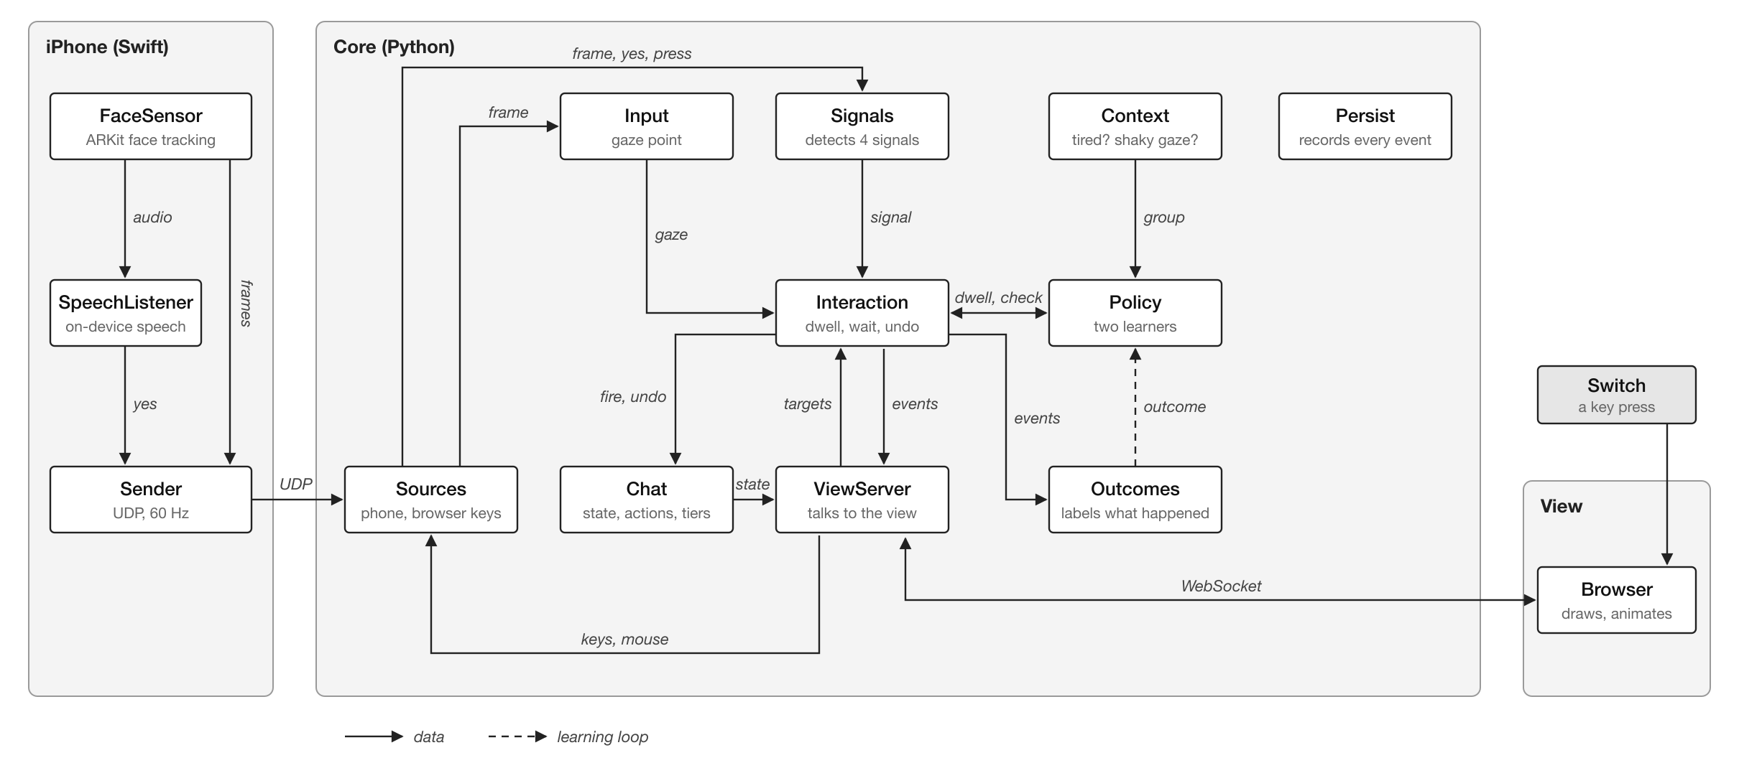
Figure 1: Architecture. The iPhone only senses, the Python core makes every decision, and the browser only draws. The dashed arrow is the learning loop: outcomes update the policy.
Architecture. The system has three parts (Figure 1). (1) iPhone app (Swift, ARKit face tracking): sends at 60 Hz over UDP the gaze ray and eye position in camera space, the nose direction, and blink and eyebrow blendshapes. On-device speech recognition listens only for the word “go”. A live face preview helps the person position themselves. (2) Core (Python, asyncio): maps gaze to the screen with a nine point calibration (quadratic least squares with a small ridge term), smooths it with an exponential filter, holds it still during blinks, and corrects slow drift from the centres of buttons just selected. It detects signals with per-person thresholds set halfway between rest and peak in a signal check (blink held 500 ms, eyebrows raised 300 ms, the spoken word, or a switch key). It runs the dwell and confirmation logic, labels outcomes, updates the learners, and logs every event. (3) View (HTML, CSS and JavaScript over a WebSocket): draws the screens and animations and knows no rules. There is no external API: all logic runs locally, so face and gaze data never leave the two devices.
Risk tiers. Every action belongs to a tier (Table 1) whose accident cost doubles with each step. Both learners use this cost.
Table 1: Risk tiers. Tier 0 and 1 fire on the learned dwell; tier 2 and 3 add a confirmation step after a fixed 1000 ms dwell.
Tier | Actions | Cost | Confirmation
0 | Open a chat, back, scroll, navigation | 1 | Learned dwell
1 | Letters, word suggestions, Space, Backspace, settings | 2 | Learned dwell
2 | Send, react, end a call | 4 | Router: dwell alone or a signal
3 | Call, delete, forward | 8 | Always a signal chosen by the router
Implicit outcomes. The learners never ask the person for feedback. Instead, the core labels each look and each confirmation request from what the person does next (Table 2).
Table 2: Implicit outcomes: how each event is labelled, and what it tells the learners.
Outcome | Rule | What it tells the learner
Accident | A selection undone within 5 s, or a letter deleted within 3 s | The dwell was too short
Worked | A selection that was not undone | The dwell was long enough
Give-up | A look filled at least half the dwell, then the same button was chosen afresh within 5 s | The dwell was too long
Stray glance | Any other look that did not fill | Normal reading; how long glances last
Blocked | A confirmation request timed out with no attempt | The check stopped an unwanted action
Statistics are kept per context group: rested or tired (over 20 minutes in, or evening) crossed with steady or shaky gaze (recent gaze spread over 1.5 times a steady baseline).
Dwell learner (tiers 0 and 1). From counts of intended and unintended looks, stray glances and give-ups, it draws by Thompson sampling [11] the probability π that a look is intended, a mean stray glance length g and a mean patience p, and scores each dwell d from 800 to 2000 ms:
with A(d) = e^{−d/g} the chance a stray glance fires, G(d) = 1 − e^{−d/p} the chance the person gives up first, λ = 0.6 per second and r_{give-up} = −0.5. After each selection the dwell moves 5% towards the best d, by at most 10 ms when shortening and up to 100 ms when lengthening. It starts at 1500 ms and holds for 20 selections per group. In words: a longer dwell stops more stray glances from firing, but makes the person wait and sometimes give up; the learner picks the dwell with the best balance, and a higher tier cost pushes it towards caution.
Modality router (tiers 2 and 3). A contextual bandit [4] keeps, per arm, tier and group, counts of worked, give-up, blocked and accident outcomes, samples their probabilities from a Dirichlet distribution and asks for the arm with the highest expected reward. A worked signal earns 1 minus its effort (which grows with the person’s time to produce it); a blocked accident earns a small reward; an accident costs the tier cost. The preferred signal starts with a bonus, and a group borrows pooled counts until it has 20 tries. In short, the router learns which confirmation works best for each person and context, at the lowest effort.

2 Compromises in Prototyping
We built the prototype wide enough to show every screen of a messaging app, and deep along the one path that carries our research question: from the camera to the learners (Table 3).
Table 3: Horizontal and vertical scope of the prototype.
 | Horizontal (breadth) | Vertical (depth)
Scope | Every screen: onboarding, signal check, calibration, chat list, thread, compose, call, message actions, settings, typing test | The full path from sensing to learning, working end to end with real users
Real | Navigation, layout, feedback, undo, tier colours, both keyboards, word suggestions and quick replies | Gaze and head pointing, signal detection, dwell and confirmation, outcome labelling, both learners, per-person saving, logging and analysis
Simulated | Contacts, chats and replies come from a local file; replies arrive after 7 s; calls connect after 3 s with no audio | Nothing on this path is simulated
Other compromises. (1) The phone is a sensor for a laptop screen rather than a standalone app, which keeps targets large and lets us log everything, but adds a second device. (2) An iPhone with Face ID is required; apps are signed with a free developer account that expires every 7 days. (3) Speech recognises one word, “go”, rather than dictation, which our interviewee with slurred speech found unreliable. (4) Word suggestions come from a fixed word list, not a language model. (5) Head pointing is built but not yet evaluated. (6) The tired flag uses a simple rule (session length or evening) rather than a fatigue measure.

3 Conceptual Design
Metaphor. Communic-aid borrows the messaging app people already know: chats, threads, a call button, a draft box and Send, so no new model of communication must be learned. Selection follows a press and hold metaphor: looking at a button presses it, and the button fills like a progress bar until it fires, so a look can always be abandoned before it counts. Risky buttons add a safety catch, like the second step of a slide to unlock: after the fill, the button shows the signal it needs (an eye, an eyebrow, “go”), and nothing happens without it.
Conceptual model. The objects are chats, messages, contacts and a draft; the actions are open, type, send, react, call, delete, forward and undo. Each action carries a tier, and the tier, not the screen, decides how much evidence it needs. The user controls what to do, which signals are on and which comes first; the system controls how long to wait and when to ask for a signal, and it adjusts both from how the person uses it. Every action can be undone for 5 seconds, and losing the face never fires anything.
Design principles. From our interviews with three people with motor impairments and the literature: (1) calm and low effort, nothing rushes or startles; (2) every visual element gives feedback or prevents a mistake; (3) the cost of an error decides the check; (4) learn from implicit behaviour, never from ratings; (5) reading is safe: text is never a target, only buttons are.
Design space. Table 4 lists the dimensions we explored and our choices. The choices favour mainstream hardware [13, 6] and per-person adaptation, in the spirit of ability-based design [12].
Table 4: Design space. Options we considered for each dimension, and the one we chose.
Dimension | Options considered | Chosen
Sensor | Eye tracker, webcam, iPhone TrueDepth | iPhone TrueDepth: cheap, mainstream, depth based
Pointing | Gaze, head, gaze and head | Gaze, with head pointing as an option
Selection | Dwell, blink, smooth pursuit, gaze gestures | Dwell with a learned time
Confirmation | None, fixed second signal, user chosen, learned | Learned per tier and context
Signals | Blink, eyebrows, voice, switch, EMG, BCI | Blink and hold, eyebrows, “go”, switch
Adaptation | Explicit ratings, implicit outcomes | Implicit outcomes
Text entry | QWERTY, grouped letters, dwell-free, AI text | Grouped (default) and QWERTY, with suggestions and quick replies
Feedback | Visual, sound, colour coding | All three

4 Prototype Description and Functionalities
Figure 2 shows the main screens. The core interaction flow is: look at a button, watch it fill, and for a risky button give the signal it shows.
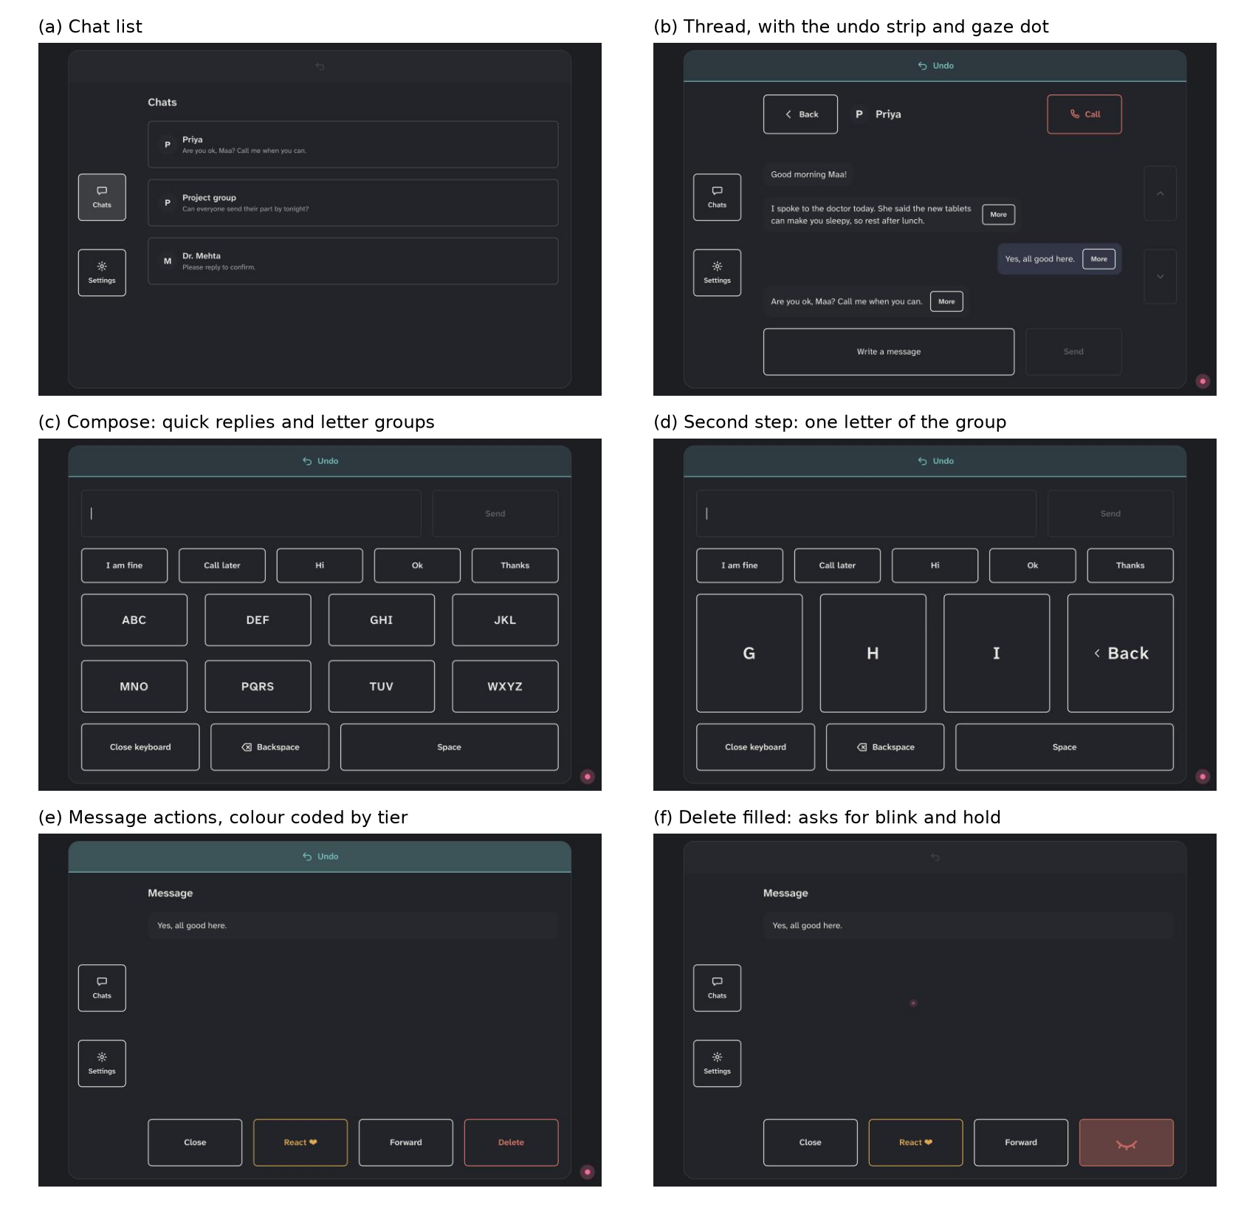
Figure 2: Screens of the working prototype. In (f) the Delete button has filled and now shows the closed eye: it waits for blink and hold before it deletes.
Navigation. Chats and Settings sit in a fixed side bar; Back, scroll buttons and the undo strip are in the same places on every screen. A chat opens a thread; More on a message opens its actions (React, Forward, Delete); Call opens a call screen with End call.
Text entry. The grouped keyboard has eight letter groups (abc to wxyz): a group, then a letter (Figure 2c, d). QWERTY is one selection per letter. Both offer word suggestions and five quick replies.
Feedback and transitions. A pink dot shows where the system thinks the person is looking. Buttons fill as they are looked at and glow when they fire; tier 2 buttons have an amber outline and tier 3 a red one. A confirmation request shows the signal’s icon on the button and waits up to 4 s; a wrong signal makes the button shake and plays a soft error tone, and a confirmed one plays a tick. After any action a teal undo strip appears for 5 s. Plain language banners appear when tracking fails (“I can’t see your eyes. Look at the screen.”, “Move a little closer”), and only after the problem has lasted a second, so they never flicker.
Setup and settings. First use asks three onboarding questions, then runs the signal check and calibration (redone automatically if the error exceeds 100 px). Settings turn signals on or off, choose the one to try first, switch sounds and keyboard, and rerun calibration or the signal check. Three switch presses always escape to safety.
Study tools. A typing test mode shows a passage and measures words per minute for two minutes from the first letter. A terminal log shows every learner decision live. Scripts produce per-person heatmaps, dwell plots and summary tables. The core has 79 automated tests.

5 User Evaluation and Results
Method. We ran a task-based usability test in a controlled setting (a quiet room, laptop on a desk, phone mounted below the screen at 40 to 60 cm, head free to move), with an experimenter present. Data came from three sources: the system’s event log (every look, selection, outcome and learner update), a two minute typing test, and the System Usability Scale [1] with open feedback after the session.
Participants. Two able-bodied adults (P1, P2) have completed the test with gaze pointing in the adaptive condition. Two more able-bodied participants and one participant with a motor impairment are scheduled.
Procedure. Signal check and calibration; free use of the app; four tasks (navigate between chats and settings and change the preferred signal; compose and send a message of at least ten letters; make and end a call; delete a message); then the typing test, three runs with each keyboard, grouped first, a new 248 character passage each run, no word suggestions. Free use lasted 9 minutes for P1 and 24 for P2. We report words per minute ((n − 1)/t × 60/5 for n characters in t seconds), accuracy from the edit distance to the passage, and keystrokes per character [10].
Table 5: Free use session, from the event log. Selections exclude undo and redo.
Measure | P1 | P2
Session length | 9 min | 24 min
Calibration error | 80 px | 69 px
Selections (tier 0 / 1 / 2 / 3) | 51 (18 / 29 / 2 / 2) | 95 (32 / 51 / 7 / 5)
Accidents | 2 (both tier 1, both undone) | 0
Dwell give-ups | 6 | 11
Stray glances | 145 | 541
Confirmation requests on tiers 2 and 3 (worked / gave up) | 5 (4 / 1) | 13 (12 / 1)
Dwell at end, tier 0 / tier 1 | 1216 / 1333 ms | 1219 / 1431 ms
Head movement, median / 95th percentile | 18 / 214 mm | 18 / 69 mm
Accidents and confirmation. Across 146 selections there were two accidents, both letters, both undone (Table 5). No tier 2 or 3 action fired by mistake. 16 of 18 confirmation requests succeeded. The router adapted within each session: when P1 gave up on raised eyebrows to confirm Send, the next Send asked for blink and hold, which worked, as did the call and the deletion that followed. P2 began with blink and hold; after three successful confirmations the router accepted dwell alone on tier 2 (four times, all worked), and after P2 made “go” the preferred signal, P2 confirmed it five times out of five.
Dwell learning. Stray glances outnumbered selections three to six times: a gaze interface produces much implicit evidence even when nothing is selected. After its warm-up the learner shortened both tiers steadily (Figure 3); tier 0 fell from 1500 to about 1220 ms for both participants. Tier 1 stayed longer, as expected from its higher cost. A new context group (P1, tired with shaky gaze) started from 1500 ms and was learned separately.
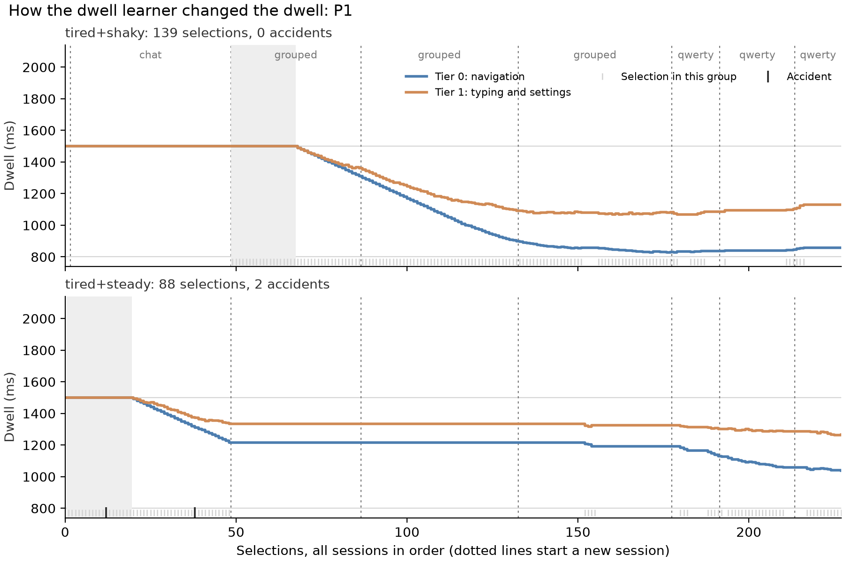
Figure 3: P1’s dwell over all sessions, one panel per context group, one line per tier. The first session is free use, then three grouped and three QWERTY typing runs. Shading marks the warm-up; marks at the bottom are selections (light) and accidents (dark).
Typing. The grouped keyboard was 1.5 (P1) and 2.8 (P2) times faster than QWERTY (Table 6), despite almost two selections per letter, and not because of the dwell, which was slightly shorter in the QWERTY runs. Target size explains it: a letter group was 316 × 113 px and a QWERTY key 113 × 67 px, while the calibration error was 69 to 80 px, about one QWERTY key.
Table 6: Typing test, mean of three two minute runs per keyboard. The dwell was still learning during this test, so the mean tier 1 dwell in use is shown.
 | Keyboard | WPM | Accuracy | Keystrokes per char. | Mean dwell
P1 | Grouped | 2.23 | 100% | 1.84 | 1261 ms
 | QWERTY | 1.50 | 91.7% | 1.06 | 1214 ms
P2 | Grouped | 1.60 | 100% | 1.86 | 1327 ms
 | QWERTY | 0.57 | 100% | 1.11 | 1259 ms
Usability (SUS). Table 7 gives the System Usability Scale scores (0 to 100; about 68 is average).
Table 7: System Usability Scale.
 | P1 | P2
SUS score | [TO FILL: P1 SUS] | [TO FILL: P2 SUS]
User feedback. [TO FILL: what P1 and P2 said: what worked, what was hard, what they would change]
Limitations. Two able-bodied participants and no fixed baseline yet, so the results show that the learners behave as intended, not that adaptation beats a fixed dwell. The typing runs were recorded while the dwell was learning and grouped always came first; the typing test now uses a fixed dwell, and the order will be counterbalanced. With a 1500 ms start and a 20 selection warm-up the learner needs about 70 selections to settle. The remaining three participants will use the app twice, adaptive and fixed (1000 ms dwell, dwell alone on tier 2, the preferred signal on tier 3), in counterbalanced order, with SUS after each.

6 Ethics and Risk Assessment
Table 8 lists the risks we identified and our mitigations. An experimenter supervised every session.
Table 8: Risks to participants and how we reduce them.
Risk | Mitigation
Eye strain and fatigue | Breaks offered between parts; the person can pause or stop at any time; the dwell lengthens after errors instead of rushing the person
Neck strain or discomfort | Head free to move; phone placed at a comfortable distance; banners ask the person to move only when tracking fails
Frustration from errors | Undo on every action for 5 s; risky actions need a second signal; a hint after 30 s of being stuck; no time pressure except the typing test
Privacy of face and voice | Camera images are shown live only and never stored; speech is recognised on the phone and only the word “go” is sent; nothing goes to a cloud service
Identification from data | Data is saved under a participant code (P1, P2); names are kept apart from the data; the shared evaluation data uses codes only
The logs hold gaze coordinates, head position and angles, and interaction events; they hold no images, audio or names. The onboarding screen offers an age range and a condition category; participants could pick any option, these answers served as selection practice, and they were not analysed.
Statement. Participation is voluntary. Each participant is told what the session involves and what is recorded, gives consent before starting, and may stop at any time without giving a reason. No sensitive personal data (names, contact details, images, audio or health records) is collected; the data is stored on the team’s computer under participant codes and used only for this course project and its write-up.

7 Conclusion
Communic-aid is a working high-fidelity prototype in which one consumer phone provides both pointing and confirmation for hands-free messaging, and the interface learns from ordinary use, without asking, how long to wait and which signal to ask for before acting. Early tests show rare, cheap, undoable accidents, no accidents on risky actions, a dwell that shortens within one session, and a router that adapts to each person. The remaining sessions will compare adaptive against fixed settings and include a participant with a motor impairment.
REFERENCES
[1] John Brooke. 1996. SUS: A “Quick and Dirty” Usability Scale. In Usability Evaluation in Industry. Taylor & Francis, 189-194.
[2] Y. Cha, D. Chun, and S. Park. 2026. iPhoneme: Brain-to-Text Communication for ALS Using ConformerXL Decoding. arXiv:2604.16441.
[3] Robert J. K. Jacob. 1990. What You Look at is What You Get: Eye Movement-Based Interaction Techniques. In Proceedings of the SIGCHI Conference on Human Factors in Computing Systems (CHI ’90). ACM, 11-18. https://doi.org/10.1145/97243.97246
[4] Lihong Li, Wei Chu, John Langford, and Robert E. Schapire. 2010. A Contextual-Bandit Approach to Personalized News Article Recommendation. In Proceedings of the 19th International Conference on World Wide Web (WWW ’10). ACM, 661-670. https://doi.org/10.1145/1772690.1772758
[5] Päivi Majaranta, Ulla-Kaija Ahola, and Oleg Špakov. 2009. Fast Gaze Typing with an Adjustable Dwell Time. In Proceedings of the SIGCHI Conference on Human Factors in Computing Systems (CHI ’09). ACM, 357-360. https://doi.org/10.1145/1518701.1518758
[6] Yogesh Kumar Meena and M. Salvi. 2025. Multimodal Appearance-Based Gaze-Controlled Virtual Keyboard with Synchronous-Asynchronous Interaction for Low-Resource Settings. https://doi.org/10.48550/arXiv.2508.16606
[7] Martez E. Mott, Shane Williams, Jacob O. Wobbrock, and Meredith Ringel Morris. 2017. Improving Dwell-Based Gaze Typing with Dynamic, Cascading Dwell Times. In Proceedings of the 2017 CHI Conference on Human Factors in Computing Systems (CHI ’17). ACM. https://doi.org/10.1145/3025453.3025517
[8] Omar Namnakani, Yasmeen Abdrabou, Jonathan Grizou, and Mohamed Khamis. 2025. GazeBlend: Exploring Paired Gaze-Based Input Techniques for Navigation and Selection Tasks on Mobile Devices. arXiv:2512.15491.
[9] Anish S. Narkar, Jan J. Michalak, Candace E. Peacock, and Brendan David-John. 2024. GazeIntent: Adapting Dwell-Time Selection in VR Interaction with Real-Time Intent Modeling. arXiv:2404.13829.
[10] R. William Soukoreff and I. Scott MacKenzie. 2003. Metrics for Text Entry Research: An Evaluation of MSD and KSPC, and a New Unified Error Metric. In Proceedings of the SIGCHI Conference on Human Factors in Computing Systems (CHI ’03). ACM, 113-120. https://doi.org/10.1145/642611.642632
[11] William R. Thompson. 1933. On the Likelihood that One Unknown Probability Exceeds Another in View of the Evidence of Two Samples. Biometrika 25, 3/4 (1933), 285-294.
[12] Jacob O. Wobbrock, Shaun K. Kane, Krzysztof Z. Gajos, Susumu Harada, and Jon Froehlich. 2011. Ability-Based Design: Concept, Principles and Examples. ACM Transactions on Accessible Computing 3, 3 (2011). https://doi.org/10.1145/1952383.1952384
[13] Xiaoyi Zhang, Harish Kulkarni, and Meredith Ringel Morris. 2017. Smartphone-Based Gaze Gesture Communication for People with Motor Disabilities. In Proceedings of the 2017 CHI Conference on Human Factors in Computing Systems (CHI ’17). ACM, 2878-2889. https://doi.org/10.1145/3025453.3025790

* Place the footnote text for the author (if applicable) here.

