TIME SHARE

Peer-to-Peer Career Guidance Platform
Final Year Project Report
Bachelor of Science in Information Technology (B.SC.IT)

Submitted by
Piyush Kumar
(CIMAGE COLLEGE PATNA)
Year: 2026

CERTIFICATE

This is to certify that the project titled “TimeShare – Peer-to-Peer Career Guidance Platform” submitted by Piyush Kumar is a bonafide work carried out under my supervision and guidance in partial fulfillment of the requirements for the award of the degree of Bsc.IT.

The project report has been approved as it satisfies the academic requirements prescribed by the institution.

Teacher / Project Guide Signature

Name of Guide: ____________________

Head of Department Signature

College Seal

Date: __________

ABSTRACT

TimeShare is a peer-to-peer career guidance platform developed to connect students with mentors, seniors, and professionals who can provide real-world career advice. Many students struggle to find reliable guidance for their career decisions due to misinformation, advertisements, and lack of direct communication with experienced individuals.

The objective of this project is to build a web-based platform where students can directly connect with mentors who have already walked the same career path. The system allows users to register as students or mentors, create profiles, discover mentors, book mentorship sessions, read informative blog posts, and communicate through a real-time chat system.

The platform is developed using the Flask web framework with Python as the backend technology. The frontend is designed using HTML, CSS, and Bootstrap. MySQL is used as the database to store user data, bookings, and messages. Real-time communication is implemented using Flask-SocketIO.

The TimeShare platform aims to simplify the career guidance process by creating a transparent, accessible, and interactive system for students and mentors.

INTRODUCTION

Career decision-making is one of the most important stages in a student's life. However, many students face confusion due to the large amount of information available on the internet, advertisements from educational institutions, and the lack of access to real mentors. As a result, students often make decisions based on incomplete or misleading information.

The TimeShare platform is designed to solve this problem by creating a peer-to-peer mentorship environment. The system allows students to connect directly with seniors and professionals who have practical experience in specific career paths. This approach ensures that students receive genuine and practical guidance instead of relying solely on theoretical information.

The platform includes several important modules such as user authentication, mentor profile creation, mentor discovery, booking system, blogging platform, and real-time chat. These modules work together to provide a complete career guidance ecosystem.

The project demonstrates the use of modern web technologies such as Python, Flask, MySQL, and SocketIO to build a scalable and interactive web application.

PROBLEM STATEMENT

Many students struggle to make informed career decisions due to the lack of reliable guidance and mentorship. Traditional career guidance methods often rely on advertisements, coaching institutes, or generic online information that may not accurately reflect real-world experiences.

Students frequently find it difficult to connect with individuals who have practical experience in their desired career fields. This lack of direct communication creates confusion, uncertainty, and poor decision-making among students.

There is a need for a platform that enables students to directly interact with experienced mentors and seniors who can provide authentic career guidance based on real-life experiences. The system should allow students to discover mentors, communicate with them, and seek advice in a transparent and accessible way.

The TimeShare platform aims to address this problem by providing a peer-to-peer mentorship environment where students can connect with mentors and receive genuine career advice.

OBJECTIVES OF THE PROJECT

The primary objective of the TimeShare platform is to create a reliable and interactive environment where students can connect directly with mentors and professionals for career guidance.

The main objectives of the project are:

1. To develop a web-based platform that connects students with mentors.
2. To provide a secure user registration and login system.
3. To allow mentors to create professional profiles and showcase their experience.
4. To enable students to search and discover mentors based on their interests.
5. To implement a session booking system for mentorship interactions.
6. To provide a blog platform where informative articles related to careers can be shared.
7. To implement a real-time chat system for direct communication between students and mentors.
8. To design a user-friendly interface that improves accessibility and usability.

TECHNOLOGIES USED

The TimeShare platform is developed using modern web development technologies that provide reliability, scalability, and ease of development.

Backend Technology:
Python programming language is used for backend development. The Flask framework is used to build the web application and handle server-side logic.

Frontend Technology:
The frontend of the platform is designed using HTML, CSS, and Bootstrap. These technologies help in creating a responsive and visually appealing user interface.

Database:
MySQL database is used to store user data, mentor profiles, bookings, blog posts, and chat messages.

Real-Time Communication:
Flask-SocketIO is used to implement real-time chat functionality between users.

Development Tools:
Visual Studio Code is used as the primary code editor for development and debugging.

Version Control:
Git and GitHub are used for version control and source code management.

SYSTEM MODULES

The TimeShare platform is divided into multiple functional modules that work together to provide a complete career guidance system.

1. User Authentication Module
This module allows users to register and log in securely. It verifies user credentials and maintains session management for authenticated users.

2. Mentor Profile Module
Mentors can create and manage their profiles by adding information such as skills, experience, and career background. This helps students identify suitable mentors.

3. Student Dashboard Module
Students can browse available mentors, read blog articles, and access mentorship features through a personalized dashboard.

4. Blog System Module
The platform includes a blogging system where users can publish articles related to career guidance, internships, and educational advice.

5. Real-Time Chat Module
The real-time chat feature allows students and mentors to communicate instantly using WebSocket technology implemented through Flask-SocketIO.

6. Admin Management Module
The admin module allows administrators to manage users, monitor activities, and maintain the platform efficiently.

SYSTEM ARCHITECTURE

The TimeShare platform follows a three-tier architecture model consisting of the presentation layer, application layer, and database layer.

Presentation Layer:
This layer includes the user interface developed using HTML, CSS, and Bootstrap. It is responsible for displaying information to users and collecting input through web forms.

Application Layer:
The application logic is implemented using the Flask framework in Python. This layer processes user requests, manages business logic, and communicates with the database.

Database Layer:
The database layer uses MySQL to store and manage application data such as user accounts, mentor profiles, blog posts, bookings, and chat messages.

The architecture ensures separation of concerns, making the system easier to maintain, scale, and improve in the future.

DATABASE DESIGN

The TimeShare platform uses a relational database system implemented using MySQL.

The main tables used in the system include:
Users Table
This table stores user information such as name, email, password, and role (student or mentor).
Mentor Profiles Table
This table contains additional mentor details including experience, skills, and professional background.

Blogs Table
The blog table stores articles created by users including title, content, image, and view count.

Bookings Table
This table records mentorship session bookings between students and mentors.

Messages Table
The messages table stores chat messages exchanged between users in real-time communication.

The relational structure ensures efficient data storage and retrieval while maintaining data integrity.
CONCLUSION

The TimeShare platform successfully demonstrates how technology can be used to simplify career guidance for students. The system provides a peer-to-peer mentorship environment where students can connect directly with experienced mentors and professionals.

The platform integrates multiple modules including user authentication, mentor discovery, blogging system, and real-time communication. These features work together to provide an interactive and user-friendly experience.

By using technologies such as Python, Flask, MySQL, and SocketIO, the project showcases the implementation of a modern web application capable of handling real-time communication and database-driven content.

Overall, the TimeShare platform offers a practical solution to the problem of unreliable career guidance and demonstrates the potential of peer-to-peer mentorship systems in helping students make better career decisions.

FUTURE SCOPE

Although the TimeShare platform provides a functional mentorship environment, there are several opportunities for further improvements and expansion.

In the future, the platform can include video mentorship sessions, allowing mentors and students to communicate through video calls. Artificial Intelligence can also be integrated to recommend mentors based on student interests and career goals.

Additional features such as mentor rating systems, secure payment integration for mentorship sessions, and mobile application support can further enhance the platform.

The system can also be scaled to support thousands of users by deploying it on cloud infrastructure and improving database optimization. These improvements will make the platform more powerful and accessible for students worldwide.

REFERENCES

1. Flask Official Documentation
https://flask.palletsprojects.com/

2. MySQL Official Documentation
https://dev.mysql.com/doc/

3. Bootstrap Documentation
https://getbootstrap.com/

4. Python Official Documentation
https://docs.python.org/

5. Socket.IO Documentation
https://socket.io/docs/

SYSTEM IMPLEMENTATION

1
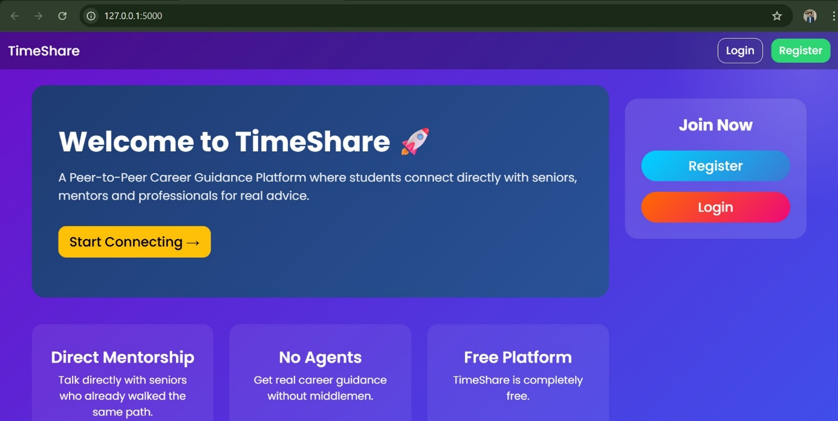
HOME PAGE

2
USER REGISTRATION PAGE

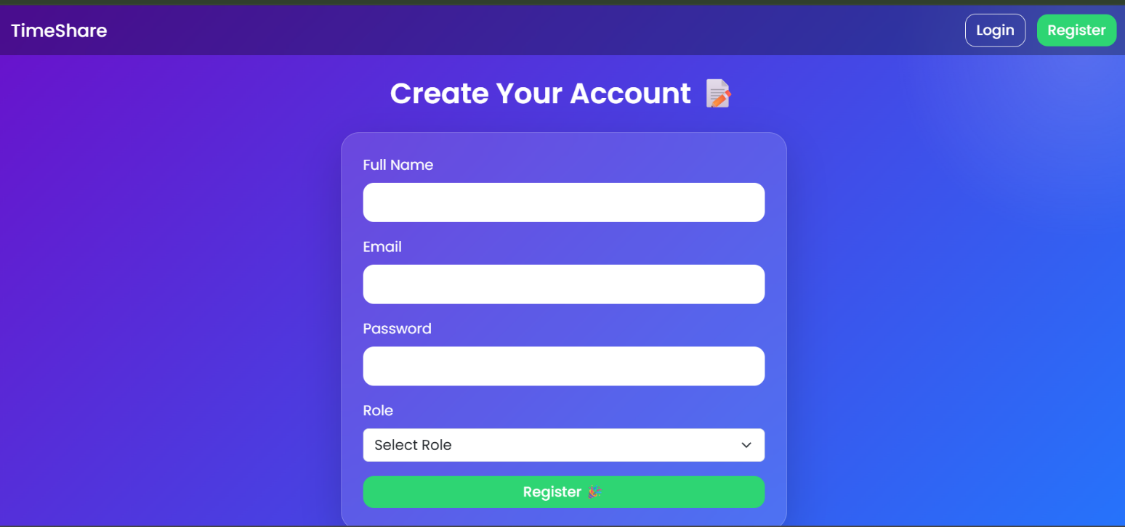

3
USER LOGIN PAGE
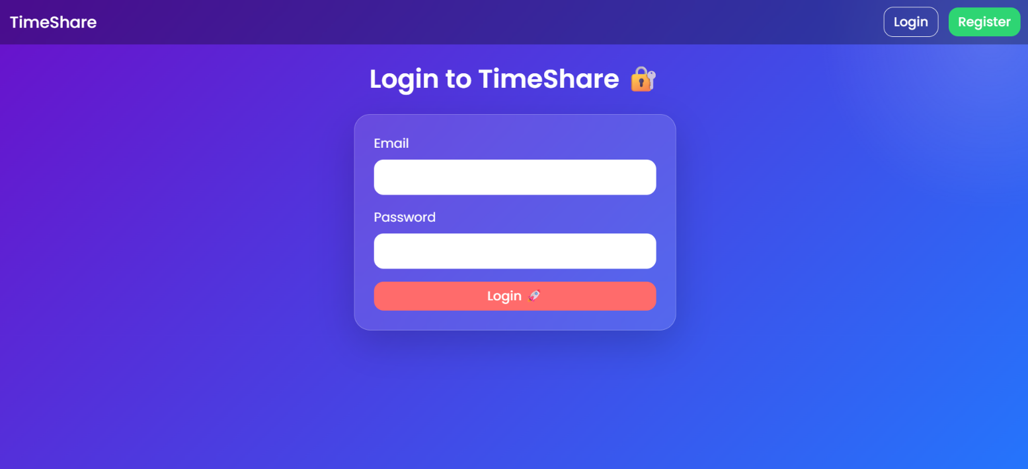

4
USER DASHBOARD
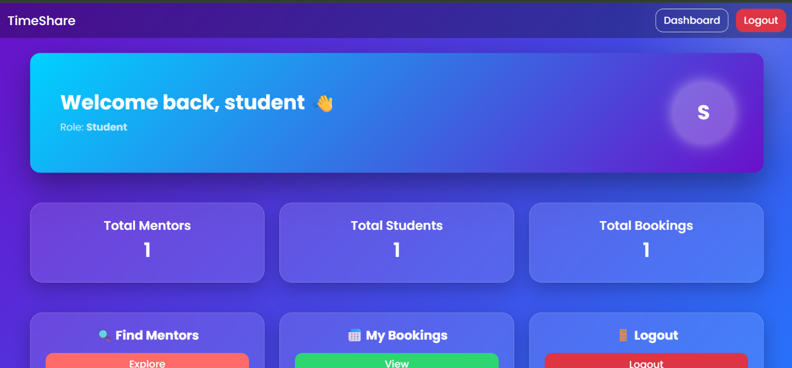

5
BLOG SECTION
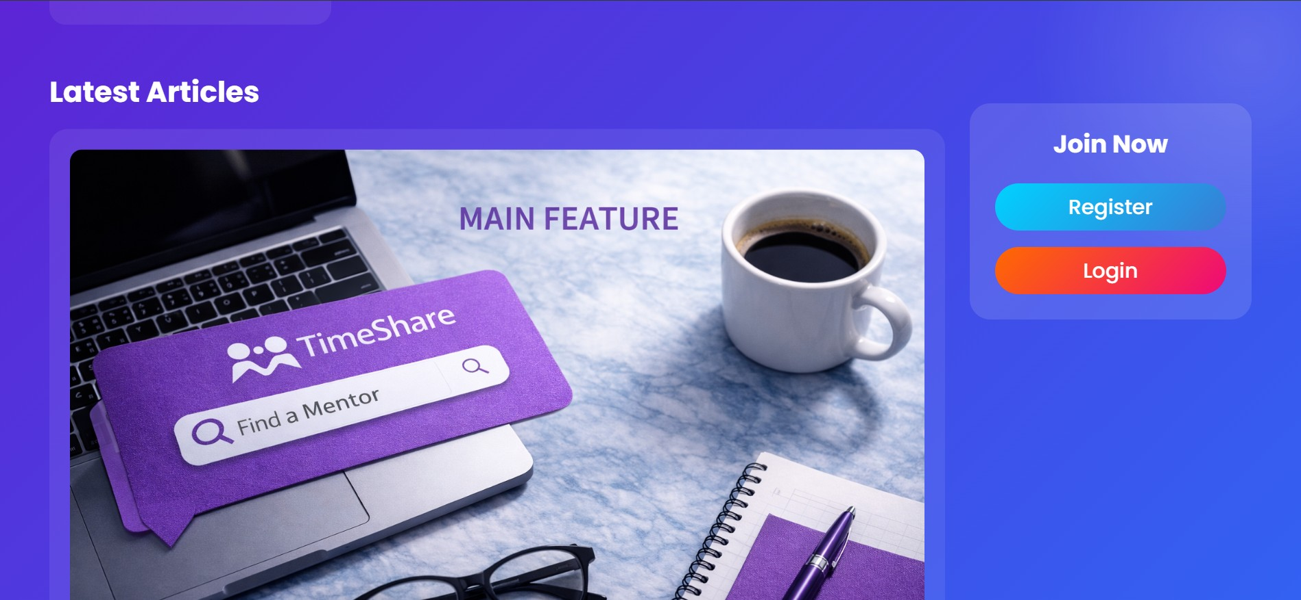

6
REAL-TIME CHAT SYSTEM
