Nurse ui
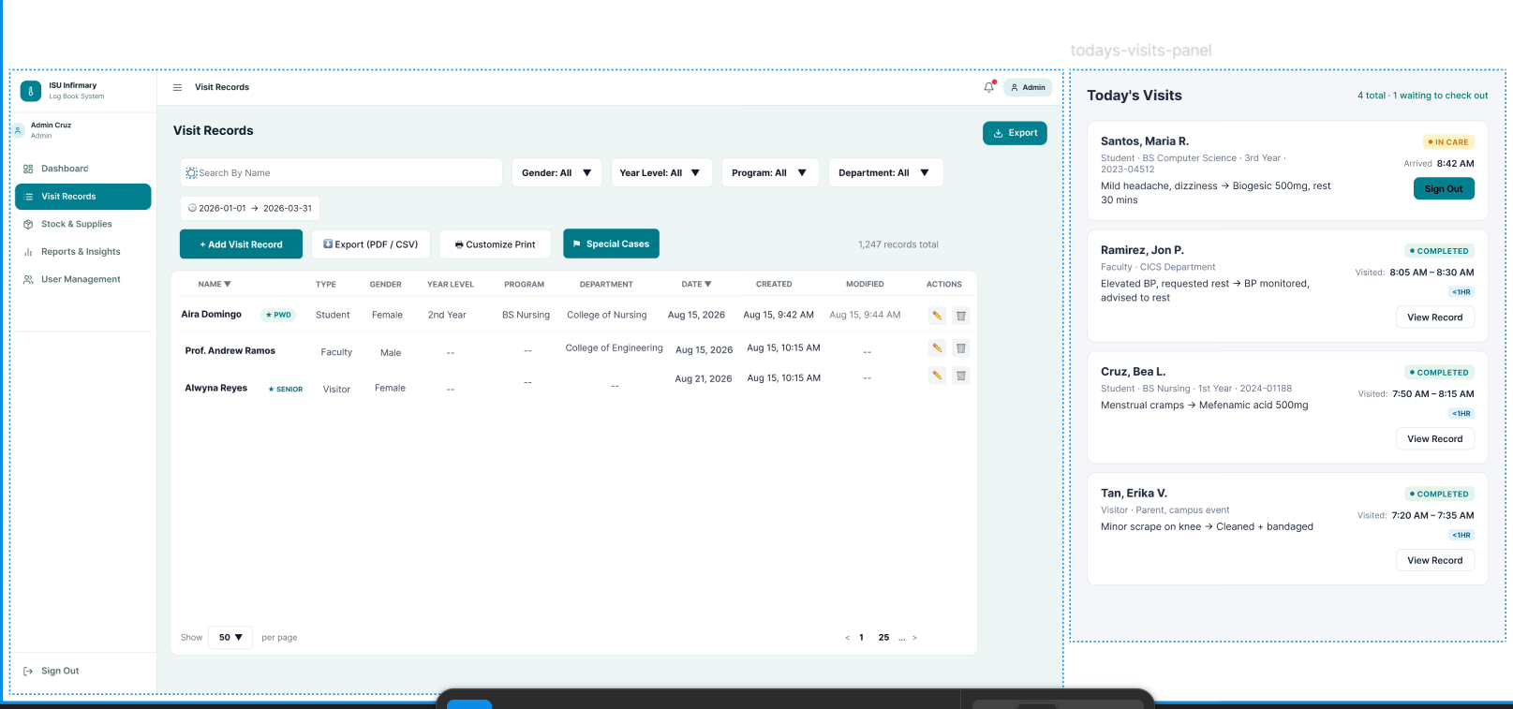
This part tatlo makikita kapag sa patients record, mga records ng normal then todays visit tas yung Priority&special cases para isahan na
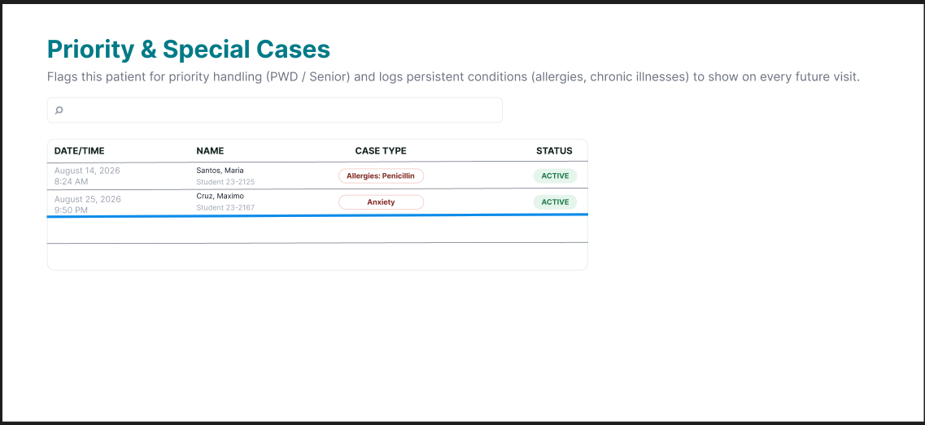
Ganyang design ang mapupunta sa visit patients
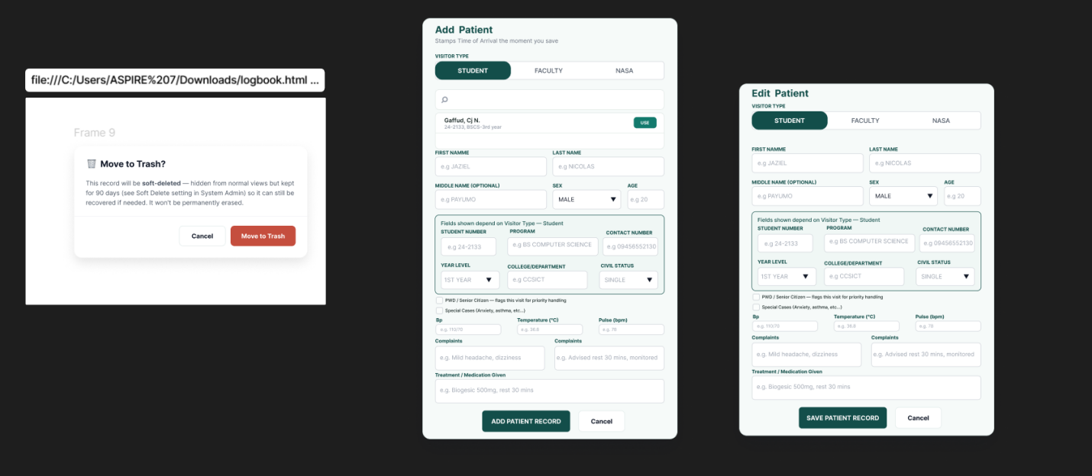
Double check if tama ang add and edit patients then we will keep the design.

Feature in admin and Nurse:
In the nurse Ui theres a request button if the stock is low or what supply is needed. And in the admin UI the the admin will either accept or deny that request

