Capstone Project for IT Professionals
CPT580S
Assignment 1
Title of assignment (Design Phase)
By: Sinothando Masiki
Student number: 219153841
Assignment submitted in part fulfilment of the requirements for the
Postgraduate:
, Faculty of Informatics & Design,
Department of Information Technology
Cape Peninsula University of Technology
Date of submission: 02 August 2026
Title: Machine Learning Early Warning System for Academic Risk in first-Year University Students in South Africa.

Table of Contents
Introduction 3
SYSTEM OVERVIEW 6
MODEL ARCHITECTURE DOCUMENTATION 10
Data Processing 14
Database Design 16
FUNCTIONAL DESIGN 22
Non-Functional Design 24
SYSTEM ARCHITECTURE 24
SECURITY DESIGN 28
USER INTERFACE DESIGN 32
REQUIREMENTS TRACEABILITY MATRIX 36
CONCLUSION 38

Introduction
Artificial Intelligence (AI) and machine learning have significantly transformed decision-making across various sectors, including healthcare, finance, manufacturing, and education. Within higher education, institutions increasingly rely on data-driven technologies to improve teaching, learning, and student support. One of the most promising applications of AI in education is the development of predictive models that identify students at risk of academic failure before poor performance or dropout occurs. These predictive models enable universities to implement timely interventions that improve student retention, progression, and academic success.
South African universities continue to experience high first-year dropout and failure rates due to a combination of academic, behavioural, socioeconomic, and institutional factors. Traditional methods of identifying academically at-risk students, such as lecturer observations, attendance monitoring, and examination results, are often reactive because they identify students only after academic difficulties have already occurred. As student populations continue to grow, manual monitoring becomes increasingly difficult and less effective, creating a need for intelligent systems capable of analysing large volumes of student data and identifying early warning signs of academic risk.
This design document presents the system design for RADAR (Rapid Analysis and Detection of At-risk Students with AI-Based Response), a machine learning-based Early Warning System designed to predict academic risk among first-year university students. The system integrates student academic records, behavioural data collected from Learning Management Systems (LMS), and demographic information to generate predictive insights that support early academic intervention. By incorporating Explainable Artificial Intelligence (XAI) techniques, the proposed system also provides transparent explanations for its predictions, enabling lecturers and academic advisors to make informed intervention decisions.
This chapter introduces the purpose, scope, objectives, stakeholders, and overall design approach of the proposed system. It also provides an overview of the functional and non-functional requirements that guide the design presented in the subsequent chapters.

1.1 Purpose of the Design Document
The purpose of this design document is to provide a comprehensive blueprint for the development of the RADAR Early Warning System. It translates the requirements identified during the analysis phase into a structured technical design that will guide the implementation of the system.
The document defines the overall system architecture, data processing workflow, database design, machine learning architecture, user interface design, security considerations, and functional components required to develop the proposed solution. It serves as a reference for developers, supervisors, and other project stakeholders throughout the implementation and testing phases.
Furthermore, the design document ensures that all system components are aligned with the research aim of developing a machine learning-based predictive model capable of identifying academically at-risk first-year university students within the South African higher education context.

1.2 Project Overview
The project focuses on the design and development of RADAR (Rapid Analysis and Detection of At-risk Students with AI-Based Response), an Artificial Intelligence (AI)-powered Early Warning System designed to predict academic risk among first-year university students. The system aims to support higher education institutions by identifying students who may be at risk of academic failure or dropout at an early stage, enabling timely academic interventions that improve student success and retention.
The proposed system integrates multiple sources of institutional data, including student academic records, Learning Management System (LMS) engagement, attendance records, and demographic information. These data are processed through a structured machine learning pipeline to generate risk predictions that classify students according to their likelihood of experiencing academic difficulties.
To support informed decision-making, the system incorporates Explainable Artificial Intelligence (XAI), allowing lecturers and academic advisors to understand the factors influencing each prediction. Rather than replacing professional judgement, the system serves as a decision-support tool that provides evidence-based insights to guide personalised intervention strategies.
The RADAR system will be implemented as a web-based application that enables authorised users to monitor student performance, view prediction results through interactive dashboards, analyse institutional trends, and generate reports that support academic planning and student success initiatives.

1.3 Project Scope
The scope of this project is limited to the design and development of a machine learning-based Early Warning System for predicting academic risk among first-year undergraduate students enrolled at South African public universities.
The system will collect and process student data obtained from institutional databases and Learning Management Systems. These data sources include academic performance indicators, attendance records, behavioural engagement metrics, and demographic information.
The system will perform the following functions:
- Collect and integrate student data from institutional sources.
- Clean, preprocess, and transform data for machine learning.
- Train and evaluate multiple machine learning classification models.
- Predict individual student academic risk levels.
- Classify students into Low, Medium, or High-Risk categories.
- Present prediction results through an interactive dashboard.
- Provide explainable prediction results using SHAP.
- Generate reports that support academic intervention.
The project does not include the implementation of automated intervention services such as email notifications, counselling appointment scheduling, or integration with external university information systems. Instead, the system provides predictive information and decision-support tools that assist lecturers and academic advisors in planning appropriate interventions.

1.4 Project Objectives
The system design presented in this document is guided by the research aim and objectives defined in the approved research proposal. The primary objective is to design and develop an Artificial Intelligence-based Early Warning System capable of predicting academic risk among first-year university students using institutional data. The design further supports the development of an efficient data processing workflow, an intuitive decision-support dashboard, and a secure, scalable architecture that facilitates early identification and intervention for academically at-risk students.

1.5 Stakeholders
The successful implementation of the RADAR system involves several stakeholders, each with specific responsibilities and expectations.
Stakeholder | Role
Students | Generate academic and behavioural data analysed by the system.
Lecturers | Monitor student performance and use prediction results to provide academic support.
Academic Advisors | Review predictions and coordinate intervention strategies for at-risk students.
Faculty Administrators | Monitor overall student performance and institutional trends through dashboards and reports.
System Administrator | Manage user accounts, system configuration, and database maintenance.
Researcher/Developer | Design, implement, test, and maintain the RADAR system.
1.6 Functional Requirements Overview
The RADAR system is expected to provide the following core functional capabilities:
- User authentication and secure login.
- Collection of student academic, behavioural, and demographic data.
- Data preprocessing and feature engineering.
- Machine learning model training and evaluation.
- Academic risk prediction.
- Student risk classification.
- Explainable prediction analysis using SHAP.
- Interactive dashboard visualisation.
- Reporting and analytics.
- Storage of prediction history.
These functional requirements form the basis for the system architecture described in later chapters.

1.7 Non-Functional Requirements Overview
In addition to its functional capabilities, the RADAR system must satisfy several quality attributes to ensure effective operation.
The system should provide secure access through authenticated user accounts and protect sensitive student information in accordance with the Protection of Personal Information Act (POPIA). The prediction engine should generate results efficiently to support timely academic intervention, while the overall architecture should be scalable to accommodate increasing student populations and future integration with additional institutional data sources.
The dashboard should provide an intuitive and user-friendly interface that enables lecturers and academic advisors to interpret prediction results with minimal training. Furthermore, the modular design of the system should facilitate future maintenance, enhancement, and deployment of improved machine learning models.

SYSTEM OVERVIEW
This chapter presents an overview of the proposed RADAR (Rapid Analysis and Detection of At-risk Students with AI-Based Response) system. The chapter describes the proposed solution to the problem identified in Chapter 1 and provides an overview of the system's users, functional components, workflow, architecture, and technology stack. The purpose of this chapter is to establish a clear understanding of how the system will operate before presenting the detailed design in the subsequent chapters.

2.1 Existing Problem
Higher education institutions continue to face significant challenges in identifying first-year students who are at risk of academic failure or dropping out. Traditional approaches to identifying academically at-risk students rely heavily on lecturer observations, attendance monitoring, academic advising sessions, and examination results. While these methods have supported student success for many years, they are largely reactive because they often identify struggling students only after poor academic performance has already occurred.
As student enrolment continues to increase, manual monitoring becomes increasingly difficult due to high student-to-lecturer ratios. Furthermore, conventional approaches typically rely on isolated indicators such as grades or attendance while overlooking behavioural engagement, demographic characteristics, and socioeconomic factors that also influence student success.
Although Learning Management Systems (LMS) and Student Information Systems (SIS) generate large volumes of educational data, many South African universities have yet to fully utilise this information for predictive analytics and early intervention. Consequently, many students who exhibit early warning signs are identified too late to receive effective academic support.

2.2 Proposed Solution
To address these challenges, this project proposes the development of RADAR, an Artificial Intelligence (AI)-powered Early Warning System that predicts academic risk among first-year university students using machine learning techniques.
The system integrates data obtained from institutional information systems, including student academic records, attendance records, Learning Management System engagement data, and demographic information. After preprocessing the collected data, the system applies supervised machine learning models to predict whether individual students are at low, medium, or high risk of academic failure.
Prediction results are presented through an interactive web-based dashboard that enables lecturers, academic advisors, and faculty administrators to monitor student performance and identify students requiring academic support. The system also incorporates Explainable Artificial Intelligence (XAI) techniques to improve transparency by explaining the factors that contributed to each prediction.
Rather than replacing academic decision-making, the RADAR system functions as a decision-support tool that provides evidence-based insights to facilitate timely and targeted intervention strategies.

2.3 System Users
The RADAR system will support multiple user groups, each with different responsibilities and system permissions.
User | Responsibilities
System Administrator | Manage user accounts, maintain the database, configure system settings, and oversee system security.
Lecturers | Monitor student academic performance, review risk predictions, and identify students requiring academic support.
Academic Advisors | Analyse prediction results, develop intervention plans, and monitor student progress.
Faculty Administrators | View institutional performance trends, generate reports, and monitor faculty-wide academic risk indicators.

Students are not intended to access the system directly. Instead, prediction results are used by university staff to inform support strategies and interventions.

2.4 System Workflow
The RADAR system follows a structured workflow that transforms raw institutional data into meaningful predictions that support academic decision-making.
The workflow begins with the collection of student data from institutional sources, including the Student Information System (SIS) and Learning Management System (LMS). The collected data undergoes preprocessing activities such as cleaning, handling missing values, encoding categorical variables, and feature engineering. The processed dataset is then used to train and evaluate machine learning models.
Once the most suitable predictive model has been selected, the system generates academic risk predictions for individual students. These predictions are categorised into predefined risk levels and presented through an interactive dashboard. Lecturers and academic advisors use the prediction results to identify students requiring early intervention and monitor institutional trends over time.
Figure 2.1 illustrates the overall workflow of the RADAR system.
Insert Figure 2.1: Overall System Workflow

2.5 High-Level System Architecture
The RADAR system follows a layered architecture consisting of four primary layers:
Presentation Layer
This layer provides the user interface through which authorised users interact with the system. It includes dashboards, reports, login pages, and visualisations that display prediction results and institutional analytics.
Application Layer
The application layer manages the business logic of the system. It processes user requests, coordinates communication between system components, manages authentication, and controls access to prediction and reporting services.
Machine Learning Layer
This layer performs data preprocessing, feature engineering, model training, prediction generation, and Explainable Artificial Intelligence (XAI) analysis. It forms the core intelligence of the RADAR system.
Data Layer
The data layer stores student records, academic performance, attendance information, Learning Management System data, prediction history, and system logs. It provides persistent storage for all system data.
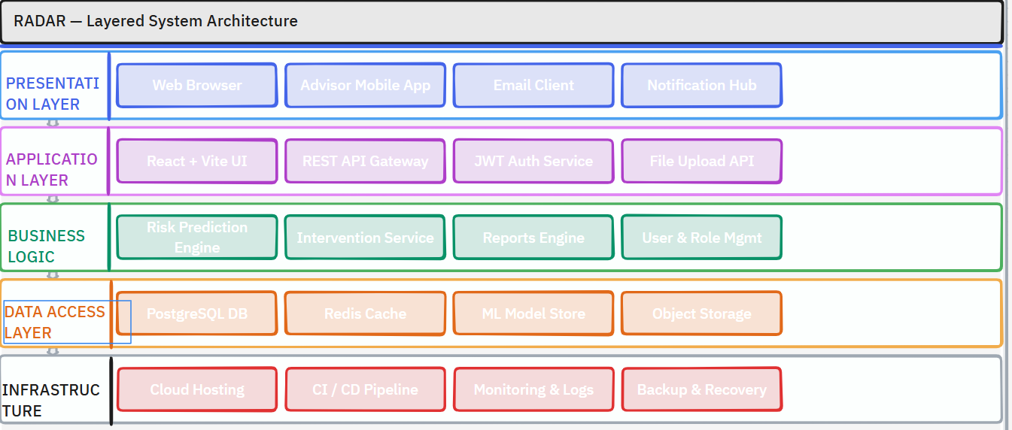 Figure 2.2: Layered System Architecture

2.6 Technology Stack
The RADAR system will be developed using technologies that support machine learning, web application development, data analysis, and visualisation. Table 2.1 presents the proposed technology stack.
Component | Technology | Purpose
Programming Language | Python | Machine learning model development and backend programming
Machine Learning Framework | Scikit-learn | Model training and prediction
Data Analysis | Pandas, NumPy | Data cleaning, preprocessing, and feature engineering
Explainable AI | SHAP | Model interpretability and feature importance analysis
Backend Framework | Flask | Web application and API development
Frontend Technologies | HTML5, CSS3, Bootstrap, JavaScript | User interface development
Database | MySQL | Storage of student records and prediction history
Data Visualisation | Plotly | Interactive charts and dashboards
Development Environment | Visual Studio Code | Software development
Version Control | Git and GitHub | Source code management
Table 2.1: Technology Stack
The selected technologies were chosen due to their widespread adoption in machine learning and web application development, strong community support, and compatibility with educational data analytics projects.

2.7 System Features
The RADAR system provides several core features that support academic risk prediction and decision-making.
The system allows authorised users to securely log in and access role-specific functionality. It collects and preprocesses institutional data before applying machine learning models to generate predictions. Prediction results are presented through interactive dashboards that display risk classifications, performance trends, and feature importance explanations. The system also generates reports that assist lecturers and academic advisors in planning early intervention strategies.
The principal system features include:
- Secure user authentication.
- Student data collection and integration.
- Data preprocessing and feature engineering.
- Academic risk prediction.
- Risk classification.
- Explainable AI analysis.
- Interactive dashboards.
- Reporting and analytics.
- Prediction history management.

MODEL ARCHITECTURE DOCUMENTATION
3.1 Overall Model Architecture
The RADAR system adopts a layered machine learning architecture that processes institutional data through a sequence of interconnected components. Each layer performs a specific function that contributes to the generation of accurate and interpretable academic risk predictions.
The architecture consists of four primary layers:
- Data Acquisition Layer
- Data Processing Layer
- Machine Learning Layer
- Prediction and Decision Support Layer
The Data Acquisition Layer collects student information from institutional systems. The Data Processing Layer prepares the collected data for machine learning by performing cleaning, transformation, and feature engineering. The Machine Learning Layer trains and evaluates predictive models before selecting the most suitable model for deployment. Finally, the Prediction and Decision Support Layer presents prediction results through interactive dashboards and provides explanations that support academic decision-making.

3.2 Data Sources
The effectiveness of any machine learning model depends largely on the quality and diversity of the data used during model development. The RADAR system integrates multiple institutional data sources to provide a comprehensive representation of student performance and engagement.
The primary data sources include:
Category | Features
Academic | GPA, Assignment Average, Test Average
Behavioural | Weekly LMS Logins, Assignment Submission Rate
Attendance | Attendance Percentage
Engagement | Resource Downloads, Discussion Participation
Demographic | Age, Faculty, Programme
The selected features represent variables identified within the literature as important predictors of academic risk.

3.3 Machine Learning Pipeline
The RADAR prediction model follows a structured machine learning pipeline that ensures consistent data preparation and reliable prediction generation.
The pipeline consists of the following stages:
- Data Collection
- Data Cleaning
- Data Transformation
- Feature Engineering
- Dataset Splitting
- Model Training
- Model Evaluation
- Risk Prediction
- Dashboard Visualisation

3.4 Data Pre-processing
Before model training, the collected dataset undergoes several preprocessing activities to improve data quality and ensure compatibility with machine learning algorithms.
The preprocessing stage includes:
Missing Value Handling
Incomplete records are identified and treated using appropriate techniques such as removal or imputation depending on the nature of the missing values.
Duplicate Removal
Duplicate student records are removed to prevent bias during model training.
Data Encoding
Categorical variables such as faculty, programme, and gender are converted into numerical representations suitable for machine learning algorithms.
Feature Scaling
Numerical variables are normalised or standardised where required to improve model performance.
Outlier Detection
Extreme observations are analysed and treated to minimise their influence on predictive performance.

3.5 Machine Learning Model Development
The machine learning component of the RADAR system is responsible for learning patterns from historical student data and generating predictions for new students.
Several supervised classification algorithms will be implemented and compared to determine the most suitable model for predicting academic risk.
The candidate models include:
- Logistic Regression
- Decision Tree
- Random Forest
- Extreme Gradient Boosting (XGBoost)
Each model will be trained using the same processed dataset to ensure fair comparison.
The model demonstrating the best predictive performance will be selected for deployment within the RADAR system.

3.6 Model Evaluation
To ensure reliability and predictive accuracy, each machine learning model will be evaluated using multiple performance metrics.
The evaluation measures include:
Metric | Purpose
Accuracy | Overall prediction correctness
Precision | Correct identification of at-risk students
Recall | Ability to identify all at-risk students
F1-Score | Balance between precision and recall
ROC-AUC | Overall classification performance
Confusion Matrix | Visual representation of prediction outcomes

These metrics provide a comprehensive assessment of classification performance and facilitate comparison between candidate models.

3.7 Explainable Artificial Intelligence (XAI)
Although advanced machine learning models often achieve high predictive accuracy, they frequently operate as "black-box" systems that provide little insight into how predictions are generated.
To improve transparency, the RADAR system incorporates Explainable Artificial Intelligence (XAI) through SHapley Additive exPlanations (SHAP).
SHAP calculates the contribution of individual features to each prediction, enabling lecturers and academic advisors to understand why a student has been classified as academically at risk.
For example, a prediction may indicate that poor attendance, declining assessment performance, and low LMS engagement are the primary contributors to a student's high-risk classification.
This level of interpretability promotes trust in the prediction model and supports informed academic intervention.

3.8 Prediction Process
Once the best-performing model has been deployed, new student data follows the same preprocessing pipeline before predictions are generated.
The prediction process consists of:
- Data Validation
- Data pre-processing
- Feature Engineering
- Model Prediction
- Risk Classification
- SHAP Explanation Generation
- Dashboard Visualisation
- Report Generation
Prediction outcomes are categorised into three risk levels:
Risk Level | Description
Low Risk | Student is progressing satisfactorily.
Medium Risk | Student may require additional academic monitoring.
High Risk | Student requires immediate academic intervention.

These classifications enable university staff to prioritise interventions according to the level of academic risk.

Data Processing

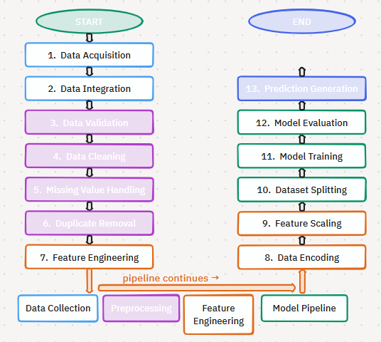
Figure 4.1: Data Processing Workflow

4.1 Data Cleaning
Data cleaning refers to the correction or removal of inaccurate, incomplete, or inconsistent records that may negatively affect model performance.
The cleaning process includes:
- Removal of duplicate records.
- Correction of formatting inconsistencies.
- Removal of invalid observations.
- Standardisation of variable formats.
- Correction of data entry errors.
Examples include converting different date formats into a consistent format or standardising programme names across datasets.
The purpose of data cleaning is to improve overall dataset quality and reduce the likelihood of bias during model training.

4.2 Feature Engineering
Feature engineering involves transforming raw data into meaningful variables that improve predictive performance.
The RADAR system will derive additional features from the original dataset to capture patterns associated with academic risk.
Examples include:
Original Variable | Derived Feature
LMS Logins | Weekly Login Average
Attendance Records | Attendance Percentage
Assignment Marks | Assessment Average
Discussion Activity | Participation Rate
Resource Access | Weekly Resource Usage

Feature engineering allows the machine learning algorithms to identify relationships that may not be immediately apparent in the raw data.

4.3 Dataset
Following training, each model will be evaluated using the testing dataset.
Performance metrics will include:
- Accuracy
- Precision
- Recall
- F1-Score
- ROC-AUC
- Confusion Matrix
The best-performing model will be selected for deployment within the RADAR system.
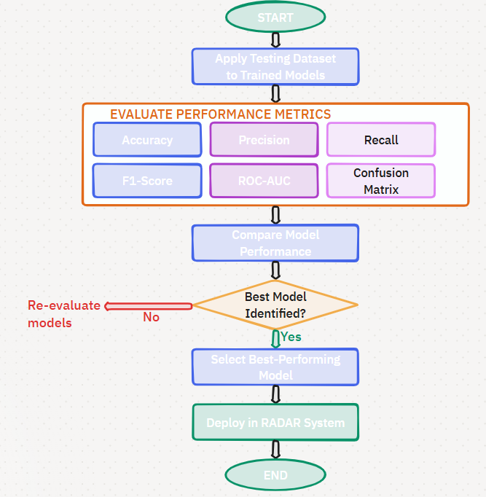Figure 4.3: Model Evaluation Workflow

Database Design
The RADAR system uses a relational database management system (RDBMS) to organise institutional data into related tables. The relational approach minimises redundancy, promotes data integrity, and supports efficient querying using primary and foreign keys.
5.1 Database Architecture
The database architecture consists of six primary entities that collectively support the operation of the RADAR system.
The major entities are:
- Students
- Academic Records
- Attendance
- LMS Activity
- Predictions
- Users
These entities interact to support data collection, machine learning model training, prediction generation, and dashboard reporting.
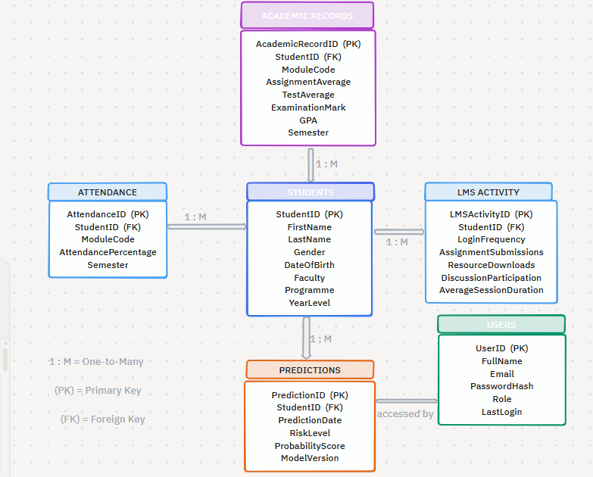
Figure 5.1: Entity Relationship Diagram (ERD)

5.2 Entity Descriptions
5.2.1 Students
The Students table stores demographic and registration information for each student.
Attributes
- StudentID (Primary Key)
- FirstName
- LastName
- Gender
- DateOfBirth
- Faculty
- Programme
- YearLevel
Each student is uniquely identified using the StudentID.

5.2.2 Academic Records
The Academic Records table stores student assessment and examination information.
Attributes
- AcademicRecordID (Primary Key)
- StudentID (Foreign Key)
- ModuleCode
- AssignmentAverage
- TestAverage
- ExaminationMark
- GPA
- Semester
Each academic record belongs to one student.

5.2.3 Attendance
The Attendance table stores lecture attendance information.
Attributes
- AttendanceID (Primary Key)
- StudentID (Foreign Key)
- ModuleCode
- AttendancePercentage
- Semester
Attendance records are linked to the Students table through the StudentID.

5.2.4 LMS Activity
The LMS Activity table stores behavioural engagement information collected from the Learning Management System.
Attributes
- LMSActivityID (Primary Key)
- StudentID (Foreign Key)
- LoginFrequency
- AssignmentSubmissions
- ResourceDownloads
- DiscussionParticipation
- AverageSessionDuration
These variables are used as behavioural predictors during model training.

5.2.5 Predictions
The Predictions table stores the results generated by the machine learning model.
Attributes
- PredictionID (Primary Key)
- StudentID (Foreign Key)
- PredictionDate
- RiskLevel
- ProbabilityScore
- ModelVersion
Each prediction is associated with one student and records the outcome produced by the deployed machine learning model.

5.2.6 Users
The Users table stores information about authorised system users.
Attributes
- UserID (Primary Key)
- FullName
- Email
- PasswordHash
- Role
- LastLogin

5.3 Entity Relationships
The entities are related through primary and foreign key relationships that maintain referential integrity.
The relationships include:
- One Student can have many Academic Records.
- One Student can have many Attendance Records.
- One Student can have many LMS Activity Records.
- One Student can have many Predictions.
- One User can generate many Reports.

5.4 Data Dictionary
The data dictionary defines the fields used within each database table.
Field | Data Type | Description | Key
StudentID | INT | Unique student identifier | PK
FirstName | VARCHAR(100) | Student first name
LastName | VARCHAR(100) | Student surname
Gender | VARCHAR(20) | Student gender
DateOfBirth | DATE | Date of birth
Faculty | VARCHAR(100) | Faculty name
Programme | VARCHAR(100) | Academic programme
YearLevel | INT | Year of study
Table 5.2: Students Table

Field | Data Type | Description | Key
AcademicRecordID | INT | Unique academic record | PK
StudentID | INT | Student identifier | FK
ModuleCode | VARCHAR(20) | Module code
AssignmentAverage | DECIMAL(5,2) | Average assignment mark
TestAverage | DECIMAL(5,2) | Average test mark
ExaminationMark | DECIMAL(5,2) | Final examination mark
GPA | DECIMAL(3,2) | Grade Point Average
Semester | VARCHAR(20) | Academic semester
Table 5.3: Academic Records Table

Table 5.4: Attendance Table
Field | Data Type | Description | Key
AttendanceID | INT | Attendance record identifier | PK
StudentID | INT | Student identifier | FK
ModuleCode | VARCHAR(20) | Module code
AttendancePercentage | DECIMAL(5,2) | Attendance percentage
Semester | VARCHAR(20) | Academic semester

Table 5.5: LMS Activity Table
Field | Data Type | Description | Key
LMSActivityID | INT | LMS activity identifier | PK
StudentID | INT | Student identifier | FK
LoginFrequency | INT | Number of LMS logins
AssignmentSubmissions | INT | Submitted assignments
ResourceDownloads | INT | Downloaded learning resources
DiscussionParticipation | INT | Forum participation count
AverageSessionDuration | DECIMAL(6,2) | Average session duration (minutes)

Table 5.6: Predictions Table
Field | Data Type | Description | Key
PredictionID | INT | Prediction identifier | PK
StudentID | INT | Student identifier | FK
PredictionDate | DATETIME | Prediction timestamp
RiskLevel | VARCHAR(20) | Low, Medium, High
ProbabilityScore | DECIMAL(5,2) | Prediction confidence
ModelVersion | VARCHAR(20) | Model version used

Table 5.7: Users Table
Field | Data Type | Description | Key
UserID | INT | User identifier | PK
FullName | VARCHAR(150) | User's full name
Email | VARCHAR(150) | Institutional email
PasswordHash | VARCHAR(255) | Encrypted password
Role | VARCHAR(50) | User role
LastLogin | DATETIME | Last login date and time

5.5 Database Security
The RADAR database contains sensitive student information and must comply with the Protection of Personal Information Act (POPIA). Security measures include:
- Role-based access control (RBAC).
- Password hashing using secure algorithms.
- Encrypted database connections.
- Regular database backups.
- Audit logging of user activities.
- Restricted access to prediction data.
- Secure storage of authentication credentials.
These measures help ensure confidentiality, integrity, and availability of institutional data.

FUNCTIONAL DESIGN
6.1 Functional Architecture
The RADAR system consists of seven core functional modules that collectively support the prediction of academic risk and intervention management.
The modules include:
- Authentication Module
- Student Data Management Module
- Data Processing Module
- Machine Learning Prediction Module
- Explainable AI Module
- Dashboard and Reporting Module
- Administration and Intervention Management Module

6.2 Functional Modules
Authentication Module
The Authentication Module verifies user credentials and controls access to the system using role-based access control. It ensures that only authorised users can access student information and system features.

Student Data Management Module
This module manages institutional student data obtained from sources such as the Student Information System (SIS), Learning Management System (LMS), attendance records, and academic results. It provides the data required for analysis and prediction.

Data Processing Module
The Data Processing Module prepares raw student data for machine learning by performing validation, cleaning, handling missing values, and feature engineering. The processed dataset is then passed to the prediction module.

Machine Learning Prediction Module
This module analyses processed student data using trained machine learning models to predict students' academic risk levels. Prediction results are categorised as Low Risk, Medium Risk, or High Risk, and stored for reporting and intervention purposes.

Explainable AI Module
The Explainable AI (XAI) Module improves transparency by explaining why a prediction was made. Using SHAP values, it highlights the factors that contributed most to a student's predicted risk level, supporting informed decision-making.

Dashboard and Reporting Module
This module presents prediction results through interactive dashboards, charts, and reports. It enables authorised users to monitor student performance, analyse institutional trends, and generate reports for decision-making.

Administration and Intervention Management Module
This module supports administrative functions, including user management and system configuration, while also enabling lecturers and academic advisors to record, monitor, and manage interventions for students identified as academically at risk.

6.3 Functional Module Interaction
The RADAR system follows a sequential workflow. Student information is collected and managed, processed into a machine-learning-ready format, analysed by the prediction model, and interpreted using Explainable AI techniques. The prediction results are then presented through dashboards and reports, allowing authorised users to monitor student performance and record interventions where necessary. Administrative functions operate across all modules by managing users, permissions, and system settings.

6.4 Use Case Summary
Actor | Primary Use Case
System Administrator | Manage users, roles, and system settings
Lecturer | View prediction results and monitor student performance
Academic Advisor | Review predictions and manage student interventions
Faculty Administrator | Generate reports and analyse institutional trends
Table 6.1: Primary System Use Cases

Non-Functional Design
Security is a critical quality attribute of the RADAR system. The system incorporates authentication, role-based access control, secure communication, password hashing and audit logging. The detailed implementation of these security mechanisms is presented in Chapter 9.
Quality Attribute | Design Objective
Performance | Generate predictions and reports efficiently
Reliability | Produce consistent and dependable prediction results
Availability | Ensure continuous access during operational hours
Scalability | Support increasing numbers of students and future enhancements
Maintainability | Simplify system maintenance and future development
Usability | Provide an intuitive interface for authorised users
Privacy | Comply with POPIA and institutional data governance
Compatibility | Operate across supported browsers and university environments
Backup and Recovery | Protect data against accidental loss or system failure

SYSTEM ARCHITECTURE
This chapter presents the overall software architecture of the RADAR system. It describes the layered architecture, software components, deployment architecture, and communication flow between system components. The proposed architecture supports scalability, maintainability, and modular system development.
The RADAR system adopts a four-layer architecture to organise its components according to their responsibilities.
The architecture consists of:
- Presentation Layer
- Application Layer
- Machine Learning Layer
- Data Layer
Each layer performs specialised functions while communicating with adjacent layers through clearly defined interfaces.

8.1 Presentation Layer
The Presentation Layer provides the graphical user interface (GUI) through which authorised users interact with the system. It enables users to access system features, view prediction results, and generate reports.
The Presentation Layer includes:
- Login page
- Dashboard
- Student profile interface
- Prediction results page
- Reports page
- Intervention management page
- User management interface
The interface is designed to be intuitive, responsive, and accessible using modern web browsers.

8.2 Application Layer
The Application Layer contains the business logic responsible for coordinating system operations. It acts as an intermediary between the user interface, machine learning services, and database.
The responsibilities of this layer include:
- User authentication and authorisation
- Student record management
- Prediction requests
- Dashboard generation
- Report generation
- Intervention management
- System administration
The Application Layer ensures that user requests are validated and processed according to institutional policies and business rules.

8.3 Data Layer
The Data Layer manages all persistent system data and provides secure storage for institutional information.
The database stores:
- Student information
- Academic records
- Attendance records
- LMS activity
- Prediction history
- Intervention records
- User accounts
- System logs
The Data Layer ensures data integrity through primary keys, foreign keys, validation rules, and backup procedures.

8.4 Component Architecture
The RADAR system consists of several interacting software components that collectively support academic risk prediction.
The major software components include:
- Authentication Service
- Student Management Service
- Data Processing Service
- Machine Learning Service
- Explainable AI Service
- Dashboard Service
- Reporting Service
- Intervention Service
- Database Service
Each component performs specialised tasks while communicating through the application layer.

8.5 Deployment Architecture
The RADAR system follows a web-based client-server architecture that supports secure access from university computers.
The deployment architecture consists of:
Client Layer
Users access the system through a web browser using institutional computers or authorised devices.
Web Server
The web server hosts the application and manages communication between users, the machine learning services, and the database.
Machine Learning Engine
The prediction engine executes trained machine learning models and generates academic risk predictions.
Database Server
The database server stores institutional data, prediction history, user accounts, and intervention records.
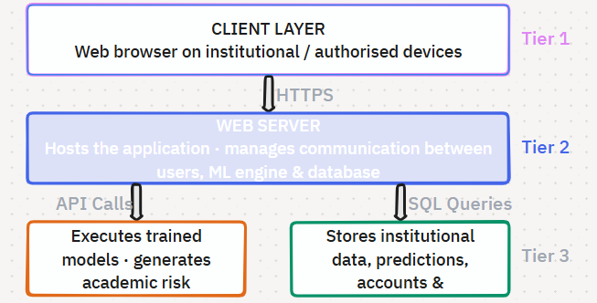Figure 8.1: Deployment Architecture

8.6 System Communication
Communication between system components follows a structured request-response model.
The communication process is as follows:
- A user logs into the system.
- The application verifies user credentials.
- The user requests student prediction information.
- The application retrieves student data from the database.
- The processed data is forwarded to the machine learning engine.
- The prediction engine generates risk predictions.
- The Explainable AI module generates prediction explanations.
- Results are returned to the application.
- The dashboard presents prediction results to the user.
This communication model ensures efficient interaction between the application, machine learning engine, and database.

SECURITY DESIGN
The security design of the RADAR system aims to achieve the following objectives:
- Protect confidential student information.
- Prevent unauthorised access to the system.
- Ensure data integrity during storage and processing.
- Maintain system availability for authorised users.
- Support accountability through audit logging.
- Comply with institutional security policies and POPIA.
- Minimise security risks associated with web-based applications.
These objectives guide the implementation of security controls throughout the system.

9.3 Authentication Design
Authentication verifies the identity of users before granting access to the RADAR system. Only authorised university personnel may access system functionality.
The authentication process consists of the following steps:
- The user enters their institutional email address and password.
- The system validates the submitted credentials.
- The password is compared with its securely stored hashed version.
- If authentication is successful, a user session is created.
- The user is redirected to the appropriate dashboard based on their assigned role.
- Failed authentication attempts are recorded in the audit log.
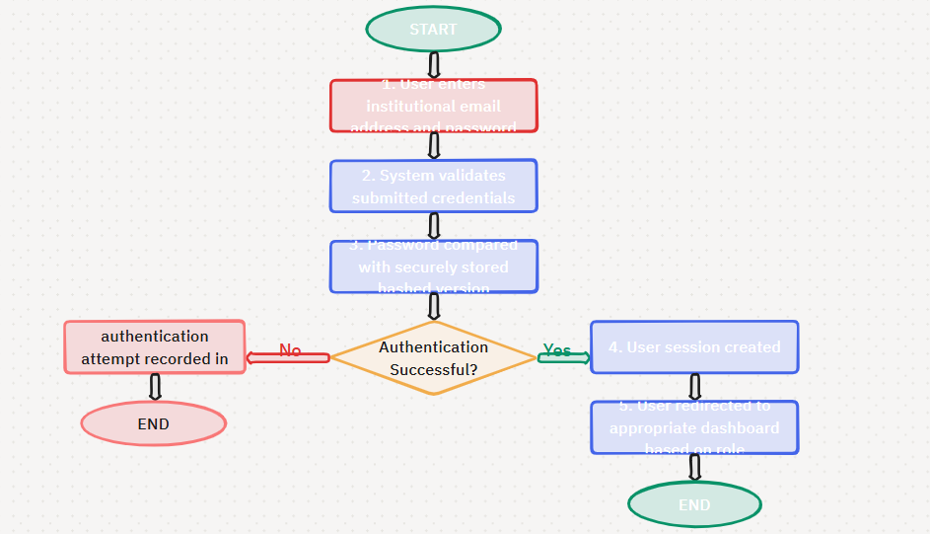
Figure 9.1: Authentication Workflow

9.4 Authorisation Design
After successful authentication, users are granted access according to their assigned roles using Role-Based Access Control (RBAC). This ensures that users can access only the information and functionality required for their responsibilities.
User Role | System Permissions
System Administrator | Manage users, configure the system, maintain the database, and view system logs
Lecturer | View student predictions, dashboards, and reports
Academic Advisor | View predictions, record interventions, and monitor student progress
Faculty Administrator | View faculty reports and institutional analytics
Table 9.1: User Roles and Permissions

9.5 Password Security
To enhance account security, user passwords will never be stored in plain text. Instead, passwords will be securely hashed before being saved in the database.
Password security measures include:
- Password hashing using industry-standard cryptographic algorithms.
- Password complexity requirements.
- Secure password reset functionality.
- Protection against brute-force login attempts.
- Session timeout after prolonged inactivity.
These measures significantly reduce the risk of password compromise.

9.6 Data Protection
The RADAR system stores sensitive personal and academic information that must be protected throughout its lifecycle.
Data protection measures include:
- Encryption of sensitive information during transmission.
- Secure storage of user credentials.
- Controlled access to student records.
- Validation of all user inputs.
- Secure database queries to minimise security risks.
- Regular database backups.
Only authorised users may access prediction results and confidential student information.

9.7 Secure Communication
Communication between users, the web application, and the database should be protected to prevent interception or unauthorised modification of data.
Security measures include:
- HTTPS for secure communication.
- Secure communication between the application server and database.
- Protection of user sessions.
- Validation of incoming requests.
These mechanisms help maintain confidentiality and integrity during data transmission.

9.8 Audit Logging
Audit logging improves accountability by recording significant system events and user activities.
The RADAR system will record events such as:
- User login and logout.
- Failed login attempts.
- Prediction generation.
- Intervention updates.
- User account changes.
- Administrative actions.
Audit logs support system monitoring, security investigations, and compliance requirements.

9.9 Backup and Disaster Recovery
To ensure business continuity, the RADAR system will implement backup and recovery procedures.
The backup strategy includes:
- Regular database backups.
- Secure storage of backup files.
- Backup verification.
- Recovery testing.
- Restoration procedures following hardware or software failures.
These procedures reduce the likelihood of permanent data loss.

9.10 Security Threats and Mitigation Strategies
The RADAR system is exposed to common security threats associated with web applications and data-driven systems. Appropriate mitigation strategies have therefore been incorporated into the system design.
Threat | Potential Impact | Mitigation Strategy
Unauthorised Access | Exposure of confidential student information | Role-Based Access Control (RBAC) and secure authentication
Weak Passwords | Compromised user accounts | Password complexity rules and password hashing
SQL Injection | Database compromise | Parameterised queries and input validation
Cross-Site Scripting (XSS) | Malicious script execution | Input sanitisation and output encoding
Session Hijacking | Unauthorised system access | Secure session management and HTTPS
Data Loss | Loss of institutional information | Regular backups and disaster recovery procedures
Table 9.2: Security Threats and Mitigation Strategies
These strategies help reduce security risks and improve overall system resilience.

9.11 POPIA Compliance
The RADAR system has been designed to comply with the Protection of Personal Information Act (POPIA), which regulates the processing of personal information in South Africa.
To support compliance, the system will:
- Collect only information necessary for academic risk prediction.
- Restrict access to authorised personnel.
- Store personal information securely.
- Maintain audit logs for accountability.
- Protect sensitive information against unauthorised disclosure.
- Process personal information in accordance with institutional policies.
Compliance with POPIA promotes responsible data governance and protects the rights of students.

USER INTERFACE DESIGN
The RADAR system provides role-based interfaces that allow authorised users to access information relevant to their responsibilities. Each interface follows a consistent layout consisting of a navigation menu, dashboard area, and content panel to promote ease of use and efficient navigation.
The main interfaces include:
- Login Screen
- Dashboard
- Student Management
- Prediction Results
- Intervention Management
- Reports
- User Management (Administrator)
The RADAR system provides a web-based, role-based user interface that enables authorised users to access prediction results, manage student information, and support academic interventions through intuitive dashboards and reports.

10.1 Login Design
The Login Interface provides secure access to the RADAR system for authorised users. Users authenticate using their institutional email address and password. Upon successful authentication, the system grants access to role-specific dashboards based on the user's permissions. Invalid login attempts generate appropriate error messages to maintain system security.
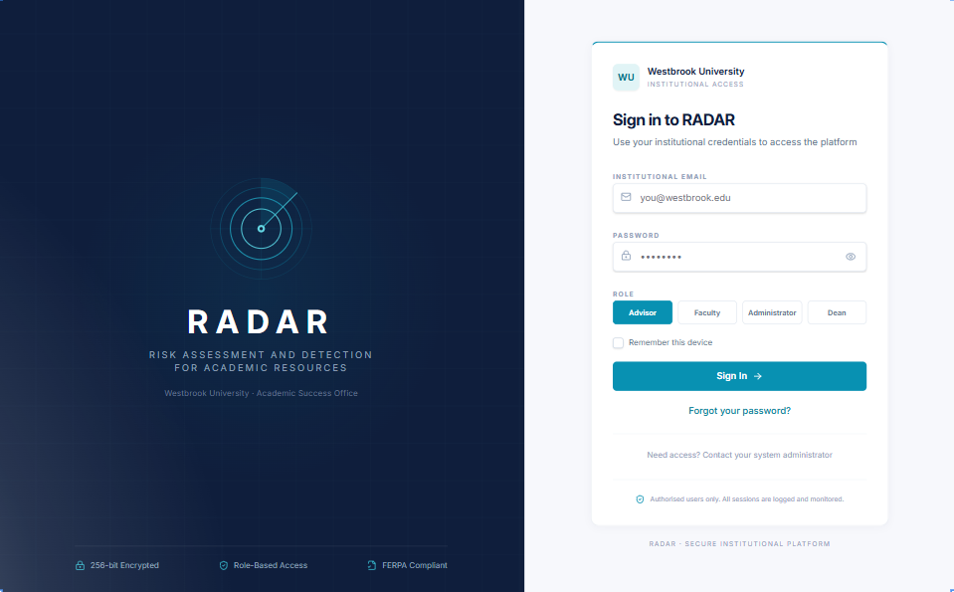
Figure 10.1: Login Page

10.2 Dashboard Design
The dashboard serves as the primary interface after login and provides users with an overview of academic risk across the institution. The dashboard enables users to identify at-risk students quickly and monitor institutional trends.
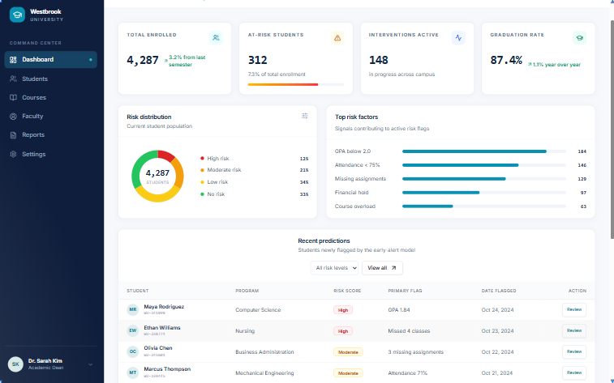
Figure 10.2: Dashboard

10.3 Student Management
The Student Management Interface enables authorised users to search, view, and manage student records within the RADAR Early Warning System. It provides a centralised view of student information, academic performance, attendance, learning management system (LMS) activity, and academic risk predictions. This interface allows lecturers and academic advisors to monitor student progress and identify individuals who may require academic support.
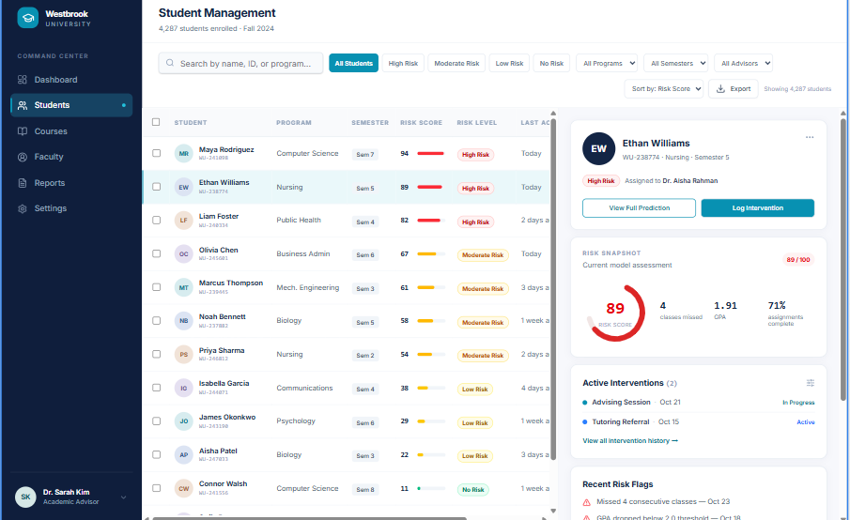
Figure 10.3: Student Management Interface

10.4 Prediction and Intervention Interfaces
The Prediction Results interface displays the machine learning prediction, associated risk level, and explanation of the factors contributing to the prediction. Academic advisors can use this information to determine appropriate intervention strategies.
The Intervention interface enables authorised users to record intervention activities, monitor student progress, and maintain intervention histories.
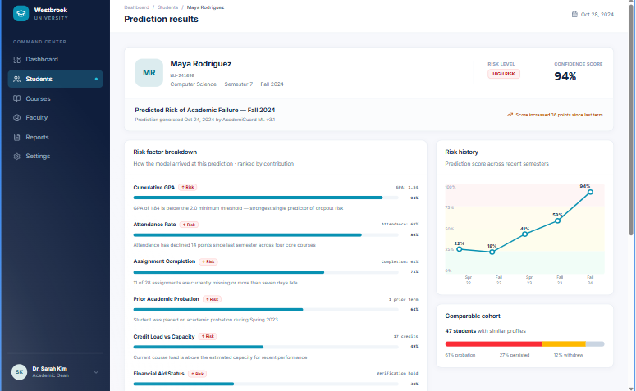
Figure 10.4.1: Prediction Results Screen
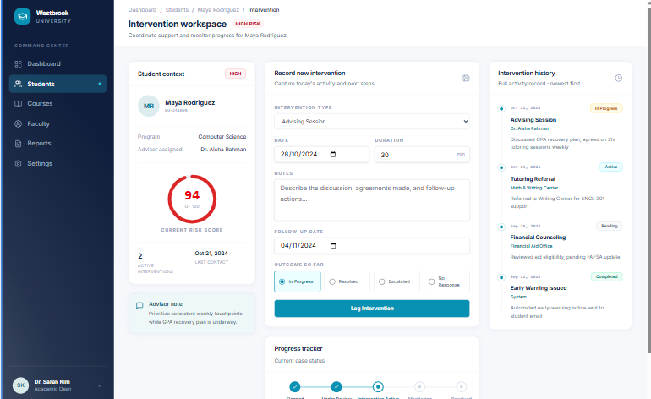
Figure 10.4.2: Intervention Management Screen

10.5 Reporting Interface
The reporting interface provides visual summaries and analytical reports that support institutional decision-making. Users can generate reports related to student risk, prediction outcomes, faculty performance, and intervention activities.
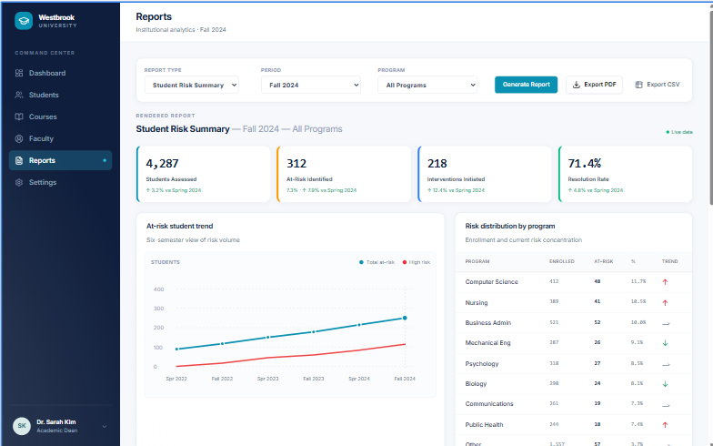
Figure 10.5: Reports Dashboard

10.6 User Interface Design Principles
The user interface was designed according to the following principles:
- Simplicity
- Consistency
- Ease of navigation
- Responsive design
- Accessibility
- Clear data visualisation
These principles ensure that users can efficiently interpret prediction results and perform their assigned tasks.

REQUIREMENTS TRACEABILITY MATRIX
The Requirements Traceability Matrix was developed to:
- Ensure that all system requirements are addressed during the design and implementation phases.
- Maintain traceability between requirements, system modules, and testing activities.
- Verify that each requirement has a corresponding implementation component.
- Support system validation and verification.
- Facilitate future maintenance and system enhancements.

11.1 Functional Requirements Traceability Matrix
Requirement ID | Functional Requirement | System Module | Design Chapter | Verification Method
FR01 | User authentication | Authentication Module | Chapter 6 | Functional Testing
FR02 | Manage student records | Student Data Management | Chapters 5 & 6 | Functional Testing
FR03 | Import institutional data | Data Processing Module | Chapter 4 | Integration Testing
FR04 | Preprocess student data | Data Processing Module | Chapter 4 | Unit Testing
FR05 | Generate academic risk predictions | Machine Learning Module | Chapter 3 | Model Validation
FR06 | Classify students into risk levels | Machine Learning Module | Chapter 3 | Functional Testing
FR07 | Display prediction explanations (SHAP) | Explainable AI Module | Chapter 3 | Functional Testing
FR08 | Display interactive dashboard | Dashboard Module | Chapter 10 | User Acceptance Testing
FR09 | Generate reports | Reporting Module | Chapter 10 | Functional Testing
FR10 | Record student interventions | Intervention Module | Chapter 6 | User Acceptance Testing
FR11 | Manage user accounts | Administration Module | Chapter 6 | Functional Testing
FR12 | Store prediction history | Database | Chapter 5 | Database Testing
Table 11.1.: Functional Requirements Traceability Matrix

11.2 Non-Functional Requirements Traceability Matrix
Requirement ID | Non-Functional Requirement | Design Solution | Design Chapter | Verification Method
NFR01 | Security | Authentication, RBAC, Password Hashing | Chapters 7 & 9 | Security Testing
NFR02 | Performance | Optimised preprocessing and database queries | Chapters 4 & 7 | Performance Testing
NFR03 | Reliability | Data validation and exception handling | Chapters 4 & 7 | System Testing
NFR04 | Availability | Backup and recovery procedures | Chapters 7 & 9 | Recovery Testing
NFR05 | Scalability | Layered modular architecture | Chapter 8 | Load Testing
NFR06 | Maintainability | Modular software design | Chapters 6 & 8 | Code Review
NFR07 | Usability | User-friendly dashboard | Chapter 10 | User Acceptance Testing
NFR08 | Data Privacy | POPIA compliance | Chapters 7 & 9 | Compliance Review
NFR09 | Compatibility | Browser-based web application | Chapters 7 & 10 | Compatibility Testing
NFR10 | Backup and Recovery | Scheduled database backups | Chapter 9 | Recovery Testing
Table 11.2: Non-Functional Requirements Traceability Matrix

CONCLUSION
This design document presented the complete design of the RADAR Early Warning System, covering the machine learning model, data processing workflow, database structure, system architecture, security mechanisms, user interface, and requirements traceability. Collectively, these design components provide a blueprint for implementing a secure and scalable web-based solution for identifying academically at-risk first-year university students.
12.1 Future Enhancements
Although the proposed design satisfies the objectives of the current project, several enhancements may be considered in future work.
Potential future improvements include:
- Integration with additional university information systems.
- Real-time data synchronisation with institutional databases.
- Mobile application support.
- Automated intervention recommendations.
- Integration of deep learning models for comparative analysis.
- Development of predictive analytics for multiple academic years.
- Continuous model retraining using newly collected institutional data.
These enhancements would extend the capabilities of the RADAR system and improve its long-term usefulness within higher education institutions.
The proposed design provides a structured foundation for implementing the RADAR Early Warning System. By integrating machine learning, explainable AI, secure data management, and user-centred interfaces, the system is expected to support the early identification of academically at-risk students and enable timely interventions that contribute to improved student success within South African higher education institutions.

