DHL Build and Deployment

Contents

1 Perquisite 2

2 Git Structure 2

3 Deploy ingress 3

4 Deploy configMap/secret 3

5 Build And Deploy Dashboard 3

5.1 Build Dashboard:- 4

5.2 Deploy Dashboard in Kubernests:- 4

6 Build And Deploy trackntrace 4

6.1 Build trackntrace:- 4

6.2 Deploy trackntrace in Kubernests:- 5

7 Build And Deploy devicestatus 5

7.1 Build devicestatus:- 5

7.2 Deploy devicestatus in Kubernests:- 5

8 Build And Deploy forkliftsocket 6

8.1 Build forkliftsocket:- 6

8.2 Deploy forkliftsocket in Kubernests:- 6

# Perquisite

Following are the prerequisite before build and deploy DHL solution in Kuberneters :

* User should have git installed in his/her desktop.User has to clone DHL solution from git@github.ibm.com:sanksinh/dhl.git
* User should have IBM cloud account
* User should install the IBM Cloud CLI .User can use following URL to install

<https://cloud.ibm.com/docs/cli?topic=cloud-cli-getting-started#idt-prereq>

Following plugin will be installed as part of CLI

1. IBM Cloud Kubernetes Service plug-in (ibmcloud ks)
2. IBM Cloud Container Registry plug-in (ibmcloud cr)
3. The Kubernetes CLI (kubectl)

* User should also install Helm
* User should have docker installed in his/her desktop
* User has to log in to IBM Cloud using following

ibmcloud login –sso

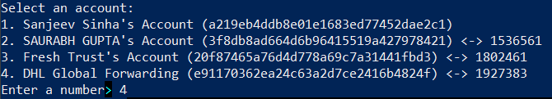

User following command to get cluster config

**ibmcloud ks cluster config --cluster bqa75pfd06pbsufni8n0**

Then Export the yml to connect to Kubernetes :-

**export KUBECONFIG=/root/.bluemix/plugins/container-service/clusters/bqa75pfd06pbsufni8n0/kube-config-dal12-global-dhl.yml**

# Git Structure

Following project included to implement DHL NGFS solution

* Dashboard : DHL will use dashboard UI to access shipment and asset detail
* Trackntrace : Trackntrace will determine shipment and device status
* Devicestatus :Devicestatus will use to get forklift cone device status
* Forkliftsocket :- This will give real time current location of forklift inside warehouse

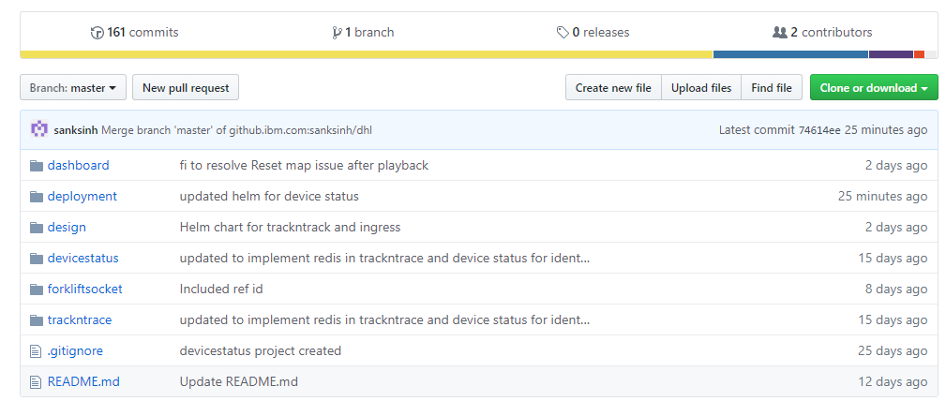

# Deploy ingress

Steps :-

1. Go to ingress chart folder

cd <path-for-dhl-solution>/dhl/deployment/chart/ingress

1. Following command will deploy the images from IBM registry to Kubernetes

helm install  dhl-ingress .

1. Following command will uninstall ingress from Kubernetes

helm uninstall  dhl-dashboard

# Deploy configMap/secret

Environment related specific configuration and secret like database, Redis connection etc will be deployed using following. Also note that for den and production there will be separate yaml for configMap and secret :-

1. Go to ingress chart folder

cd <path-for-dhl-solution>/dhl/deployment/config

1. Following command will deploy configMap

kubectl apply -f config-map-dev.yaml

1. Following command will deploy secret

kubectl apply -f secret-dev.yaml

# Build And Deploy Dashboard

## Build Dashboard:-

Steps :-

1. Go to dashboard folder

cd <path-for-dhl-solution>/dhl/dashboard

1. Following command will build the docker images

docker build --rm -t dhl-dashboard .

1. Tag the image as per IBM Cloud registry

docker tag dhl-dashboard:latest us.icr.io/dhl-global/dhl-dashboard:dev

1. Push the images to IBM Cloud registry

docker push us.icr.io/dhl-global/dhl-dashboard:dev

## Deploy Dashboard in Kubernests:-

Steps :-

1. Go to deployment chart folder

cd <path-for-dhl-solution>/dhl/deployment/chart/dashboard

1. Following command will deploy the images from IBM registry to Kubernetes

helm install  dhl-dashboard .

1. Following command will uninstall the PODs from Kubernetes

helm uninstall  dhl-dashboard

# Build And Deploy trackntrace

## Build trackntrace:-

Steps :-

1. Go to dashboard folder

cd <path-for-dhl-solution>/dhl/trackntrace

1. Following command will build the docker images

docker build --rm -t dhl-trackntrace .

1. Tag the image as per IBM Cloud registry

docker tag dhl-trackntrace:latest us.icr.io/dhl-global/dhl-trackntrace:dev

1. Push the images to IBM Cloud registry

docker push us.icr.io/dhl-global/dhl-trackntrace:dev

## Deploy trackntrace in Kubernests:-

Steps :-

1. Go to deployment chart folder

cd <path-for-dhl-solution>/dhl/deployment/chart/trackntrace

1. Following command will deploy the images from IBM registry to Kubernetes

helm install  dhl-trackntrace .

1. Following command will uninstall the PODs from Kubernetes

helm uninstall  dhl-trackntrace

# Build And Deploy devicestatus

## Build devicestatus:-

Steps :-

1. Go to dashboard folder

cd <path-for-dhl-solution>/dhl/devicestatus

1. Following command will build the docker images

docker build --rm -t dhl-devicestatus .

1. Tag the image as per IBM Cloud registry

docker tag **dhl-devicestatus**:latest us.icr.io/dhl-global/dhl-devicestatus:dev

1. Push the images to IBM Cloud registry

docker push us.icr.io/dhl-global/dhl-devicestatus:dev

## Deploy devicestatus in Kubernests:-

Steps :-

1. Go to deployment chart folder

cd <path-for-dhl-solution>/dhl/deployment/chart/devicestatus

1. Following command will deploy the images from IBM registry to Kubernetes

helm install dhl-devicestatus .

1. Following command will uninstall the PODs from Kubernetes

helm uninstall  dhl-devicestatus

# Build And Deploy forkliftsocket

## Build forkliftsocket:-

Steps :-

1. Go to dashboard folder

cd <path-for-dhl-solution>/dhl/forkliftsocket

1. Following command will build the docker images

docker build --rm -t dhl-forklift .

1. Tag the image as per IBM Cloud registry

docker tag dhl-forklift:latest us.icr.io/dhl-global/dhl-forklift:dev

1. Push the images to IBM Cloud registry

docker push us.icr.io/dhl-global/dhl-forklift:dev

## Deploy forkliftsocket in Kubernests:-

Steps :-

1. Go to deployment chart folder

cd <path-for-dhl-solution>/dhl/deployment/chart/forklift

1. Following command will deploy the images from IBM registry to Kubernetes

helm install  dhl-forklift .

1. Following command will uninstall the PODs from Kubernetes

helm uninstall  dhl-forklift