FAQBNB Application Review
Session: January 11, 2026 at 2:53 PM
Application: faqbnb-staging.up.railway.app
Version: v0.2 | Build: 55881d9 | Date: 2026-01-09

INSTRUCTIONS FOR LLM AGENT
This document contains 5 change requests for the FAQBNB application.
A) You must create an implementation plan for these changes using Agent 00.
B) Once done review your work to make sure you did not forget any important consideration
C) Construct a pipeline using Agent 00b

REQUEST 1: Make Dashboard Cards Clickable
Screen: Dashboard / Home screen
Priority: HIGH
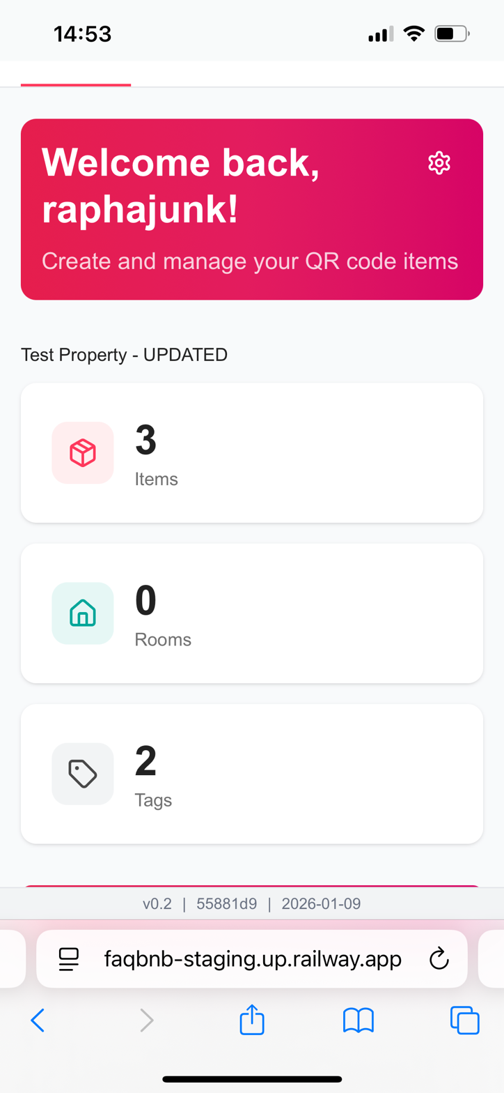

Current State
Dashboard shows summary cards with counts (3 Items, 0 Rooms, 2 Tags) but they are static and non-interactive.

Problem
Users expect to click on dashboard statistics to drill down into details. This is standard UX for dashboard interfaces.

Required Change
- Click "3 Items" → Navigate to Items list
- Click "0 Rooms" → Navigate to Rooms list
- Click "2 Tags" → Navigate to Tags list

REQUEST 2: Fix Data Model - Separate Item from Article/Instructions
Screen: Step 8 - Item Details
Priority: CRITICAL
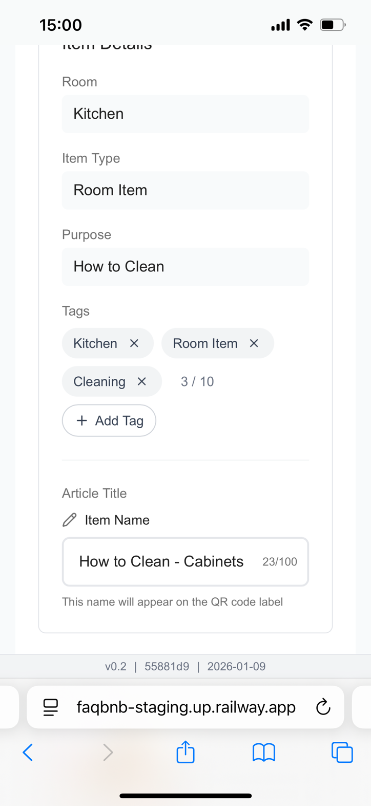

Current State
The UI conflates Item and Article. Shows "Article Title" as "How to Clean - Steamer" and says this will appear on the QR code label.

Problem - Data Model Misunderstanding
The application confuses the relationship between Items, Articles, and QR codes. The current implementation is incorrect.

Correct Data Model
Concept | Description | Example
Item | A physical thing. Gets ONE QR code. | Fridge, Oven, Steamer
Article | Instructions/content about an item. Multiple per item. | "How to Clean", "How to Turn Off"
Purpose | = Article Title (same thing) | "How to Clean"
QR Code | ONE per Item (not per article) | Scan "Fridge" → see all articles

Required Changes
- Item Name should be just the item (e.g., "Steamer") — NOT "How to Clean - Steamer"
- Article Title = Purpose (e.g., "How to Clean")
- QR Code label shows Item Name only (e.g., "Steamer")
- When user scans QR for "Steamer," they see list of all articles: "How to Clean," "How to Turn Off," etc.

REQUEST 3: Fix "What's Next" Screen - Remove Invalid Options
Screen: Step 9 - "What's Next?"
Priority: HIGH
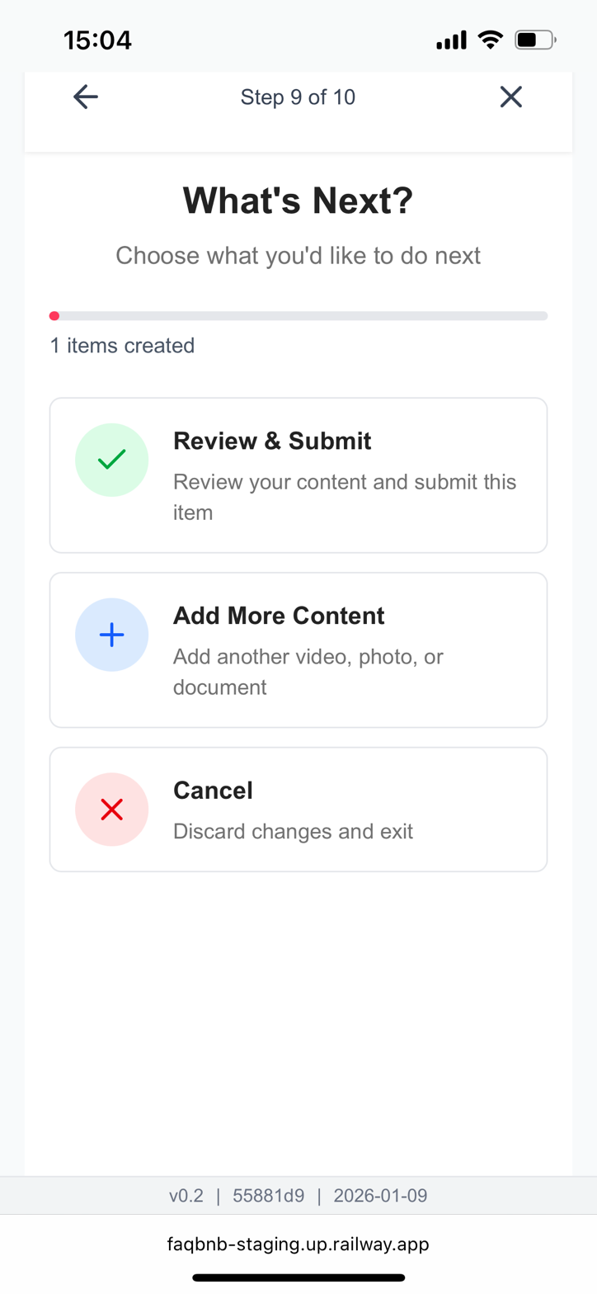

Current State
Shows "Review & Submit", "Add More Content", "Cancel" with a back arrow. Step counter shows "Step 9 of 10".

Problem
- The item has already been saved at this point
- "Cancel" makes no sense — there's nothing to cancel
- Back arrow makes no sense — can't go back after saving

Required Changes
- REMOVE the Cancel button
- REMOVE the back arrow
- This screen should be a post-workflow menu, not a numbered step
The 4 options should be:
- Edit Instructions - Edit the instructions/article just created
- Add New Instructions - Create different instructions for the same item
- Create New Item - Start fresh with a different item
- Done - Exit the workflow completely

REQUEST 4: Update Navigation Menu - New Structure & Mobile Labels
Screen: Top Navigation Menu (all screens)
Priority: MEDIUM

Current State
Menu has 3 items: Home, My Items, My Properties. "Home" uses a house icon which conflicts with property/home terminology.

Problem
- "Home" conflicts with property homes
- "My" prefix is unnecessary
- Takes too much space on mobile
- Missing "Instructions" menu item

Required Changes - New Menu Structure (4 items)
Desktop Label | Mobile Label | Icon
Dashboard | D/B | Dashboard/grid icon (NOT house)
Items | Items | Box/cube icon
Instructions (NEW) | Instr. | Document/list icon
Properties | Prop. | House/building icon
Key: Move house icon to Properties (makes sense for real estate). Use dashboard/grid icon for Dashboard.

REQUEST 5: Fix Workflow Step Count - Should End at Step 8
Screen: Save Item + Item Saved confirmation
Priority: HIGH
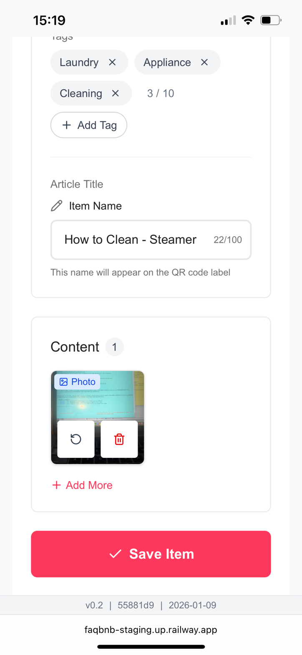
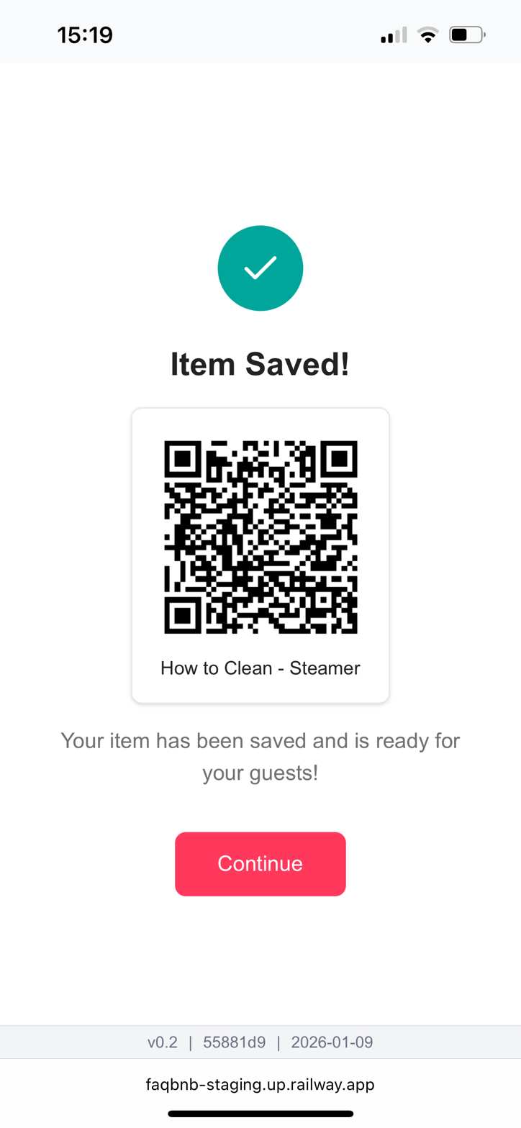

Current State
Step counter shows "8 of 10" on the Save Item screen. After saving, shows "Item Saved!" with QR code, then "Continue" leads to more steps.

Problem
The "Save Item" button actually saves the item and the workflow is complete at that point. The QR code confirmation proves the item is saved. There should be no steps 9 and 10.

Required Changes
- Change step counter to "Step 8 of 8" (not 8 of 10)
- "Save Item" is the FINAL workflow step
- "Item Saved!" with QR code = END of workflow
- "Continue" button leads to post-workflow menu (from Request 3), which is NOT a numbered step

SUMMARY - AGENT 01 TICKET CREATION
Agent 01 must create 5 separate tickets:
Ticket | Description | Priority | Type
REQ-1 | Make dashboard cards clickable | HIGH | UI/UX
REQ-2 | Fix data model - separate Item from Article | CRITICAL | Data/Logic
REQ-3 | Fix "What's Next" screen options | HIGH | UI/UX
REQ-4 | Update navigation menu structure | MEDIUM | UI/UX
REQ-5 | Fix workflow step count (8 of 8) | HIGH | UI/Logic

PIPELINE EXECUTION ORDER
For EACH ticket above, execute the following pipeline:
Agent 01 → Create ticket with full details from this document
Agent 02 → Analyze ticket, plan implementation approach
Agent 03 → Implement the changes in code
Agent 05 → Review implementation, test, and deploy
IMPORTANT: Process tickets in priority order: CRITICAL first, then HIGH, then MEDIUM.

