FAQBNB Application Review
UI/UX Change Requests for Development Team
Application URL: faqbnb-staging.up.railway.app

Overview
This document contains UI/UX change requests for the item creation workflow. The main issues identified are: redundant steps, duplicate navigation buttons, unclear labeling, and incorrect screen content on the review page.

Issue 1: Redundant Content Selection Step

Current State (REMOVE THIS SCREEN)
Location: Step 4 of 8 - "How would you like to add content?"
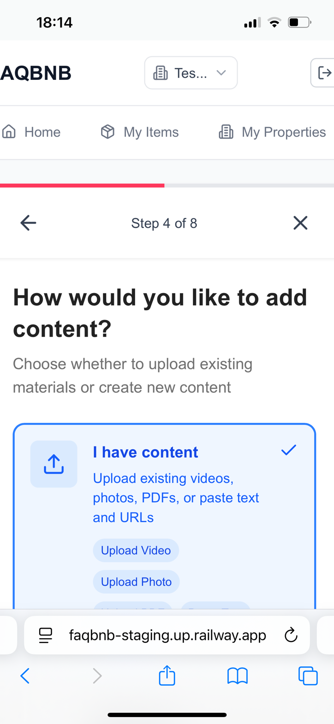

Problem
This step asks users to choose between "I have content" (upload existing) or creating new content. However, the NEXT step already provides ALL options (Record Video, Take Photo, Write Text, Upload File, Add Link), making this step completely redundant.

Required Change
ELIMINATE Step 4 entirely. Replace it with the "Choose Content Type" screen (currently Step 5), shown below:
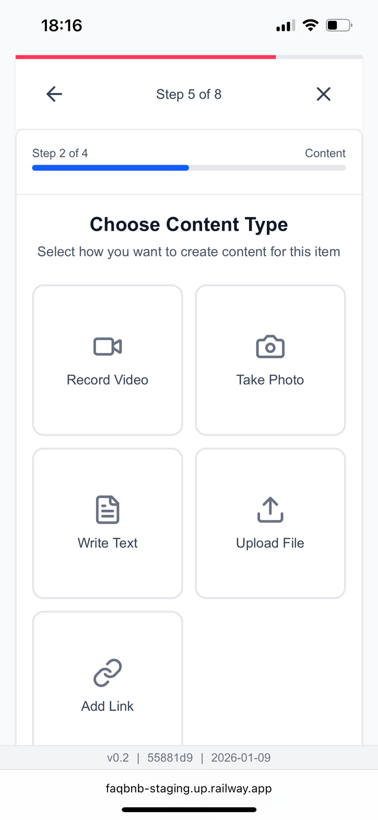

Issue 2: "Upload File" Label Too Vague

Current State
On the "Choose Content Type" screen, the button says "Upload File" which does not communicate what file types are supported.

Required Change
Update the label to clarify that users can upload: Video, Image, PDF, or Text files. Suggested labels: "Upload File (Video, Image, PDF, Text)" or show supported formats as subtitle text beneath the button.

Issue 3: Duplicate Navigation Buttons on Content Input Screens

Current State
The "Write Instructions" screen (and similar content input screens) shows TWO sets of navigation buttons: one within the content area (Back/Continue) and another at the bottom of the screen (Cancel/Back/Continue).
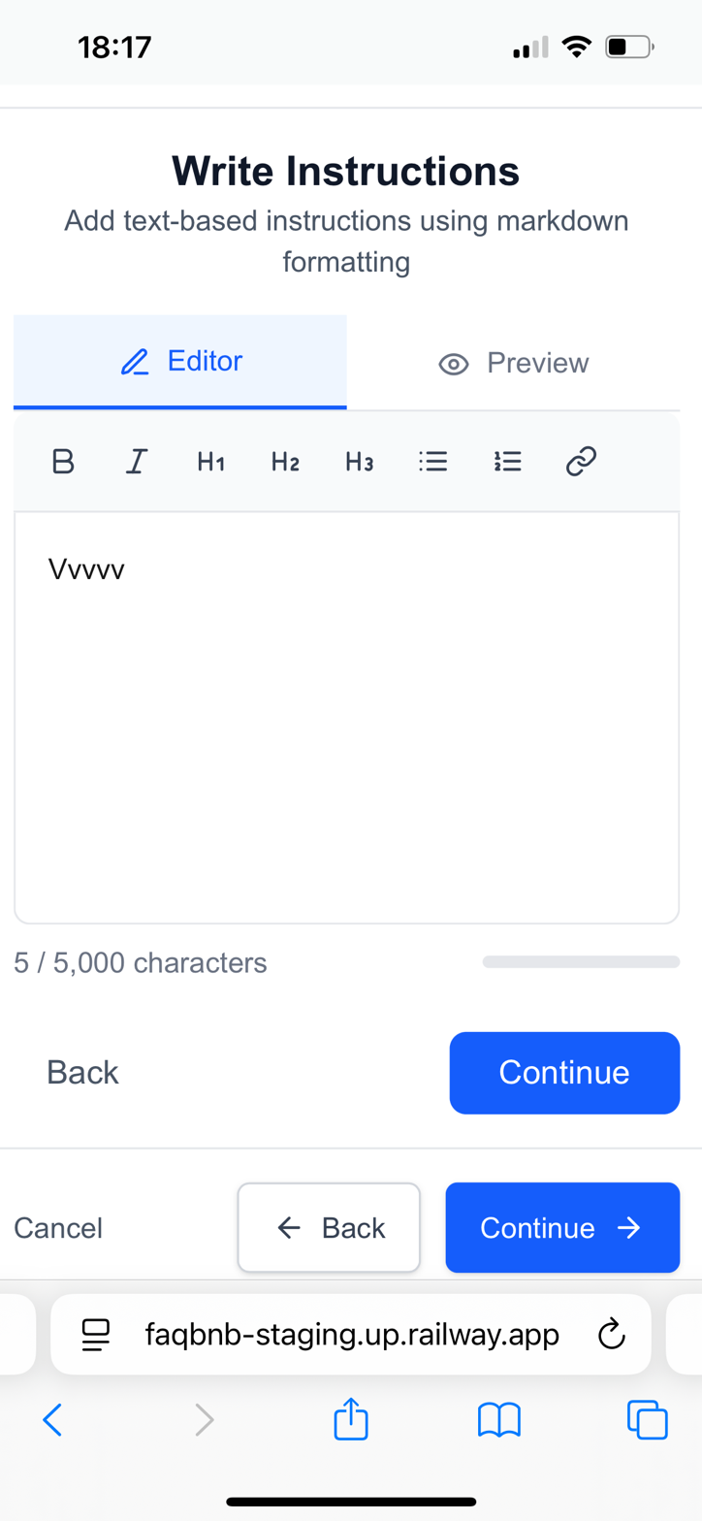

Required Change
REMOVE the bottom navigation bar (Cancel/Back/Continue). Keep only the inline buttons with this logic:
Before content is provided: Show only "Back" button
After content is provided: Show "Back" + "Continue" buttons
This applies to ALL content input screens (Write Text, Upload File, Record Video, Take Photo, Add Link).

Issue 4: Duplicate Buttons on "Content Added Successfully" Screen

Current State
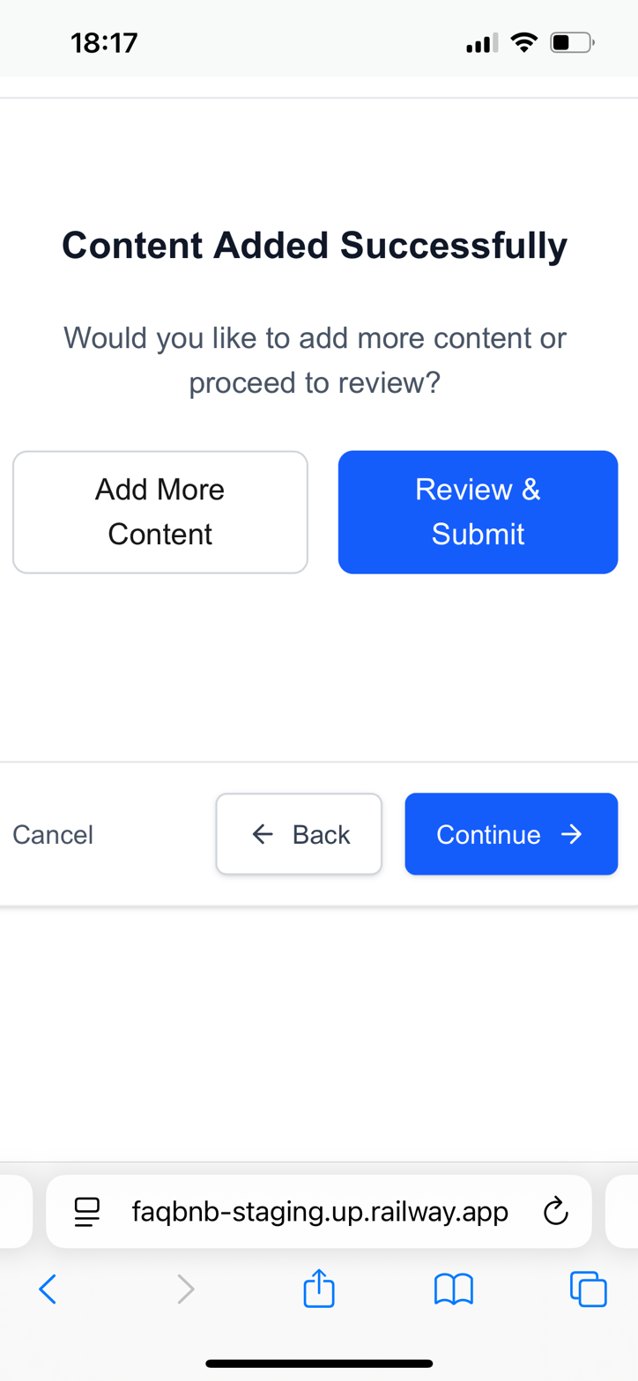

Required Change
REMOVE the bottom navigation bar. This screen should have exactly 3 options only:
1. Review & Submit - Proceed to review the submission
2. Add More Content - If item type allows multiple content pieces
3. Cancel - Exit entirely, MUST show confirmation dialog warning user they will lose their work

Issue 5: Review Screen Shows Wrong Content

Current State
The "Review Your Item" screen shows empty placeholders with large "Add Media" and "Add Link" buttons, instead of displaying what the user actually submitted.
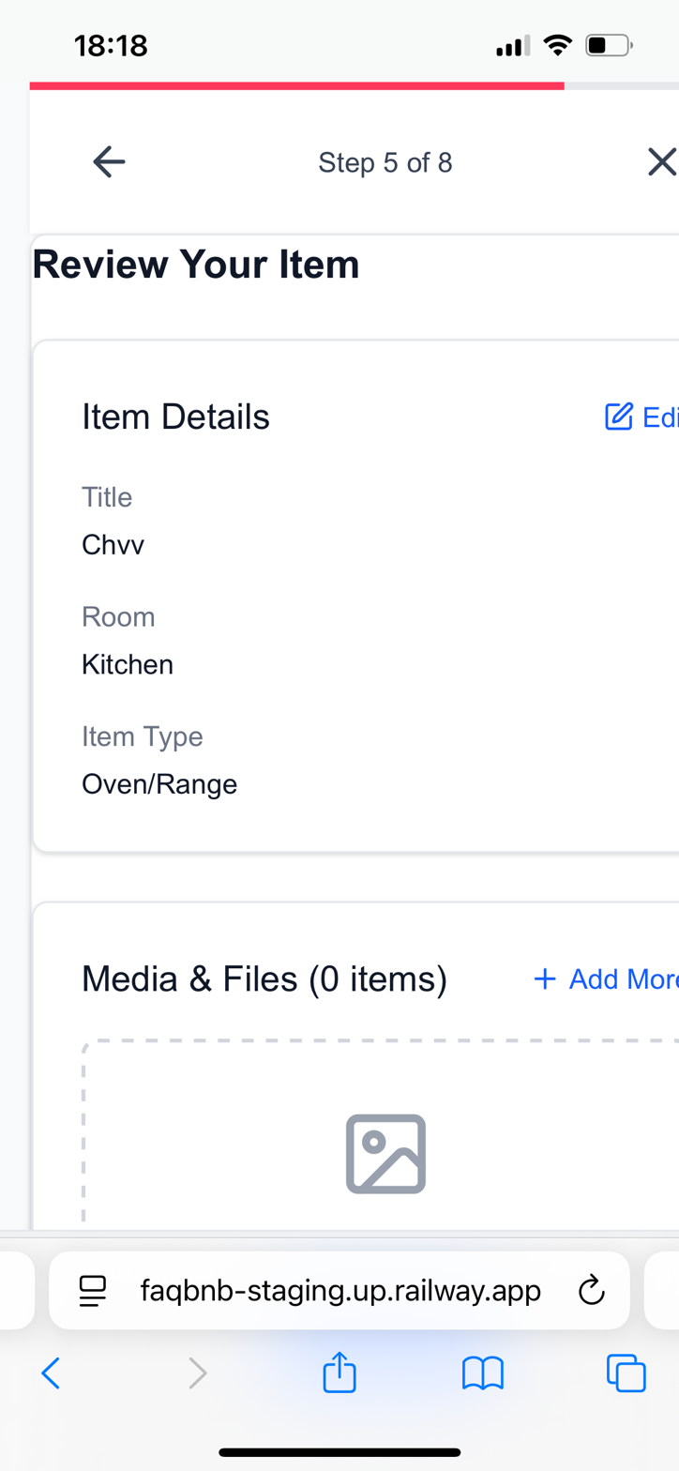
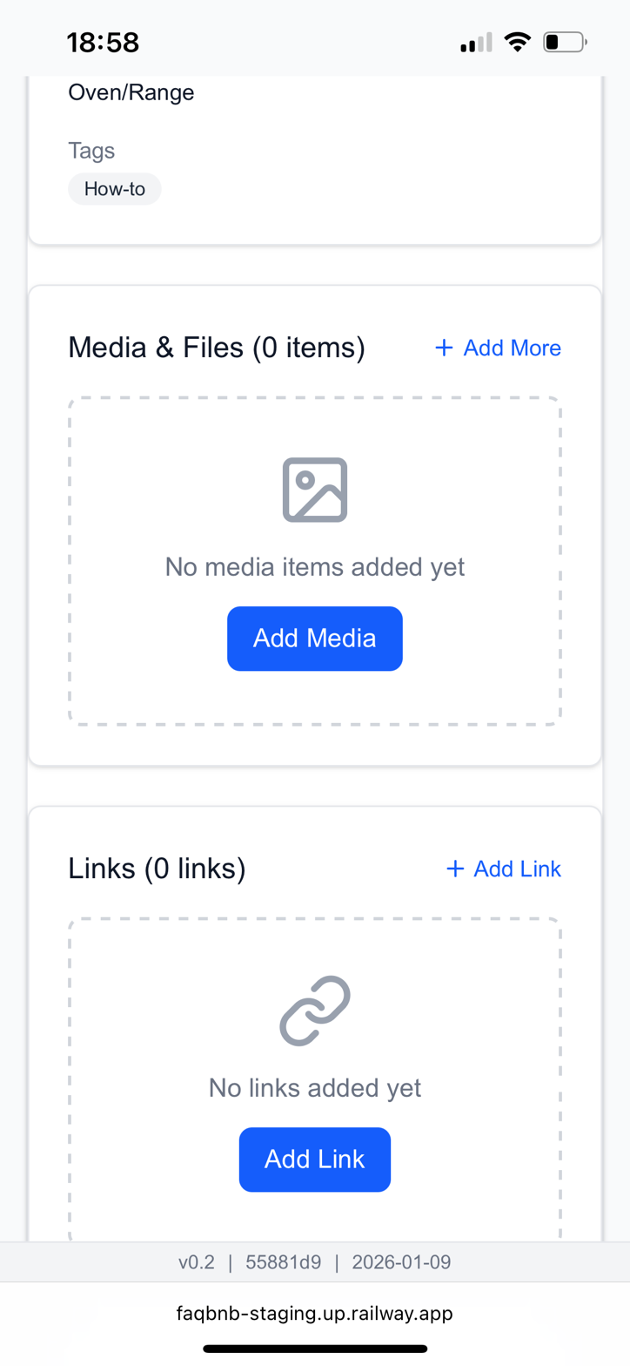

Problems
1. Shows empty states with "Add Media" / "Add Link" buttons instead of previewing submitted content
2. Big action buttons to add more content are distracting and not the purpose of this review screen
3. Missing key fields that should be pre-populated by the system

Required Changes
A. Display submitted content: Show a preview of what the user actually entered (text, images, videos, files, links)
B. Remove prominent "Add" buttons: If "Add More" functionality is needed, put a small link at the bottom, not large call-to-action buttons
C. Pre-populate item details: The system should auto-fill fields based on earlier user selections:
- Title: Auto-generated based on item type selection (e.g., if user selected "Fridge" earlier, title defaults to "Fridge")
- Room: Should already be selected earlier in the workflow
- Item Type: Should already be selected earlier in the workflow
- Purpose (NEW FIELD NEEDED): Add a field for the purpose of the content (e.g., "How to clean the fridge"). This should be selectable earlier in the workflow so it can be pre-filled here.

Workflow Architecture Changes

Current Flow Problem
Currently the user provides item metadata (title, room, type) at some point, but the review screen shows these fields need to be filled or are incomplete.

Recommended New Flow
Step 1: User selects Room (e.g., Kitchen)
Step 2: User selects Item Type (e.g., Fridge, Oven/Range)
Step 3: User selects Purpose/Intent (e.g., "How to use", "How to clean", "Troubleshooting")
Step 4: Choose Content Type (Record Video, Take Photo, Write Text, Upload File, Add Link)
Step 5: Input/Upload Content
Step 6: Content Added Successfully (options: Add More / Review & Submit / Cancel)
Step 7: Review Your Item (pre-filled with all selections, showing content preview)
Key Principle: System auto-generates Title and Description based on user's selections (Room + Item Type + Purpose). Example: Room=Kitchen, Item=Fridge, Purpose="How to clean" → Auto-title: "How to clean - Fridge" or "Kitchen Fridge - Cleaning Instructions"

Summary of Changes
1. DELETE Step 4 ("How would you like to add content?")
2. UPDATE "Upload File" label to show supported formats
3. REMOVE duplicate bottom navigation bars from all content screens
4. ADD confirmation dialog when user clicks Cancel (to warn about losing work)
5. REDESIGN Review screen to show actual submitted content, not empty states
6. ADD "Purpose" field to the workflow (selectable early, pre-filled at review)
7. IMPLEMENT auto-generation of Title based on user selections

