

ADDIS ABABA UNIVERSITY

ADDIS ABABA INSTITUTE OF TECHNOLOGY

CENTER OF INFORMATION TECHNOLOGY AND SCIENTIFIC COMPUTING

**Assignment 1 Fundamental of Web Development**

**Prepared By:**- Sintayehu Sermessa

**Id:- ATR/8798/11**

**Section:- IT**

February 2020

1.History of Internet evolution

The origins of the internet data back nearly 40 years with the U.S. military funding of research network subbed Arpanet in 1969. Since then, the Internet has undergone has more than just a name change. The number of computers connected to the Internet has grown exponentially, while the number of users has risen from beyond the United State to every corner of the globe. Internet has revolutionized the computer and communication world like nothing before. The invention of the telegraph, telephone, radio, and computer set the stage for this unprecedented integration of capabilities.

The first documented portrayal of the social interactions that could be enabled through networking was series of memos written by J.C.R Licklider of MIT in August 1962 discoursing his” Galactic Network” concept. He envisioned a globally organized set of computers through which everyone could quickly access data and programs from any site. In spirit, the concept was very much like the internet of today. Licklider was the first head of computer research program at DARPA (Defense Advanced Research Projects Agency).

The near indestructibility of information on the Internet derives from a military principle used in secure voice transmission: decentralization. In the early 1970s, the RAND Corporation developed a technology (later called “packet switching”) that allowed users to send secure voice messages. In contrast to a system known as the hub-and-spoke model, where the telephone operator (the “center”) would patch two people (the “bars”) through directly, this new system allowed for a voice message to be sent through an entire network, or web, of carrier lines, without the need to travel through a central hub, allowing for many different possible paths to the destination.

During the Cold War, the U.S. military was concerned about a nuclear attack destroying the center in its center-and-bar model; with this new web-like model, a secure voice transmission would be more likely to endure a large-scale outbreak. A web of data pathways would still be able to communicate secure voice “packets,” even if a few of the nodes places where the web of connections intersected were wrecked. Only through the destruction of all the nodes in the web could the data traveling along it be completely wiped out an unlikely event in the case of a highly decentralized network. This decentralized network could only function through common communication protocols. Just as we use certain protocols when communicating over a telephone “hello,” “goodbye,” and “hold on for a minute” are three examples any sort of machine-to-machine communication must also use protocols. These protocols constitute a shared language enabling computers to understand each other clearly and easily.

**The Building Blocks of the Internet**

In 1973, the U.S. Defense Advanced Research Projects Agency (DARPA) began research on protocols to allow computers to communicate over a distributed network. This work paralleled work done by the RAND Corporation, particularly in the realm of a web-based network model of communication. Instead of using electronic signals to send an unending stream of ones and zeros over a line (the equivalent of a direct voice connection), DARPA used this new packet-switching technology to send small bundles of data. This way, a message that would have been an unbroken stream of binary data extremely weak to errors and corruption could be packed as only a few hundred numbers. 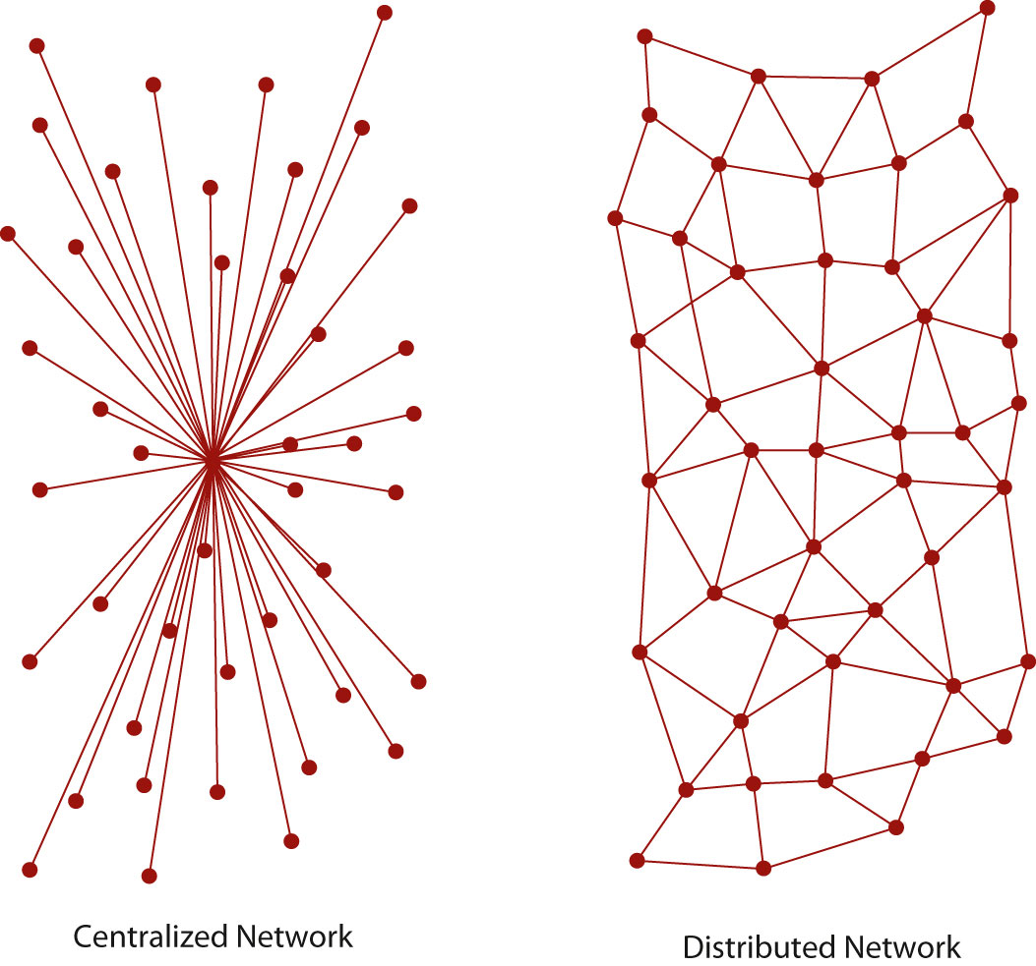

2 The Five Popular Websites

* Pahe Link(https://pahe.in/)
* Edx Link(https://www.edx.org)
* TEDEd Link(https://ed.ted.com)
* 0123MOVIEHD
* Solo learn Link(https://www.sololearn.com/)