1. Senspp module overview: (more information can be found in the thesis Sensapp platform)

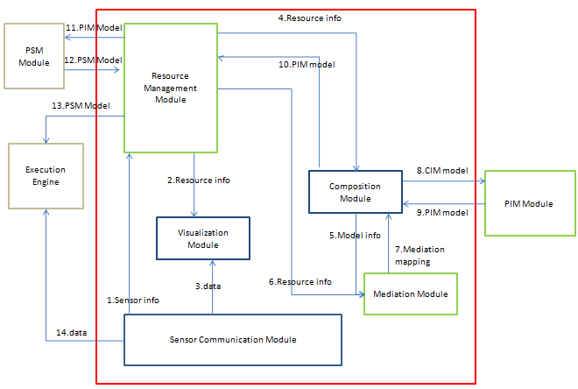

The modules, with blue box, are implemented modules. The modules, with green box, are on-going modules. And the modules, with grey box, are on-planning modules. The modules, inside the red box, are developed by me. The others are developed by my colleague.

Table 3-1 shows the functions of each module in the Sensapp platform.

Table 3-1 the functions of each module

|  |  |
| --- | --- |
| **Module** | **Functions** |
| Sensor communication module | This module builds the bridge to enable the communication between sensors and platform. It can register sensor, collect the sensor data and package them into the OGC/SWE resources (historical data resource and event resource), and enable the platform to consume these resources. |
| Resource management module | This module provides the management functions for OGC/SWE resources. It can register OGC/SWE service as resource, visualize the properties, delete resource, and provide the resource info to other modules. |
| Visualization module | This module enables the users to visualize the sensor and sensor data. It can list sensors, display them on the map according to the location, and visualize the historical sensor data and real-time event data. |
| Composition module | This module enables the application designer to compose the OGC/SWE resource from resource management module to generate the EPM model. It can get resource info from resource management module, abstract it as model notation, compose these notations and generate related model documents (WSDL and BPMN document). |
| Mediation module | This module provides the on-line editor for user to set the mediation for the data flow of EPM model. It can visualize the data object and set the mapping rule. |
| PIM module | This module transforms the EPM model to the PIM model. It can get CIM model info from composition module, get the mediation info, and generate the PIM model files (BPEL document). |
| PSM module | This module transforms the PIM model into PSM and executable files. It can enable the user manipulate the PIM model to add the BPEL engine specific info, and generate the PSM BPEL document. |
| Execution Engine | This module is a BPEL engine, which can deploy the PSM BPEL document, and run it as a Web service. |

2. Source code:

1. The source code of resource management module (resource portlet) can be found in the envision project of kenai.com.
2. The source code of sensor communication module (middle layer- adaptor services) can be found in the folder middle layer. It is a normal java Web project which uses servlet to handle the requests.
3. The source code of visualization module and mediation module can be found in the folder visualization_mediation-portlet.
4. The source code of composition module (composition portlet) can be found in the envision project of kenai.com

3. Deployment:

The war files of Sensapp platform includes: one war file for resource portlet, two war file for Sensapp’s Oryx, one war file for composition portlet, one war file for visualization and mediation, one war file for 52° north SOS, one war file for 52° north SES, and one war file for adapter service.

1. Deploy Liferay platform
2. Download the Liferay with the Community Edition Tomcat 6.x Bundle from <http://www.liferay.com/web/guest/downloads/portal>.
3. Follow this guide to install the Liferay: <http://www.installationwiki.org/Installing_Liferay_Portal#Quick_Liferay_Portal_Installation>.
4. Deploy the middle layer
5. Get the latest version war files of 52° north SOS and 52° north SES from: <http://52north.org/communities/sensorweb/>.
6. Download and install the PostgreSQL database from: <http://www.postgresql.org/>. Use the version 9.x for Windows and 8.x for Linux.
7. Follow this guide to setup the SOS service in the tomcat of Liferay: <https://svn.52north.org/svn/swe/main/SOS/Service/trunk/SOS/52n-sos/doc/howto/how2install_SOS.pdf>.
8. Follow this guide to setup the SES service in the tomcat of Liferay: <https://svn.52north.org/svn/swe/incubation/SES/ses-1.0/trunk/doc/Installation%20Guide%20for%20SES.pdf>.
9. Deploy the war file of adapter service, and add the URL of the SOS service and SES service into the configuration file, which in the folder “\WEB-INF\conf”.
10. Deploy the Sesnapp’s Oryx
11. Download and install the python from: <http://www.python.org/getit/>. Use the version 2.6.6 for Windows and 2.5.2 for Linux.
12. Download and install Firefox Browser from <http://www.mozilla.com/de/firefox/>. Use the version 4 or higher.
13. Setup the Database environment of Oryx. Login the Postgresql database and create a new user “poem” with the password “poem”. Create a new database “poem” with the owner poem. Use the command line to locate to "oryx-workspace/poem-jvm/data/database/db_schema.sql" and run the following command: “◦psql poem < db_schema.sql postgres”.
14. Deploy the two war files of Sensapp’s Oryx into the tomcat of Liferay.
15. Deploy the resource, composition, visualization , mediation portlets and adaptor services.
16. Copy the war files of these portlets into the deploy folder of Liferay.
17. Start the tomcat of the Liferay.