Approval
Fill the table below with details of author, reviewers and approver. A minimum of one reviewer is mandatory. In case of multiple reviewers, please add more rows after the Reviewer row (click inside any column within the Reviewer row and choose Table > Insert > Rows and then fill the empty Role column with the text 'Reviewer').
Independent and regulatory reviewers are subjective to the document being prepared and the corresponding rows shall be removed if not applicable.
Please use Skanray date format (DD-MMM-YYYY) where ever dates are to be input. Insist on the same format while entering manually.
Role | Name | Signature | Date
Author | Mohith Manoj
Reviewer | Chethan DM
Reviewer | Rakshith N
Reviewer | Dhanya S
Reviewer  Independent | Dipjyoti Bharali
Approver | Sunil R Rao
 |  | Effective Date [a]
[a] If date not specified, date of approver signature applies.
Revision Status
This section contains details about revisions, person revising the document and release dates.
The first version of any document shall bear the revision 'A draft 1'. This version is then sent for review to the members listed in the section 'Approval' above. If there are correction required to be done on 'A draft 1', the same is implemented and sent again for review with revision 'A draft 2'. Once there are no more corrections, the document gets released with revision 'A' which is subsequently signed off. If this same document is to be revised after sign-off, the next version starts at 'B draft 1' or '1 draft 1' if the project has crossed a certain milestone as described in the Design Control Procedure document (SOP-000011-0-10).
Indication of draft versions of a document shall be made in the page header field only. Revision history table should only contain approved revisions (meaning A, B etc. and not 'A draft 1' 'A draft 2' and the like).
Rev # | Revised By | Date of Rev | Effective Date
1 | Mohith Manoj

Revision Log
Table below contains references to corrections applied on all versions of the document. Once a correction is identified, the respective revision number and section number are entered in the first two columns. Then the next two columns shall carry the newer document revision and the section number where the correction was applied.
Usage of cross-references are suggested for filling the 'New Section' column till and only till completing the corrections. Afterwards the cross-references should be replaced with ordinary text.
The revision history table shall include only those comments that are accepted during review.
Old Rev # ^{[a]} | Old Section ^{[b]} | New Rev # ^{[c]} | New Section ^{[d]} | Change Details | ECR / ECO # ^{[e]} | Reported By ^{[f]}
[a] Revision number of this document where the correction was identified.
[b] Section number in the older revision where the correction was identified.
[c] Revision number of the document which carried the correction.
[d] Section number in the document which carries the correction.
[e] Applicable / mandatory only if the change made is in accordance with an ECR/ECO (for design documents only).
[f] Name of the reviewer reporting the anomaly.
Table Of Contents
1Introduction 4
1.1System Overview 4
1.2References 4
1.3Definitions and Acronyms 4
1.4Document conventions 4
2Design Considerations 4
2.1Assumptions 4
2.2Constraints and dependencies 4
2.3System Environment 5
2.4Risks and Volatile Areas 5
2.5Software safety classification 5
3Architecture 6
3.1Overview 6
3.2Parameter manager aggregator 6
3.3Data / Configuration Sharing 6
3.4Software update 6
3.4.1Upgrade metadata file 7
3.4.2Adding a new enum type key 7
3.4.2.1Packet structure 7
3.4.2.2Message structure 8

Introduction

System Overview
This software component is responsible for implementing a HMI for the system. The software is built around a custom built Linux operating system tailored for running on an Arm CPU based System On Module. It is designed using Gtk toolkit for the widget system and Glib / Gdk for back end.

References
SRS :
S/W or F/W Part Number :
Used in (part number) :
Other Document References
REF | Title | Number | Revision
ED-01 | SDD - Embedded Linux Platform Library | 3-75-057-0020-07 | 0

Document Conventions
References: See section Errore: sorgente del riferimento non trovata for reference marked with This Style.
NOTE
Contents formatted with this paragraph style are used for providing implementation guidance or rational for requirements. These are not to be subject to quantitative / qualitative verification.

Constraints And Dependencies
Library | Version | Linking | License
EML | > 255 | Static | Skanray proprietary (in-house developed)
gtkmm | 3.24 | Dynamic | LGPLv2.0
librsvg | 2.47 | Dynamic | LGPLv2.1
sqlite | 3 | Dynamic | Public domain
poppler |  | IPC | GPL

System Environment
- OS: Linux
- Back-end: Weston
- Storage: EMMC

Software Safety Classification
Software safety classification assessment is performed as shown below.
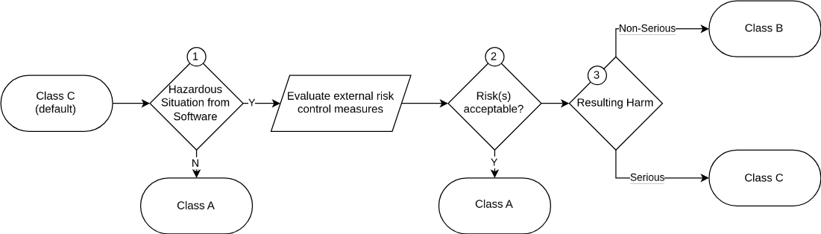
Based on below analysis the software is classified under ‘Class B’ as per IEC 62304.
Component Safety Assessment Summary (as On 12-FEB-2024)
Component HMI
Total Contribution x
Residual x
Residual (Serious) x
RID | Acceptable (PRE) | Severity (POST) | Acceptable (POST)

1 – Hazardous Situation From Software
This software component represents the HMI that the operator uses to monitor the vital parameters of a patient. An interruption in the software could potentially interfere with essential performance of the device. Hence further evaluation is necessary.

Data / Configuration Sharing
The software is designed based on the concept of data managers (settings / measurements / status) provided by EML for sharing data and configuration information with various back-end and UI elements. The hierarchy of this implementation is as below.
 | Component | Function
 | CC2601::CChiefManager | This is a singleton object that functions as a container for other managers and performs tasks that requires data / action from more than one manager. e.g. Logging clinical measurements when ventilation cycle status changes.  Accessible via CC2601::CChiefManager::GetDefault() static method.
 | CC2601::CVentilatorSettingsManager | Accessible via CC2601::CChiefManager::GetManager_Settings().  Derived from EML::CSettingManager.
 | CC2601::CVentilatorMeasurementManager | Accessible via CC2601::CChiefManager::GetManager_Measurement().  Derived from EML::CMeasuredParameterManager.
 | CC2601::CVentilatorStatusManager | Accessible via CC2601::CChiefManager::GetManager_Status().  Derived from EML::CStatusManager.
 | EML::CSystemDB | System database access helper. The system database See R#0002 in ED-01 for details.

Software Update
Software updates are executed using an external ‘Launcher’ application. At the time of boot, the Launcher application searches for external USB storage device with valid installation archives and prompts the user with available update packages.
Update packages are archives with following structure.

Adding A New Enum Type Key
Preparing The Schema
Add an enum child to the schemalist.
<enum id="org.skanray.rms08.flow-sensor.adult">
<value nick="Sensatronic" value="0" />
<value nick="Hamilton" value="1" />
<value nick="Envitec" value="2" />
</enum>
Add the child key(s) to the respective folder.
<key name="flow-sensor-adult"
enum="org.skanray.rms08.flow-sensor.adult">
<default>"Sensatronic"</default>
<summary>Flow sensor for adult patients</summary>
<description>Flow sensor for adult patients.</description>
</key>
The schema is now ready to be compiled. Refer R#0001 in ED-01 for details.

Packet Structure
 | Command | Length | Frame(s) | CRC

Command
Refer [MICOMP] for details on various commands supported by the communication.

Message Structure
The basic structure of a ZMQ frame is as shown below. Multi-byte fields are little-endien.
ID | LEN | PAYLOAD | CHECKSUM
1 byte | 2 bytes | n bytes | 4 bytes
CHECKSUM
This field contains a 32 bit CRC for ID, LEN and PAYLOAD fields combined. The computation parameters are,
Polynomial : 0x04C11DB7
Initial remainder : 0xFFFFFFFF
Final XOR : 0xFFFFFFFF
Reflect input : true
Reflect output : true
boost::crc_32_type represents the type of CRC computer to be used.

Poppler being GPL, is not suitable to be linked directly or even at run-time to application code since it would then make the application code also GPL. To avoid conflict a separate application / service is designed that uses poppler to render PDF documents.

