1. **Explain what the *current directory* is and what the *home directory* is. Demonstrate how to set your current directory to a particular directory and how to find out your current directory and how to set your current directory to your home directory.**

**Home Directory:** On login, home is the default working directory for the user. It contains the user’s personal data, configuration files, settings of a software etc. The content of home directory is private and the user has a complete control of it.  
  
**Current directory:** The directory in which the user is working currently is known as working directory. The home may also be the working directory, if the user is working in it. Working directory can be changed using cd command.

1. **Demonstrate that you can create a simple C program (eg hello.c) with a text editor from command line (not with a GUI tool) and compile it with gcc and generate executable with appropriate name (eg hello).**

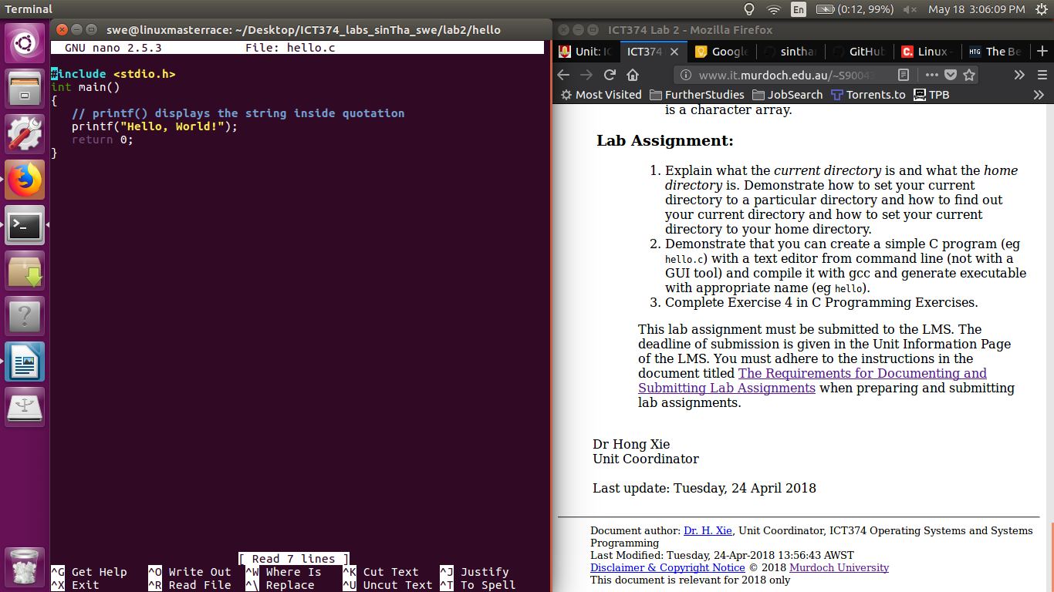

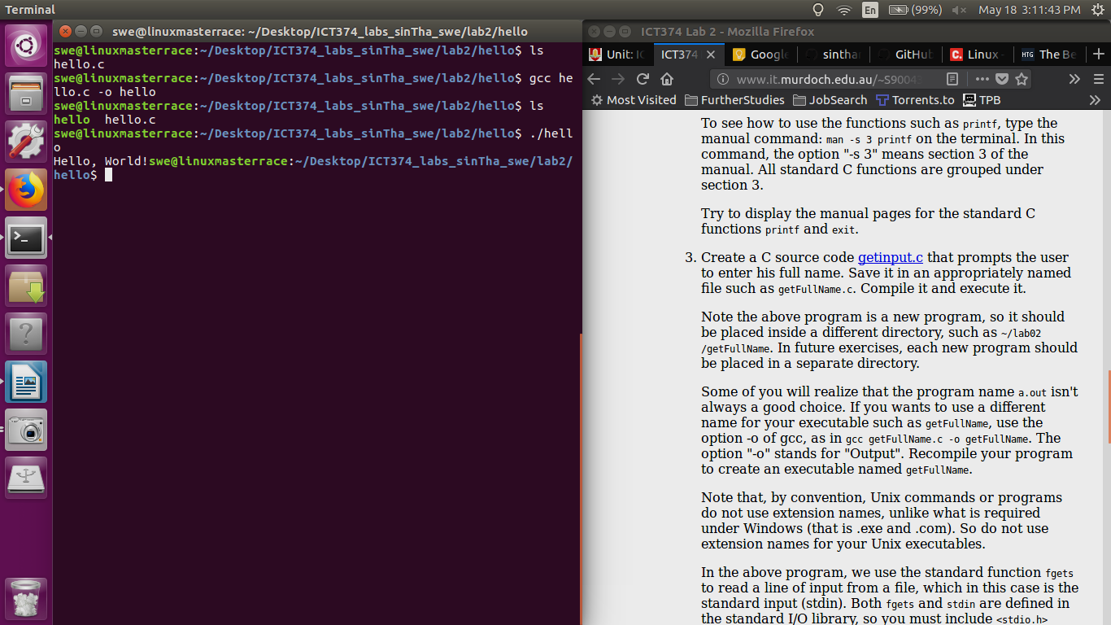

1. **Complete Exercise 4 in C Programming Exercises.**

