1. Demonstrate Unix Exercise 2 (chmod).

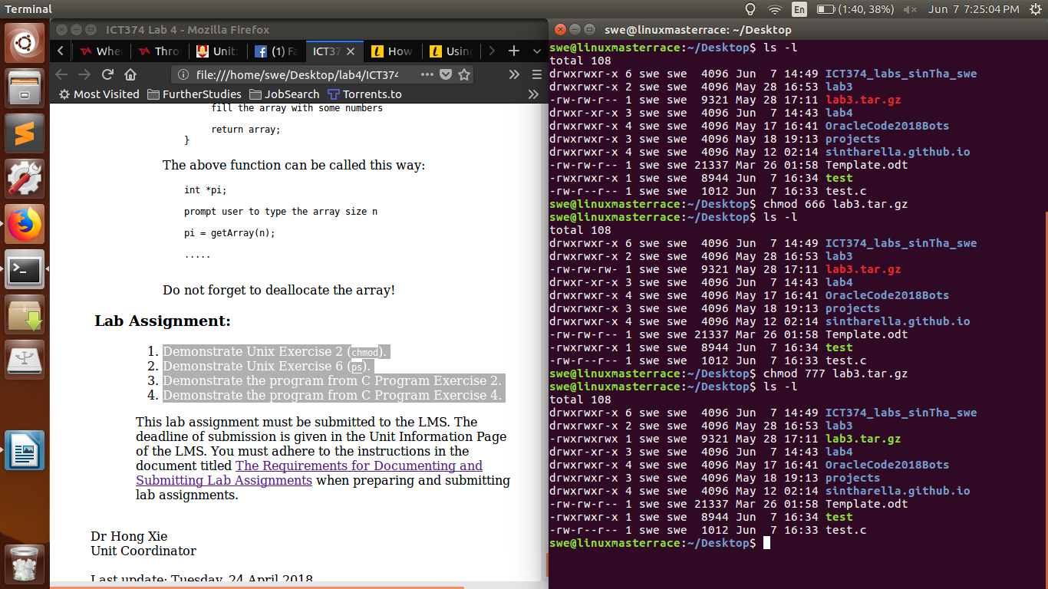

1. Demonstrate Unix Exercise 6 (ps).

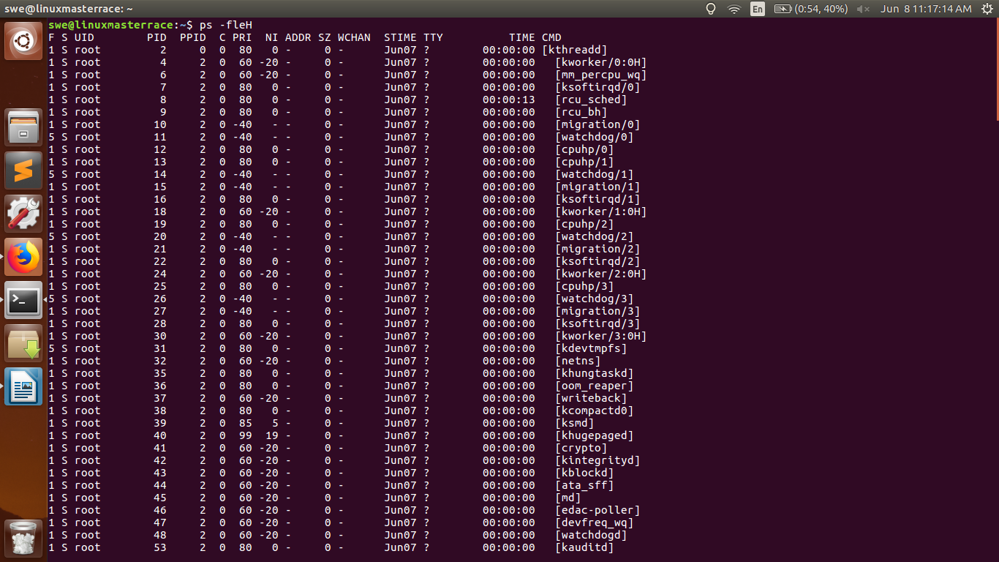

1. Demonstrate the program from C Program Exercise 2.

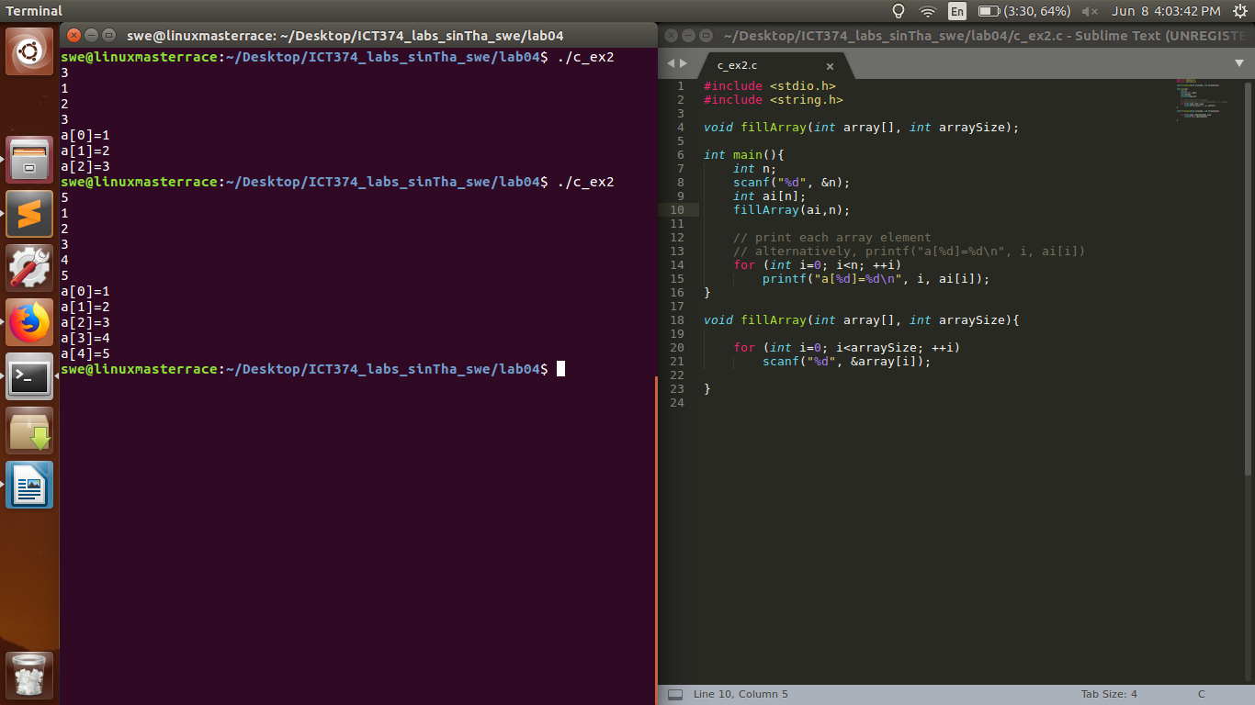

1. Demonstrate the program from C Program Exercise 4.

