1. Demonstrate Unix Exercises 2 and 4.

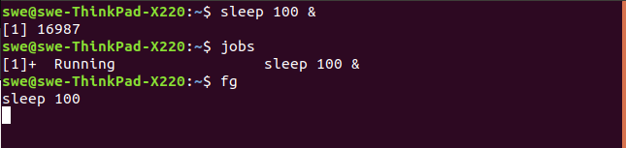

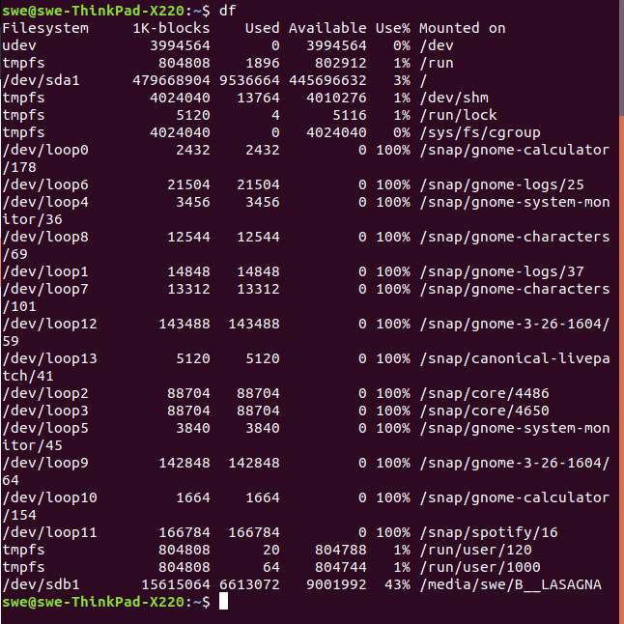

1. Complete C Programming Exercise 3.

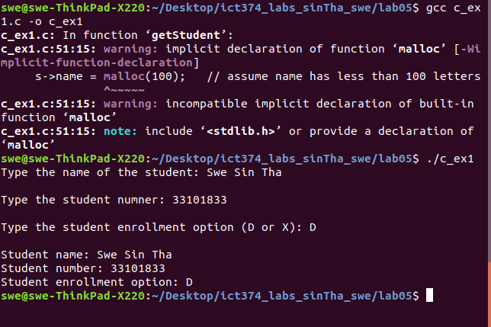

1. Complete Unix Programming Exercise 5.

