1. Demonstrate C Programming Exercise 4.

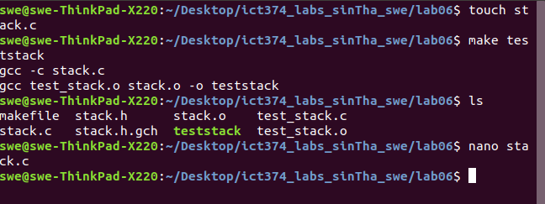

1. Complete Unix Programming Exercise 2.

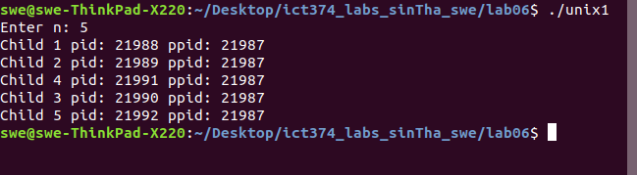

1. Complete Unix Programming Exercise 6.

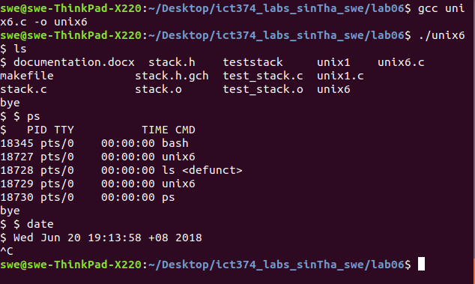

1. Complete Unix Programming Exercise 7.





