# Title: Family Tree Program

Author: Swe Sin Tha

Date: 4 April 2018

File Names: Address.java, Member.java, Tree.java, GUI.java, Main.java

Statement of Purpose: The family tree program manages several heirarchies of related people

# Requirements

The family tree program manages herarchies of families. The specifications is that it should be built using Java and use a GUI to interact with the data. Opening an existing tree, creating a new tree, viewing one person and their immediate relatives are the basic requirements. The program is also required to use serialization and JfileChooser for file handling, swing components to build the GUI and make use of exception handling.

# User Guide

The program can run directly in NetBeans IDE or conversely be compiled on the command line. It is assumed Java SE 8 is installed. The user will need to ‘cd’ into the directory containing all the java files. The command ‘javac *.java’ can be used to compile all the files. The command ‘java <main filename>’ can then be used to enable the GUI.

# Structure

As the single responsibility principle states: each class should have only one clear responsibility. Separating the application logic from the UI logic makes the program work smoother. Therefore the design approach for the program was to separate the GUI from the backend logic. Which is why the process to designing this program was to develop the Address, Member and Tree classes first and then test them through the console before integrating the GUI onto the program. This led to smoother integration of the GUI with the logic classes. The UML section describes the design of the program.

## UML

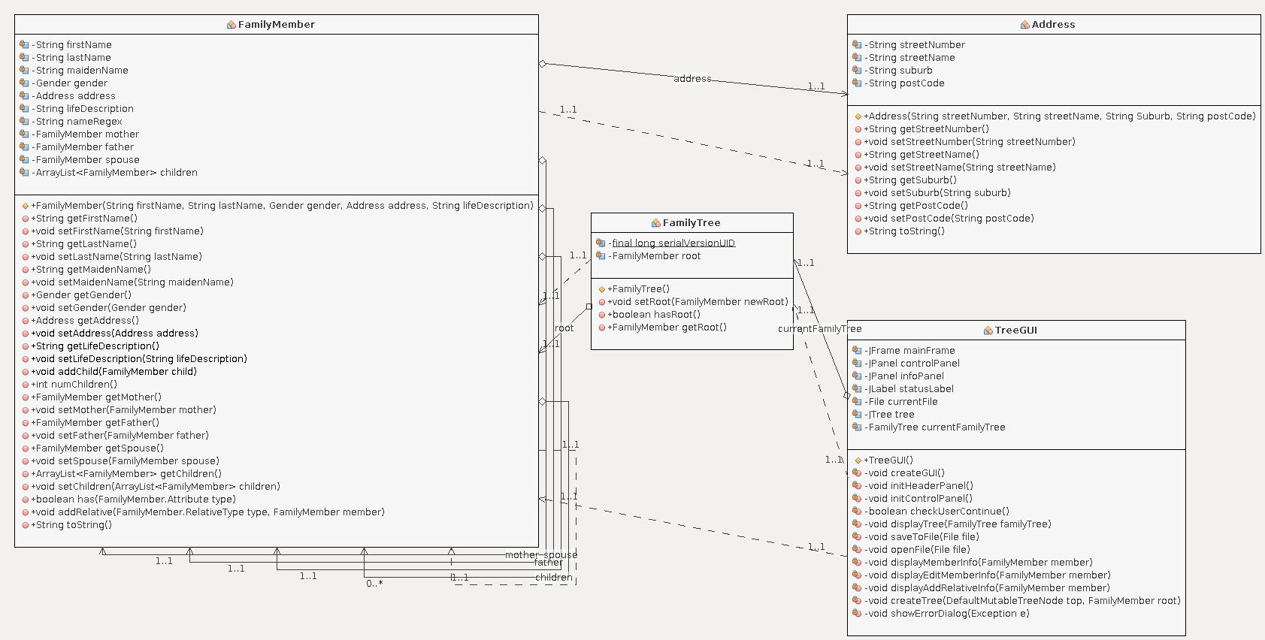

# Limitations

There is no indication as to whether certain actions have been performed like whether a tree has been created, a file opened or saved, certian actions like editing a family member’s information cancelled in the middle. A dedicated status bar to perform that could be added in future edits.

More testing is required to preemiptively predict all the erros and exceptions that might occur for more extensive exception handling.

# Testing

|  |  |  |  |  |
| --- | --- | --- | --- | --- |
| # | Features | Yes | No | Comments |
| 1 | Is a basic GUI program for recording information about a family tree present (Swing components)? | ✔ |  |  |
| 2 | Can a family member have some immediate relatives? (mother, father, zero or one spouses, zero or more children and zero or more grandchildren) |  | ✔ | No grandchildren |
| 3 | Does a family member have a first name, birth surname, marriage surname, gender, an address and description text? | ✔ |  |  |
| 4 | Does an address have a stree number, street name, suburb and postcode? | ✔ |  |  |
| 5 | Does a family tree contain all the information from 2, 3 and 4 for a whole bunch of related people? | ✔ |  |  |
| 6 | Can the GUI show details for one person at a time? | ✔ |  |  |
| 7 | Does a family tree have a specified starting person (root node)? | ✔ |  |  |
| 8 | Can the GUI show a family tree in a heirarchal way that represents the family tree information? | ✔ |  |  |
| 9 | Can the GUI be used to change the displayed person to one of the immediate relatives of the current person? | ✔ |  |  |
| 10 | Can the GUI be used to start a new empty family or edit an existing one? | ✔ |  |  |
| 11 | Can the GUI be used to add an immediate relative of an existing person or can the details of an existing person be changed? | ✔ |  |  |
| 12 | Can the family tree be stored for subsequent editing and viewing (Serialization, JFileChooser)? | ✔ |  |  |
| 13 | Can the program handle exceptions (Exception handling)? | ✔ |  |  |

# 1, 2

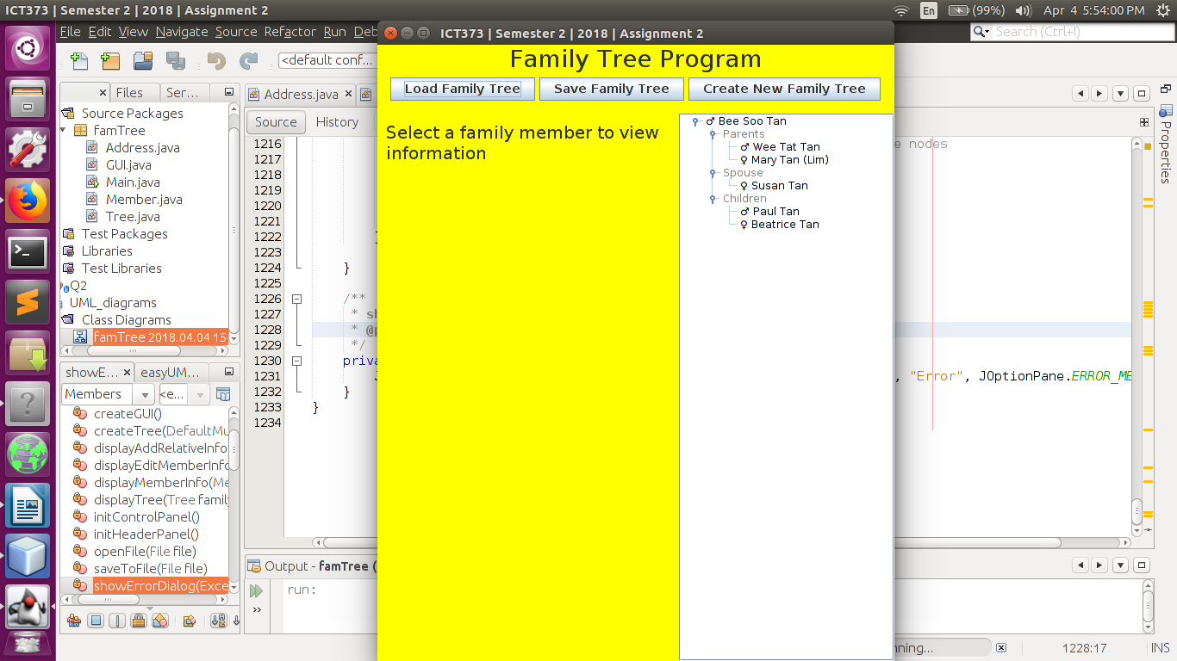

# 3, 4, 5, 6, 7, 8

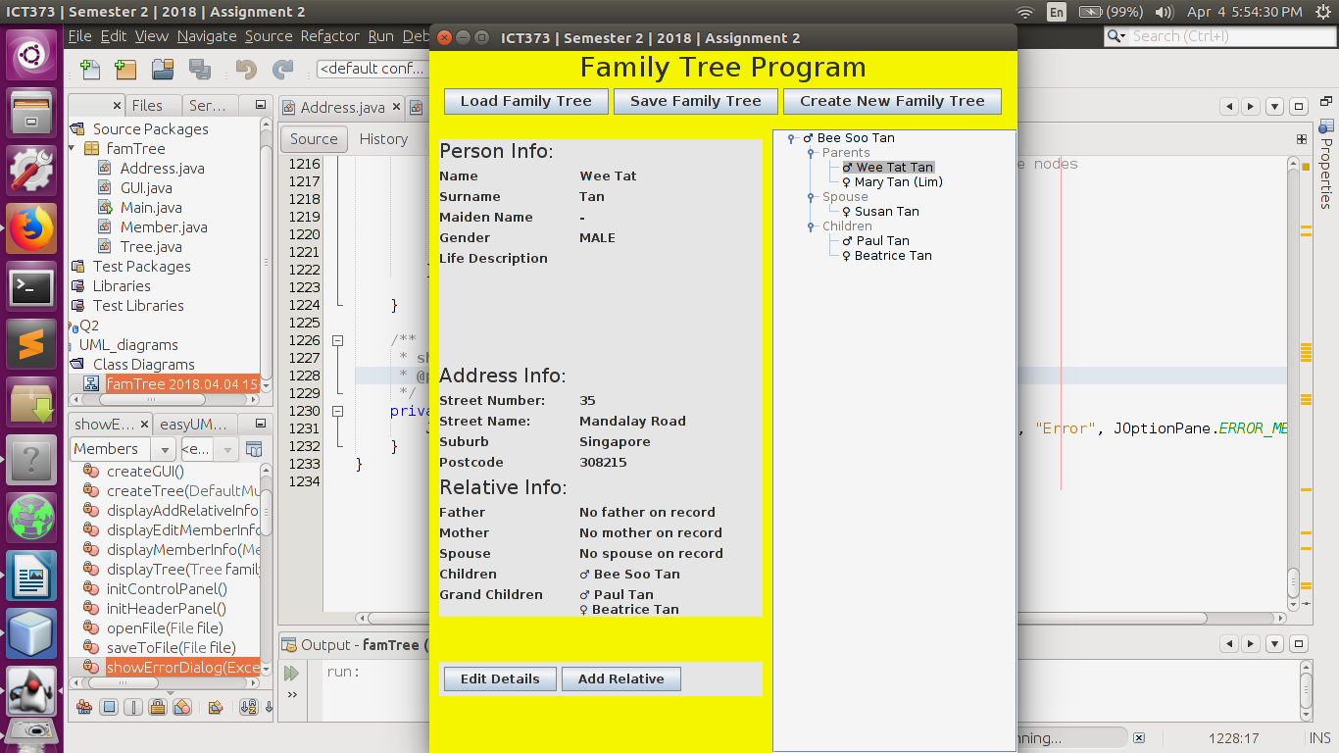

#9, 10, 11

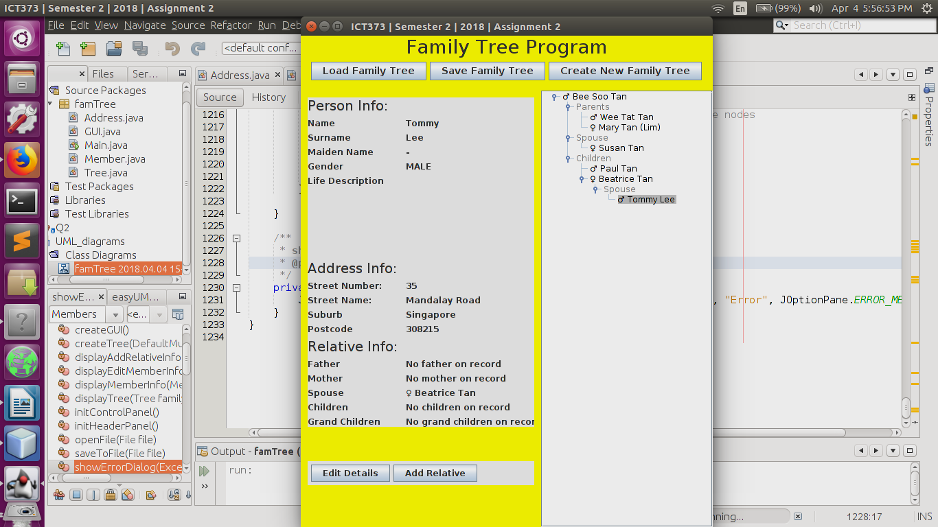

#12

