1. **Demonstrate that you can archive all files in a directory and compress the archive file.**

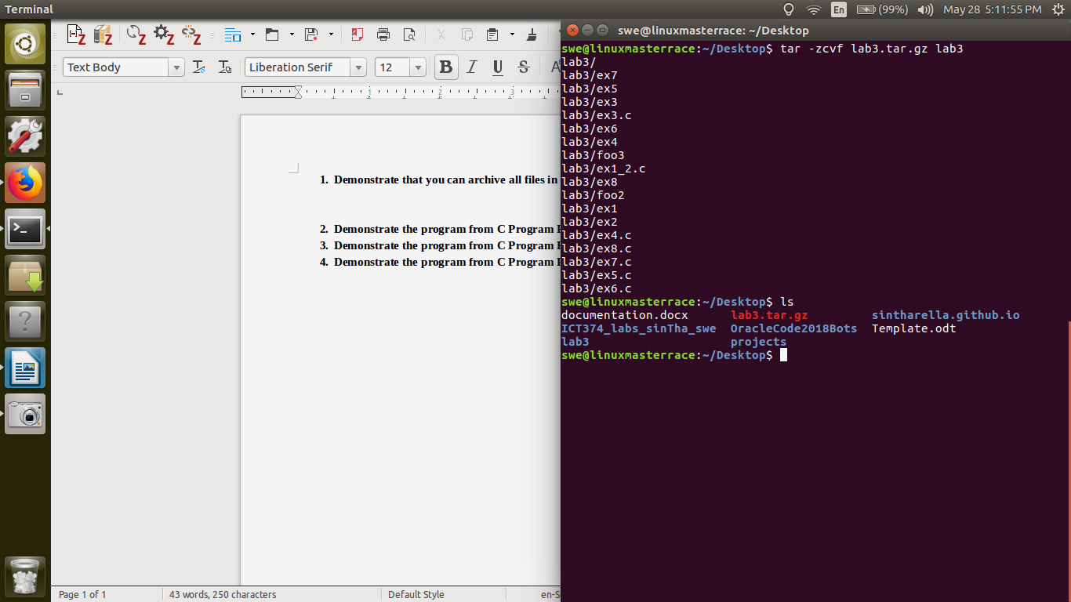

1. **Demonstrate the program from C Program Exercise 2.**

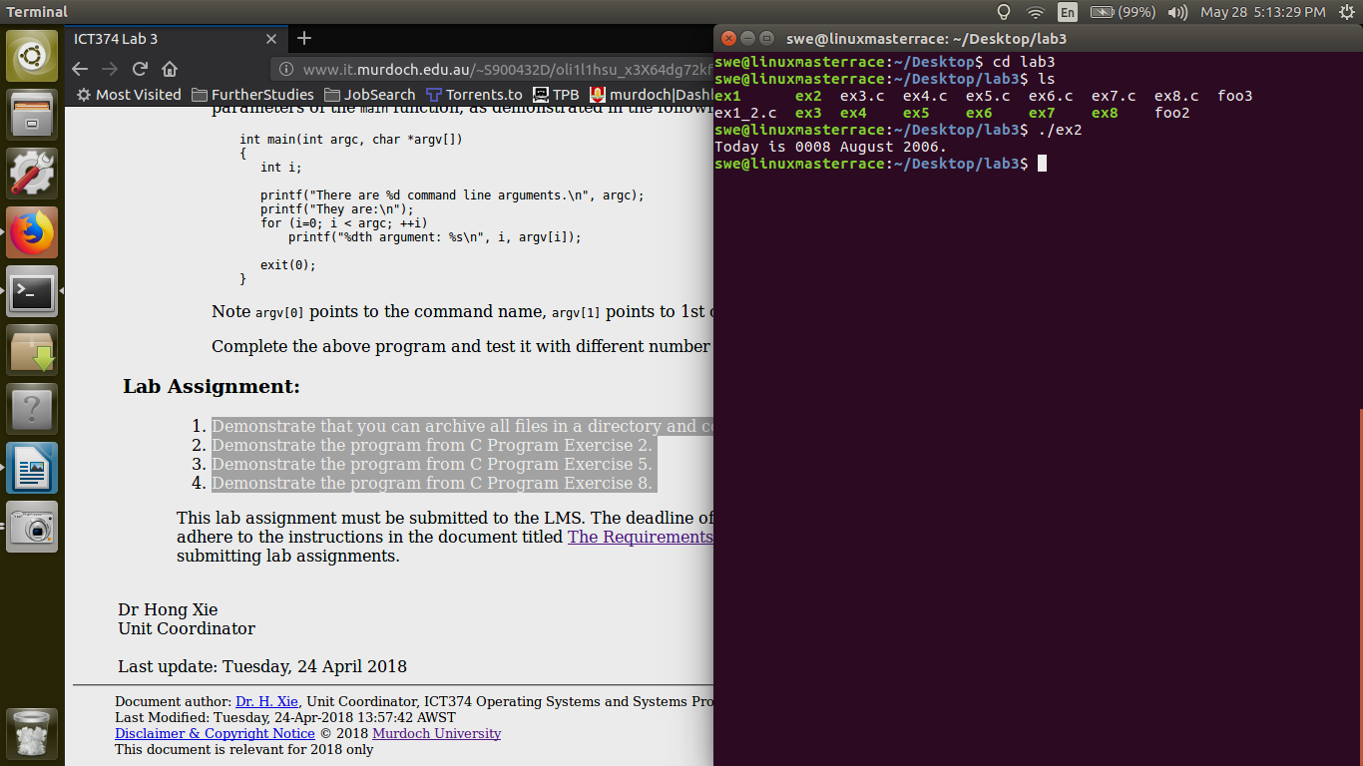

1. **Demonstrate the program from C Program Exercise 5.**

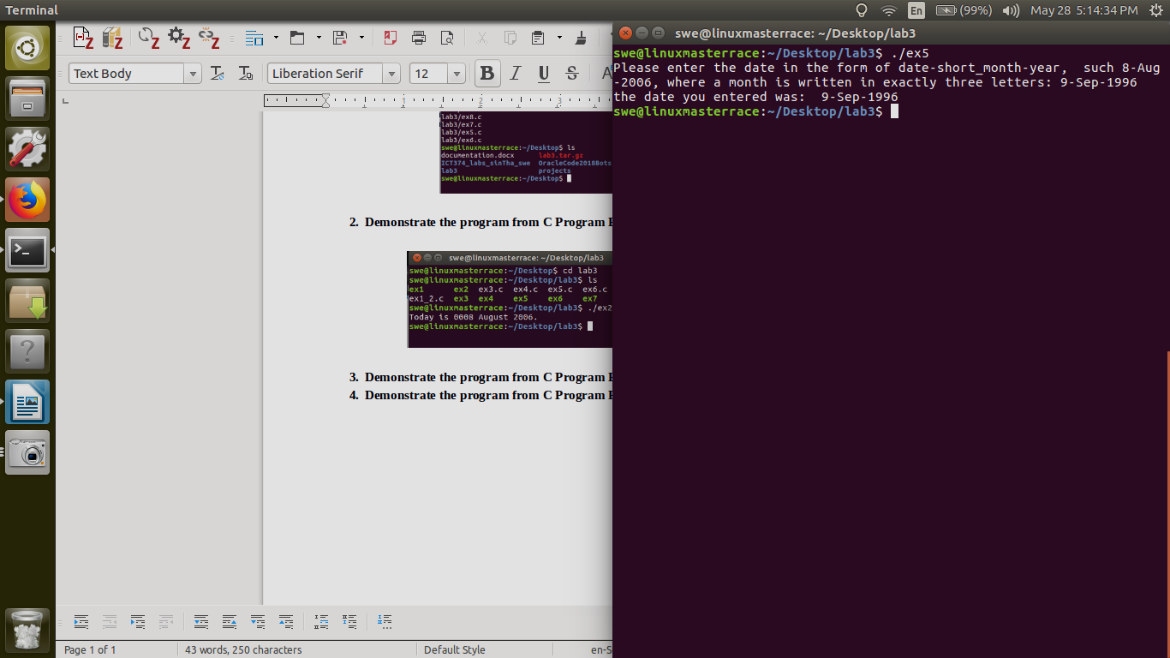

1. **Demonstrate the program from C Program Exercise 8.**

