GIFT AUTONOMOUS WEB PORTAL

## A Major Project Report submitted in Partial fulfillment, The requirement for the Degree

**OF**

## Bachelor of Engineering & Technology

**Submitted By**

## Mr. Suman Raj (1901298222)

**Ms. Sinurita Mahapatra (1901298204)**

**Ms. Adyasha Priyadarshini Sahoo (1901298231)**

## Under the Guidance Of Mr. Priyabrata Nayak

**(Asst. Prof. Department of CSE)**

## For the Session (2022-2023)



**DEPARTMENT OF COMPUTER SCIENCE AND ENGINEERING GANDHI INSTITUTE FOR TECHNOLOGY (GIFT) BHUBANESHWAR**

## Affiliated ToBiju Patnaik University of Technology - Wikipedia

**BIJU PATNAIK UNIVERSITY OF TECHNOLOGY, ODISHA**



## DECLARATIONBiju Patnaik University of Technology - Wikipedia

We hereby declare that the project work entitled **“GIFT AUTONOMOUS WEB PORTAL ”** submitted to the GIFT, Bhubaneshwar, is a record of an original work done by me under the guidance of **Mr Priyabrata Nayak ,** Asst. of Computer Science & Engineering and this project work is submitted in the partial fulfillment of the requirements for the award of the degree of Bachelor of Technology in Computer Science & Engineering. The results embodied in this thesis have not been submitted to any other University or Institute for the award of any degree or diploma.

#### Mr. Suman Raj (1901298222) ( )

**Ms. Sinurita Mahapatra (1901298204) ( )**

**Ms. Adyasha Priyadarshini Sahoo (1921298231) ( )**

**DEPARTMENT OF COMPUTER SCIENCE GANDHI INSTITUTE FOR TECHNOLOGY**

**(AFFILIATED TO BIJU PATNAIK UNIVERSITY OF TECHNOLOGY, ODISHA)**

CERTIFICATE

This is to certify that **SINURITA MAHAPATRA** undertook this project entitled " **GIFT AUTONOMOUS WEB PORTAL** "from 15.03.2023 to 8.06.2023. As part of this project, she has completed all the phases of software life cycle of the said application for the partial fulfillment of the requirement for the degree of Bachelor in COMPUTER SCIENCE ENGINEERING from Centre for Post Graduate Studies, GIFT, Bhubaneswar.

# Mr. Priyabrata Nayak Mrs. Dr. Archana Panda

**PROJECT GUIDE PROJECT COORDINATOR**

# Dr. Sujit Panda

**HOD, CSE EXTERNAL EVALUATOR**



# ACKNOWLEDGEMENTBiju Patnaik University of Technology - Wikipedia

We would like to express our deepest appreciation to Mr Priyabrata Nayak for providing us support and valuable suggestions during the time of our project development. This time in project development was both opportunity and challenge.

We would like to thank BPUT University and GIFT (Gandhi Institute For Technology) for providing us this golden opportunity to enhance our knowledge in various programming and research areas. We are also appreciative of the effort of HOD Sir,. Dr. Sujit Panda for supporting us throughout this project.

We would also like to appreciate the help of various venue for providing us essential data required for our project as well as their time in guiding us so as to how our project will be more effective in users prospective. We are also grateful to our teachers for their constant support and guidance.

At the end we would like to express our sincere thanks to all the friends and others who helped us directly or indirectly during this project work.

#### Mr. Mr. Suman Raj (1901298222) ( )

**Ms. Sinurita Mahapatra (1901298204 ( )**

**Ms. Adyasha Priyadarshini Sahoo (1921298231) ( )**

**Abstract**

GIFT The autonomous web portal shall automate the current manual system using computerized equipment and full-fledged computer software to meet the requirements so that the valuable data/information can be stored for a longer period of time with easy access and manipulation of same.  
The autonomous web portal of the college is considered as an error free, secure, reliable and fast administration system. It can help the user administrator to focus on his other activities instead of focusing on the records. Thus, it helps the organization in better utilization of resources. The organization can keep computerized records without redundant entries. This means that one is not distracted by information that is not relevant while being able to access the information.  
The objective is to automate the existing web portal using computerized equipment and full-fledged computer software to meet the needs of the organization so that their valuable data/information can be stored for a longer period of time and easy access and manipulation of the same. Basically, the project describes how to provide good performance and better services to the customers.

**Table of Contents**

ACKNOWLEDGEMENT ii

ABSTRACT iii

LIST OF FIGURES vii

LIST OF TABLES viii

1. INTRODUCTION 10
   1. Purpose…………………………. 11
   2. Objectives …………………………………………………………………………….......11
   3. Project Features 11
   4. Scope and Limitations 11
      1. Scope of project………………. 12
      2. Limitation of project 12

2 HARDWARE AND SOFTWERE REQUIREMENT 13

2.1Hardware Requirement 13

2.2Software requirement 13

3. OVERALL DESCRIPTION………….. 14

3.1Product perspective 14

3.2 Product Functions………………………………………………………………………..14

3.3 User class and characteristics……………………………………………………………14

3.4 Operating Environment …………………………………………………………………15

3.5 Constraints……………………………………………………………………………………15

3.6 User case model………………………………………………………………………………15

3.6.1 Students…………………………………………………………………………………15

3.62 Admin……………………………………………………………………………………15

* 1. Assumption and dependencies………………………………………………………………..15

4.SPECIFIC REQUIREMENT………..............................................................................................16

4.1 Use case reports……………………………………………………………………………….16

4.1.1 Admin……………………………………………………………………………….….16

4.1.2 Student…………………………………………………………………………………20

5. FUNCTIONAL REQUIREMENTS……………………………….……………………………25

6. NON-FUNCTIONAL REQUIREMENTS ………………………..………………..………….26

6.1 Performance requirement…………………………………………………………..…..…..26

6.2 Safety requirement…………………………………………………………………………26

6.3 Security……………………………………………………………………………,………26

7. Design………………………………………………………………………………….…….. 26

7.1 Scope and Purpose…………………………………………………………..……………26

7.2 Overall System Design Objectives……………………………………………………….26

8. System Architecture Design………………………………………………………….………..27

8.1 System Architecture………….…………………………………………………………….27

9. Data Design……………………………………………………………………………………28

9.1Entity Relationship Diagram………………………………………………………...……..28

10. FUNCTIONAL DESIGN ………………………..……………………………………………….29

10.1 Data Flow Diagram………………………………………………………………………29

10.2 Decision Tree………………………………………………………….…………………30

11. BENEFITS……………………………………………………………………………………….31

12. RESULT ANALYSIS AND CONCLUSION…………………………………………..……..31

12.1Result and Analysis………………………………………………………………………..31

13. CONCLUSION ……………………………………………………..………………………….39

14. REFERENCES……………………………………………………………….………………..39

# 

# LIST OF FIGURES

# FIGURE PAGE

Figure 1: GIFT Autonomous Web Portal……….……………………………………….9

Figure 2:  User Case Model……………………………………………………………15

Figure 3: User Case Model……………………………………………………………17

Figure 4: Use case report – Display Student Details……………………………………19

Figure 5: Use Case Report- Edit student detail into the website……………………….20

Figure 6: Use Case Report- Register student on website……………………………….22

Figure 7: Use Case Report- Login into the system………………………………………23

Figure 8: Use Case Report- Edit Student Details Into Database…………………………25

Figure 9: Architecture Diagram…………………………………………………………..27

Figure 10:Entity Relationship Diagram……………………………….………………….28

Figure 11:-Data Flow Diagram……………………………………………………………29

Figure 12 Decision Tree…………………………………………………………………..31

Figure 13: Admin/User Home Page……………………………………………………….32

Figure 14Admission Page…………………………………………………………………………33

Figure 15: Programs Offered……………………………………………………………….33

Figure 16: About Page……………………………………………………………………...34

Figure 17: Requirements of College……………………………………………………….34

Figure 18: Form Download…………………………………………………………………35

Figure 19 : Examination Info………………………………………………………………..35

Figure 20: Prospectus Page…………………………………………………………………36

Figure 21: Administrator Login Page……………………………………………………….36

Figure 22: Admin Page……………………………………………………………………...37

Figure 23: Updating Home Page……………………………………………………………37

Figure 24: User Access………………………………………..……………………….…...38

Figure 25: Student Information………………………………………………….…………38

# 

# INTRODUCTION

**GIFT AUTONOMOUS WEB PORTAL** was developed to overcome the problems prevailing in the practicing manual system. This software is supported to eliminate and, in some cases, reduce the difficulties faced by the existing system. In addition, this system is tailored to the specific needs of the company to ensure a smooth and effective operation.

The application is pared down as much as possible to avoid data entry errors. In addition, error messages are issued when invalid data is entered. The user does not need any formal knowledge to use this system. Thus, it proves that it is user-friendly., **GIFT AUTONOMOUS WEB PORTAL** can lead to an error-free, secure, reliable and fast management system. It can help the user to focus on their other activities instead of focusing on the records. In this way, it helps the organization make better use of its resources.

Every organization, big or small, has challenges to overcome and manage the information of students, college, course, faculty, fees. Every college site has different needs, so we develop exclusive employee management systems customized to your management needs. This is to assist you with strategic planning and help you ensure your organization is equipped with the right level of information and details for your future goals. For busy executives who are always on the go, our systems have remote access capabilities that allow you to manage your employees at any time.



Figure 1: GIFT AUTONOMOUS WEB PORTAL

**1.1Purpose**

The purpose of the GIFT Web Portal is to allow an organization's administrator to edit and find out a student's personal information and to allow the student to keep their profile up to date. It'll also facilitate the retention of all student records, such as their ID, name, mailing address, phone number, DOB, etc. Thus, all information about a student will be available in a few seconds.

Overall, student information management becomes an easier task for the administrator and students of any organization.

**1.2 Objective**

The main objective of the college website project is to manage the details of college, student, staff, course, fees. It manages all information about college, faculty, fees, college. The project is completely built on the administrative side so that only the administrator has access. The purpose of the project is to create an application program to reduce the manual work for managing college, student, faculty, employee. It tracks all the details about the employee, course, fees.

## 1.3Project Features

1. Provides the ability to search for various factors such as college, staff, course, fees
2. College website also manage faculty details online for course details, fees details, college.
3. It tracks all information of students, faculty, courses etc
4. Manage the information of students
5. Displays the information and description of the college, staff members
6. Increases the efficiency of the management of the college, student
7. It deals with monitoring the information and transactions of the course.
8. Manage the information of the college
9. Editing, adding and updating records is improved, resulting in proper resource management of college data.
10. Integration of all fee records.

## 1.4Scope and Limitations

As with any technology, there are potential drawbacks to using GIFT Autonomous Web Portal, such as threats to privacy, violations of rights and personal freedoms, potential data theft and other crimes. There’s also the risk of errors due to flaws int the technology. Though there are some weaknesses of this system, there is a tremendous scope in present world. Here we discuss about scope and limitations of our project.

### 1.4.1Scope of project

* + - 1. The Scope of the project college website
      2. It can help to collect perfect management in detail. In a very short time, the collection will be obvious, simple and useful. It will help a person to know the past year's management perfectly and vividly. It will also help with all the ongoing work related to the college website. It will also reduce the cost of collecting the administration and the collection process will run smoothly.
      3. Our project aims to automate business processes i.e. we have tried to computerize various processes of college website.
      4. - In the computer system, the person has to fill the various forms and the number of copies of the forms can be easily made at one time.
      5. - In the computer system, it is not necessary to create the manifest, we can print it directly, which saves our time.
      6. - Supporting employees in recording the effort in their respective work areas.
      7. - Efficient use of resources by increasing their productivity through automation.
      8. - The system generates different types of information that can be used for different purposes.
      9. - It meets the requirements of the users
      10. - Be easy to understand for the user and the operator
      11. - Be easy to use
      12. - Have a good user interface
      13. - It is expandable
      14. - Be delivered on time and within budget.

### 1.4.2Limitation of project

* + - 1. The main problem is large variability of system administration as a result updating everytime can be a serious issue
      2. Difficulties in code writing.
      3. Difficulty to overcome ambiguity.

## 

## 2.HARDWARE AND SOFTWARE REQUIREMENTS

### 2.1Hardware Requirement

* Intel Pentium IV processor or equivalent or higher
* 512 MB Ram or Higher
  + - * 20 GB HDD or Higher
      * Network Connectivity

### 2.2 Software requirement

The software is the non-physical part of the system that uses the hardware components to successfully run the system that has been built. The system must have word processor. The system will run windows Operating System.

Operating system: Windows

Front End: HTML5, CSS3, JavaScript

Back End : PHP and RDBMS and MySQL

Building system: XAMPP

**3.OVERALL DESCRIPTION**

**3.1 Product Perspective :**

The website **Student Information** **System** is aimed towards recording a considerable number of student records and needs online assistance for managing records of students. Website should be user-friendly, ‘quick to learn’ and reliable website for the above purpose.

**Student Information** **System** is intended to be a stand-alone product and should not depend on the availability of other website. The system will also have an administrator who has full-fledged rights with regards to performing all actions related to control and management of the website.

**3.2 Product Functions :**

There are two different users who will be using this product:

* + - * Administrator who can view and edit the details of any students.
      * Students who can view their details as well as they can edit their details.

The features that are available to the Administrator are:

* + - * + An Administrator can login into the system and perform any of the available operations.
        + Can enable/disable student.
        + Can edit student information to the database.
        + Can make search for a specific student.
        + Can access all the details of the student.

The features that are available to the student are:

* Student can login into the system and can perform any of the available options.
* Can view his/her personal details.
* Can edit his/her personal details
* Can upload his/her resume.
* Can upload his/her image.

**3.3 User Classes and Characteristics :**

There are mainly two kinds of users for the product.

The users include:

* + - * Administrator
      * Student

**3.4 Operating Environment :**

The product can run on any browser.

**3.5 Constraints :**

* Every user must be comfortable using computer.
* All operations are in English so user must have basic knowledge of English.
  1. **Use Case Model :**

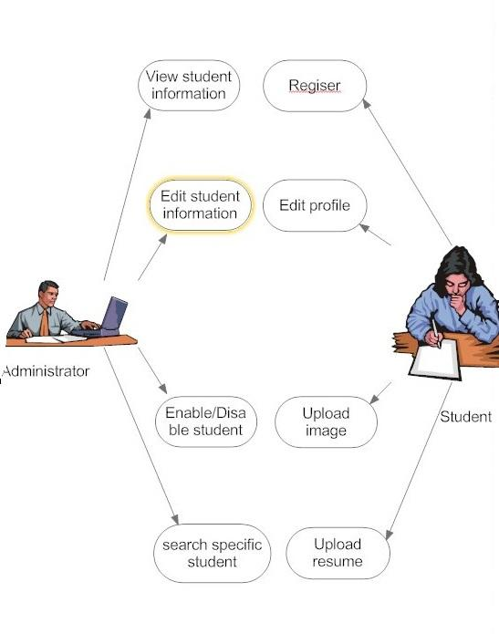

FIGURE 2 USE CASE MODEL

**3.61Administrator:** Responsible for managing student records.

* Login into the website
* Update student details
* Search student details
* Display student details
* Enable/Disable student
  1. **Student:** Has the access rights to view and edit their personal details.
* Login into the website
* Display student details
* Edit their details
* Upload their images
* Upload their resumes

**3.7 Assumptions & dependencies**

* Administrator is created in the system already.
* Roles and tasks are predefined.

**4.SPECIFIC REQUIREMENTS :**

* 1. **Use Case Reports**

**4.1.1 Administrator:** Responsible for managing student details.

**Use-case:** Login into the website

**Goal in context:** Gain access to the website

**Brief Description:** This use case is used when the administrator wants to access the website to enable/disable/update the personal details of the student.

**Preconditions:** The Administrator must be logged onto the website in order for this use case to begin.

**Basic Flow:**

* The Website prompts the administrator for the user name and password.
* The Administrator enters the user name and password.
* The Website verifies the password and sets the user’s authorization.
* The Administrator is given access to the Website to perform his tasks.

**Alternative Flow:**

* The administrator enters invalid username and password then he

will not be allowed to enter the website**.**

**Post conditions:** The website state is unchanged by this use case.

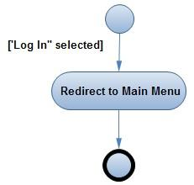

FIGURE 3- Use Case Report- Login into the website

**Use Case :** Display student details

**Goal in context:** View the details of a student

**Brief Description:** This use case is used when the administrator wants to view the personal details of the students already existing in the database on the screen.

**Preconditions:**

* The Administrator must be logged into the system in order for this use case to begin
* The details of the student must pre-exist in the database
* The student id must be entered correctly.

**Basic Flow:**

* The Administrator logs onto the System.
* The Administrator search the student from following keys:-
* Student id
* First/last name
* Registration date
* status
* The System prompts for the student detail from one of the above keys.
* The student details are displayed on the screen.

#### *Alternative Flow:*

#### *Student Not Found*

If in the **Display a student** sub-flows, a student with the specified id number does not exist, The system displays an error message. The Administrator can then enter a different id number or cancel the operation, at which point the use case ends.

**Post conditions:**

The student details are displayed on the screen already existing in the system. The state of the system remains unchanged**.**

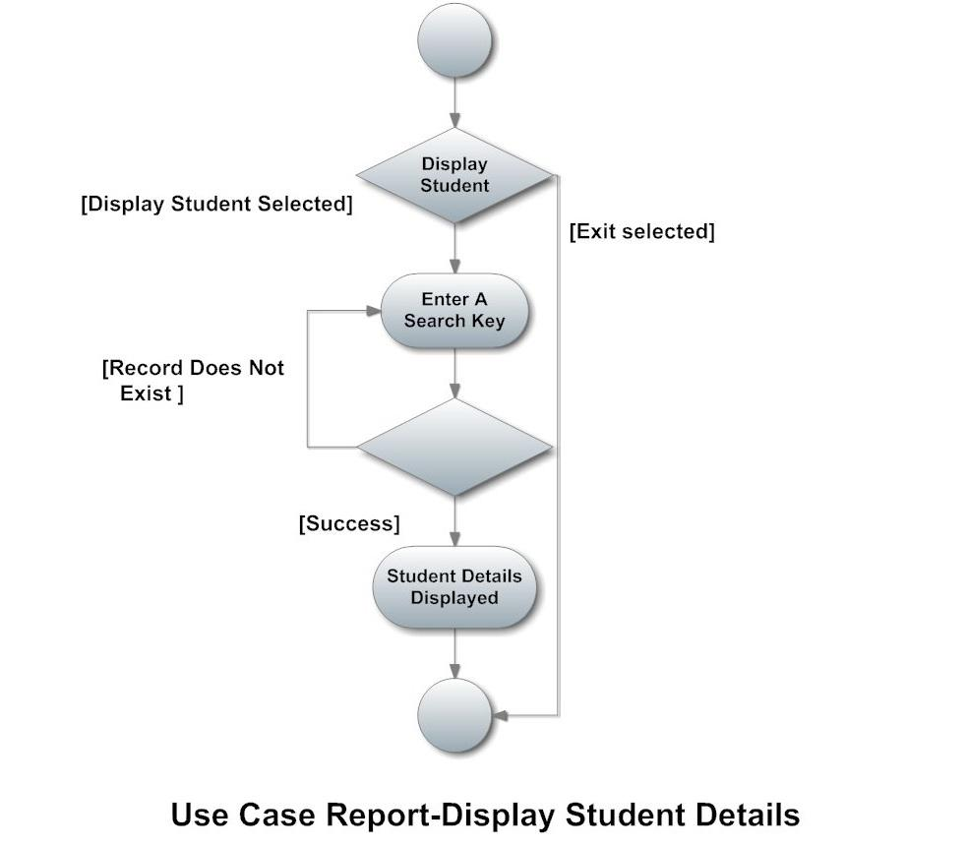

Figure 4- Use case report – Display Student Details

**Use Case :** Edit student details

**Goal in context:** Edit the details of a student

**Brief Description:** This use case is used when the administrator wants to edit the personal details of the himself/herself already existing in the database.

**Preconditions:**

* The Administrator must be logged into the system in order for this use case to begin.
* The details of the student must pre-exist in the database

**Basic Flow:**

* The Administrator logs onto the System.
* The Administrator can edit following keys:-
* First/last name
* Gender
* DOB
* Contact no
* Qualification
* City
* Email1
* Email2
* Address
* Description
* The Website updates the database according to edited details.
* The student details are edited in the database.

#### *Alternative Flow:*

#### *There is no alternative flow of this use case diagram.*

**Post conditions:**

The student details get updated in the database**.**

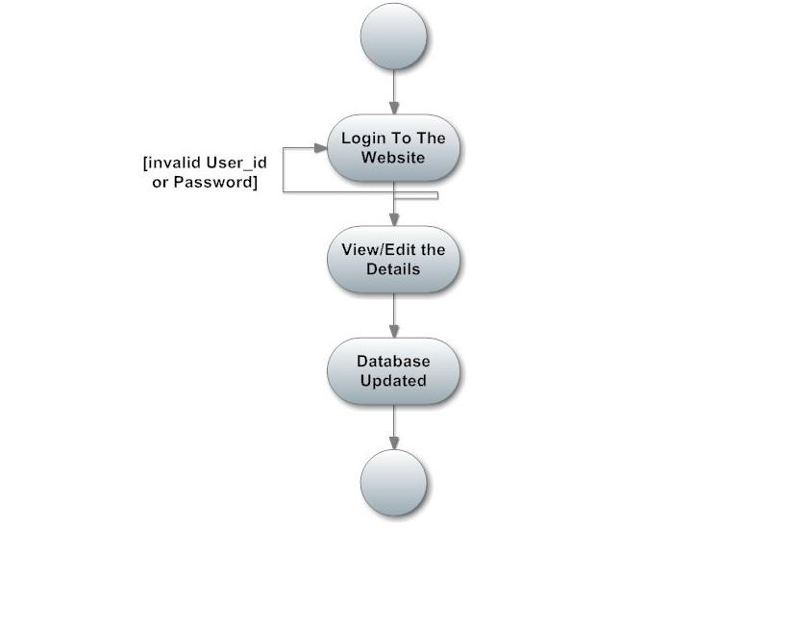

Figure 5 Use Case Report- Edit student detail into the website

**4.2. Student**

**Use Case :** student registration

**Goal in context:** Registration of a student

**Brief Description:** This use case is used when the student register himself/herself in the database online.

**Preconditions:**

* The Student must accessed the website in order for this use case to begin.
* The user id must be unique and entered correctly.

**Basic Flow:**

* The Student enters into the website.
* The student fill his/her details from the following keys:-
* Student id
* password
* First/last name
* Status
* Gender
* DOB
* Contact no
* Qualification
* City
* Email1
* Email2
* Address
* Description
* Resume
* Image
* The System details are added to the database.
* The student details are displayed on the screen.

#### *Alternative Flow:*

#### *User ID not unique: if the user id entered is not unique then it will show an error message.*

**Post conditions:**

The student get registered on the website and to login into that particular the administrator must enable it.

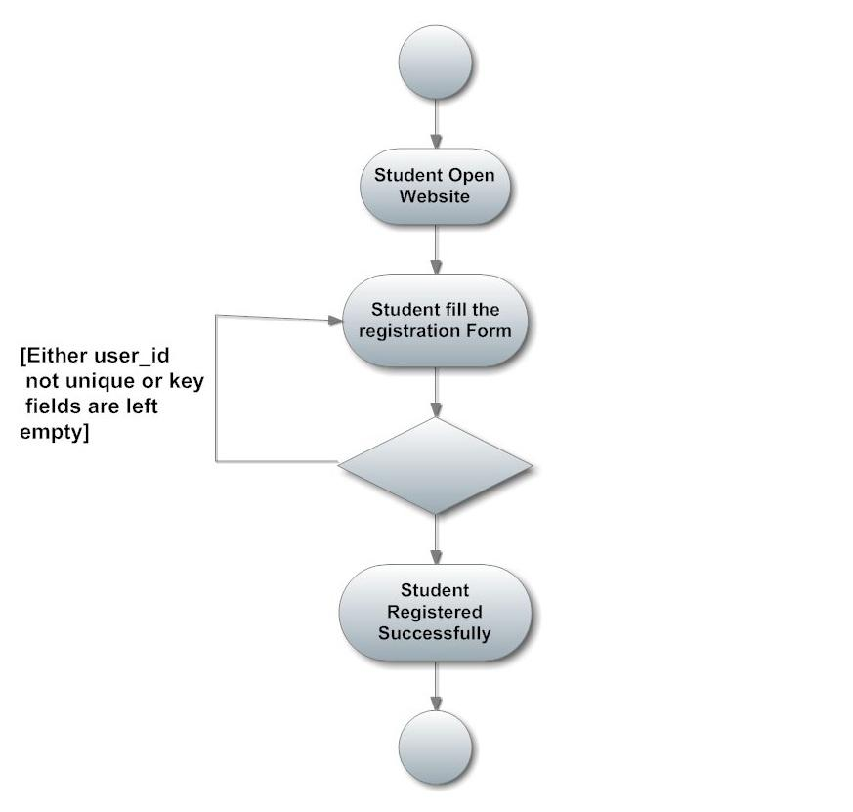

Figure 6- Use Case Report- Register student on website

**Use-case:** Login into the website

**Goal in context:** Gain access to the website

**Brief Description:** This use case is used when the student wants to access the website

**Preconditions:** The Administrator must enabled the particular student onto the website in order for this use case to begin.

**Basic Flow:**

* The website prompts the student for the user name and password.
* The Student enters the user name and password.
* The website verifies the password and sets the user’s authorization.
* The Student is given access to the website to perform his tasks.

**Alternative Flow:**

* The Student enters invalid username and password then he will not be allowed to enter the website**.**

**Post conditions:** The website state is unchanged by this use case.



Figure 7- Use Case Report- Login into the system

**Use Case :** Edit student details

**Goal in context:** Edit the details of a student

**Brief Description:** This use case is used when the student wants to edit the personal details of the himself/herself already existing in the database.

**Preconditions:**

* The Student must be logged into the system in order for this use case to begin.
* The details of the student must pre-exist in the database
* The student must be enabled by administrator.

**Basic Flow:**

* The Student logs onto the System.
* The Student can edit following keys:-
* First/last name
* Gender
* DOB
* Contact no
* Qualification
* City
* Email1
* Email2
* Address
* Description
* The Website updates the database according to edited details.
* The student details are edited in the database.

#### *Alternative Flow:*

#### *There is no alternative flow of this use case diagram.*

**Post conditions:**

The student details get updated in the database**.**



Figure 8- Use Case Report- Edit Student Details Into Database

**5 Functional Requirements :**

* The Administrator will be given more powers (enable/disable/ update) than

other users.

* It will be ensured that the information entered is of the correct format. For example name cannot contain numbers. In case if incorrect form of information is added, the user will be asked to fill the information again.
* The system can be accessed anytime.

**6 Non- Functional Requirement :**

**6.1. Performance Requirements:**

The proposed system that we are going to develop will be used as the Chief performance system for providing help to the organization in managing the whole database of the student studying in the organisation. Therefore, it is expected that the database would perform functionally all the requirements that are specified.

**6.2. Safety Requirements:**

The database may get crashed at any certain time due to virus or operating system failure. Therefore, it is required to take the database backup.

**6.3. Security Requirements:**

We are going to develop a secured database. There are different categories of users namely Administartor ,Student who will be viewing either all or some specific information form the database.

Depending upon the category of user the access rights are decided. It means if the user is an administrator then he can be able to modify the data, append etc. All other users only have the rights to retrieve the information about database.

**7. DESIGN PHASE**

* 1. **Scope and purpose**

The purpose of the design phase is to develop a clear understanding of what the developer want people to gain from his/her project. As you the developer work on the project, the test for every design decision should be "Does this feature fulfill the ultimate purpose of the project?"

A purpose statement affects the design process by explaining what the developer wants the project to do, rather than describing the project itself.

The Design Document will verify that the current design meets all of the explicit requirements contained in the system model as well as the implicit requirements desired by the customer.

**7.2Overall System Design Objectives**

The overall sy stem design objective is to provide an efficient, modular design that will reduce the system’s complexity, facilitate change and result in an easy implementation. This will be accomplished by designing strongly cohesion system with minimal coupling. In addition, this document will provide interface design models that are consistent user friendly and will provide straight forward transition through the various system functions.

**7.2Structure of Design Document**

* *System Architecture Design* – The System architecture section has detailed diagram of the system, server and client architecture.
* *Data Design* – The data Design include an ERD as well as Database design.
* *Functional Design Description –* This section has the functional partitioning from the SRS, and goes into great detail to describe each function.

8.**System Architecture Design**

**8.1System Architecture**

The SIMS is a system which contain major part which include: student Detail, Student image and resume.

The user selects one of the available options as an input to the system. According to the input by the user the system acts and the rest of the functions are performed accordingly.The administartor can operate on any student details.But the normal student or users can only access their details of all the functionalities.

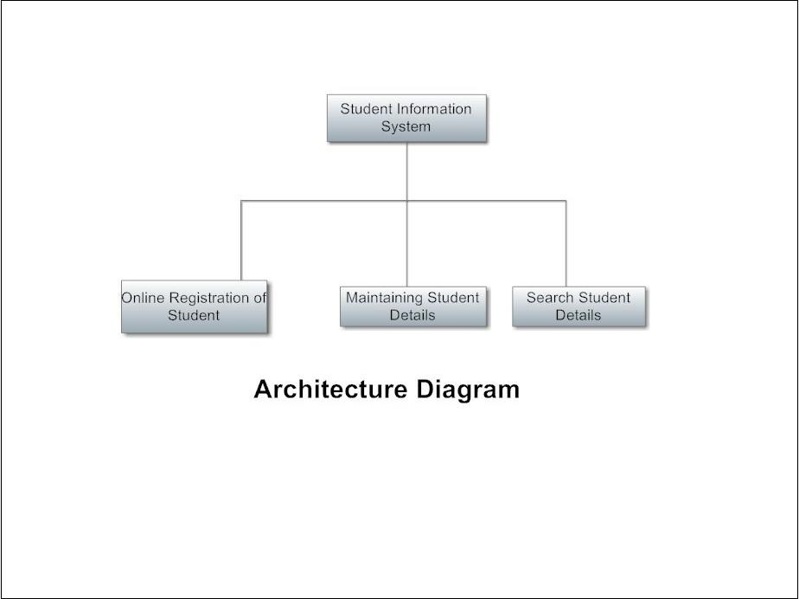

Figure 9- Architecture Diagram

**9. Data Design**

**9.1Entity Relationship Diagram :**

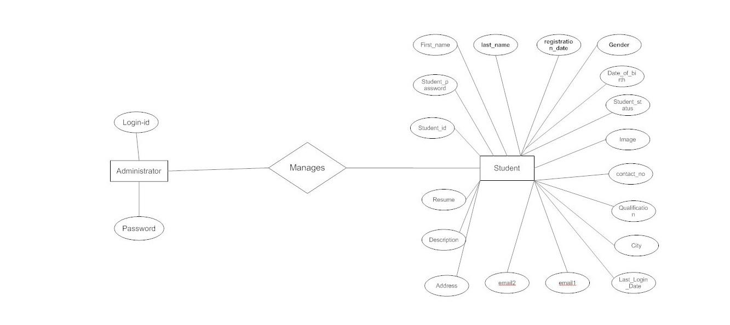

Figure 10-Entity Relationship Diagram

**10.Functional Design Description**

**10.1Data Flow Diagram :**

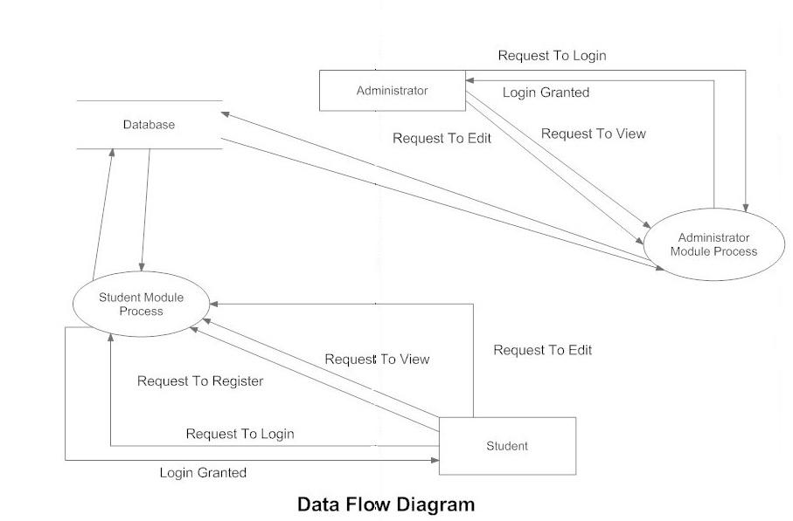

Figure 11 -Data Flow Diagram

**10.2Decision Tree :**

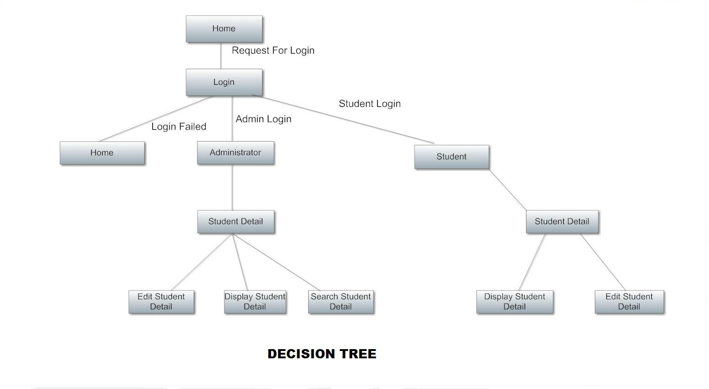

Figure 12- Decision Tree

## 

## 

## 

**11.BENEFITS**

The benefits that are available to the Administrator are:

* + - * + An Administrator can login into the system and perform any of the available operations.
        + Can enable/disable student.
        + Can edit student information to the database.
        + Can make search for a specific student.
        + Can access all the details of the student.

The benefits that are available to the student are:

* Student can login into the system and can perform any of the available options.
* Can view his/her personal details.
* Can edit his/her personal details
* Can upload his/her resume.
* Can upload his/her image.

# RESULT ANALYSIS AND CONCLUSION

## 12.1Result and Analysis

The following screenshots in Appendices section of the application home page demonstrates the key functionality the application provides.

## 

Figure 13: Admin/User Home Page

Given above is the main home page. The home page has admission and campus tour in the right-hand side , Welcome at the center and news and events , and quick links to the left.

* **Admission -** Admission is the page where we can apply any form online and we can enter data .We can also download form and get more information about fees and examination purpose.
* **Campus tour-** It provides various facilities such as laboratories , computer lab , workshop, hostel , canteen and many more.
* **News and events –** It gives us UpToDate news about what events will occur in upcoming times.
* **Quick links –** It gives us links on student list, scholarship , exam timetable and much more.

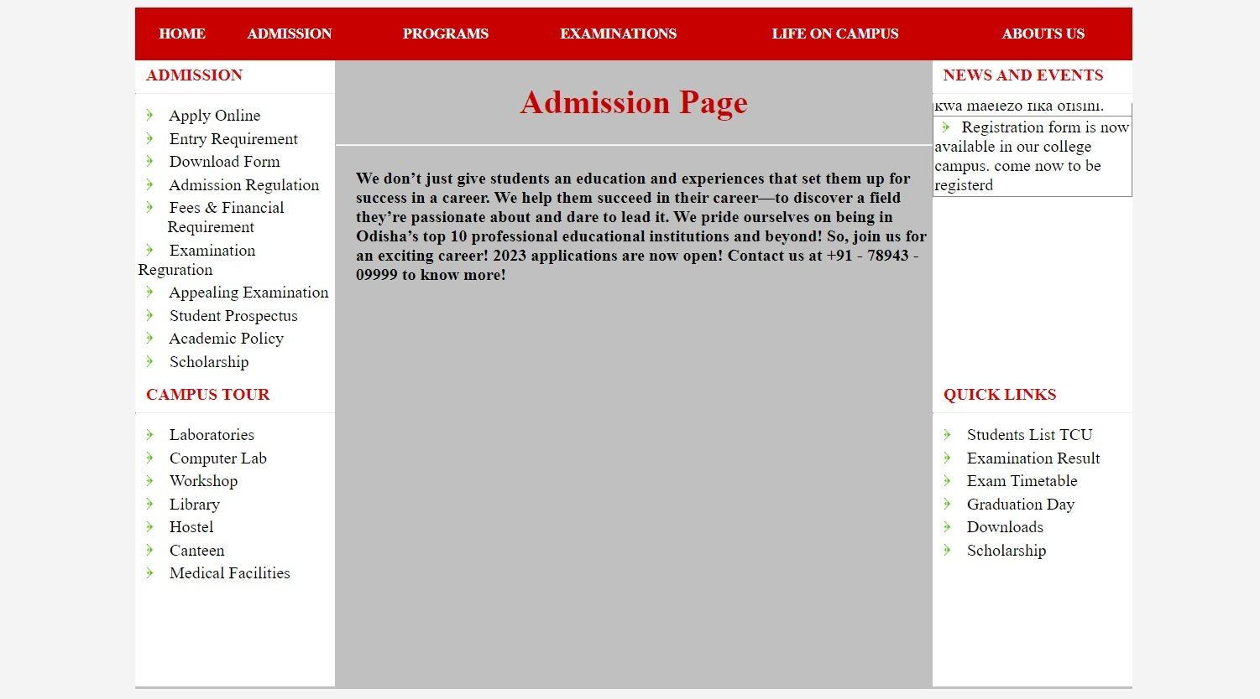

Figure 14: Admission Page

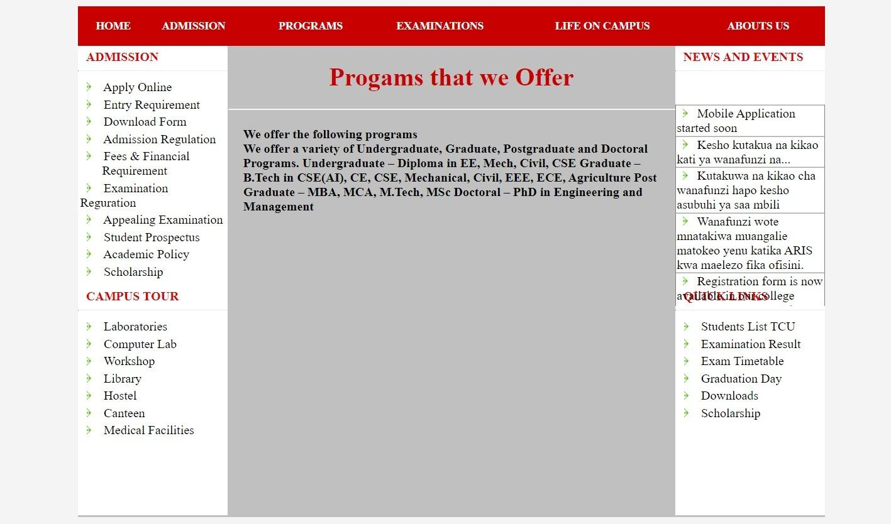

Figure 15: Programs Offered

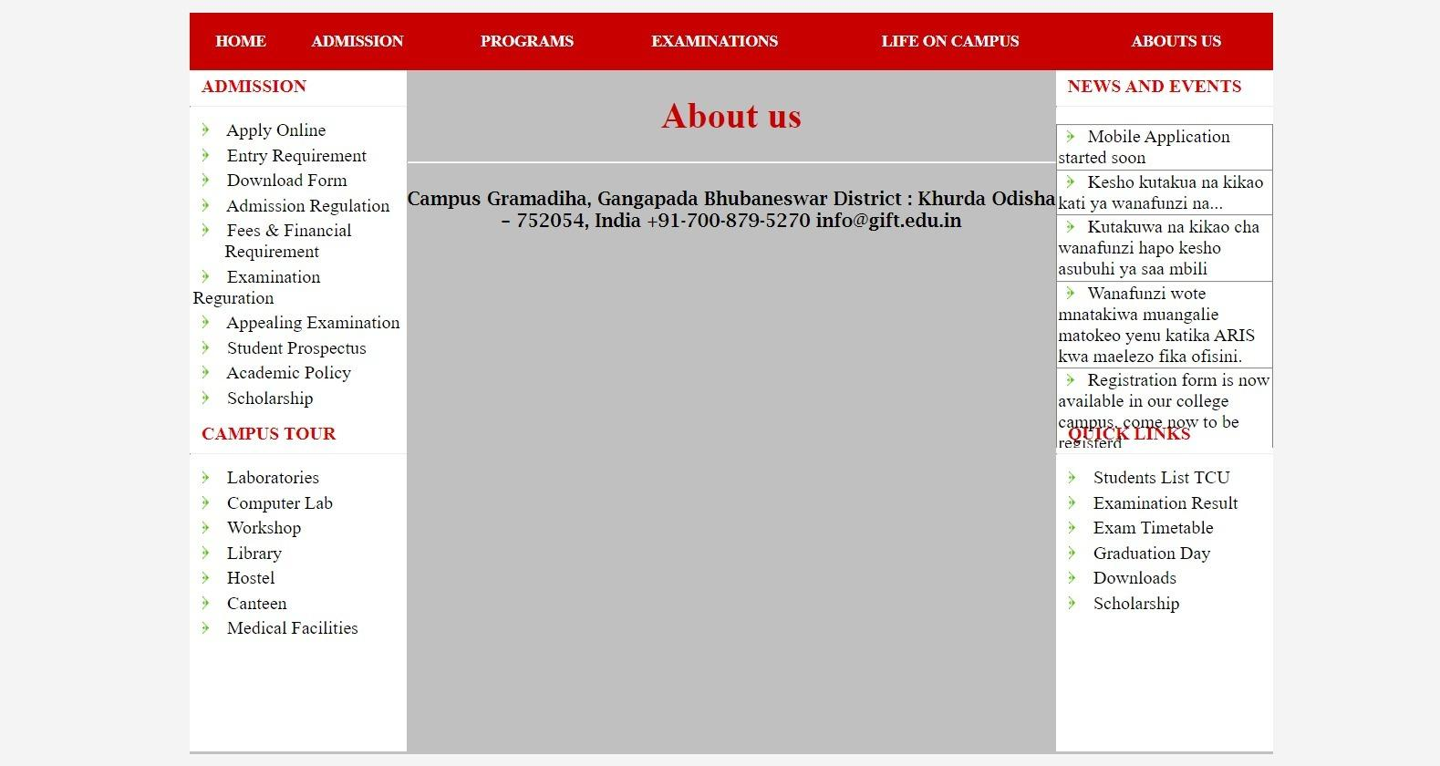

# 

# Figure 16: About Page

# 

# 6 FUTURE SCOPE

# Figure 17: Requirements of College

# 

# Figure 18: Form download

# 

# Figure 19: Examination Info

# 

# Figure 20: Prospectus Page

# 

# Figure 21: Administrator login

# 

# Figure 22: Admin Page

# 

# Figure 23: Updating Home Page

# 

# Figure 24: User Access

Figure 25: Student Informations

# 

# 13.CONCLUSION

* Our project is only a humble venture to satisfy the needs to manage their project work. Several user-friendly coding have also adopted. This package shall prove to be a powerful package in satisfying all the requirements of the school. The objective of software planning is to provide a frame work that enables the manger to make reasonable estimates made within a limited time frame at the beginning of the software project and should be updated regularly as the project progresses.

# 14. REFERENCES

1. PHP book by Vasvani (TMH publications).
2. Beginning PHP5 by WROX.
3. [www.google.com](http://www.google.com).
4. www.wikipedia.com
5. www.w3schools.com
6. Informatics practices by Sumita Arora.