Research Proposal on Color Scheme Analysis of Chinese Fast Food Restaurant Dining Area
Qianru (Carol) Huang

Catalog
Abstract: 1
1. Thesis Review 1
2.2 The choice of color 3
2.2.1 The principle of the biological impact of color on people 3
2.2.2 Distribution of color modules in the restaurant 3
2.3 Color Matching 3
2.3.1 Warm colors 4
2.3.2 Cool colors 4
2.3.3 Color scheme 4
2.4 Questionnaire Design 5
2.4.1 Characteristics of customer perception of restaurant color environment 5
2.4.2 Restaurant color considerations 6
2.4.3 Restaurant considerations for college students: 6
2.4.4 Considerations 6
2.5 Questionnaire survey 7
2.5.1 Specific steps 7
2.5.2 Respondents' profile 7
3. Analysis methods 7
4. Experimental results 7
4.1 From the five dimensions, the scores of eight kinds of fast food restaurant color design solutions 7
4.2 Variable Exploration I: Warm and cold tones 10
4.2.1 Comparison of the scores of cool and warm colors: 10
4.2.2 Significance comparison of the effects of cold and warm colors on the five dimensions: 11
4.3 Variable Exploration II: different color schemes 11
4.3.1 Comparison of the scores of different color schemes: 11
4.3.2 Significance comparison of the effects of different color schemes on the five dimensions: 12
4.4 Variable Probe III: Individual differences between subjects 14
4.4.1 Gender 14
4.4.2 Age 17
4.4.3 Major 20
4.5 Discussion 21
5. Suggestions (reflections) 21
5.1 Exploration of dimensional design and interrelationship between dimensions 21
5.2 Correspondence between pattern design and variables and expansion of variables 22
5.3 Determination of analysis perspectives and aspects that still need to be refined 22
6. Conclusion 22

Abstract: The purpose of this study is to investigate the specific effects of different color designs on customers' evaluation of restaurants and the psychological perception of different colors. Our research is divided into five main steps: first, a review of the thesis, which aims to identify research gaps and to find references for the development of a research methodology. The second step was to create a model and design a color scheme. Based on the analysis of the decoration style of the dining area of famous fast food brands, we introduced two variables of "warmth and coolness" and "color harmony", and designed eight color schemes, including four types of warm and cold colors each, and single, contrasting and tri-color systems were involved. The third step was to create and distribute a questionnaire. Based on the customer's perceived characteristics and considerations of the restaurant color environment, five evaluation indexes were set: beauty and neatness, unique style, class and price, service level, and dining comfort. Then, SPSS analysis was conducted on the questionnaire data. Finally, the experimental results and conclusions were drawn and reflections were made.
Through the study, the effects of the differences between warm and cold colors, the differences in color harmony (monochromatic, contrasting, and triadic), and the differences in subjects (gender and age) on the five dimensions were investigated. At the same time, we also made some reflections and suggestions on the design of dimensions and the interrelationship between dimensions, the correspondence between pattern design and variables and the expansion of variables, and the determination and refinement of analysis angles.
【Key words】 Restaurant Color Design; Cold and Warm Colors; Color Harmony; SPSS Analysis

1. Thesis Review
The different nature of color will lead to different visual effects, which will lead to different psychological feelings and even influence people's behavioral activities [1]. Therefore, the color design of the restaurant will have a great impact on the customer's evaluation of the restaurant. Color design needs to meet people's spiritual and psychological needs when dining, and is the most important part of the overall design of the restaurant [2].
In the existing literature, most of the content of color design in restaurants is mainly focused on exploring the application of color in the creation of atmosphere, theme expression and color psychology in restaurants. For example, the study concluded that warm colors such as red give people a warm and friendly feeling, suitable for use in restaurant decoration; while some cold colors such as yellow-green, blue-green may even have a destructive effect on people's appetite, not suitable for use in restaurant color design; black and white colors give people a clean and tidy feeling, suitable for quick theme restaurants [3]. The above descriptions are rather general, only briefly introducing the psychological effects of color hue, brightness and other properties on people [4], without specifically elaborating on the specific color design will have an impact on the customer's evaluation of the restaurant in several indicators. At the same time, most of the existing literature can only give a direction for the choice of colors, but not a specific color scheme. Following this idea, we decided to dig further into the existing literature to establish a specific color scheme. Through questionnaires, data analysis and experiments, we investigated the influence of color design on customers' evaluation of restaurants in several aspects, and through analysis and generalization, we sorted out the different psychological feelings of different colors.
In the existing literature, the research idea of related topics is: "theoretical data cell phone collation - investigation and analysis part - research experiment part - application inspiration part - conclusion part" [5]. On this basis, we summarized a research method, namely, "data collection - determining color matching - questionnaire survey - data analysis - experiment - revelation and application - drawing results".
In order to design the questionnaire and conduct the experiment, we also referred to some literature from other fields. Firstly, for the selection of the color scheme, we synthesized some literature on the color design of restaurants and summarized and selected several color schemes as samples for our questionnaire and experiment. In addition, in the process of creating the questionnaire, in order to determine the evaluation indexes, we drew on the literature that studied related topics such as "factors influencing customers' choice of dining places", from which we extracted several points such as "safety and hygiene", "high and low price", and "unique style" as the most priority factors for customers when choosing a restaurant [6]. Since some of the evaluation criteria and influencing factors are not relevant to our study, or are difficult to judge by just changing the color scheme, after analyzing and summarizing, we finally determined the survey indicators in our study.
This paragraph provides a cursory overview of our analysis and use of the literature in our study and presents our proposed new ideas based on our reading of the existing literature. Detailed references will be listed below.
2. Experimental design
2.1 Model construction
Before the study, the dining area decoration styles of famous Chinese fast food brands were summarized and analyzed by combining actual pictures and related literature, mainly divided into interface design and furnishing. The classification and characteristics are as follows:

Decorating style
Interface design
- Floor: Flooring materials such as stone, tile and flooring are often used with a glossy surface and easy to clean.
- Wall: treatment also tends to be simple, decorative techniques are mostly flat painting, wall painting and simple patterns.
- Top surface: the presence or absence of a top surface is a key factor in distinguishing the building's indoor and outdoor environment
Furnishings – Furniture
- Chinese table: generally square or rectangular, square shape appears to blend with the surrounding environment, taking the meaning of "uprightness, neutrality, benevolence and harmony".
- Chinese chairs: "backrest chair", curvature in line with modern ergonomics: omit the two sides of the armrests, more convenient to move [7].
Accordingly, we designed a more typical dining area plan, as shown in Figure 1.
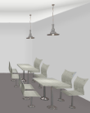
Fig.1

2.2 The choice of color

2.2.1 The principle of the biological impact of color on people
Color has an undetectable but significant impact on human physiology and psychology. In the S0R model (stimulus-biological response) model, based on its three stages (environmental stimulus perception, interpretation of emotions by visual information, and response to stimuli based on emotional responses [8]), the emotional state model was then developed - namely, the pleasure arousal dominance (PAD). This includes pleasure, a feeling of joy or satisfaction. Arousal, a sense of stimulation caused by the surrounding environment. Dominance, a feeling of being in control of a situation. Nowadays, the PAD model has been widely used in the study of consumer behavior.
For example, in the retail industry, the first visual impression of the retail environment can evoke the image of the brand and convey merchandising opportunities [9] and impulse buying behavior [10], and color is one of the important factors of decoration and design in restaurants, so it is explained by the model of S0R. The color of the fast food restaurant we designed is equivalent to a visual stimulus to emotions, and our investigation focused on whether this stimulus makes people have a better impression of this fast food restaurant. The stimulus increases the rate of entry and return customers of the fast food restaurant, which leads to higher sales of the fast food restaurant.

2.2.2 Distribution of color modules in the restaurant
In current restaurant design, one primary color is usually used to cover the interior wall surfaces, while the furniture and interior decorations are decorated with secondary colors. This pattern was also chosen in warakul Tantanatewin and vorapat Inkarojrit's experiments on the effect of color and mood on dining. This pattern of color palette would be more in line with the aesthetic concept and give more visual comfort [11]. We observed pictures of a restaurant decoration and simply simulated the interior of the restaurant in ps and divided the modules to be colored into the five most basic elements: interior walls, tables, chairs, floor and ceiling.

2.3 Color Matching
In the color scheme we design a total of two variables, one for warm and cold colors, and one for color schemes. These two color schemes have completely different physiological and psychological emotional stimuli, so when they are applied to fast food restaurants they will appear to have their own advantages and disadvantages, very complex.

2.3.1 Warm colors
Warm and cool colors often have completely different psychological and physiological effects on people [12]. Physiologically, warm colors tend to increase one's blood pressure and respiratory rate [13], and can confuse one's perception of time, making one believe that time has become faster [14]. Psychologically, warm colors tend to make people excited, energetic, more easily distracted, more easily satisfied, and more easily pleasurable.
Warm colors are considered to be the most suitable colors for advertising backgrounds, they can attract people's attention and make them want to walk in, they can increase the chances of casual purchases in retail [15], and they can increase appetite by giving people a pleasant mood. However, the physiological effects of warm colors may also increase customer anxiety, and warm colors, especially red, may even have an avoidance warning, avoiding more applications in retail, while in the restaurant industry they may cause avoidance of food intake, especially sweets and soft drinks. Warm colors are therefore suitable for restaurant interiors in some ways, and extremely unsuitable in others.

2.3.2 Cool colors
The effect of cool colors is almost the opposite. Physically, cool colors help to reduce stress, relieve tension and pressure, and also facilitate concentration. And psychologically, cool colors represent a quiet and peaceful mood, making people feel calm and harmonious and refreshing. A brighter, more civilized background with a cooler dominant color makes life easier, and it is generally seen that cooler interiors will produce higher levels of positive emotional tones and higher purchase intentions than warmer interiors [17]. And for many vegetables, they look the freshest and tastiest in a cool-colored environment [18]. But at the same time, cold colors make people too calm and can somewhat reduce their desire to dine. This is not conducive to the operation of fast-food restaurants, as it is the opposite of the concept of small profits and fast food speed.

2.3.3 Color scheme
Therefore, we found that it is impossible to conclude from previous studies on color which color is most suitable for fast food restaurants. Moreover, in many literatures, we only searched for the effect of a single color or a single color scheme on the restaurant or food, while significantly less literature mentioned the role of the overall impression caused by matching up the colors in it. Therefore, on the basis of warm and cold colors, we refer to the interior color scheme of Chinese fast food restaurants such as Kung Fu, East Dawning, and Yonghe Soybean Milk, and Western fast food restaurants such as KFC, McDonald's, and Pizza Hut's restaurants (see figure). Then a single (neighboring color scheme), contrasting color scheme and tri-color scheme were used to give different colors to five elements of interior walls, tables, chairs, floors and ceilings in an attempt to create a corresponding color scheme based on visual harmony.
Figure 2. Real Kung Fu
Figure 3. straw hat fish
Figure 4. DICOS
Figure 5.KFC
Figure 6. Pizza Hut
Figure 7. McDonald's
Fig. 8. Yuelongxuan
Fig. 9 Deep Sea 800m
Fig. 10 CosTA
Fig. 11 Big Bear's
Fig. 12 Tiffany's Restaurant
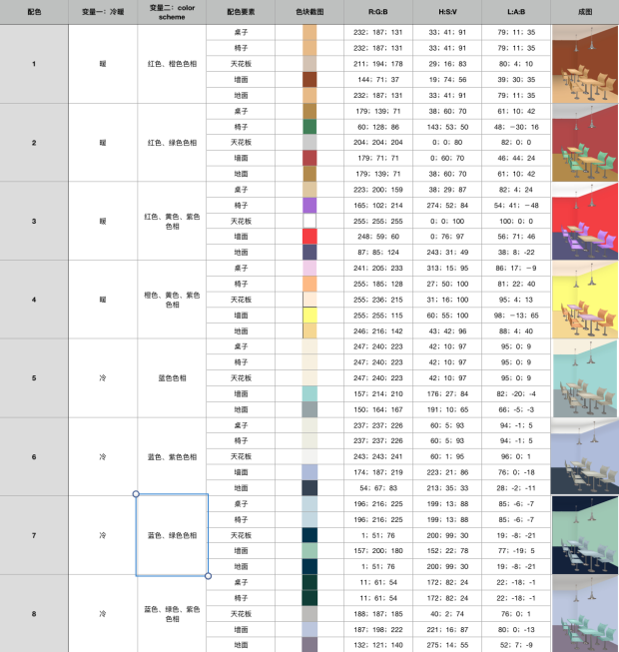
Table 1

2.4 Questionnaire Design
[Knowledge background]

2.4.1 Characteristics of customer perception of restaurant color environment
2.4.1.1 Subjectivity
Customers' perception of the restaurant environment is increasingly subjective and personalized pursuit, so the theme of the restaurant, the environment is also increasingly diversified, theme restaurants and special decorations are the embodiment of this feature:
2.4.1.2 Hierarchy
Attribute layer: intuitive perception of the overall environment of the restaurant, through environmental perception in the heart to form a general impression of the restaurant.
Result layer: After the direct relationship with the restaurant environment, customers will make a comparison between the restaurant environment and their own expectations, the nature and size of the comparison difference, which directly affects the customer's perception of the restaurant and the possibility of future patronage.
Target layer: based on internal expectations for the restaurant environment to produce internal expectations, which is the most important part of the restaurant environment to consider.
2.4.1.3 Trade-offs
For price, environment and product quality will be internally evaluated, if the three in the customer's inner level is about the same, the customer will produce more comfortable, value for money feeling.
2.4.1.4 Multidimensionality
Environment, quality and price are the main factors to consider, but for different consumers, the proportion of the three factors is different. (刘金凤. 主题餐厅顾客感知价值影响因素研究[D」.沈阳理工大 学,2015.)

2.4.2 Restaurant color considerations
Whether the color combination is reasonable, beautiful (aesthetics)
Color atmosphere is comfortable (comfort)
Color affects the degree of neatness (Qi) (neatness)
The degree of hygiene affected by color (hygiene degree)
The proportionality between the color of the environment and the cost of eating (monetary cost: price: non-monetary cost: ease of adaptation of color) (price estimation)
Whether the color echoes the theme of the restaurant (whether it is suitable for fast food style)
Whether the color environment is highly recognizable (attention/recognition/likelihood of standing out from similar restaurants)
Different colors bring potential for the internal assessment of the service level (enthusiasm or not, attentiveness or not) (service level)
Whether the color and the main dishes echo whether the harmony (taste of dishes) [19]

2.4.3 Restaurant considerations for college students:
The importance of the factors influencing the choice of dining places for college students was investigated. The results of the analysis revealed that the main factors influencing the choice of dining places for college students were, in order of importance: food safety, image of dining places (brand image, decoration style), convenience (location, traffic situation, restaurant popularity), taste of dishes and service level (service attitude and service efficiency) [20". Satisfaction with the restaurant as a whole" is also an important measure [21].

2.4.4 Considerations
For this group, we need to understand the influence of the overall color environment of the restaurant on the subjective perception of the diner. In order to obtain accurate data and to expand the dissemination of the questionnaire, the following factors were considered in the questionnaire design:
2.4.4.1 Science
In order to obtain accurate and convenient quantitative data, the pictures selected for the questionnaire were designed by members of the color matching group with professional programs, and all pictures had specific quantitative values for the color scheme, and the questionnaire results were analyzed specifically and deeply by members of the sPss group.
2.4.4.2 Integrity
Since the influence of restaurant color environment on people is a holistic perception, and this questionnaire mainly investigates customers' overall perception of color environment, so the color scheme is chosen from the overall perception, taking the overall environment of warm and cold tones as the main comparison object, and the pictures of different warm and cold tones are randomly ordered.
2.4.4.3 Interference and uniqueness of variables
Since it is necessary to obtain customers' predictions about the price level and service level of the restaurant, it is important to exclude as much as possible the interfering factors other than color that may affect respondents' perceptions (such as decoration, décor, table and chair style, etc.). In order to reduce the interference, we unified the theme of the questionnaire pictures to the tables and chairs that are common in all grades and types of restaurants, and only changed the warm and cold colors and color matching of the tables, chairs, walls and floors to minimize the interference of other interfering factors.
2.4.4.4 Dissemination and Interesting
Therefore, based on the scientific nature of the questionnaire, we added a fun element to the overall style of the questionnaire by naming it "What type of foodie are you" and giving the respondents a specific "type of foodie" feedback after the questionnaire was completed according to the specific situation of answering the questions. In order to reduce the burden on the respondents, only eight representative pictures were selected as questions.
2.4.4.5 Relevance
The questionnaire is based on the color selection of the restaurant, which is a question close to life. The design of the questionnaire must match the actual situation and the psychological needs of customers. In order to ensure the realism of the questionnaire questions, we set up the questionnaire questions and the distribution of the score of the answers, referring to several indicators of the most concern of customer reviews on software such as Meituan and VW, and conduct offline interviews, and finally came up with the five factors (beautiful and clean, unique flavor, when this price, service level, dining comfort) that customers are most concerned about when choosing a restaurant as the topic options.

2.5 Questionnaire survey

2.5.1 Specific steps
The questionnaire team members were identified on April 11, and started to search for literature, conduct offline interviews, and design the questionnaire.
On April 13, the color scheme and color matching results of the students in the color matching group were determined, and the questionnaires were distributed after the pictures were obtained. By April 15, 153 questionnaires were collected, 153 of which were valid.

2.5.2 Respondents' profile
Of the 153 questionnaires returned
1. 27.45% of the respondents were male and 72.55% were female. 2.
Respondents covered all age groups from 18 to 40 years old and above. 3.
3. 60.35% of the respondents were freshmen undergraduates, which is the highest percentage. Sophomore undergraduates accounted for 34.31%, the second highest percentage.
4. Undergraduates were interviewed from 28 departments.
2.5.3 Screenshot of the questionnaire (partial)

3. Analysis methods
The analysis methods used by this group are generally as follows:
1. ANOVA was used to analyze the scores of the eight restaurants from five dimensions
2. ANOVA was used to analyze the effect of warm and cold colors on the five dimensions
3. Analyzing the effect of different color schemes on the five dimensions using the mean descending and standard deviation analysis method in descriptive statistics
4. ANOVA analysis was used to analyze the significance of the effect of different color schemes on the five dimensions
5. The analysis of the significance of the gap between gender on the preferences of different color schemes was performed using one-way ANOVA analysis
6. ANOVA was used to analyze the significance of the difference between age and color preference.
7. The general linear model analysis method was used to analyze the significance of the gap between arts and science majors on the preference of different color schemes.

4. Experimental results

4.1 From the five dimensions, the scores of eight kinds of fast food restaurant color design solutions
 | Sum of squares | Degrees of freedom | Mean Square | F | Significance
Aesthetically pleasing and clean between groups | 392.587 | 7 | 56.084 | 26.288 | .000
Unique style between groups | 127.866 | 7 | 18.267 | 7.783 | .000
Grade Price Between Groups | 130.402 | 7 | 18.629 | 10.467 | .000
Service Level Between Groups | 109.195 | 7 | 15.599 | 9.147 | .000
Dining comfort between groups | 245.659 | 7 | 35.094 | 18.965 | .000
The P-value for the significance of all eight colorways on the five dimensions was 0.000, so that the effect of all eight colorways on the five dimensions was significant.
Aspects of aesthetics and neatness: It can be seen from the average graph of the eight color schemes that the difference between the aesthetic and neatness of color scheme 6 (blue-green-violet) and 7 (purple-orange-yellow) is not significant, while color scheme 3 (red-yellow-violet) and 4 (red-green) are very different from other color schemes, especially color scheme 3 (red-yellow-violet) is much lower than other color schemes.
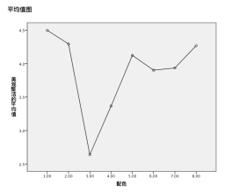
Aspects of style: From the average graph of the unique degree of style of the eight color schemes, it can be seen that color scheme 1 (Tiffany blue) and color scheme 3 (red, yellow and purple) have a large difference on the unique degree of style, and color scheme 1 (Tiffany blue) has the lowest unique degree of style, while color scheme 3 (red, yellow and purple) has the highest unique degree of style.
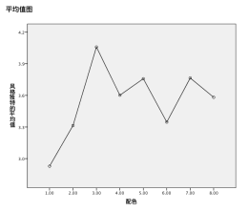
Aspects of Class and Price: From the average graph of the eight colorways of grade and price, we can see that the grade and price of colorway 1 (Tiffany blue), 3 (red, yellow and purple), 4 (red and green) are lower, while especially the grade and price of colorway 3 (red, yellow and purple), 4 (red and green), colorway 5 (blue and green), 8 (brown) are higher.
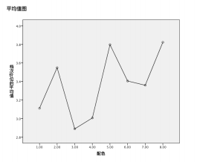
Aspects of service level: The graph of the mean of the service level of the eight colorways shows that the service level of colorway 3 (red, yellow, purple) and 4 (red, green) is significantly lower than the service level of colorway 1, 2, 5, 6, 7, 8 Service level.
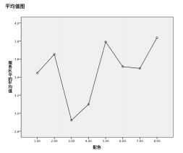
Aspects of dining comfort: The average of the dining comfort of the eight colorways shows that the dining comfort of colorway 3 (red, yellow, purple) and 4 (red, green) is significantly lower than the other colorways, especially colorway 3 (red, yellow, purple).
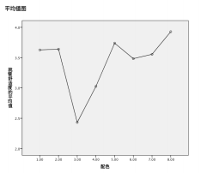
In summary, based on the scoring of each color scheme in five dimensions, the eighth group ranked first in three dimensions: class and price, service level, and dining comfort, while the third group ranked first in the unique style dimension, but ranked last in all the other dimensions. Moreover, the standard deviation of the scores of the third group in the unique style dimension was obviously large, and it was assumed that some of the subjects scored especially high (7 points).
Meanwhile, the ANOVA of five dimensions of the eight color schemes revealed that color scheme 3 (red, yellow and purple) had the highest style uniqueness, while aesthetic neatness, class and price, service level and dining comfort were the lowest.

4.2 Variable Exploration I: Warm and cold tones

4.2.1 Comparison of the scores of cool and warm colors:
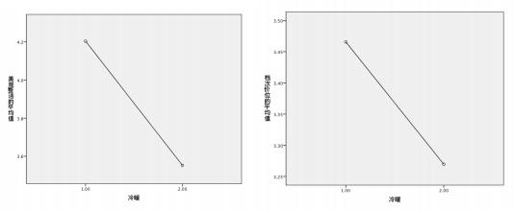
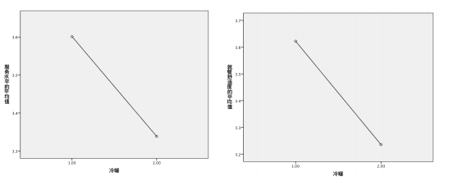
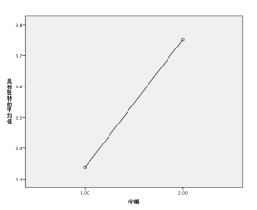

Cool colors have higher average scores than warm colors in terms of aesthetic neatness, aesthetic tidiness, service level, and dining comfort, while warm colors are higher than cool colors in terms of unique style.

4.2.2 Significance comparison of the effects of cold and warm colors on the five dimensions:
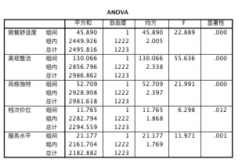
Dining comfort
Aesthetics and cleanliness
Unique style
Class price
Service level

Square and
Square of the mean
Significance
Between groups

From the above table, it can be seen that the significance of warm and cold colors on dining comfort, beauty and cleanliness, and unique style is P = 0.000, while the significance of class price is P = 0.012, and the significance of service level is P = 0.001. Therefore, the effect of warm and cold colors on all five dimensions is significant, but the significance of warm and cold colors on class price, service level, and especially class price is slightly lower than the other three dimensions.

4.3 Variable Exploration II: different color schemes

4.3.1 Comparison of the scores of different color schemes:
Mean Standard Deviation
4.268 1.54326
i1
h1 | 3.9346 1.4809
e1 | 3.366 1.55492
d1 | 2.6405 | 1.40775
4.0588 1.89957
d2
h2 | 3.7647 1.54223
e2 | 3.6013 1.64373
i2 | 3.5817 | 1.44009
3.8235 1.43782
i3
h3 | 3.3595 1.35051
e3 | 3.0065 1.4072
d3 | 2.8889 | 1.43525
3.8366 1.3739
i4
h4 | 3.4967 1.38661
e4 | 3.098 1.36577
d4 | 2.9216 | 1.32053
3.8954 1.45622
i5
h5 | 3.5556 1.43678
e5 | 3.0261 1.43246
d5 | 2.4314 | 1.32667
A single color is higher than other colors in terms of beauty and neatness, class and price, service level and dining comfort, and lower than other colors in terms of unique style. While the three roles in the unique style dimension is significantly higher than the other colors, in the other four dimensions are lower than the other colors. Red and green contrasting colors are always in the middle.

4.3.2 Significance comparison of the effects of different color schemes on the five dimensions:
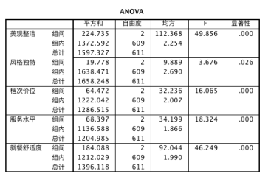

Dining comfort
Aesthetics and cleanliness
Unique style
Class price
Service level

Square and
Square of the mean
Significance
Between groups

The above table shows that the three color schemes (single, contrast, triangle) have a significant P-value = 0.000 for aesthetics and neatness, class and price, service level, and dining comfort, and P = 0.026 for distinctiveness of style. Therefore, the effect of three color schemes (single, contrast, and triangle) on all five dimensions was significant, but the effect of three color schemes (single, contrast, and triangle) on the uniqueness of style was slightly less significant than the other four.
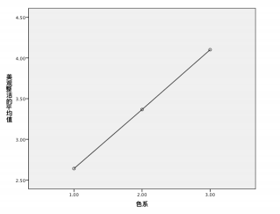
Color scheme 1 (three-color scheme) has the lowest level of aesthetics and cleanliness, and color scheme 3 (single color scheme) has the highest level of aesthetics and cleanliness.
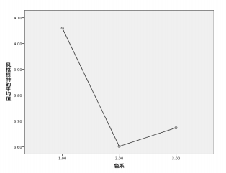
Color Scheme 1 (three character system) has the highest degree of style uniqueness, while Color Scheme 2 and 3 (contrasting color system, single color system) have lower degree of style uniqueness.
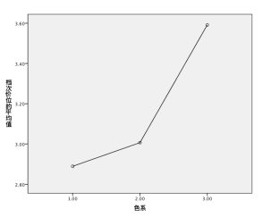
Color scheme 3 (single color scheme) has the highest grade price, while color scheme 1 and 3 (three color schemes, contrasting color schemes) have the lowest grade price.
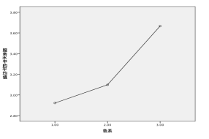
The service level of color scheme 3 (single color scheme) is the highest, and the service level of color scheme 1 and 3 (triple color scheme, contrast color scheme) is low.
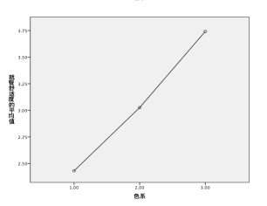
The dining comfort level was highest in color scheme 3 (monochromatic) and lowest in color scheme 1 (trichromatic).

4.4 Variable Probe III: Individual differences between subjects

4.4.1 Gender
4.4.1.1 Significance of gender differences in preferences for different color palettes:
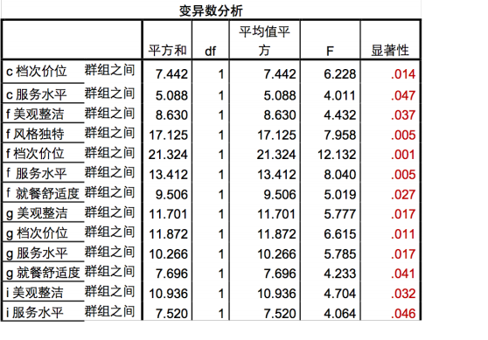
Dining comfort
Aesthetics and cleanliness
Unique style
Class price
Service level

Square and
Square of the mean
Significance
Between groups

Analysis of variance
Square and
Square of the mean
Significance
Between groups

Based on the observational analysis, significant differences in gender were reported for the fifth and sixth groups with P 0.037, 0.005, 0.001, 0.027, 0.017, 0.011, and 0.04, respectively. Women scored significantly higher than men on all dimensions of both color schemes. The remaining two dimensions were also significantly different in the second and eighth groups, with p-values of 0.014, 0.47, 0.032, and 0.046, respectively, also higher for females than for males. (The fifth group is blue-green color scheme, the sixth group is blue-green-violet color scheme, the eighth group is brown color scheme, and the second group is blue-violet color scheme) It is assumed that females prefer a single-color scheme or a similar color scheme, and prefer cooler colors.
4.4.1.2 The effect of gender on the five dimensions :
The effect of gender on class price and dining comfort was more significant, with a significance of 0.032,0.028 respectively.
Inter-subject effect check
Dependent variable: Grade price

Source |  | Class III Sum of Squares |  |  | df | Square of the mean | F
  Significance
 |  |  |  | 3 |  |  |   3.819  .010
Modified model |  | 21.360a |  |  |  | 7.120
 |  |  |  | 1 |  |  |  | .000
intercept distance |  | 10728.884 |  |  |  | 10728.88  4 | 5754.8  52
Gender |  |  |  |  |  |  | 4.613 | .032
Gender |  |  | 8.599 | 1 |  | 8.599 | 4.613
Cold and warm colors | 11.320 |  |  | 1 |  | 11.320 | 6.072 | .014
 |  |  |  | 1 |  |  |  | .744
Gender *  Cold and warm colors |  | .199 |  |  |  | .199 | .107
122
0
Error |  | 2274.470 |  |  | 122  0 | 1.864
Total 122
16110.000
4
Total after correction 122
2295.830
3
a. Square of R = .009 (Adjusted square of R = .007)

Inter-subject effect check
Dependent variable: Dining comfort

Source \ | Class III Sum of Squares | d  f | Square of the mean | F | Significance
Modified model | 55.833a | 3  1  1  1  1  1  2  2  0  1  2  2  4  1  2  2  3 | 18.611 | 9.330 | .000
intercept distance | 11155.023 |  | 11155.02  3 | 5591.9  60 | .000
Gender | 9.677 |  | 9.677 | 4.851 | .028
Cold and warm colors | 33.796 |  | 33.796 | 16.942 | .000
Gender * Cold and warm colors | .266 |  | .266 | .134 | .715
Error | 2433.695 |  | 1.995
Total | 16867.000
Total after correction | 2489.529

Square of R = .022 (Adjusted square of R = .020)

4.4.2 Age
4.4.2.1 Percentage of each status and grade
Our survey respondents were mainly university students (including undergraduate and graduate students), accounting for 89.5% of all respondents, while primary and secondary school students accounted for 2% and non-students for 8.5%. Among the university students, most of them were in their first two years of college (54.2% and 30.7%, respectively).
4.4.2.2 Analysis of relevant indicators
F | Significance
between groups
Dining comfort
blue
tiffany
4.310
.015
b-g Dining comfort
between groups
3.225
.043
b-g-p Grade Price
between groups
3.144
.046
brown Aesthetic and
between groups
3.100
.048
neat

There was no significant difference in the judgment of most of the color scheme dimensions by identity, except for: dining comfort in tiffany blue (P=0.15), dining comfort in blue-green group (P=0.043), class and price in blue-green-violet group (P=0.046), and aesthetics and neatness in brown group (P=0.048).
The details are as follows: (visualized in graphs)

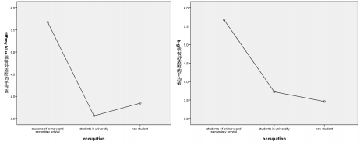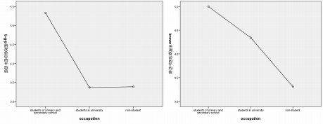
As can be seen from the above graphs, elementary and middle school students scored each indicator higher than the other two groups, and the overall trend is decreasing with age. Except for tiffany blue, it is obvious that college students are less receptive to it than the other two groups.
By extension, we can analyze the scores of different identities on "aesthetics and neatness" since there is a positive correlation among all indicators (for space limitation, we do not include the comparison of all indicators in the text). The scores are as follows:
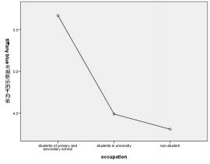
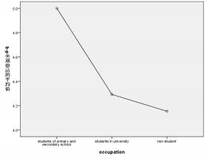
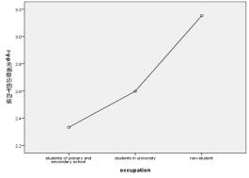
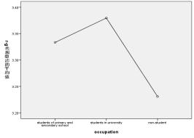

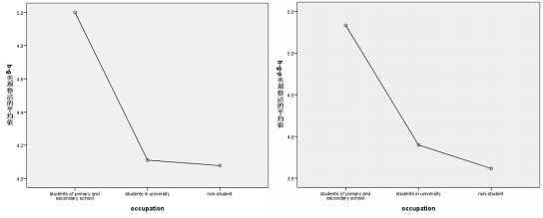
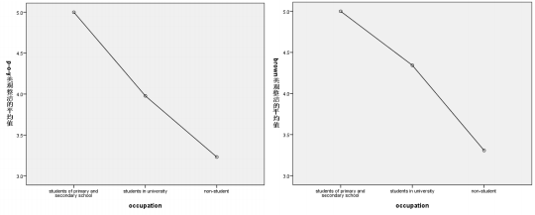
It is easy to find that the scoring of similar colors, in general, tends to decline with age (status), with college students being the highest in terms of acceptance of red and green contrasting colors, and being favored by relatively older people in terms of high color red, yellow and purple clashing colors. This is also confirmed to some extent by the pure age grouping:
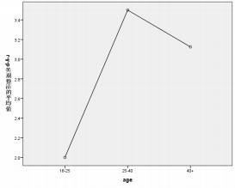
Note: The above analysis was based on the returned questionnaires only, due to the large differences in the number of subjects with different status and age, errors could not be excluded. Among the subjects with bachelor degree or above, there was no significant difference in the judgment of different indicators by grade, and the P value of all indicators was greater than 0.05. The differences were mainly concentrated in different status.

4.4.3 Major
Through the between-subjects effect test, we found that the effect of different majors (arts and sciences) on the favorability of the color scheme was not significant, and the data of each group were as follows: F=0.771, P=0.612 for aesthetics and neatness; P=0.446, F=0.874 for unique style; P=0.586, F=0.778 for class and price; F=0.517, P=0.822 for service level; F=0.525, P=0.816 for dining comfort.
Relevance Analysis
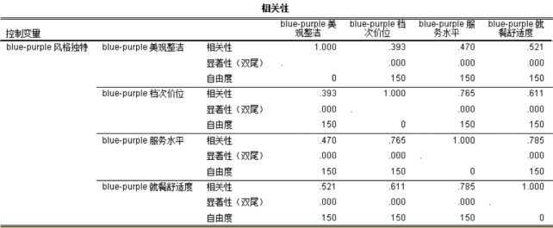
Correlation
Control variables

Significance (two-tailed)

Degree of freedom

Dining comfort
Aesthetics and cleanliness
Unique style
Class price
Service level

For instance, the above graph shows that the indicators are positively correlated with each other, and the difference is not significant.

4.5 Discussion
The purpose of our study is to investigate the effect of color design on customers' evaluation of fast food restaurants. In the existing literature, most of the content on color design in restaurants is mainly focused on the application, and often no experimental investigation is done, and color scheme suggestions are given directly. Not only do they not specifically elaborate on which indicators of color design will have an impact on customers' evaluation of restaurants, but they also only give a direction for the choice of colors, rather than a specific color scheme.
To this end, through literature compilation and market research, we firstly determined the five-dimensional scale of restaurant evaluation based on the s0R (stimulus-biological response) model: beauty and cleanliness, unique style, class and price, service level, and dining comfort. Starting from the customer's visual perception - the degree of "beauty and cleanliness", then to the customer's "class and price", "service level" and "style and uniqueness", and finally to the overall "dining comfort" to measure, in order to accurately reflect the customer's perception of the restaurant when facing different color design. The 7-point Likert scale was used as a reference for the measurement, and a scale of 1 to 7 was designed.
Second, to determine the different color schemes, two variables, "coolness" and "color harmony", were introduced. In particular, two-color schemes, cool and warm, were designed according to "coolness", and three-color schemes, namely, Complementary/Analogous, Complementary, and Triadic, were designed according to "color harmony”. In order to control the variables in the design of the experimental restaurant style, the five elements of table, chairs, ceiling, walls, and floor were identified and designed as a unified pattern to control the influence of different numbers, positions, and styles of several elements in the picture. Then determine the following eight color scheme: blue (cold single), blue and purple (cold single), blue and green (cold single), blue, green and purple (cold single), red and orange (warm single), red and green (warm contrast), red and yellow and purple (warm triangle), orange and purple (warm triangle). The different elements are colored to produce the image.
The experiment first collected information about the subjects' gender, age, status, and profession, and then collected the subjects' data of 1~7 scores in 5 dimensions for the 8 patterns.

5. Suggestions (reflections)

5.1 Exploration of dimensional design and interrelationship between dimensions

First of all, although the dimension design was based on three levels: "intuitive visual perception - mental preconceptions of other aspects of the restaurant - overall perception", the number of dimensions was too small and the correspondence between the three levels was not close enough.
Secondly, the positive and negative correlations between dimensions are also worth exploring, such as the correlation between unique style and aesthetics, and the correlation between service level and price level, etc.

5.2 Correspondence between pattern design and variables and expansion of variables
First of all, the pattern design and variable settings are not closely integrated. The pattern was not designed in the way of 2 (cold, warm) *3 (single, contrast, triangle) according to the two variables, which lacked representation and was somewhat arbitrary: the four cold-toned drawings were all single-color, and the four warm-toned drawings were divided into one single color, one contrast color, and two triangular roles.
Second, when designing the variables, saturation and lightness can also be considered. For example, the overall saturation or lightness of the color scheme in a single-color family of cool tones is changed in several gradients and a pattern is generated for the same experiment.

5.3 Determination of analysis perspectives and aspects that still need to be refined
The use of two perspectives, "from dimensions" and "from variables", in the analysis is not conducive to the integration of conclusions.

6. Conclusion
(1) Cold and warm color differences: cold color system is more likely to make customers into a fast-food restaurant aesthetic and clean, high price level, high service level, more comfortable dining feeling; while warm color in will make the restaurant style appears unique. At the same time, the influence of cold and warm colors on the five dimensions are significant, but the influence of cold and warm colors on the grade price, service level, especially the grade price is slightly lower than the restaurant aesthetics, dining comfort and service level grade.
(2) Color harmony differences: the single-color system is higher than other color systems in terms of beauty and cleanliness, class and price, service level and dining comfort, and lower than other color systems in terms of unique style; while the three-color systems are significantly higher than other color systems in the unique style dimension, and lower than other color systems in the other four dimensions; the contrast color system has been in the middle of the state. At the same time, three color families (single, contrast and triangle) have a significant effect on all five dimensions, but the effect of three-color families (single, contrast and triangle) on the degree of style distinctiveness is slightly less significant than the other four.
(3) Subject differences:
1.Gender: Gender has a greater influence on the price and comfort of dining than the other three, i.e., when faced with different restaurant color schemes, there are significant differences between men and women in their perceptions of the price and comfort of dining. At the same time, in general, women are more sensitive to color differences and prefer a single color scheme or similar color schemes and cool colors.
(2) Status and age: The survey respondents were mainly college students (including undergraduates and postgraduates), accounting for 89.5% of all respondents, while primary and secondary school students accounted for 2% and non-students accounted for 8.5%. The scores of primary and secondary school students were higher than those of the other two groups for each indicator, and the overall trend was decreasing with age. At the same time, there was no significant difference in the judgment of most of the color scheme indicators among different identities, which means that people of different identities and ages have the same perception when facing different color schemes. But in the face of a certain color scheme, there will be some differences in a certain index, such as the dining comfort index of the iffany blue, the dining comfort index of the blue-green group, the grade and price index of the blue-green-violet group, and the aesthetic and neat index of the brown group.

