Identity Construction, Social Capital, and Digital Mobilization - “Sixology” Parody under the Internet Meme Theory

ABSTRACT

From the parody video of Hu Ge in 2006, “a bloody case caused by a hoe”, which set off a wave of internet parody, to the "Liu Xue" and the "Ming Xue" that have caused Internet users to carnival, the emergence of endless internet parody has formed a shocking subculture spectacle. This paper treats the phenomenon of spoofing the "Liu Xue" as a dynamic process of continuous replication and imitation, from two perspectives of generation logic and dissemination characteristics, and combines the qualitative and quantitative modal analysis method proposed by Limor Shifman, and provides a more complete analysis of the imitation mode of the "Liu Xue". On the one hand, it compares the formation paths of the "Liu Xue", discusses the causes of the phenomenon of online spoofing from an ephemeral perspective, and analyzes the social capital and digital mobilization behind the "Liu Xue" from a macro level, while on the other hand, it also discusses the micro level of the participants of the "Liu Xue". On the other hand, we also explore the positions and behavioral motives of the participants of the "Liu Xue" at the micro level. The present study analyzes the specific case of "Liu Xue", which helps us understand other similar online spoofing phenomena and participant groups from a small perspective.

Keywords: Internet Culture, Internet Parody, Meme, Liuxiaolingtong

Content
ABSTRACT 2
1 Introduction 6
1.1 Background of the study 6
1.2 Research significance and innovation points 7
1.3 Research review 9
1.4 Research Program 24
2 The origin and development of "Liu Xue" 31
2.1 The concept of "Liu Xue" 31
2.2 The germination and development of "Liu Xue" 33
2.3 Participating groups of "Liu Xue" and online platforms 39
3 The Content Construction of "Liu Xue" Meme 45
3.1 The nature of "Liu Xue" meme 45
3.2 Dissemination of contents of Liu Xue meme 47
3.3 Types of imitations of "Liu Xue" meme 48
3.3.1 Direct quotation: indiscriminate copying 49
3.3.2 Transposition: the combination of pictures and texts out of context 50
3.3.3 Collage reorganization: the dismemberment and reconstruction of the text 52
4 Analysis of the spread of "Liu Xue" modalities 57
4.1 Forms of dissemination of "Liu Xue" modalities 57
4.1.1 Pictures (Emojis) 57
4.1.2 Linguistic sentences 59
4.1.3 Video 62
4.2 The generation logic of "Liu Xue" meme 64
4.2.1 Communication host: imitation of the communicator 64
4.2.2 Communication environment: driven by economic interests 67
4.2.3 Dissemination: Boosted by Replication Technology 69
4.2.4 Communication Culture: The Impact of Participatory Culture 70
5 Postmodernist cultural significance of "Liu Xue" modalities 73
5.1 Diverse positions of "Liu Xue" modalities 74
5.2 Resistance to social contradictions 85
5.3 Identity, self-expression and capital accumulation 89
5.4 Imaginative solutions to problems 91
6 Conclusion 94
Reference 97
Appendix 101
I. Interviewees 101
II. Outline of the interview. 102

1 Introduction

1.1 Background of the study
From Hu Ge's spoof video "The Bloodshed Caused by a Steamed Bun" in 2006, which started the boom of online spoofing, to the phenomenon of "toad worship" which once triggered the frenzy of Internet users, to the recent "goat placenta" fad. The endless network spoof phenomenon has constituted a "shocking" cultural landscape. The rise of network spoof culture and the development and popularity of the Internet is inseparable, although the same new media technology "child", but the network spoof culture is different from other network culture, such as hacker culture, ACG culture, etc., with its unique "style", which have been attracting people's attention.
In early December 2018, the Wu Cheng'en Former Residence Memorial Hall in Huai'an City, Jiangsu Province, became the focus of the attention of netizens. A netizen posted a video saying that a large number of exhibits were arranged in the former residence, such as the Liuxiaolingtong and the Monkey King family, but there were few exhibits related to Wu Cheng'en, and some visitors questioned: "Is this Wu Cheng'en's former residence or Liuxiaolingtong's" (Tian Miaoqi & Yu Gui, 2020) (hereinafter referred to as the "former residence incident ")¹. Many netizens questioned the actor Liuxiaolingtong and the memorial hall as a result. After this incident, the relevant management staffs made a clarification, and Liuxiaolingtong also made a statement indicating that he did not participate in the relevant activities and the exhibition. These statements did not let the netizens on the incident to calm down, but further provoke the netizens on the Liuxiaolingtong related words and actions of concern. Then, the Internet appeared the so-called study of the "emerging discipline" is the netizens call themselves the "Liu Xue" research. And those who study and use "Liu Xue" are also called "Liu Xue Scholars" by netizens.
For a while, imitating the sentences spoken by the "Liuxiaolingtong" was popular on social networks, accompanied by many related expression packs and videos. According to the Baidu index, on December 27, 2018, the search index of "Liuxiaolingtong" reached 22,172. The search index of "Liu Xue" also rose from 0 to 11,212 after the "former residence incident".
As with most Internet spoof phenomena, the fervor of the "Liu Xue" did not last too long, but this does not mean that the focus on it has lost its significance. On the contrary, when examined from the perspective of cultural studies, "Liu Xue" is a typical product of online spoof culture, and its own long formation history and unique cultural connotation make it stand out from many other online spoof phenomena.

1.2 Research significance and innovation points
1.2.1 Research significance.
First of all, this thesis combines network spoofing with modal theory, and starts from the microscopic perspective of specific cases, capturing a typical network spoofing phenomenon - "Liu Xue", analyzing its origin and development, content construction, generation and dissemination. Compared with other domestic research on Internet spoofing from a macro perspective, the comprehensive analysis of specific cases helps to start from the phenomenon, and the analysis of the "Liu Xue" case in this paper has a long span of time and richer selected materials, so that we can use more sufficient data to realize a small view of the big, so as to better understand the Internet spoofing itself. It has certain theoretical significance for the study of this kind of phenomenon.
Secondly, from the perspective of practice, this study adopts in-depth interviews, starting from an in-depth understanding of the life history of the participants of the "Liu Xue" phenomenon, and introduces a cultural perspective to analyze the pluralistic and resistant cultural practices of the participants of the "Liu Xue", and to explore The study explores the motivation and significance of the production and practice of online spoofing culture by the makers and participants of the "Liu Xue", and grasps the formation of spoofing culture from the perspective of the subject, which has certain practical reference value for our understanding of other similar groups involved in online spoofing.
1.2.2 Innovations
This paper treats the phenomenon of "Liu Xue" as a dynamic process of continuous copying and imitating communication, and combines the qualitative and quantitative modal analysis method pioneered by Limor Shifman from two perspectives: generative logic and communication form. The parodic approach of the "Liu Xue" modalities has been more completely sorted out in a trinity of parodic dimensions from form, content to stance.
On the one hand, we analyze the social capital and digital mobilization behind "Liu Xue" from the macro level, and on the other hand, we explore the mentality and behavioral motives of "Liu Xue" participants from the micro level. The study of "Liu Xue" is still a relatively new theory in China, and domestic scholars have mostly focused on linguistics, mostly on Internet buzzwords, and the discussion of "Liu Xue" is mostly at the level of cultural controversy, with few in-depth studies from the perspective of modality. Therefore, from this perspective, this study is also exploratory and pioneering to a certain extent.

1.3 Research review
1.3.1 Review of the study of network spoofing (parody)
1.3.1.1 Meaning of "parody
The term "parody" is generally believed to be derived from the Japanese word "くそ", pronounced as "parody". In general, there is no authoritative definition of spoofing in China because of the differences in research positions and objects of different researchers, and the understanding and definition of spoofing are mainly from Hu Jiangfeng's Spoofing and Youth Subculture². In his article, he mentions that spoofing is actually a kind of cultural behavior with subversive nature, which can also be understood as a cultural phenomenon reflecting the deconstruction of authority or classic events or figures.
In the collection of studies on "spoofing," three key words are mentioned: spoofing, spoofing culture, and spoofing phenomenon. These concepts are not strictly distinguished in different literature, but are used together. In this paper, we try to distinguish the relationship between these three concepts by synthesizing Wang Xiaonan's and Hu Jiangfeng's research on spoofing. In terms of the definition of spoofing, both of them basically agree, that is, spoofing is essentially a kind of comic and humorous presentation in behavior or speech. But when this kind of presentation gradually forms a scale of propagation and develops into a widespread phenomenon, it becomes what we call "spoof phenomenon", and behind this phenomenon represents the culture created by this group, namely "spoof culture". In other words, in Wang Xiaonan's opinion, there is a close relationship between that concept, spoofing can be regarded as words and actions, and the spoofing phenomenon is a kind of large-scale spoofing words and actions, and what is presented behind this phenomenon is a spoofing culture.
In Symbolic ridicule: social expression and cultural governance of online spoofing (Zeng Yiguo, 2018), the origin of spoofing is shown that the term "parody" first appeared in Japanese ACG, and then the term spread rapidly in Taiwan's online forums, and then became popular in Hong Kong until it was introduced into China around 2000. It was translated as "spoof" in mainland China around 2000, and at the same time the range of objects it refers to has been expanding³. Although the phenomenon of spoofing existed in China long before the word "parody" appeared, the emergence of a real spoofing culture is closely related to the rapid development and popularity of the Internet in China.
The earliest spoofing phenomenon that attracted widespread public attention was in early 2006, when the video A Steamed Bun Caused Bloodshed generated sensational attention, and the producer of the video, Hu Ge, was thus given the title of "Godfather of Spoofing". The video is in the form of CCTV and legal platform narration, the content material is selected from the famous director Chen Kaige's film Wuji, the creator through different forms of editing, combination, quirky dubbing and other "nonsensical" form, loudly satirized the Wuji film. Once the film was released, it resonated strongly with the audience, and A Steamed Bun Caused Bloodshed quickly became a hit with netizens on the Internet, and Hu Ge himself became the "first internet celebrity" of the year. This incident set off a trend of spoofing on the Internet, and a large number of Internet spoofing works appeared, especially among the youth group, and the Internet spoofing culture began to become a high-profile cultural phenomenon.
1.3.1.2 Research content of "spoofing"
In China, there is a large amount of literature on the topic of Internet spoofing, but the perspective of the study is relatively single, especially from the cultural perspective, which focuses on the psychological level, social influence and linguistic analysis of spoofing words.
The research on culture from the perspective of psychoanalysis mainly combines Bakhtin's carnival theory, analyzes the psychological mechanism of online spoofing cultural groups and the discourse strategy of spoofing phenomenon, and explains the reasons for the emergence of online spoofing phenomenon from the psychological level. The consistency of "spoofing" with folk carnival in the spiritual dimension, "carnival is to break the order and bondage to the daily cyclical life, a return to the original state of pursuit and a manifestation of people's emotional release"⁴ (Zeng Yiguo, 2018). Spoofing can somehow be an antidote to the stress and anxiety people face in modern society. Of course, in addition to this, many studies have found other psychological characteristics, such as the pursuit of monetary rewards, rebellious and curious psychology, and so on.
From the perspective of social analysis, many researchers have followed the Birmingham School's idea of analyzing culture from the perspective of class, but in the light of China's specific national conditions, they have abandoned the class discourse of the Birmingham School and adopted the structural contradictions of China's social "transition" to explain the roots of culture generation and the resistance shown by cultural groups. In this paper, Huang Jingbao's The Evil of the World, he discusses the class discourse of the Ming-Han School. In An Economic Analysis of Spoofing, Huang Jingbao mentions that economic factors are involved in spoofing culture and influence the emergence and direction of spoofing culture, and suggests that there is a complex relationship between economic development and spoofing culture, both positive and negative⁵. It can be said that Internet spoofing is a ritual solution to these structural contradictions. In addition, some studies point out the positive contribution of postmodern thinking and the innovation of media technology to spoofing.
The study from the perspective of symbolic analysis continues the Birmingham School's focus on cultural "style" and explores in detail the construction of style in online spoof culture from the symbolic level. Zhang Yinjie's textual analysis of Hu Ge's spoof of CCTV news broadcasts in 2008 points out that Hu Ge adopted parody and juxtapose, appropriated the symbolic system of news broadcasts, interpreted news events from a marginal position, and deconstructed the seriousness and authority of mainstream media. Many similar studies also reveal that the emergence of the spoof phenomenon is largely a struggle for discourse power by marginal groups, and such a practice is achieved precisely through style. Compared with many other online cultures, the uniqueness of online spoof culture is also reflected in its display of style.
"Parody" is a particularly common type of expression in participatory culture in much of the foreign literature⁶ (Christian, 2010; Jenkins, 2006; Jenkins et al., 2013; Milner, 2013; Shifman, 2011, 2013b). Meanwhile, spoofing is a form of parody marked by a critical distance from the quoted text⁷ (Hutcheon, 2000), praised for its role in subverting social and artistic norms (Bakhtin, 1982), hailed as a cultural resource for exercising the role of active citizenship⁸ (Hariman, 2008), and used by disenfranchised groups as a weapon against the dominant⁹ (Pratt, 1991), as a weapon used by disenfranchised groups against the dominant culture. The combination of participatory media and imitative messages may produce a powerful range of cultural resistance. In the highly controlled Chinese Internet, parody is used to violate social and political hierarchies¹⁰ (Gong and Yang, 2010; Szablewicz, 2014). However, there is no guarantee that spoofing is truly revolutionary in character; Jameson (1990) argues that postmodern spoofing (or "parody") no longer preserves its critical nature and is used to produce uncritical, unexamined pleasure¹¹.
In general, contemporary studies on the phenomenon of online spoofing mostly focus on the specific products of spoofing culture, but less on the whole stage of spoofing phenomenon generation and transmutation; they mostly analyze and interpret the phenomenon of online spoofing from a macroscopic point of view from a high level, but less into the life history of online spoofing cultural groups, and lack the ability to grasp the construction of spoofing cultural style from the perspective of the subject of cultural practice.
1.3.2 Review of research on modal theory
1.3.2.1 Meaning of Meme
Meme is a unit of cultural transmission or imitation - like a gene - that is transmitted from person to person through replication or imitation, a term coined by biologist Dawkins (1976) in 1976 to describe the smallest unit of natural selection in a culture¹². Dawkins noted that the genetic molecule DNA transmits genetic information through replication transmits genetic information and is the mechanism by which organisms evolve to self-replicate. In the cultural domain, there is also replicable molecular evolution, i.e., modalities, which reproduce themselves in the modal library. This means that modalities survive as a unit of information in the brain through replication, and they spread from one vector to another through imitation. Assimilation, memory, expression and transmission are the four stages involved in modal replication, which has three characteristics: fidelity of replication, prolificacy and persistence. Similarly, modal factors play a key role in sociocultural evolution and development and are complementary to genes¹³ (Qin Xiaoyan, 2008). In response to his work, his student Susan Blackmore refined and developed the theory of modal factors (Blackmore, S. J., 1999), which subsequently attracted widespread attention in the West and entered various fields, and the research team on this field grew in a few short years¹⁴.
1.3.2.2 The core of meme theory: imitation and replication
In Blackmore's view, the fundamental reason for the vitality of modality is imitation. Francis Heylighen (1992) breaks down this process into four interrelated stages: "assimilation - memory - expression - communication transmission"¹⁵. The host, the player in the communication process that assumes the role of reception and transmission, is also indispensable in the four stages. First is assimilation, where the modality, after gaining the host's attention, successfully enters the host's cognitive system, but in the end only part of this information may be adopted, or possibly all of it. The second is memory. For the host, the role of memory is to store the received modalities in both of them. Only the clearer and longer the modality is in the host's memory, the more effective the transmission will be in the next stage of transmission. Then comes the expression. Expression means that the host needs to linguistically organize the modalities in the memory so that it takes the host. Finally, there is transmission. As the final stage of modality transfer, transmission is both a process and a result of that process. When this part of the modality transfer process is completed, it means that the transfer of the modality is over and a new round of modality transfer begins.
During the whole imitation phase, the most important thing is the degree of knowledge between the host and the modality. Only the host's perception of the modality is clear enough, which directly affects the outcome of the modality transmission. Lynch (as cited in Ho, 2003) argues that even a so-called replication form cannot really achieve a completely consistent cognitive idea¹⁶; no communication process is sufficiently complete and objective enough not to bear traces of the transmitter/host's personal thoughts¹⁷ (Blackmore, 1999).
In other words, at each stage of modal reproduction, there are changes and trade-offs, so for each modal, the inevitable fate is to undergo numerous selection sessions, which is both their required ability and the driving force for their evolution. The pressure to be selected is not only among the modalities themselves, but also among the many different modalities in the so-called competition for survival. The same holds true for the entire meme-pool when extended to individual modalities. They can be found in people's electronic forms of entertainment, in sources of information, and in attempts to occupy more of their attention¹⁸ (Dawkins, 1976; Blackmore, 1999). From the perspective of the survival of individual modalities, this is not an easy step, and the opportunity to perform imitation and replication requires competition with other modalities of the same type as well as different types, such that it is also called cultural adaptability by Blackmore¹⁹ (Blackmore, 1999). Modes with strong cultural resilience are considered strong modalities and vice versa are weak modalities²⁰ (Wu, H. & Wang, L. Y., 2010).
While many scholars would debate around the definition of modality and in the delineation of its scope, there is a consensus on the view of the essence of modality, that is, the core of modality is replication. In the process of transmission of modalities, replication is fundamental, both in the development of a single modality and in the competition between multiple modalities, and thus the feature of replication is indispensable for the transmission of modalities.
1.3.2.3 Research content of modal theory
a. Foreign research status.
In his classic book "The Selfish Gene", Dawkins mentioned the concept of "meme", which led to the research on modal factors²¹. In his book, he introduced the idea of evolution into the field of culture and proposed the idea of cultural evolution, which requires the help of cultural modalities, i.e., the continuous change of culture relies on cultural factors to reproduce and spread (Dawkins, 1976). This idea has been endorsed by many scholars, such as Aaron Lynch, Daniel Dennet, and Richard Brodie, who have also mentioned and expanded on this idea in their treatises²². More famously, Dennet connected the modal view to the memory of the human brain, and in "The Interpretation of Consciousness" and "Darwin's Dangerous Idea" he proposed that the reason the human brain can store so much is that things are stored in modal units. In his book The Modal Machine, Dawkins' student Blackmore synthesized the views of many scholars and, after responding to the shortcomings of modal theory, introduced the analysis of modal theory into other disciplines such as religion, linguistics, and sociology, which furthered the study of modality as a separate branch²³.
At this point, the study of modal theory has achieved a comprehensive period of vertical and horizontal research, and the analysis of modal theory has moved from theory to practice, from the initial cultural subfield to multiple fields such as philosophy, sociology, and psychology, and to a deepening degree.
b. Status of domestic research.
The domestic research on modal factor theory started late, and the initial research was also mainly focused on the translation of existing foreign works, the more typical ones being "The Selfish Gene" by Dawkins and "The Modal Machine" by Blackmore. Domestic scholars followed the direction of these two works and analyzed modalities from a cultural perspective, but did not give rise to further theoretical development on the subject. It was not until modality theory entered linguistics that the study of modality gradually began to gain real momentum in China. Professor Gui Shichun's 2002 book Language and Culture was the impetus for the introduction of modalism into linguistics²⁴. In his book, he talked about the relationship between modality and culture, and between modality and the brain. His contribution was the first time he introduced the "meme" modality to culture. In "Modality and Social Pragmatics", he and his students discussed in detail the pragmatics application of modality theory, which led to the further study of modality²⁵. The study of modality began to be further studied in depth. After them, the research on modalities in linguistics is still in its heyday, and the representative scholars of this period include Cai Shaolian, Xie Chaoqun, He Xuelin, and others.
The research on modalities in the field of linguistics has also promoted the research on modalities in related fields, such as the research on modalities in translation theory, the article "Thinking about translation norms based on modalities" mentions how to apply modalities in translation to enhance the effectiveness of translation²⁶ (Ma Xiao, Chen Shunyi, 2014); then in the field about language teaching, there are also scholars who talk about connecting language teaching in the classroom with modalities²⁷ ( Zhou Yishu, 2014); some scholars also talk about the study of modalism in the field of language cognition, which focuses on the close connection between cognition and modalism, and the propagation role of modal units in language cognition²⁸ (Zheng Sifang, 2013); then there is the relationship between modalism and pragmatics, and the connection between these two has been gradually deepened with the development of Internet technology, especially the flourishing of Internet popular phrases, etc., from The connection between the two has deepened with the development of Internet technology, especially the rise of Internet buzzwords, which depends to a large extent on the influence played by modalities in language²⁹ (Hou Jianbo,Sun Jingyi, 2014).
In addition to the four major categories of language-related modal theories mentioned above, domestic scholars have gradually expanded their research on modal theory to other fields, more often in the intersection of linguistics and other disciplines, such as linguistics and sociology, psychology, and brain science. After reviewing the literature and analyzing it, it is easy to find that the research on modalism in China is not only late compared to foreign countries, but also limited in terms of research direction, depth and level. However, the reason for this problem is that modalism was initially introduced to China from translators, which is closely related to linguistics. Therefore, in the later development of modalism, no major breakthrough in the field of research has been achieved.
There are many reasons for the cultural importation of the concept of modality into China, one of which is its use by domestic scholars to explain a particular trend or evolutionary evolution of culture, and the summary of learning about this has become a focus in academic circles. The so-called modalities are mainly used as units of a particular culture at the moment, which can also be used as units of cultural evolution and evolution, and the existence of such units can be considered as a mechanism by which one can observe such mechanisms to summarize fixed patterns and thus predict the culture that will produce trends. Modes can also be understood as the basic factors of reproducible transmission, where a specific culture spreads within a society under the role of transmission of information. In the article "Modalities and Communication" published in 2007, Chaoqun Xie and He Naturally write, "Cultural messages are seen as selfish replicating factors or thinking viruses that exploit the human ability to imitate and replicate each other in an effort to keep themselves spread and perpetuate their own lives"³⁰. Since the language used by most people in a society is a vehicle for culture and is itself a culture, modality can be used in the study of language. Perhaps because modal theory has not been introduced to the country for a long time, there are still only a few research articles on modal theory and the evolution of culture. The above-mentioned article "Modalities and Communication" and others mainly explain and analyze modal theory, which allows readers to consider the evolution and transmission of language and culture from different perspectives.
In addition, some scholars have tried to establish the relationship with modality theory from other disciplines, such as Wang Chunlei (2022) in "A psychodynamic study of language modality based on the modularity of brain networks", which analyzes the relationship between social psychology and modality, but such articles are relatively rare³¹.
Time Stage | Subject/Filed | Representatives | Research focus
1976- | Biology | Richard Dawkins | "Meme" has been proposed as cultural transmission units or cultural replication factors.
1976-1999 | Interest in a variety of disciplines, including philosophy, psychology, and linguistics | （Daniel Dennett）,  （Richard Brodie）etc. | The idea that the human brain is made up of many modalities was transferred to the conscious mind and the domain of language.
1999 | Sociology | Susan Blackmore | With The Modal Machine, modality began to be studied as a complete theoretical mechanism, forming a systematic theory of modality (memetics).
1999-2008 | Extensive penetration into various fields such as psychology, sociology, cultural studies, philosophy, language teaching | Kate Distin, ect.  Xie Chaoqun, He Ziran | The study of the origin of language, the transmission of conceptual ideas, and so on.  (At present, most of the domestic scholars' researches are also focused on this stage, because the theory was introduced by translation scholars and introduced late, so the domestic research on modality is focused on linguistics.)
2008-2013 | Ecology, geography, etc. |  | The concept of "organism" of modality is proposed, and more and more attention is paid to the combination of modality theory and social practice.
2013 | Journalism and Communication | Limor Shifman | The term "internet meme" is proposed, meaning "a set of digital objects with common features in terms of content, form and/or position, which are created under the role of mutual consciousness and are transmitted, imitated and/or transformed by many users through the Internet. "
2013- | Political communication, cultural studies, and other fields |  | The focus of attention is on cultural connotations.  Wang Yanlong et al. proposed the application of modal factors to the examination of online culture.  Subsequently, it was further expanded to the social field as well as the political field, and scholars such as Guo Xiaoan considered modalities as a new way of political participation and mobilization to study the spread of modalities in political discourse.
1.3.2.4 Meme theory in the digital era
Modes existed before the advent of the Internet, but the Internet turned the dissemination of modalities into a highly visible practice³² (Blackmore, 1999; Shifman, 2013). In the words of Limor Shifman, an "internet meme" is defined as "a set of digital objects that share common characteristics in terms of content, form, and/or stance, which are created with mutual awareness and are disseminated, imitated and/or transformed by many users through the Internet"³³ (Shifman, 2014, 41).
Formally, most web modalities are visual, but they can also be textual and audio clips. The key to a web modality is not its popularity, but user engagement: the modality is a derivative of parodies, remixes, mashups, and other "communicable media" (Jenkins, Ford, & Green, 2013) that serve as raw materials³⁴ (Shifman, 2014).
Researchers of network modality have begun to focus more on the cultural connotations of modality, viewing it as a prism that reveals aspects of contemporary digital culture (Burgess, 2008), and that modality is intertwined with and influences culture (Shifman, 2012), so that it is not an isolated unit but a complex cultural building block³⁵. Therefore, online modalities become effective units of analysis and are applied to the examination of online culture such as online buzzwords (Ge Houwei & Bejunhua, 2017); duangs (Shifman & Thelwall, 2014), emojis, and videos³⁶ (Shifman, 2013).
In "Meme In digital culture," Shifman (2014) pioneered a theory that draws on Carey's (1989) view of communication as ritual and Bennett and Segberg's (2012) theory of connective behavior to emphasize meme and the political implications of network parody³⁷. She argues that memes, as a means of constructing connections between the personal and the political, are also communicational rituals that demonstrate the uniqueness of each playful and performative individual and construct shared identities and a sense of belonging.
The study of modalities has further expanded from the cultural field to the social field as well as the political field, with some scholars considering modalities as a new form of political participation and mobilization (Guo, Xiaoan, & Yang, Shaoting, 2016) and studying how specific modalities as an online political discourse are disseminated³⁸ (Seiffert-Brockmann, Diehl, & Dobusch, 2018). Modal research in the political field revolves around its use as a common framework or reference point for political discourse and action, focusing on it as a form of political participation (Sharbaugh & Nguyen, 2014.) or protest behavior³⁹ (Shomova, 2021). As an important means for people to participate in political discussions or politicians' propaganda, political modalities, by virtue of their multiplicity of meanings and rich visual forms, have allowed for a greater integration of politics and popular culture (Liu & Ying, 2021), which offers the possibility for political modalities to express other intentions⁴⁰.
Some scholars have used the "socialist" modality as an example to reflect on official propaganda in terms of emotion theory, arguing that these modal practices blur official interpretations⁴¹ (Zhang, 2020), pointing out that the humorous nature of the "socialist" modality is often associated with irony, and that Political humor and satire play an increasingly important role in our political landscape⁴² (Gilkerson, 2012). In line with this, there has been a growing body of research in recent years on young people's engagement, creativity and autonomy when using digital social media (Winocur & Dussel, 2020), and modalities can be reshaped for different purposes and used symbolically in different contexts (Octavita & Zaimar, 2018), thus becoming a tool for the dissemination of political satire⁴³. How online modalities that disseminate information through humor and satire are used for political satire has become a topic of interest for scholars⁴⁴ (Kulkarni, 2017). Previous studies have provided cases of how apolitical content becomes political content⁴⁵ (Meng, 2011; Szablewicz, 2014); however, other studies have found the opposite result - a depoliticized political symbol, not out of intentional selection and appropriation, but from the openness of the modality and the nature of ambiguity and its natural life cycle⁴⁶ (Hao Yu & Ji Min, 2020).
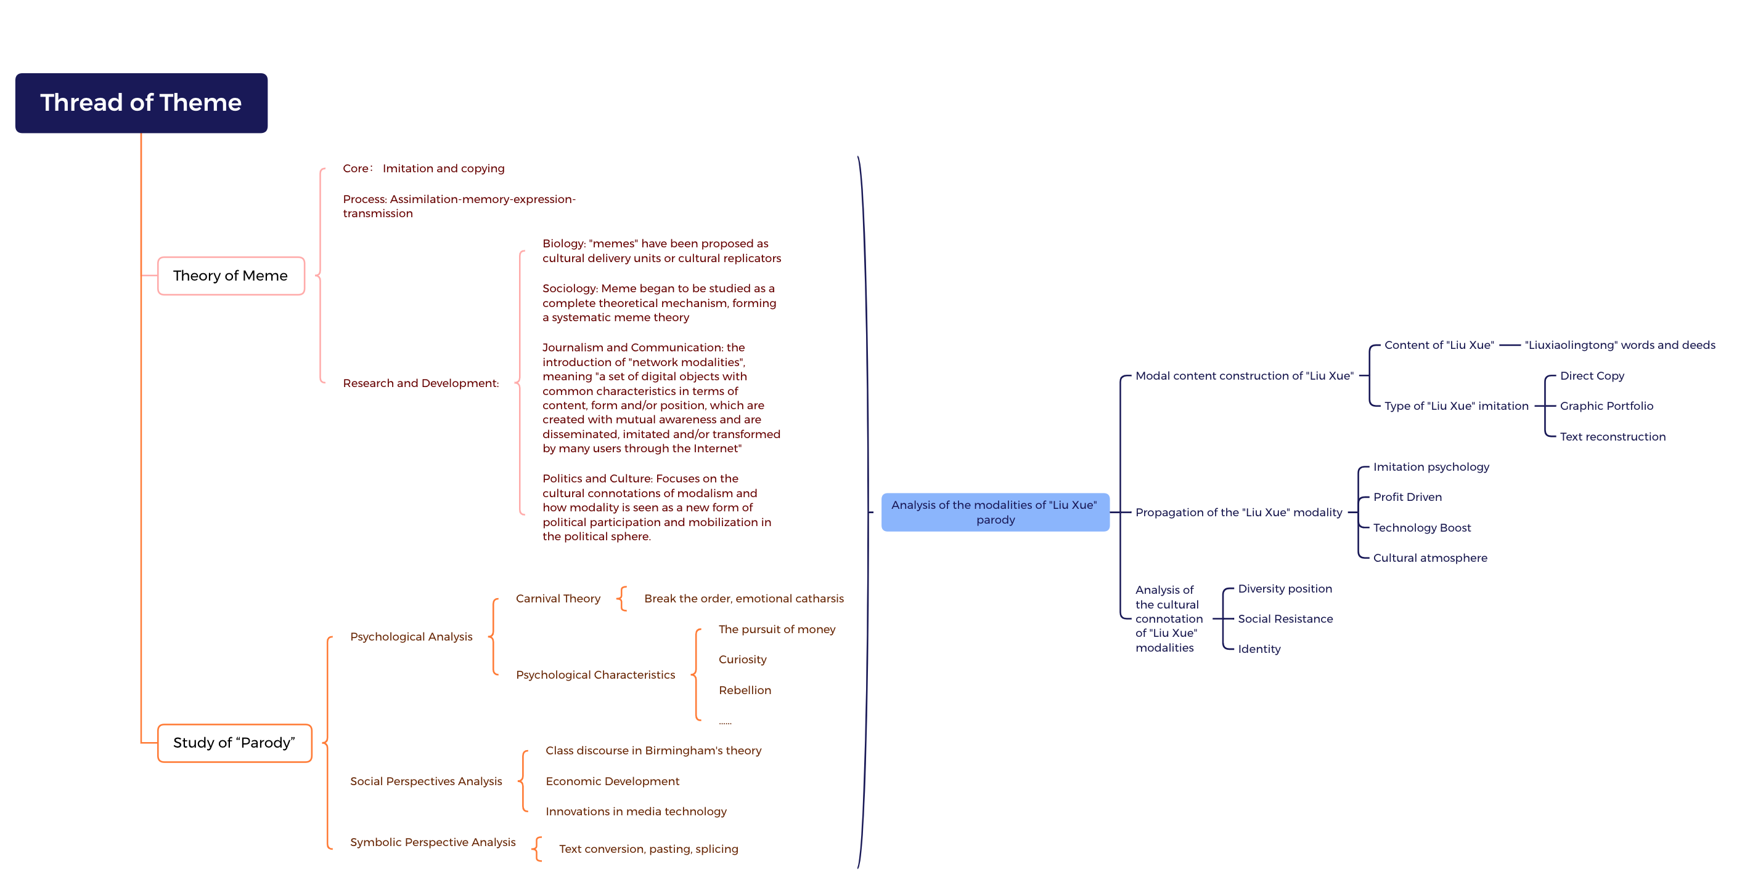
Figure 1 Analytical framework of the "Liu Xue" meme

1.4 Research Program
1.4.1. Research questions
In this study, we hope to investigate the phenomenon of "Liu Xue" online spoofing under the perspective of cultural research combined with modal theory, and we hope to investigate and answer the following three questions.
The first question is: What is the "Liu Xue" spoof? What are the contents and types included in the fermentation process of this phenomenon?
The second question is: What are the forms and dynamics of the dissemination of the "Liu Xue" of modus operandi?
The third question is: As a popular cultural phenomenon, what kind of cultural connotation does the spread of the "Liu Xue" demonstrate?
1.4.2. research methodology
Returning to Dawkins' original idea that "modalities are units of imitation," Shifman (2013) breaks down the analysis of modalities into three dimensions: content, form, and stance⁴⁷. The first dimension is primarily concerned with the "content" of a given text, referring to both the idea and the ideology it conveys. The second dimension has to do with "form": this is the physical embodiment of the message, perceived through our senses. It includes both the visual/auditory dimension specific to certain texts and the more complex genres/modalities that organize them (such as lip-synching or animation). Although the idea of modality and its expression has been widely discussed, a third dimension, related to "communication", is presented here for the first time and is labeled "stance" because of its relevance to the message that modalities convey about their own communication. stance). More specifically, Shifman (2013) extends Englebertson's (2007) definition by using "stance" to describe the way speakers position themselves between texts, the linguistic codes of texts, and speakers and other potential speakers. Like form and content, stance is an important dimension of modality analysis: when re-creating text, users can decide to mimic a particular position they find attractive or use a completely different discourse orientation.
This thesis will draw creatively on Shifman's approach to modality analysis, using textual analysis and in-depth interviews to concretize the content, form, and position dimensions of the "Liu Xue" modality.
(1) Text analysis method
As Alan Mckee says, textual analysis is a methodology of academic research to collect information and analyze it⁴⁸. In this study, we collected texts, emojis, and videos related to the "Liu Xue" event from December 2018 to the present by using "Liuxiaolingtong" and "Liu Xue" as the main keywords on social platforms such as posting, Weibo, and Tik Tok. This article uses the text, emoticons, and videos related to the "Liu Xue" incident from December 2018 to the present. This thesis adopts the three conditions for text selection mentioned by Alan McKee in Textual Analysis: A Beginner′s Guide: remaining texts, text types, and the public environment in which the texts are widely disseminated, to filter the collected texts related to "Liu Xue". Because of the long span of time and the large volume of texts, as shown in Tables 1 and 2, we selected the materials that were used more frequently (at least five times) among the texts that were not relevant to the research topic, and finally obtained the following textual discussions about the "Liu Xue" event We obtained 1000 articles, 700 emoticons and 355 videos. We also compared, analyzed, and synthesized them, and extracted the general types of imitation and replication in the "Liu Xue" events and the general characteristics of strong "Liu Xue" modalities, so as to understand the "Liu Xue" In this way, we can understand the characteristics and manifestations of the modal communication of "Liu Xue", which is conducive to better understanding the practical significance of the modal communication of spoof culture.
Table 1 Statistical graph of relevant data from December 2018 to date
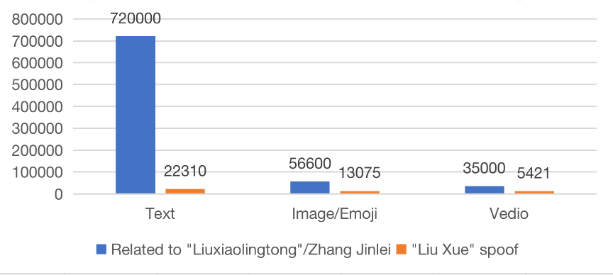

Table 2 High-frequency words in the "Liu Xue" spoof
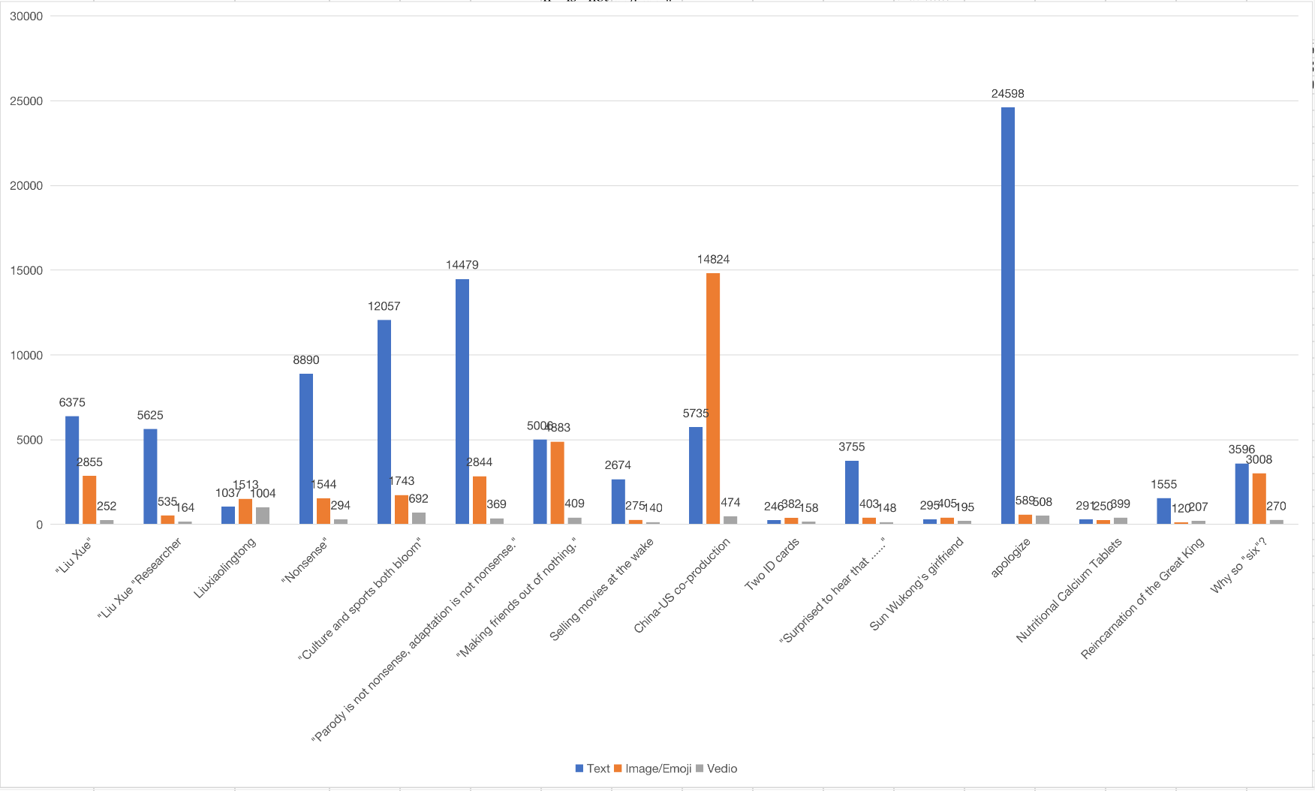
(2) In-depth interview method
It is difficult to fully understand the motives, values, opinions, perceptions, emotions, memories and other information of "Liu Xueers" by using simple questionnaires. Therefore, this study will use the in-depth interview method to select 22 "Liu Xue" participants (Table 1) from the perspectives of gender, age, education, degree of "Liu Xue" participation, and occupation, etc. The interview outline will be prepared, and a semi-structured interview method will be adopted to encourage their free responses to specific questions and in-depth interactions with them, which will be used to discover detailed explanations and speculations of the interviewees' positions on specific issues.
Table 3 Basic information of interviewers
No. | Name | Gender | Age | Education | Occupation | Length of participation（min） | Source path
1 | Wang | Male | 19 | HS | Student | 110 | Tieba
2 | Li | Male | 17 | HS | Student | 135 | Tieba
3 | Wang | Male | 28 | College | Student | 120 | Zhihu
4 | Yang | Female | 22 | College | Student | 100 | Tieba
5 | Li | Female | 35 | Bachelor | Programmer | 140 | Zhihu
6 | Liu | Male | 13 | Specialist | Student | 100 | Zhihu
7 | Yang | Male | 22 | Bachelor | Student | 130 | Zhihu
8 | Yu | Female | 24 | Bachelor | Unemployed | 100 | By Friend
9 | Wu | Male | 37 | Bachelor | Coach | 110 | Zhihu
10 | Wu | Male | 21 | Bachelor | Student | 120 | By Friend
11 | Zhao | Male | 32 | Master | Worker | 200 | Tieba
12 | Li | Female | 16 | MS | Student | 110 | Bilibili
13 | Li | Male | 14 | MS | Student | 130 | Tieba
14 | Chang | Male | 13 | MS | Student | 100 | By Friend
15 | Li | Female | 27 | HS | Worker | 100 | Tieba
16 | Wang | Male | 9 | PS | Student | 75 | Tieba
17 | Liu | Male | 15 | MS | Student | 110 | Bilibili
18 | Liu | Male | 16 | MS | Student | 120 | Weibo
19 | Zheng | Male | 19 | Bachelor | Student | 120 | Weibo
20 | Lv | Male | 21 | MS | Worker | 130 | Tieba
21 | Fan | Female | 24 | Bachelor | Free Worker | 180 | Douban
22 | Yang | Female | 19 | Bachelor | Student | 80 | Douban

2 The origin and development of "Liu Xue"
In the first half of 2019, the per capita weekly online time of China's Internet users was 27.9 hours, and among the massive data produced by users, spoofing is not uncommon, but not all spoofs can be promoted to a phenomenon or even become a viable culture, and "Liu Xue" is precisely a special case among them⁴⁹ (Zhang Wenyi & Mo Shaoqun, 2022).
As a special phenomenon of online spoofing, "Liu Xue" needs to be clearly defined before an in-depth study can be conducted on it. Second, what distinguishes "Liu Xue" from other spoofs is that it has a clear and long history of development. Therefore, in order to truly understand "Liu Xue", it is necessary to sort out the whole process of its formation and development. Again, the groups and platforms involved in "Liu Xue" are not to be ignored in the analysis.

2.1 The concept of "Liu Xue"
"Liu Xue" was firstly originated from the criticism of Liuxiaolingtong among the group of western travel enthusiasts, and these voices with the nature of "dissent" gradually accumulated and gathered more and more supporters, making its influence expanding, and it is in this process that the unique term "Liu Xue" emerged It is in this process that the term "Liu Xue" emerged and became widely accepted⁵⁰ (Tian, Miaoqi & Yu, Gui, 2020). The emergence of this term, which is parodied in serious literary studies such as "red studies," means that this cultural phenomenon can no longer be equated with criticism of someone, but exists as a form of spoof, but these criticisms of Liuxiaolingtong, which originate from fans of the Western travels, largely define "Liu Xue", because almost all of "Liu Xue" cultural production is based on these criticisms. is built on these criticisms. Netizens use these criticisms as raw material for secondary production and dissemination, making it a spoof phenomenon that has taken the Internet by storm.
Therefore, it can be said that the cultural core of "Liu Xue" is the Liuxiaolingtong itself, specifically the criticism of his words and actions, and the cultural outcomes are the contents produced and reproduced by the Liuxiaolingtong itself, including the emoji packs, online language, spoof videos and so on. However, the production of content alone is not enough to explain the reason for the "Liu Xue" fire. In terms of communication channels, these cultural achievements are made possible by the large-scale dissemination of the network media, which really brought them to the view of the online public. Both emoji packs and online sentences have the property of extremely strong social communication. In major social media, such as WeChat, Zhihu, Sina Weibo, etc., Internet users make multiple displays of attitudes and identities by using and spreading these cultural achievements⁵¹ (Sui Yan & Li Yan, 2020).
Fisk has divided the productivity of fans into three parts, which are symbols, statements, and texts⁵² (Fisk, 2008). Although "Liu Xue" is not a fan culture, the productivity of its participating subjects can be divided by borrowing this theory. The symbolic resources of "Liu Xue" are mainly the Liuxiaolingtong itself and his words and actions; statement productivity signifies symbolic meaning by producing "Liu Xue"-exclusive language, emojis and videos; and textual productivity is the many texts that are actually visible and can be disseminated, such as Liuxiaolingtong bodies, etc.
Summing up the above analysis, a relatively clear definition of "Liu Xue" can be made: "Liu Xue" is an online spoof culture formed by using Liuxiaolingtong and its words and deeds as materials, and a series of spoof cultural achievements such as language, pictures and videos produced by netizens are disseminated through social media.

2.2 The germination and development of "Liu Xue"
In this section, we search for information about the formative stage of "Liu Xue" on websites such as Zhihu, news materials, Baidu Post, and Bilibili (later referred to as "B Station"), and organize and analyze the information we find, mainly from the stages, time, events, and attitudes of netizens toward Liuxiaolingtong. This section is divided into several aspects.
Since this subsection focuses on the history of "Liu Xue" formation, the stages after "Liu Xue" became a pop culture phenomenon on the Internet are not discussed in this section. This study selects the event that first attracted the attention of Internet users and triggered subsequent criticism as the starting point, and divides this historical time period into several smaller periods to depict the overall formation and development process in detail.
2.2.1. Budding period: "Journey to the West" remake caused controversy
Time: 2007-2012
Event: In 2007, director Zhang Jizhong decided to remake "Journey to the West", but news spread that Liuxiaolingtong opposed to the remake and parody of "Journey to the West". In response, Zhang Jizhong had spoken directly to the media about his dissatisfaction, "I do not agree with some people's argument that "Journey to the West" cannot be remade, it is only you Liuxiaolingtong remake, words should not be said. The adaptation of "Journey to the West" is not the patent of a particular person, only allow you to shoot the relevant things, do not allow others to move, there is no such reason" ⁵³ (Tian Miaoqi & Yu Gui, 2020).
By around 2012, the criticism of Liuxiaolingtong and the collection of its critical materials had become different from the sporadic and scattered state at the beginning, but presented a certain small-scale state, and the number of people with knowledge about the matter gradually increased. Although the vast majority of the posts from that time could no longer be found online due to data maintenance at Baidu's posting bar, many of the participants still retained memories.
"...... My specific exposure to "Liu Xue" content was in the postings, I was in junior high school (shopping for postings), which is about 12 years as I mentioned before. At that time there was already a lot of such (critical) material, including in Tianya (forum) as well."
(Interview)
Impact: Liuxiaolingtong in this period can still be said to be a highly respected old artist in the minds of all people, loved by everyone for his portrayal of the classic Monkey King, but knowledge of him is limited to this. Although his remarks at this time had also caused some doubts, but such doubts were only limited to a small group of people among the Western travel enthusiasts, and with the development of time, such doubts would soon be forgotten and did not trigger widespread concern.
2.2.2. Enlightenment period: "virtue has been lost" is known
Time: 2012-2015
Event: In 2015, the movie "Shi Dang Dang Zhi Xiong Qi Tian Dong", in which Liuxiaolingtong acted, was broadcasted, but it was labeled as a "thunder drama" due to its low production standard and inconsistent plot, and was criticized by netizens on Zhihu and B website. In the same year, a question was asked on Zhihu: "What do you think about Liuxiaolingtong against the haphazard creation of "Journey to the West"?" And there were already a lot of voices criticizing Liuxiaolingtong as a person in the answer.
Impact: The difference in Liuxiaolingtong's image among different groups in this period is great, "Around 2014-2015, 'Liuxiaolingtong has a deficient virtue' is already a well-known thing in the circle of Westward Journey enthusiasts." As for the general public outside of the western travel enthusiasts, their attitude towards Liuxiaolingtong is not much different from before. The main reason is that Liuxiaolingtong himself is less exposed and few fans follow his daily activities. In 2014, someone in Baidu Know asked, "Mr. Liuxiaolingtong is so famous and plays the Monkey King so well, but why does he only have 500,000-odd Weibo followers?" At this stage, the voice of criticism of Liuxiaolingtong did not convert into a network spoof.
2.2.3. Formative period: "Spring Festival event" attracted attention
Time: 2016-2018
Event: 2016 is the Year of the Monkey in the Chinese lunar calendar. Before the start of CCTV's Spring Festival Gala, there were rumors on the internet that Liuxiaolingtong and Guo Fu Cheng would both appear in the Spring Festival Gala as "Qi Tian Da Sheng" and perform "Monkey Show" together, but the program was killed. "The company's main business is to provide a wide range of products and services to the public. The "Monkey King" on the Spring Festival Gala stage. For a while, "Liuxiaolingtong on the Spring Festival Gala" and "Liuxiaolingtong program was killed" has also become a popular topic on microblogging. Within a few days, the number of fans on Liuxiaolingtong's Sina Weibo account rose several times, and attention quickly increased.
On March 22, 2016, a netizen with the screen name NE Evil Spirit answered the question "How do you think Liuxiaolingtong's editorial "Journey to the West" has cut down the "dregs and superstitions" of the original? What did Liuxiaolingtong do to make people so upset?" In his answer, NE Evil Spirit used the word "superstition" to answer the question. In the answer, NE Evil Spirit listed 9 major criticisms against Liuxiaolingtong with detailed information collection. This answer was regarded as a classic "Liu Xue" by the participants of "Liu Xue" with its various informative materials and comprehensive analysis, and NE Evil Spirit was also dubbed as a "Liu Xue Researchers" and a "leader of the subject.
In the period after the Spring Festival, Liuxiaolingtong screened new followers through Weibo interaction. Many of those who questioned and criticized him were blackballed by him, even hurting some of the "gourmets" by mistake. Liuxiaolingtong has repeatedly "hung up" on Weibo to question his comments, and has turned off the Weibo comment function several times. In addition, Liuxiaolingtong hired a lawyer and used legal weapons to fight back against the online skeptics. A college student was pressured to put out a long apology on Weibo, but Liuxiaolingtong said he would not accept the apology and would take him to court. This series of moves also directly triggered the discontent of many netizens, and a wave of criticism of Liuxiaolingtong gradually accumulated, and most "Liu Xue" participants were exposed to "Liu Xue" in this period.
"The initial exposure to 'Liu Xue' was in July 2018, when I happened to see a reply about Liuxiaolingtong while brushing up on Zhihu."
(Interview)
"In the second half of 2018, it was another person on my public team who discovered "Liu Xue" and shared with me ...... some of the spreading momentum it had developed. I got the point of it and started creating it in public."
(Interview)
During this period, B Bilibiliecame the second largest "Liu Xue" position besides Zhihu. some UP owners of B station, such as Tong Tian Da Sheng Sun Wukong and Dare to ask where the film is, also released some "Liu Xue" videos with more than one million views, making the influence of "Liu Xue" further increased.
Impact: At this stage, due to the exposure of the "Spring Festival Gala Incident", the attention of Liuxiaolingtong was rapidly increased. It is also because of the increasing attention, coupled with the widespread spread of the answers on social media, the criticism that was previously only in a small circle gradually became public knowledge, and the attitude of most netizens also began to change at this stage, from the original respect and love for the old artist to dissatisfaction and criticism. The emergence of the word "Liu Xue" also marked the conversion of the original criticism into a kind of online spoof, and it was during this period that more and more spoof results appeared, which also laid the foundation for the creation of later spoof templates. For example, the phrase "the style of writing is two flowers", which was widely used and spread during the period when "Liu Xue" was popular, was created by a "Liu Xue" on Weibo, @LifetimeBowdown "Liu Xue" (now cancelled), who imitated Liuxiaolingtong's quotes during this period, not by Liuxiaolingtong himself. (See Figure 2)
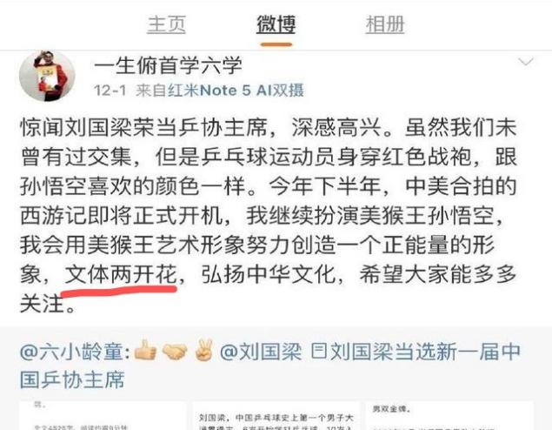
Figure 2: "Culture and sports both bloom"
2.2.4. peak period: "the incident of the former residence" has become an explosive point
Time: late 2018 - early 2019
Event: If the impact of "Liu Xue" was limited, the "former residence incident" on December 3, 2018 became the fuse that ignited the whole network⁵⁴.
Many netizens' accumulated discontent was completely ignited after this incident, and social media was flooded with questions and criticisms against Liuxiaolingtong, and there were even a lot of personal attacks. The "style of writing" style, which was imitated from the Liuxiaolingtong language, also spread virally in the social media with its strong applicability, wit and deconstruction.
Impact: The popularity of "Liu Xue" changed most people's perceptions of Liuxiaolingtong, and they joined in the "sensational" spoof camp, and Liuxiaolingtong himself was forced to respond in the media. At the same time, because of the large number of netizens, "Liu Xue" had abundant cultural productivity, and a large number of sentences and quotes were created and imitated, and expression packs and videos were forwarded in Sina Weibo and friends circle, and "Liu Xue" officially became popular on the Internet and became a popular online cultural phenomenon.
2.2.5 Summary
The formation and development of "Liu Xue" until its final explosion is not a simple accidental event on the Internet, but there is a certain historical inevitability behind it, and only by going deeper into the history can we better understand this cultural phenomenon and grasp its meaning and value.

2.3 Participating groups of "Liu Xue" and online platforms
A portrait of the online spoofing participant groups reveals that most of them are students or young groups with a medium level of education and lack of spending power⁵⁵ (Hu, 2022). For such groups, cultural and artistic forms that require a higher threshold obviously do not meet their appetite. Comparatively speaking, no high level of education or income is required to participate in or create spoofs, just a computer or cell phone with Internet access, and everyone can participate in spoofs. The spoof abandoned mainstream and authority, and flexibly used parody and collage to pursue entertainment and deconstruction, which is also in line with the cultural interests of this group, and therefore they are enthusiastic about it.
However, the examination of the "Liu Xue" participant group should also grasp its specificity, which is mainly reflected in the early days of "Liu Xue". By combing the history of "Liu Xue" formation, we can find that the birth of "Liu Xue" is inseparable from the group of westward travel enthusiasts in the network, and most of the early participants are also from this group, and what they have in common is their love for the original novel "Journey to the West" and westward travel culture. All along, the novel Journey to the West has a large number of fans. The advent of the Internet era has provided an excellent platform for Westward Journey fans to communicate and discuss. Whether it is Baidu posting bar or major forums, there are the figure of western travel enthusiasts. The topics they often discuss include not only the plot and ideological connotation of the original Journey to the West, but also various film and television works, literary works, game works and art works adapted from Journey to the West, etc. The CCTV version of Journey to the West and the Monkey King played by Liuxiaolingtong are also in the scope of their discussion. Most of the fans of Journey to the West on the Internet are "pan-West fans", not just fans of a certain TV series or a certain actor, so they are the first group to find out the problem and express their dissatisfaction with Liuxiaolingtong.
In 1986, the CCTV version of "Journey to the West" was officially aired during the Chinese New Year, and since then, it has been replayed by TV stations every winter and summer, with more than 3,000 reruns, making it the most replayed TV series in China. Most of the "Liu Xue" participants born after the 1980s will have the experience of watching the CCTV version of "Journey to the West" on TV during the summer and winter holidays, and the actor who played the role of Sun Wukong in the TV series, Liuxiaolingtong, was also loved by them and even became their childhood idol, in their hearts Liuxiaolingtong is the embodiment of Sun Wukong, symbolizing freedom, fearlessness and tenacity. After they grow up and become adults, their childhood worship becomes a fond memory, and the romantic myth is crushed by the ruthless reality, but Liuxiaolingtong as a symbol still occupies a place in their hearts, becoming the embodiment of their demands to resist all kinds of real problems, and to some extent shaping their emotional structure. That is why the "degradation" of Liuxiaolingtong is so unacceptable and outrageous to them.
"He was a very good actor and is a childhood memory that many people - including me - cannot erase."
(Interview)
"Liuxiaolingtong was always my childhood idol until I went and really got to know Liu Xue. I grew up brushing up on the 86th edition of Journey to the West every year, including the sequel to Journey to the West ...... (after learning about Liuxiaolingtong's dark material) after a sea change in my perception of my childhood idol, and a disgusted revulsion."
(Interview)
In addition, the term "Liu Xueman" is often used to refer to Liu Xue participants, but its use is controversial, and many "Liu Xue" participants do not consider themselves to be Liu Xuemen.
"I don't approve of the behavior of those 'Liu Xueers' on the Internet, I think they have a little bit of a blind streak."
"...... my Liu Xue attainment is still far from dare to call 'Liu Xue home', in my eyes can be called 'Liu Xue home' only ...... people who have made outstanding contributions to the development of Liu Xue ......"
(Interview)
Based on the differences in the perceptions of different participants, it is difficult to provide a strict and clear definition of "Liu Xue Researchers". For the sake of rigor, "Liu Xue Researchers" are not used in this study to refer to the group of "Liu Xue" participants.
As a kind of online spoof, the scope of Liu Xue participants, creators, western travel enthusiasts and other Internet users is different. As a kind of spoof culture derived from the community of Western travel enthusiasts, a large proportion of its early creators and participants were Western travel enthusiasts, and even though a large number of ordinary Internet users were influxed later because of the popularity of "Liu Xue", Western travel enthusiasts still relied on the production of quality content to occupy a certain position among the creators of "Liu Xue". In addition, the participants of "Liu Xue" include many other netizens who joined for various reasons. And obviously, the creators of "Liu Xue" spoof results are included in the scope of "Liu Xue" participants. Among these creators, it is actually still possible to subdivide them, such as general creators and creators who become opinion leaders. The superimposed combination of multiple layers constitutes the participant group of "Liu Xue". The basic relationships and composition of the participant groups of "Liu Xue" can thus be represented in Figure 3：
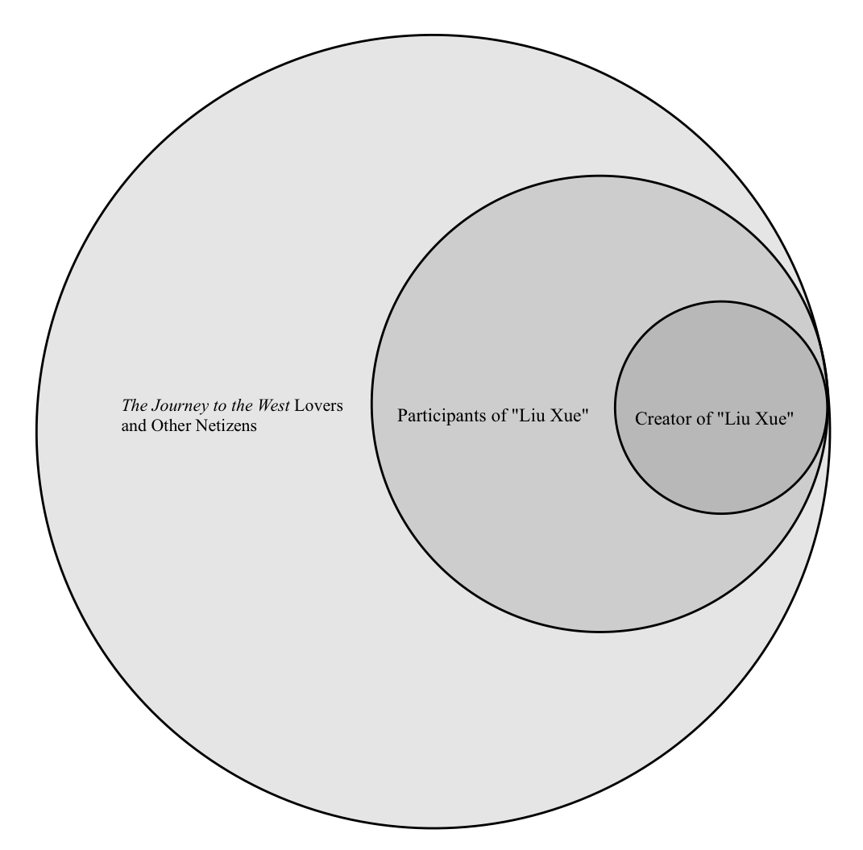
Figure 3: Composition of "Liu Xue" participant groups
The Internet has contributed to the rise of spoof culture and provided fertile soil for its growth. In the case of "Liu Xue", although its presence was almost all over the Chinese Internet during the boom period, "Liu Xue"s pioneering position or base has always been in B Station and Zhihu, which is inseparable from the characteristics of the two platforms, and the different platforms are fields where political, economic, cultural and other forces are integrated and intertwined⁵⁶ (Zhang, R., 2020). The first is Bilibili, which is currently the largest pop-up video website in China, and according to its Q4 2019 financial report, the average daily active users of Bilibili reached 37.9 million in Q4, with a total net revenue of over 2 billion⁵⁷. The content of Bilibili has been mainly focused on ACG culture from its inception to the present, with a predominantly young user base, so it can be said that it is inherently a sub-culture website. Within the content ecology of B, web spoofing has always existed in abundance, and is often used as one of the selling points to attract new users. Therefore, whether for the purpose of attracting traffic or creating an ecology on the site, the operators of B-site have been boosting spoof content on the site, such as the launch of the "Bilibili creative incentive program" and even a special "ghost animal" section for posting spoof videos. B site has thus become an excellent platform for the dissemination of "Liu Xue", and many "Liu Xue" participants have learned about "Liu Xue" after watching videos by the "B site "Liu Xue" double wall" uphosts "Dare to ask where the film is" and "The Great Sage Sun Wukong". "The second is Zhihu, which is one of China's most famous brands. The second is Zhihu, which is the most popular and active online Q&A community in China. Zhihu positions itself as a high-quality knowledge-sharing Q&A community, encouraging its own users to produce high-quality, in-depth answers and opening up attempts at knowledge socialization, forming a participatory cultural form that is shared, open, and decentralized⁵⁸ (Zeng Runxi & Wei Feng, 2016). The unique and friendly community atmosphere has enabled Zhihu to gather its own group of participants - "geeks", i.e., a group obsessed with a certain field, which includes the group of Westward Journey enthusiasts who created the "Liu Xue". The geeks in Zhihu are brave enough to pursue cultural power, dare to dismantle mainstream culture, and enjoy achieving self-identity in getting rid of mainstream cultural symbols, thus making Zhihu a promised land for the participating groups.

3 The Content Construction of "Liu Xue" Meme
In "Spoofing: Rebellion and Subversion", Zeng Yiguo points out that the current spoofing culture belongs to the popular text as Fisk said, which is a kind of "producer text". Unlike the "author's text" and "reader's text," the producer's text is a free and loose text, which requires the audience to participate in the text and has a closer relationship between the text, the public and social reality. At a time when social media are highly flourishing, countless new texts have multiplied and intertextual text chains have been formed among them. Therefore, no text is complete, and to study the text of prank culture, it needs to be examined in an open and fluid space, in the context of "intertextual relations" and modes of reception. In this chapter, we will explore the content of "Liu Xue" from its creation to its development to the modal phenomenon, as well as the types of parody presented as content, starting from the content of the images, texts, and videos that generate "Liu Xue".

3.1 The nature of "Liu Xue" meme
The current popular "Liu Xue" is a carrier of popular culture, which is actually transmitted by one individual in society and received by another⁵⁹ (Fengmei Ren, 2010). Generally speaking, the more popular cultural content is received by a larger group of people in the process of transmission, and when these already-received people continue to transmit it, some similar characteristics of this culture will appear, and this characteristic, perhaps a similar expression, is the so-called network modalities. The spread of the "Liu Xue" modal culture is actually nothing more than a group of people exporting culture, continuing to imitate and replicate it, and that is how the so-called "Liu Xue" became popular.
In the case of "Liu Xue", it was very easy for the participants to acquire the identity of participation. What they needed to do in order to replicate and transmit the "Liu Xue" modalities was simply to obtain the text of the "Liu Xue" on various platforms on the Internet, which could be pictures/emotional packs, videos, or simple text. After having some knowledge of these messages, they memorize them in their minds or save the texts and then act as transmitters to paste the content they want to transmit on different online platforms, which is the simplest act, and then a process of spreading "Liu Xue" modalities is completed. Of course, this process is not exactly the same, as each participant will inevitably bring their own character's emotion when spreading "Liu Xue", which is also necessary in the process of modality spreading, and is indispensable for the creation of new modalities. On the whole, any imitation process that seems to be achieved without any intentional effort needs to go through four stages: "identification - collection - expression - transmission"⁶⁰ (Hu, Bing & Zhang, 2022).
It seems that the ease of participating in the "Liu Xue" imitation process leads to mass participation, which is indeed one reason, but there is also a willingness to participate for the participants themselves, that is, their willingness to actively join the online carnival. Blackmore suggests that humans have a natural tendency to imitate⁶¹ (Blackmore, 1999). From birth, children begin a journey of imitation, modeling the words and actions of their parents and imitating the crawling of animals. And the process of human growth is also filled with a lot of imitation, such as imitating other people's dress to improve their dressing style, imitating professionals' paintings to improve their painting, and imitating successful people's speeches to improve their verbal skills ...... It can be said that imitation is ubiquitous in our real life. Therefore, the "Liu Xue" incident, which was initially triggered by a small group of people, has gradually been swollen as a topical event that has been hotly debated on the whole network, and imitation has never stopped. But unlike imitating what people wear, imitation in the "Liu Xue" incident involves other areas of life, such as participating in social discussions, gaining pleasure by spreading "Liu Xue", following others to discuss hot topics as if it is a fashion, etc. The other effects of this imitation will intensify the frequency and degree of imitation of the Liu Xue incident more quickly. Therefore, people are more willing and enthusiastic about participating in "Liu Xue" events and copying and spreading "Liu Xue" modalities, which is the reason why "Liu Xue" has been able to become an online cultural phenomenon for a period of time⁶² (Ruan Xiangyu, 2016).

3.2 Dissemination of contents of Liu Xue meme
There are three main vehicles for the results of "Liu Xue"s mediated text production: pictures (emoticons), verbal sentences, and videos. The content carried by these forms mainly revolves around Liuxiaolingtong's words and actions related to the famous film and television work "Journey to the West" in which he acted. The role of the Monkey King played by Liuxiaolingtong is a childhood memory for many people, and the work is regarded as a classic and is regularly broadcast on CCTV channels. Many netizens have asked about his attitude towards the adaptation of the work, and Liuxiaolingtong himself is strongly opposed to the adaptation of the work, but his own words and actions are inconsistent with the acceptance of some crude works and advertising staged, which has led to imitation and theatrical comments from netizens against his words and actions. In the video tribute to the death of the director of "Journey to the West", Yang Jie, the Liuxiaolingtong advertised his upcoming film in a joint venture with China and abroad, and was called "selling the film in the hearth" by netizens because of the embarrassing appearance of the food, and also imitated his phrases, modified and made up many paragraphs. The specific common format is "I was surprised to hear that... deeply happy... although... but... and the Monkey King's aura of righteousness is the same. The second half of this year, the Sino-US co-production of Journey to the West is about to officially start, I continue to play the Monkey King Sun Wukong, I will use the Monkey King artistic image to try to create a positive image, literature and sports, to promote Chinese culture, I hope you can pay more attention." Netizens summed up a set of discourse system about "Liu Xue", in which Liuxiaolingtong is called "six iron Chenglai", that is, Liuxiaolingtong + Wu Chengen + Zhang Jinlai, and these contents can be seen everywhere in various forms of imitation copy.

3.3 Types of imitations of "Liu Xue" meme
The generation of an online hot topic event requires a high level of replication of the modalities. In the process of transmission of tens of thousands of copies, the subjectivity possessed by the subject of communication must be considered which is why Donald Campbell proposed the phenomenon of competition for the survival of modalities. For each participant, the diverse and different knowledge backgrounds create preferences and therefore trade-offs in the transmission of modalities. Regardless of whether these behaviors are "replications" or not, they are simply similar expressions, not mechanical transmission⁶³ (He Ziran, 2021).
The variability of this preference can be analyzed in terms of the types of modal communication chosen, i.e., the participants adopt different types of content communication, which can be divided into three different forms of imitation. The most common type of fusion of multiple imitation types in the process of dissemination⁶⁴ (Gao, Wenmei, 2017).

3.3.1 Direct quotation: indiscriminate copying
In the reproduction and dissemination of online modalities, direct quotation is understood as "undifferentiated reproduction", that is, it is sent directly by copying and pasting without any other forms of deletion, deformation or enrichment⁶⁵ (Ge Houwei & Bejunhua, 2017). In the past perception, direct reproduction was used to increase the frequency of content use as well as to improve the efficiency of use, such as the printing process that we are most familiar with. Nowadays, along with the development of science and technology, direct reproduction has become a quick and easy behavior. In the case of the "Liu Xue" incident, the participants' direct quotation of the "Liu Xue" modalities is to browse the text content related to it and then disseminate it in its original form, or to directly copy and forward the content of others' communication. Take the picture of "Liu Xue" as an example, we can find many pictures of spoofed Liuxiaolingtong on the Internet, and the participants only need to save these pictures and send them out when needed, and this copying behavior is completed.
For example, in the "Liu Xue" of December 3, 2018, the "former residence incident" as an example, this event has triggered netizens to imitate the style of language from Liuxiaolingtong " two styles blooming" sentence style, "Forbidden City" incident, for example, triggered a viral spread in social media with its strong applicability, wit and deconstruction. According to Weibo and posting search statistics, for example, the frequency of using "literary and stylistic" was as high as 170 million times in 2018. The "literary and stylistic flower" is not unique, as more emoji images related to the Monkey King and Liuxiaolingtong himself are used in high frequency.
The direct quote parody type does not require a high level of participation, or any requirement at all, as long as the participant clicks on the event in question and what is being discussed, he can quickly become a part of it, simply by reposting a photo or repeating a phrase that someone else has said. In a way, it can be said that the largest number of participants are involved in the dissemination of modalities in this way. Those who are able to create new modal content are in the minority, but the new forms of content they create require such a large group of direct quotes to spread the modal to a wider audience, which is the basis for the popularity of the modal⁶⁶.

3.3.2 Transposition: the combination of pictures and texts out of context
In the process of dissemination and imitation of modalities, what can catch people the fastest is the combination of graphic texts, or more precisely the direct sensory stimulation of pictures. In the "Liu Xue" incident, the most widely circulated is the character of Liuxiaolingtong paired with what he said, or people combine his image with other scenes to form a strong contrast effect, and the effect brought by this effect is more capable of stimulating people's senses than a sentence or a catchy or complex meaning. In "Emoji Stories", Jiang Lan talks about how the face is crucial to a person. If we compare a person to a container, the face comes first because we can touch the character most directly from the character's face, especially the character's emotion.
This could also explain why emojis could become popular in a very short period of time and remain unchanged to this day. This kind of information conveyed without excessive understanding allows people to receive the main points in a short time, whether it is serious or flirtatious or relaxed and other kinds of meanings are easily transmitted and easily received, it is in the face of the state that words cannot be presented, a more varied form of fable in the picture, to resolve this kind of unspeakable scene. That's why we feel "one picture for all" in many moments.
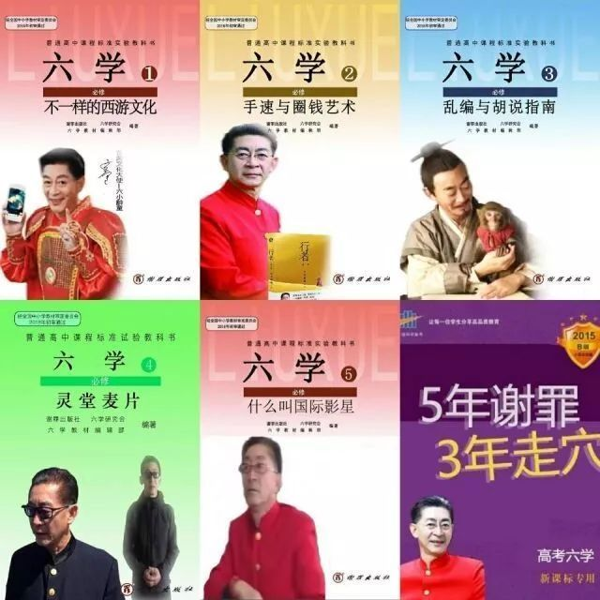

Figure 4: "Liu Xue" spoof pictures
Figure 4 combines the common style of high school textbook covers with the image of Liuxiaolingtong to create a "textbook cover" of "Liu Xue". The text on the cover is a parody of the textbook's phrases that summarize the many "black points" of Liuxiaolingtong, such as being rich, arrogant, etc., and is accompanied by a picture of Liuxiaolingtong related to this black point.
The parody form understands the direct impact of pictures/expressions, so it combines them in different expression scenarios on the basis of the text, forming a new content that is both familiar and refreshing in an easy way, which often has a strong contrast or contrast effect, and therefore has more emotional and value penetration⁶⁷ (Wu, H. & Wang, L., 2010). The positive impressions represented by textbooks or teaching aids are dissolved in such a parody mode in an ironic way, and the positive image created in the past with the image of Liuxiaolingtong is also subverted in this process. The images also represent, to some extent, the similar upbringing of some of the "Liu Xue" participants.
Shifman (Shifman, L, 2014) used research to demonstrate that although people can "indiscriminately transmit" the same humor by copying and forwarding, people like to create their own modalities. While responding to pop culture with copycat parodies, netizens are also enthusiastically expressing themselves⁶⁸.

3.3.3 Collage reorganization: the dismemberment and reconstruction of the text
The reorganization form is based on the continuous development of modern technology, especially the PS technology, which allows participants to smoothly perform a variety of strange and brainy needs, piecing together various forms of elements to achieve a complete deconstruction of the raw material and make it into a new textual content. The similarity between this genre and that of the transference genre lies in the fact that both are pastiches of different materials, while the latter is more thorough and requires more creativity than the former⁶⁹ (He, 2017).
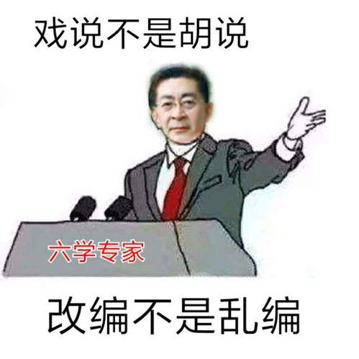
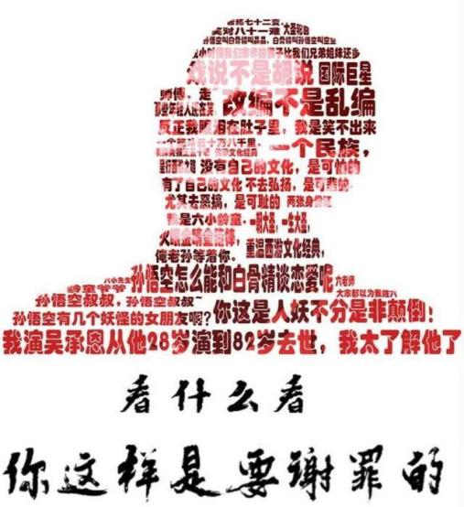
For example, "Parody is not nonsense, adaptation is not nonsense." This is a phrase often repeated by Liuxiaolingtong on many public occasions to express his dissatisfaction with and criticism of certain film and television adaptations of famous novels. Through various combinations of characters and words, netizens conveyed their mockery of Liuxiaolingtong's own words and characters. (As in Figure 5)
Figure 5 "Parody is not nonsense" Figure 6: "Liu Xue" spoof pictures
Figure 6 combines the controversial remarks of Liuxiaolingtong and his personal image through image processing techniques, forming a visual effect as if the words were composed into a figurehead, presenting a distorted image of Liuxiaolingtong in an exaggerated and unnatural aesthetic style. The images dismember and reorganize the remarks expressed by Liuxiaolingtong on different occasions out of their specific contexts, creating a comic effect as a way to express his dissatisfaction and banter with himself.
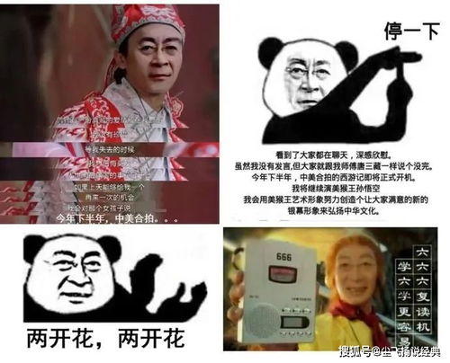
In the parody mode of collage reorganization, any element of the expression, image or emoji is like a machine part, which can be extracted and combined at will. One of the most common is to implant the character's face into other expressions with rough lines, creating a mismatched weirdness as a way to express more emotions.

Figure 7: "Liu Xue" spoof pictures
These expressions are implanted into different bodies or scenes; in Figure 7, the heads of Liuxiaolingtong are spliced into familiar movie scenes as well as simple emoji avatars, and become representatives of other images through PS technology, so that the splicing effect dilutes the serious atmosphere of the original pictures or films, and turns them into witty playgrounds instead. For netizens, the tiger head-swapping technique destroys the original relationship of the image, but satisfies the inner need for deconstruction and spoofing⁷⁰ (Yang Man, 2017).
Taking images/expression packs as an example, the compositions that are emphasized in the process of collage and reconstruction are the following categories: (1) the tension of the character's facial emotions; (2) body language; (3) scenes that are closely integrated with the character; and (4) text related to the character. These four components are used as criteria for selecting material when reconstructing material, as well as being the key combination points for conducting reconstruction. The so-called tension of facial expressions, that is, the character's face emotions cannot be too bland, need to show a certain sense of dramatic exaggeration, such as the impressive smile of Yao Ming, the surprised face of Erkang, to the expression of the glare of the Liuxiaolingtong in the "Liu Xue" incident, the expression of showing teeth, etc. The necessity of the tension of such expressions is that when placed in other scenes, it also allows people to grasp the emotional characteristics of the character at a glance, and at the same time easier and The tension of such expressions is necessary because they can be placed in other scenes to capture the emotional characteristics of the characters at a glance, and at the same time, they are easier to form conflicts or contrasts with the scenes, which can convey the emotions better, and the intention of the communicator is also better understood. It is worth noting that after the material is deconstructed, the emotions of the characters in the original material will also be interpreted and applied differently in the new scenes, for example, the expression of surprise or joyful smile of the Liuxiaolingtong will be interpreted as a greedy smile or self-ironic surprise after being put into some scenes.
In addition to the need for tension in the characters' emotions, the scenes in which the characters are placed are also a valued part of the reconstruction process. For example, the combination of the image of Liuxiaolingtong and the textbook, together with the anti-educational words he said, immediately brings out the whole content full of playful mockery vividly. Although the new content still bears traces of the original material, it is also a good way to achieve the effect of both integration and conflict with the new content.
On the whole, the patchwork is the source of innovation that allows the modalities to continue to spread, both as an expression of the will of the participants and as a continuum of communication, but this continuous innovation requires a large number of directly copied groups as a basis for a phenomenon, such as "Liu Xue", to expand its power and form a spectacular online phenomenon.

4 Analysis of the spread of "Liu Xue" modalities
Hundreds of contents are scattered in the Internet space, and in the process of imitating each other in a strong way, countless new derivatives may be generated every moment. The intertwined replication paths are dazzling, but there are actually rules behind the seemingly trivial and chaotic. The content of this chapter explores the forms of communication that can be adopted in the process of imitative replication of "Liu Xue" content and the driving forces to achieve this modal communication.

4.1 Forms of dissemination of "Liu Xue" modalities
There are three main vehicles for the production of mediated texts of "Liu Xue": pictures (emoticons), verbal sentences, and videos. However, these three communication carriers are not isolated from each other, but interspersed and intergraded, and there is an extremely rich intertextual relationship among the three forms, for example, the videos and expression packs of "Liu Xue" will have a large number of "Liu Xue" sentences applied within them, and many of "Liu Xue" expression packs are also intercepted fragments of videos of "Liu Xue". At the same time, in addition to the intertextual relationship between the three forms/vectors, there is also an intertextual quality within each form.

4.1.1 Pictures (Emojis)
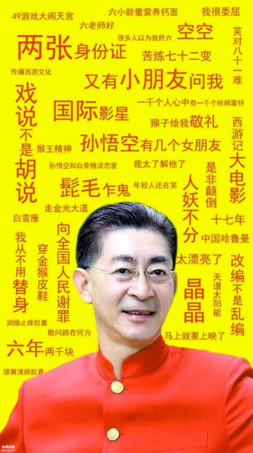
The spoof pictures or expression packs of "Liu Xue" are mainly made with Liuxiaolingtong as the prototype, produced not only by combining the image of Liuxiaolingtong with other pictures through collages and other means, but also by directly intercepting exaggerated and unnatural pictures of Liuxiaolingtong to create a witty and ironic effect, deconstructing the positive image of Liuxiaolingtong that has been constructed in mainstream communication channels⁷¹ (Lin Xiaomu, 2019). In addition, the linguistic syntax of "Liu Xue" is also widely used in it. Some typical spoof images are selected below for specific analysis.
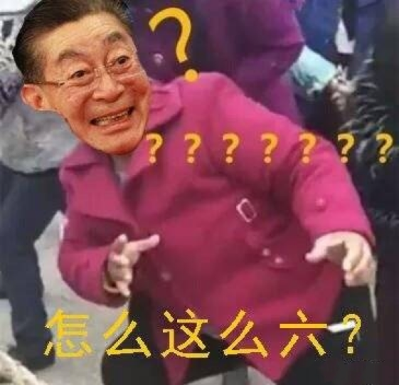
Figure 8: "Liu Xue" spoof pictures. Figure 9: "Liu Xue" spoof pictures
Figure 8 and Figure 9 combines the controversial remarks of Liuxiaolingtong and his personal image through image processing techniques, forming a visual effect as if the head of a person is composed of words, showing a distorted image of Liuxiaolingtong with an exaggerated and unnatural aesthetic style. The images dismember and reorganize Liuxiaolingtong's statements expressed on different occasions out of their specific contexts, creating a comical effect that expresses ridicule and disdain for him and his statements.
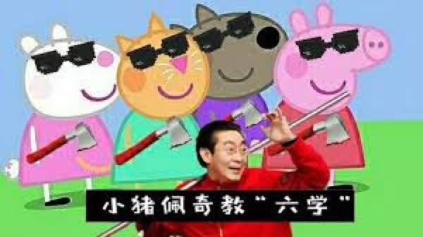
Figure 10: "Liu Xue" spoof pictures
Figure 10 combines the familiar cartoon character image of "Peppa Pig" with the image of Liuxiaolingtong to create a satirical image of Peppa Pig teaching "Liu Xue". The image is originally cute and childish, and is modified to look strange with sunglasses on the eyes. Behind this combination, which seems to be humorous and amusing, it conveys people's dissatisfaction and mockery of "Liuxiaolingtong" and the "Liu Xue".

4.1.2 Linguistic sentences
"Liu Xue" linguistic sentences are also an important part of "Liu Xue", and they are mainly derived from various public statements made by Liuxiaolingtong, including lectures, interviews, meetings, and social media. The way "Liu Xue" participants use "Liu Xue" linguistic sentences is not only to imitate and apply Liuxiaolingtong's speech, but also to produce creations based on it. The linguistic sentences of "Liu Xue" thus formed are mainly divided into two categories, one is sentence templates and the other is idiomatic vocabulary.
"Liu Xue" linguistic syntax is a kind of anti-language, which is used in Key Concepts: A Dictionary of Communication and Cultural Studies to describe language that expresses the opposite of the dominant linguistic order, more or less intentionally created and maintained⁷² (Fiske, 2004), and which expresses various situations of resistance in the linguistic field⁷³ (Tang, 2020).
(1) Sentence templates
The most popular and most used sentence template in "Liu Xue" is the following one.
"...... Speaking of ......, later this year, the Sino-US co-production of Journey to the West will officially start soon, I will continue to play the Monkey King Sun Wukong, I will use the artistic image of the Monkey King to try to create a positive image, literature and sports two Blossom, to promote Chinese culture, I hope you can pay more attention."
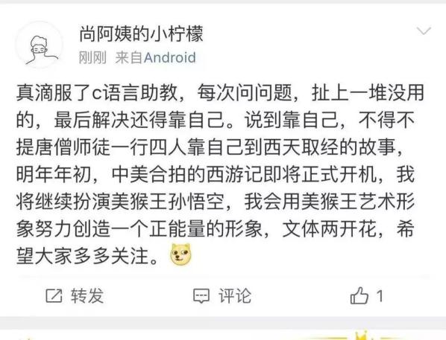
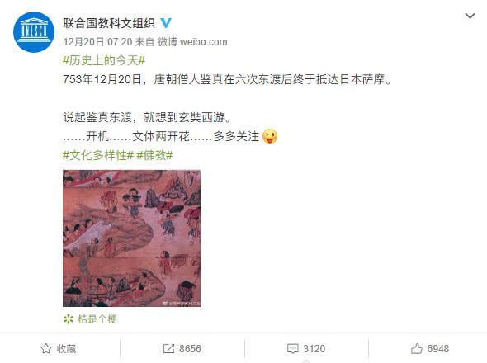
This is a parody of the last words in the video tribute to director Yang Jie, which was sarcastically described by many netizens as "selling a film in a funeral hall". This template has been used by netizens in almost all kinds of scenarios, starting with a statement about something unrelated, and continuing with the rest of the template in the middle by grabbing a relevant point and turning it around by "talking about" (see Figure 11). In addition, this template has been widely disseminated, and many variations and abbreviated versions have appeared. (See Figure 12)
Figure 11: Netizen's sentence template application Figure 12: "Liu Xue" sentence
In addition to this, there are some more used sentence templates that are mainly direct parodies of the original words of the Liuxiaolingtong, and in the case of the "Liu Xue" participants, mostly ironic in their use, such as.
"Parody is not nonsense, adaptation is not nonsense."
This is a phrase often repeated by Liuxiaolingtong on many public occasions to express his dissatisfaction and criticism of certain film and television adaptations of famous books.
"Surprised to hear that ......"
This is also a template with high applicability, from Liuxiaolingtong's Weibo. Liuxiaolingtong's tweets are often published in tribute to the death of celebrities, mostly starting with the word "shocking", which has been criticized by some netizens as "rubbing it in".
"I can't laugh when you are funny, I have tears in my stomach."
This is the pain that Liuxiaolingtong expressed in some lectures about spoofing and adapting famous works.
(2) Idiom Vocabulary
The connection with "Liu Xue" is established mainly by swapping words or words in idioms, e.g.
"Against Law"(The law and his last name sound the same)
Refers to the violation of the will of the Liuxiaolingtong (i.e., Zhang Jinlei).
"Nonsense" refers both to the "Liu Xue" participant's ability to use the "Liu Xue" verbal syntax proficiently and also ironically to the Liuxiaolingtong's often credulousness. ((The word is associated with his last name and first name)
"Making friends out of nothing."
This refers to the fact that when Liuxiaolingtong participates in programs and gives lectures, he often says that there are children outside asking himself such-and-such questions, which is also a satire of Liuxiaolingtong's frequent big talk.

4.1.3 Video
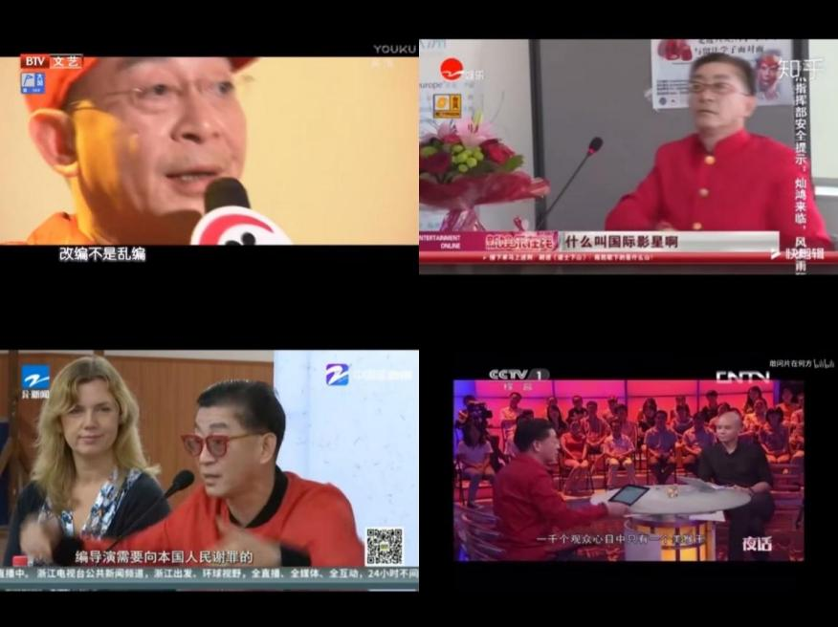
In the current new media environment, video communication occupies an important position with the advantages of multiple media such as pictures, text and sound. For the media text of "Liu Xue", the vehicle of video cannot be ignored. Likewise, the video of "Liu Xue", like its pictures and verbal sentences, is made on the model of Liuxiaolingtong and its words and actions. There are numerous videos of "Liu Xue", and in general they can be simply divided into two categories: the organization of quotations and the creation of themes.
Figure 13: Screenshot of "Liu Xue" video in the category of quotation collation
The video shown in Figure 13 clips together many of Liuxiaolingtong's statements and synthesizes them into a video of so-called quotations. There are many similar videos in "Liu Xue" videos. Although these videos only edit the original video footage and do not create secondary processing, they actually express criticism of Liuxiaolingtong behind the seemingly neutral attitude. And this critical attitude is mainly achieved by selecting material that can cause controversy, combining remarks repeated on different occasions, etc. This unadorned way of presentation can also obtain the maximum degree of conviction and approval from most netizens.
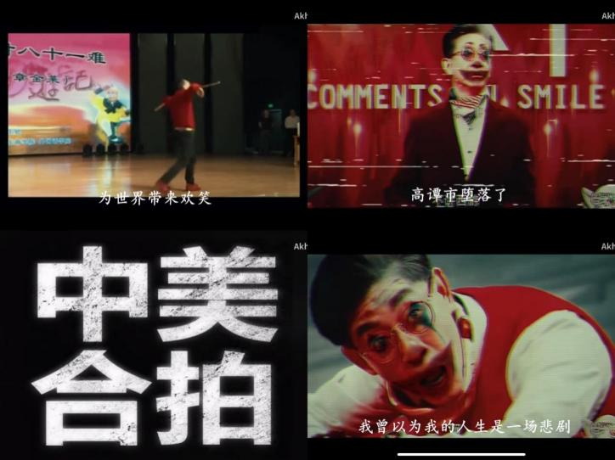

Figure 14: Screenshot of the theme creation class "Liu Xue" video
Figure 14 shows another type of "Liu Xue" video, which is more complex and richer in production techniques, and is created by secondary processing based on the original video material, such as the "ghost animal" video on the Beeping Beeping website. Figure 8 is the Liuxiaolingtong of some video footage and the 2019 film "Joker" trailer clips together. The movie "Joker" tells the story of how the protagonist Arthur turns from a sociopathic comedian to a criminal clown, while this video uses Liuxiaolingtong as the main character of the movie through the clip to express the attitude towards Liuxiaolingtong from an intertextual perspective.
To sum up, three kinds of intertextual texts, pictures (emojis), verbal sentences and videos, together form "Liu Xue", and they mainly convey the attitudes of creators and users through parody, collage and isomorphism styles. As the production of intertextual texts, they share three main characteristics: first, the subversion of the original text, such as the exaggeration and scandalization of Liuxiaolingtong images, specific words and actions; second, the construction of new meanings, such as the creation of new symbolic images of Liuxiaolingtong through secondary creation; third, the barriers to understanding in intertextual relationships, such as the lack of specific knowledge may not be able to understand some "Liu Xue" texts. It is worth noting that some of the "Liu Xue" texts have no bottom line in scandalizing and attacking Liuxiaolingtong in order to express the strong attitude of the creators, such as photoshopping the image of Liuxiaolingtong in a highly sexually suggestive picture.

4.2 The generation logic of "Liu Xue" meme

4.2.1 Communication host: imitation of the communicator
The essence of the modality is imitation, and the subject of imitation is also called the propagation host. The identity of the host is echoed with the characteristics of the modality, the so-called host, that is, the place where the modality lives, or the subject on which the modality relies. Without the host as a subject, there would be no modality, and no process of propagation of the modality. If we take the analogy with the process of biological evolution, the replication of the host for the modalities is equivalent to the process of biological self-reproduction, i.e., the evolution of different modalities by being selected in the pool of modalities, which is what Shifman calls mimicry⁷⁴ (Nissenbaum, A. & Shifman, L., 2015). At this level, it can be said that the continued development of modalities is facilitated by the selection and transmission of modalities by the host. And this participatory process requires propagation spontaneity on the part of the host. And this has been demonstrated by psychological as well as sociological studies.
As early as the nineteenth century, French scholars spoke of an intrinsic impulse for imitation that is rooted in human biology. In the evolutionary process of human beings, it was also imitation that achieved the continuous leap in human survival, as well as the phenomenon that imitation is even inevitable in group⁷⁵ (Cao Jin & Jin Yan, 2016). Blackmore has also suggested that humans are good at imitation⁷⁶ (Blackmore, 1999). And this characteristic has been confirmed in many social behavior experiments or psychological experiments, such as the experiment on face rubbing once set up by Professor Shattram. When he arranged two groups of test subjects, one group would start rubbing their faces and repeat the behavior repeatedly, and the other group would also start rubbing their faces. Although not all of the testers did the behavior at the same time, all of the testers in the other group did the behavior at different times. This experiment largely confirms that imitation is a spontaneous behavior possessed by human beings. And when analyzing the ancient human period from a sociological perspective, it will be found that imitation behavior is very common, and the reason for this is that people imitated as a way of communication instead of language during the period when language was not fully developed or formed⁷⁷ (Li, Jie & He, Naturally, 2014). It has been shown through research that imitation has other functions for humans.
First of all, imitation enables the communication and exchange of human emotions. People can perceive other people's emotions more clearly through imitating behaviors. A Dutch scholar has done an experiment on this. The experiment was conducted by selecting two groups of experimenters and having them watch a group of people perform behaviors that had a clear emotional orientation, such as positive or pessimistic emotions. One group was then asked to recreate the watched behavior as closely as possible to achieve accurate imitation, while the other group was not asked to imitate the behavior, preferably not to imitate it at all. The two groups were then asked to communicate with the performers of the behavior, and it was found that the experimenters who had performed the mimicry behavior were more able to achieve an emotional connection and better communication with the performers of the behavior, compared to the experimenters who did not perform the mimicry behavior. It is clear that imitation increases the imitators' recognition and understanding of emotions. For example, if a group of people go to see a movie, some people will be moved by the same storyline, while others will find it bland. This is reflected in the network modality, which means that participants can get close to a group through the process of imitation and replication, or when the text content produced by a group resonates with the emotions of others, it is easier to extend this behavior and further expand the spread. And through this act of imitation, participants are also more likely to find group identity and realize the emotional connection with people who have the same type of thoughts as themselves.
Second, imitation can achieve interpersonal intimacy. This point is derived from the emotional empathy talked about in the previous point to the level of social connection. The scholar Tarde argues that imitation behavior has a greater positive impact in promoting social bonding as well as development, especially in dealing with some major difference issues where imitation can act as a moderator, such as class differences⁷⁸ (Gabriel De Tarde., 2013). People tend to develop a sense of familiarity with people who behave similarly to themselves in their Nissan lives. For example, "Liu Xue" participants use "Liu Xue" linguistic sentences in a way that, in addition to imitating and applying the rhetoric of Liuxiaolingtong, they also produce creations based on it, formed by the linguistic sentences of "Liu Xue".

4.2.2 Communication environment: driven by economic interests
In the information age, the most effective product in economic development is no longer the tangible goods, but the intangible commercial value. A more accurate description would be that a commodity/personality has popularity. The most typical and familiar is the value of a celebrity. For example, if a celebrity who is a household name endorses a product, there will be a significant increase in the sales of the product. When people buy the product, they are not only considering the value of the product itself, but also the value of the public figure behind the product, which adds value to the product. The same is true for the modal effect. If an event is related to a celebrity, i.e., a well-known figure in society, the effect of the event is far more effective than if the same thing happened to an ordinary person. This type of economic phenomenon is also known as the "attention economy" by the famous scholar Michael H. Goldhaber⁷⁹. Attention in this case is attention. Placed in the modal discussion, with the flourishing of various online platforms, the attention of the public to information is not only the effectiveness of the event itself, but also the great influence of the communication brought by the person with a certain degree of attention.
In 2016, rumors about Liuxiaolingtong performing at CCTV's Spring Festival Gala made "Liuxiaolingtong on Spring Festival Gala" and "Liuxiaolingtong program killed" a popular topic on Weibo. Within a few days, the number of followers of Liuxiaolingtong's Sina Weibo account increased several times, and the number of followers also increased quickly.
This typical modal text fully illustrates two issues: first, huge attention will bring about imitation practices of considerable scale; second, imitations are easy to gain attention because of their similarity to the one that successfully exploded⁸⁰ (Zhang Xiaoping & Song Bingxiu, 2015).
For the ordinary online masses, they do not have significant influence effectiveness in the process of participating in the spread and development of the modalities. Compared to the celebrity effect and the marketing methods of professional corporate teams, the numerical advantage they have by then and the large number of innovative and approachable ideas enable them to form a scale of attention more quickly and powerfully, which is the economic effectiveness that belongs to this group This is the economic effect of this group. Therefore, what is more important for modal content is the modal effect of the participants in the process of its generation.

4.2.3 Dissemination: Boosted by Replication Technology
Dawkins suggests that three conditions need to be met for modalities to successfully achieve widespread dissemination: longevity, prolificness, and replication accuracy. Web technologies can largely satisfy these conditions and enhance their effectiveness. First, for longevity, Internet technologies can easily achieve long-term preservation of data content, especially when storage space is constantly growing. And for prolificness, the efficient and fast Internet context allows the same content to be distributed tens of thousands of times in a short period of time, and of course for different content as well. The era of reproduction has also gradually moved from the previous manual reproduction to camera reproduction and then to today's ever-improving image reproduction technology such as PS (Photoshop for short), making the process of image generation and reproduction more streamlined while also completing the situation of leaps and bounds in reproduction quality.
Of course, at the beginning of the camera era, the constant change of technology also required people to master this technology more professionally, and they had to learn a certain amount of expertise to acquire this image production ability. At the same time, the equipment for image production required a considerable amount of money, which also limited the access of some people who did not have access to these technologies (Shifman, L., 2013). Today, image processing has gradually become more accessible to the general population, the difficulty of mastering this technology has been reduced, and the equipment used to produce it is becoming more accessible to the general public. And the continuous upgrading of image processing technology has made people not satisfied with simple image reproduction, but started to perform more complex operations on images, such as cutting, jigsaw, keying and retouching, which provide strong technical support for the development of modal elements. Especially, these techniques are indispensable in some graphic reconstruction and the production of expression packs.
As professional software such as PS still needs to be operated by professionals after learning, a number of simple image processing software has started to flood the software market and enter people's daily life, these "rookie-level" software has greatly promoted the popularization of image processing, and is also the mainstay of the process of modelling. These "rookie" software programs have greatly contributed to the popularization of image processing and are the mainstay of the modal communication process.
In addition to the above-mentioned tools, which directly promote the innovation of communication texts, the diversity of communication platforms is also one of the important boosts of the Internet technology. Most of the information about the "Liu Xue" incident collected in this paper comes from the social platforms Weibo, Baidu Post, Zhihu, and b-site. These platforms involve video, textual discussion, and a combination of text and video. In addition to these major platforms, many new but extremely vigorous social video software have emerged, such as Tik Tok and QuickTime, which have become very popular in recent years⁸¹ (Xia, Deyuan & Wang, 2021). By constantly keeping up with the ease of content creation and dissemination, these softwares provide great technical support for Internet users to participate in various online events with one click.

4.2.4 Communication Culture: The Impact of Participatory Culture
The development of information networks is gradually blurring the boundaries of various types of culture, while creating more new types of culture and constantly tapping and broadening the diversity of groups involved in culture. It is in this scenario that the masses are also more likely to integrate themselves into a certain type of cultural phenomenon and become part of it after the difficulty of participating in events is reduced⁸² (Yang Man, 2017). This low difficulty of cultural participation also fuels people's enthusiasm for participation to a little extent. Henry Jenkins has suggested that cultural interaction flourishes during periods of media abundance, and has proposed a "participatory culture" to explain this phenomenon⁸³ (Jenkins, H., 2013). Barry Wildman has also proposed a similar idea, namely "cyber-individualism," in which the cultural participation identity of individuals becomes more prominent in the Internet era⁸⁴ (Ling, Y., 2019).
In this participatory cultural climate, on the one hand, the manifestation of individual identity needs to be accomplished through networked vocalization, so people go into the network to achieve self-identity; on the other hand, networked individualism is not in conflict with groupness; on the contrary, in this era, people's individualism is often acquired by going towards groupness, and people look for the interaction and closeness with others to orientation of the self. In the case of "Liu Xue", an analysis of the groups involved reveals that most of the people involved in this event were not fans of the Western tour, nor were they loathers or supporters of the Liuxiaolingtong itself, but more of them were not originally familiar with the event and had no emotional bias about the main characters, but the point that motivated them to participate was that the participation itself made them become and move towards a group, and in In this group, they are able to identify themselves more and gradually perceive themselves. One of the oddities we can often see is that many young Internet users like to boast of their uniqueness, but this mark has also become a label for a category of people in the Internet age, as in not being unique, and this can be seen as a cultural influence of the Internet individualism they will be subjected to in the Internet age.

5 Postmodernist cultural significance of "Liu Xue" modalities
According to the "50th Statistical Report on the Development of the Internet in China" released by the China Internet Information Center on August 31, 2022, as of June 2022, the size of China's Internet users was 1.051 billion, and the Internet penetration rate reached 74.4%⁸⁵ (2022). China's Internet users are mainly teenagers, young people and middle-aged groups, and (the highest percentage of Internet users in the age group of 20-29 years old, amounting to 27.9%. According to statistics, the average weekly Internet access time of our Internet users is 29.5 hours, which means that, in terms of general trend, teenage audiences spend an average of more than 4 hours a day using desktop computers, laptops, tablet PCs and cell phones to "surf" the Internet. Based on their media usage, teenage audiences also share similar interests and hobbies. The teenage audience clearly shows the eagerness to follow the trendy culture. "In the traditional media era, adolescents used newspapers, radio, television, art, and other platforms to create online cultural circles and to confirm their identities; in the new media era, adolescents are using digital technology and symbols to create new cultural forms"⁸⁶ (Cao Yue, 2019).
This new form of online culture, in the form of images and audio, meets the cultural needs of the public, especially the young people, in terms of intuition, entertainment and vulgarity, and therefore has rapidly occupied the market of cultural communication and become the main form of cultural communication nowadays. If we borrow Bakhtin's carnival theory to look at online culture, it is easy to see that people are reveling in the open online space like a medieval carnival, dissolving the boundaries between the center and the periphery, making authority seem less important and allowing grassroots and people to gain unprecedented freedom of expression. Based on the current social reality in China, this chapter explores the pluralistic stance of participants and the cultural practices of resistance from a cultural perspective.

5.1 Diverse positions of "Liu Xue" modalities
5.1.1 Cultural identity
Cultural identity is the process of integrating an individual into a group culture, where the individual and the group share a code of thought and behavior, or share certain values⁸⁷ (Tao Dongfeng, 2004). In the process of cultural identity, people do not mechanically and simply accept the heritage of tradition or history, but actively create and change the culture itself. Cultural identity is a shared attitude of individuals, groups, and even nations who recognize a culture and its code of values, for which the groups in the culture put into practice and jointly proclaim a cultural concept. There is another kind of dynamic cultural identity, which is ethnic identity, or subcultural identity, and it is a subculture that arises outside of national identity and national identity. This ethnic cultural identity upholds a specific value, and those who share this value naturally belong to this culture, forming a cultural ethnic identity⁸⁸ (Zhou Xian, 2007). The formation of the "Liu Xue" group is a manifestation of this ethnic identity. The most important cultural core of the "Liu Xue" is Liuxiaolingtong himself, and although the "Liu Xue" developed out of the criticism of Liuxiaolingtong, the participants of the "Liu Xue" or Most of the concerns of the "Liu Xue Researchers" are due to their previous love for Liuxiaolingtong and the CCTV version of Journey to the West, so their attitudes are very complicated and contradictory. This part is mainly analyzed in the context of the events related to Liuxiaolingtong and the content of the interviews.
In addition, for the group of Journey to the West’s lovers discussed in the previous section, the original Journey to the West is an important source of their cultural identity. In such a context, the group of Westward Journey enthusiasts does not have a natural respect for Liuxiaolingtong, so it is naturally difficult to agree with some of Liuxiaolingtong's words and actions that seem "arbitrary", "domineering" and "superficial" to them. "superficial". The hidden contradiction of such cultural identity also laid the groundwork for the later collection of critical materials on Liuxiaolingtong, and even the formation and development of the "Liu Xue" phenomenon.
Therefore, the controversy over the words and actions concerning Liuxiaolingtong that provoke criticism is also an important core of the cultural identity of this spoof culture of "Liu Xue"⁸⁹ (Qin Xiaoyan, 2008). Specifically examined, it can be summarized into the following four aspects：
a. Anti-deity is not worthy of a place
For a long time, Liuxiaolingtong has been portrayed in an extremely positive light, and he and his portrayal of the Monkey King have become cultural symbols that have influenced a generation of people. When some negative events are associated with his past "glorious" image, the criticism of the so-called "unworthy of virtue" comes more violently.
First of all, Liuxiaolingtong has published several books about Journey to the West, such as Liuxiaolingtong Pints Journey to the West and Listen to Sun Wukong Talk about Journey to the West, but in the eyes of many Journey to the West enthusiasts, Liuxiaolingtong's understanding of the profound Journey to the West is completely shallow and one-sided, and it is using the IP of Journey to the West for its own profit. The interview also included direct statements from Westward Journey enthusiasts that they too agree that the figure behind his actions is profit. This is a big departure from the virtues of the character he created earlier.
"The so-called 'tasting' of the Journey to the West, and then repeatedly lectures, books, interviews, which is completely chicken soup, not in the class, the book is to circle money, in fact, earn money from his 'reputation'. "
(Interview)
As some fans of Journey to the West said in the interview, they are dissatisfied with the publication of Journey to the West - 2016 Year of the Monkey Collector's Edition edited by Liuxiaolingtong. Because Liuxiaolingtong has repeatedly said in public "refused to spoof", "respect the original", but this time he even abridged the original on the grounds of "bad superstition".
"My previous impression of Mr. Six has always been that he cherished the Journey to the West and the interpretation of the role of the Monkey King made me admire him, but then what he did and said made me look at his words and actions are not the same."
(Interview)
Secondly, Liuxiaolingtong repeatedly denied to the media that he used a double in the filming of the CCTV version of Journey to the West, and even said that he would use legal means to sue the "slander" people, but combined with the remarks of the double himself and other crew members, as well as the netizens of the TV series of careful observation, it can be proved that not only the use of a double in the filming process, and even a double also More than one person.
Once again, Liuxiaolingtong has for years been a "defender" of the "orthodox" Journey to the West culture, opposing spoofing, attacking other adaptations of Journey to the West in an insinuating manner, and advocating for legislation on masterpieces, trying to use laws and regulations to restrict others' adaptations, and these actions have been effective. However, his own production of Wu Cheng'en and the Journey to the West was criticized for its childish adaptation and poor plot, and for its lack of respect for history.
b. Anti-seeing profit and forgetting righteousness
First of all, after the CCTV version of "Journey to the West" was released to great success, the four actors of the master and disciples, including Liuxiaolingtong, went around for commercial performances to make money, which triggered the conflict between them and director Yang Jie. They not only sued Yang Jie to the TV station leaders, but also lobbied the rest of the crew not to go to Yang Jie's house anymore. Yang Jie had even said she would not watch "Journey to the West" again for ten years.
"The reason he is known to the public is because of the role of Sun Wukong in Journey to the West, so I have always felt that director Yang Jie should be considered a kindness to him, and he should not do this kind of ungrateful behavior of stepping back on his feet after becoming famous ......"
(Interview)
Secondly, Liuxiaolingtong portrayed the image of not loving money to the outside world, but actually went around giving lectures and selling books to earn money, and several videos of Liuxiaolingtong's arrogant and grandstanding attitude during book signings were circulated online. In addition, Liuxiaolingtong has also sued the game company for violating his portrait rights and denounced the game as vulgar, but he himself endorses a mobile game with the theme of Journey to the West, and there are many spoof adaptations in the handheld game that Liuxiaolingtong had criticized. As someone in the interview talked about：
"The mouth speaks of cultural justice, but the mouth eats fame and profit ......"
(Interview)
Once again, Liuxiaolingtong in the funeral of director Yang Jie during the interview, still do not forget to promote the film they will start, this move also triggered the anger of many netizens, the interview of this incident was also mentioned by many people to the netizens called "spirit hall selling film", said it rubbed the deceased hot, before, he also had in the sand monk's role of Yan Huaili's death anniversary microblogging, with a picture is the film's promotional posters (see Figure 15).
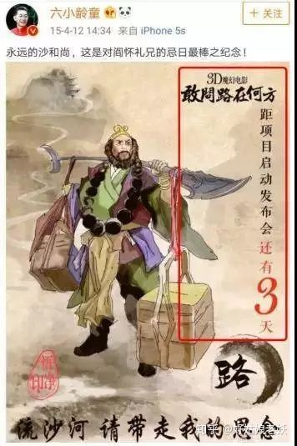
Figure 15: Liuxiaolingtong on the anniversary of the death of Yan Huaili
posted microblogging
"His behavior is a great disrespect for the deceased, and his current identity is too different, this kind of use has been deceased friends to earn traffic, the behavior of eyeballs is really eating greedy, people naturally also feel angry."
"I really find it hard to understand that this kind of behavior is what Liuxiaolingtong can do?"
(Interview)
c. Anti-random lying
First of all, Liuxiaolingtong with its understanding of and Journey to the West, for the Monkey King, often in lectures, interviews and other activities, expressing the words that make many fans of the West disagree.
"He went to school lectures and talked about saying that Sun Wukong was the first person to go to heaven in the ancient and modern world, that Wu Chengen was a great prophet, that the principle of the fire eye and microscope is similar, that the clairvoyance and telescope are the same, and that the principle of the smooth ear and the telephone are similar."
(Interview)
Secondly, Liuxiaolingtong in 2000 in the interview that a film version of Journey to the West will be prepared, after almost every year will mention the film, the film's project, start, release time has changed many times, delayed progress, by many netizens question whether the film really exists.
Once again, a photo taken on Mount Emei won a gold medal in an international photography award, showing a monkey saluting the Monkey King played by Liuxiaolingtong. This monkey was actually raised by humans and would salute whenever the handler ordered, but Liuxiaolingtong repeatedly emphasized in interviews that this monkey was wild to add to the legendary nature of the story, and in the photo accompanying the relevant Weibo post, he also intentionally or unintentionally chose a photo of the monkey with the chain photoshopped off of it (see Figure 16).
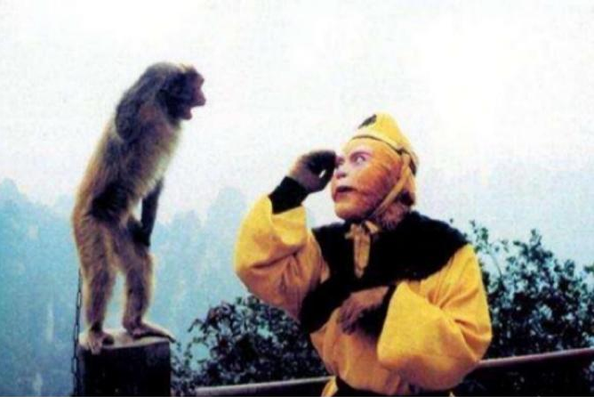
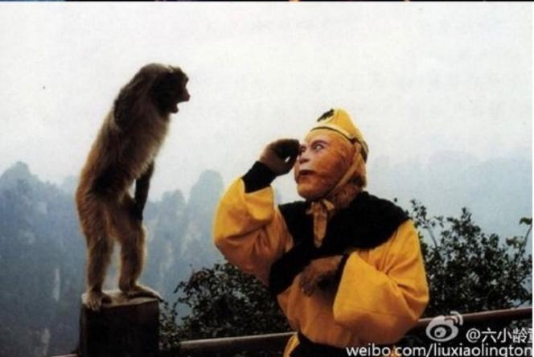
Figure 16: Comparison between the original picture and the matching picture
"I don't know when it became hard for us to feel that what he says is true and trustworthy, that his seems to tell any lie in order to be famous and earn money"
(Interview)
d. Anti-stagnation
First of all, in Liuxiaolingtong's acting career, he has played the role of Sun Wukong in many TV dramas, parties and events other than the CCTV version of Journey to the West, but the image he portrayed was not a copy of the image of the year, not innovative in the least.
"The so-called 'tasting' of the Journey to the West, and then repeatedly lectures, books, interviews, which is completely chicken soup type, not in the class, the book is to circle money, in fact, earn money from his 'name'. "
(Interview)
Secondly, in a large number of lectures and television programs attended by Liuxiaolingtong, the content of Liuxiaolingtong often does not differ, the repetition of specific words is extremely high, to many questions he has a specific set of answer templates, but also by netizens teased as "repeater".
"We all affectionately call him a 'repeater' ......"
(Interview)
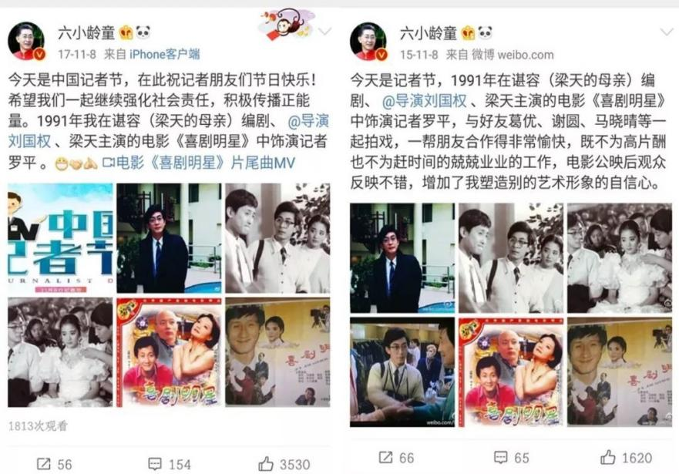
Once again, Liuxiaolingtong always posts microblogs on New Year's Day, celebrity anniversaries, and national events, but both the copy and the pictures are often repeated over several years, and are dubbed by "Liu Xue" participants as "repetition machines" (see Figure 17).
Figure 17: Tweets posted by Liuxiaolingtong at the festival

"...... This behavior is quite fake, always saying the same thing, as if they are setting up a cultural persona, and some famous actors and directors, we can all see that well, the same thing everyone will say, the Internet still has a memory."
(Interview)
An examination of the stylistic origins of "Liu Xue" cannot be divorced from its ontology, namely the Liuxiaolingtong itself and its words and actions. The reconstitution of this core signifier by "Liu Xue" participants produces their symbolic productivity. However, the specific symbolic productivity is dependent on the individual's understanding of the cultural commodity to be generated, which is attached to the individual's private meaning, fundamentally internal, and in such a case is difficult to use as an easily communicable symbol. At this point, textual productivity needs to take over the burden of dissemination, and it is precisely the dissemination of intertextual texts that has made "Liu Xue" popular on the Internet.
5.1.2 Hotness and entertainment principle
Imitation of change is the dynamic nature of the development of modal transmission, and this always-ready production mechanism makes it possible to generate a large number of text images around the original event as well as videos with a strong timeliness, always catching the new trend and following the hot trend in time⁹⁰ (He Nature. (2017). Often the current hot celebrity netizens, variety films and videos, as well as elements of Internet buzzwords can be quickly echoed in various images in culture, and it can be said that modalities are reflections of popular culture, which is precisely the heat-by-heat nature of netizens for novel hot events in the context of the Internet, making them part of the driving force for the fermentation of events.
"In fact, I do not know much about this thing, I think, but I also heard it from my friends, like the circle of friends, short video or something, and after seeing it, I thought it was quite interesting, so I wanted to forward it to other friends to see, maybe after watching it just want to be happy ......"
(Interview)
Sociologist Bauman has classified "gamers" as a postmodern trend⁹¹ (Hou, Jianbo & Sun, 2014), and this mentality has made entertainment and games the hegemony of modern discourse through the flow, for example, the public always prefers entertaining, light-hearted and eye-catching information; in social scenes, people are also eager to deliver and in social scenes, people are also eager to pass on and produce jokes to show the spirit of humor. Images in the Internet era combine the visual effect of eye-catching and the witty comedy of the jokes, which is a perfect form to interpret the art of "laughing". The expressions of embarrassment, funny postures and connotations, the unconventional entertainment factor makes people unable to stop laughing, and they are happy to share their happiness at the same time, and the funny humor is a common feature of the Internet. The light-hearted and entertaining atmosphere arouses people's desire to participate in it, and the back-and-forth activities become an interesting social game that brings people the pleasure of expression and communication. "Liu Xue", as an online spoof, is essentially a deconstruction of the long-standing image of the "Monkey King" that exists in people's imagination, and belongs to a culture that is different from the mainstream culture. "Liu Xue" actually follows the pattern of spoof culture to produce its own culture, using its unique style to dismantle the image of Liuxiaolingtong constructed by mainstream media and official authority in the past. The new image created by "Liu Xue" is distorted, even stigmatized, and at the same time highly entertaining, presenting a new symbolic positioning⁹² (Hao Yu & Ji Min, 2020). Along with the popularity of "Liu Xue", this symbolic positioning became a carrier of meaning in interpersonal interactions, a linguistic material for communication, and so much so that it became an exhibition of "Liu Xue" participants' self-styles.
"...... I think this thing is very interesting, our classmates have been talking about it among themselves for a while, and there are a lot of emojis related to this in the class group."
(Interview)

5.2 Resistance to social contradictions
Birmingham School scholars tend to adopt a "structural interpretation" in their analysis of youth prank culture. In their view, culture is never a neutral term; it is subordinate to ideology, and specific socio-historical situations give it specificity. "Structural interpretation grounds the study of subcultures in the overall class structure of society and analyzes the influence of class and structural factors on the formation of subcultures"⁹³ (Tang, 2020). It emphasizes the contradictions that social structures have in themselves, and that the formation of such cultural styles has a direct correlation with the structural location in which they are located.
Phil Cohen sees such culture as a compromise between two conflicting needs: the need to express and produce spontaneity and difference from parental culture, and the need to maintain identity with parental culture. Therefore, Internet spoof culture has a "potential function", that is, "...... expresses and solves the contradictions that are still hidden or unresolved in the parental culture, although through a magical technique "⁹⁴ (Zhang Wenyi & Mo Shaoqun, 2022).
The reform and opening-up policy that began after the Third Plenary Session of the Eleventh Central Committee in 1978 brought about sweeping changes to Chinese society, and China thus entered a long period of transition. Even today, more than 40 years later, as China enters a new period of comprehensive and deepening reform, the pain and disagreements brought about by the drastic transformation still deeply affect Chinese society, which is concentrated in the various social conflicts that are currently highlighted. For the "Liu Xue" participants, who are mainly the post-80s and post-90s, although they may not have personally experienced the wave of layoffs similar to the one triggered by the restructuring of state-owned enterprises in 1998, the current downward pressure of China's economy has increased, and problems and contradictions such as the difficulty in employment of college students, the surge in housing prices, the problems of the three rural areas, the solidification of classes, corruption, and the moral crisis are significant, and the emotional structure of the youth group is also affected and shaped by the experience of social contradictions. The emergence of subcultures has created a new era for the youth. The emergence of subcultures provides youth groups with "collective solutions" to social conflicts, cultural clashes and class experiences, and deals with social problems in an ideological way. The existence of online spoof culture is the style in which youth groups adopt their own unique expression strategies to construct their culture, often reflecting social conflicts in the hope of drawing attention to and somehow solving the problem⁹⁵ (Guo Xiaoan & Yang Shaoting, 2016). At the same time, they are actively avoiding their own degradation into a silent majority, trying to maintain an independent and active community.
"Liu Xue means that by exposing the act of Liuxiaolingtong, the historical reasons and social problems behind the emergence of this series of problems are exposed."
(Interview)
In the process of modernization, the influence of the market economy has permeated every aspect of our society, economic material standards have taken a dominant position in measuring people's lives, and interpersonal relationships have become an extension of the profit field. To a certain extent, it has also affected people's emotional structure, and human nature is gradually replaced by economic and instrumental rationality, and the value of "money first" makes traditional ethical and moral concepts diminish. The "Liu Xue" community obviously does not fully agree with this situation, and they can accept that people make money in a reasonable way, but the deep-rooted influence of traditional ethics makes "profit-oriented" not a reasonable category for them. This is one of "Liu Xue" criticisms of Liuxiaolingtong, which is "against profit and forgetfulness of justice" (see Figure 18).
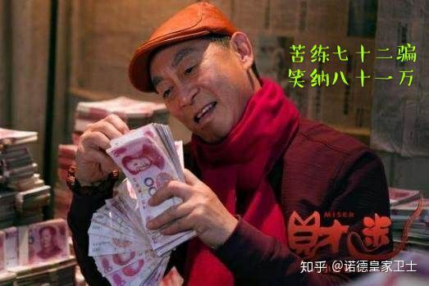

Figure 18: Satirical Liuxiaolingtong greed emoji

"(Liuxiaolingtong) is also an ordinary person trapped in the world of fame and fortune."
(Interview)
Moreover, after the May Fourth Movement, the few elite modern intellectuals who held the power of discourse were the producers of society's mainstream cultural ideology, and elite discourse once occupied the position of the center of our discourse; they assumed the responsibility of providing spiritual and cultural products to society as a whole, and held the ability and power to write history and interpret reality. In contrast to these elite intellectuals, who stood at the center of the stage, the general public was largely silent, and a relationship of oppression and oppressed was formed between the two groups, intentionally or unintentionally, at the level of discourse. The inequality between the grassroots and the elite, as well as the inequalities that existed in the society in transition, inevitably led to attacks and resistance, and the emergence of the Internet provided a powerful weapon for such resistance. Faced with Liuxiaolingtong, who holds the power of discourse and has substantial influence on the decisions of government organs, "Liu Xue" creators and participants flexibly use the style of Internet spoof culture to deconstruct Liuxiaolingtong's words and actions, satirize his misconduct, and dissolve his authority as a cultural elite, completing the parody and resistance to the hegemony of elite discourse.
"I think we now look back and actually have a sense of 'democracy' and 'science'. Attacking authority and opposing dictatorship is democracy."
(Interview)
Whether the "Liu Xue" participants express their cultural identity through "Liu Xue", such as "against profit and righteousness" or "against conformity", they are using subcultural rituals to express their resistance to social contradictions, which are deeply embedded in their emotional structure. They are not only relieving the structural pressure they are forced to bear, but also actively competing for the right to speak in public events⁹⁶ (Yang Man, 2017). Their resistance is not passive and unnecessary, but contains a romantic pursuit of a more ideal society.

5.3 Identity, self-expression and capital accumulation
In the post-Birmingham school of subcultural studies, postmodernism is a wave of thought that cannot be ignored. Postmodernism emerged in the 1960s, and was born in the postmodern society with changing socio-political and economic forms and rapid development of science and technology, and occupies an important position in the current Western cultural studies. Postmodernist scholars advocate deconstructionism, deny authority and grand narratives, and advocate the ideology of pluralism, popularization, and secularization⁹⁷ (Qin Xiaoyan, 2008). The traditional positions and interpretations of subcultural studies are challenged and deconstructed, and more and more new categories and theories are proposed and used to explain the emerging cultural styles. In the postmodern context, the resistance of subculture has a different interpretation.
In the era of media convergence, the pranking culture group also conceals the search for identity behind the ritual resistance, which is the process of heterogeneous individuals combining other identities with their own⁹⁸ (Tang Jingtai, 2020). The group of internet pranksters naturally has the pursuit of "novelty", which is considered to be a sign of being a youth group. The youth group has a natural identity crisis and fear of taking responsibility for adulthood, and the online spoof culture is created as a manifestation of self-identification with the group they live in, thus resisting the mainstream culture and values of adults and negotiating their social existence with ritualistic styles. Like other groups of spoof culture, "Liu Xue" participants have their own set of symbolic systems, including the language used online, emoji packs, user avatars, personalized signatures, and various creations on Weibo, B-site, and Zhihu, among others. These "mock languages" and "mega-texts" build a sense of identity among "Liu Xue" participants, and thus enhance their sense of identity and social and cultural environment. Social media provides a perfect platform for the consumption of this kind of online prank, and heterogeneous individuals become the group of online pranking in the socialized atmosphere of the platform media, and the identity of self and group is bred in it.
On the basis of Bourdieu's "cultural capital" theory, Thornton puts forward the concept of "subcultural capital", pointing out that subculture becomes the "consumption" object and "performance" content of a specific group of people nowadays. "Those who are qualified to "consume" subcultures can gain a sense of belonging to a group and a sense of common taste⁹⁹ (Ling, 2019).
"It's like sending a paragraph 'Chinese and American collocation (of sentences)', you do not understand the stalk, I will feel superior, the more I will want to play the stalk. And people who don't understand it will not understand it themselves because others play the stalk (and thus) get to know the "Liu Xue", so that the "Liu Xue"is on fire."
(Interview)
The style of spoof culture helps the online spoof culture group to form their own online spoof capital by means of unique customs and forms through the writing of social identities, thus coordinating various social relationships. In the diverse field of social space, cultural capital can be plundered and occupied by mainstream commercial culture by all means. In this context, the resistance behavior of the disadvantaged network spoofing groups cannot be interpreted only as a struggle for cultural capital and symbolic capital, because of the reality of unequal distribution of economic capital in social space, this behavior is more a struggle and accumulation of economic and social capital behind it, and a struggle for social power relations, which also shows to some extent the inseparable relationship between culture and economy. Under the tide of commercialization and the squeeze of mainstream culture, the online spoof culture group constructs itself with the help of style and ritual existence to obtain the qualification of survival and development¹⁰⁰ (Yang Man, 2017).

5.4 Imaginative solutions to problems
No matter how one understands it, the resistance manifested by "Liu Xue" and other spoof cultures is often limited to a relatively "calm" resistance at the cultural level, expressing attitudes through style rather than resorting to extreme resistance in the form of violent conflict. The resistance of the prank culture is realized in rituals, and such rituals are given an entertaining quality in the pranks, in which the pranksters are immersed in an orgy of emotions, expressing their resistance to authority and power. But just as Bakhtin said, the utopian freedom and equality in the carnival will end with the carnival, because of the multiple deficiencies in political, economic and cultural resources, the resistance of the spoof culture is ultimately limited, and the victory of resistance can only be imaginative and symbolic¹⁰¹ (Shao, Ping & Zhong, Hong-Shi, 2012). "Liu Xue" spoof did not change the status of Liuxiaolingtong's cultural elite; he still appears as a guest on various TV programs and parties, published books continue to be released, and even after "Liu Xue", Liuxiaolingtong has received a number of commercial endorsements. Although "Liu Xue" has enabled the participants to gain a certain level of discourse, the conflict between youth culture and patriarchal culture also remains, and the structural contradictions in society remain difficult to resolve.
"There really aren't that many people who are concerned about this now, that's how people's concerns are, they come and go quickly, but this thing is being discussed like this, I think it's leaving something in history, like those popular quotes ......"
(Interview)
Although spoofing is only an "imaginary solution" to a problem, it does not mean that ritual resistance is meaningless. The popularity of "Liu Xue" has had a real impact on Liuxiaolingtong, for example, he has responded positively to the controversy many times, and he rarely appears in his lectures and programs with comments similar to those that caused controversy before, and his Weibo account has been set to be visible only for six months. As Gramsci argues, the formation of hegemony is not the unilateral will of the ruler, but the result of negotiations between the ruler and the ruled, and this leadership is based on the "common sense" and consent of the citizens. The importance of spoofing is that it provides participants with a transient liberation through ritual, a cultural experience that symbolizes the formation of the phenomenon of online spoofing and the rise of marginalized groups¹⁰² (Piata, A., 2016). Although "Liu Xue"may lose its heat, there will still be an endless stream of spoof phenomena enriching the content and shape of spoof culture, and the response and resistance to contradictions and inequalities will still be able to continue and evolve, which is not only a symbolic victory, but also a civilian victory.
However, on a deeper level, the process of "six studies" from its creation and development to its gradual loss of "hotness" is a microcosm of the slow evolution of domestic online spoof culture in the context of "Internet+". The process of the "Liu Xue" from the creation, development and finally losing "hotness" is a microcosm of the development and evolution of domestic online spoof culture in the context of "Internet+". From the unscrupulousness in the early stage and entertainment to death in the middle stage, they have now gradually stepped into the circle of socialist core values, gradually showing the fading of resistance discourse, which is the coupling of network time and space and film art, and the resistance of virtual space and real society. From this, we can also see that especially in the cultural content system constructed by the network world, resistance has blurred the object of focus, style has lost its clear position, and the concept of multiculturalism has replaced the concept of dichotomy and dominance of a single mainstream culture. In short, the disappearance of stylized domestic online spoofing does not mean the revelry of the niche interest group, nor does it represent the dichotomy with mainstream culture. The online media, with its transformed and precipitated media experience, will promote the merging and benign two-way interaction between online spoofing culture and mainstream culture, and may also release richer narrative possibilities and ideational space.

6 Conclusion
This study attempts to analyze the phenomenon of "Liu Xue" online spoofing from the perspective of modal theory and explore the construction behavior of online spoofing culture.
Various spoof phenomena on the Internet do not appear overnight, but have their own unique history of formation behind them, and "Liu Xue" is no exception. This study compares the history of the formation and development of the "Liu Xue" Internet spoofing phenomenon and divides the history of the formation of "Liu Xue" into four stages, namely the germination period, the initiation period, the formation period and the peak period. The division is mainly based on the key events that occurred within each stage and the attitudes of Internet users toward Liuxiaolingtong within this period. From this, we can find that the emergence of the spoof phenomenon is a unity of chance and necessity, which is not only influenced by multiple factors, but also its own connotation and style are constantly changing. From the viewpoint of the participating subjects, the early stage is dominated by the westward travel enthusiasts, while later in the text dissemination attracts a large number of participants with similar life experiences in the network spoof culture, and the main gathering places of these "Liu Xue" participating groups are B station and Zhihu. At the textual level, "Liu Xue" is mainly composed of three intertextual texts: pictures (expression packs), verbal sentences, and videos, which convey the attitudes of creators and users through parody, collage, and isomorphism styles.
This study explores the construction of Liu Xue's style from two aspects: cultural identity and social positioning (positioning). In terms of cultural identity, "Liu Xue" participants generally agree with Liuxiaolingtong's acting skills, love his portrayal of the Monkey King and his appearance in CCTV's version of Journey to the West, and have a high opinion of the original Journey to the West. "Liu Xue"criticism of Liuxiaolingtong focuses on four aspects: virtue is not worthy of position, forgetfulness of righteousness, faithfulness, and conformity to the old ways. In terms of social positioning, "Liu Xue" is a network spoof culture that is different from the mainstream culture, deconstructing the image of Liuxiaolingtong mainstream according to the production mode of spoof culture and showing a new symbolic positioning.
By delving into the phenomenon of "Liu Xue" network spoofing through the appearance of style, we can find the resistance embedded in it, and the participants of "Liu Xue" precisely use this form of spoofing to express their resistance to social contradictions. In postmodernist theory, "Liu Xue" can help participants gain identity and achieve the accumulation of cultural and symbolic capital in the resistance. However, although "Liu Xue" is to some extent a liberation for the people, it is still only an imaginary solution to the real problem.
While expressing resistance, the participant groups of Internet spoof culture are inevitably suppressed and incorporated by the mainstream culture, and such incorporation is carried out in two ways - in the form of ideology and in the form of commercialization. From the former, it is mainly through the media that the dangers of "Liu Xue" are exaggerated or the differences of "Liu Xue" are eliminated with sameness. From the latter, it is mainly the commercial marketing in the Internet with the help of "Liu Xue" or the production of "Liu Xue" goods. "Liu Xue" under the double intake loses its ability to intervene in reality, and its resistance and subversion largely disappear, being incorporated into the matrix of mainstream and commercial culture. Nonetheless, the struggle of the group counter-collections of online spoofing has continued, and the style of "Liu Xue" and the resulting resistance has remained, while the larger culture of online spoofing has never been overcome.
These are some of the findings of this study, but there are still some shortcomings in this study due to the limitation of personal research ability. This study focuses on the analysis of a single case, and the number of interviewees is not yet sufficient due to the conditions, so there may also be inadequacies in terms of reliability and validity.
Finally, regarding the future research direction of this study, we will develop theoretical perspectives based on existing theories and use more diversified theories to explore the phenomenon of online spoofing. In addition, on the basis of this study, a comparative study can be conducted on several cases of Internet spoofing phenomenon, which is believed to further refine and deepen the understanding of the commonality of Internet spoofing culture.

Reference
I. English Literature
Books
[1] Shifman, L. (2014). Memes in digital Culture. The MIT Press.
[2] Blackmore, S. J. (1999). The meme machine. Oxford University Press.
[3] Brodie, R. (2011). Virus of the mind: the new science of the meme. Hay House.
[4] Dawkins, R. (1976). The Selfish Gene. Oxford University Press.
[5] Gabriel De Tarde. (2013). The laws of imitation. Redditch: Read Books.
[6] Jenkins, H. (2013). Textual poachers: television fans and participatory culture. New York ; London: Routledge. (Original work published 1992)
[7] Gilkerson. (2012). Participatory Satire? Political Humor, the Colbert Super PAC Project, and the Colliding Worlds of Late Night Comedy and Modern American Politics. ProQuest Dissertations Publishing.
[8] Daniel P. (2007). Consciousness explained. New York Etc.: Little, Brown And Company.

Journals
[9] Gal, N., Shifman, L., & Kampf, Z. (2016). “It Gets Better”: Internet memes and the construction of collective identity. New Media & Society, 18(8), 1698–1714. https://doi.org/10.1177/1461444814568784
[10] Nissenbaum, A. and Shifman, L. (2015). Internet memes as contested cultural capital: The case of 4chan’s /b/ board. New Media & Society, 19(4), pp.483–501. doi:10.1177/1461444815609313.
[11] Benaim, M. (2018). From symbolic values to symbolic innovation: Internet-memes and innovation. Research Policy, 47(5), pp.901–910. doi:10.1016/j.respol.2018.02.014.
[12] Vásquez, C. and Aslan, E. (2021). ‘Cats be outside, how about meow’: Multimodal humor and creativity in an internet meme. Journal of Pragmatics, 171, pp.101–117. doi:10.1016/j.pragma.2020.10.006.
[13] Cannizzaro, S. (2016). Internet memes as internet signs: A semiotic view of digital culture. Sign Systems Studies, 44(4), 562. https://doi.org/10.12697/sss.2016.44.4.05
[14] Piata, A. (2016). When metaphor becomes a joke: Metaphor journeys from political ads to internet memes. Journal of Pragmatics, 106, 39–56. https://doi.org/10.1016/j.pragma.2016.10.003
[15] Kanai, A. (2016). Sociality and Classification: Reading Gender, Race, and Class in a Humorous Meme. Social Media + Society, 2(4), 205630511667288. https://doi.org/10.1177/2056305116672884
[16] Zhang, R. (2020). Re-directing socialist persuasion through affective reiteration: a discourse analysis of “Socialist Memes” on the Chinese internet. AI & SOCIETY. https://doi.org/10.1007/s00146-020-01107-7
[17] Kearney, R. (2019). Meme Frameworks. Video Journal of Education and Pedagogy, 4(2), 82–89. https://doi.org/10.1163/23644583-00401013
[18] McKee, A. (2022). “Popular culture” in popular culture: academic and vernacular usage. Annals of the International Communication Association, 1–11. https://doi.org/10.1080/23808985.2022.2046127
[19] Seiffert-Brockmann, J., Diehl, T., & Dobusch, L. (2017). Memes as games: The evolution of a digital discourse online. New Media & Society, 20(8), 2862–2879. https://doi.org/10.1177/1461444817735334
[20] Burgess. (2018). Internet Memes. In the SAGE Handbook of Social Media (p. 412–). SAGE Publications Ltd. https://doi.org/10.4135/9781473984066.n23
[21] Heylighen. (1992). A cognitive-systemic reconstruction of maslow’s theory of self-actualization. Behavioral Science, 37(1), 39–58. https://doi.org/10.1002/bs.3830370105
[22] Lynch. (1996). Thought contagion: how belief spreads through society / Aaron Lynch. (1st ed.). Basic Books.

II．Chinese Literature
Journals
[1]章文宜 & 莫少群.(2022).解读青年文化症候：“躺平”模因的感觉结构分析. 未来传播(04),26-35. doi:10.13628/j.cnki.zjcmxb.2022.04.011.
[2]胡兵 & 张静文.(2022).模因论视阈下“梗”的生成与传播研究. 当代传播(02),93-96.
[3]王纯磊,何丽,冯蕾 & 史蕾.(2022).基于大脑网络模块化的语言模因心理动力研究. 西安外国语大学学报(01),35-38. doi:10.16362/j.cnki.cn61-1457/h.2022.01.002.
[4]何自然.(2021).语言模因中的元语用意识. 华文教学与研究(01),41-47. doi:10.16131/j.cnki.cn44-1669/g4.2021.01.006.
[5]夏德元 & 王宇博.(2021).模因论视域下短视频对外传播的媒介逻辑. 新闻爱好者(01),36-39. doi:10.16017/j.cnki.xwahz.2021.01.009.
[6]樊林洲.(2020).表情包的视觉模因信息表征和传播优势. 新疆社会科学(06),108-116.
[7]黄婉童.(2020).新闻事件网络流行语的传播要素及其动力. 新闻爱好者(05),91-93. doi:10.16017/j.cnki.xwahz.2020.05.024.
[8]郝雨 & 吉敏.(2020).互联网“模因”生成规律与非理性传播控制——关于防范舆论风险的新视角. 当代传播(02),41-44.
[9]田淼琪 & 俞贵.(2020).社交媒体时代网络流行梗的传播学思考——从“六学”梗谈起. 巢湖学院学报(01),97-103.
[10]隋岩 & 李燕.(2020).论网络语言对个体情绪社会化传播的作用. 国际新闻界(01),79-98. doi:10.13495/j.cnki.cjjc.2020.01.005.
[11]汤景泰.(2020).话语竞争与集体协同——论网络娱乐式抗争的行动机制. 西北师大学报(社会科学版)(01),65-70. doi:10.16783/j.cnki.nwnus.2020.01.008.
[12]曹钺.(2019).当代青年“锦鲤”文化症候解读——基于网络模因的发展谱系与意涵网络. 当代青年研究(06),110-115.
[13]林小木.(2019).网络表情包新闻配图研究. 编辑之友(11),44-50. doi:10.13786/j.cnki.cn14-1066/g2.2019.11.008.
[14]凌云.(2019).模因论视域下网络流行语及其文化阐释. 江西社会科学(08),234-239.
[15]付晓光 & 苏齐晟.(2019).模因论视角下网络空间正面宣传的实践创新思路——以社交短视频为例. 中国出版(14),41-44.
[16]曾一果.(2018).符号的戏讥:网络恶搞的社会表达和文化治理. 南京社会科学(12),106-115. doi:10.15937/j.cnki.issn1001-8263.2018.12.015.
[17]杨嫚.(2017).网络表情包的亚文化风格构建:从自我表达到公共空间. 西安交通大学学报(社会科学版)(05),88-93. doi:10.15896/j.xjtuskxb.201705010.
[18]何自然.(2017).语言模因与公共领域的生态环境. 中国外语(03),20-27. doi:10.13564/j.cnki.issn.1672-9382.2017.03.009.
[19]高文梅.(2017).模因论视角下网络流行语传播的认知. 出版广角(02),78-80. doi:10.16491/j.cnki.cn45-1216/g2.2017.0119.
[20]葛厚伟 & 别君华.(2017).强势网络流行语模因的传播要素与社会性. 中国出版(05),53-56.
[21]郭小安 & 杨绍婷.(2016).网络民族主义运动中的米姆式传播与共意动员. 国际新闻界(11),54-74. doi:10.13495/j.cnki.cjjc.2016.11.004.
[22]阮先玉.(2016).网络流行语模因现象的社会文化解读. 社会科学家(08),156-160.
[23]曾润喜 & 魏冯.(2016).强势模因视角下网络流行语的语义演变及流行理据——基于“你懂的”八年进化轨迹的研究. 语言文字应用(02),91-96. doi:10.16499/j.cnki.1003-5397.2016.02.013.
[24]曹进 & 靳琰.(2016).网络强势语言模因传播力的学理阐释. 国际新闻界(02),37-56. doi:10.13495/j.cnki.cjjc.2016.02.003.
[25]张小平 & 宋丙秀.(2015).网络流行语模因性语义传播分析——“逆袭”一词的个案研究. 现代传播(中国传媒大学学报)(01),164-165.
[26]马萧 & 陈顺意.(2014).基于模因论的翻译规范思考. 解放军外国语学院学报(06),1-7+22+156.
[27]侯建波 & 孙静怡.(2014).模因论视角下的网络新文体. 外语教学(05),19-22. doi:10.16362/j.cnki.cn61-1023/h.2014.05.010.
[28]周一书.(2014).模因论在对外汉语课堂教学中的应用研究. 语言教学与研究(04),9-16.
[29]李捷 & 何自然.(2014).语言模因的主体性与语境化. 外语学刊(02),59-64. doi:10.16263/j.cnki.23-1071/h.2014.02.016.
[30]郑四方.(2013).比较与融合:认知语言学和模因论. 西安交通大学学报(社会科学版)(05),76-80+105. doi:10.15896/j.xjtuskxb.2013.05.005.
[31]武和平 & 王玲燕.(2010).强势模因的生成、复制及传播——“山寨”一词的个案研究. 语言教学与研究(05),78-83.
[32]任凤梅.(2010).网络语言传播的模因论解读. 河南社会科学(05),203-204.
[33]王笑楠.(2010).对网络恶搞现象的文化分析. 河南师范大学学报(哲学社会科学版)(03),210-213. doi:10.16366/j.cnki.1000-2359.2010.03.057.
[34]侯国金.(2008).模因宿主的元语用意识和模因变异. 四川外语学院学报(04),50-58.
[35]胡疆锋.(2008).恶搞与青年亚文化. 中国青年研究(06),5-12. doi:10.19633/j.cnki.11-2579/d.2008.06.002.
[36]覃晓燕.(2008).后现代语境下的恶搞文化特征探析. 现代传播(中国传媒大学学报)(01),71-73.
[37]黄敬宝.(2007).恶搞的经济学分析. 中国青年研究(09),61-64. doi:10.19633/j.cnki.11-2579/d.2007.09.015.
[38]谢朝群 & 何自然.(2007).模因与交际. 暨南大学华文学院学报(02),46-52+62. doi:10.16131/j.cnki.cn44-1669/g4.2007.02.008.
[39]何自然,何雪林.(2003).模因论与社会语用. 现代外语(02),200-209.
[40]第50次中国互联网络发展情况统计报告.(2022)http://www.gov.cn/xinwen/2022-09/01/content_5707695.htm
[41]邵萍 & 仲红实.(2012).模因理论视角下的跨文化意识培养研究.山东社会科学(06),160-162. doi:10.14112/j.cnki.37-1053/c.2012.06.014.
Books
[41]费斯克.(2008). 传播研究导论. 北京大学出版社.
[42]费斯克.(2004). 关键概念：传播与文化研究辞典. 新华出版社
[43] 雷蒙德·威廉斯.(2013) 漫长的革命. 上海人民出版社.

Appendix

I. Interviewees
1. Wang, male, 19 years old, high school student, westward travel enthusiast.
2. Li, male, 17 years old, high school student, active discussant of "Liu Xue" in posting bar.
3 Wang, male, 28 years old, university student, Zhihu opened a post to analyze the "Liu Xue"incident, "Liu Xue" topic discussion participant.
4 Yang, female, 22 years old, university student, participant in the posting of the Liu Xue incident.
5 Li, female, 35 years old, undergraduate programmer, participant of "Liu Xue".
6 Liu, male, 13 years old, middle school student, fan of Liuxiaolingtong, one of the hosts of Liuxiaolingtong super talk, opposed to "Liu Xue".
7 Yang, male, 22 years old, undergraduate student, participant of Zhihu "Liu Xue".
8 Yu, female, 24 years old, this degree to be employed, a fan of the West, an active participant of "Liu Xue".
9 Wu, male, 37 years old, professional coach with a bachelor's degree, participant of "Liu Xue".
10 Wu, male, 21 years old, undergraduate student, fan of Liuxiaolingtong, active participant of Liuxiaolingtong super talk, opposed to "Liu Xue".
11 Zhao, male, 32 years old, graduate degree, staff, participant of posting "Liu Xue".
12 Li, female, 16 years old, middle school student, fan of Liuxiaolingtong, Liuxiaolingtong discussion post initiator, opposed to "Liu Xue".
13 Li, male, 14 years old, middle school student, active participant of "Liu Xue" in the posting discussion post.
14 Chang, male, 13 years old, middle school student, participant of "Liu Xue" topic.
15 Li, female, 27 years old, high school education, employee, "Liu Xue"participant.
16 Wang, male, 9 years old, elementary school student, western travel enthusiast, "Liu Xue" participant.
17 Liu, male, 15 years old, middle school student, making "Liu Xue" videos in b station, "Liu Xue" active participant.
18 Liu, male, 16 years old, middle school student, microblogging "Liu Xue" topic participant.
19 Zheng, male, 19 years old, undergraduate student, microblogging "Liu Xue" topic participant.
20 Lv, male, 21 years old, secondary school education, service industry, participant of "Liu Xue" topic in posting, "Liu Xue" opponent.
21 Fan, female, 24 years old, undergraduate freelance, "Liu Xue" active participant.
22 Yang, female, 19 years old, undergraduate student, "Liu Xue" topic participant.

II. Outline of the interview.
Gender: Age: Education: Occupation.
1. Do you know about network spoofing?
2. Do you know about the "Liu Xue" incident? From what channels did you learn about "Liu Xue"? Where have you read about "Liu Xue"-related content? Please explain in detail what you think and feel about it?
3. What is the earliest "Liu Xue" beauty you have seen? What is the most impressive impression on you?
4. Besides "Liu Xue", do you know other spoof events? What are the main channels? What are the other spoofs that impressed you? Please give examples.
5. What is the main reason for your participation in the "Liu Xue"e incident? Please list them in as much detail as possible.
6. What do you think should be the conditions for the "Liu Xue" incident to spread widely? Please give us some examples.
7. Would you recommend "Liu Xue"-related content to your friends? For example, discussions, photos or texts about it. If so, what are the reasons for doing so?
8. Is there anything you find objectionable in the "Liu Xue" spoof? Please give examples of why.
9. What do you think is the value of the "Liu Xue" incident?
10. Do you think this kind of spoof has any effect on your life?

