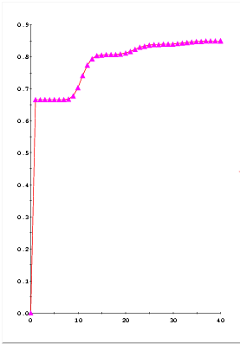
Concentration of component A in Mixer.

