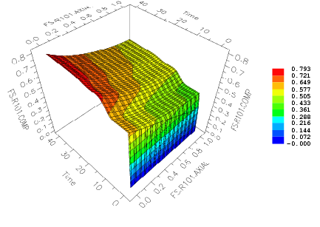
Concentration of component A in Reactor.

