**Engagement with Indigenous groups**

We have contacted the səl̓ilwətaɁɬ təməxʷ (Tsleil-Waututh) and šxʷməθkʷəy̓əmaɁɬ təməxʷ (Musqueam) regarding their interest in participating in the survey and how these data can be most useful to them. Last updated 2022-10-18

**Study Background**

The sampling was started by Varoon P. Supratya and Siobhan Schenk who are PhD candidates in the labs of Patrick T. Martone (<https://www3.botany.ubc.ca/martone/>) and Laura Wegener Parfrey (<https://www.zoology.ubc.ca/~parfrey/parfrey_lab/>), respectively, both at the University of British Columbia.

Both Varoon and Siobhan study macroalgae for their degrees. Macroalgae are marine foundation species in intertidal ecosystems, but data regarding their historical abundance, diversity, and phenology remains lacking in many regions, including British Columbia.

This absence of historical baselines may hinder assessments of how macroalgae are affected by anthropogenic stressors, such as extreme weather events (e.g., 2021 heat dome) or invasive species. Obtaining baseline data may be especially important for urban intertidal zones, where the impact of increasing anthropogenic stressors is underappreciated.

To fill this data gap, they started a collaborative long-term survey in 2021 to document year-round macroalgal biodiversity in a highly biodiverse urban intertidal zone, Girl in a Wetsuit, Stanley Park, Vancouver, British Columbia, Canada. This site was chosen because both labs often collect macroalgae there and due to the high biodiversity previously mentioned while choice highlighting the often-underappreciated biodiversity of urban ecosystems.

**Preliminary Findings**

After one year of data, we have captured the early recruitment and growth period of kelps (brown algae) and monitored the shift in dominant algae at the site from kelp-dominated to *Ulva* (green algae) dominated through the summer months. The plot below shows the distance from the seawall on the y-axis, the month on the x-axis, the year and transect ID as the X and Y panels respectively for *Nerocystis leukatena*, which is Varoon’s focal kelp species.

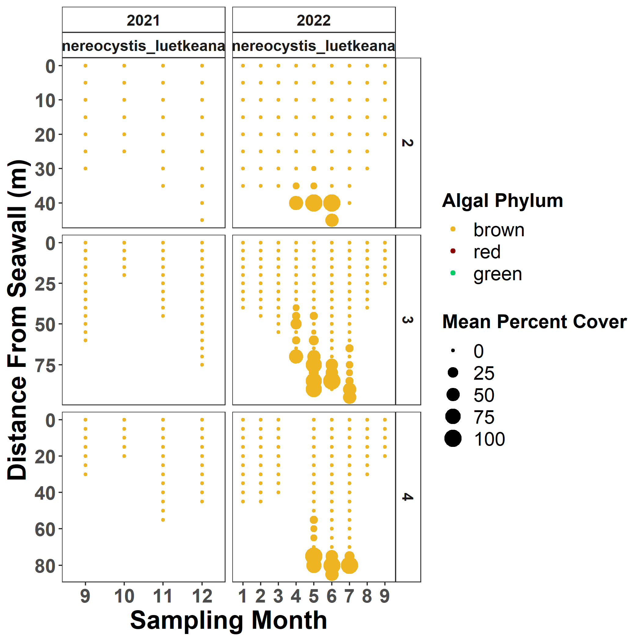

**Volunteers**

We have recruited volunteers to assist with the sampling during the low-tides that occur during the day through help of the Stanley Park Ecological Society (<https://stanleyparkecology.ca/>) and our own labs. In particular, we would like to acknowledge the contributions of:

Emma Jourdain

Connor Wardrop

Alyana Lalani

Emma Menchions