**INSTITUTE OF COMPUTER APPLICATIONS**

**DIGITAL DOCUMENT SYSTEM**

**BALENDRES, JULIUS KENN**

**BUTLAY, ERVIN JOHNES**

**DELA TORRE, JOMILEN**

**EDULLANTES, JIM CHRISTIAN**

**SIOC, RYAN JAY**

**DECEMBER 2020**

**DESCRIPTION**

A Digital Document System is a cloud-base management system that is used to manage, store, track and delete digital documents or digital image in the website that can make the client work anywhere, whenever there is an internet connection. The Digital Document System will help by making the client’s Documents or image Paperless, by just scanning the client’s information, such as certificates, Designations, client’s information, etc. then, upload it to the website. Aside from uploading the digital files, the clients can also retrieve their digital documents, by downloading the file. A Digital Document System is well known for the paperless and security, when it comes to submit your digital files, aside from that. The client’s information is also secure, as it is uploaded in cloud storage file.

However, The Institute of computer applications (ICA) faculty does not have the said system, to be specific, the instructors of the faculty are submitting their works in paper-based documents rather than digital based documents. One of the Instructors said that they were having problems in gathering data last time in their AACUP, due to paper-based documents. Some of the documents were scattered, and some of the instructor have not passed the said documents.

In response to these problems, The Students of Web and mobile electives proposed and develop the Digital Document System, in order to make the documents less hassle, paperless and more secured.

**FLOWCHART**

USERS FLOWCHART:

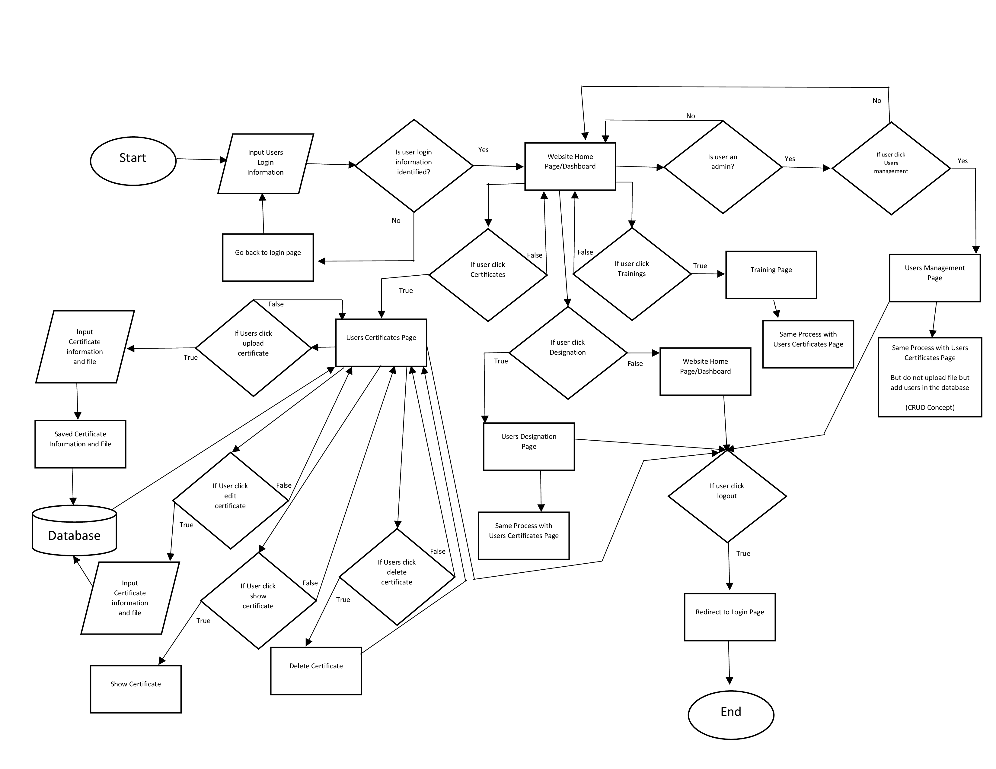ICA FACULTY DIGITAL DOCUMENT SYSTEM

**ENTITY RELATIONSHIP DIAGRAM**

Entity Relationship Diagram:

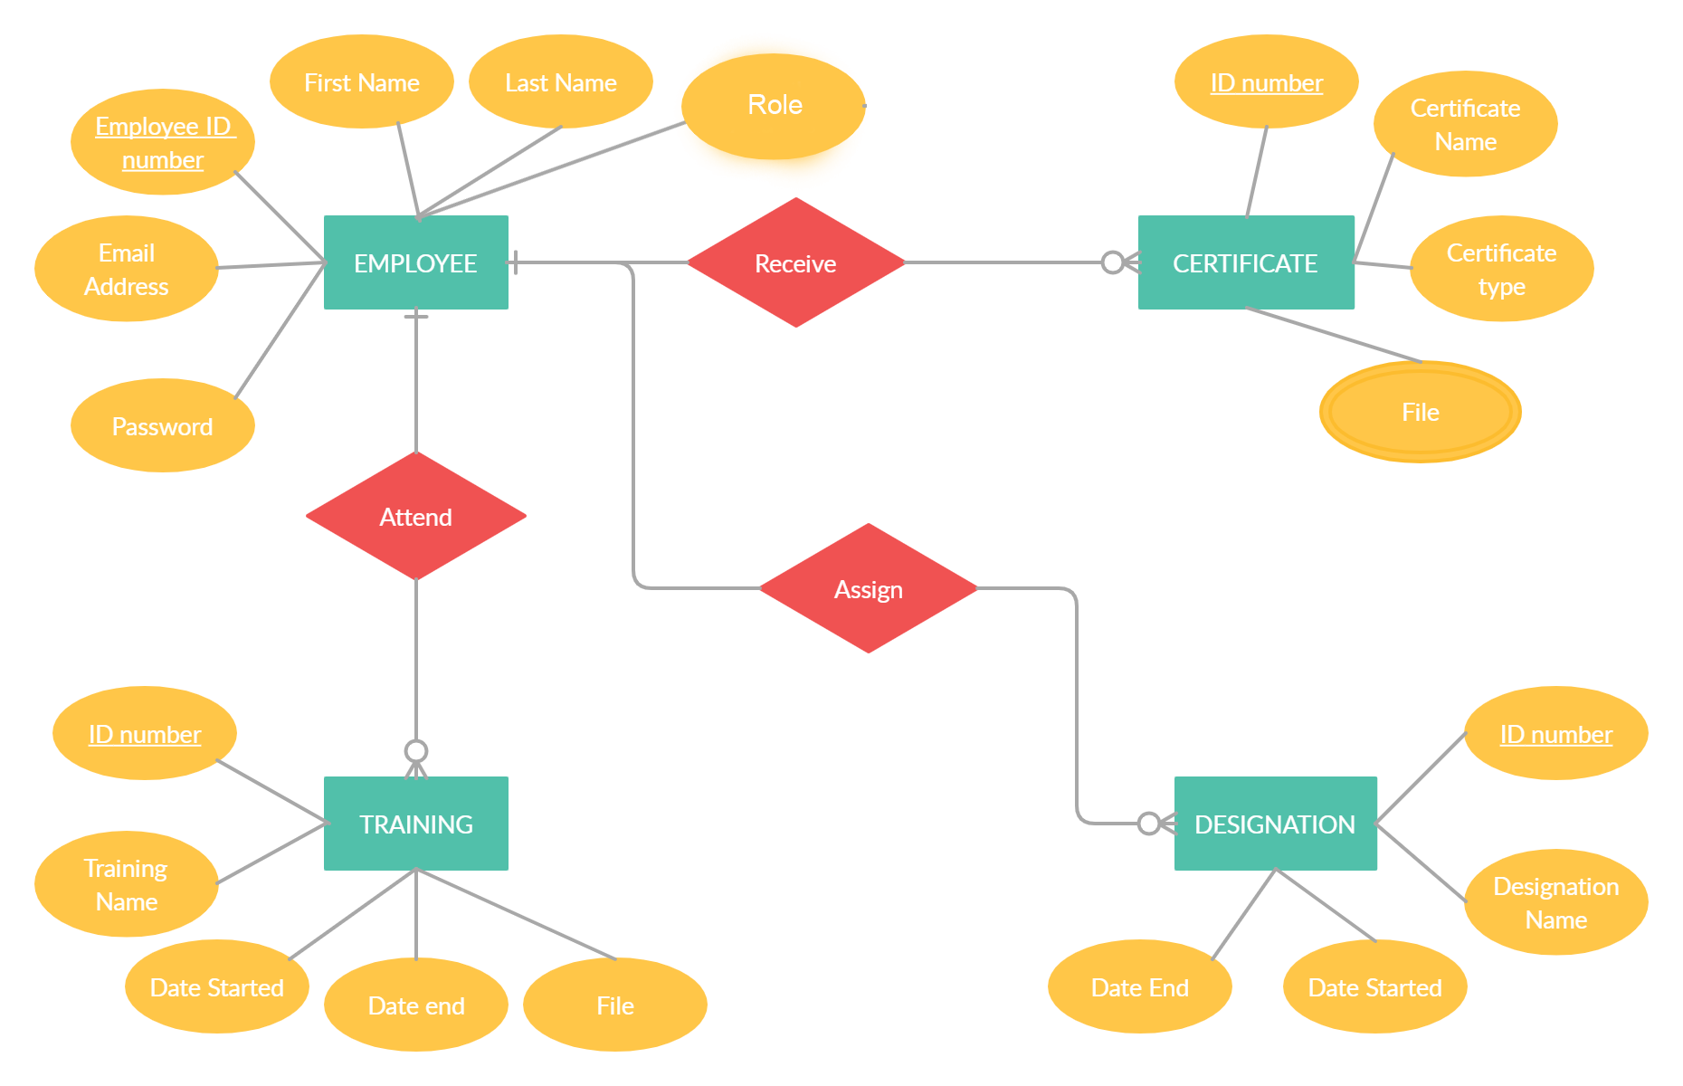Ica Faculty Digital Document System

**USER MANUAL**

INTRODUCTION

**ICA Faculty Digital Document System** is web base management system developed by using PHP web framework Laravel, the system store important documents and data such as faculty information, certificates, and designations with the scanned document or digital file. The system will secure the important document to make sure that users can access it at any time and from anywhere and also to avoid losing or misplacing the document.

This guide will help you get the most from your learning experience by using all of the helpful features and functions of the ICA Faculty Digital Document System.

1. ACCESS AND PROFILE

A.1 Log in

Enter your e-mail and password into the login form. If you do not have login information yet, you can contact the administrator. The employee with the role of an administrator is the one who can create a user profile with the login information.

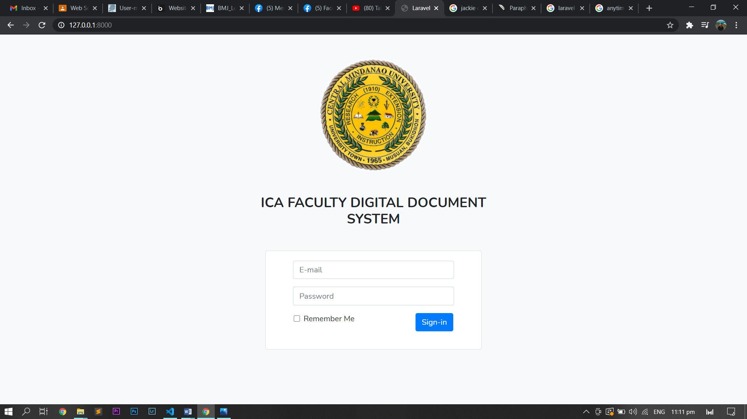

A.2 Profile

The user profile is the next page after logging in, the page contains the basic information of the user such as Employee ID, First Name, Last Name, and Email Address. The user profile also can access by clicking the employee name in the right upper corner of the page and it will drop-down a list of links, one of the links is a dashboard that contains the user profile.

1. USER MANAGEMENT

The user management can be open by clicking the link in the drop-down list, seen in the right upper corner of the page. This features only access if the employee with the role of administrator or admin.

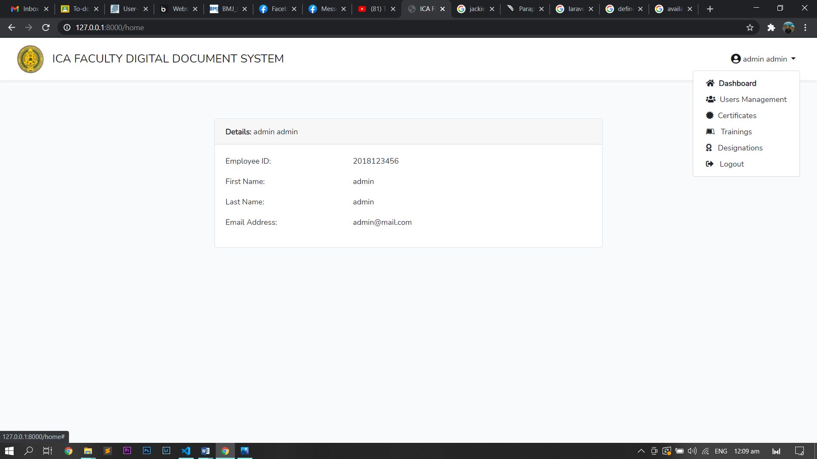

B.1 Interface

The page contains a table of the employees or users and its information such as **Employee ID,**First Name**, Last Name, Email, Roles, and date and time were created. The page also has search user section, create new user section and action section with act to the show user and edit user.**

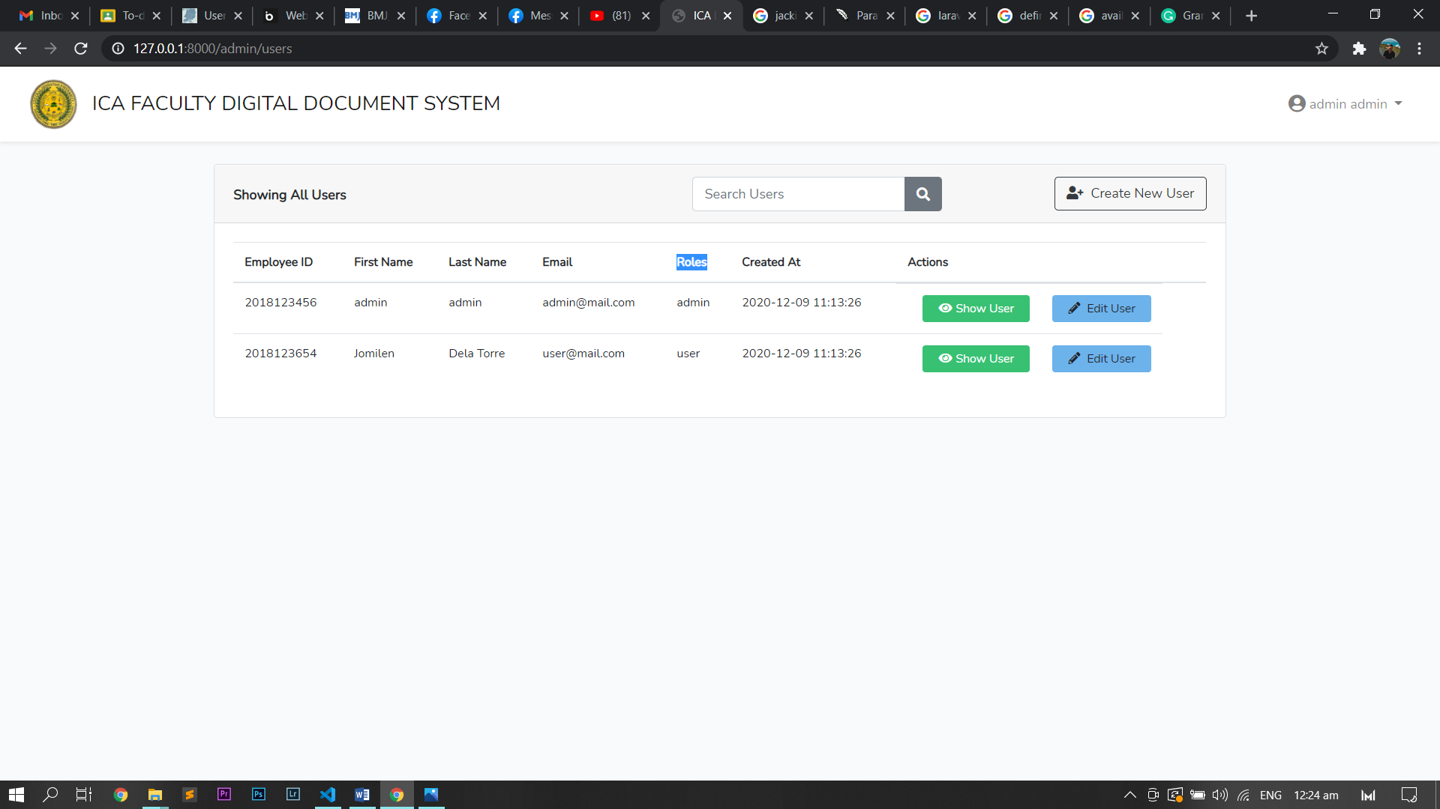

B.2 **Search User Section**

The search user section is a search engine that finds a particular employee by using either first name or last name after clicking the search button it will show the employee that has the word search in their first name or last name.

B.3 **Create New User Section**

When you click the Create New User it will prompt you to another page and if the administrator wants to go back to the user management page you can click the Back To Users button and if not the administrator will fill up the information for the new user information such as employee id, first name, last name, email, and password. As soon as you filled up and click the Create New User the system will go back to the user management page with the updated list of the user.

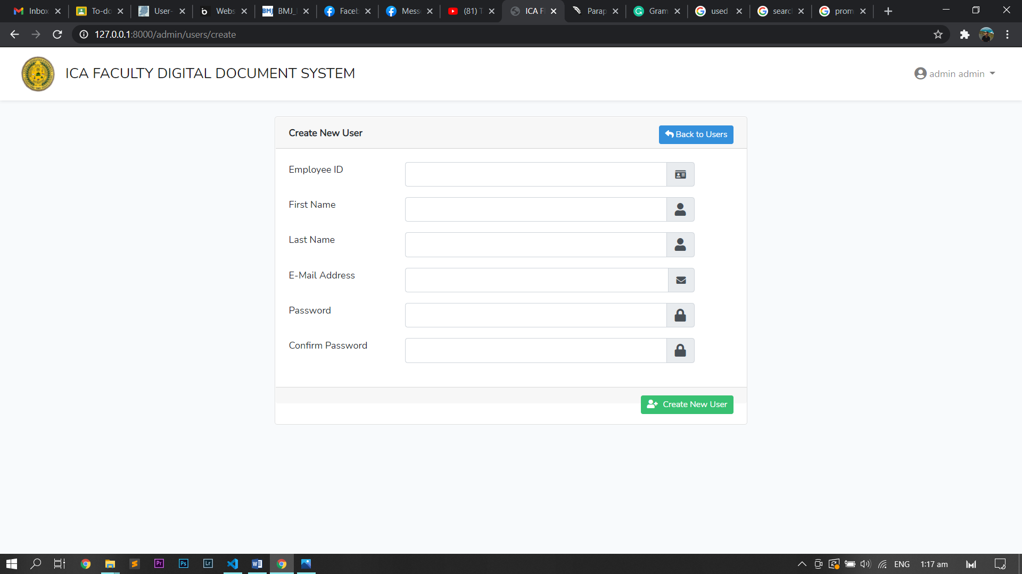

B.4 Edit User **Section**

When you press the button Edit User from the action it will prompt to the editing page where the administrator can edit user information such as employee id, first name, last name, email, password, and the role of the employee it’s either admin or user. When you click on the save changes, the dialogue will appear where the administrator can see the Cancel button that cancels the changes and the Confirm button that confirming the changes and upon clicking it will go back to the user management page with the updated information of the user.

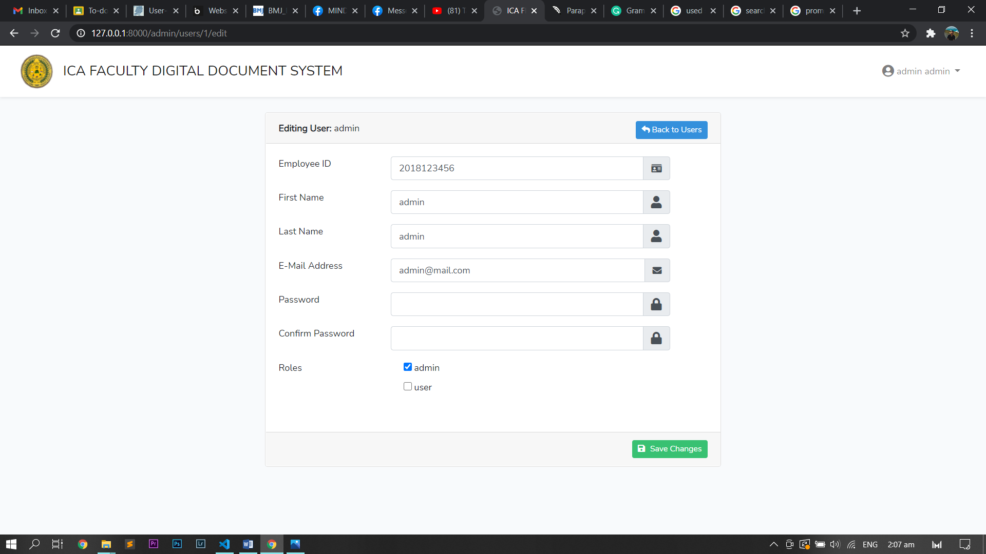

B.5 Show User **Section**

When you push the Show User button, the user will be prompted to the user information where show the information of the specific user. The page also Edit this User button that will prompt to Editing page and also it has to delete this User where when the user clicks it, the dialogue will appear and administrator cancels the by clicking Cancel button or clicking Confirm button were confirming to delete the user and as soon as the user confirms it will go back to user management with successfully delete the user.

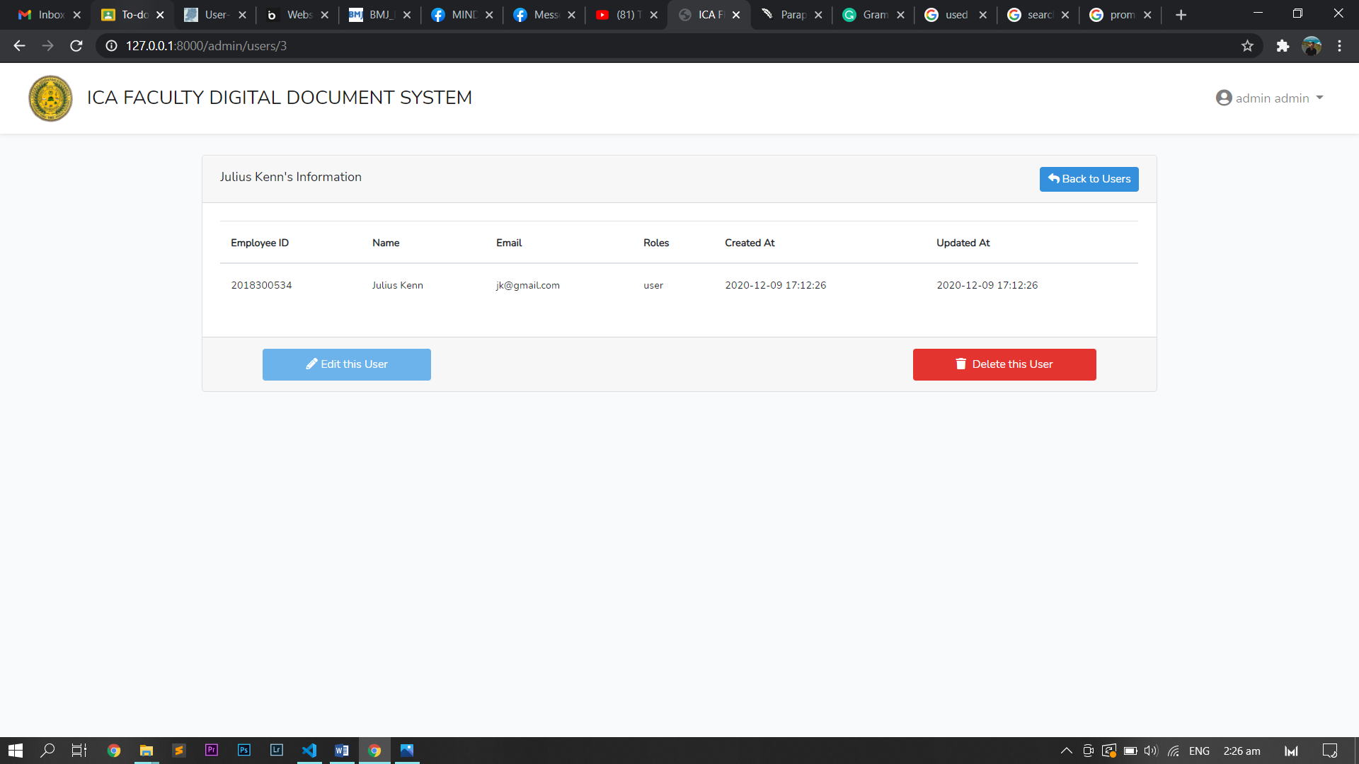

1. CERTIFICATES

The Certificates can be open by clicking the link in the drop-down list, seen in the right upper corner of the page. This can be access by both user and administrator.



C.1 Interface **Section**

The page contains a table of certificates and with information, the information varies on the role of the employee, for the employee with user role the information displayed in the table are ID, Certificate name, certificate type it either speaker or participant and date and for the employee with the role of admin the displayed is same as the employee with the role of the user but with the employee ID that owns the certificate. The page also has a search certificate section, upload certificate section, and action section in every certificate with act to show certificate and edit certificate.

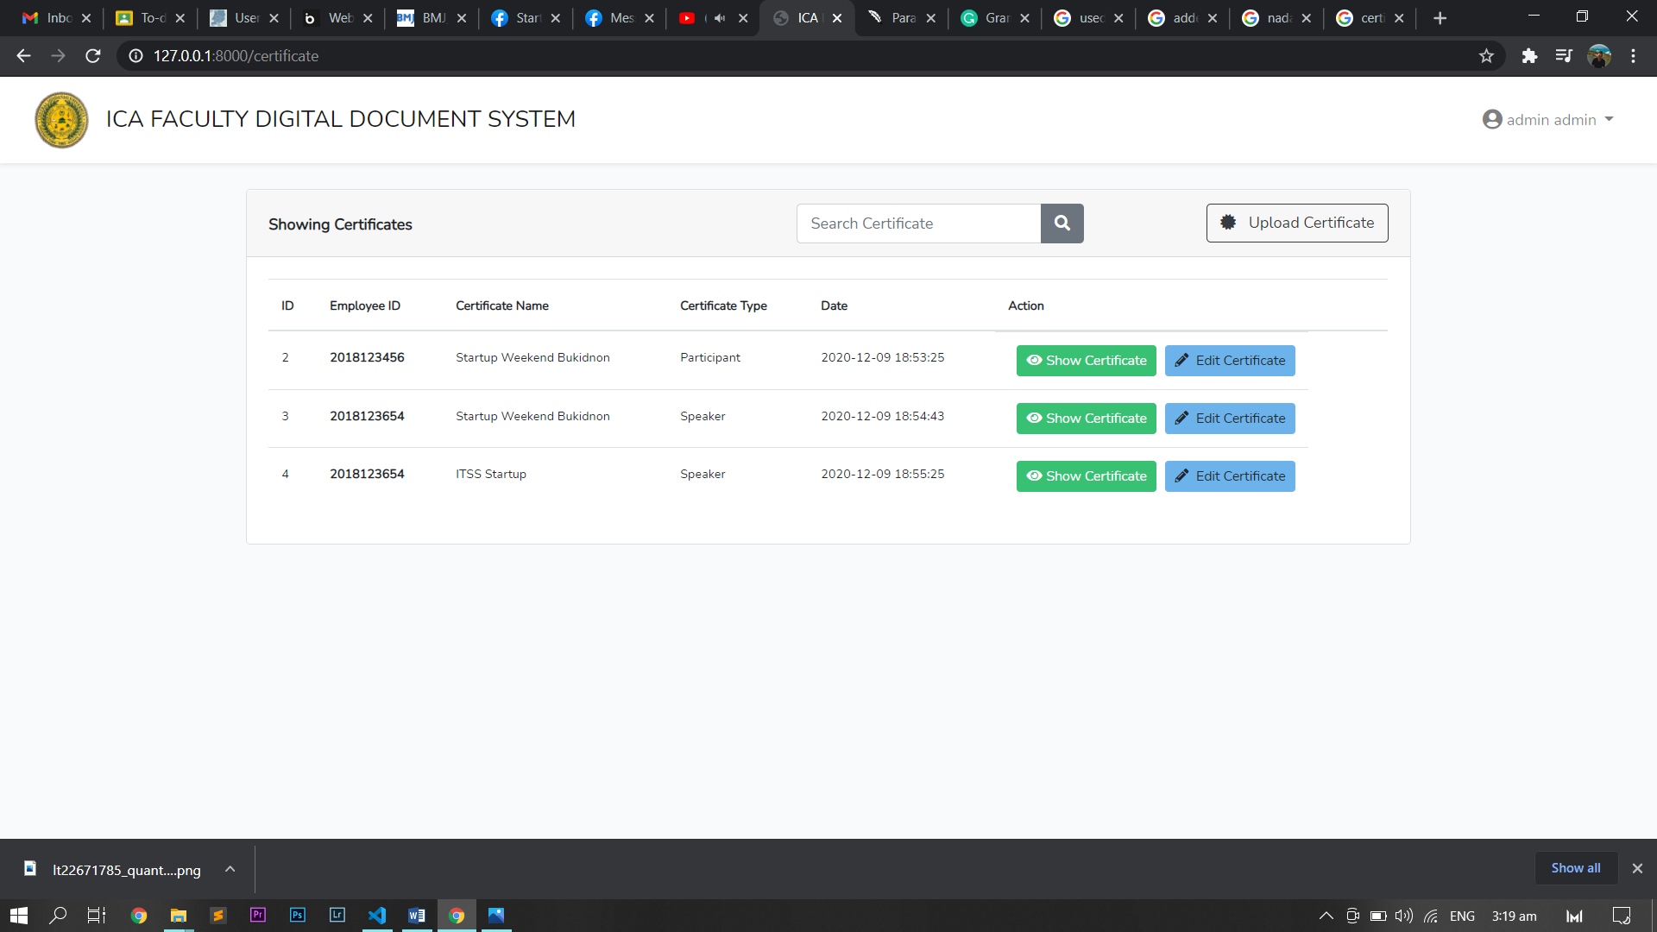

C.2 **Search User Section**

The search certificate section is a search engine that finds a particular certificate by using the certificate name after clicking the search button it will show the certificate information that has the word search in the certificate name.

C.3 Upload Certificate

As soon as you click the upload certificate button it will prompt you to the upload new certificate page which you will fill up information needed to upload the certificate, information such as certificate name, certificate type which it’s either participant or speaker, and the scanned certificate or digital file of the certificate. When you press the button to upload the certificate it will successfully upload the certificate and it will go back to the certificates page with the updated list.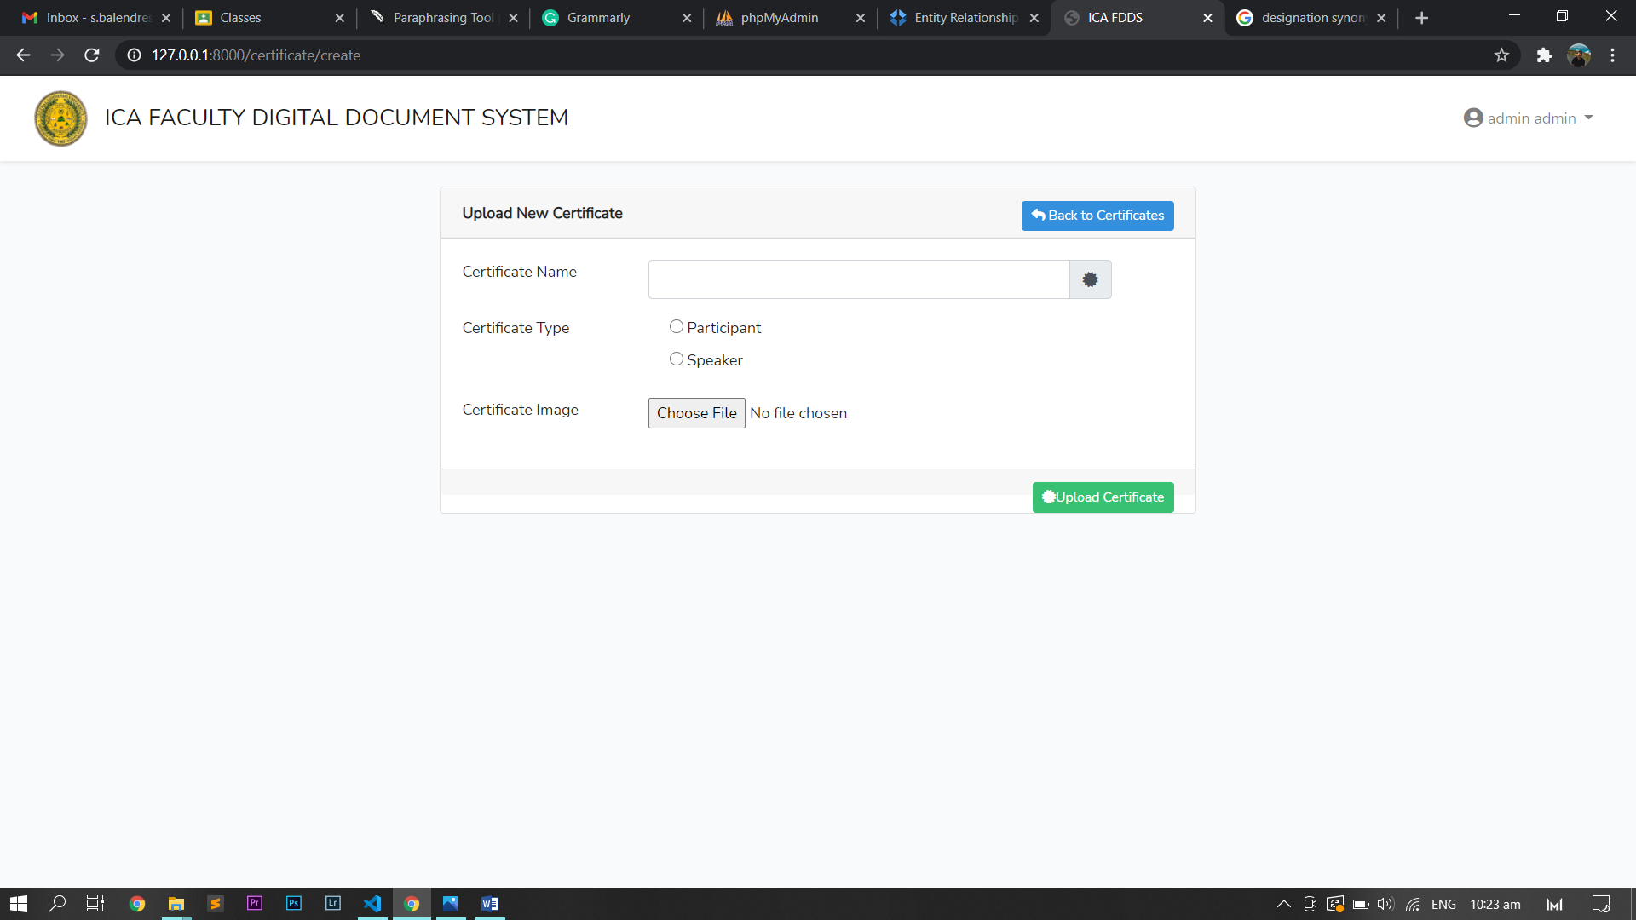

B.4 Edit Certificate **Section**

Every certificate has a set of actions and one of the action is edit certificate which when you click it, it will prompt you to the edit certificate page where you can edit the information of the certificate such as certificate name, certificate type, and certificate image. As you are done changing the information and you click the edit certificate button it will instantly change the information successfully and you will go back to the certificates page with the updated information. 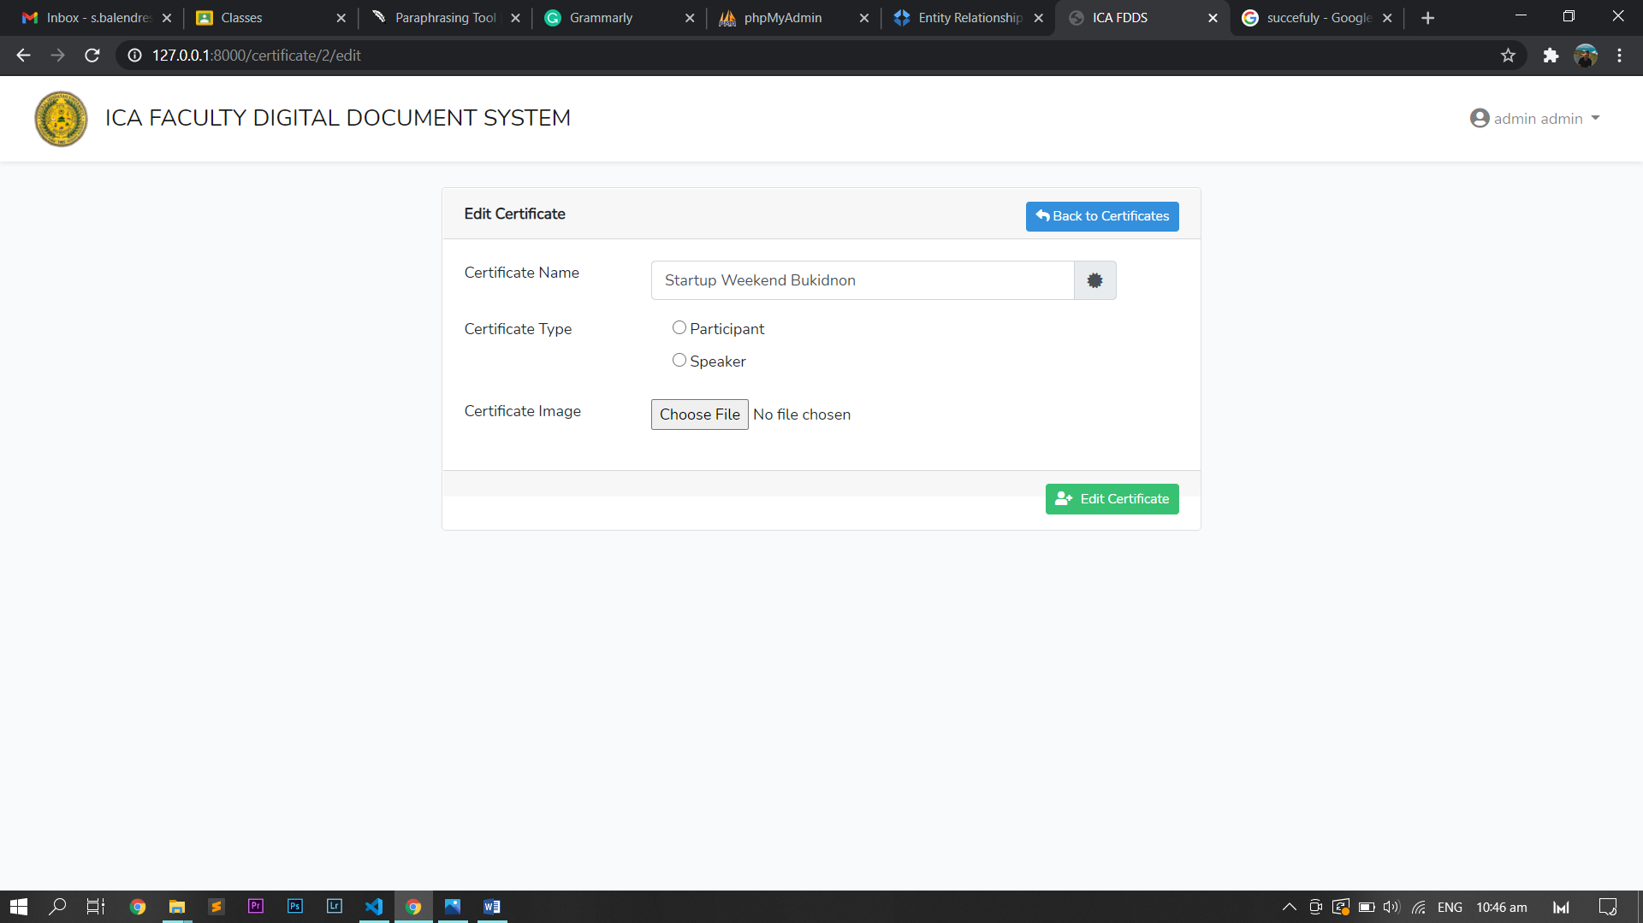

B.5 Show Certificate **Section**

The other action that can be done is show certificate, as soon as you press the show certificate button it will prompt you to the certificate information page which contains the information of the certificate such as certificate ID, employee ID that own the certificate, certificate name, certificate type, date and type uploaded certificate and the image of the certificate. The page also has the option to go back to the certificate page, editing the certificate by clicking the edit this certificate button and delete this certificate which when you click it, the dialogue will appear where you can choose to cancel or confirm to delete the certificate and if you click to confirm to delete the certificate it will go back to the certificate page with the updated list of the certificate.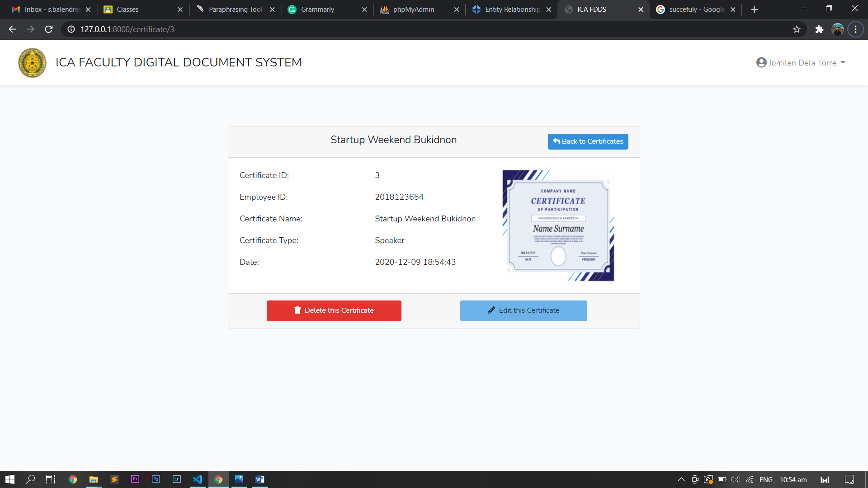

1. TRAININGS

The Training can be open by clicking the link in the drop-down list, seen in the right upper corner of the page. This can be accessed by both user and the administrator.



D.1 Interface **Section**

The training page contains the table of training attended by the employee with the information but the information displayed is dependent on the employee role. In the employee with the role of user, the information displayed are ID, Training Name, date from or started and date to or ended in the other hand the employee with the role of admin ID, Employee ID than attend the training, Training Name, date from or started and date to or ended. The page also has a search Training file section, upload training file section, and action section in every Training file with act to show training file and edit training file.

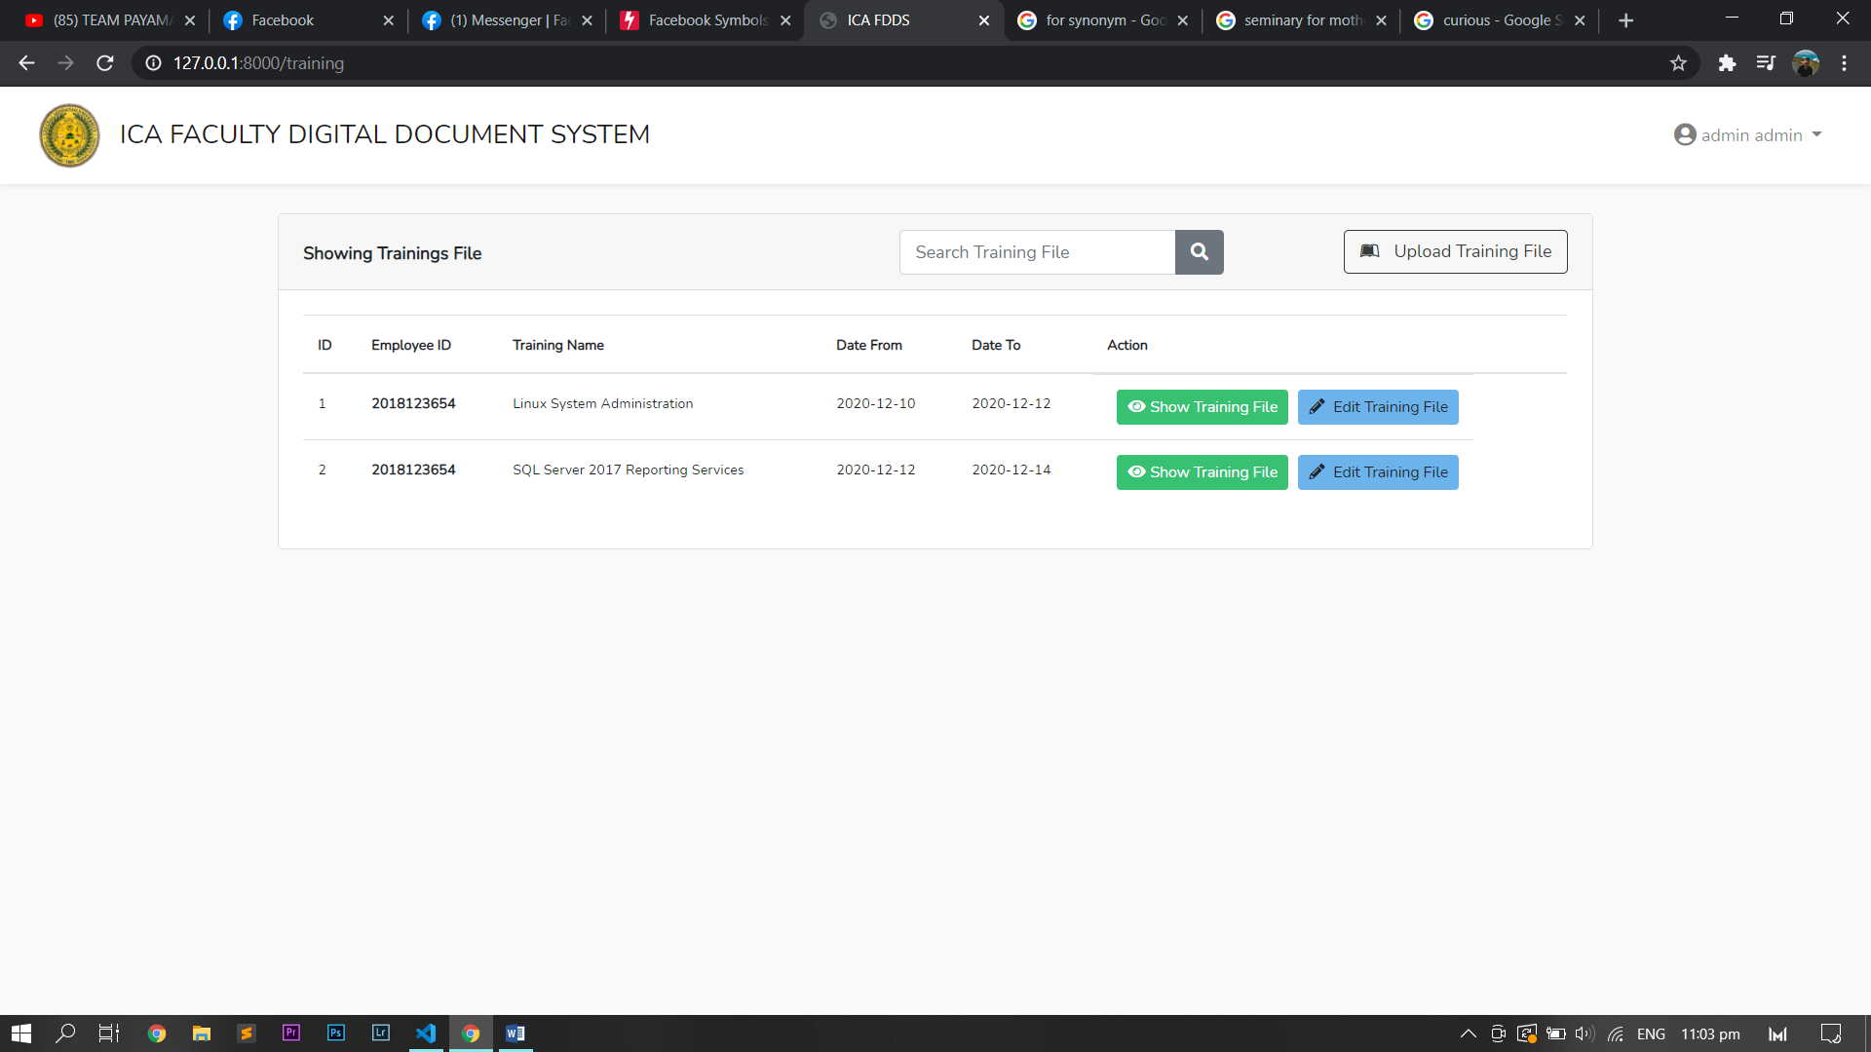

D.2 **Search Training File Section**

The **search training file** section is a search engine that finds a particular training file by using the training name after clicking the search button it will show the training information that has the word search in the training name.

D.3 Upload Training File Section

In uploading the new training file you can click the button upload training file to prompt to the upload new training file page where you fill-up the information needed such as training name, date from or started, date to or ended, and the scanned file or digital file. upon clicking the upload training file it will go back to the training file page with the updated list of training files.

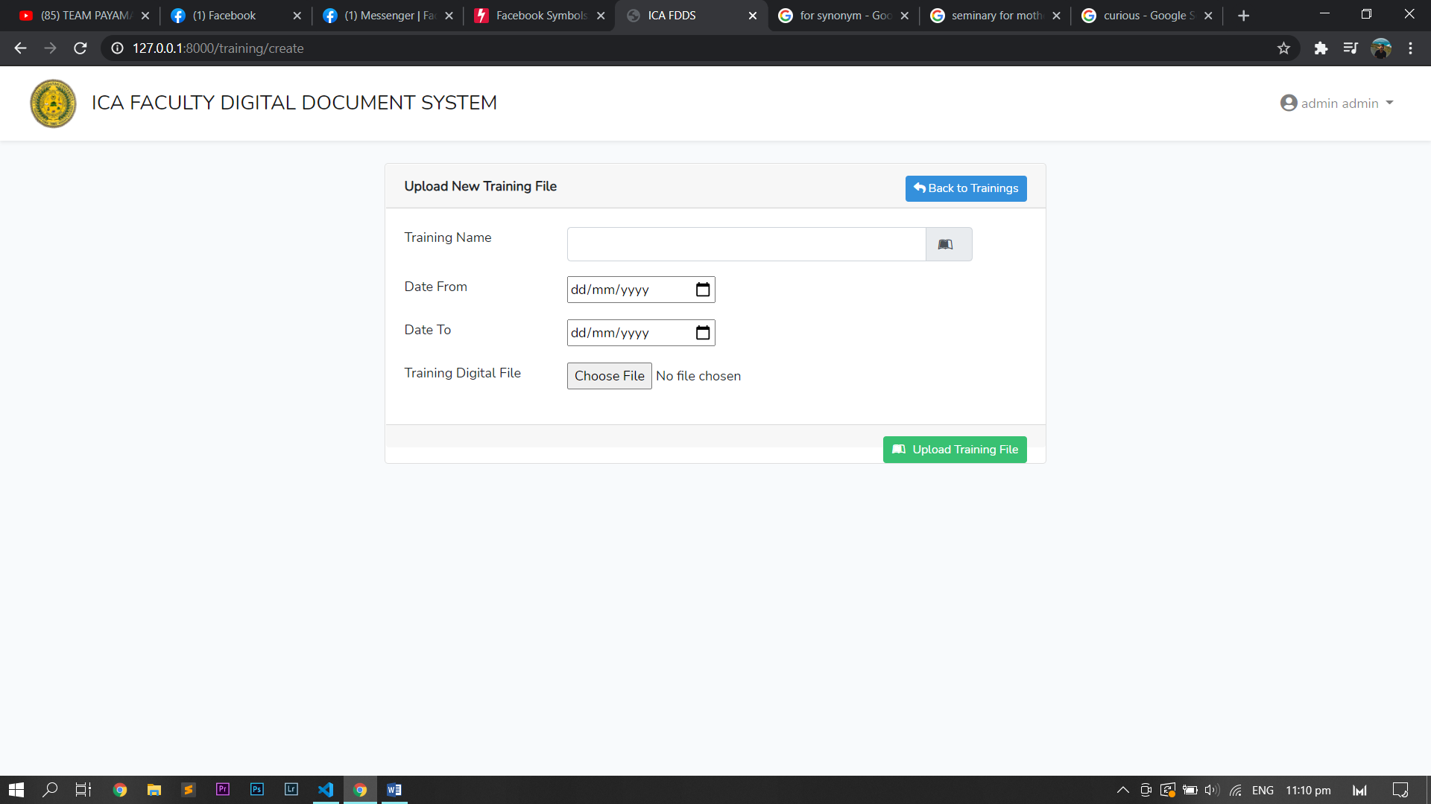

D.4 Edit Training File Section

When you edit the training file you can click one of the action buttons the edit training file after clicking you will prompt to the edit training file page where you can change the information such as Training name, date from, date to, and training digital file by uploading the scanned file after changing the information you can now proceed by clicking the edit training button then you will go back to training file page with the updated information.

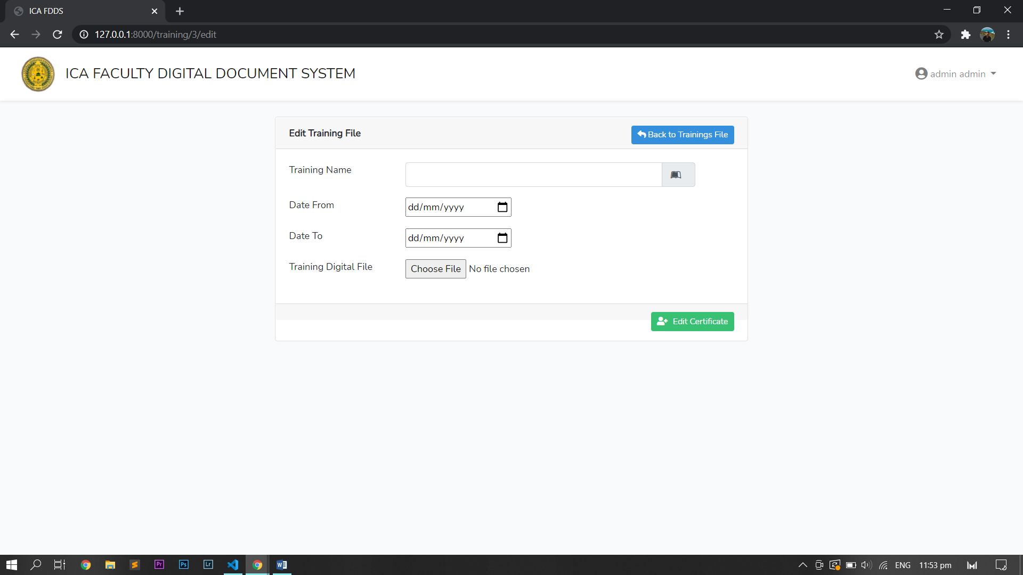

D.5 Show Training File Section

The other action you can perform in the training file is show training file where when you click it, it will prompt to the training file information page where you can find the information of the file such as training ID, employee ID that attend the training, training name, date from, date to and the picture of the file or certificate. The page also has the option to edit the training or deleting the training, in deleting the training when the button is clicked dialogue will appear and you can choose to cancel or confirm the deleting of the file and when you delete the file you will go back to training file page with the updated list of training file.

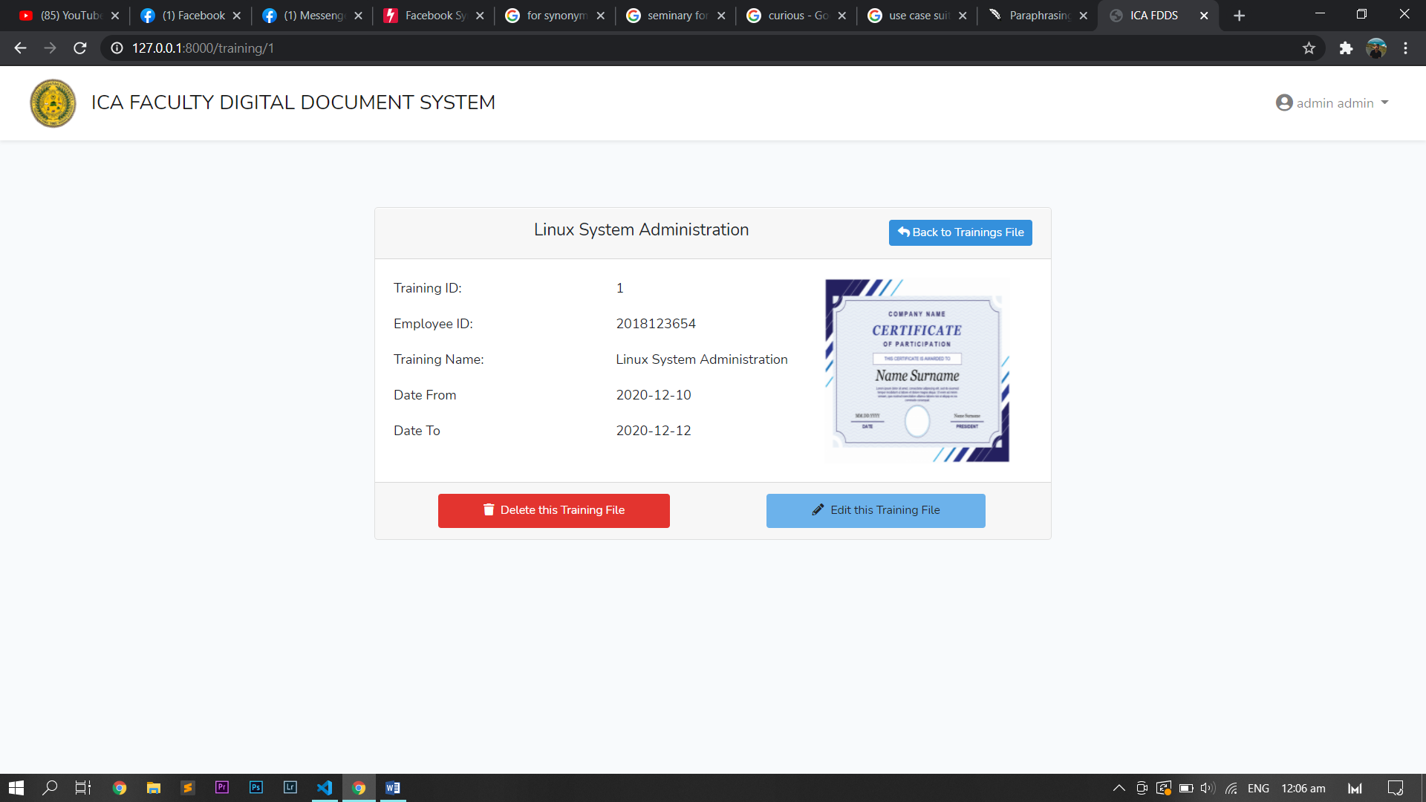

1. DESIGNATIONS

You may open the designation by clicking on the icon in the drop-down list displayed in the upper right corner of the screen and both the user and the administrator can access it.



E.1 Interface **Section**

**The designation page includes the designation table with the details supported by the employee, but the information shown depends on the role of the employee. In the employee with role of user the information displayed are ID, Designation name, date from or started and date to or ended where in the employee with the role of admin are ID, Employee ID that attend, Designation name, date from or started and date to or ended.** The page also has a search designation file section, upload designation file section, and action section in every designation with act to show training file and edit training file.

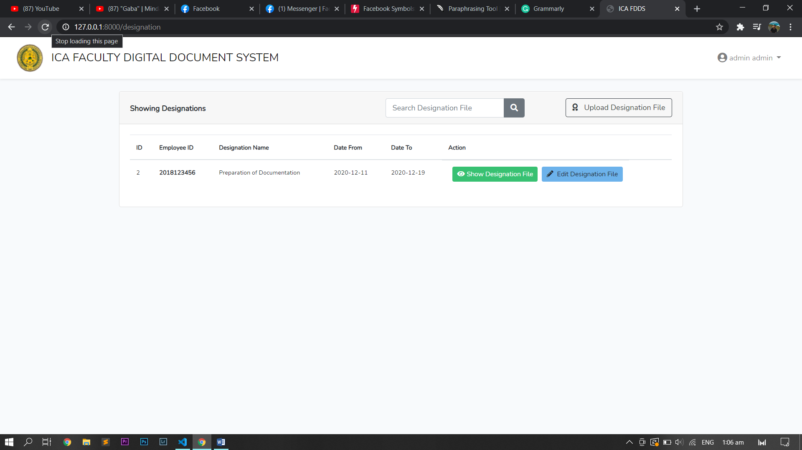

E.2 Search Designation File Section

The portion of the search designation file is a search engine that uses the designation name to locate a certain designation file after pressing the search button and shows the designation information that the term search has in the designation name.

E.3 Upload Designation File Section

When you upload a new designation file, you can press the Upload Designation File button to prompt you to upload a new designation file page to fill in the appropriate detail, such as the name of the designation, the date of the file or its start, the date of the file or its end, and the scanned file or digital file. When the insert designation file is clicked, it will return to the designation file page with the modified designation file list.

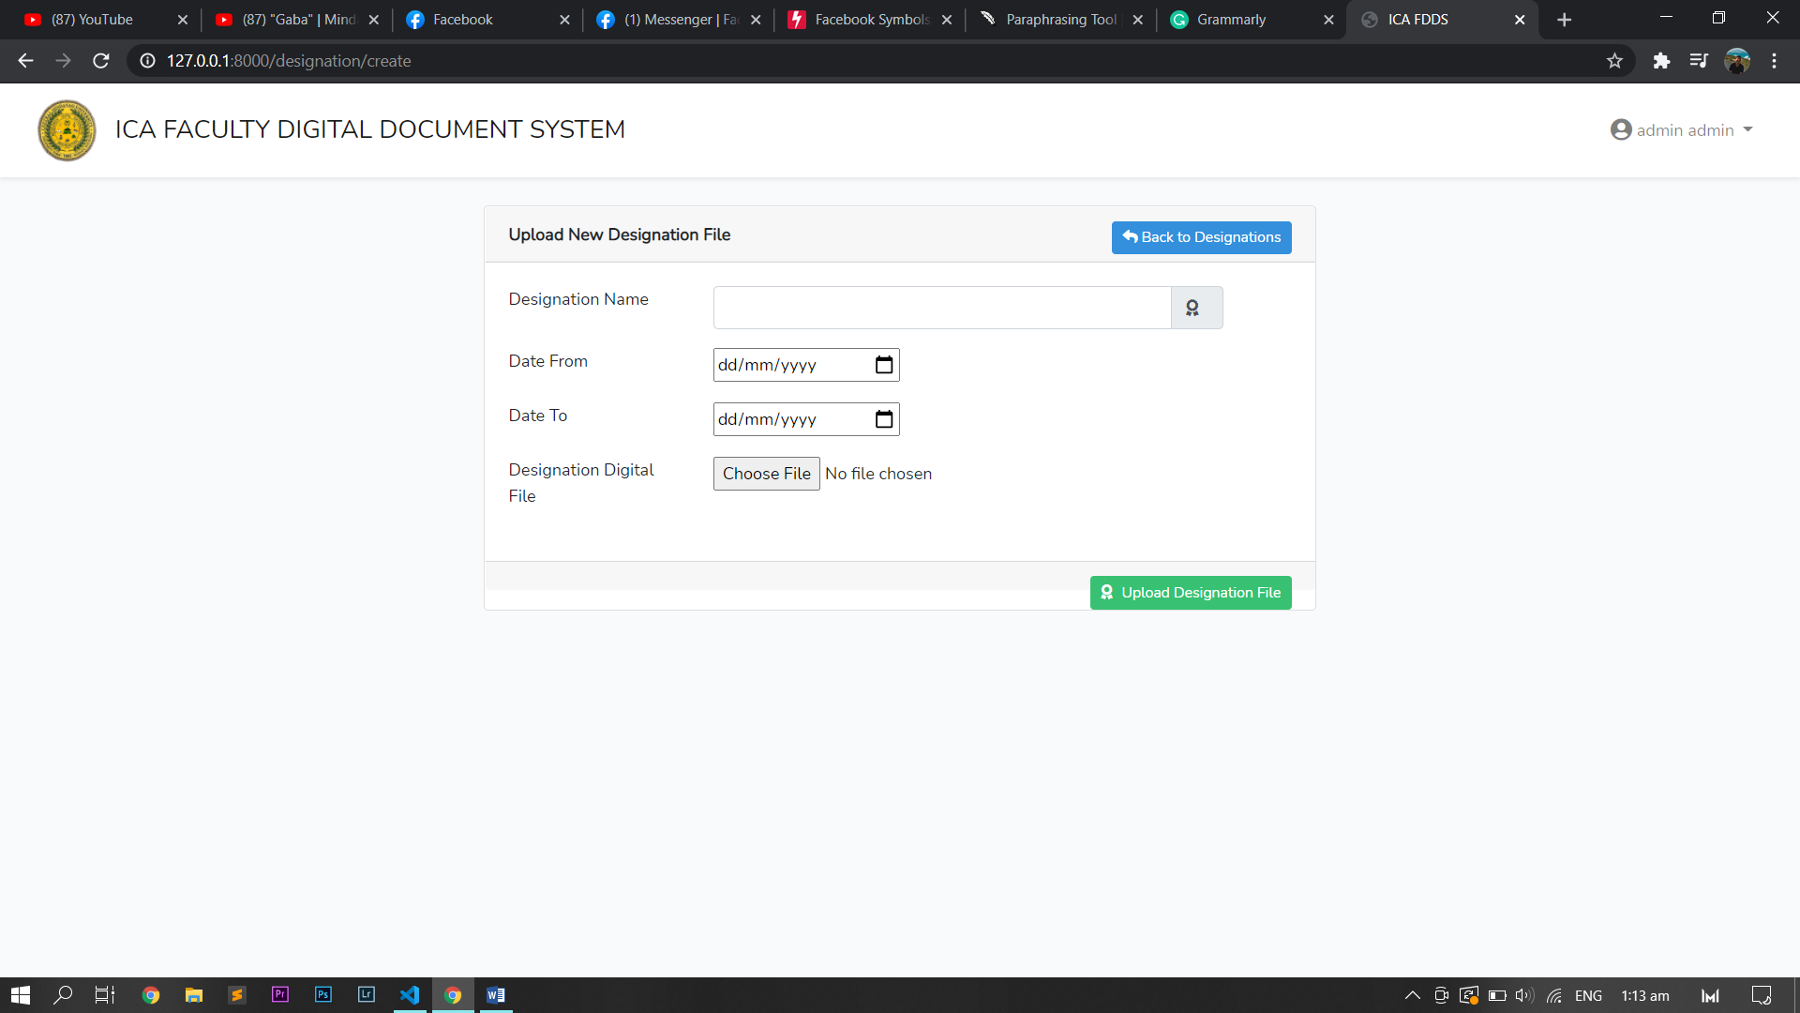

E.4 Edit Designation File Section

When you edit a designation file, after clicking the edit designation file button, you will be prompted to edit the designation file page, where you can modify details such as the designation name, date from, date to and designation of the digital file by uploading the scanned file, after modifying the information that you can now continue by clicking the edit designation button.

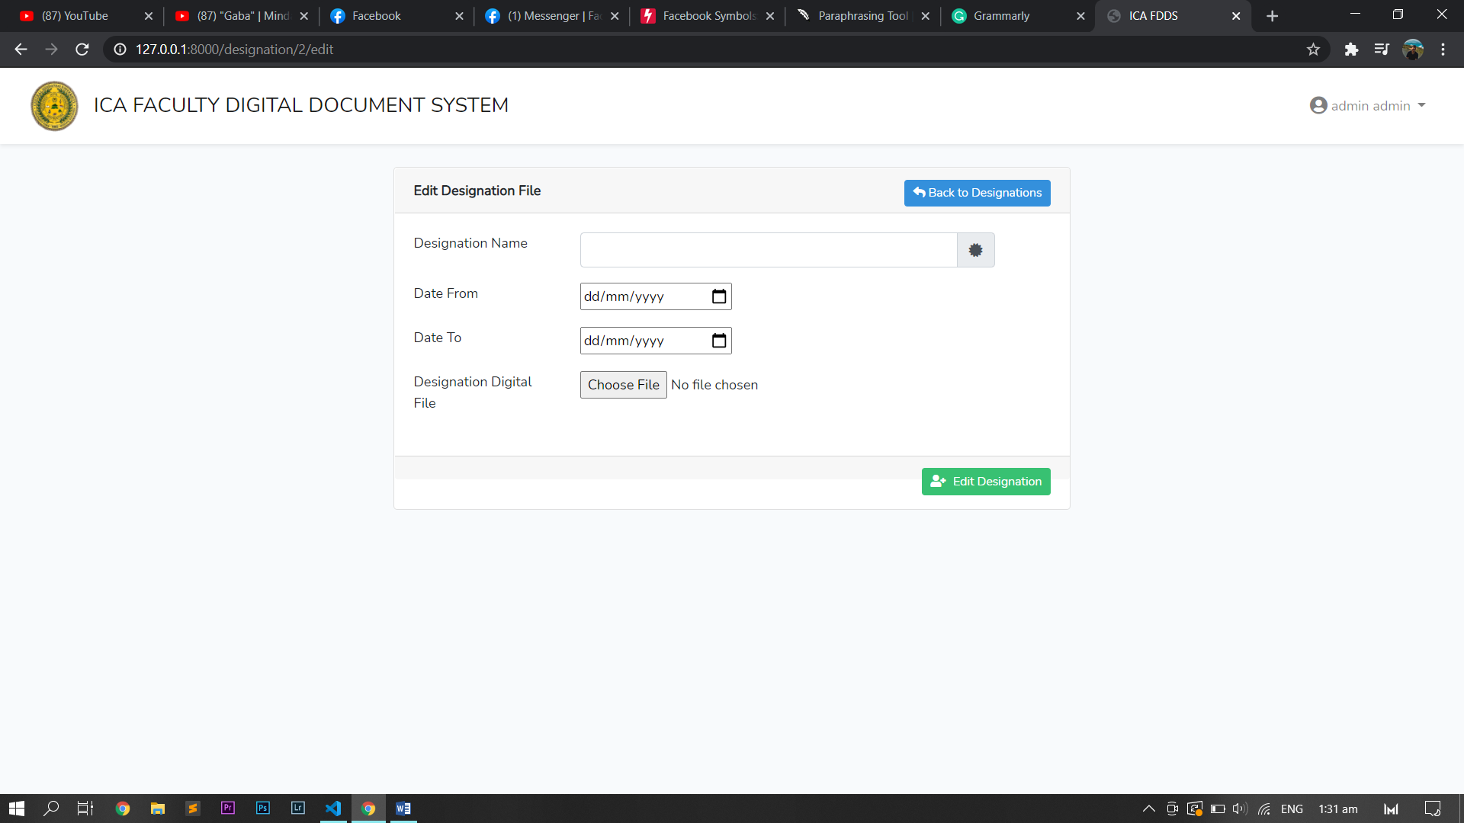

E.5 Show Designation File Section

The other action you will perform in the designation file is to view the designation file information, where you can request the designation file information tab when you click on it, where you will find the file information such as the designation ID, the employee ID undergoing the training, the name designation, date from, date to and image of the certification. The page also has the ability to change the designation or delete the designation. When you delete the designation, the dialog shows when the button is clicked and you may cancel or confirm the deletion of the file. When you delete the file, you can return to the designation file page with the modified designation file list.

