Siobhan Harrington - W209.3 - Assignment 3

## Introduction

Our W209 group proposed a data visualization comparing state gun violence prevention laws and correlated gun violence rates over a 17 year period. In late November, 2019, we conducted a usability test with friends and family. I personally interviewed three people and asked them to complete a series of tasks as outlined in the “Usability Test Tasks and Questions” section. Some of the tasks were completed effortlessly and some tasks were harder than I expected. I recorded notes of these interactions in the “User Interaction Notes” section. Finally, I created a running list of enhancements and priorities in the “Enhancements Prioritization” section. The visualization we used for this set of usability testing can be found at: <http://people.ischool.berkeley.edu/~priteshnpatel/w209/>. For convenience, here is a screen shot of the visualization.

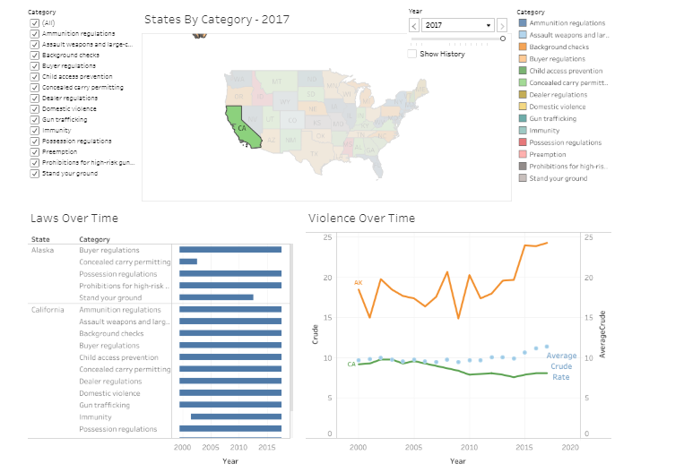

## 

## Usability Test Tasks and Questions

We assembled a list of usability questions that will help us understand how effective our visualization is. Our hope was that with minimal guidance, users can interact with our data visualization and easily answer these specific questions:

1. How many law types are included in this data visualization?

2. What time frame is covered by this data visualization?

3. Which states had ammunition regulation laws in 2005?

4. Which states had ammunition regulation laws in 2010?

5. What gun restrictions were in place in West Virginia in 2002?

6. For West Virginia, what is the crude rate for firearm violence in 2015?

7. For West Virginia, what is the difference between crude rate for firearm violence and the average crude rate in 2016?

8. For West Virginia, what happened to the crude rate for firearm violence after the Stand your ground law was removed?

9. For West Virginia, what happened to the crude rate for firearm violence after the concealed carry permitting and possession regulations law was removed?

10. What type of law do you think is most effective at reducing firearm violence?

## 

## User Interaction Notes

### Participant 1

Click [here](https://zoom.us/recording/share/Is5bBHzIJVrz7vkrlNEPSbE2QPjIGIvvZaRsSXkpzhmwIumekTziMw) for a recording of the usability test. Participant 1’s background is in computers, so he’s very familiar with using technology to get a better understanding of various subject areas.

He skimmed the introduction section. He did not expand any of the subject areas. Perhaps this is because he was unaware that he could, or perhaps it was because he was uninterested **(Enhancement Item #1)**.

He quickly understood the layout of the top section of the visualization (map). He identified the answer to the first question in the introduction text, but easily found the year filter. After two seconds, he discovered that the time filter is much quicker with the drop down as opposed to the forward/backward options. He answered questions 1-4 in no time and without any struggle.

We hoped that users would realize they could click on West Virginia to filter out the bottom section and easily answer questions 5-9. However, participant 1 did not make this connection. For question 5 (What gun restrictions were in place in West Virginia in 2002?), he knew he needed to look in the lower left hand corner. However, instead of clicking on West Virginia, so that only this state’s data displays, he scrolled to the bottom of the list with all states included. He was able to answer this question, but it took a little time. However, question 6 (For West Virginia, what is the crude rate for firearm violence in 2015?) was a greater challenge. Here is what participant 1 saw when he tried to answer this question:

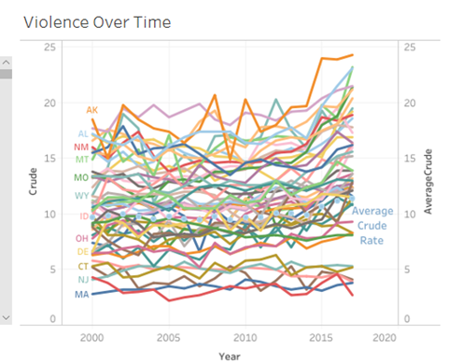

Obviously, the busy data visualization above was not what we intended. We hoped he would have clicked on the state West Virginia in the top section map. Then participant 1 would see the graphic below and easily answer the question. Clearly, we needed better labelling/instructions to highlight the filter feature **(Enhancement Item #2).**

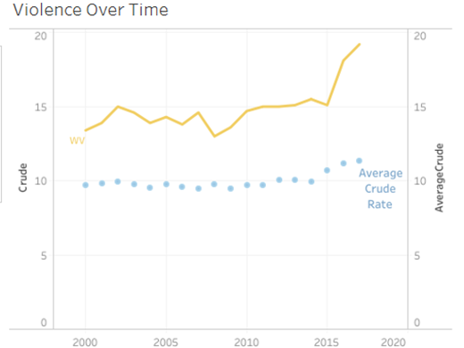

After allowing participant 1 to struggle for the maximum amount of time that his patience would allow, I hinted that the map was acting as a filter. Once he realized he could click on West Virginia, he easily answered questions 5-9. Currently, when a state does not have a particular regulation, the state outline and color disappears. He provided feedback that the map would look better if the state map outline remained and only the shading disappeared **(Enhancement Item #3).**

Question 10 requires a bit of patience and exploration. Participant 1 clicked on a couple of regulations but saw no clear correlation. He quickly gave up. To be fair, there is not a clear cut data case that any of these laws consistently correlates to reduced gun violence. He did note that the data visualization communicated a great deal of information and would be helpful in understanding if there was a relationship between gun violence prevention laws and actual gun violence..

### Participant 2

Click [here](https://zoom.us/recording/share/YArIlCLpkV40pUckBSArTWFK6rSHDgl6Yn7-Gf65O3o?startTime=1574754861000) for a recording of the usability test. Participant 2 does not have a strong background in computers but is very detailed oriented.

She diligently reviewed the intro section and discovered after some time that the background sections could expand.. She reviewed several gun violence law categories that were unfamiliar to her. She quickly answered how many law types based on the introduction paragraph alone.

For question 2, she was forced to spend some time on the visualization. Instead of using the drop down, she intuitively used the page backward button. This button was very slow since it refreshes the page with each click rather than a single click to the year. It was frustrating for the user to navigate slowly year by year **(Enhancement Item #4)**.

For question 3, she did not understand that clicking the “All” button would remove all the items. Instead she removed the items one by one which took a long time because with each click, the map has to fully refresh **(Enhancement Item #5)**.

Question 4 she answered easily, and she quickly figured out that she could click on a state to get the answer to question 5. As she was hovering over West Virginia, she expected to see all the regulations for West Virginia instead of just 1 regulation **(Enhancement Item #6)**. Because this was misleading, I added Item 6 as Major Usability error.

For Question 6, she found a feature I had not yet seen. She double clicked on the “Violence Over Time” graph at the bottom. Then, there was an option to “View Data”. She was able to get the answers for question 6 and 7 from this data. From observing her, I think participant 2 is more comfortable with data in table format and it was a helpful, tableau feature. However, the data that appears is not well-labelled. The average crude rate has a label of “Null” as shown below **(Enhancement Item #7)**.

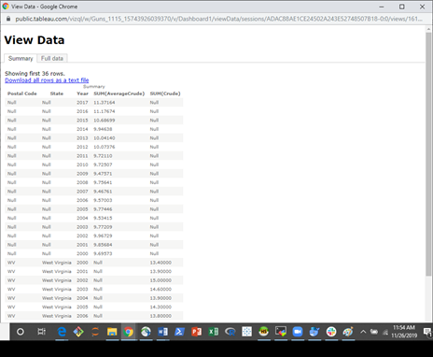

Questions 8 and 9 forced participant 2 to use the graphs at the bottom as they were designed. She finally engaged with these visualizations and she was able to easily answer the questions. Participant 2’s opinion about gun violence prevention laws were not changed by this graphic. She realized that there were several omitted variables in this data visualization.

### Participant 3

Click [here](https://zoom.us/recording/share/CpmJuRA-8TUI33aanQ-WpnX8bwfF3Ve3HHshQFdmwZWwIumekTziMw) for a recording of the usability test. Participant 3 spends a lot of time working with data and reporting (tableau specific). She first read through the introduction. She did figure out the law regulations expanded. She leveraged the introduction to answer questions 1 and 2. For question 3, she was forced into the data visualization section. She quickly found the year filter and the gun regulations filter. She knew that clicking “All” would remove all the regulations, so she easily pulled up the answer to questions 3 and 4.

For Question 5, Participant 3 demonstrated similar behavior to Participant 1. In the lower left hand corner, she scrolled through all the states to the very bottom for West Virginia and correctly answered the question. However, question 6 is not answerable unless the data is filtered. Once she had a hint that she could click on the states in the map, she easily came to the answer for question 6.

Questions 7, participant 3 was able to get to the answer, but it took her a little bit of time to find the correct year with the mouse-over. For question 8, she found all the information and knew how to use the visualization, but she misread what year the blue box was in. Having gridlines **(Enhancement Item #8)** would help users find the exact point in time on both lower section graphs more accurately and more easily.

Overall, she had positive feedback about the tool, but agrees that some direction in the state filtering would be helpful. She also commented that since the “Violence Over Time” graph is difficult to read with all the states, our team should consider only displaying the “National Average Crude Rate” until the user selects one or more states **(Enhancement Item #9)**.

## Enhancement Prioritizations – MoSCoW

|  |  |  |  |  |  |
| --- | --- | --- | --- | --- | --- |
| **Item** | **Description** | **Enhancement** | **MoSCoW** | **Severity** | **Level Of Effort** |
| 1 | In the introduction section, some participants seem unaware that there is a more detailed description for each gun law category | Adjust the format to display a high level statement and a note that the user can click for more details. | Should Have | Minor Usability (2) | Small |
| 2 | User is unaware that clicking on a state will filter the bottom section. | Add some clarification in the introduction to exploration. Modify the tool tip to highlight that the user can select one or ctl/select multiple states to filter the charts below. | Must Have | Major Usability (3) | Small |
| 3 | State Outlines Disappear when the law category does not exist in that state. Users would prefer the line to exist but the state would not be shaded. | Modify the tableau map to show borders regardless of shading. | Could Have | Cosmetic(1) | Small |
| 4 | The right/left page navigation for the filter is slow, because you have to wait for each year to refresh the data. | Add a note or a tool tip that selecting a specific year is faster with the drop down. | Should Have | Minor Usability(2) | Small |
| 5 | User did not know how to use the “All” option to remove all the law category types and instead deselected each item one by one. Because the screen refreshes every time, this was a frustrating process. | Either note that a user can use “All” to deselect the options OR give a “Clear All” option. | Could Have | Minor Usability(2) | Small |
| 6 | The mouse-over for each state on the map only contains one regulation category and is misleading to users. | Either add in all the regulation categories for each state or remove the regulation categories from the mouse-over. | Must Have | Major Usability(3)  (misleading) | Small |
| 7 | The “View Data” option for the Violence Over Time Line Graph shows the average line data as a series of “Null” state records. | Change “Null” to read something user friendly like “National Average” | Should Have | Minor Usability(2) | Medium |
| 8 | Users have to carefully hover over points on the two lower graphs to understand the data point for a given year. | Add in tick lines for the two lower graphs so that it is easier for users to understand the data point for a given year. | Could Have | Cosmetic(1) | Medium |
| 9 | The lower right hand graph is unreadable when all states are selected. | Default the lower right hand graph “Violence Over Time” to only show the average crude rate unless one or more states are selected. | Could Have | Minor Usability(2) | Medium |