Design and Development of Intelligent Transportation Systems for Campus Bus Management: A Comprehensive Technical Review

Shankar Gadhve Assistant professor Dept- Information Technology St. Vincent Pallotti College of Engineering and Technology, Nagpur, Maharashtra, India. sgadve@stvincentngp.edu.in
Siona Babu UG Student Dept-Information Technology St. Vincent Pallotti College of Engineering and Technology, Nagpur, Maharashtra, India. sionababu.24@stvincentngp.edu.in
Anushree Khobe UG Student Dept-Information Technology St. Vincent Pallotti College of Engineering and Technology, Nagpur, Maharashtra, India. anushreekhobe.24@stvincentngp.edu.in

Bhakti Hiwase UG Student Dept- Information Technology St. Vincent Pallotti College of Engineering and Technology, Nagpur, Maharashtra, India. bhaktihiwase.24@stvincentngp.edu.in
Anushka Raut UG Student Dept-Information Technology St. Vincent Pallotti College of Engineering and Technology, Nagpur, Maharashtra, India. anushkaraut.24@stvincentngp.edu.in

Abstract- Timely and safe transportation is essential for student life in colleges and universities. However, many institutions still use manual communication or fixed schedules. This leads to uncertainty, wasted time, and safety issues. To address these problems, we suggest a real-time college bus tracking system. This system allows students, drivers, and administrators to access live updates and route information through a web-based platform. Our system includes driver-side GPS tracking, a Firebase cloud database, and the Google Maps API to show accurate bus locations and estimated arrival times. The design ensures transparency, low cost, and easy access from any browser without needing extra hardware. A three-layer communication model connects students, drivers, and administrators through real-time notifications, attendance logging, and route monitoring. This solution encourages punctuality, safety, and sustainability by cutting down on wait times and improving route usage across the campus network.
Keywords - GPS, Firebase, Google Maps API

I. INTRODUCTION
Effective and dependable transportation management has become a critical feature in contemporary educational institutions, yet many colleges continue to rely on manual scheduling or personal interaction between drivers and students. For this reason, miscommunication and mismanagement occurs, creating ambiguity regarding the arrival and departure times of buses. The lack of a standardized or formal process leads to inconveniences and diminishes punctuality and overall safety.
In recent years, with the advancements of technologies such as Global Positioning System (GPS), Global System for Mobile Communications (GSM), and cloud applications, real-time tracking systems have emerged that can ameliorate these issues. A College Bus Tracking System implements all of these technologies, to provide live location tracking, estimated arrival times and real-time notifications to students, parents, and administration. These systems facilitate transparency, while increasing communication, within the scope of campus transport service.
The focus of this review paper is to explore existing models and research developments within real-time vehicle/bus tracking systems. Technologies such as Firebase and mobile-based GPS tracking are examined and assessed for their advantages and shortcomings and possibilities for implementation within a campus context. Finally, emerging technologies and sustainable frameworks are examined for their use in improving transport systems, in anticipation of a smart/connected campus.
II. LITREATURE SURVEY
The paper by Hemachandran et al. (2020) presents a detailed discussion on how GPS, GSM, IoT, and BeiDou (BDS) satellite systems can enhance the accuracy of vehicle tracking. The model efficiently transmits vehicle coordinate and performance information in real-time, via GSM allowing for continuous tracking without the need for heavy backend server. The user can send and receive simple SMS messages programming vehicle location and alerts to their regular mobile phone, and it works with or without internet. The framework enhances vehicle security by allowing remote lock or unlock functions, as well as alerts via text messaging if the vehicle moves without authorization or exceeds the driver's speed limit. The research indicates the scalability of the frameworks and the researchers conclude that an IoT-based framework with GSM-enabled real-time tracking system enhances safety, efficiency, and reliability in transportation management and represents a step toward future advances in cloud-computing and AI-driven predictive-analytic based systems to build smarter and more sustainable tracking systems. [1]

The study by J. Navya Sree et al. (2021) proposes an Android-based real-time college bus tracking system with incorporating GPS, Google Maps API, and a server-database architecture to provide live tracking of location updates to the students. The college bus tracking system utilized the GPS coordinates from the location of the driver’s phone to send coordinates to a central server and displayed the exact location of the bus as well as the bus route on the students’ mobile devices using the Google Maps API. The academic and practical significance of smartphones as a means of leveraging their GPS capabilities over external hardware makes their implementation inexpensive, efficient, and easily accessible for bus tracking and diminishing wait time. [2]
The paper by Prashanth H. S. et al. (2025) focuses on GPS and GSM technologies for real-time vehicle location tracking, often supported by mobile and web-based interfaces for user accessibility. Google Maps API displays bus routes, while cloud databases like Firebase store and sync data in real time. Some implementation employ IoT frameworks , Arduino, or Raspberry Pi modules for automation and sensor integration, while others use RFID for bus and passenger identification. Additionally, SMS-based alert mechanisms are adopted to notify users in areas with limited internet connectivity. These technologies create a reliable, low-cost, and accessible platform for efficient campus transportation tracking. [3]

The study by Ashish Sonar et al. (2022) presents a college bus tracking system built using Android technology integrated with GPS and Google Maps API to provide real-time bus location updates. The system employs Firebase cloud storage to upload and synchronize the driver’s GPS data, enabling students to track their buses instantly through a mobile application. It operates on a client–server architecture, where the driver’s smartphone continuously sends latitude and longitude data to the server, which is then displayed visually to users. The system also uses authentication modules for admin, driver, and student access, ensuring secure data handling. By combining Android Studio, GPS, cloud storage, and Google Maps, the proposed framework delivers an efficient, user-friendly, and cost-effective solution for real-time campus transportation management. [4]
III. PROBLEM DEFINITION
Numerous institutions of higher learning are still operating their transportation systems in an inefficient manner by relying on fixed schedules or loose communication of drivers or students with administration. This results in the ability to accurately predict the time of arrival of the bus. This means students are sometimes unnecessarily waiting or sometimes miss their bus. There usually is also an inability to communicate in real time, or have a point of visibility in the event of a delay on the route or a mechanical malfunction or emergency that doesn't allow the bus or driver to remain on schedule, safety is compromised with students on the bus, the driver or the transportation department. Route planning for bus usage and efficiency is inefficient and therefore, the bus operation is wasting time and burning fuel for no reason. These situations suggest a need for a Smart Live Bus tracking system. A Smart Live bus tracking system will have the ability to GPS track the bus location using the technology and allow real time bus tracking, time of arrival and alerts to students on unexpected delays or emergencies. Smart Live Bus Tracking System can also provide administrative recommendations based on route analysis and optimization. A Smart Live Bus Tracking System will increase safety, improve use of time, improve operational efficiency, and assist with ongoing digital transformation/smart campus initiatives implementation in India as outlined in the SIH25013 Problem Statement by the Government of Punjab.
IV. PROPOSED APPROACH
The College Bus Tracking System is an innovative, web-based solution designed to enhance the safety, transparency, and operational efficiency of student transportation. Unlike conventional systems that rely on expensive GPS modules or GSM-based updates prone to delays and inaccuracies, this system leverages the driver’s smartphone GPS integrated with the Google Maps API and Firebase Realtime Database. This combination enables precise, real-time bus tracking and efficient student attendance management. The proposed solution is cost-effective, easy to implement, and accessible through any web browser—eliminating the need for dedicated mobile applications or additional hardware installations.
The system architecture includes three main user roles: Student/Driver, School Admin, and Local Coordinator. The Driver registers and logs in through a simple web interface, activating GPS tracking via their smartphone. The School Admin oversees route management, bus allocation, and student data while monitoring live updates from all active vehicles. Meanwhile, the Local Coordinator functions as a supervisor, accessing the dashboard to track bus locations, monitor progress, and verify student attendance in real time.

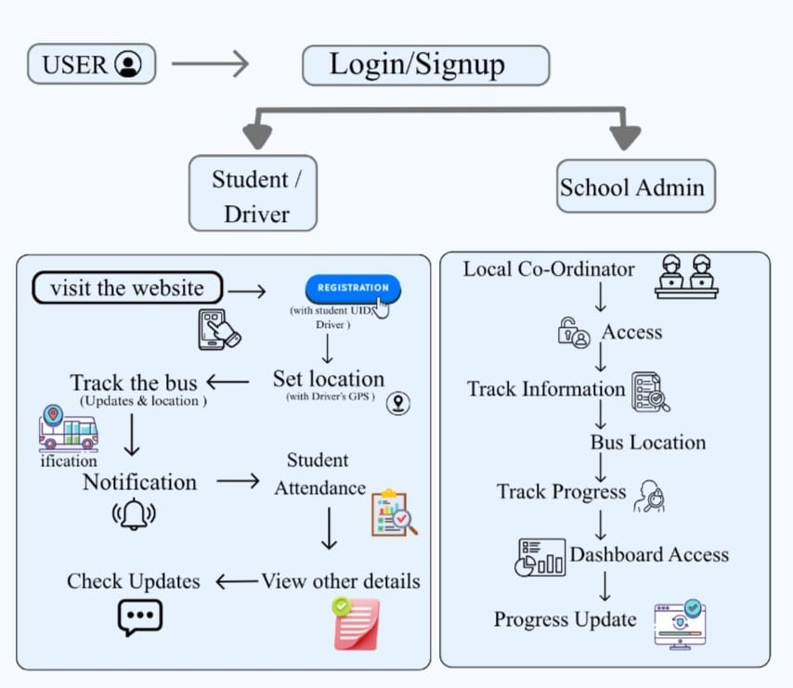

Once the bus journey begins, the driver’s GPS coordinates are automatically captured and transmitted to the backend via a REST API. The Firebase Database stores and syncs this information across all connected users, ensuring that students, parents, and administrators can view live updates of the bus’s location, estimated time of arrival (ETA), and route progress. The frontend, built using HTML, CSS, and JavaScript, displays this data in an interactive and user-friendly format through embedded Google Maps.
The notification module provides instant alerts to students and parents regarding bus arrival times, route deviations, or delays. In case of emergencies, such as a breakdown or traffic congestion, the system sends immediate updates through the web portal. Furthermore, the admin dashboard allows authorities to add, edit, or delete bus and driver details, monitor multiple routes simultaneously, and analyze attendance or punctuality statistics.
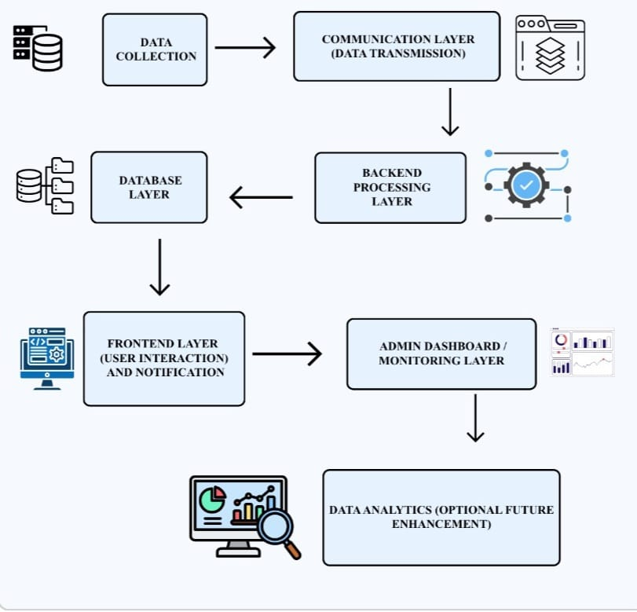
The notification module provides instant alerts to students and parents regarding bus arrival times, route deviations, or delays. In case of emergencies, such as a breakdown or traffic congestion, the system sends immediate updates through the web portal. Furthermore, the admin dashboard allows authorities to add, edit, or delete bus and driver details, monitor multiple routes simultaneously, and analyze attendance or punctuality statistics.
For future enhancement, the backend supports data analytics and predictive modeling, which can optimize bus routes, predict delays based on traffic history, and generate weekly or monthly performance reports. Integrating machine learning models in future versions can further improve ETA accuracy and enhance decision-making for transport administrators.
The proposed College Bus Tracking System combines simplicity, affordability, and technological efficiency. By leveraging existing smartphone hardware and cloud-based technologies, it minimizes infrastructure costs while delivering a secure, transparent, and user-friendly transportation management platform. Its automatic attendance tracking, real-time monitoring, and instant notification features collectively ensure student safety, punctuality, and parental peace of mind, marking a significant advancement in modern educational transport management.

V. RELATED WORK
Several studies and projects have explored the development of intelligent transportation systems for educational institutions to improve safety, efficiency, and communication. J. Navya Sree et al. (2021) proposed an Integrated College Bus Tracking System using GPS and Android technology, allowing students to view the real-time location of their buses through a mobile application. Similarly, research by P. Kumar et al. (2020) introduced a GSM and GPS-based bus monitoring model that provided location updates via SMS; however, it faced limitations such as high cost, network dependency, and delayed updates. Another work by R. Kaur and S. Sharma (2019) developed a mobile-based transport management system that enhanced student safety by integrating emergency alerts and route optimization features.
While these systems contributed to the advancement of transport monitoring, most relied heavily on dedicated mobile apps or expensive GPS modules, which limited accessibility and scalability. In contrast, the proposed College Bus Tracking System eliminates these dependencies by utilizing the driver’s smartphone GPS integrated with Google Maps API and Firebase Realtime Database. This approach offers a more affordable, web-based, and real-time tracking solution that is easy to deploy and maintain, making it a significant improvement over earlier implementations.
V. CONCLUSION
The College Bus Tracking System successfully addresses the key challenges faced by traditional college transportation management, such as lack of real-time visibility, poor communication, and inefficient route planning. By integrating smartphone-based GPS tracking with Google Maps API and Firebase Realtime Database, the system provides an affordable, accurate, and easily accessible platform for monitoring bus locations and managing student attendance. It enhances safety and punctuality while minimizing manual effort and dependency on outdated methods. The system’s

web-based design ensures flexibility and usability across multiple devices without requiring additional hardware or mobile applications. Through live updates, automated alerts, and route management, it enables smoother coordination between students, drivers, and administrators. Overall, this project demonstrates a scalable, cost-effective, and efficient solution that contributes to the digital transformation of campus transportation, aligning with the broader vision of developing smart campus initiatives in India.
VI. REFERENCES
[1] Hemachandran K 1, Shubham Tayal 2, G Sai Kumar 3, Vamshikrishna Boddu 4, Swathi Mudigonda 5, and Muralikrishna Emudapuram 6.”A Technical Paper Review on Vehicle Tracking System”, International Conference on Computer Networks, Big Data And IoT.

[2] J. Navya Sree ,C. Mounika1 , T. Mamatha1 , B. Sreekanth1 , N. Diwakar1 , Noor Mohammed2,” Integrated College Bus Tracking System”, International Journal of Scientific Research in Science and Technology, Volume 8, Issue 3, June 2021 https://doi.org/10.32628/IJSRST2183164

[3] Prashanth H S1, Adithya M2, Achyutha U N3, Aditya V4, Anirudh M Mudamb, “A Survey on Real-Time College Transport Tracking Solutions: User Perspectives and Design Considerations”, International Journal of Advanced Research in Computer and Communication Engineering, Vol. 14, Issue 5, May 2025

[4] Ashish Sonar, Sanket Patil, Sushil Urkude, Swapnil Sandhan,” College Bus Tracking System”, International Journal of Advanced Research in Science, Communication and Technology, Volume 2, Issue 1, May 2022

[5] 1.Kalyani Akhade, 2.Krishna Dadge, 3.Rutuja Nikam, 4.Dipti Satpute, 5.Kunal Shinde,”A Real Time Bus Tracking Application”, International Journal of Innovative Science and Research Technology , Volume 9, Issue 4, April – 2024 https://doi.org/10.38124/ijisrt/IJISRT24APR1696

[6] Akshay Sonawan, Ankeet Bhanushali, Kushal Gogri, Milind Khairnar,” Real Time Bus Tracking System”, International Journal of Engineering Research & Technology, Vol. 9 Issue 06, June-2020

[7] Ms. M. Sowndharya, Yuvraj K, Rahul S Srichandiran , Sriram S,”Smart College Bus Tracker: Real-Time Location and ETA Predictor”, International Journal of Scientific Research and Engineering Development”, Volume 8 Issue 3, May-June 2025

[8] N.Malligeswari1, Jothilakshmi2 ,P.Arunadevi3, K. Sindhumathi,” College bus tracking system”, International Journal of Engineering Technologies. June 2023 https://www.researchgate.net/publication/373298501

