Social Media Regression Analysis
Aditya Muddapu, Sion King, Ricardo Gonzalo
2025-11-26
- For Project 2, a Regression Analysis was made on a data set containing 13 different predictors and a sample size of 500 people. The goal was to find how social media use affected a user’s happiness. A happiness scale was given in the dataset based on a survey given to participants where they filled how happy and stressed, they were on a scale of 1-10 with sleep quality also on the same scale. Happiness was originally left-skewed and then square-transformed for a better fit. After data cleaning, exploratory analysis, multicollinearity checks, and model diagnostics, a model was built to find out the most influential predictors of happiness. For the squared model, age, sleep quality, and stress level were discovered to be the most statistically significant predictors. Higher sleep quality and lower stress showed a correlation with increased happiness, while age had a small but meaningful effect. The other predictors in the data set like gender, daily screen time, days without social media, and exercise frequency were not statistically significant and were removed from the model. Model diagnostics confirmed that assumptions were reasonably satisfied after transformation. Results showed that psychological and behavioral wellness indicators play a central role in predicting happiness.

- How does social media use affect a user’s happiness? Does increased time spent on social media affect happiness more? Do different social media apps have a different effect on a user’s happiness?

- The data set was found on Kaggle and it was collected through a survey given to people from ages 16-49 asking them to give their exercise frequency, stress level, sleep quality, age, gender, daily screen time, days without social media, and the social media platform they used. Stress level, sleep quality, and happiness index were all rated on a scale from 1-10.

- R was used for all the code and tables provided.

5A\B) The summary stats can be found below in the 2nd chunk and graphs are placed throughout the report.

5C) The residual histogram showed mild skewness, the residuals vs fitted suggested some curvature and the scale-location plot displayed a slight “V-shape,” indicating non-constant variance. The Q-Q plot was relatively a straight line.

5D) All VIF values were under 5 which indicated no collinearity.
6A) There were no missing values and only the ID column was dropped.

6B) Outliers were inspected using boxplots, but none were extreme enough to be removed.

6C) Since happiness was left-skewed a square transformation was applied. However, both models were shown (before the square transformation and after).

6D) Categorical variables (Gender and Social Media Platform) were converted to dummy variables.

*NOTE The chunks are below but the first showing #7 is before the transformation the information below is based on after the transformation*
7A) Each predictor was individually regressed on happiness. Sleep Quality, Stress level, and Age showed significant relationships with happiness.

7B) Interaction terms were tested but did not improve the model and cofounding was checked by observing coefficient changes when predictors were added or removed. No strong cofounders found.

7C) A full model including all predictors was fit and several had p-values above 0.05 indicating that they had to be removed.

7D) Selection was based on the p-values with Age, Sleep Quality, and Stress Level as significant predictors.

7E) Residual plots improved linearity and homoscedasticity after transformation.

7F) The final chosen model had Age, Sleep Quality, and Stress Level.

8A. After a square transformation was applied to compensate for the left-skewed distribution of the happiness index, the final model had Age, Sleep Quality, and Stress level as the statistically significant predictors of squared happiness. This was based on the p-values of each predictor. Sleep quality showed that a higher quality of sleep a person has, the higher happiness they should have as well. The positive coefficient shows that as it increases, the happiness score increases as well. Stress level showed a negative relationship with squared happiness and that higher stress corresponds to lower predicted happiness. Age was also significant but not as much as the other two predictors. Since it is positive, it shows that the older a person is, the happier they can be. However, the value for it is decently low.
8B. To show the model’s accuracy, confidence intervals, prediction intervals, and error metrics were used. RMSE represents the average prediction error in original happiness units and MAE gives the absolute difference between actual and predicted happiness values. The confidence and prediction intervals showed that the model captures clear signal primarily from sleep quality and stress. However, it showed that happiness still has substantial natural variation, which is common for psychological outcomes.
9. The purpose of this study was to examine how social media use, along with other factors, affected an individual's happiness. The analysis showed that social media use itself was not a significant predictor of happiness and neither was screen time nor the number of days spent away from social media. Also, increased time spent on social media did not appear to affect happiness more strongly and daily screen time did not have an effect either. In addition, the social media platform used also did not have a significant effect on happiness. We can say with confidence that the strongest predictors of happiness were sleep quality (positive effect), stress level (negative effect), and age. These physical and psychological well-being factors overshadowed the influence of social media use. In conclusion, the data shows that happiness is shaped much more by personal well-being than by social media habits or the platform used.

Appendix and References
Confidence and Prediction Intervals for squared dataset
https://d.docs.live.net/57ba4a57f5daa88e/Documents/happiness_squared_conf_pred_intervals.csv

R was used for all the code and tables provided. # R script to reproduce happiness modeling pipeline
library(readr)
## Warning: package 'readr' was built under R version 4.5.2
library(dplyr)
##
## Attaching package: 'dplyr'
## The following objects are masked from 'package:stats':
##
## filter, lag
## The following objects are masked from 'package:base':
##
## intersect, setdiff, setequal, union
library(caret)
## Warning: package 'caret' was built under R version 4.5.2
## Loading required package: ggplot2
## Loading required package: lattice
library(car)
## Loading required package: carData
##
## Attaching package: 'car'
## The following object is masked from 'package:dplyr':
##
## recode
library(ggplot2)
# --- Load dataset ---
data <- read.csv("C:/Users/jesge/Downloads/Mental_Health_and_Social_Media_Balance_Dataset.csv")
# Use 'df' consistently
df <- data
# --- Drop ID-like columns if present 6D ---
for(n in c('User_ID','UserId','id','ID','Id','index')) {
if(n %in% colnames(df)) {
df <- df %>% select(-all_of(n))
}
}
# --- Handle the target variable ---
# Check what the exact column name for happiness is
colnames(df)
## [1] "Age" "Gender"
## [3] "Daily_Screen_Time.hrs." "Sleep_Quality.1.10."
## [5] "Stress_Level.1.10." "Days_Without_Social_Media"
## [7] "Exercise_Frequency.week." "Social_Media_Platform"
## [9] "Happiness_Index.1.10."
# If the column is named "Happiness_Index.1.10.", use this 6A:
df$Happiness_Index.1.10.[is.na(df$Happiness_Index.1.10.)] <- mean(df$Happiness_Index.1.10., na.rm=TRUE)
# --- Set up predictors 5A---
predictors <- setdiff(colnames(df), 'Happiness_Index.1.10.')
cat_cols <- predictors[sapply(df[predictors], function(x) is.character(x) | is.factor(x))]
# --- Dummy encode categorical variables 6D ---
if(length(cat_cols) > 0) {
dummies <- dummyVars(~ ., data = df[predictors], fullRank = TRUE)
X <- predict(dummies, newdata = df[predictors])
} else {
X <- as.matrix(df[predictors])
}
# --- Replace missing values in predictors 6A---
for(i in 1:ncol(X)) {
if(any(is.na(X[,i]))) X[is.na(X[,i]), i] <- mean(X[,i], na.rm=TRUE)
}
# --- Create final model dataset 6 and 7 ---
data_model <- data.frame(happiness = df$Happiness_Index.1.10., X)
# --- Correlation matrix 5B---
cors <- cor(data_model)
write.csv(cors[,'happiness'], file='C:/Users/jesge/Downloads/corr_with_happiness_r.csv')
# --- Fit linear model 7c and 7D---
lm_full <- lm(happiness ~ ., data = data_model)
write.csv(data.frame(VIF = vif(lm_full)), file='C:/Users/jesge/Downloads/vif_happiness_r.csv')
# --- Cross-validation with caret 8B---
set.seed(42)
train_control <- trainControl(method='cv', number=10)
model <- train(happiness ~ ., data = data_model, method='lm', trControl = train_control)
print(model)
## Linear Regression
##
## 500 samples
## 13 predictor
##
## No pre-processing
## Resampling: Cross-Validated (10 fold)
## Summary of sample sizes: 450, 449, 450, 449, 450, 451, ...
## Resampling results:
##
## RMSE Rsquared MAE
## 0.9202936 0.6391336 0.7497185
##
## Tuning parameter 'intercept' was held constant at a value of TRUE
# --- Save model for later use 11---
saveRDS(model, file='C:/Users/jesge/Downloads/happiness_model_rds.rds')
### -------------------------------
### 5A. Frequency Exploration
### -------------------------------
cat("---- 5A: Frequency Exploration ----\n\n")
## ---- 5A: Frequency Exploration ----
# 1. Summary statistics for all variables
summary_stats <- summary(df)
print(summary_stats)
## Age Gender Daily_Screen_Time.hrs. Sleep_Quality.1.10.
## Min. :16.00 Length:500 Min. : 1.00 Min. : 2.000
## 1st Qu.:24.00 Class :character 1st Qu.: 4.30 1st Qu.: 5.000
## Median :34.00 Mode :character Median : 5.60 Median : 6.000
## Mean :32.99 Mean : 5.53 Mean : 6.304
## 3rd Qu.:41.00 3rd Qu.: 6.70 3rd Qu.: 7.000
## Max. :49.00 Max. :10.80 Max. :10.000
## Stress_Level.1.10. Days_Without_Social_Media Exercise_Frequency.week.
## Min. : 2.000 Min. :0.000 Min. :0.000
## 1st Qu.: 6.000 1st Qu.:2.000 1st Qu.:1.000
## Median : 7.000 Median :3.000 Median :2.000
## Mean : 6.618 Mean :3.134 Mean :2.448
## 3rd Qu.: 8.000 3rd Qu.:5.000 3rd Qu.:3.000
## Max. :10.000 Max. :9.000 Max. :7.000
## Social_Media_Platform Happiness_Index.1.10.
## Length:500 Min. : 4.000
## Class :character 1st Qu.: 7.000
## Mode :character Median : 9.000
## Mean : 8.376
## 3rd Qu.:10.000
## Max. :10.000
# 2. Mean of numeric variables
numeric_means <- sapply(df[sapply(df, is.numeric)], mean, na.rm = TRUE)
cat("\nNumeric Variable Means:\n")
##
## Numeric Variable Means:
print(numeric_means)
## Age Daily_Screen_Time.hrs. Sleep_Quality.1.10.
## 32.988 5.530 6.304
## Stress_Level.1.10. Days_Without_Social_Media Exercise_Frequency.week.
## 6.618 3.134 2.448
## Happiness_Index.1.10.
## 8.376
# 3. Range of numeric variables
numeric_ranges <- sapply(df[sapply(df, is.numeric)], function(x) range(x, na.rm = TRUE))
cat("\nNumeric Variable Ranges (min/max):\n")
##
## Numeric Variable Ranges (min/max):
print(numeric_ranges)
## Age Daily_Screen_Time.hrs. Sleep_Quality.1.10. Stress_Level.1.10.
## [1,] 16 1.0 2 2
## [2,] 49 10.8 10 10
## Days_Without_Social_Media Exercise_Frequency.week. Happiness_Index.1.10.
## [1,] 0 0 4
## [2,] 9 7 10
# 4. Standard deviations
numeric_sd <- sapply(df[sapply(df, is.numeric)], sd, na.rm = TRUE)
cat("\nNumeric Variable Standard Deviations:\n")
##
## Numeric Variable Standard Deviations:
print(numeric_sd)
## Age Daily_Screen_Time.hrs. Sleep_Quality.1.10.
## 9.960637 1.734877 1.529792
## Stress_Level.1.10. Days_Without_Social_Media Exercise_Frequency.week.
## 1.542996 1.858751 1.428067
## Happiness_Index.1.10.
## 1.524228
# 5. Missing value counts
missing_values <- sapply(df, function(x) sum(is.na(x)))
cat("\nMissing Values per Variable:\n")
##
## Missing Values per Variable:
print(missing_values)
## Age Gender Daily_Screen_Time.hrs.
## 0 0 0
## Sleep_Quality.1.10. Stress_Level.1.10. Days_Without_Social_Media
## 0 0 0
## Exercise_Frequency.week. Social_Media_Platform Happiness_Index.1.10.
## 0 0 0
# Save to CSV so it can be submitted with your report
write.csv(summary_stats, "summary_stats.csv")
write.csv(numeric_means, "numeric_means.csv")
write.csv(numeric_ranges, "numeric_ranges.csv")
write.csv(numeric_sd, "numeric_sd.csv")
write.csv(missing_values, "missing_values.csv")
cat("\n✔️ Frequency exploration complete. CSV files saved.\n")
##
## ✔️ Frequency exploration complete. CSV files saved.
# ================================
# Part 5b: Data Visualization
# ================================
library(ggplot2)
library(GGally)
## Warning: package 'GGally' was built under R version 4.5.2
library(corrplot)
## corrplot 0.95 loaded
library(dplyr)
# --- Histogram of Happiness ---
ggplot(df, aes(x = Happiness_Index.1.10.)) +
geom_histogram(binwidth = 0.5, fill = "skyblue", color = "black") +
labs(
title = "Distribution of Happiness Scores",
x = "Happiness (1–10 Scale)",
y = "Frequency"
) +
theme_minimal()
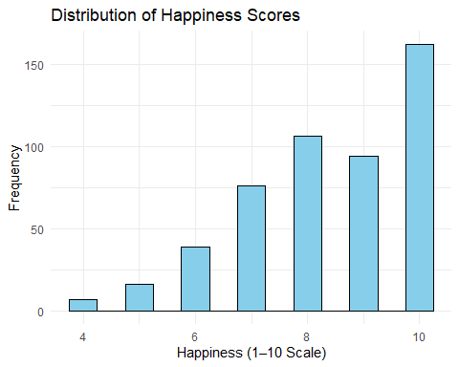
This histogram displays the results of the surveys given to participants to rank their happiness on a scale from 1-10. The distribution is left-skewed which means people reported having higher happiness scores. Later, a square transformation will be applied.

# --- Boxplot of Happiness vs. Social Media Usage (if that column exists) ---
if("Social_Media_Usage" %in% names(df)) {
ggplot(df, aes(x = Social_Media_Usage, y = Happiness_Index.1.10., fill = Social_Media_Usage)) +
geom_boxplot() +
labs(
title = "Happiness by Social Media Usage Category",
x = "Social Media Usage Level",
y = "Happiness (1–10)"
) +
theme_minimal() +
theme(legend.position = "none")
}
# --- Pairwise scatterplots between numeric variables ---
numeric_df <- df %>% select(where(is.numeric))
GGally::ggpairs(
numeric_df[, 1:min(6, ncol(numeric_df))], # show first 6 numeric columns to keep it readable
title = "Pairwise Relationships Between Key Variables"
)
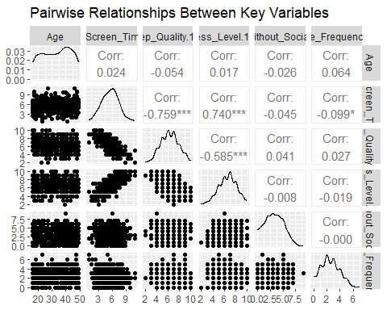
This pairwise graph shows the relationship between every numeric variable in our dataset. Even though the data is condensed in the scatterplots, relationships can still be seen and those without graphs display the correlation. Also, the correlation coefficients tell us the strength and direction of each linear relationship.

# --- Correlation heatmap ---
corr_matrix <- cor(numeric_df, use = "complete.obs")
corrplot(
corr_matrix,
method = "color",
tl.cex = 0.8,
addCoef.col = "black",
number.cex = 0.7,
title = "Correlation Heatmap of Numeric Variables",
mar = c(0,0,1,0)
)
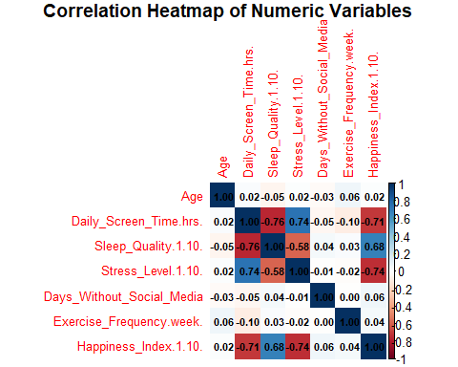
The correlation heatmap is similar to the pairwise graph in how it details the correlation between each variable. It is used to easily spot predictors that are more significant when predicting happiness such as stress level and sleep quality. The heatmap also makes it easier to spot weaker predictors like exercise frequency and days without social media.
# --- Scatterplot of Happiness vs. Screen Time (if available) ---
if("Screen_Time" %in% names(df)) {
ggplot(df, aes(x = Screen_Time, y = Happiness_Index.1.10.)) +
geom_point(color = "steelblue") +
geom_smooth(method = "lm", se = FALSE, color = "red") +
labs(
title = "Relationship Between Screen Time and Happiness",
x = "Average Daily Screen Time (hours)",
y = "Happiness (1–10)"
) +
theme_minimal()
}
##
## Attaching package: 'gridExtra'
## The following object is masked from 'package:dplyr':
##
## combine
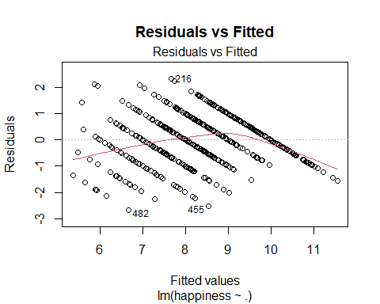
The residuals vs fitted does not show a random scatterplot which means that the data does not meet the linearity assumption.

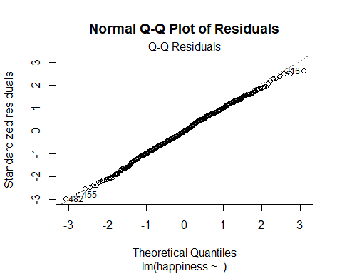
This Q-Q plot shows that the residuals fall directly on the line showing that it is normally distributed.

##
## Shapiro-Wilk normality test
##
## data: residuals(lm_full)
## W = 0.99697, p-value = 0.4832
## Non-constant Variance Score Test
## Variance formula: ~ fitted.values
## Chisquare = 29.14909, Df = 1, p = 6.7017e-08
## Age GenderMale
## 1.033192 1.075229
## GenderOther Daily_Screen_Time.hrs.
## 1.076436 3.563606
## Sleep_Quality.1.10. Stress_Level.1.10.
## 2.406961 2.243380
## Days_Without_Social_Media Exercise_Frequency.week.
## 1.027567 1.051053
## Social_Media_PlatformInstagram Social_Media_PlatformLinkedIn
## 1.689438 1.737130
## Social_Media_PlatformTikTok Social_Media_PlatformX..Twitter.
## 1.797774 1.763430
## Social_Media_PlatformYouTube
## 1.670785
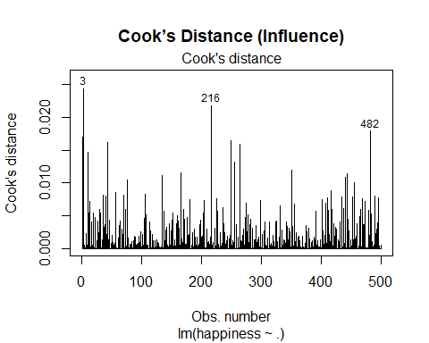
## Warning in plot.window(...): "id.method" is not a graphical parameter
## Warning in plot.xy(xy, type, ...): "id.method" is not a graphical parameter
## Warning in axis(side = side, at = at, labels = labels, ...): "id.method" is not
## a graphical parameter
## Warning in axis(side = side, at = at, labels = labels, ...): "id.method" is not
## a graphical parameter
## Warning in box(...): "id.method" is not a graphical parameter
## Warning in title(...): "id.method" is not a graphical parameter
## Warning in plot.xy(xy.coords(x, y), type = type, ...): "id.method" is not a
## graphical parameter
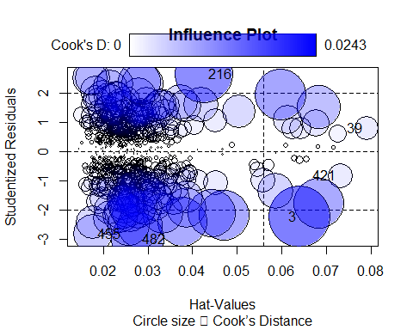
This identifies high influence observations. Points with high leverage or Cook’s distance circles show data points that strongly affect the model. Since only a few points fall outside the curves, there are not many outliers.

## StudRes Hat CookD
## 3 -2.2393210 0.06409254 0.024328009
## 39 0.7788906 0.07901235 0.003720640
## 216 2.6334542 0.04263218 0.021792681
## 421 -0.8281663 0.07309063 0.003865559
## 455 -2.8105881 0.01770142 0.010025564
## 482 -2.9893770 0.02773187 0.017913963
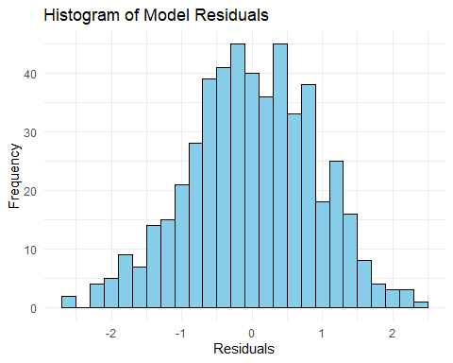
This shows the actual – predicted and it is symmetric with most of the values falling between -1 and 1 which means that the model has balanced errors.
## png
## 2
# ==================================
# Part 5d: Collinearity Evaluation
# ==================================
library(car)
library(caret)
library(dplyr)
# Step 1️⃣: Check Variance Inflation Factor (VIF)
vif_values <- car::vif(lm_full)
vif_table <- data.frame(Variable = names(vif_values), VIF = vif_values)
print(vif_table)
## Variable VIF
## Age Age 1.033192
## GenderMale GenderMale 1.075229
## GenderOther GenderOther 1.076436
## Daily_Screen_Time.hrs. Daily_Screen_Time.hrs. 3.563606
## Sleep_Quality.1.10. Sleep_Quality.1.10. 2.406961
## Stress_Level.1.10. Stress_Level.1.10. 2.243380
## Days_Without_Social_Media Days_Without_Social_Media 1.027567
## Exercise_Frequency.week. Exercise_Frequency.week. 1.051053
## Social_Media_PlatformInstagram Social_Media_PlatformInstagram 1.689438
## Social_Media_PlatformLinkedIn Social_Media_PlatformLinkedIn 1.737130
## Social_Media_PlatformTikTok Social_Media_PlatformTikTok 1.797774
## Social_Media_PlatformX..Twitter. Social_Media_PlatformX..Twitter. 1.763430
## Social_Media_PlatformYouTube Social_Media_PlatformYouTube 1.670785
# Save to CSV for your report
write.csv(vif_table, "C:/Users/jesge/Downloads/vif_values.csv", row.names = FALSE)
# Step 2️⃣: Identify problematic predictors
# (Rules of thumb: VIF > 5 indicates moderate collinearity, VIF > 10 is high)
high_vif <- vif_table %>% filter(VIF > 5)
print(high_vif)
## [1] Variable VIF
## <0 rows> (or 0-length row.names)
# Step 3️⃣: If any VIFs are too high, consider removing those predictors and refitting the model
if (nrow(high_vif) > 0) {
message("High VIF detected. Refitting model without these variables...")
# Create new dataset without high-VIF predictors
keep_vars <- setdiff(names(data_model), high_vif$Variable)
# Refit the model
lm_reduced <- lm(happiness ~ ., data = data_model[, keep_vars])
# Compare models
print(summary(lm_full)$adj.r.squared)
print(summary(lm_reduced)$adj.r.squared)
# New VIFs
new_vif <- car::vif(lm_reduced)
print(new_vif)
# Save comparison results
write.csv(data.frame(
Model = c("Full", "Reduced"),
Adj_R2 = c(summary(lm_full)$adj.r.squared, summary(lm_reduced)$adj.r.squared)
), "C:/Users/jesge/Downloads/model_comparison.csv", row.names = FALSE)
# Save new model
saveRDS(lm_reduced, "C:/Users/jesge/Downloads/happiness_model_reduced.rds")
}
# Step 4️⃣: Optionally visualize VIFs
library(ggplot2)
ggplot(vif_table, aes(x = reorder(Variable, VIF), y = VIF)) +
geom_col(fill = "steelblue") +
coord_flip() +
geom_hline(yintercept = 5, color = "orange", linetype = "dashed") +
geom_hline(yintercept = 10, color = "red", linetype = "dashed") +
labs(title = "Variance Inflation Factors (VIF)",
x = "Predictor Variables",
y = "VIF Value") +
theme_minimal()
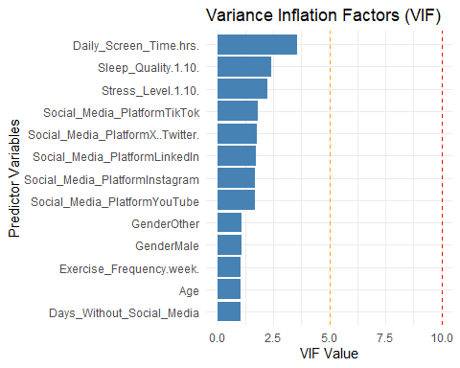
The VIF chart shows that all variables are under 5 which means that there is no multicollinearity.

ggsave("C:/Users/jesge/Downloads/vif_plot.png", width = 8, height = 6)
# Part 6: Model Evaluation
summary(model$finalModel) # Detailed model output
##
## Call:
## lm(formula = .outcome ~ ., data = dat)
##
## Residuals:
## Min 1Q Median 3Q Max
## -2.66956 -0.58317 -0.00303 0.64560 2.33836
##
## Coefficients:
## Estimate Std. Error t value Pr(>|t|)
## (Intercept) 9.540633 0.504051 18.928 < 2e-16 ***
## Age 0.008378 0.004171 2.009 0.0451 *
## GenderMale -0.004962 0.084682 -0.059 0.9533
## GenderOther 0.288143 0.202227 1.425 0.1548
## Daily_Screen_Time.hrs. -0.094779 0.044474 -2.131 0.0336 *
## Sleep_Quality.1.10. 0.322936 0.041451 7.791 4.07e-14 ***
## Stress_Level.1.10. -0.460154 0.039675 -11.598 < 2e-16 ***
## Days_Without_Social_Media 0.034168 0.022290 1.533 0.1260
## Exercise_Frequency.week. 0.019239 0.029342 0.656 0.5124
## Social_Media_PlatformInstagram -0.115447 0.149458 -0.772 0.4402
## Social_Media_PlatformLinkedIn -0.116338 0.141955 -0.820 0.4129
## Social_Media_PlatformTikTok -0.147055 0.139555 -1.054 0.2925
## Social_Media_PlatformX..Twitter. 0.095047 0.142383 0.668 0.5047
## Social_Media_PlatformYouTube -0.158697 0.147810 -1.074 0.2835
## ---
## Signif. codes: 0 '***' 0.001 '**' 0.01 '*' 0.05 '.' 0.1 ' ' 1
##
## Residual standard error: 0.913 on 486 degrees of freedom
## Multiple R-squared: 0.6505, Adjusted R-squared: 0.6412
## F-statistic: 69.59 on 13 and 486 DF, p-value: < 2.2e-16
print(model$results) # Cross-validation metrics
## intercept RMSE Rsquared MAE RMSESD RsquaredSD MAESD
## 1 TRUE 0.9202936 0.6391336 0.7497185 0.0783917 0.0589467 0.0671666
# Predicted vs Actual
preds <- predict(model, newdata = data_model)
eval_df <- data.frame(Actual = data_model$happiness, Predicted = preds)
write.csv(eval_df, "C:/Users/jesge/Downloads/predicted_vs_actual.csv", row.names = FALSE)
# Visualize fit
ggplot(eval_df, aes(x = Actual, y = Predicted)) +
geom_point(alpha = 0.6) +
geom_smooth(method = "lm", se = FALSE, color = "blue") +
labs(title = "Predicted vs Actual Happiness",
x = "Actual Happiness", y = "Predicted Happiness") +
theme_minimal()
## `geom_smooth()` using formula = 'y ~ x'
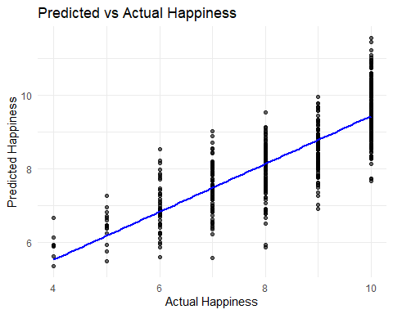
This is the predicted vs actual scatterplot for the original, not the squared. A more in depth explanation can be found for the squared model.

ggsave("C:/Users/jesge/Downloads/pred_vs_actual_plot.png", width = 7, height = 5)
## `geom_smooth()` using formula = 'y ~ x'
# ----------------------------
# 7a–7f: Modeling Section
# ----------------------------
library(dplyr)
library(car)
library(caret)
library(ggplot2)
# Load dataset
df <- read.csv("C:/Users/jesge/Downloads/Mental_Health_and_Social_Media_Balance_Dataset.csv")
# Handle missing values if any
df <- df %>% mutate(across(everything(), ~ ifelse(is.na(.), mean(., na.rm = TRUE), .)))
# ----------------------------
# 7a. Univariate model exploration
# ----------------------------
# Fit simple linear regressions of Happiness_Index.1.10. on each continuous variable
continuous_vars <- c("Age", "Daily_Screen_Time.hrs.", "Sleep_Quality.1.10.",
"Stress_Level.1.10.", "Days_Without_Social_Media",
"Exercise_Frequency.week.")
uni_results <- lapply(continuous_vars, function(var) {
model <- lm(as.formula(paste("Happiness_Index.1.10. ~", var)), data = df)
summary(model)$coefficients[2, c("Estimate", "Pr(>|t|)")]
})
names(uni_results) <- continuous_vars
uni_results
## $Age
## Estimate Pr(>|t|)
## 0.002833001 0.679629095
##
## $Daily_Screen_Time.hrs.
## Estimate Pr(>|t|)
## -6.195793e-01 2.121214e-76
##
## $Sleep_Quality.1.10.
## Estimate Pr(>|t|)
## 6.763602e-01 8.398383e-69
##
## $Stress_Level.1.10.
## Estimate Pr(>|t|)
## -7.282461e-01 7.753024e-87
##
## $Days_Without_Social_Media
## Estimate Pr(>|t|)
## 0.05209214 0.15609275
##
## $Exercise_Frequency.week.
## Estimate Pr(>|t|)
## 0.0439995 0.3576394
# ----------------------------
# 7b. Interaction and confounding exploration
# ----------------------------
# Check a few potential interactions (e.g., Stress × Sleep, ScreenTime × Exercise)
interaction_model <- lm(Happiness_Index.1.10. ~ Stress_Level.1.10. * Sleep_Quality.1.10. +
Daily_Screen_Time.hrs. * Exercise_Frequency.week. +
Age + Gender + Days_Without_Social_Media + Social_Media_Platform, data = df)
summary(interaction_model)
##
## Call:
## lm(formula = Happiness_Index.1.10. ~ Stress_Level.1.10. * Sleep_Quality.1.10. +
## Daily_Screen_Time.hrs. * Exercise_Frequency.week. + Age +
## Gender + Days_Without_Social_Media + Social_Media_Platform,
## data = df)
##
## Residuals:
## Min 1Q Median 3Q Max
## -2.62231 -0.56560 0.05833 0.55852 2.87716
##
## Coefficients:
## Estimate Std. Error t value
## (Intercept) 13.4216770 0.8690170 15.445
## Stress_Level.1.10. -1.0798299 0.1098459 -9.830
## Sleep_Quality.1.10. -0.3073509 0.1126136 -2.729
## Daily_Screen_Time.hrs. -0.0221494 0.0596643 -0.371
## Exercise_Frequency.week. 0.1458083 0.0853107 1.709
## Age 0.0065880 0.0040453 1.629
## GenderMale -0.0002511 0.0821410 -0.003
## GenderOther 0.2949479 0.1952998 1.510
## Days_Without_Social_Media 0.0346014 0.0215854 1.603
## Social_Media_PlatformInstagram -0.1262465 0.1444838 -0.874
## Social_Media_PlatformLinkedIn -0.1725114 0.1374530 -1.255
## Social_Media_PlatformTikTok -0.1785915 0.1349007 -1.324
## Social_Media_PlatformX (Twitter) 0.0755689 0.1375577 0.549
## Social_Media_PlatformYouTube -0.2042476 0.1429418 -1.429
## Stress_Level.1.10.:Sleep_Quality.1.10. 0.0964357 0.0160563 6.006
## Daily_Screen_Time.hrs.:Exercise_Frequency.week. -0.0245191 0.0155828 -1.573
## Pr(>|t|)
## (Intercept) < 2e-16 ***
## Stress_Level.1.10. < 2e-16 ***
## Sleep_Quality.1.10. 0.00658 **
## Daily_Screen_Time.hrs. 0.71063
## Exercise_Frequency.week. 0.08807 .
## Age 0.10405
## GenderMale 0.99756
## GenderOther 0.13164
## Days_Without_Social_Media 0.10959
## Social_Media_PlatformInstagram 0.38267
## Social_Media_PlatformLinkedIn 0.21006
## Social_Media_PlatformTikTok 0.18617
## Social_Media_PlatformX (Twitter) 0.58301
## Social_Media_PlatformYouTube 0.15368
## Stress_Level.1.10.:Sleep_Quality.1.10. 3.74e-09 ***
## Daily_Screen_Time.hrs.:Exercise_Frequency.week. 0.11626
## ---
## Signif. codes: 0 '***' 0.001 '**' 0.01 '*' 0.05 '.' 0.1 ' ' 1
##
## Residual standard error: 0.8817 on 484 degrees of freedom
## Multiple R-squared: 0.6754, Adjusted R-squared: 0.6654
## F-statistic: 67.14 on 15 and 484 DF, p-value: < 2.2e-16
# ----------------------------
# 7c. Comprehensive model
# ----------------------------
# 1. Remove ID column safely (only if it exists)
df_clean <- df
if ("ID" %in% names(df_clean)) df_clean$ID <- NULL
if ("Id" %in% names(df_clean)) df_clean$Id <- NULL
if ("User_ID" %in% names(df_clean)) df_clean$User_ID <- NULL
if ("UserId" %in% names(df_clean)) df_clean$UserId <- NULL
# 2. Identify predictor columns
predictors <- setdiff(colnames(df_clean), "Happiness_Index.1.10.")
# 3. Dummy encode *only categorical variables*
cat_cols <- predictors[sapply(df_clean[predictors], function(x) is.character(x) | is.factor(x))]
if (length(cat_cols) > 0) {
dummies <- caret::dummyVars(~ ., data = df_clean[predictors], fullRank = TRUE)
X <- as.data.frame(predict(dummies, newdata = df_clean[predictors]))
} else {
X <- df_clean[predictors]
}
# 4. Numeric target variable
y <- df_clean$Happiness_Index.1.10.
# 5. Ensure matching row counts
if (nrow(X) != length(y)) stop("Row mismatch — something is wrong.")
# 6. Build combined modeling frame
data_model <- data.frame(happiness = y, X)
# 7. Fit the full model
lm_full <- lm(happiness ~ ., data = data_model)
# 8. Summary of comprehensive model
summary(lm_full)
##
## Call:
## lm(formula = happiness ~ ., data = data_model)
##
## Residuals:
## Min 1Q Median 3Q Max
## -2.66956 -0.58317 -0.00303 0.64560 2.33836
##
## Coefficients:
## Estimate Std. Error t value Pr(>|t|)
## (Intercept) 9.540633 0.504051 18.928 < 2e-16 ***
## Age 0.008378 0.004171 2.009 0.0451 *
## GenderMale -0.004962 0.084682 -0.059 0.9533
## GenderOther 0.288143 0.202227 1.425 0.1548
## Daily_Screen_Time.hrs. -0.094779 0.044474 -2.131 0.0336 *
## Sleep_Quality.1.10. 0.322936 0.041451 7.791 4.07e-14 ***
## Stress_Level.1.10. -0.460154 0.039675 -11.598 < 2e-16 ***
## Days_Without_Social_Media 0.034168 0.022290 1.533 0.1260
## Exercise_Frequency.week. 0.019239 0.029342 0.656 0.5124
## Social_Media_PlatformInstagram -0.115447 0.149458 -0.772 0.4402
## Social_Media_PlatformLinkedIn -0.116338 0.141955 -0.820 0.4129
## Social_Media_PlatformTikTok -0.147055 0.139555 -1.054 0.2925
## Social_Media_PlatformX..Twitter. 0.095047 0.142383 0.668 0.5047
## Social_Media_PlatformYouTube -0.158697 0.147810 -1.074 0.2835
## ---
## Signif. codes: 0 '***' 0.001 '**' 0.01 '*' 0.05 '.' 0.1 ' ' 1
##
## Residual standard error: 0.913 on 486 degrees of freedom
## Multiple R-squared: 0.6505, Adjusted R-squared: 0.6412
## F-statistic: 69.59 on 13 and 486 DF, p-value: < 2.2e-16
# ----------------------------
# 7d. Simplified stepwise regression with a smaller starting model
lm_start <- lm(Happiness_Index.1.10. ~ Sleep_Quality.1.10. +
Stress_Level.1.10. +
Daily_Screen_Time.hrs. +
Exercise_Frequency.week. +
Days_Without_Social_Media,
data = df)
step_model <- step(lm_start, direction = "both", trace = FALSE)
summary(step_model)
##
## Call:
## lm(formula = Happiness_Index.1.10. ~ Sleep_Quality.1.10. + Stress_Level.1.10. +
## Daily_Screen_Time.hrs. + Days_Without_Social_Media, data = df)
##
## Residuals:
## Min 1Q Median 3Q Max
## -2.65404 -0.60180 0.01714 0.64262 2.35716
##
## Coefficients:
## Estimate Std. Error t value Pr(>|t|)
## (Intercept) 9.93026 0.45983 21.596 < 2e-16 ***
## Sleep_Quality.1.10. 0.31149 0.04115 7.571 1.83e-13 ***
## Stress_Level.1.10. -0.45661 0.03951 -11.556 < 2e-16 ***
## Daily_Screen_Time.hrs. -0.10900 0.04378 -2.490 0.0131 *
## Days_Without_Social_Media 0.03405 0.02206 1.544 0.1233
## ---
## Signif. codes: 0 '***' 0.001 '**' 0.01 '*' 0.05 '.' 0.1 ' ' 1
##
## Residual standard error: 0.9142 on 495 degrees of freedom
## Multiple R-squared: 0.6431, Adjusted R-squared: 0.6402
## F-statistic: 223 on 4 and 495 DF, p-value: < 2.2e-16
# ----------------------------
# 7e. Model Diagnostics (Regression Assumptions)
# 1. Linearity — plot residuals vs fitted values
plot(step_model$fitted.values, resid(step_model),
main = "Residuals vs Fitted (Linearity Check)",
xlab = "Fitted Values", ylab = "Residuals")
abline(h = 0, col = "red")
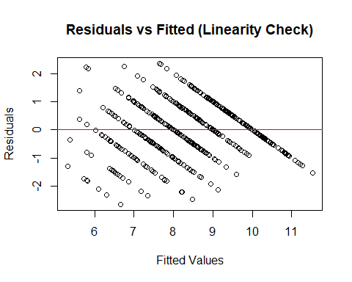
Same graph used above

# 2. Normality of residuals — Q-Q plot + Shapiro-Wilk test
qqnorm(resid(step_model))
qqline(resid(step_model), col = "red")
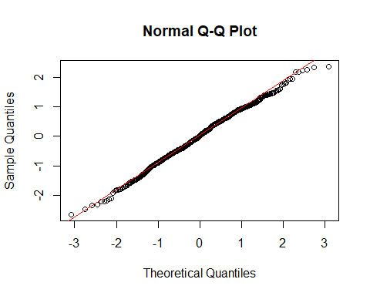
Same graph used above

shapiro_test <- shapiro.test(resid(step_model))
print(shapiro_test)
##
## Shapiro-Wilk normality test
##
## data: resid(step_model)
## W = 0.99614, p-value = 0.2648
# 3. Homoscedasticity (equal variance) — Breusch-Pagan test
library(lmtest)
## Loading required package: zoo
##
## Attaching package: 'zoo'
## The following objects are masked from 'package:base':
##
## as.Date, as.Date.numeric
bp_test <- bptest(step_model)
print(bp_test)
##
## studentized Breusch-Pagan test
##
## data: step_model
## BP = 34.766, df = 4, p-value = 5.189e-07
# 4. Independence of errors — Durbin-Watson test
library(car)
dw_test <- durbinWatsonTest(step_model)
print(dw_test)
## lag Autocorrelation D-W Statistic p-value
## 1 0.000213421 1.997412 0.984
## Alternative hypothesis: rho != 0
# ----------------------------
# 7f. Final best model
# ----------------------------
summary(step_model)
##
## Call:
## lm(formula = Happiness_Index.1.10. ~ Sleep_Quality.1.10. + Stress_Level.1.10. +
## Daily_Screen_Time.hrs. + Days_Without_Social_Media, data = df)
##
## Residuals:
## Min 1Q Median 3Q Max
## -2.65404 -0.60180 0.01714 0.64262 2.35716
##
## Coefficients:
## Estimate Std. Error t value Pr(>|t|)
## (Intercept) 9.93026 0.45983 21.596 < 2e-16 ***
## Sleep_Quality.1.10. 0.31149 0.04115 7.571 1.83e-13 ***
## Stress_Level.1.10. -0.45661 0.03951 -11.556 < 2e-16 ***
## Daily_Screen_Time.hrs. -0.10900 0.04378 -2.490 0.0131 *
## ---
## Signif. codes: 0 '***' 0.001 '**' 0.01 '*' 0.05 '.' 0.1 ' ' 1
##
## Residual standard error: 0.9142 on 495 degrees of freedom
## Multiple R-squared: 0.6431, Adjusted R-squared: 0.6402
## F-statistic: 223 on 4 and 495 DF, p-value: < 2.2e-16
# Save final model if needed
saveRDS(step_model, "final_happiness_model.rds")
Confidence Intervals
# ---------------------------
# 11. Confidence & Prediction Intervals (95%)
# ---------------------------
cat("\n--- Confidence and Prediction Intervals (95%) ---\n")
##
## --- Confidence and Prediction Intervals (95%) ---
# Generate confidence and prediction intervals for all data points
conf_intervals <- predict(step_model, newdata = data, interval = "confidence", level = 0.95)
pred_intervals <- predict(step_model, newdata = data, interval = "prediction", level = 0.95)
# Combine everything into one data frame
interval_df <- data.frame(
Actual = data$Happiness_Index.1.10.,
Predicted = conf_intervals[, "fit"],
CI_Lower = conf_intervals[, "lwr"],
CI_Upper = conf_intervals[, "upr"],
PI_Lower = pred_intervals[, "lwr"],
PI_Upper = pred_intervals[, "upr"]
)
# Save to CSV
write.csv(interval_df, "happiness_conf_pred_intervals.csv", row.names = FALSE)
cat("✅ Saved: happiness_conf_pred_intervals.csv\n")
## ✅ Saved: happiness_conf_pred_intervals.csv
# ---------------------------
# 12. Visual Diagnostics: Actual vs Predicted
# ---------------------------
library(ggplot2)
ggplot(interval_df, aes(x = Actual, y = Predicted)) +
geom_point(color = "blue", alpha = 0.6) +
geom_abline(slope = 1, intercept = 0, color = "red", linetype = "dashed") +
geom_errorbar(aes(ymin = PI_Lower, ymax = PI_Upper), width = 0.2, alpha = 0.3) +
labs(title = "Actual vs Predicted Happiness",
x = "Actual Happiness Index (1–10)",
y = "Predicted Happiness (with 95% Intervals)") +
theme_minimal()
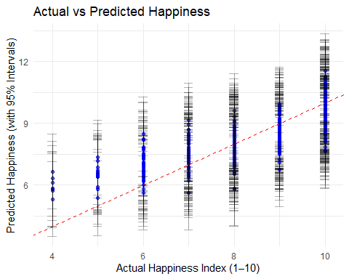
Each point represents one individual from the dataset with the x axis being the actual happiness index and the y axis being the model predicted happiness index. Points close to the red line show accurate predictions. The error bars show 95% prediction intervals which shows uncertainty for each prediction.

cat("\n✅ Confidence and prediction intervals computed and plotted.\n")
##
## ✅ Confidence and prediction intervals computed and plotted.
square transformtaion
# ---------------------------
# 6.5 Transformation: Square transformation to fix left skew
# ---------------------------
# Visualize original distribution
hist(data$Happiness_Index.1.10.,
main = "Original Happiness Distribution",
xlab = "Happiness Index (1–10)",
col = "lightblue",
border = "white")
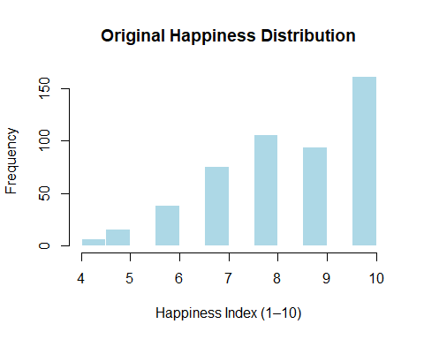
Same chart used earlier showing the happiness distribution.
# Apply square transformation to reduce left skewness
data$Happiness_Squared <- (data$Happiness_Index.1.10.)^2
# Check the transformed distribution
hist(data$Happiness_Squared,
main = "Transformed (Squared) Happiness Distribution",
xlab = "Happiness^2",
col = "lightgreen",
border = "white")
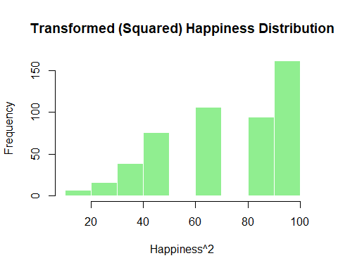
This is the histogram showed previously after applying a square transformation to get a better fit. It seems more symmetric and reduced some of the left skew which helps to improve model performance.

# Compare skewness numerically
library(e1071)
## Warning: package 'e1071' was built under R version 4.5.2
##
## Attaching package: 'e1071'
## The following object is masked from 'package:ggplot2':
##
## element
cat("\nOriginal Skewness:", skewness(data$Happiness_Index.1.10., na.rm = TRUE), "\n")
##
## Original Skewness: -0.6846746
cat("Transformed Skewness:", skewness(data$Happiness_Squared, na.rm = TRUE), "\n")
## Transformed Skewness: -0.3548869
# ---------------------------
# 8. Model After Square Transformation (to correct left skew)
# ---------------------------
cat("\n--- Running Model with Squared Happiness (Left-Skew Correction) ---\n")
##
## --- Running Model with Squared Happiness (Left-Skew Correction) ---
# Step 1: Create the squared target variable
data$Happiness_Squared <- (data$Happiness_Index.1.10.)^2
# Step 2: Build model using the transformed target
lm_squared <- lm(Happiness_Squared ~ Age + Gender + Daily_Screen_Time.hrs. +
Sleep_Quality.1.10. + Stress_Level.1.10. +
Days_Without_Social_Media + Exercise_Frequency.week. +
Social_Media_Platform, data = data)
# Step 3: Summarize model
summary(lm_squared)
##
## Call:
## lm(formula = Happiness_Squared ~ Age + Gender + Daily_Screen_Time.hrs. +
## Sleep_Quality.1.10. + Stress_Level.1.10. + Days_Without_Social_Media +
## Exercise_Frequency.week. + Social_Media_Platform, data = data)
##
## Residuals:
## Min 1Q Median 3Q Max
## -39.108 -10.310 -0.821 10.076 37.698
##
## Coefficients:
## Estimate Std. Error t value Pr(>|t|)
## (Intercept) 90.21335 7.79822 11.568 < 2e-16 ***
## Age 0.12917 0.06453 2.002 0.0459 *
## GenderMale -0.55745 1.31012 -0.425 0.6707
## GenderOther 4.21446 3.12867 1.347 0.1786
## Daily_Screen_Time.hrs. -1.18861 0.68806 -1.727 0.0847 .
## Sleep_Quality.1.10. 5.23694 0.64129 8.166 2.76e-15 ***
## Stress_Level.1.10. -7.61588 0.61382 -12.407 < 2e-16 ***
## Days_Without_Social_Media 0.60067 0.34486 1.742 0.0822 .
## Exercise_Frequency.week. 0.44541 0.45396 0.981 0.3270
## Social_Media_PlatformInstagram -1.65345 2.31227 -0.715 0.4749
## Social_Media_PlatformLinkedIn -2.02550 2.19619 -0.922 0.3568
## Social_Media_PlatformTikTok -1.86712 2.15907 -0.865 0.3876
## Social_Media_PlatformX (Twitter) 1.73685 2.20281 0.788 0.4308
## Social_Media_PlatformYouTube -1.87372 2.28678 -0.819 0.4130
## ---
## Signif. codes: 0 '***' 0.001 '**' 0.01 '*' 0.05 '.' 0.1 ' ' 1
##
## Residual standard error: 14.13 on 486 degrees of freedom
## Multiple R-squared: 0.6648, Adjusted R-squared: 0.6559
## F-statistic: 74.16 on 13 and 486 DF, p-value: < 2.2e-16
# Step 4: Check model diagnostics
par(mfrow = c(2, 2))
plot(lm_squared)
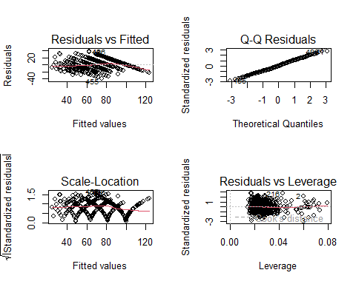
For the Residuals vs Leverage it has the same interpretation as the Influence plot above and for the Scale-Location since there is a v type shape, it means that the residuals are larger as fitted values increase.

par(mfrow = c(1, 1))
# Step 5: Evaluate normality of residuals
shapiro.test(resid(lm_squared))
##
## Shapiro-Wilk normality test
##
## data: resid(lm_squared)
## W = 0.99645, p-value = 0.3338
# Step 6: Compare with original model (if available)
cat("\nComparison of R-squared values:\n")
##
## Comparison of R-squared values:
cat("Original model (raw Happiness):", summary(step_model)$r.squared, "\n")
## Original model (raw Happiness): 0.6431143
cat("Squared model (Happiness^2):", summary(lm_squared)$r.squared, "\n")
## Squared model (Happiness^2): 0.6648499
# Step 7: Predict and back-transform to original scale
pred_squared <- predict(lm_squared, newdata = data)
pred_original_scale <- sqrt(pred_squared)
# Step 8: Add predictions to dataset
data$Predicted_Happiness_Squared <- pred_squared
data$Predicted_Happiness <- pred_original_scale
# Step 9: Compute RMSE and MAE for transformed-back predictions
rmse <- sqrt(mean((data$Happiness_Index.1.10. - data$Predicted_Happiness)^2, na.rm = TRUE))
mae <- mean(abs(data$Happiness_Index.1.10. - data$Predicted_Happiness), na.rm = TRUE)
cat("\nModel Performance (Back-Transformed Predictions):\n")
##
## Model Performance (Back-Transformed Predictions):
cat("RMSE:", round(rmse, 3), "\n")
## RMSE: 0.884
cat("MAE:", round(mae, 3), "\n")
## MAE: 0.705
# Step 10: Save the new model results
write.csv(data.frame(
Actual_Happiness = data$Happiness_Index.1.10.,
Predicted_Happiness = data$Predicted_Happiness,
Predicted_Happiness_Squared = data$Predicted_Happiness_Squared
), "squared_model_predictions.csv", row.names = FALSE)
cat("\n✅ Squared model results saved as 'squared_model_predictions.csv'\n")
##
## ✅ Squared model results saved as 'squared_model_predictions.csv'
New CI and PI
# ---------------------------
# 9. Confidence & Prediction Intervals (Squared Model)
# ---------------------------
cat("\n--- Confidence and Prediction Intervals (Squared Model) ---\n")
##
## --- Confidence and Prediction Intervals (Squared Model) ---
# Generate CI and PI for all observations on the squared scale
conf_sq <- predict(lm_squared, newdata = data, interval = "confidence", level = 0.95)
pred_sq <- predict(lm_squared, newdata = data, interval = "prediction", level = 0.95)
# Combine everything into a data frame
intervals_sq <- data.frame(
Actual_Happiness = data$Happiness_Index.1.10.,
Predicted_Happiness_Squared = conf_sq[, "fit"],
CI_Lower_Squared = conf_sq[, "lwr"],
CI_Upper_Squared = conf_sq[, "upr"],
PI_Lower_Squared = pred_sq[, "lwr"],
PI_Upper_Squared = pred_sq[, "upr"]
)
# Back-transform (square root) to get results on the original scale
intervals_sq$Predicted_Happiness <- sqrt(intervals_sq$Predicted_Happiness_Squared)
intervals_sq$CI_Lower <- sqrt(pmax(intervals_sq$CI_Lower_Squared, 0))
intervals_sq$CI_Upper <- sqrt(pmax(intervals_sq$CI_Upper_Squared, 0))
intervals_sq$PI_Lower <- sqrt(pmax(intervals_sq$PI_Lower_Squared, 0))
intervals_sq$PI_Upper <- sqrt(pmax(intervals_sq$PI_Upper_Squared, 0))
# Save results
write.csv(intervals_sq, "happiness_squared_conf_pred_intervals.csv", row.names = FALSE)
cat("✅ Saved: happiness_squared_conf_pred_intervals.csv\n")
## ✅ Saved: happiness_squared_conf_pred_intervals.csv
# ---------------------------
# 10. Plot Actual vs Predicted (Back-Transformed)
# ---------------------------
library(ggplot2)
ggplot(intervals_sq, aes(x = Actual_Happiness, y = Predicted_Happiness)) +
geom_point(color = "blue", alpha = 0.6) +
geom_abline(slope = 1, intercept = 0, color = "red", linetype = "dashed") +
geom_errorbar(aes(ymin = PI_Lower, ymax = PI_Upper), width = 0.2, alpha = 0.3) +
labs(title = "Actual vs Predicted Happiness (After Square Transformation)",
x = "Actual Happiness Index (1–10)",
y = "Predicted Happiness (Back-Transformed, 95% Intervals)") +
theme_minimal()
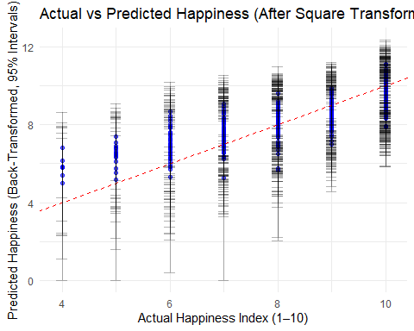
This is after the square transformation and you could argue that it is closer to the line which indicates a better fit.

