GST and the Cost of Living: A One-Off Effect Amid Global and Structural Forces

Name: Lee Sean Xiang
Date: 11/09/2025

Ask any Singaporean about their biggest worry today and you’ll probably hear the same answer: the cost of living. From a bowl of noodles at the hawker centre to monthly utilities and rent, daily expenses feel heavier than they used to. For many, the 2023–2024 GST increases stand out as the main culprit. After all, the Goods and Services Tax had been unchanged at 7% for 15 years before it rose to 8% in January 2023 and then 9% in January 2024. It’s tempting to point to GST and say, “That’s why life feels so expensive now.”
But is it really that simple? Using data on consumer prices, housing, incomes, interest rates, and industrial production, this op-ed argues that GST has played only a small, one-off role. The real story lies in global shocks, structural housing pressures, and monetary tightening.
GST has been around since 1994, when it started at 3% as part of Singapore’s strategy to broaden the tax base while keeping income taxes competitive. It climbed gradually to 7% by 2007 and then stayed there until the recent hike to 9%, staged in two steps. The government has been upfront about why: with an ageing population and heavier healthcare bills, Singapore needs stable, broad-based revenue. To cushion the impact, schemes like the permanent GST Voucher and the Assurance Package provide offsets, especially for lower-income households.
The debate has always been about fairness. Critics say GST is regressive because lower-income families spend a larger share of their earnings on consumption. The government responds that once transfers and rebates are counted, the overall system remains progressive.
Figure 1. CPI inflation trend (YoY %) with GST markers (Jan 2023; Jan 2024)
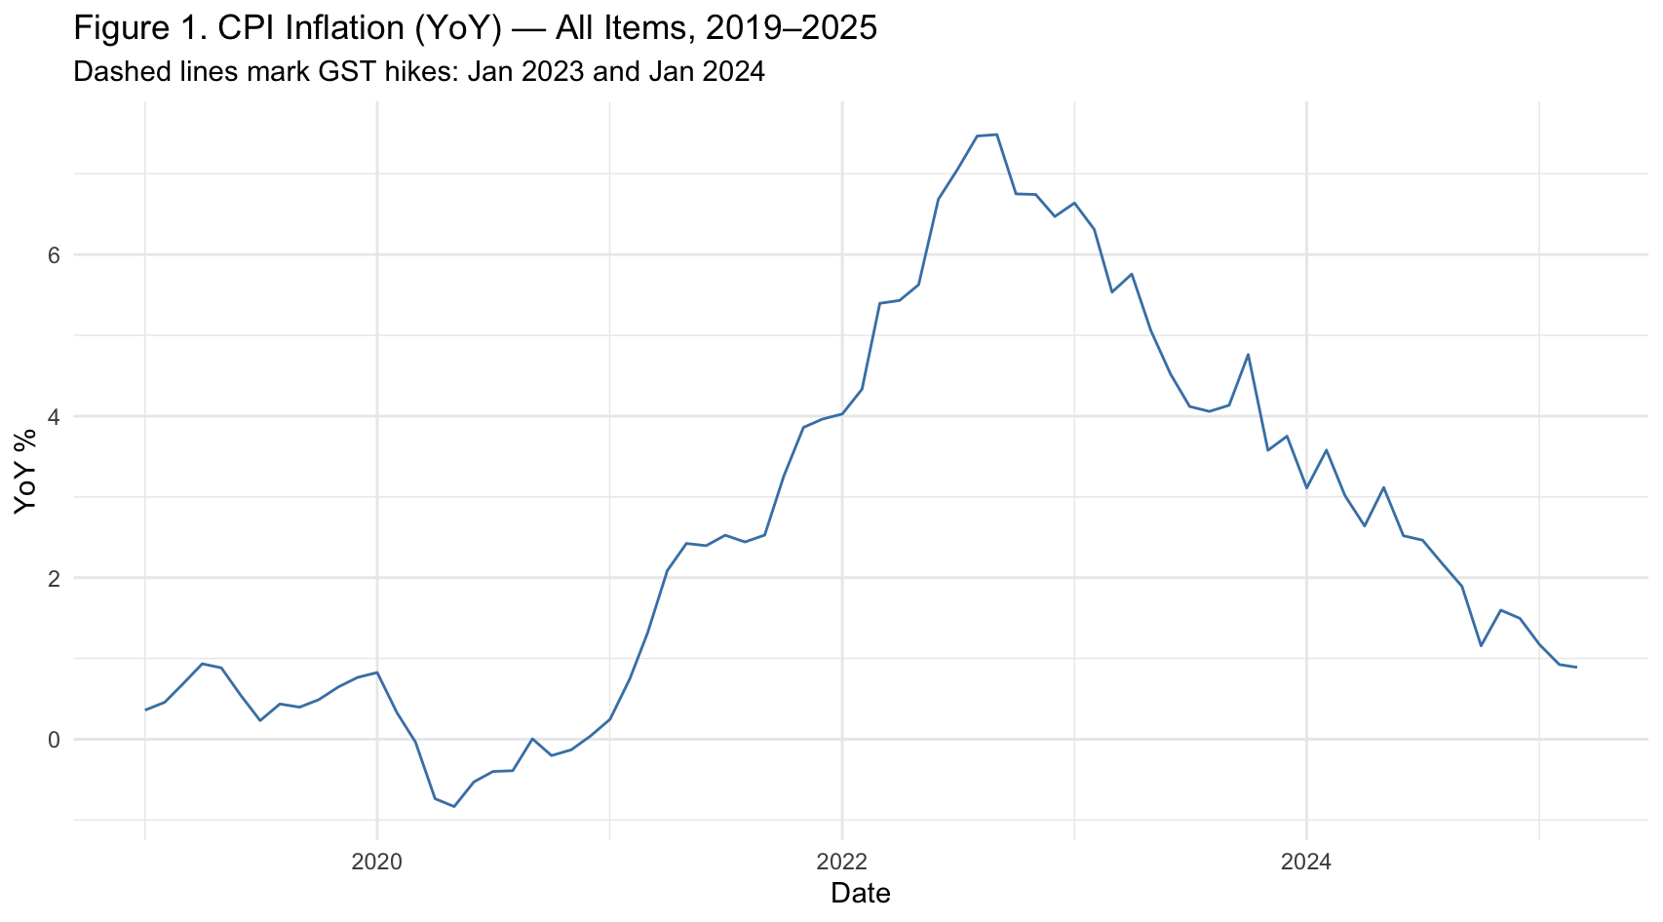
Inflation picked up from 2021 and surged to almost 8% in late 2022 — before GST went up. From 2023 onwards, the trend reversed, with inflation easing steadily to about 2% by 2025. The dashed lines in Figure 1 mark the GST hikes, but there’s no sign of sudden jumps there. In other words, the hikes did not trigger new waves of inflation; they were absorbed into an ongoing cooling trend.
Figure 1a. Animated CPI inflation (YoY %) over time 
The animation in Figure 1a makes the timing even clearer. Month by month, inflation climbs through 2021, peaks in 2022, then falls through 2023 and 2024. The GST hikes come and go, and the line keeps moving downward. The picture tells its own story: GST wasn’t the spark behind Singapore’s inflation peak.
Figure 1b. Breaking Down CPI
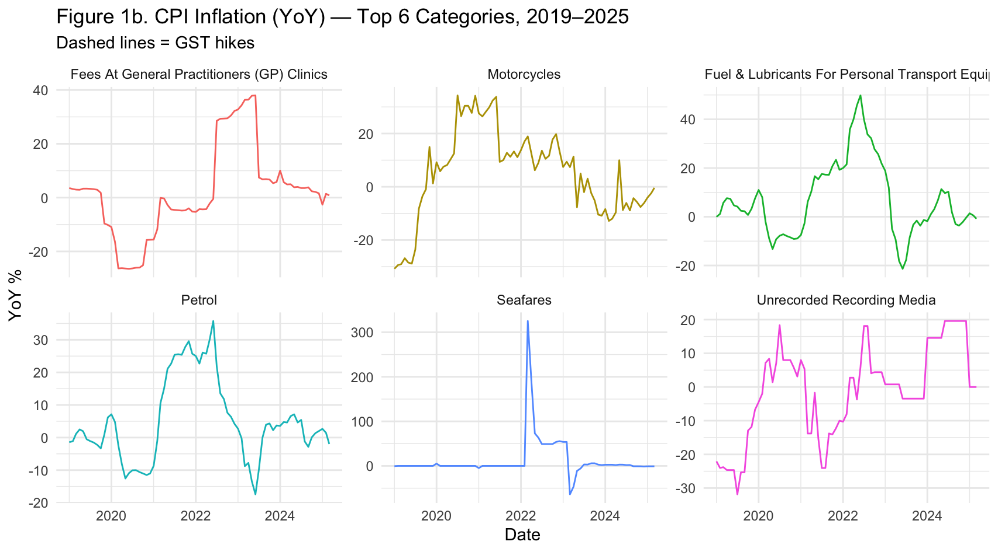
Looking at subcategories in Figure 1b, the biggest swings came from petrol, COE-linked transport, rents, utilities, and certain healthcare costs. These were driven by global energy shocks, supply bottlenecks, and local market dynamics. None of them show a clean jump at GST dates. If anything, GST was a background detail compared to these bigger forces.
Figure 2. HDB Resale Price Index (1Q2009=100)
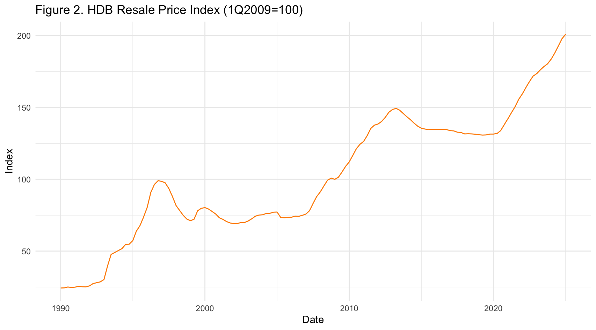
Resale prices were flat for years between 2013 and 2019. Then, after the pandemic, they took off. By 2024–2025, the index was at record highs. This surge reflects construction delays, a shortage of new flats, and pent-up demand. The GST hikes don’t explain the timing; prices were already climbing fast. What matters more here are supply-demand imbalances in housing, not consumption taxes.
Figure 3. Median Income (Nominal vs Real)
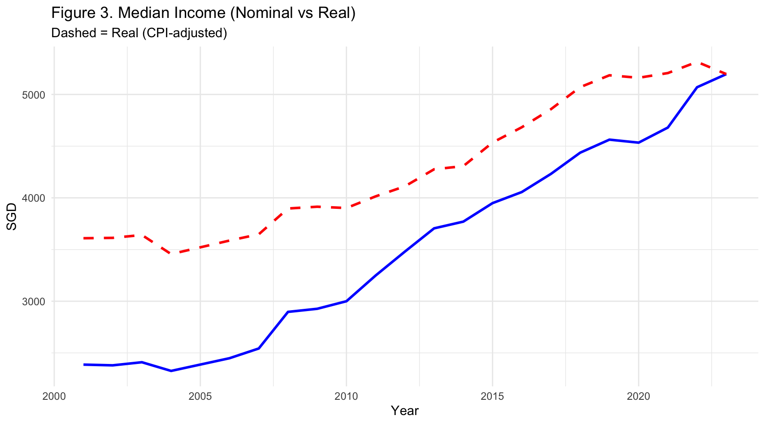
Nominal wages have grown steadily since 2000. But once inflation is factored in, the growth is far less dramatic. Real incomes dipped during crises and were hit hard in 2022–2023, when inflation spiked. Although they recovered somewhat by 2024, purchasing power has not kept pace with headline wage growth. GST may have chipped away slightly, but it was global inflation that squeezed households hardest.
Figure 4. Bank interest rates (selected series)
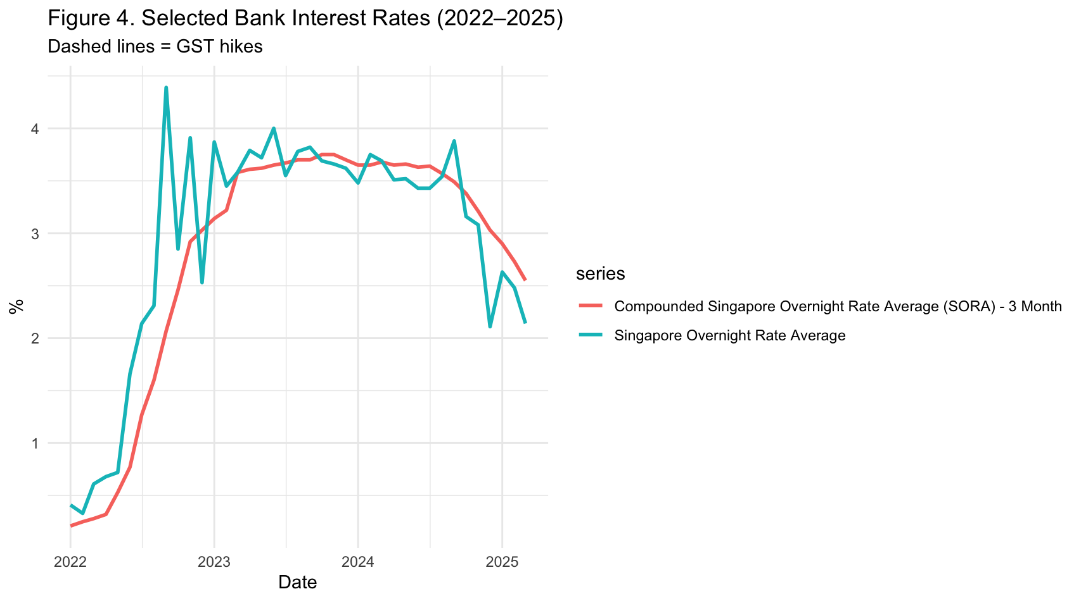
Interest rates tell a different story altogether. From 2022, SORA and overnight rates surged as central banks worldwide tightened policy. By early 2023, rates were above 4%, only easing later in 2024. For borrowers, this meant higher mortgage and loan payments. The dashed GST lines in Figure 4 don’t coincide with any turning points. The pain here was monetary, not fiscal — driven by the global fight against inflation.
Figure 5. Index of Industrial Production (YoY %, selected clusters)
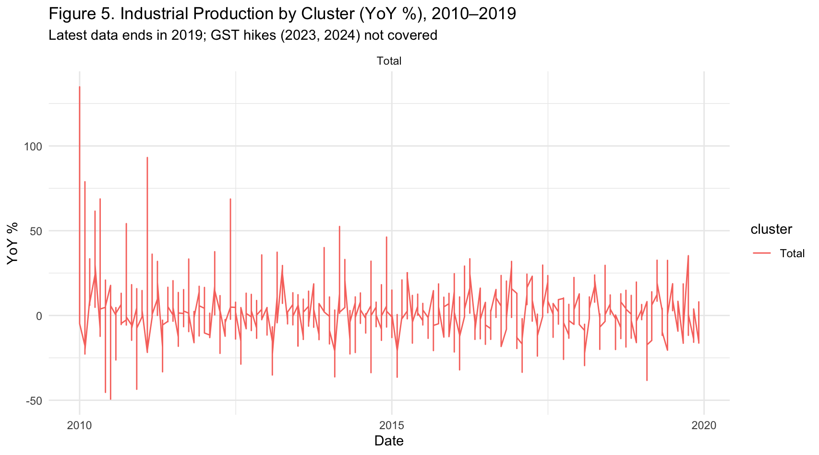
Industrial production data, shown in Figure 5, runs only up to 2019. Even so, it’s instructive: Electronics shows wild swings tied to global demand, while Chemicals and General Manufacturing are steadier. The key point is that industry moves with external markets, not local taxes. We can’t see the GST period in this dataset, but the historical trend underlines how little GST matters to export-oriented production.
Across all five figures, the pattern is consistent. Inflation peaked in 2022, before GST went up. Housing prices soared due to supply constraints. Wages grew, but real incomes were eroded by global inflation. Borrowing costs spiked because of worldwide monetary tightening. Industrial production cycled with global demand.
GST, in contrast, shows up only as a modest, one-off adjustment. It’s part of the story, but not the headline. The numbers suggest Singaporeans’ frustrations with rising costs are real — but the culprit isn’t GST alone. The real drivers are structural and global.

