BITP 3123 Distributed Application Development

Declaration of Solution for

Exercise 7

| Lab Week 13 Sem 2 2022/2023

|  |  |
| --- | --- |
| Matric No: | B032220024 |
| Name: | Siow Zhe Yi |

**Fakulti Teknologi Maklumat dan Komunikasi,**

**Univsersiti Teknikal Malaysia Melaka**

Table of Contents (This section must be updated)

Link to Github for Exercise 7 1

Design of Solution for Exercise 7 1

List of Classes for the Solution of Exercise 7 1

Sample of Output 1

# Link to Github for Exercise 7

The solution is available at https://github.com/siowzheyi/lab13.git

# Design of Solution for Exercise 7

Insert class diagram with its description

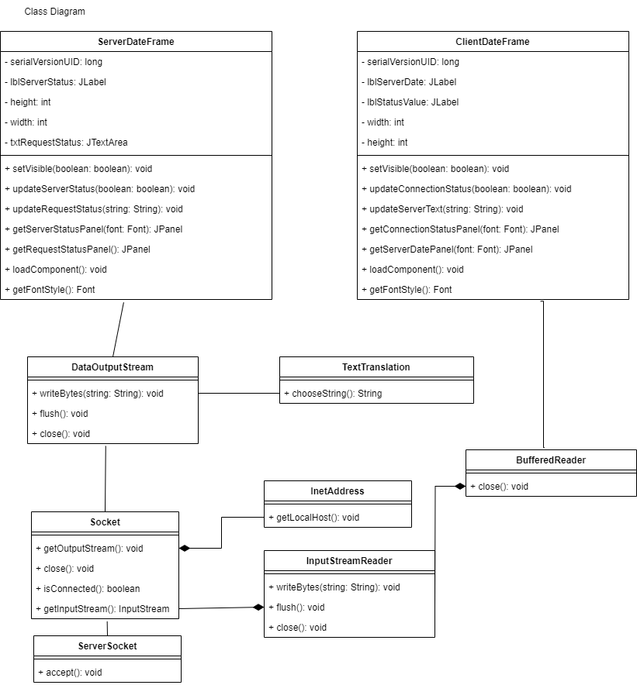

# List of Classes for the Solution of Exercise 7

List all classes and methods that are used as solution in this exercise. The list should indicate the class used for the server-side and client-side solutions separately.

Classes – methods

ServerDateFrame - setVisible, updateServerStatus, updateRequestStatus, getServerStatusPanel, getRequestStatusPanel, loadComponent, getFontStyle

ClientDateFrame – setVisible, updateConnectionStatus, updateServerText, getConnectionStatusPanel, getServerDatePanel, loadComponent, getFontStyle

DataOutputStream – writeBytes, flush, close

Socket – getOutputStream, close, isConnected, getInputStream

ServerSocket – accept

TextTranslation – chooseString

InetAddress – getLocalHost

InputStreamReader – writeBytes, flush, close

BufferedReader - close

# Sample of Output

Include screenshot or output file if any

