●
·· ·· SHNHA Stock Code
科 300853

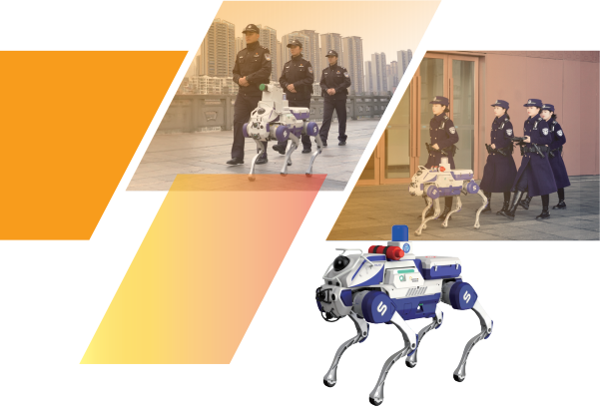

SHENHAO
TECHNOLOGY
Intelligent Solutions for Police Security

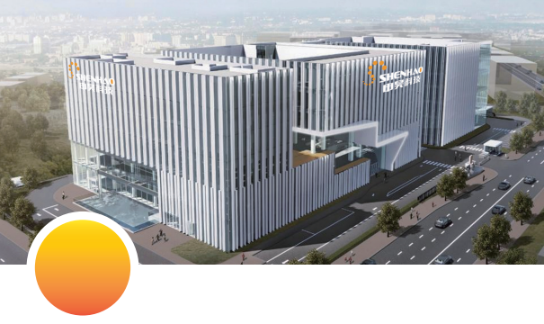

Company
Introduction
Hangzhou ShenHao Technology Co., Ltd., founded in 2002, is a listed company focused on the research and development of robotics and artificial intelligence technologies, serving the industrial health sector. Centered around intelligent operation and maintenance robots, the company has built a comprehensive “land-sea-air-tunnel” product architecture to provide intelligent integrated solutions for industrial equipment safety and urban public safety, helping improve quality and efficiency in the industrial sector and enhancing urban safety management. With years of technical expertise and innovation capabilities, the company has successfully developed a series of AI-powered operation and maintenance robotic equipment, achieving industrial applications across multiple sectors such as power grids, rail transit, emergency management, ecological environment, underwater marine, and oil and gas chemicals. This has effectively improved equipment reliability and safety, reduced labor intensity, and promoted the transition from traditional to intelligent operation and maintenance.

Public Security Overview
To meet the intelligent and multi-dimensional security needs of public security, a tri-integrated "air-ground-countermeasure" smart system has been established. An anti-drone active defence system deployed in key areas provides real-time alerts for unauthorized drone activities within a 5-kilometer range through drone detection and countermeasures. Ground patrol is supported by quadruped police robots forming a ground matrix, equipped with various payload devices, capable of navigating community alleys, construction rubble, and other complex environments to assist police operations. An intelligent drone patrol system forms a dynamic monitoring network, autonomously inspecting and using AI to identify various road anomalies such as illegal lane changes and road debris, enabling real-time coordination with the command center for closed-loop handling. These three applications offer full-scenario, all-weather intelligent protection for public security.

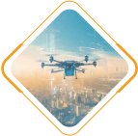
Air

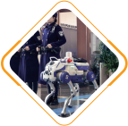
Ground

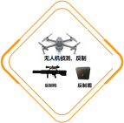
Countermeasures


Low-Altitude Security Management Platform
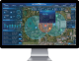
The low-altitude security management platform conducts radio detection around key targets using drone detection and positioning devices. When a drone is detected approaching, the system automatically checks whether it is on the whitelist. If identified as unauthorized, it activates countermeasure devices to perform radio jamming or navigation spoofing, forcing the drone to land or retreat, and locates the operator’s position, thereby achieving unattended low-altitude security control against terrorism and unauthorized drones. Additionally, relevant units can be equipped with portable countermeasure devices, which are lightweight, flexible, and easy to deploy, meeting the needs of mobile operations.
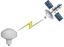
Beidou, GPS Satellite
Timing Antenna

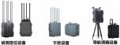

Low-Altitude Security Control Platform
Spatiotemporal Security Isolation Device
Time Server
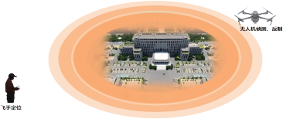

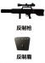
Police Zone, Alert Zone,
Countermeasure Zone

Detection Range ≥ 5km

Strike Range ≥ 3km
Portable Countermeasure device

Detection Range | ≥5 km (depends on environment and drone model) | Detection Coverage | 360° omnidirectional
Jamming Frequencies: | 400MHz，800MHz，1.2GHz，1.4GHz，1.5GHz，2.4GHz，5.2GHz，5.8GHz | Navigation Spoofing Range | 500–1000 meters
Jamming Distance | ≥2 km (depends on environment and drone model) | Spoofing Frequencies | GPS L1, GLONASS L1
Time Synchronization Accuracy | ≤100ns | Navigation Spoofing Power | ≤10mW
Function Description



Whitelist and Blacklist Management
Remote Management
Platform Visualisation
The system adopts a B/S architecture, supporting multi user and multi terminal remote access; it features rich interfaces and can be integrated with higher level management platforms
The intelligent management system uses a blacklist and whitelist to automatically initiate countermeasures against unauthorized drones, ensuring airspace security.
Real-time display of drone and operator positions, utilizing high-precision GIS and data visualization technology to comprehensively monitor airspace conditions.
Automatically records all drone flight paths and identification information, providing comprehensive data support for post-event analysis and evidence collection.
Supports multi-drone detection and positioning, utilizing multi-target tracking algorithms to simultaneously display multiple flight paths, enabling efficient management of complex airspace.



Provides 24/7 unattended operation, enabling all-weathering monitoring and coordination to ensure comprehensive airspace security without blind spots
Unattended Operation
Tracking and Evidence Collection
Multi-Drone Detection


Application Scenarios

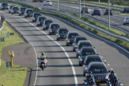
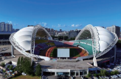
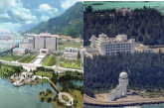


Police Patrol Quadruped Robot
The police patrol quadruped robot addresses key challenges in urban public safety, such as blind spots in manual patrol coverage, delayed emergency response, and high-risk intervention in hazardous scenarios. It conducts urban safety patrols using a bionic quadruped motion platform integrated with facial recognition modules, 5G modules, voice broadcast modules, and more, enabling all-weather, comprehensive security monitoring and control.
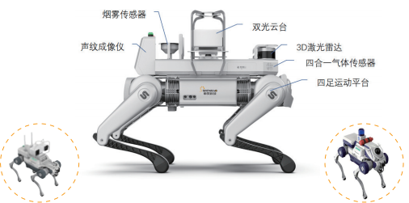

Maximum Walking Speed: 1.5 m/s | Maximum Running Speed: 3 m/s | Maximum Slope Angle: 25°
Maximum Step Height: 20 cm | Maximum Step Slope: 30° | Overall Battery Life: 2–3 hours
Quadruped Payload Capacity: 20 kg | Visible Light Resolution: 1080P, supports facial capture
Function Description


Voice Broadcast
Abnormality Alerts
Remote-Controlled Patrol

The robot is operated for patrol using a configured small remote controller or mobile control terminal.
The robot can be configured to automatically broadcast voice messages during patrol.

The robot is equipped with red and blue warning lights that can flash alerts according to task requirements.


Facial Capture

The robot carries a portable fire extinguisher for emergency firefighting and can transport emergency supplies such as medicines.
The robot can autonomously capture facial images and integrate with third-party facial recognition platforms.
The robot's video can be transmitted in real time.
Video Transmission
Emergency Fire Extinguishing / Storage Box


Function Description

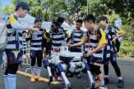
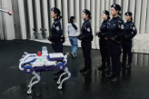
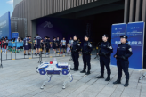


Intelligent Drone Patrol System
The Intelligent Drone Patrol System includes drone management applications, analysis and recognition applications, and real-scene mapping applications. The drone management application integrates remote drone control, mission and trajectory planning, and equipment/team management for comprehensive drone operations. The analysis and recognition application leverages image recognition to analyse visible and infrared images in milliseconds, with AI models accurately identifying scenarios such as illegal parking and lane obstruction. The real-scene mapping platform supports both remote manual and AI-based mapping based on accident response workflows and integrates the DeepSeek large model to generate accident pre-analysis reports, assisting traffic police in accident investigation applications.
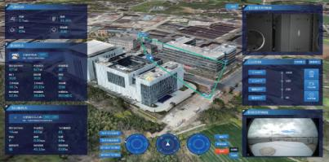

Data Layer / Acquisition Layer | Fixed Drone Station, Mobile Drone Station | Portable Lightweight Drone, Medium Multi-Purpose Drone |  | Wide  Angle/Zoom  Visible  Light,  Infrared/  Laser Rangefinder, Starlight Wide-Angle |  | Loudspeaker,  Gas Detector, Laser Rangefinder |  | Haohan Flight Brain,  Onboard Flight Algorithms, Private Network
Network Layer | 4G / 5G / 1.4G / OPGW Private Network / Beidou
System Platform Layer | Drone Management Platform  Remote Manual Control System  Traffic Inspection Task Planning/Management |  | Image/Flight Algorithms Device/Team Management | Analysis and Recognition Platform  Illegal Vehicle Detection Road Congestion Detection | Pedestrian on Expressway Detection  Crowd Gathering Detection |  | Wrong-Way Driving Detection  ............ | Analysis and Recognition Platform  On-Site Aerial  Overview  Record Mapping
Application Layer | Highway Traffic Management  3D GIS Modeling | Task Dispatch  Abnormal Event Alerts |  | Point-to-Point Flight  Inspection Report |  | Historical Video Retrieval |  | Statistical Analysis
Function Description



: o Remote Drone Control
Resource Coordination Management

Intelligent Task Planning
Long-Distance Drone Flight Control
Intelligent Task Workflow Planning
Efficient Resource Allocation



Dual-Mode Real-Scene Mapping
Real-Time Multispectral Data Analysis

Real-Time Multispectral Analysis
Accurate Scene Recognition
Dual-Mode Real-Scene Mapping
Accurate Scene Recognition


Application Scenarios

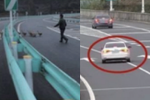
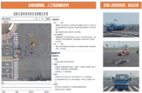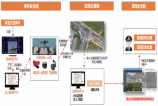



Industrial Health has ShenHao Troubleshooting is No Longer Difficult


0571-88308196
V H
IPI ()
+
TLINE
联系热线
marketing@shenhaoinfo.com www.shenhaoinfo.com
浙江省杭州市余杭区余杭街道宇达路5号
杭 州 申 昊 科 技 股 份 有 限 公 司 H A N G Z H O U S H E N H A O T E C H N O L O G Y C O . , L T D

