**Guidance on writing a good figure title and legend**

* The figure title and legend should give enough information for the reader to be able to understand and interpret the data presented. However, it should not go into exhaustive detail about experimental methods (typically covered in the materials and methods section), or analyse the results (covered in the main body of a paper).
* The title may be descriptive (explaining the type of experiment) or declarative (stating the overall finding). Figures and graphs, by their very nature, show data. It is therefore unnecessary to give them titles such as “Figure showing the amount of cell survival.”
* Figure legends should be as concise as possible. Eliminate any unnecessary words.
* Any symbols, colours, abbreviations, etc. used in the figure that are not immediately intuitive to the reader should be explained in the figure legend. Any statistical analyses used should be succinctly described, e.g. “error bars represent standard error of the mean (SEM)”.
* Correct formatting should be used throughout (e.g. italicized species names, correct Greek symbols where applicable, super- and sub- scripts used appropriately).

Some examples are shown below.

Tucker NP, D'Autréaux B, Studholme DJ, Spiro S, Dixon R. DNA binding activity of the Escherichia coli nitric oxide sensor NorR suggests a conserved target sequence in diverse proteobacteria. J Bacteriol. 2004 Oct;186(19):6656-60. doi: 10.1128/JB.186.19.6656-6660.2004.

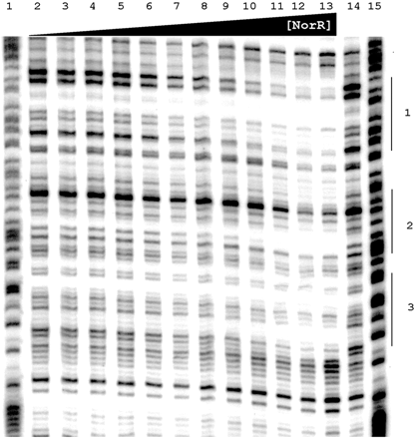

DNase I footprinting of NorR with the template strand of the norVW promoter. The DNA fragment was the 362-bp EcoRI-BamHI fragment, 5′ end-labeled at the EcoRI site. G+A sequencing tracks prepared with the Maxam and Gilbert method are in lanes 1 and 15. Lane 14 contained no NorR. Binding reactions shown in lanes 3 to 14 contained increasing concentrations of NorR identical to those shown in Fig. [**1**](https://jb.asm.org/content/186/19/6656.long#F1). Regions of NorR protection were deduced from three independent experiments and are denoted by the solid lines to the right of the footprint, labeled 1 for the high-affinity site and 2 and 3 for the low-affinity sites.

Williamson, G., Tamburrino, G., Bizior, A., Boeckstaens, M., Dias Mirandela, G., Bage, M. G., Pisliakov, A., Ives, C. M., Terras, E., Hoskisson, P. A., Marini, A. M., Zachariae, U., & Javelle, A. (2020). A two-lane mechanism for selective biological ammonium transport. *eLife*, *9*, e57183. <https://doi.org/10.7554/eLife.57183>

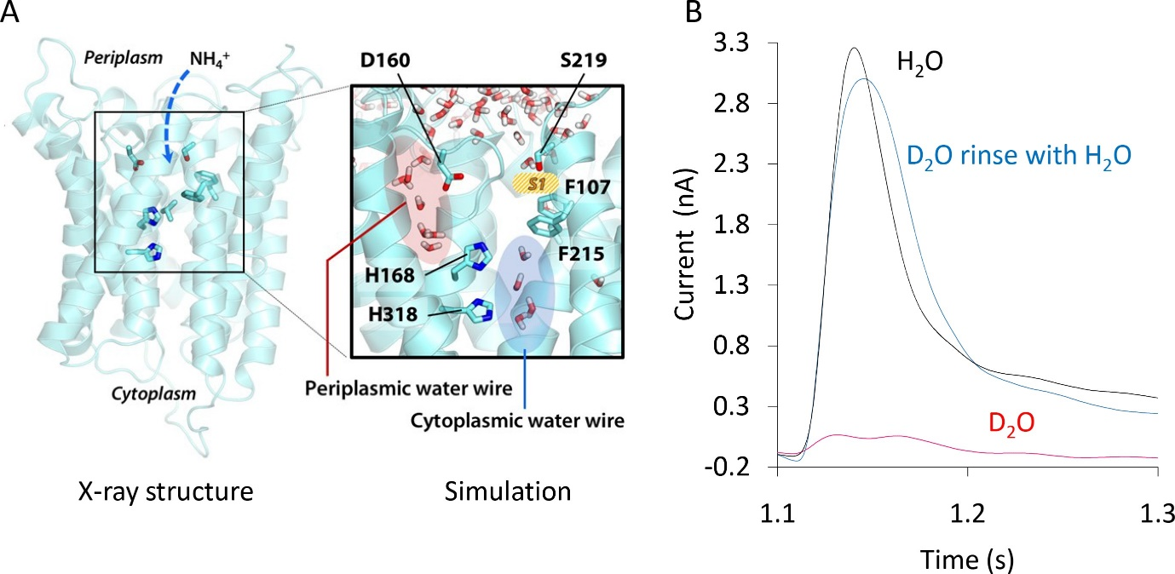

**Formation and functionality of the periplasmic (PWW) and cytoplasmic (CWW) water wires in AmtB.**

(A) Extended atomistic simulations show a hydration pattern across the protein, in which cytoplasmic and periplasmic water wires, connected via H168, form a continuous pathway for proton transfer from the S1 NH4+ sequestration region to the cytoplasm. (B) Transient currents measured following a 200 mM ammonium pulse on sensors prepared with solutions containing either H2O (black) or D2O (red). D2O sensors were rinsed with H2O solutions and subsequently exposed to another 200 mM ammonium pulse (blue)

McHugh, R. E., O'Boyle, N., Connolly, J., Hoskisson, P. A., & Roe, A. J. (2019). Characterization of the Mode of Action of Aurodox, a Type III Secretion System Inhibitor from *Streptomyces goldiniensis*. *Infection and immunity*, *87*(2), e00595-18. <https://doi.org/10.1128/IAI.00595-18>

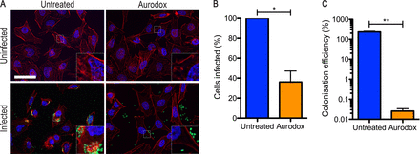

**Effect of Aurodox on EHEC infection of epithelial cells and A/E lesion formation.** (A) Representative microscopy images from EHEC cell infection assay. Cells were infected with 107 EHEC cells transformed with prpsM-gfp (green) to facilitate quantification and imaging. HeLa cells were actin stained with phalloidin-Alexa Fluor 555 (red) and mounted in Vectashield with DAPI (blue). Scale bar represents 50 μm. Insets contain a ×4 magnification of the indicated area. (B) Colonization was quantitated by counting the numbers of cells possessing EHEC on their surface and expressing as a percentage of the total. (C) Following infection, HeLa cells were washed to remove nonadherent bacteria and subsequently lysed to release colonized bacteria. The CFU of EHEC in the lysate were enumerated, and colonization efficiency was calculated by expressing as a percentage of the inoculum. Significance was calculated by paired Student’s t test. *, P < 0.05; **, P < 0.01.

Feeney, M. A., Chandra, G., Findlay, K. C., Paget, M., & Buttner, M. J. (2017). Translational Control of the SigR-Directed Oxidative Stress Response in *Streptomyces* via IF3-Mediated Repression of a Noncanonical GTC Start Codon. *mBio*, *8*(3), e00815-17. <https://doi.org/10.1128/mBio.00815-17>

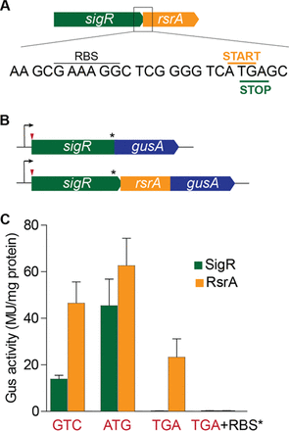

**SigR and RsrA are not produced at equimolar levels, and rsrA can be translated independently of sigR.** (A) Sequence showing the rsrA RBS and the overlap between the sigR stop codon and the rsrA start codon. (B) The sigR-gusA and rsrA-gusA translational reporter fusions used. The positions of the mutations made in the sigR start codon and the rsrA RBS are indicated by the red arrowhead and the asterisk, respectively. (C) Relative SigR and RsrA expression levels when the sigR start codon is GTC (wild type), ATG, or TGA (stop) and when the rsrA RBS is mutated in combination with a TGA sigR start codon. The rsrA RBS mutation used was GAAAGG to TCTAGA. MU, Miller units.

Gallagher, K. A., & Jensen, P. R. (2015). Genomic insights into the evolution of hybrid isoprenoid biosynthetic gene clusters in the MAR4 marine streptomycete clade. *BMC genomics*, *16*, 960. https://doi.org/10.1186/s12864-015-2110-3

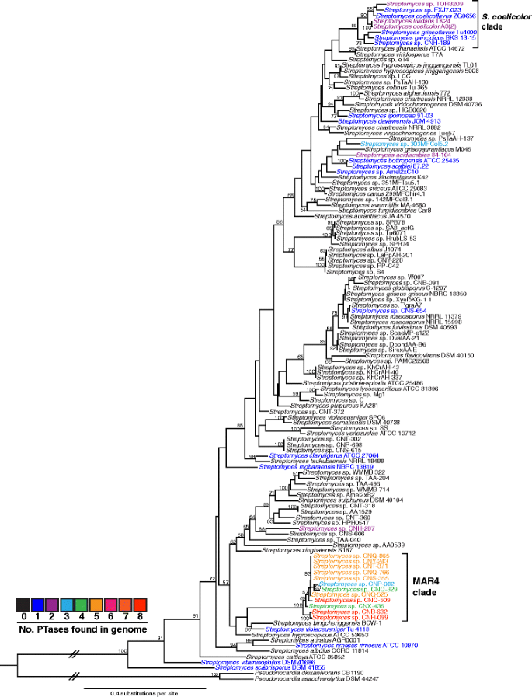

Maximum likelihood phylogeny of the 120 *Streptomyces* strains used in this study. Phylogeny is based on concatenated AtpD and RpoB amino acid sequences. Bootstrap values >50 % are indicated at their respective nodes (based on 100 replicates). Colors indicate the number of ABBA PTases found in each genome. The MAR4 and *S. coelicolor* clades are indicated. Sequences derived from two *Pseudonocardia* genomes were used to root the tree