Locally-built firmware
The following steps were adapted from the build instructions.

Pre-requisites
The following packages support the build process. Some of these packages are often installed with the base image.
sudo apt install git cmake build-essential xz-utils python3 python3-serial wget zip

Clone the repository
Using the git clone method permits subsequent pull operations with less effort for the inevitable rebuild operations for incremental updates to the source. Using the ~/projects folder as a base in the example below is a local convention:
- Download the repository using the following commands
cd ~/projects
git clone https://github.com/loboris/MicroPython_K210_LoBo.git

Build the firmware

- Change the working directory to MicroPython_K210_LoBo/k210_freertos

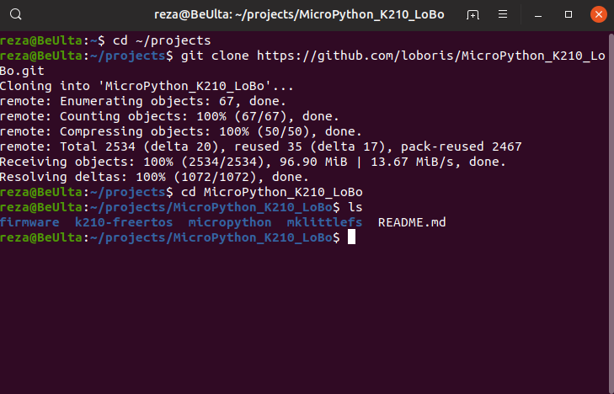
- Build the firmware locally with the following command:

./BUILD.sh

The option to use multiple threads was skipped inadvertently. The option is -jN where N is the number of threads.
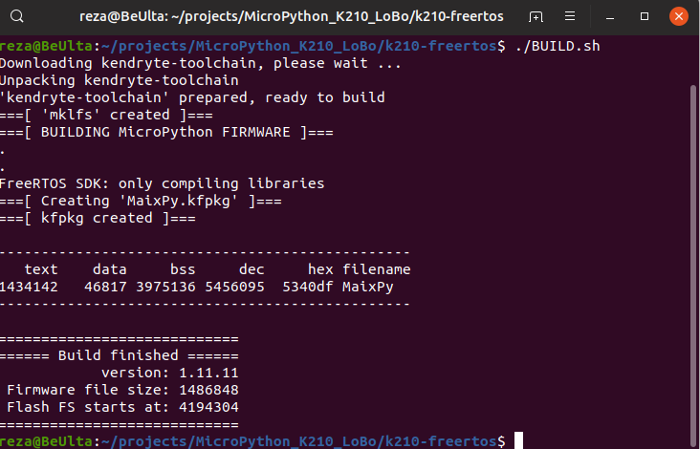

Flash the firmware
Flash the firmware to the board from the current working directory with the following command:
./kflash.py -p /dev/ttyUSB0 -b 2000000 -t MaixPy.bin

The flash operation failed because the K210 was not detected. Two USB ports are detected as shown below. Two different USB Type-C cables were used. Both cables work with Pixel 2XL with the same desktop environment.
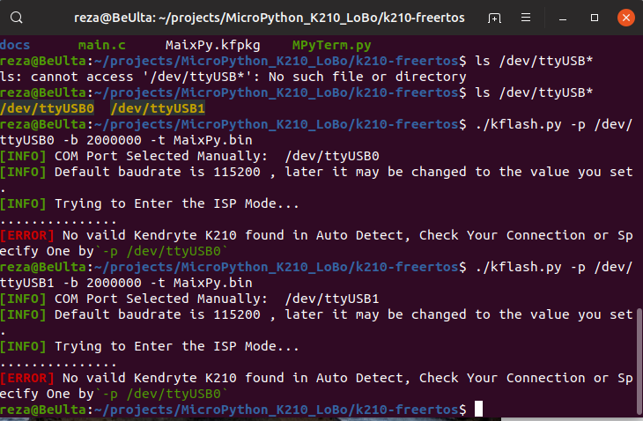
The motherboard is ASUS Prime H370M-PLUS CSM that has a USB 3.1 Gen 1 TypeC port. The ASUS user manual states that this is a 24-pin USB port for Type C devices. The Maixduino has been connected directly to this port as well as through a USB 2.0 port with a TypeC pin at one end.
https://dlcdnets.asus.com/pub/ASUS/mb/LGA1151/PRIME_H370M-PLUS/E13887_PRIME_H370M-PLUS_UM_WEB.PDF

The OS is Ubuntu 19.04 with all update/upgrade completed prior to building the firmware locally.
reza@BeUlta:~$ lsb_release -a
No LSB modules are available.
Distributor ID: Ubuntu
Description: Ubuntu 19.04
Release: 19.04
Codename: disco
reza@BeUlta:~$ uname -a
Linux BeUlta 5.0.0-25-generic #26-Ubuntu SMP Thu Aug 1 12:04:58 UTC 2019 x86_64 x86_64 x86_64 GNU/Linux
reza@BeUlta:~$

reza@BeUlta:~$ lsusb
Bus 002 Device 001: ID 1d6b:0003 Linux Foundation 3.0 root hub
Bus 001 Device 007: ID 0c45:0133 Microdia
Bus 001 Device 016: ID 2341:0043 Arduino SA Uno R3 (CDC ACM)
Bus 001 Device 020: ID 0403:6010 Future Technology Devices International, Ltd FT2232C/D/H Dual UART/FIFO IC
Bus 001 Device 015: ID 2341:0043 Arduino SA Uno R3 (CDC ACM)
Bus 001 Device 014: ID 046d:0990 Logitech, Inc. QuickCam Pro 9000
Bus 001 Device 013: ID 05e3:0607 Genesys Logic, Inc. Logitech G110 Hub
Bus 001 Device 012: ID 2341:0043 Arduino SA Uno R3 (CDC ACM)
Bus 001 Device 011: ID 2341:804e Arduino SA
Bus 001 Device 010: ID 0483:374b STMicroelectronics ST-LINK/V2.1
Bus 001 Device 009: ID 05e3:0607 Genesys Logic, Inc. Logitech G110 Hub
Bus 001 Device 008: ID 04d9:a09f Holtek Semiconductor, Inc. E-Signal LUOM G10 Mechanical Gaming Mouse
Bus 001 Device 021: ID 18d1:4ee1 Google Inc. Nexus Device (MTP)
Bus 001 Device 001: ID 1d6b:0002 Linux Foundation 2.0 root hub
reza@BeUlta:~$

Bus 001 Device 022: ID 0403:6010 Future Technology Devices International, Ltd FT2232C/D/H Dual UART/FIFO IC

Bus 001 Device 022: ID 0403:6010 Future Technology Devices International, Ltd FT2232C/D/H Dual UART/FIFO IC
Device Descriptor:
bLength 18
bDescriptorType 1
bcdUSB 1.10
bDeviceClass 0
bDeviceSubClass 0
bDeviceProtocol 0
bMaxPacketSize0 8
idVendor 0x0403 Future Technology Devices International, Ltd
idProduct 0x6010 FT2232C/D/H Dual UART/FIFO IC
bcdDevice 5.00
iManufacturer 1 Kongou Hikari
iProduct 2 Sipeed-Debug
iSerial 3 01525E7649
bNumConfigurations 1
Configuration Descriptor:
bLength 9
bDescriptorType 2
wTotalLength 0x0037
bNumInterfaces 2
bConfigurationValue 1
iConfiguration 0
bmAttributes 0x80
(Bus Powered)
MaxPower 100mA
Interface Descriptor:
bLength 9
bDescriptorType 4
bInterfaceNumber 0
bAlternateSetting 0
bNumEndpoints 2
bInterfaceClass 255 Vendor Specific Class
bInterfaceSubClass 255 Vendor Specific Subclass
bInterfaceProtocol 255 Vendor Specific Protocol
iInterface 0
Endpoint Descriptor:
bLength 7
bDescriptorType 5
bEndpointAddress 0x81 EP 1 IN
bmAttributes 2
Transfer Type Bulk
Synch Type None
Usage Type Data
wMaxPacketSize 0x0040 1x 64 bytes
bInterval 0
Endpoint Descriptor:
bLength 7
bDescriptorType 5
bEndpointAddress 0x02 EP 2 OUT
bmAttributes 2
Transfer Type Bulk
Synch Type None
Usage Type Data
wMaxPacketSize 0x0040 1x 64 bytes
bInterval 0
Interface Descriptor:
bLength 9
bDescriptorType 4
bInterfaceNumber 1
bAlternateSetting 0
bNumEndpoints 2
bInterfaceClass 255 Vendor Specific Class
bInterfaceSubClass 255 Vendor Specific Subclass
bInterfaceProtocol 255 Vendor Specific Protocol
iInterface 0
Endpoint Descriptor:
bLength 7
bDescriptorType 5
bEndpointAddress 0x83 EP 3 IN
bmAttributes 2
Transfer Type Bulk
Synch Type None
Usage Type Data
wMaxPacketSize 0x0040 1x 64 bytes
bInterval 0
Endpoint Descriptor:
bLength 7
bDescriptorType 5
bEndpointAddress 0x04 EP 4 OUT
bmAttributes 2
Transfer Type Bulk
Synch Type None
Usage Type Data
wMaxPacketSize 0x0040 1x 64 bytes
bInterval 0
Device Status: 0x0000
(Bus Powered)

