MANCOSA Study Hub
Quick Start Guide
A simple, illustrated guide to finding your way around the portal. No tech skills needed.
Updated June 2026 • Covers all four subjects: OB, IKM, OM and MM.

What is this?
An online study portal for four subjects — Organisational Behaviour (OB), Information & Knowledge Management (IKM), Operations Management (OM) and Marketing Management (MM). For each subject you get teaching notes for every unit, theory cards, worked past-paper answers, cases and exam tools — all in one place.

1. Finding your way around
Everything starts from the menu on the left of the screen. At the top are general links (like Home). Below that, under Subjects, are the four subjects — click one to open it. Each subject opens its own set of tools (Units, Theories, Cases, Past Papers and more).
- Click a subject to open its tools.
- Click Home (top of the menu) any time you feel lost.
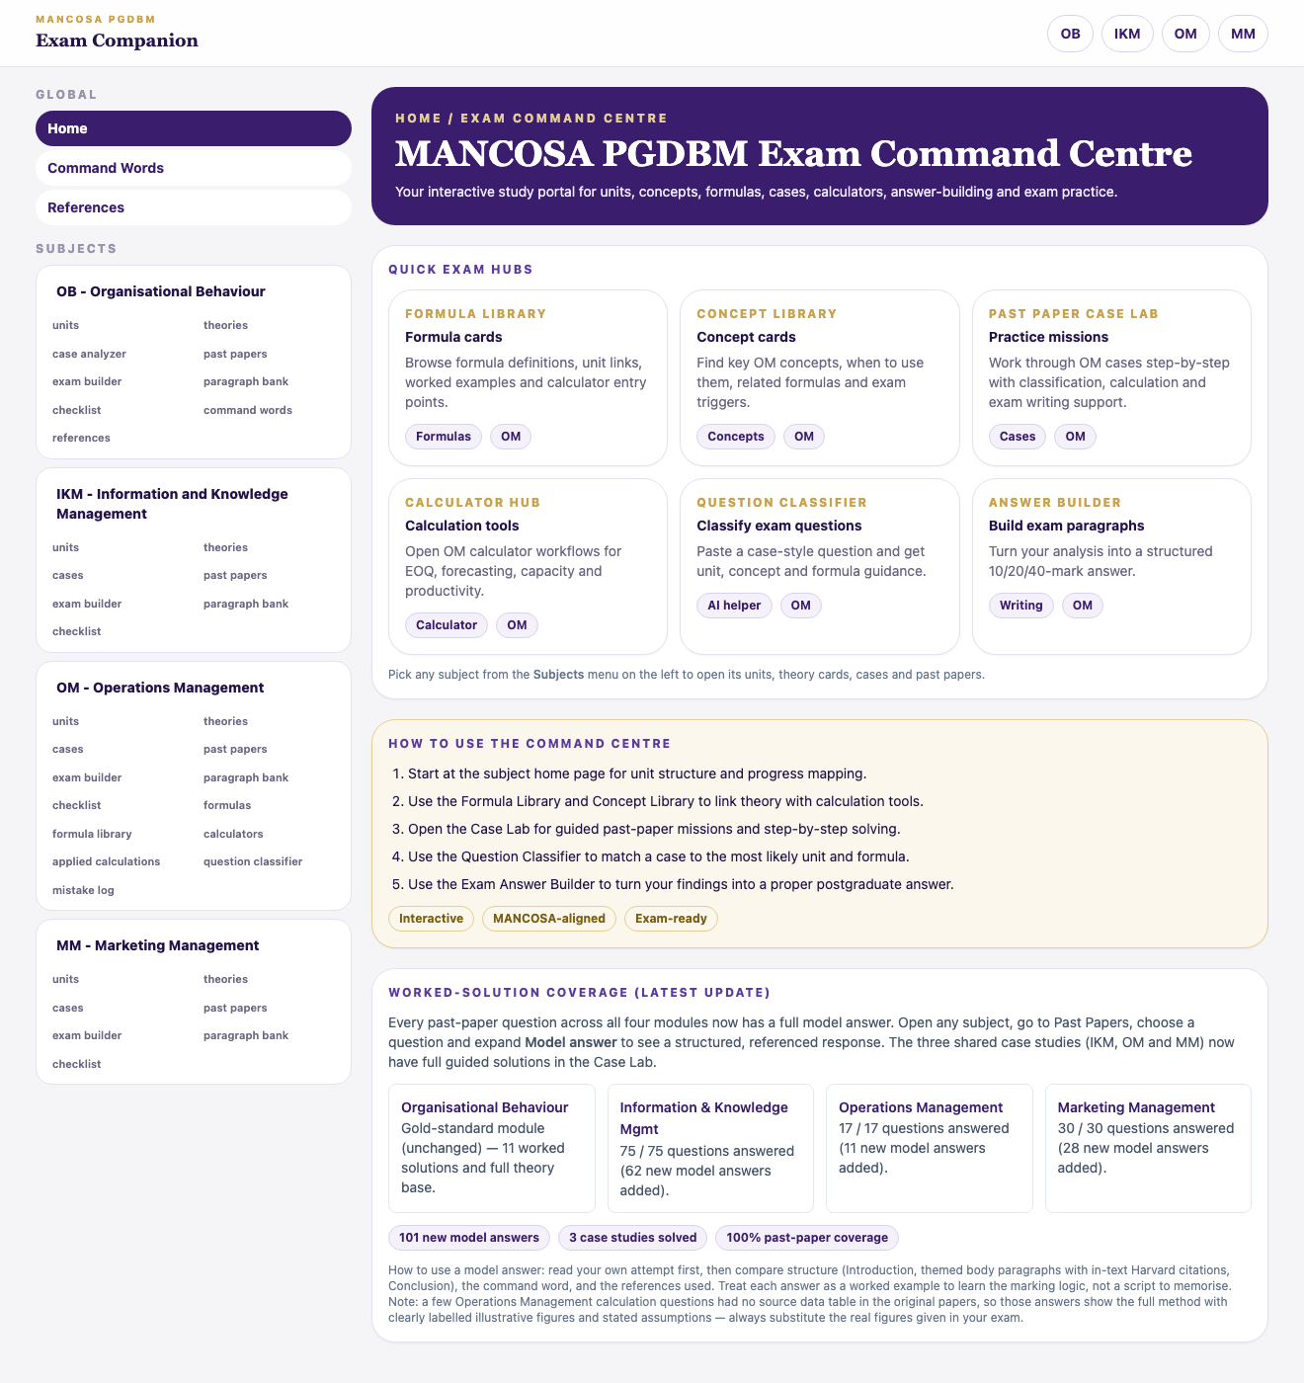
The home page. The Subjects menu is the purple bar on the left — it stays there on every page.
On a phone: the left menu is hidden to save space. Tap the menu icon (☰) in the top corner to open it, then tap a subject.
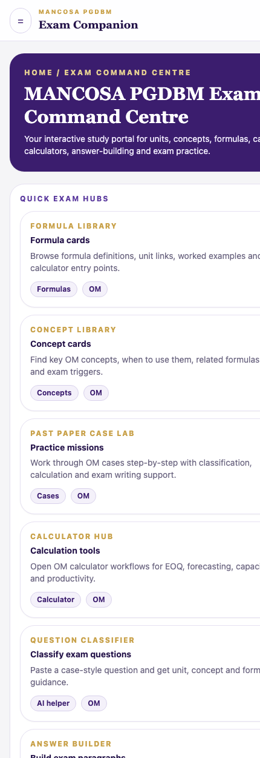
On a phone, tap the ☰ icon (top-left) to open the Subjects menu.

2. The five things you'll use most
a) Units — start here for any topic
Click a subject → Units → pick a unit. Every unit in all four subjects now opens with a plain-language “Unit notes (start here)” box. This is the most important new feature — you can understand the whole unit from this box before opening anything else.
- Introduces the unit and why it matters.
- Explains each key idea simply, with an everyday example.
- Shows how it links to the theories.
- Gives a table mapping each learning outcome → module content → theory to use.
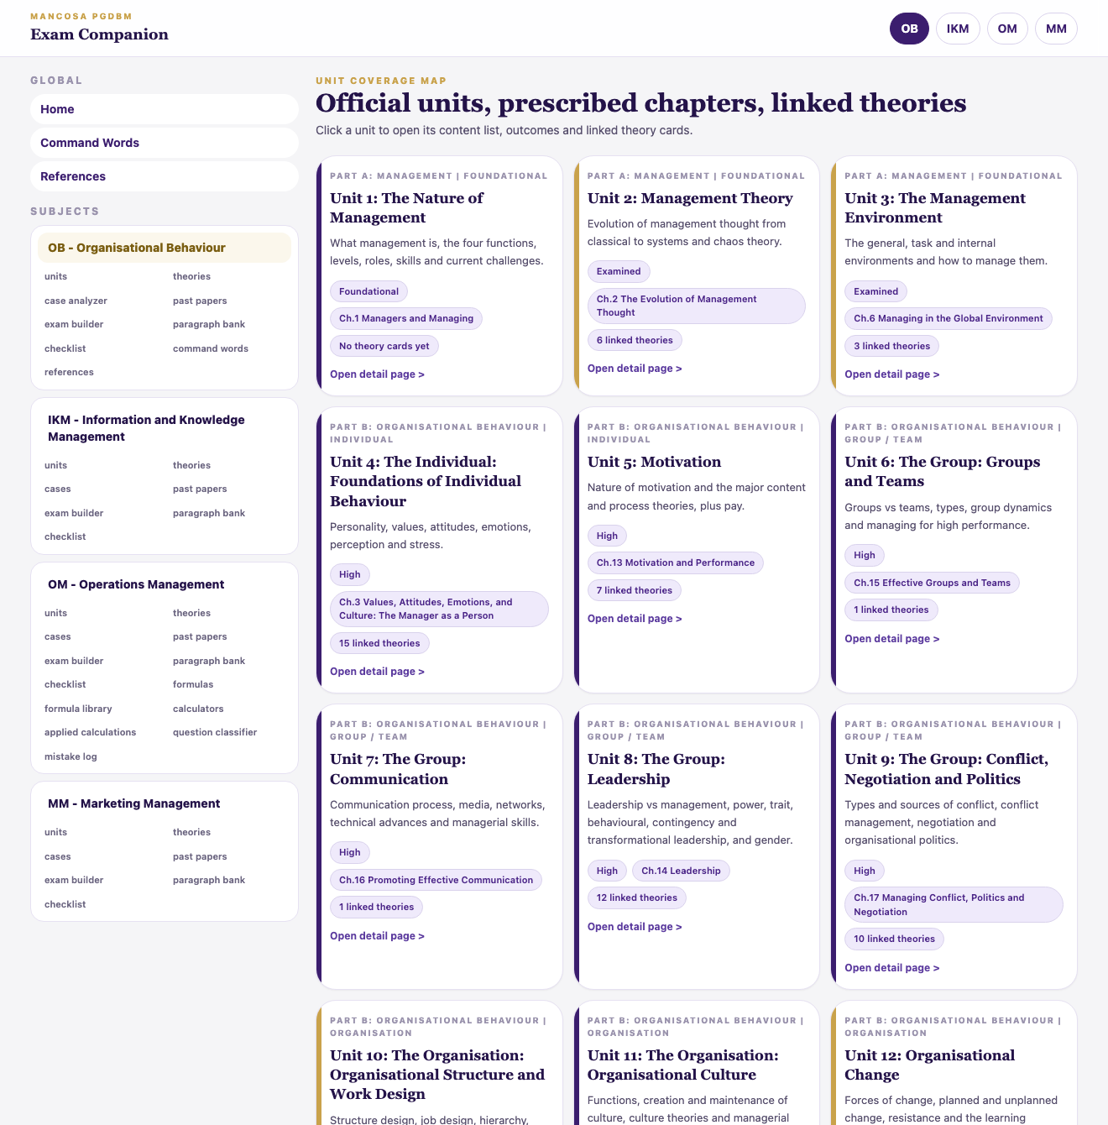
Step 1: open a subject and click Units to see the list of units.
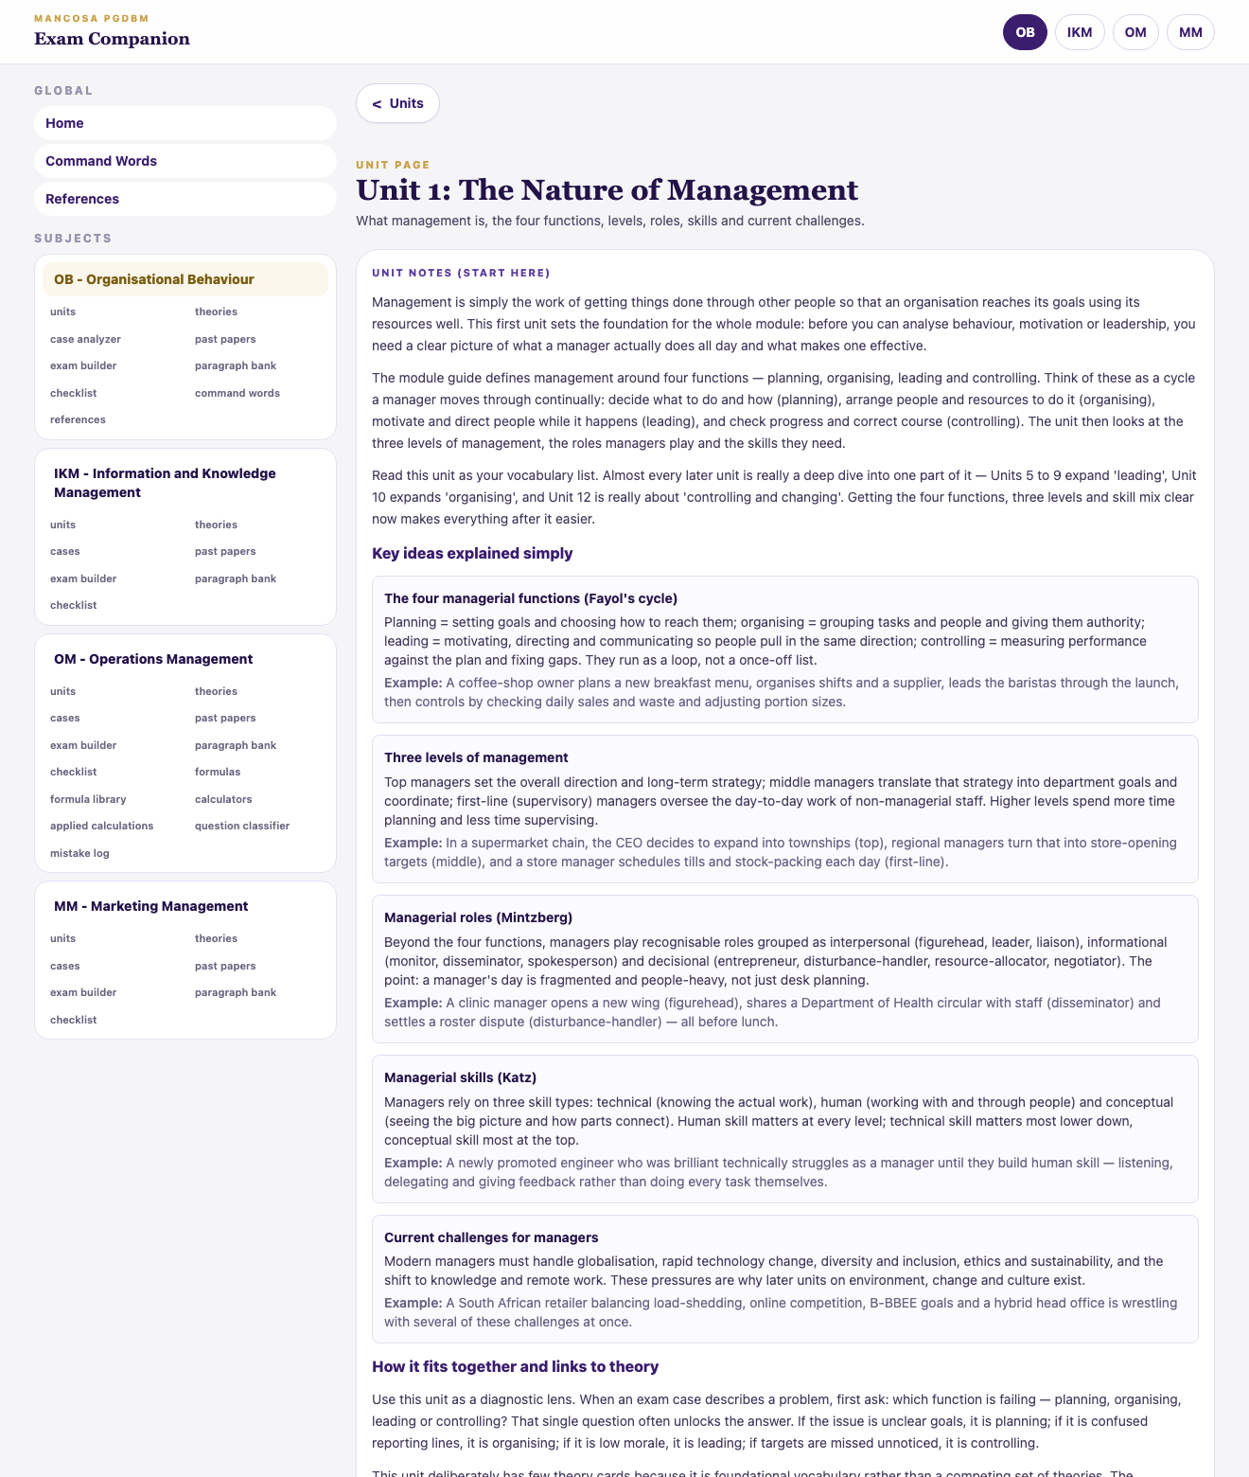
Step 2: open a unit. It now leads with the “Unit notes (start here)” box — introduction, key ideas with examples, theory links, and (further down the same box) an outcome → content → theory table.
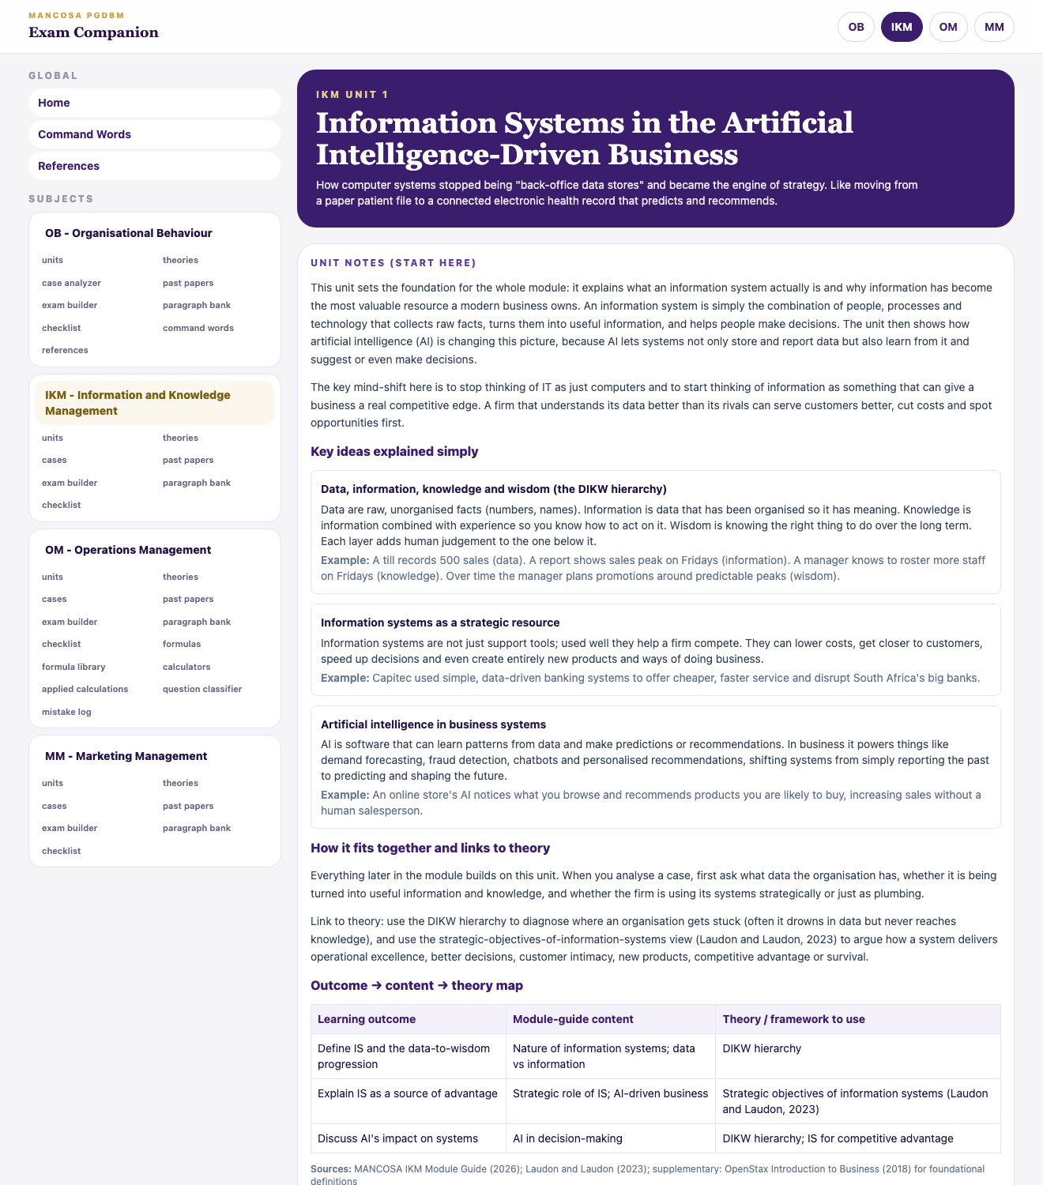
The same “start here” notes now appear in every subject — here in Information & Knowledge Management.
b) Theories — the frameworks and models
Click a subject → Theories → click any card. Each card explains the theory simply, with a real example, a South African example, and the mistakes to avoid.
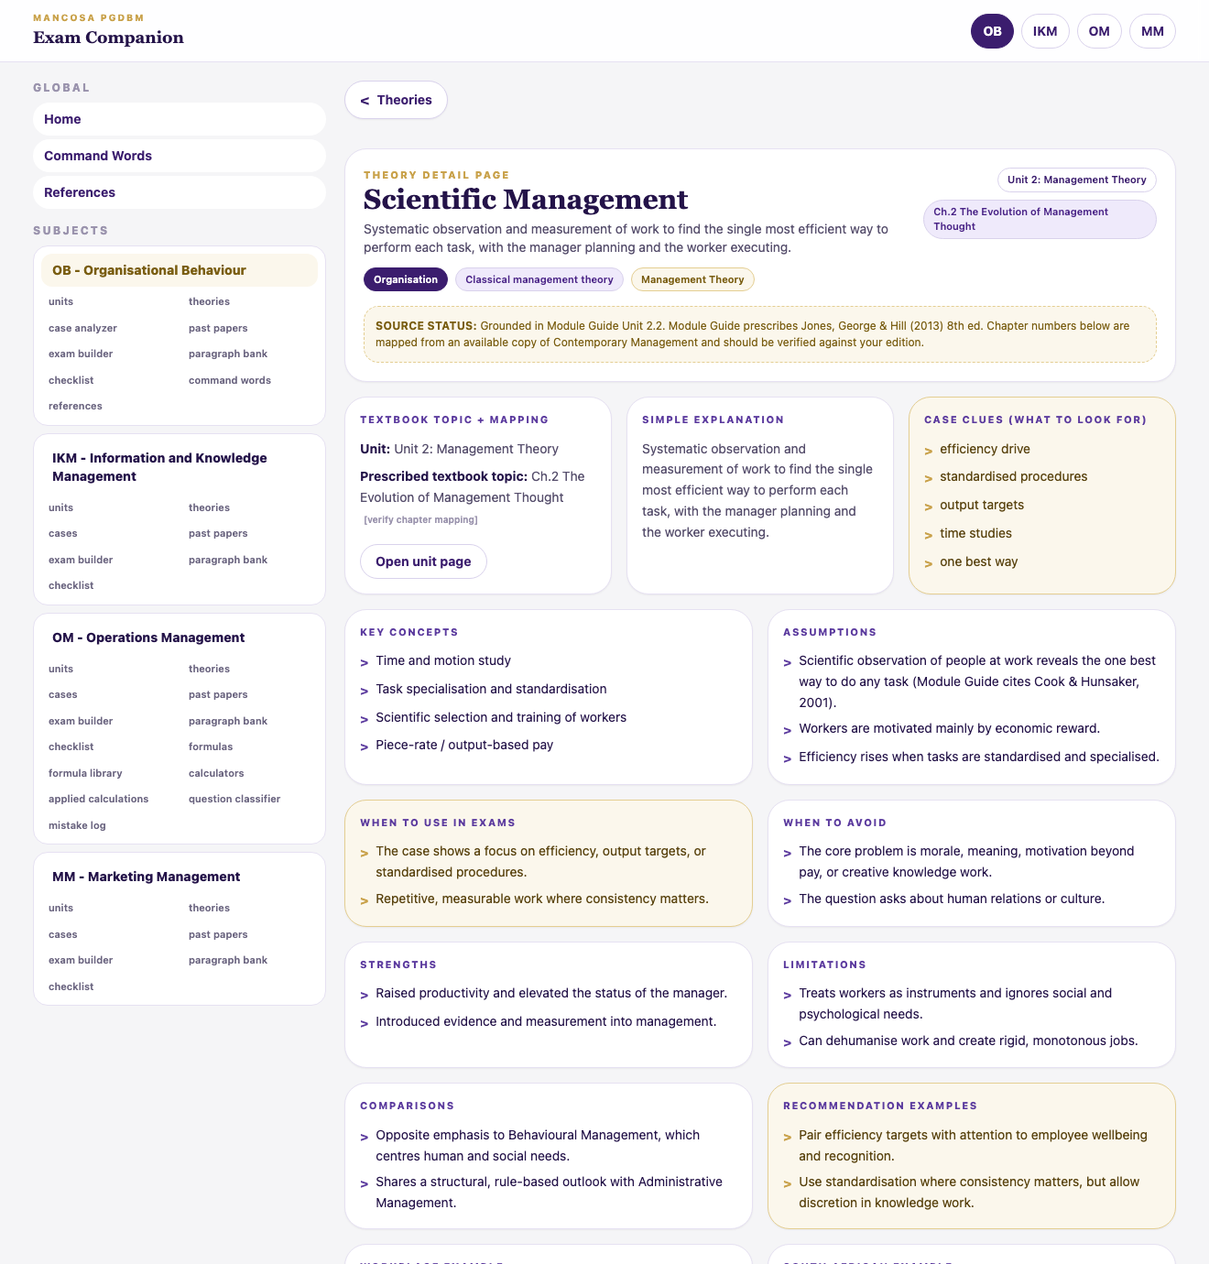
A theory card: a plain definition, what it is for, worked and South African examples, and common mistakes.
c) Past Papers — real exam questions with model answers
Click a subject → Past Papers → pick a question, then read the Worked answer to see a full, structured answer you can learn from.
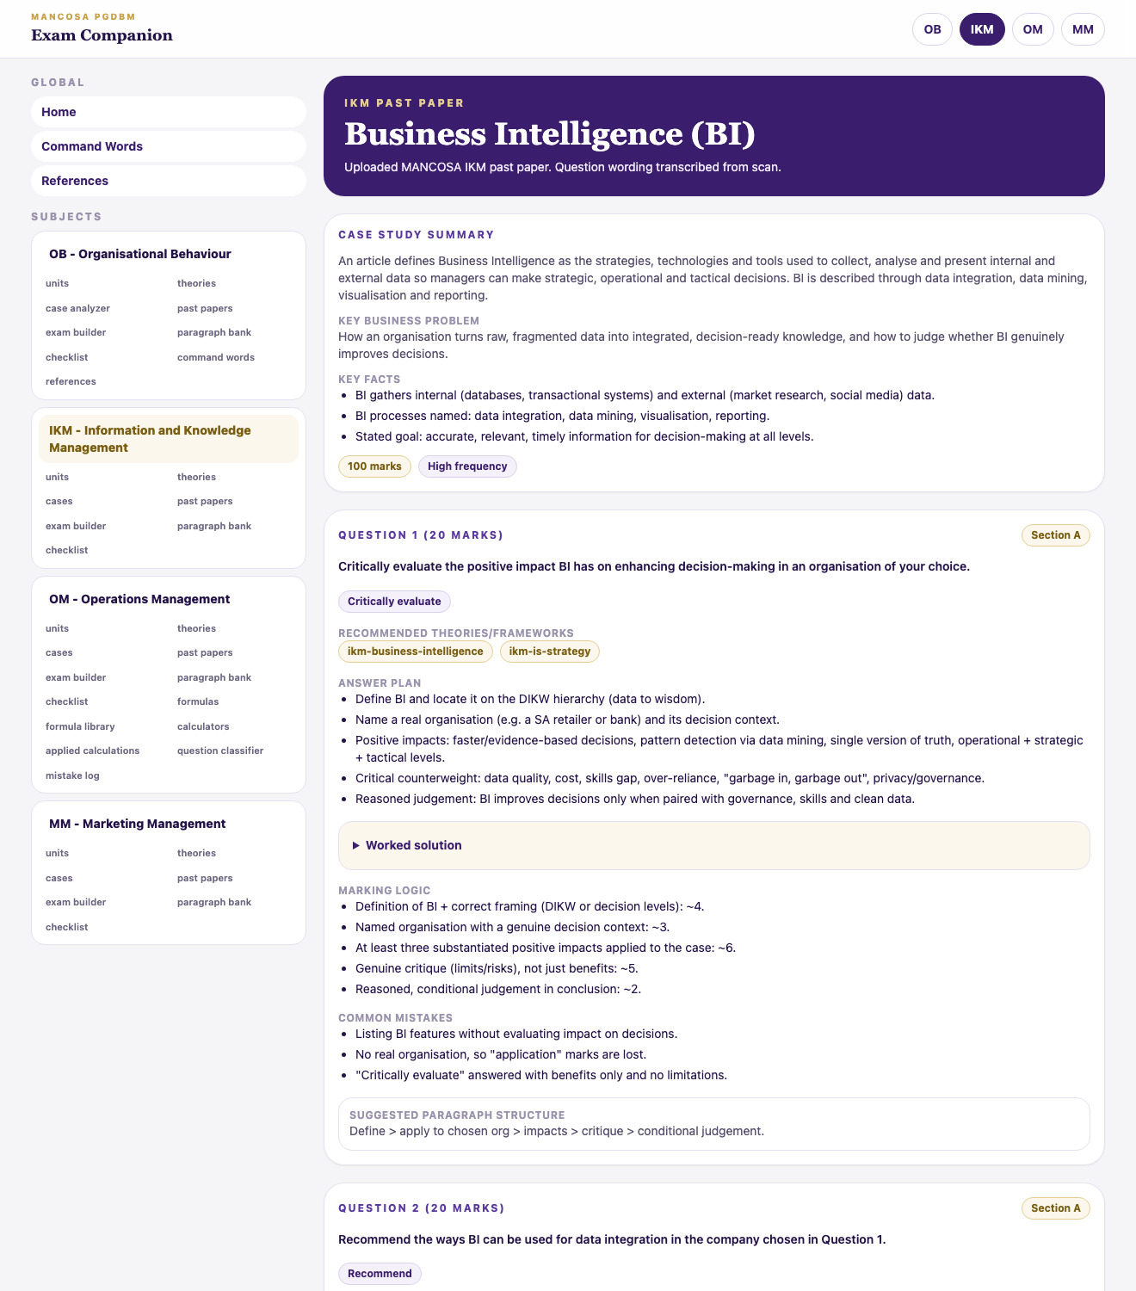
A past-paper page: each question shows an answer plan, the marking words, and a full worked answer.
d) Cases
Practise applying what you've learned to a scenario, step by step.
e) Exam tools (mainly OM)
Formula cards, calculators and an answer builder to help you write proper exam answers.

3. How to actually study with it
A simple routine that works for any topic:
- Pick your subject from the left menu.
- Open Units and read the “Unit notes (start here)” box for your topic.
- Click into the Theories linked in the unit to go deeper.
- Go to Past Papers, try a question yourself first, then check the Worked answer.
- Compare your answer to the model: structure, examples and references.

4. Quick tips
- Coloured / underlined text is clickable — it takes you somewhere useful.
- Use the “← Back” links or Home if you get lost.
- Start with Unit notes when a topic is new; use Past Papers when revising.
- You don't have to read everything — jump straight to the unit or question you need.
That's it. Open a subject, read a unit's notes, try a past paper — you'll get the hang of it quickly.

