**Part 1**

1. First div – **Red** and Second div – **Orange**
2. Adding a pink backgroup to the Id
   1. 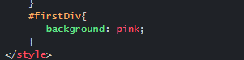
3. Add the class yellow-card to the class attribute
   1. 

**Part 2**

1. **Section 2**
   1. It’s because of the two equal signs, the two equal signs convert the values to the same type before performing the comparison. It’s called type coercion
   2. You’re going to have to use three equal signs like === instead of ==
2. **Section 3**
   1. Because of hoisting, variable that are declared by VAR are created before any code execute
   2. We have to use ‘use strict’

**Part 3**

1. By using Bootstrap grid system.
   1. 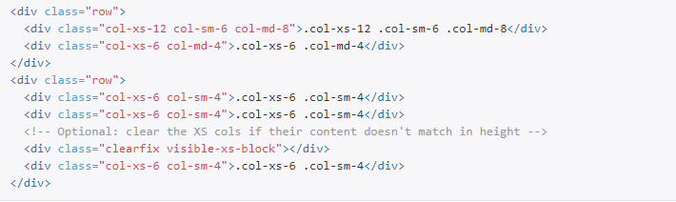
   2. Reduces the number of individual http requests to the server by combining multiple files
   3. Reduces the file download size by removing whitespace and comments.
   4. In return makes the user experience a pleasure
   5. ensure you have Experiments enabled in the browser
   6. enable support for source maps in the browser
   7. enable source map support in your rails 3.1+ webapp