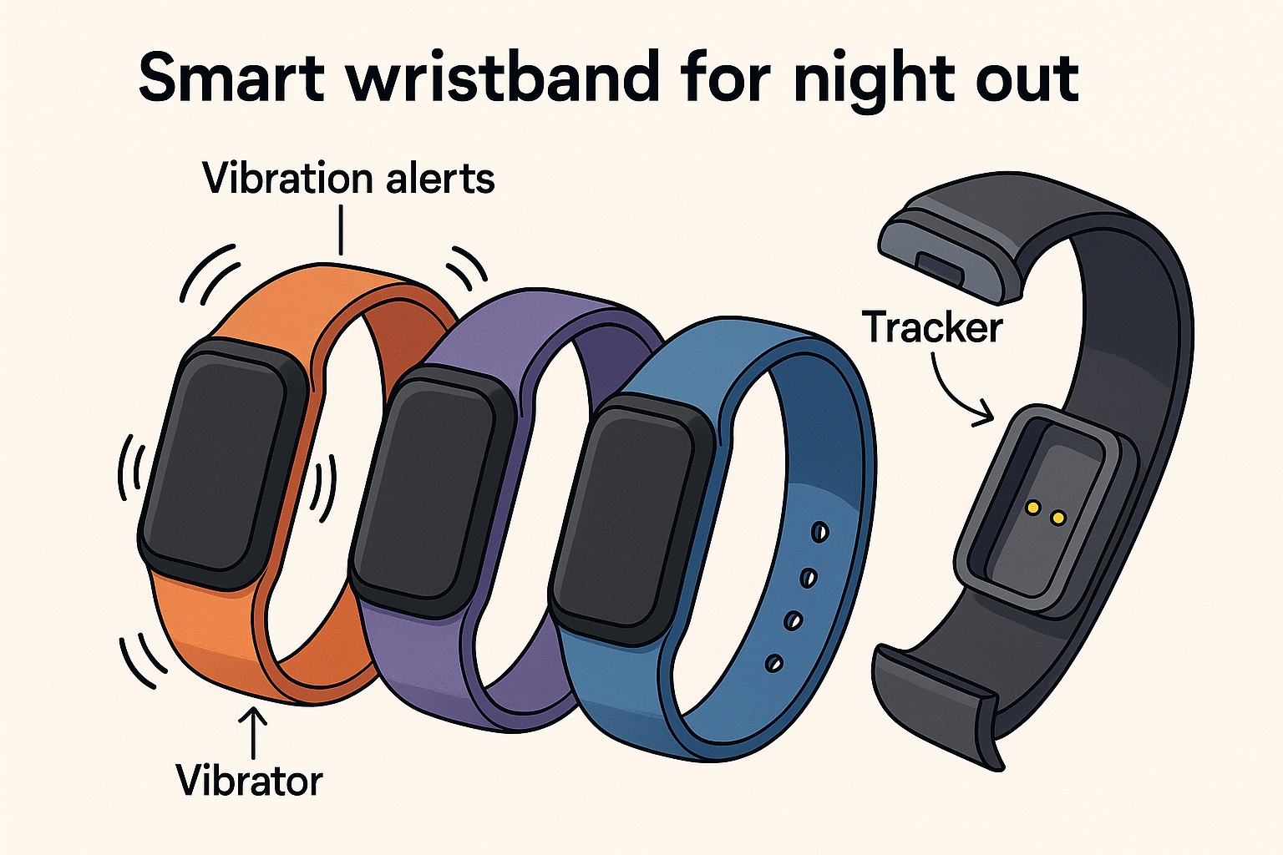
Uber Safety Wristband – Technical Specification
1. Outer Band Design
- Material: Medical-grade silicone (soft, flexible, hypoallergenic, sweat-resistant).
- Size Options: Small, Medium, Large with adjustable strap holes.
- Colors: Black, Blue, Red, Green (customizable with LEDs for visibility).
- Ingress Protection: IP67 waterproof (rain and accidental splashes).
2. Core Electronics Module (Removable Tracker Unit)
The heart of the wristband, detachable for charging and servicing.
GPS Tracker
- Chipset: u-blox M10 series (low power, high precision).
- Accuracy: ±1.5m outdoors, A-GPS support for faster fixes.
- Purpose: Allows ride tracking and safety monitoring during events.
Connectivity
- Bluetooth Low Energy (BLE 5.2): For pairing with mobile app.
- Optional LTE-M/NB-IoT Module: For standalone tracking without phone (premium model).
- Range (BLE): ~10–15 meters indoors, ~50 meters outdoors.
Processor
- MCU: Nordic nRF52840 (integrated BLE + low-power Cortex-M4F).
- Optimized for wearable devices.
3. Vibration Alert System
- Type: Coin Vibration Motors (10mm diameter, 3mm thick).
- Placement: 4–6 motors evenly spaced around the band for 360° tactile alerts.
- Intensity: ~1.2G vibration strength, enough to be felt in noisy environments.
- Control: Patterns (single buzz = reminder, double buzz = Uber outside, rapid buzz = emergency alert).
4. LED Indicators
- RGB micro-LEDs embedded on band edges.
- Functions:
  - Green pulse = Uber en route.
  - Blue pulse = Connected to app.
  - Red flash = Emergency mode.
  - White = Battery charging.
5. Safety Tracker Features
- Emergency SOS: Long press activates alert → shares location with Uber driver and emergency contacts.
- Geofencing: If user leaves predefined safe zone (e.g., event venue), notification is sent.
- Back-to-Car Ping: Vibrates when the registered Uber is within 50m radius.
6. Battery & Charging
- Battery Type: Lithium-polymer 120mAh.
- Battery Life:
  - 48 hours with periodic GPS + BLE.
  - 7 days standby in Bluetooth-only mode.
- Charging: Magnetic pogo-pin dock (USB-C base).
- Charge Time: ~1 hour (fast charging).
7. Software Integration
- Mobile App (iOS/Android):
  - Uber trip sync (time, driver info, pickup).
  - Safety dashboard (live location sharing, alerts).
  - Vibration patterns configuration.
  - Analytics of trips (distance, cost, estimated wait time).
- Cloud Backend (optional premium):
  - Anonymous safety statistics (crowded zones, average trip safety rating).
  - Integration with event organizers (track group exit flow).
8. Additional Features
- Low-Power Mode: When idle, tracker switches to BLE beacon only.
- Anti-Tamper: If strap is forcibly removed, sends alert to app.
- Expandability: Could support NFC for event check-ins (future upgrade).
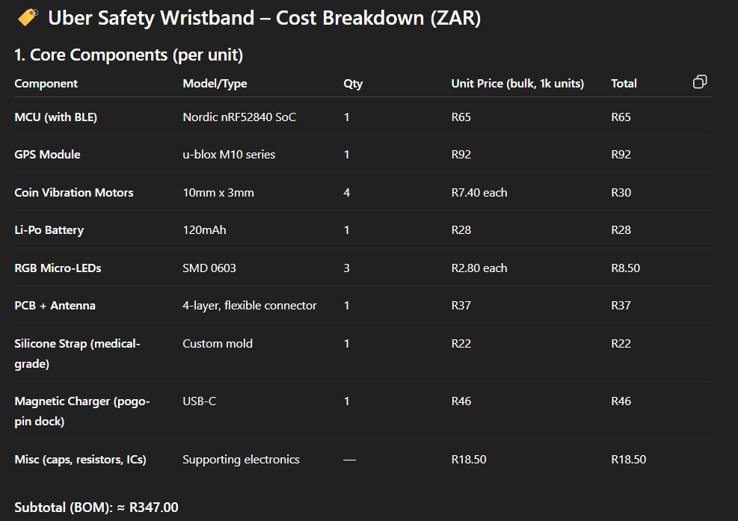
✅ In summary:
The wristband combines u-blox M10 GPS + Nordic BLE MCU, powered by a 120mAh LiPo battery, with coin vibration motors all around the band, RGB LEDs, and a magnetic charging dock. It is rugged, waterproof, comfortable, and directly tied into Uber’s system for round-trip safety tracking.
2. Manufacturing & Assembly Costs
- PCB assembly & testing: R46
- Injection molding + strap finishing: R28
- Packaging (box, manual, cable): R23
Added Assembly Total: ≈ R97.00
3. Total Cost Per Unit
- R347 (BOM) + R97 (Assembly/Packaging) ≈ R444 per wristband (for 1,000-unit batch).
4. Market Pricing Strategy
Wearables typically use a 2.5× – 3× markup.
Suggested Retail Price (SRP): R1,100 – R1,300
This keeps it:
- Competitive with imported smartbands (Fitbit Inspire ~R1,500+).
- Still profitable (≈ 60–65% gross margin).
5. Scaling Cost Reductions
- At 10,000+ units, BOM drops to ~R280–R300.
- Total per unit (with assembly): ~R380.
- This allows SRP to stay at R1,100–R1,300 while increasing margins.
Summary in Rands:
- Unit cost (1k order): ≈ R444
- Target retail price: R1,100 – R1,300
- Gross margin: ~60–65%

your SA Gig Guide project to Uber South Africa (or the right people at Uber) to see if they’d be interested.
Here’s a draft email you can adapt and send:

Subject: Partnership Proposal: SA Gig Guide + Uber Integration
Hi [Name / Uber SA Partnerships Team],
I hope this message finds you well. My name is [Your Name], and I’ve been working on a project called SA Gig Guide — a modern event discovery and planning tool designed for South Africans who want seamless nights out.
The platform allows users to:
- Browse curated events by genre, budget, and popularity.
- Preview venues with maps, safety notes, and area advisories.
- Set reminders and share group plans (including per-person ride splits).
- Book transport options directly — making Uber the natural integration point.
I believe there’s a strong fit with Uber, especially in connecting event discovery with safe, reliable transport. With Uber as the preferred ride option in the flow, users can effortlessly go from “finding the vibe” to “arriving together.”
Here’s a quick look at the MVP:
- Tech: Built with React + TailwindCSS and integrates reminders, maps, and event posting.
- Live demo: [link if you have it]
- Screenshots attached below.
I’d love to explore a potential partnership or pilot with Uber South Africa — particularly around integrating Uber buttons, safety features, and ride estimates directly within the event planning experience.
Would you be open to a short call or meeting to discuss this?
Looking forward to your thoughts.
Best regards,
[Your Name]
[Your Contact Info]
[Optional: LinkedIn / Portfolio link]

