**Airport Flight Control Simulator**

**Requirement Specifications**

**PREPARED BY: PRINCE KUMAR**

**DATE: 01/11/2022**

**1. Requirement Analysis**

* Organizes and regulates the process of landing aircraft at an airport.
* Simulator to find out best utilization of holding pattern.
* The system will have a holding pattern.
* Instructions to the aircrafts is issued according to the holding pattern.

**Objective:**

Develop an Air Traffic Controller simulation over an airport.

To achieve a safe, orderly and expeditious flow of air traffic.

**Functionalities:**

* Configure
  + Configure holding pattern
* Add
  + Add new aircraft for landing.
* Instruction
  + Issue instructions for aircrafts at every time tick.
* Change
  + Change the current fuel capacity with time.
* Schedule
  + Randomly schedule emergency landing
* Proposed system is intended to be used by ATC trainees, pilots.
* Success Metrices:

Robust and Efficient holding Pattern

Minimal Collison

Highly Efficient use of runways

**2.Functional Specification**

* Suppose a scenario where Tom(Pilot) wants to land his aircraft on Delhi Airport the he will send his request for landing to the Jerry (ATC Controller).
* In the request Quagmire will mention
* Current fuel capacity
* Current altitude
* Emergency Siren(If applicable)
* Aircraft Type
* Aircraft Size

**Scenerio 1:**

* Based on the request Jerry (ATC Controller) will try to fit Tom (the pilot) in the holding queue.
* If a runway is not occupied, then Jerry will allocate the runway to Tom and send instruction to promote from holding pattern to final approach.
* If the runway is not available but it will be available for Tom before his fuel capacity hits critical mark, Lois will instruct Tom to demote from final approach to holding pattern**.**

**Scenerio 2:**

* If Micky ( a traveler) needs immediate medical attention, then Tom will raise emergency signal and Jerry will check if emergency runway is available if yes, the Quagmire will be instructed to emergency promote to front of file approach.
* If emergency runway is occupied then Jerry will check if any other aircraft have extra fuel if yes then that aircraft will be instructed to abort landing, return to back of final approach, Tom lands.

**Scenerio 3:**

* If Jerry (ATC Controller) is not able to plan landing for Tom (The pilot) and he has sufficient fuel to go to nearest airport, then Tom will be instructed to redirect to another airport.
* If Tom does not have sufficient fuel, then he will be instructed to emergency promote to front of file approach.

**Intial UI Design:**

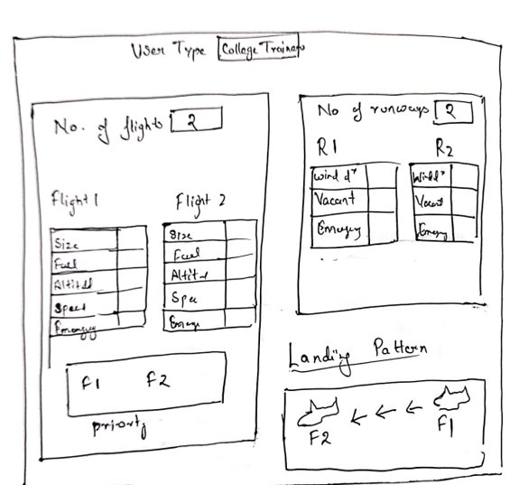

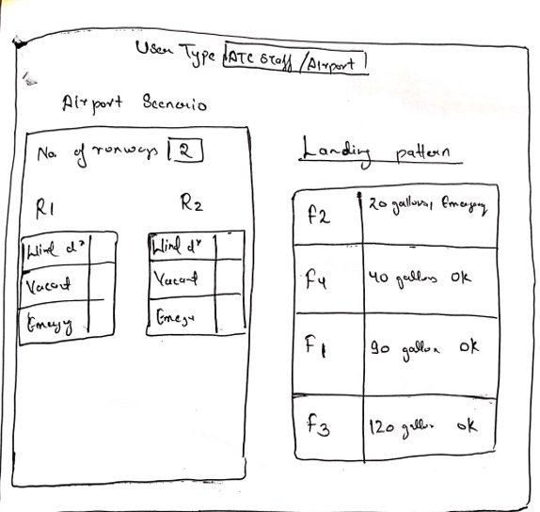

**3. External Interface Specification**

* Https communication Protocol will used for the interaction of aircraft with ATC server.
* GUI will be used to send request and show the respective responses.

**4.Technical Specifications**

* Software Specifications

Browser

Server

Code Editor

* Hardware Specifications

Laptop with minimum 4GB RAM

**THANK YOU!**