1. Monday May 10th, at around 9:50am
   1. Our NOC monitors all went dark
   2. Ping reply’s and access were unreachable
   3. IBM monitor alert tool notified me of the ping offline alert
2. 9:51am,
   1. I opened a ticket through the IBM unified support system
   2. I logged into the IBM management console and as any first attempt with hardware is to reboot the equipment. The management console reported the equipment error below: (server time in UTC)
   3. 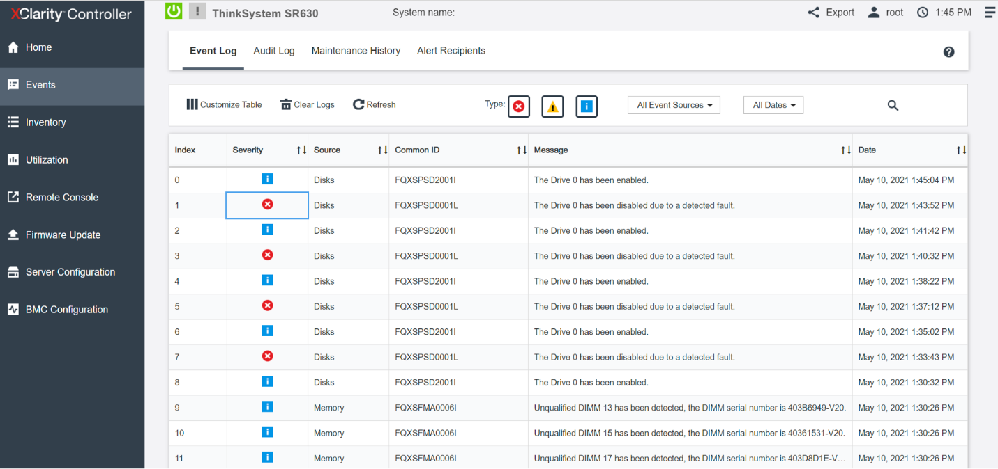
3. 10:23am
   1. IBM (Justin Mercado) confirms hard disk failure, escalates to TOR01 datacenter
4. 10:31am
   1. IBM (Walter Thorne) receives ticket reports he is investigating
5. 10:54am
   1. IBM (Rosario Costabile – Site manager) – chimes in that they are investigating and working with the technicians to bring the equipment back online. Promises updates every 20 minutes.
6. 11:27
   1. IBM (Walter Thorne) – confirms unracking the equipment, performed physical inspection and orders a drive swap.

*-><- Hello Jonathan, After unracking host <vdc01>, we performed a physical inspection of the server. We found that there is no damage to the RAID Controller cables, and no physical damage or issues to the chassis. Additionally, we also removed <HDD0>, and cleaned it's SATA connectors using Deoxit wipes. Unfortunately, this did not bring <HDD0> back online upon re-seating. We are now going to proceed with a drive-swap on the failed disk <HDD0>. Normally in this situation we would perform an OS Reload transaction with your last OS, but records show that you installed your own OS not done by our automation. As this is the case, we will let you know when the drive swap has been completed, and host <vdc01> has been racked and is ready to proceed. Once the drive-swap and OS Reload have been completed, we can install the old failed <HDD0> into an empty drive slot of host <vdc01>, so that you may attempt to salvage any data as needed. Please give us some time to complete the drive-swap, and we will provide another update shortly. Sincerely, Walter T. Datacenter Technician IBM Cloud*

1. 11:53
   1. IBM (Walter Thorne) confirms malfunction equipment replaces with identical replacement.
2. 12:51
   1. IBM (Walter Thorne) confirms re-racking the equipment online, however only the management console responding to ping reply
3. *2:38pm*
   1. Jonathan Geller confirms I have finalize re initializing a new OS on the drive and confirm system is responsive, however access to the defunct drive, still unavailable
4. 3:11pm
   1. IBM (Walter Thorne) requests permission to perform multiple reboots to force the drive online via the RAID controller. Permission is granted.
5. 4:42pm
   1. IBM (Walter Thorne) confirms he is unable to bring the equipment back online, however will continue to investigate.
6. 4:44pm
   1. Jonathan Geller requests we bypass the RAID Controller and plug the equipment in to a USB port via a sata cable.
7. 5:26
   1. IBM (Tenzin Wangyal) confirms they have done that and are rebooting the equipment manually
   2. Equipment boots up with access to the disk, and with access to vitals on it reporting errors.
8. 8:09pm
   1. Jonathan Geller reaches out for a status update, as the IBM management console is reporting a system board failure. (image below)
   2. 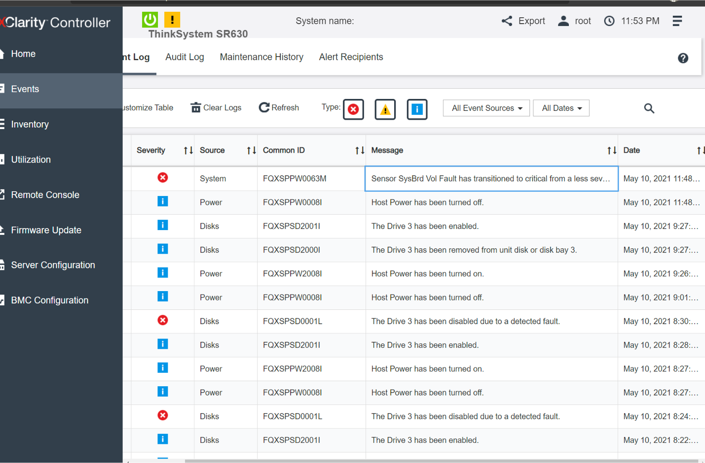
   3. The machine is no longer responsive, and server cannot be powered on
9. 20:16
   1. IBM (Ricardo Salazar) begins investigation
10. 20:49
    1. IBM (Rosario Costabile Site manager) confirms back a diagnosis
    2. *-><- Hi Jonathan, We're received this ticket back at the TOR01 datacenter. Due to the additional issue you're seeing regarding the SysBrd Vol Fault error, we are preparing a new chassis so that we can eliminate hardware as being a possible cause. I did find the following article that states the issue may be related to the older firmware on the machine (2.61): https://support.lenovo.com/us/en/solutions/ht509247-sr630-reports-sensor-sysbrd-vol-fault-when-in-os-idle-mode-lenovo-thinksystem-sr630 Regardless, we'd rather be on the safe side so I'm working with the team to build out another server to match your current specifications. Once the server is built out, we'll start an automated job that will transfer all our backend data from the current server over to the new one, and during this process we'll move all drives into the new host as well. Please rest assured, we want to get you a fully operational server as quickly as possible. Also, we have not forgotten the failed drive that you would like to get access to - once we get a fully working server, we'd like to try a couple things to maybe get it online long enough to grab what you need. We'll keep you updated every 20 minutes as we work to get you an operational server as soon as possible. Regards, Rosario C Site Manager, TOR01 IBM Cloud*

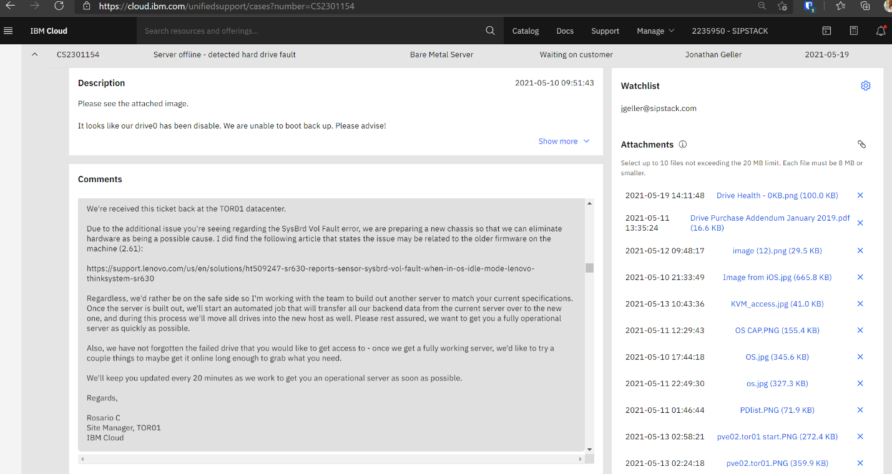

1. 9:02pm
   1. IBM (Tenzin Wangyal) confirms they are ‘kitting an identical’ equipment to match what we had
   2. 10:49 tenzin confirms hardware chassis transfer in progress and this time they are currently flashing the problematic firmware
2. Tuesday 1:29am
   1. IBM (Brian Lee) confirms transfer and firmware updates complete, continuing to transfer drives
3. 1:44am
   1. IBM (Rosario C) confirms trying to get the equipment online without success.
4. 1:56am
   1. IBM (Opeyemi Umoette) confirms new machine booting to management interface
5. 2:07am
   1. Jonathan Geller requests if the defunct equipment can be couriered
6. 2:31am
   1. IBM (Opeyemi U) reiterates they do not have a process for customers to purchase equipment
7. 9:57am
   1. IBM (Haieda Rasuli) provides some information on equipment purchase for recovery
   2. *-><- Hello Jonathan, First off we appreciate your cooperation in this matter. Given that attempts to recover the drive have been unsuccessful we are Addressing your request in update 45 "are you able to courier me the drive at our expense." we would need some information from you to get you the accurate information: Shipping information So that we can determine if it is possible for us to proceed with approvals: - Customer Name - Customer Mailing Address we are asking for this information now because there are certain restrictions and processes for this option: - we cannot ship internationally - we cannot accommodate diversion risk locations (a diversion risk refers to high risk shipment. For example, the customer wants to ship to a random warehouse across from an airport.) Additional mentions: - Cost of HDD/SSD - Admin fee: ~$150.00 The Customer Success Manager (CSM) is authorized to approve or deny this process so we will contact the CSM Please let us know if you have any questions in regards to the above and we will be happy too assist you. Regards, Haieda R. Datacenter Tech, IBM Cloud*

...

This carries on for days.

...

1. 9:03am May 13
   1. Jonathan alerted the IBM team that while still connected to the IBM VPN, noticed we are unable to access ANY of our equipment.
2. 9:32
   1. IBM (Todd B) indicates he will need to send to another team to investigate.
3. 10:53
   1. IBM (Abraham E) confirms the management interfaces are accessible, however from my VPN, traffic might be blocked by a security gateway, and is transferring to their internal security team for further investigation.
   2. ... no updates to VPN until...
4. 5:26pm May 14
   1. Jonathan Geller requests status of VPN management or why we are unable to boot / access other equipment.
5. 5:42
6. Ssutherl***com2021-05-14 17:42:42
7. -><- I cannot approve this ticket on behalf of Legal until the customer has signed and uploaded the Drive Purchase Addendum [see update 110].

In a separate thread, Rosario C was trying to get me to sign the addendum.

May 17th, I receive the following notice in the IBM notification panel that they are fixing firmware procedures to prevent component failures.

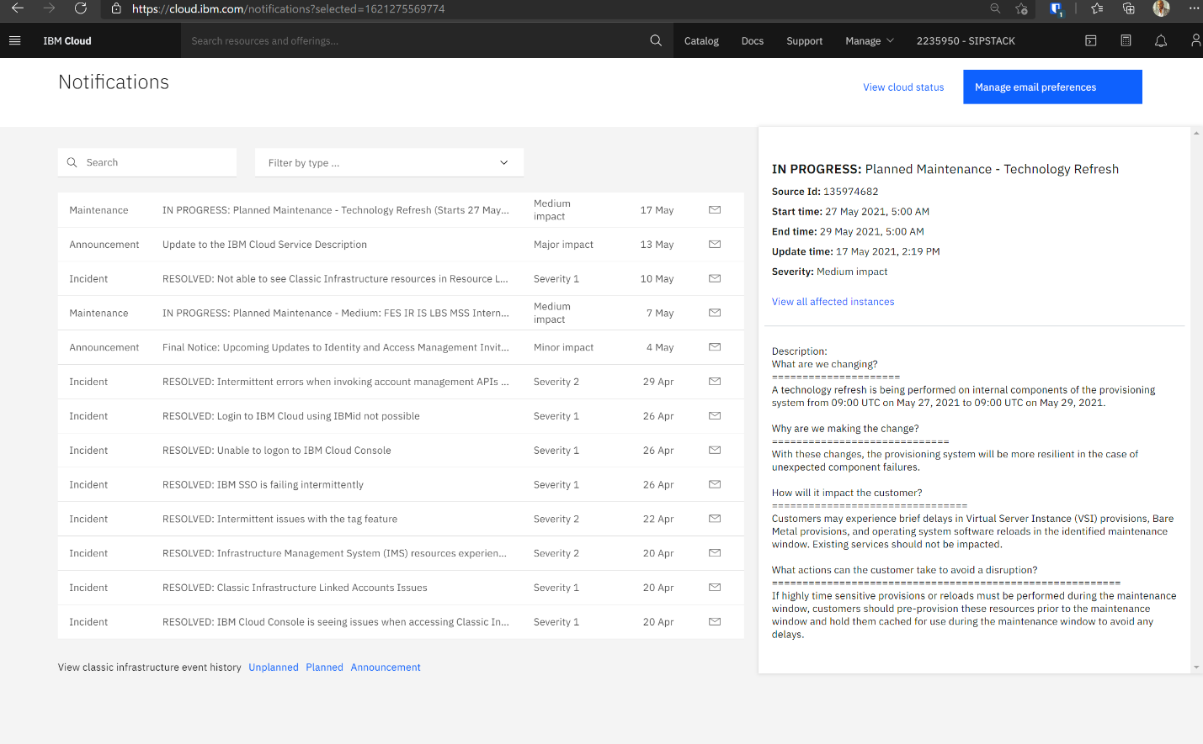

May 18th, we receive positive news we can inspect the drive:

**<email screenshot from ssutherl has been removed to protect privacy>**

Citing: we can schedule a time to inspect the hardware from a confernece room at the datacenter.

I comply with instructions, provide details to the questions asked, and provided multiple time windows to schedule this inspections:

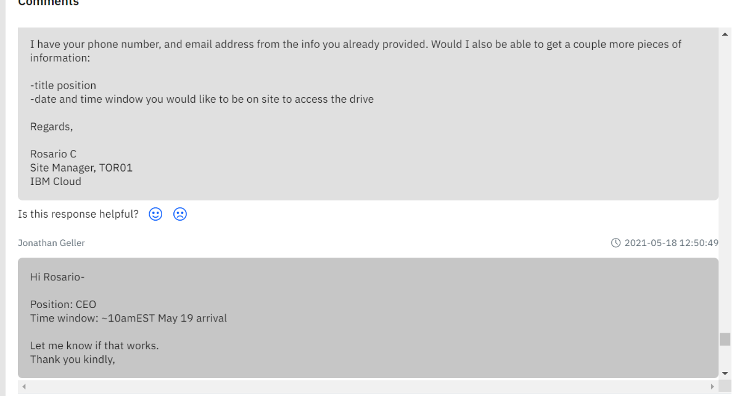

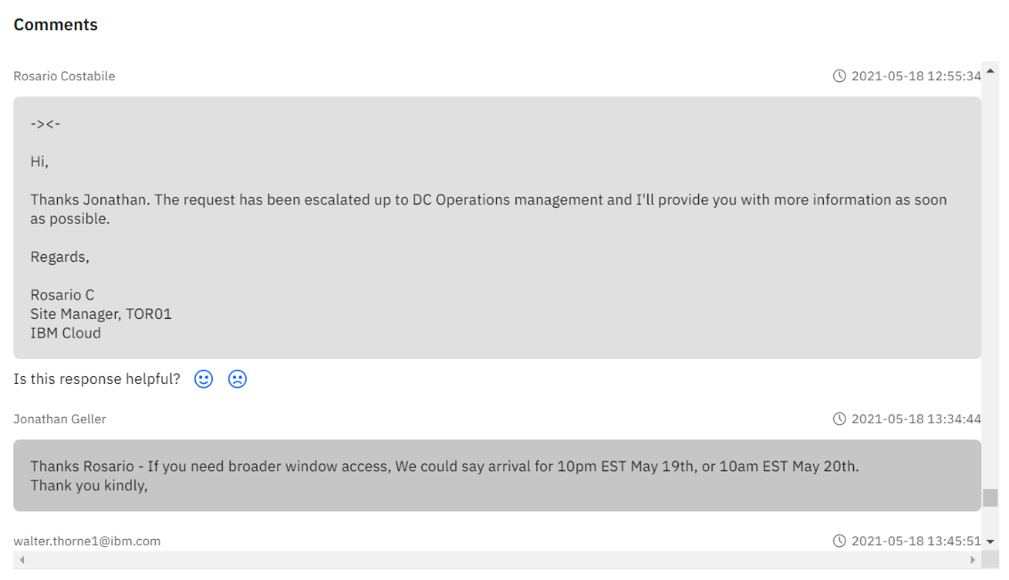

Only to hear back with the following email:

**<email screenshot from ssutherl has been removed to protect privacy>**

Citing: drive inspection rejected by compliance department, refers back to drive purchase addendum.

…

May 18th (same day) I receive the following email:

**<email screenshot from pierre.chhin has been removed to protect privacy>**

Citing: His credentials and role, and that event has been escalated to top management chain for executive review. Request to connect for a phone call.

I had a phone conversation with Pierre at 9:20pm.

He suggested he wants to help, by plugging in the hard drive to diagnose. I let him know, for security reasons this had to be done on one of our servers in inventory @ ibm, while I am remotely monitoring via the management console (KVM).

Pierre spent 1 hour the following day just poking around not doing much. (I took all the screenshots).

Wednesday May 19, the below email is received

**<email screenshot from ssutherl has been removed to protect privacy>**

Citing: his boss advised IBM can give drive at no cost, however addendum still required, offers to modify title on agreement.

Our response was that he only agreement we sign would omit the limited liability statements. To which we receive the below email.

**<email screenshot from ssutherl has been removed to protect privacy>**

Citing: general counsel rejects the proposed addendum set forth by SIPSTACK general counsel.

… SIPSTACK retains special counsel, further summary can be found an a future document.