Design Document for Golden Bike Shop
Siqiao Chen
Regis University

Requirement Description:
Golden, Colorado is a small town situated on the western edge of the Denver metropolitan area. Because of its proximity to Denver and civic improvements it has seen growth in tourism. Recreational biking, along Clear Creek, is a popular activity. The Golden Bike Shop rents bikes on a daily/hourly basis and has seen growth so that an automated system for rentals and other management functions is needed. What is desired is a web-based system where customers can reserve and pre-pay for bike rentals. Kiosk stations will be available in the store for customers that have not made advance reservations. This system must also handle inventory management for the bikes.
Bikes available for rental have a number of characteristics to accommodate a wide variety of customers – including young adults interested in higher performance biking, older adults wanting a more comfortable biking experience, bikes for children, and other special needs bikes. To accommodate the bicyclist needs, the system must be capable of displaying an inventory of available bikes. The customer must be able to search the inventory for available bikes matching search criteria. The customer must be able to select a group of bikes for rental on a given day. To complete the transaction the customer enters credit card information and other personal data. The credit card is not charged until after the bikes are returned.
The in-store kiosk stations function the same as the general web-based interface with the exception that they have a credit card swipe capability so that the customer does not need to key in their credit card information. All rentals require a valid credit card. Store employees are available for customers requiring assistance at the kiosk stations. Reservations may be changed or cancelled until 24 hours before the scheduled rental time.
Upon return of a bike the duration of the rental is noted and compared to the requested rental duration. The final rental charge is determined and the credit card is charged. Store employees record any problems with bikes upon their return. A returned bike is out of service until it has been inspected by a store employee. A late fee is assessed if the bike is returned more than 30 minutes after the requested rental return. The late fee is reduced if the renter phones the store to notify that the rental will be late.
Management must be able to set the charge for reservation changes and cancellations. Management must also be able to set the bike rental rates. Typically rates reflect seasonal variations in bike usage. However, rates must also be able to be changed to reflect holidays and other events. Bike rental rates are set by the type of bike – performance, recreational, or other.

Management also must be able to take bikes out of service for maintenance and be able to add bikes to the inventory. Adding a bike to the inventory requires entering data to the system to describe the bike.
Various reports are needed from the system, such as a summary report describing the inventory and summary reports of rental history for the inventory. The system must also be able to report on the rental history for individual bikes, noting how often the bike has been rented and any problems recorded during inspection and maintenance.

Use Case: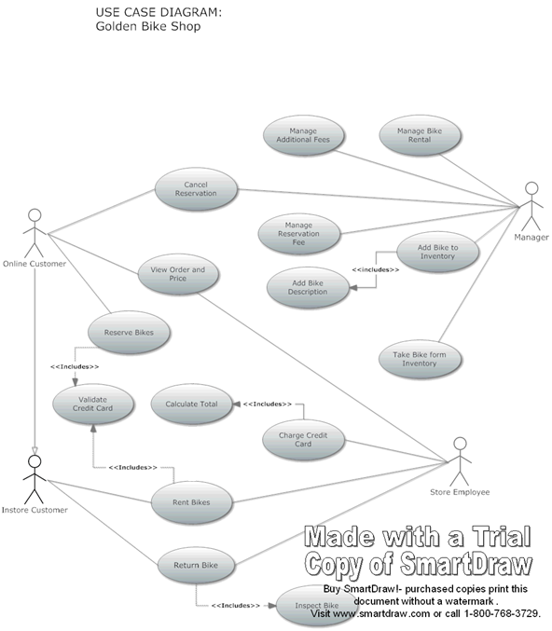

Use Case: Reserve Bikes
Id: UC- 1
Description
The customer needs to search online for available bike model and quantity then reserve.
Level:
Fish Level
Primary Actor
Online Customer
Pre-Conditions
Online Customer must access the site website.
Post Conditions
Success end condition
Online Customer found wanted bike and save it for Reservation.
Failure end condition
Online Customer cannot find a bike. The Online Customers goal cannot be achieved.

Main Success Scenario
- Online Customer search Bike Type.
- Website Displays list of Bike Model for the Type, Fee info and quantity.
- Online Customer Click on desired bike.
- Online Form show form of quantity and date.
- Online customer picks quantity and date then submits the form.
- System lists all the reservations and displays the estimated price by using Calculate Total (UC-4) and generates form for user to enter credit card related information.
- Online Customer Enters Credit Card Information.
- System must include a Validates Credit Card process (UC-3), then save the order to system and generates a unique case number for customer.

Extensions
2a System may not contain the type of Bike in inventory at the moment.
2a1. System display error says that there is no available bike currently in that type.
2a2. System will return to the main page for another search.
5a Customer may want to add another bike
5a1. Online Customer select “Add another Reservation”.
5a2.Online Customer continue from step 1.

Variations
The online Customer may visit or call store employee ask for available bike.
Frequency
0-50 reservation request per day.

Use Case: View Order and Price
Id: UC- 2
Description
The customer must be able to view Order and Price at any time.
Level:
Fish Level
Primary Actor
Online Customer
Store Employee
Pre-Conditions
Online Customer must access the website and at least at step 6 of UC-1 reserve bikes.
Post Conditions
Success end condition
Online Customer is able to see the order.
Failure end condition
Online Customer cannot find the order.

Main Success Scenario
- After Customer submits the reservation form system generates the order list.
- System uses Calculate Total process (UC-4) to calculate the total charge by fee info and reserved days.

Extensions
1a User may go back to website any time to check the order.
1a1. Online Customer enters in unique case number on website.
1a2. Website loads and displays saved reservation order.
2b Store employee must be able to view order.
1b1. Store employee enters uniqure case number on instore console.
1b2. Website loads and displays saved reservation order.
Frequency
0-100 order request per day.

Use Case: Cancel Reservation
Id: UC- 3
Description
Online Customer must be able to Cancel Reservation.
Level:
Fish Level
Primary Actor
Online Customer
Manager
Pre-Conditions
Online Customer submits the reservation.
The Reservation is 24 hour before scheduled rental.
Post Conditions
Success end condition
Reservation is canceled.
Failure end condition
Reservation is not been canceled.
Minimal Guarantee
Display and log the cancelation request and the reason why the order is not able to be canceled.

Main Success Scenario
- System asks for The Case Number of reservation and Last Name on Credit Card and user to reenter credit card number.
- Online Customer provides the Case Number, Last Name and Credit Card Number.
- System conform the Cancellation action.

Extensions
3a system may not be able to match the customer information.
3a1. System display error: “Information does not match!” then provides link returns to step 1.
3b system finds out the date is within 24 hour before the scheduled rental.
3b1. System displays the error message “Cannot cancel the reservation with-in 24 hour before the scheduled rental, please contact with the store. “ Then provide link returns to step 1.
3c manager may need to cancel the order by hand
3c1. Reservation Management Console asks manager the case number
3c2. Manager input the case number
3c3. System force the reservation to be canceled.
Frequency
0-10 requests per day.

Use Case: Rent Bikes
Id: UC- 4
Description
In store Customer must be able to rent a bike. Online Customer must be able to check out the reserved bikes.
Level:
Sea Level
Primary Actor
Instore Customer
Supporting Actors
Store Employee
Pre-Conditions
Customer walks in the store.
Post Conditions
Success end condition
Customer rent bikes.
Failure end condition
Customer cannot rent wanted bike.

Main Success Scenario
- Customer asks the store employee for bike rental.
- Store Employee introduces the available bikes to customer.
- Customer picks the wanted bikes and date.
- Store Employee generate the order, system uses Calculate Total (UC-4) to estimate the price.
- Customer confirms to rent.
- System include validate the credit card (UC-3) step, and provides the Credit Card swapper tool.
- Customer swaps the card.
- Card is validated and Customer checks out the bikes.

Extensions
5 Customer may want to pick another bike due to the estimated price.
5a1. Customer goes back to Step 2 to choose bike, or walk out of the store.
1b Customer may have online reservation.
1b1. Customer shows the store employee the reservation case number or name & Credit card.
1b2. Store Employee directly check out the reserved bikes for Customer.
8c Card may not pass the validation.
8c1 Store Employee notifies the customer that the card is invalid and asks for another card.
8c2 Customer shows another card and goes back to step 7 or chose to leave.
Frequency
0-50 requests per day.

Use Case: Return Bikes
Id: UC- 5
Description
In store Customer must be able to return bikes during store hour.
Level:
Fish Level
Primary Actor
In-Store Customer
Supporting Actors
Store Employee
Pre-Conditions
Customer walks in the store.
Customer rent bikes.
Post Conditions
Success end condition
Customer returned bikes.
Failure end condition
Customer cannot return bike due to information mismatches.

Main Success Scenario
- Customer asks the store employee to return the bike.
- Store Employee checks the bike and the rental order and accepts the bike.
- Store Employee must then Inspect Bike (UC-8) and generates receipt and inspection report.
- Customer receives the receipt and inspection report.

Extensions
2 Store Employee found that the returned item is not original from store.
2a1. Store Employee reports to the store manager for solution.
Frequency
0-50 requests per day.

Use Case: Add Bike to Inventory
Id: UC- 6
Description
Manager must be able to add Bike to Inventory
Level:
Fish Level
Primary Actor
Manager
Pre-Conditions
Store gets new bike.
Store has bikes back from service.
Post Conditions
Success end condition
Bike is added to Inventory.

Main Success Scenario
- Store Manger take new bike into Inventory.
- System checks and require manager to add bike description
- Store Manager adds bike description (UC-12).
- Item is added into Inventory

Extensions
1a Store manager received repaired bike.
1a1. Store manager received repaired bike and take it into inventory.
1a2. System logs the service record and go to step 2.
Frequency
0-5 requests per day.

Use Case: Take Bike from Inventory
Id: UC- 7
Description
Manager must be able manage the bike inventory manually by putting bike in service.
Level:
Fish Level
Primary Actor
Manager
Pre-Conditions
Store has bikes in service from service.
Post Conditions
Success end condition
Bike is set as in service. Bike quantity in inventory is edited.
Failure end condition
Bike is not available for service. Bike quantity cannot be modified.

Main Success Scenario
- Store Manger get report from store employee that the bike need to be repaired, or the bike need scheduled maintenance, and put a bike to service.
- System logs the service and modifies inventory.

Extensions
1a Store manager finds out a bike need scheduled maintenance.
1a1. Store Manager finds out bike need maintenance and put it in service.
1a2. System logs the service and modifies Inventory.
Frequency
0-5 requests per day.

Use Case: Charge Credit Card
Id: UC- 8
Description
Store employee must charge the customer for rental.
Level:
Sea Level
Primary Actor
Store Employee
Pre-Conditions
Customer returns bikes.
Bike is inspected.
Post Conditions
Success end condition
Credit Card is been charged.
Failure end condition
Customer refuses the charge.
Credit Card cannot be charge due to other problems.
Minimal Guarantee
Information must be logged.

Main Success Scenario
- Store Employee sends the repair fee, days rented to system.
- The system must Calculate Total (UC-4) for the case.
- Store Employee fire the charge.
- Credit Card Company confirms the charge.

Extensions
4 Credit Card Company may not confirm the charge.
4a1. Store Employee reports to the store manager for solution.

Frequency
0-50 requests per day.

Use Case: Manage Reservation Fee
Id: UC- 9
Description
Manager must change Bike Reservation
Level:
Fish Level
Primary Actor
Manager
Stakeholders and Interests
Online Customer: Online Customer wants to know about reservation and fee info.
Pre-Conditions
Manager Access the Reservation Management console.
Post Conditions
Success end condition
Reservation Fee is changed.
Failure end condition
Reservation Fee is not changed.

Main Success Scenario
- The Reservation Management console asks Store Manager to input Fee info.
- Store Manager adds Reservation Fee.
- System updates new fee info.

Frequency
0-1 requests per week.

Use Case: Manage Additional Fee
Id: UC- 10
Description
Manager must be able to add Additional Fee for special days like holidays or events.
Level:
Fish Level
Primary Actor
Manager
Stakeholders and Interests
Customer: Customer wants to know about additional fee info for special days.
Pre-Conditions
Manager Access the Additional Fee Management console.
Post Conditions
Success end condition
Additional Fee is changed.
Failure end condition
Additional Fee is not changed.

Main Success Scenario
- The Reservation Management console asks Store Manager to input Fee info and date Info.
- Store Manager adds Fee info and date info.
- System record fee info and apply this fee at the selected date.
Frequency
0-1 requests per week.

Use Case: Manage Bike Rental
Id: UC- 11
Description
Manager must be able to set Rental to Bike according to performance, recreational or other.
Level:
Fish Level
Primary Actor
Manager
Stakeholders and Interests
Customer: Customer wants to know about rental info.
Pre-Conditions
Manager Access the Rental Management console.
Post Conditions
Success end condition
Reservation Fee is changed.
Failure end condition
Reservation Fee is not changed.

Main Success Scenario
- The Rental Management console asks to Store Manager select one type of bike from a list of all bike types.
- Store Manager selects one types of bike.
- Rental Management console ask Manager to input new fee info.
- Store Manager set the Fee info.
- System records the new fee info and apply it went new order is arrived.

Frequency
0-10 requests per month.
Domain Object Analysis
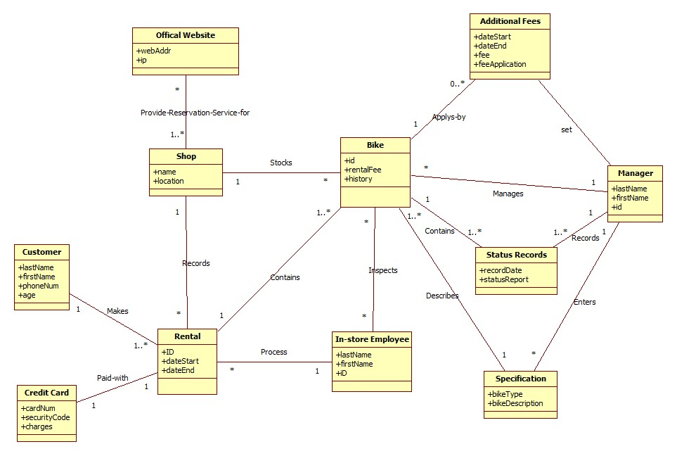

Sequence Diagrams:
