SiQiWang report
Contents
Task 1 1
1.1 1
1.2 2
1.3 3
1.4 5
Task 2 5
Task 3 10

Task 1

1.1

- Log into the Azure portal at https://portal.azure.com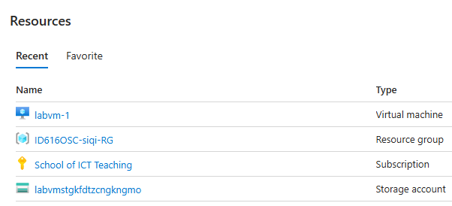
- Find labvm-1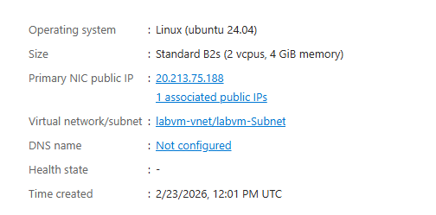
- Ip:20.213.75.188

1.2
- )Open PuTTY on your lab PC
- Enter the VM’s public IP address in the Host Name field, ensure port is 22, and connection type is SSH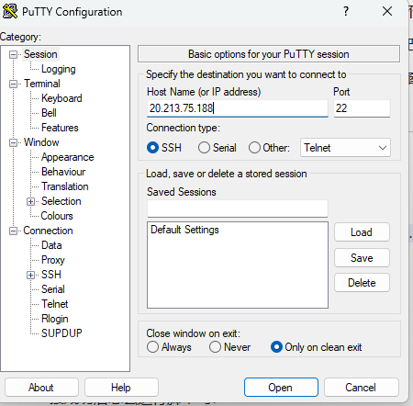

Click Open and accept the server’s host key if prompted
(4)
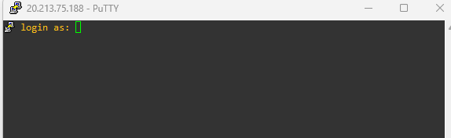
Open putty use ip:20.213.75.188 ,post 22, ssh
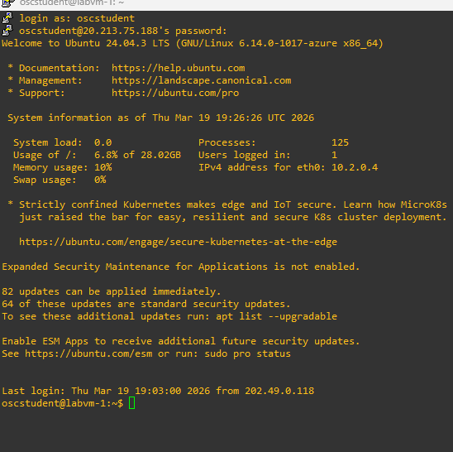

1.3
Step 1 — Rename the login name:
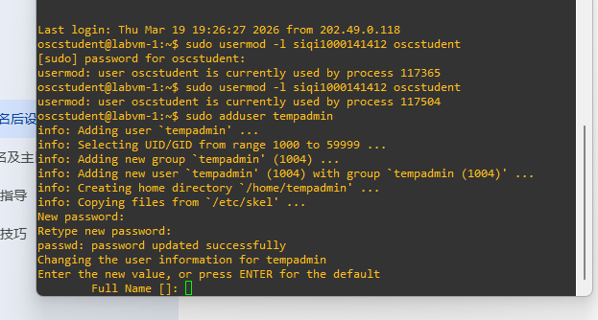
Create a new user
sudo adduserv
sudo usermod -aG sudo tempadmin
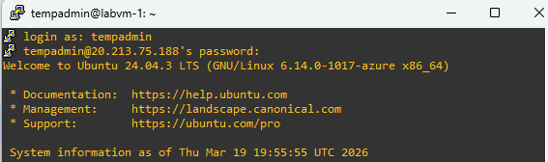
Password 123456
Step 2 — Rename the primary group to match, Step 3 — Move and rename the home directory:
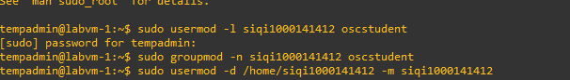
Step 4 — Verify all changes:
Id check
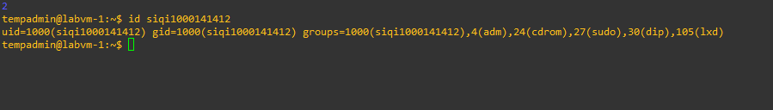
ls -la /home/ check
Confirm system user list records
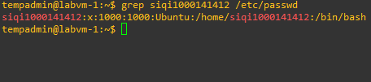

1.4
Change passwords
!Wangyutanng123
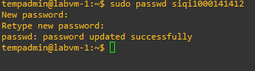

Task 2
Install git if not already present
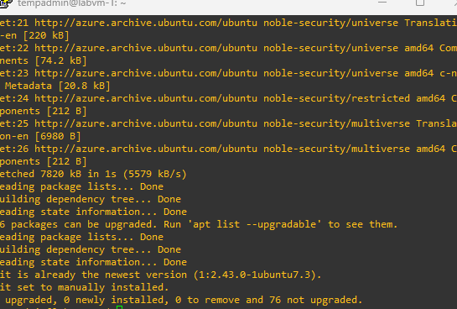
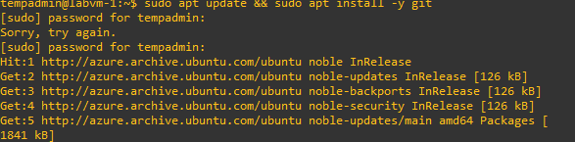
Figure: git clone https://github.com/OlayinkaOP/checkpoint1-files.git
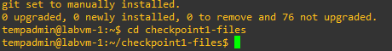
Figure: cd checkpoint1-files
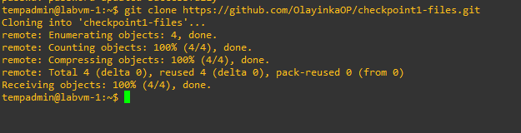download work from github

Figure 1: Create file: nano onboard_users.sh
Figure 1
Figure 2-3:: Execution of onboard_users.sh script showing successful processing of multiple users from CSV.
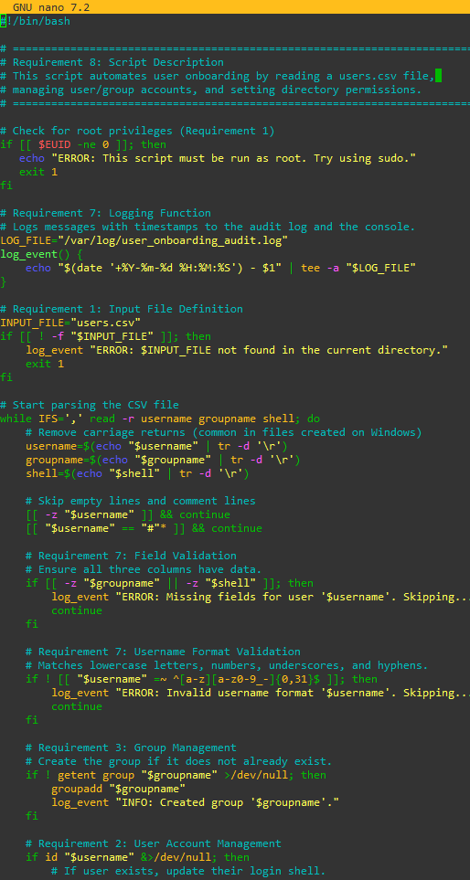
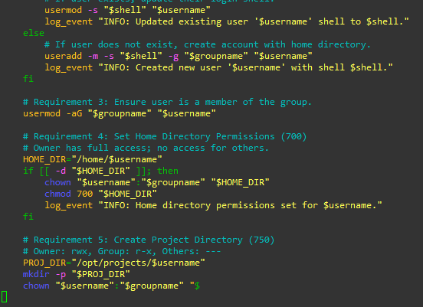

Figure 4: Screenshot of script running, Contents of the audit log file demonstrating timestamped records for all administrative actions. Screenshot of environment verification
Verification Log (Requirement 7)
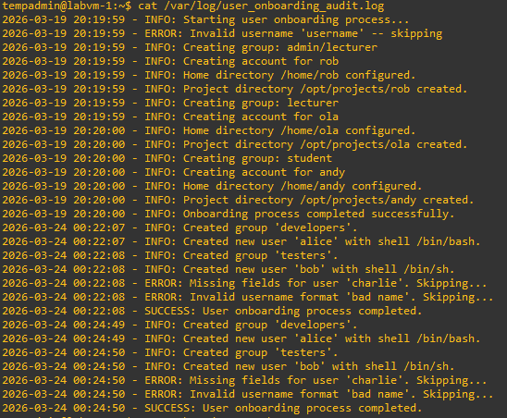
- id alice
Figure 5: Verify user alice (Requirement 2 & 3)
This command means to view the identity information of user Alice.
- ls -la /home/
This command is typically executed to check which users are on the server or to check if the permissions settings for those user folders are correct or not.
Figure 6: (Requirement 4)
- 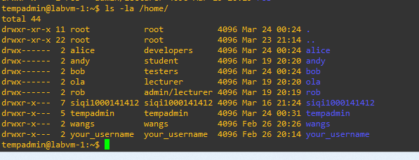
ls -la /opt/projects/
This command displays a detailed list of all project files and folders under the /opt/projects/ directory.
(Requirement 5)
Figure 7: Verification of created user 'alice' and the applied security permissions
(700 for home, 750 for projects).
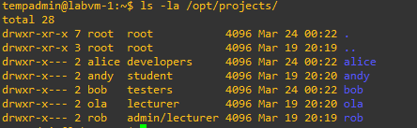
Figure 8: The log file sys_log.txt is included in the cloned repository.
Verify it is present: ls -lh checkpoint1-files/sys_log.txt head -5 checkpoint1-files/sys_log.txt
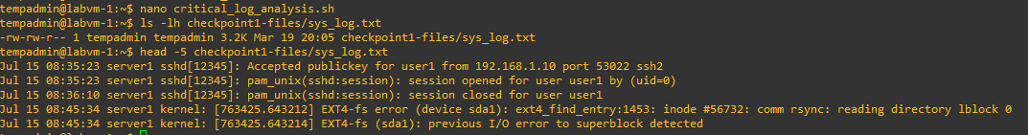

Task 3
Figure 9: nano critical_log_analysis.sh to create a file
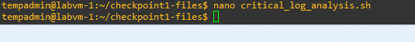
- 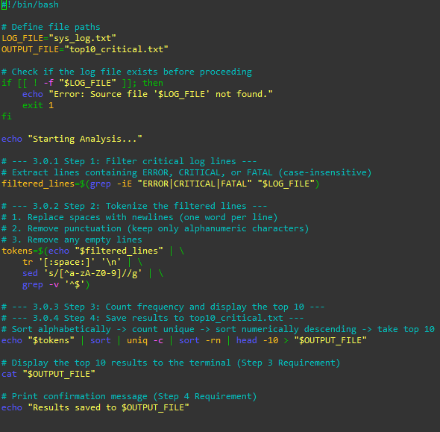
Figure 10: Terminal output of critical_log_analysis.sh showing the frequency of top 10 error-related tokens
Step 1 — Filter critical log lines
Use the -i parameter of grep to make it case-insensitive, and -E to enable extended regular expressions for matching multiple patterns.
Store the filtered results in a variable so that subsequent processing steps do not need to repeatedly read large files
filtered_lines=$(grep -iE "ERROR|CRITICAL|FATAL" sys_log.txt)

Ste tr replaces spaces with newlines, making each word a newline.
sed uses regular expressions to remove all non-alphanumeric characters.
The final grep -v removes any blank lines that might be generated.
tokens=$(echo "$filtered_lines" | tr '[:space:]' '\n' | sed 's/[^a-zA-Z0-9]//g' | grep -v '^$')
p 2 — Tokenize the filtered lines

Step 3 — Count frequency and display the top 10
sort Sorts identical words together
uniq -c Counts
sort -rn Sorts in reverse numerical order (highest first)
head -10 Retrieves only the first ten lines
echo "$tokens" | sort | uniq -c | sort -rn | head -10

Step 4 — Save results to top10_critical.txt
Redirect the final results to a file in the working directory
echo "$tokens" | sort | uniq -c | sort -rn | head -10 > top10_critical.txt
Print the confirmation message as required by Requirement 4
echo "Results saved to top10_critical.txt"

Figure 11: Graph: Grant permissions chmod to critical_log_analysis.sh

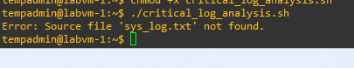
Figure 12: As the script could not find a log file named sys_log.txt in the current directory, so i copied the log file and run again

Figure 13: finally, and redo the ./critical_log_analysis.sh
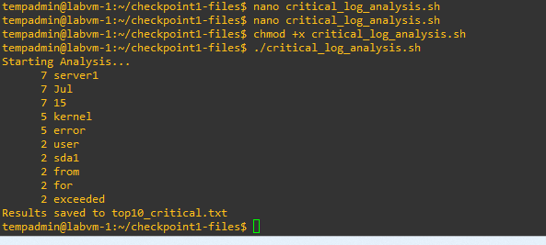
Figure 14: Output of the critical_log_analysis.sh script showing the top 10 most frequent tokens." And shown results save to top 10_critical.txt

