Database Schema Documentation
End-to-End Weather Data Engineering Pipeline for Weather Trends and Outdoor Planning
This database stores user-selected location information and weather forecast data loaded from the Open-Meteo API into a Microsoft SQL server database for dashboard analysis and outdoor planning.
The schema is normalized to approximately Third Normal Form (3NF) by:
- separating users, locations, and weather observations into related tables
- avoiding repeated location data in each weather record
- linking tables through primary and foreign keys for efficient querying
Database Overview
The database contains three tables:
- user
- location
- weather_observation
Entity Relationship Summary
Table | Purpose
User | Stores dashboard user information and basic user classification for the system audience.
Location | Stores selected locations and geographic coordinates used in Open-Meteo API requests.
weather_observation | Stores hourly or daily weather forecast metrics used for dashboard KPIs, trend charts, and outdoor planning indicators.

Table Documentation
1. user
Purpose
Stores information about the person or organization using the dashboard. The proposal identifies likely users as residents, commuters, outdoor planners, and local organizations.
Primary Key
- user_id
Relationships
- One user can relate to many location records.
- Referenced by location.user_id.
Table Structure
Column Name | Data Type | Key | Description
user_id | INTEGER | Primary Key | Unique user identifier
first_name | TEXT |  | User first name
last_name | TEXT |  | User last name
Email | TEXT | Unique | User email address
user_type | TEXT |  | User category such as resident, commuter, outdoor planner, or organization

2. location
Purpose
Stores the selected locations used by the pipeline and dashboard. This table supports normalization by separating repeated coordinate and place information from the weather records.
Primary Key
- location_id
Foreign Keys
- user_id -> user.user_id
Relationships
- Many location records can belong to one user.
- One location can relate to many weather_observation records.
- Referenced by weather_observation.location_id.
Constraints
- Unique combination of location_name, latitude, and longitude to reduce duplicate saved locations.
Table Structure
Column Name | Data Type | Key | Description
location_id | INTEGER | Primary Key | Unique location identifier
user_id | INTEGER | Foreign Key | Links the location to a user
location_name | TEXT |  | Name of the selected city or place.
Latitude | DECIMAL(8,5) |  | Latitude used in the API request.
Longitude | DECIMAL(8,5) |  | Longitude used in the API request.

3. weather_observation
Purpose
Stores the weather forecast data retrieved from the Open-Meteo API and loaded into SQLite for dashboard analysis. This table supports the project deliverables of KPI cards, temperature trend charts, precipitation totals, and outdoor planning indicators.
Forecast data includes
- temperature
- humidity
- wind speed
- cloud cover
- precipitation
- rainfall probability
- hourly timestamps
- weather code
Primary Key
- weather_id
Foreign Keys
- location_id -> location.location_id
Relationships
- Many weather_observation records can belong to one location.
- Each weather record is associated with one selected location used for analysis and dashboard display.
Table Structure
Column Name | Data Type | Key | Description
weather_id | INTEGER | Primary Key | Unique weather record identifier
location_id | INTEGER | Foreign Key | Links the weather record to a location
forecast_timestamp | DATETIME |  | Timestamp for hourly or daily forecast values.
Temperature | DECIMAL(5,2) |  | Temperature value used in KPI cards and trend charts.
Humidity | DECIMAL(5,2) |  | Humidity value returned by the API.
wind_speed | DECIMAL(5,2) |  | Wind condition value used in dashboard planning views.
cloud_cover | DECIMAL(5,2) |  | Cloud cover metric returned by the API.
Precipitation | DECIMAL(5,2) |  | Precipitation amount used in rainfall charts and summaries.
rainfall_probability | DECIMAL(5,2) |  | Rainfall probability used in dashboard KPI cards.
weather_code | INTEGER |  | Unique WMO weather condition code.

Cardinality Relationships
Parent Table | Child Table | Relationship Type
user | Location | One-to-Many
location | weather_observation | One-to-Many

Normalization Notes (3NF)
This schema is normalized to approximately Third Normal Form:
- Repeating user information is separated into user.
- Repeating location and coordinate data is separated into location.
- Weather metrics are stored in weather_observation and linked to a location through a foreign key.
- Non-key attributes depend on the key of their own table rather than on another non-key field.

ER Diagram
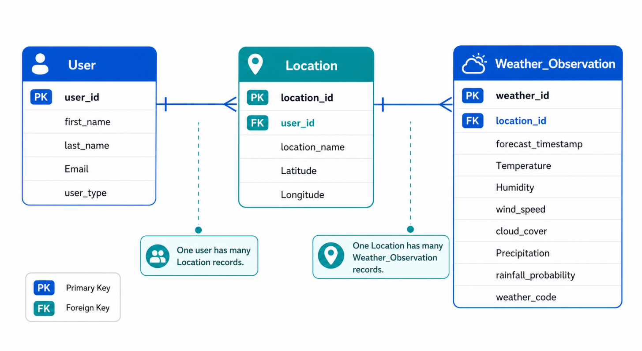
Data Source
Weather Data Source
Weather forecast data is sourced from the Open-Meteo API, which the proposal identifies as the project’s primary data source.
The API provides:
- hourly weather data
- temperature values
- humidity values
- wind speed values
- cloud cover values
- precipitation values
- weather codes
- coordinate-based forecast retrieval using latitude and longitude
Example Relationship Flow
- A user selects a location such as Louisville, Kentucky.
- That saved record is stored in location with its latitude and longitude.
- The ETL pipeline pulls forecast data for that location from Open-Meteo and stores each time-based record in weather_observation.
- The dashboard then queries weather_observation by location_id to generate KPI cards, temperature trend lines, precipitation totals, and outdoor planning indicators.
This design reduces duplication, supports the ETL workflow described in the proposal, and provides a clear structure for SQL-based dashboard querying.

