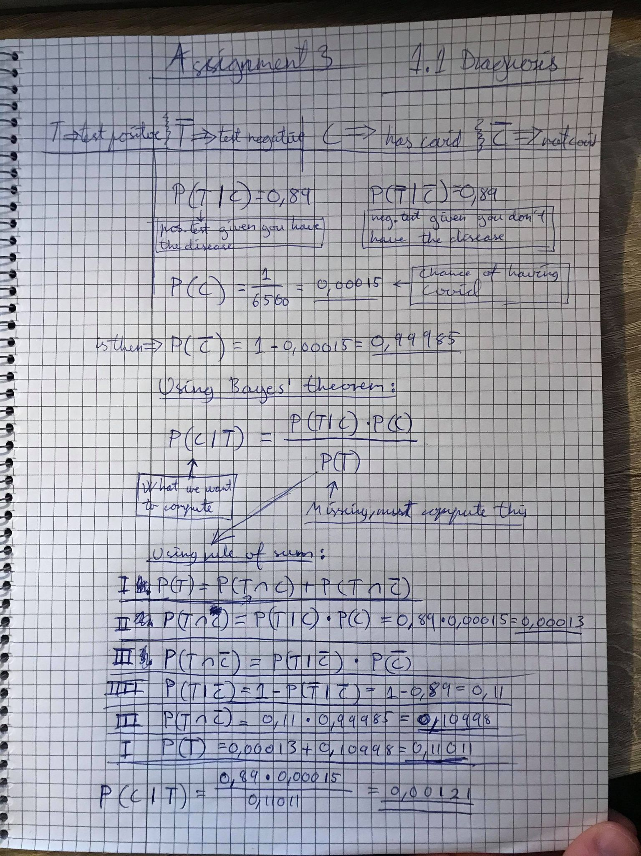

Chance of having the disease is 0.00121

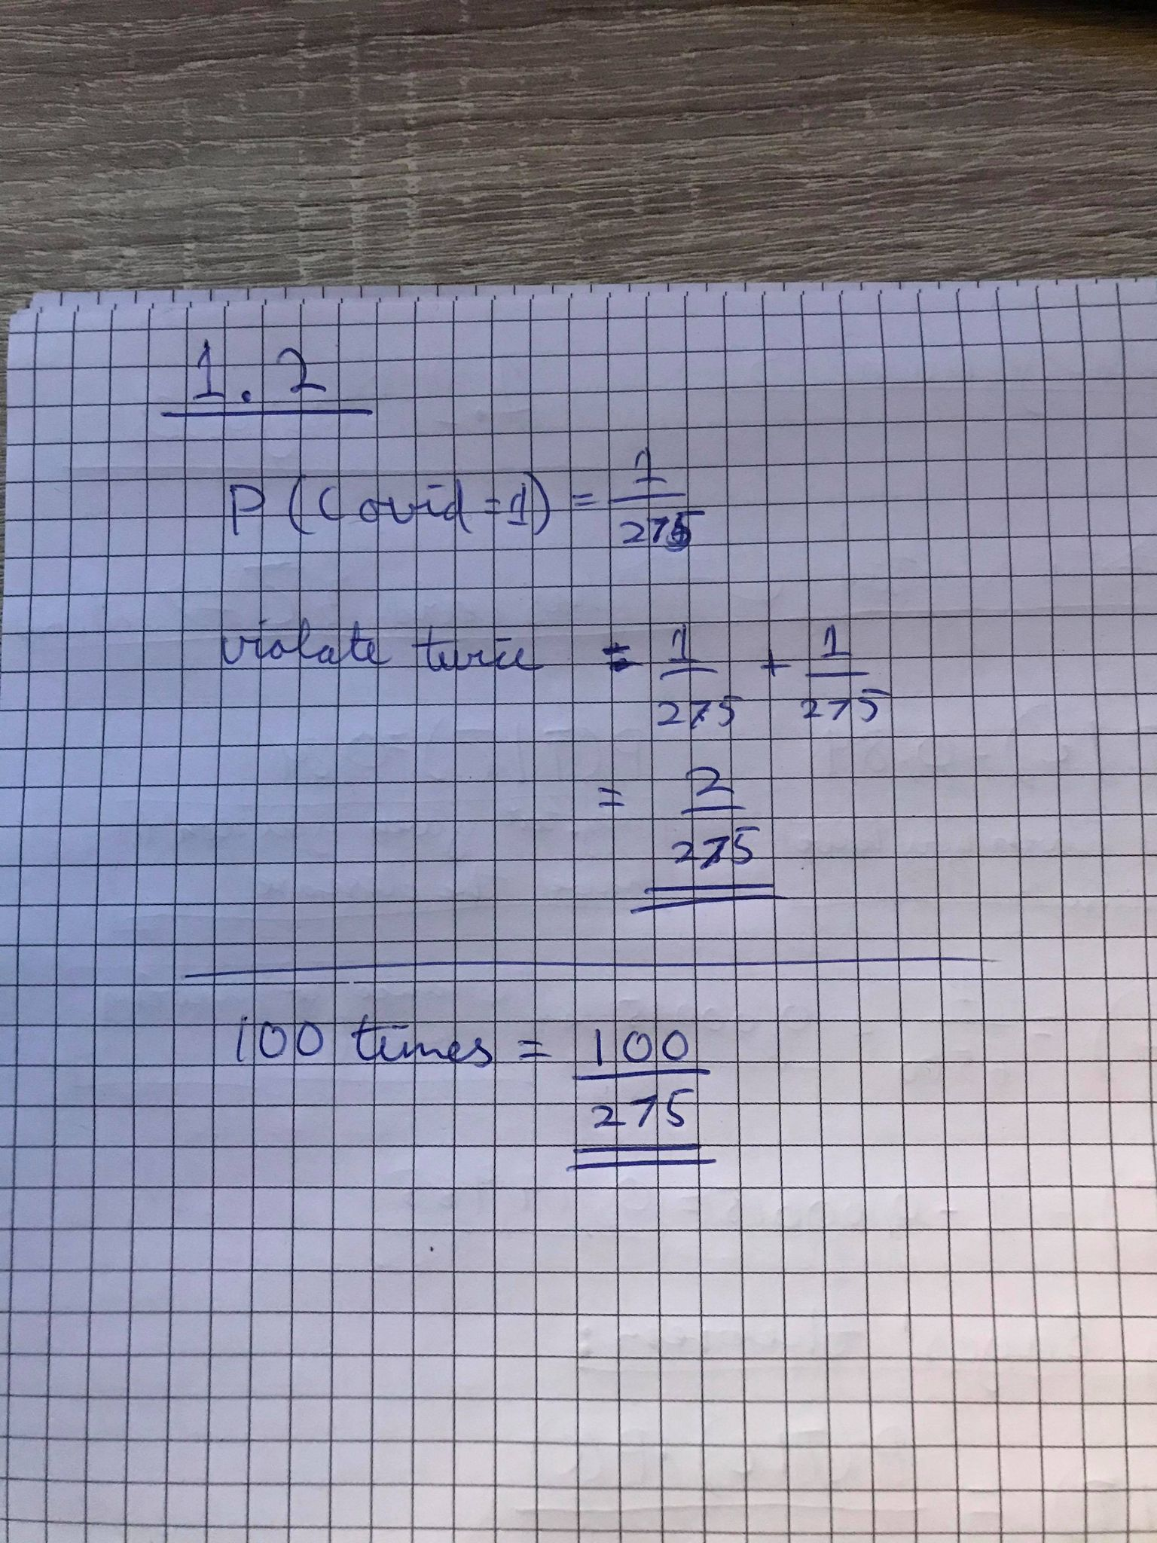



3.194% of the fruits will test as having worms

Given that an apple has tested for worms, the probability that there is a worm inside is 0.06262