FEM ASSIGNMENT 2 : “SUBMODELING”

GLOBAL MODEL | CPS8, Rough Mesh, no fillet
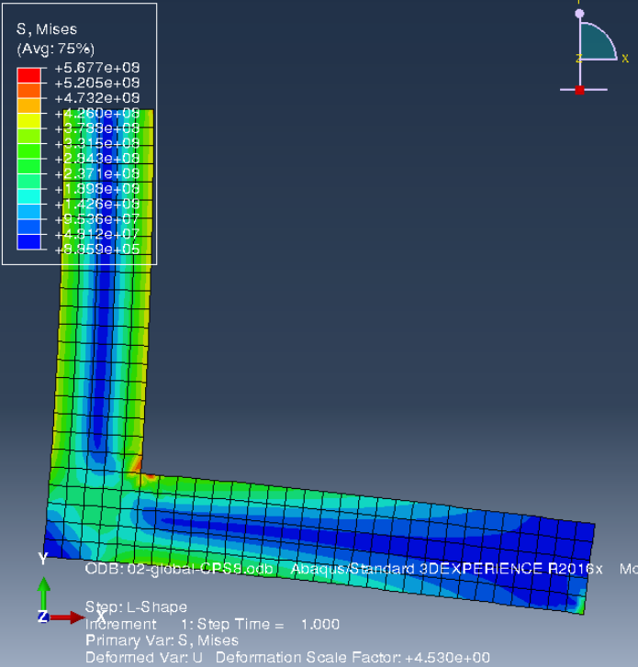 | 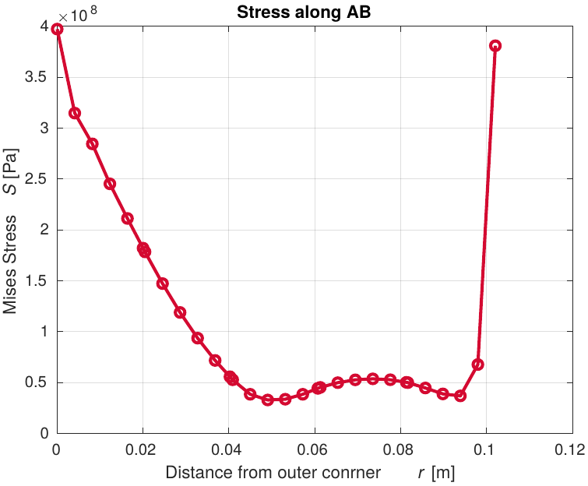

SUB MODEL | CPS8, Rough Mesh, no fillet
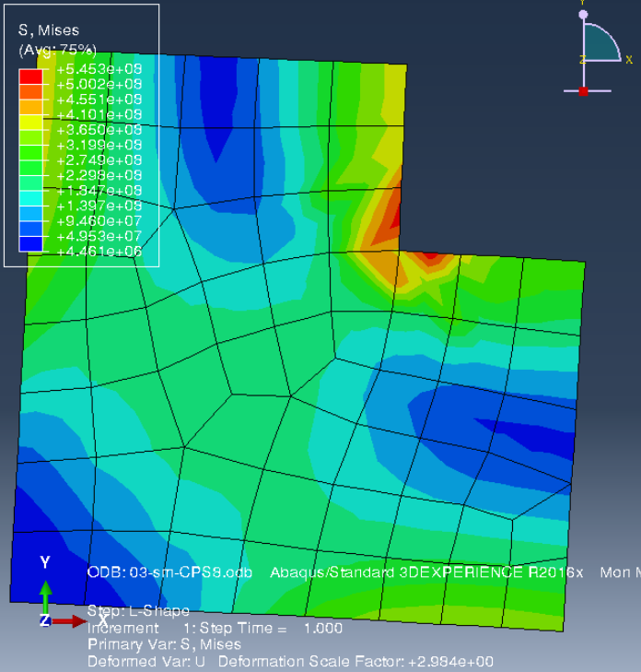 | 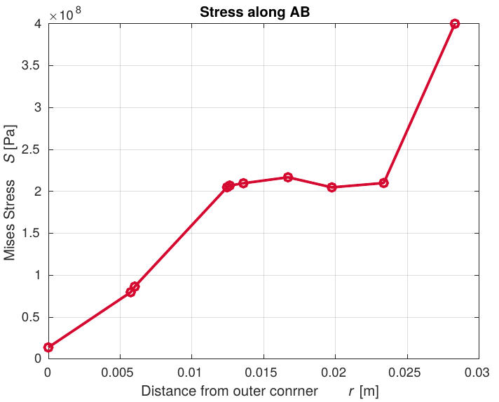

SUB MODEL | CPS8, Rough Mesh, 1mm fillet
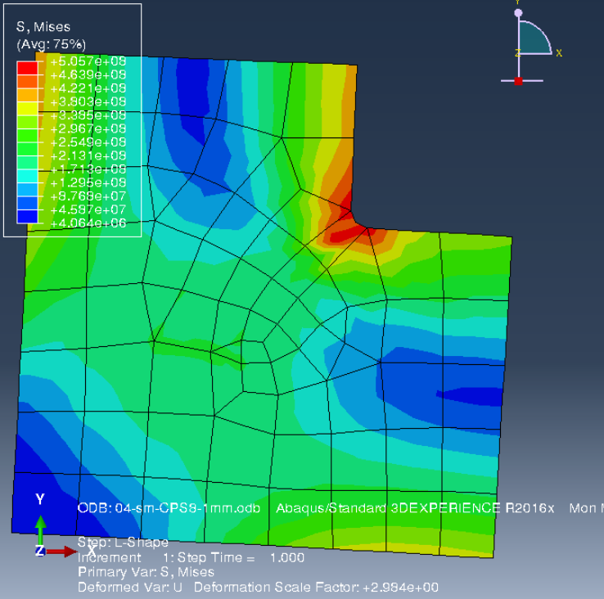 | 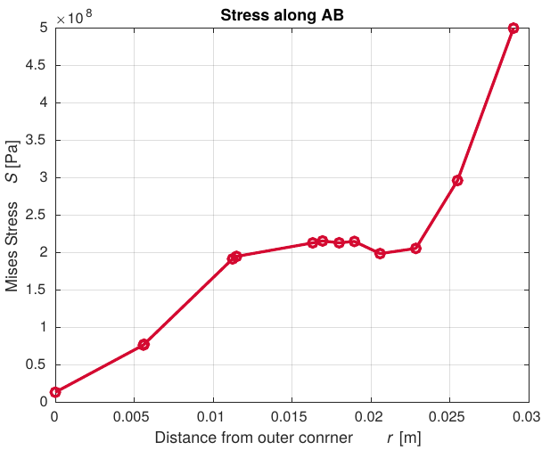

SUB MODEL | CPS8, Fine Mesh, 1mm fillet
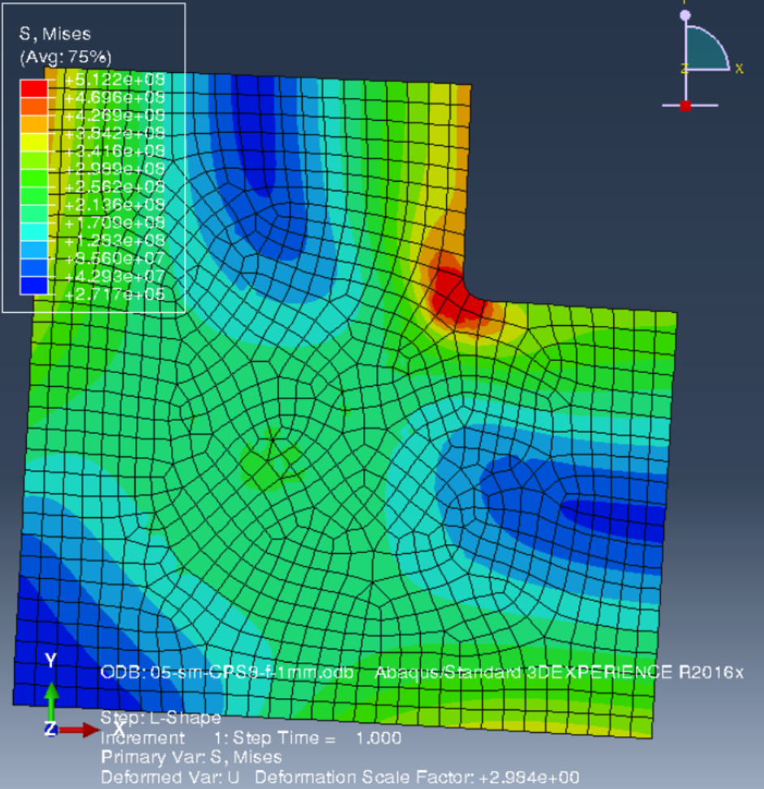 | 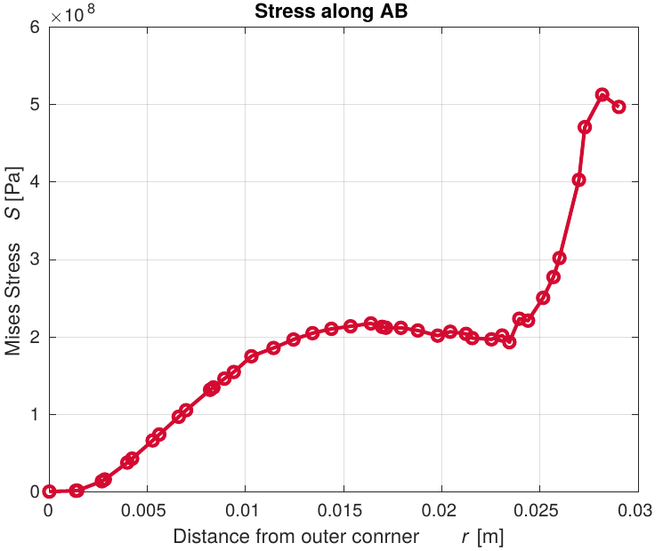

SUB MODEL | CPS8, Fine Mesh, 5mm fillet
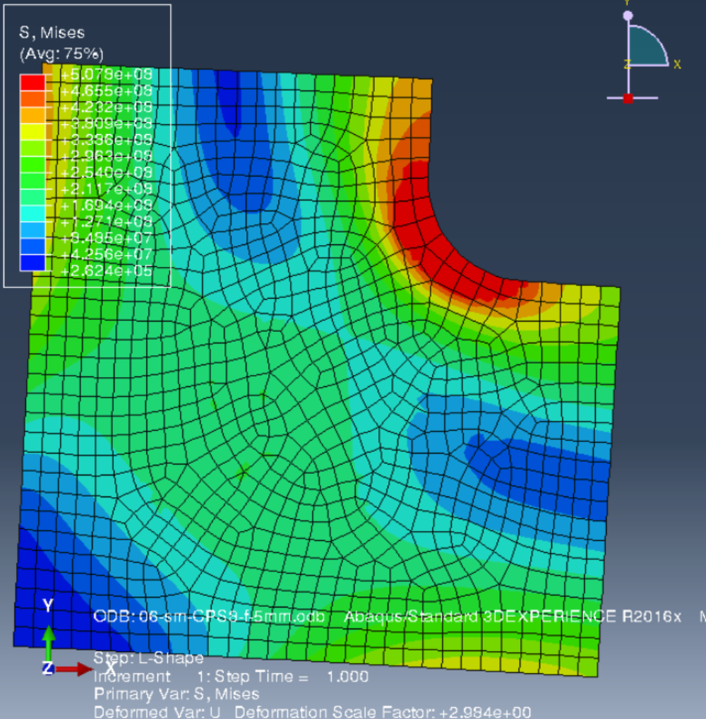 | 