Nicholas Richard Harding

20200344

IT Ticketing Solutions

Team Members the following members contributed to this document  
Nicholas Harding  
Mathew Brencyz  
Pradip Panthi  
Brijesh Kachhadiya

**DESIGN USER INTERFACE DOCUMENT**

Task 1

Contents

1) **Produce Site Map** 2

**Active link to completed site** 2

2) **Produce Wireframes** 3

**Index - Home page** 3

**Desktop View 1440px wide** 3

**iPad Mini –Portrait 768px wide** 4

**Android – Portrait view 360px wide** 5

**Now Showing Page** 6

**Desktop View 1440px wide** 6

**iPad Mini –Portrait 768px wide** 7

**Android – Portrait view 360px wide** 8

**Upcoming Movies Page** 9

**Desktop View 1440px wide** 9

**iPad Mini –Portrait 768px wide** 10

**Android - Portrait view 360px wide** 11

**Bookings Page Wireframe and Mock up** 12

**Desktop View 1440px wide** 12

**iPad Mini –Portrait 768px wide** 17

**Android** 19

**Additional Design Content** 21

**Icons Made** 21

**Ticket layout Template** 21

**TASK 4:**

1. **Produce Site Map**
   1. **Site Map – Current Site**
      1. **Index(home)**
      2. **Now Showing**
      3. **Upcoming Movies**
      4. **Sign Up**
         1. **Thank You Page**
      5. **Contact Us**
   2. **Site Map – New Site**
      1. **Index(home)** – update nav menu to be at the top and keep the responsive design already implemented
      2. **Now Showing** – update to make content responsive
      3. **Bookings** – create page that will handle all booking aspects (select cinema, select movie, select time and select seat) after booking is made it will display a booking confirmation and ticket number/serial
      4. **Upcoming Movies** – update content to be responsive
      5. **Sign Up** – update content to be responsive and java verify input from users, will display a thank you message over the top after completion
      6. **Contact Us** – update content to be responsive

## **Active link to completed site**

<https://nicksresponsiveweb.000webhostapp.com/>

This was created following this document as well as the previous System Design and Solution Design Document.

1. **Produce Wireframes**

Navbar links will not have grey background it is just to emphasize the hover size of the link which changes color on hovers, the dark grey link will have a dark gradient background active to display active page. Blue text represents hyperlinks.

**Index - Home page**

**Desktop View 1440px wide**

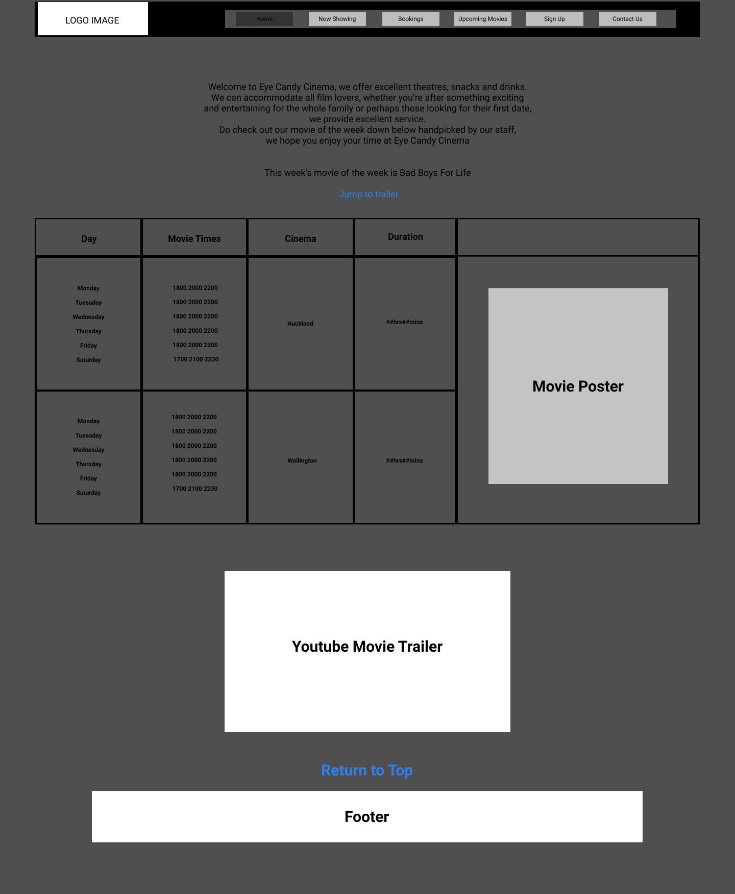

### **iPad Mini –Portrait 768px wide**

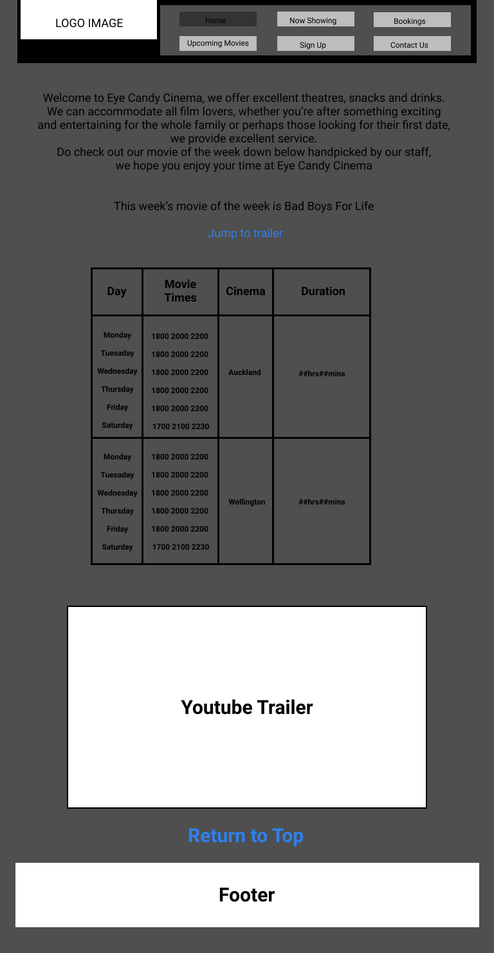

### **Android – Portrait view 360px wide**

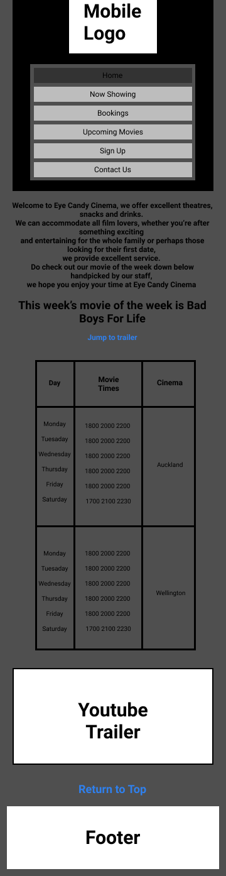

## **Now Showing Page**

### **Desktop View 1440px wide**

### **iPad Mini –Portrait 768px wide**

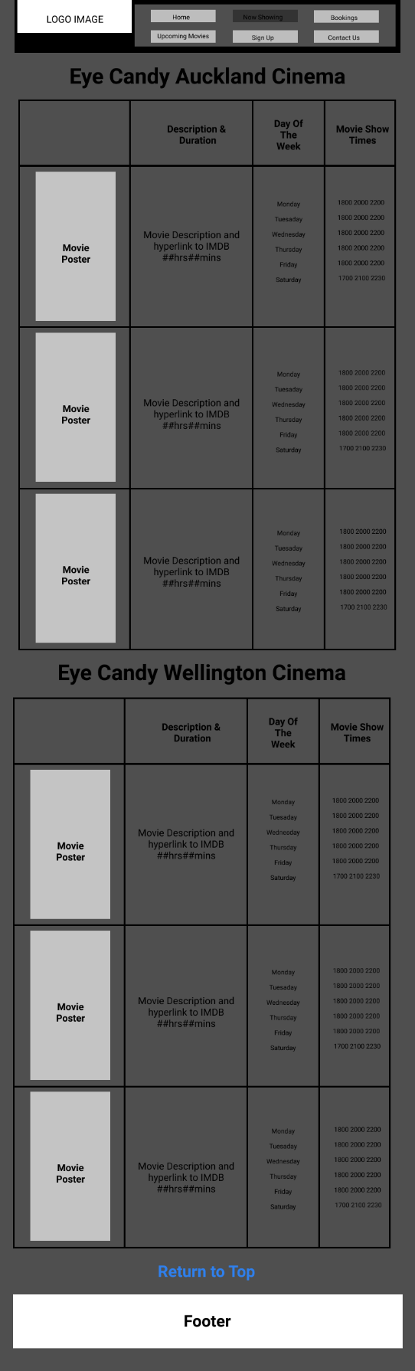

### **Android – Portrait view 360px wide**

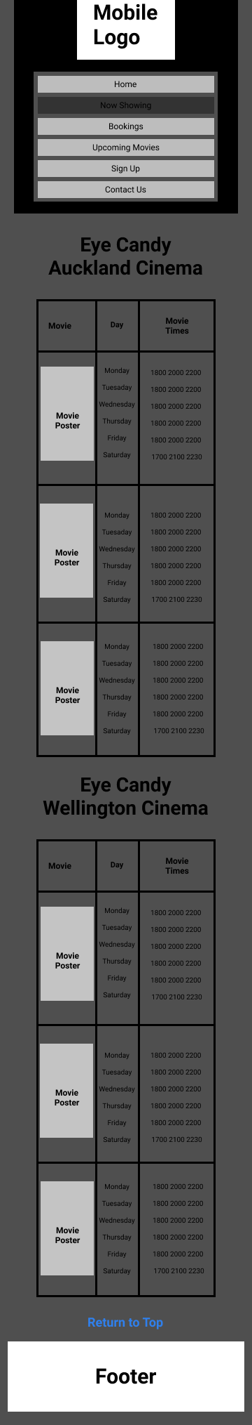

## **Upcoming Movies Page**

### **Desktop View 1440px wide**

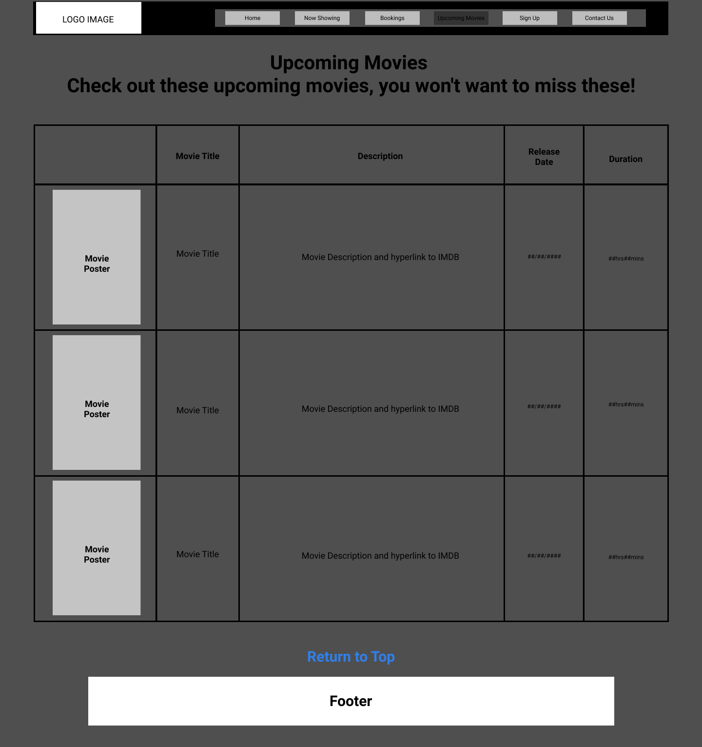

### **iPad Mini –Portrait 768px wide**

### **Android - Portrait view 360px wide**

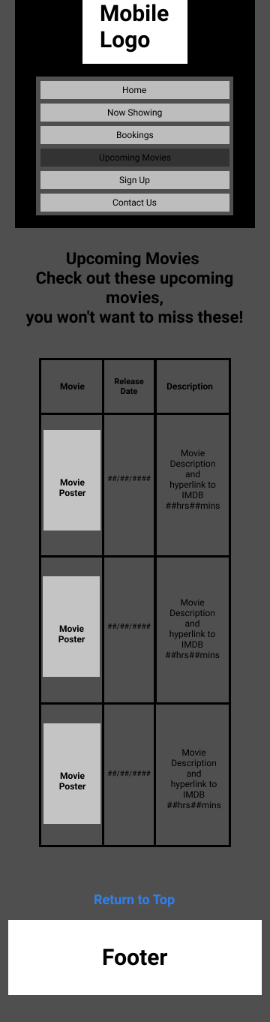

# **Bookings Page Wireframe and Mock up**

## **Desktop View 1440px wide**

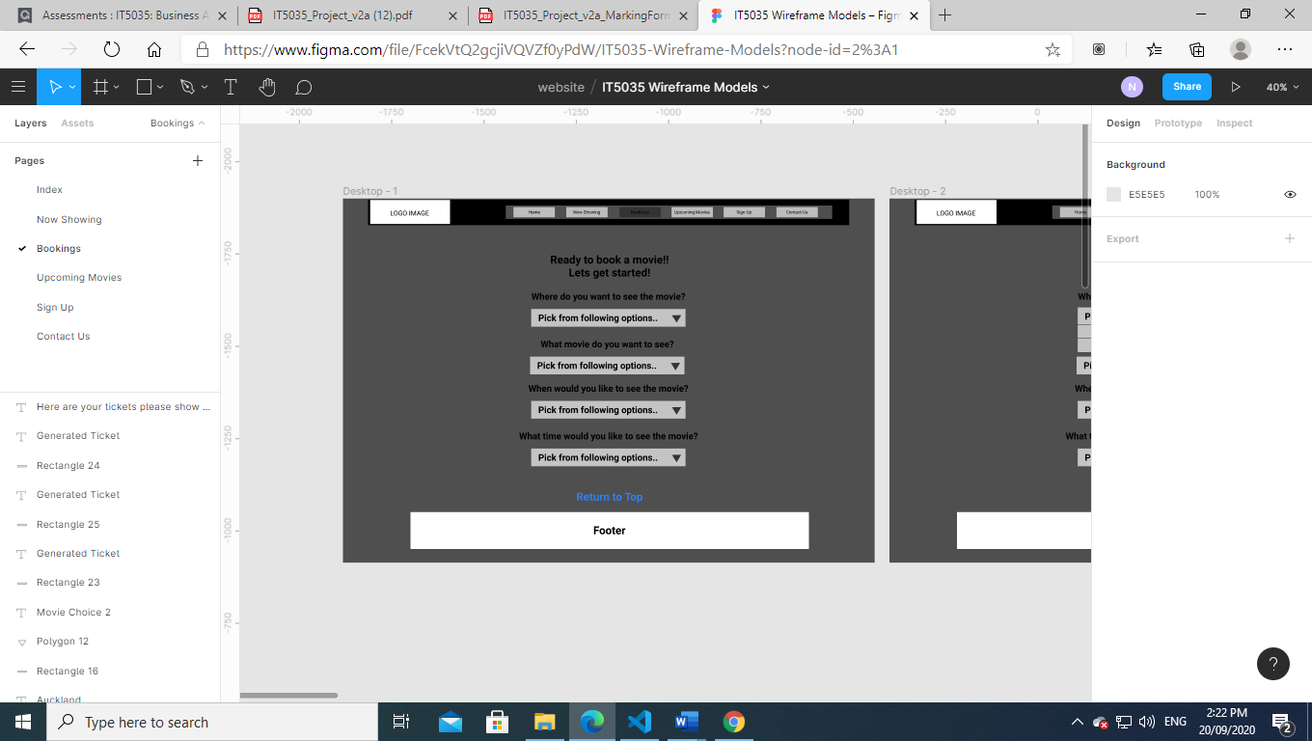

Cinema Location Field

Movie Field

Date/Day Field

Time Field

All four initial selections will be formed into the following flow, the movie time will prompt the user to fill in the Location, Movie and Day fields first so that the available times for that movie can be displayed accurately, all fields will be drop selections apart from the date selection which will display a calendar and only permit future dates and opened days and prevent earlier dates

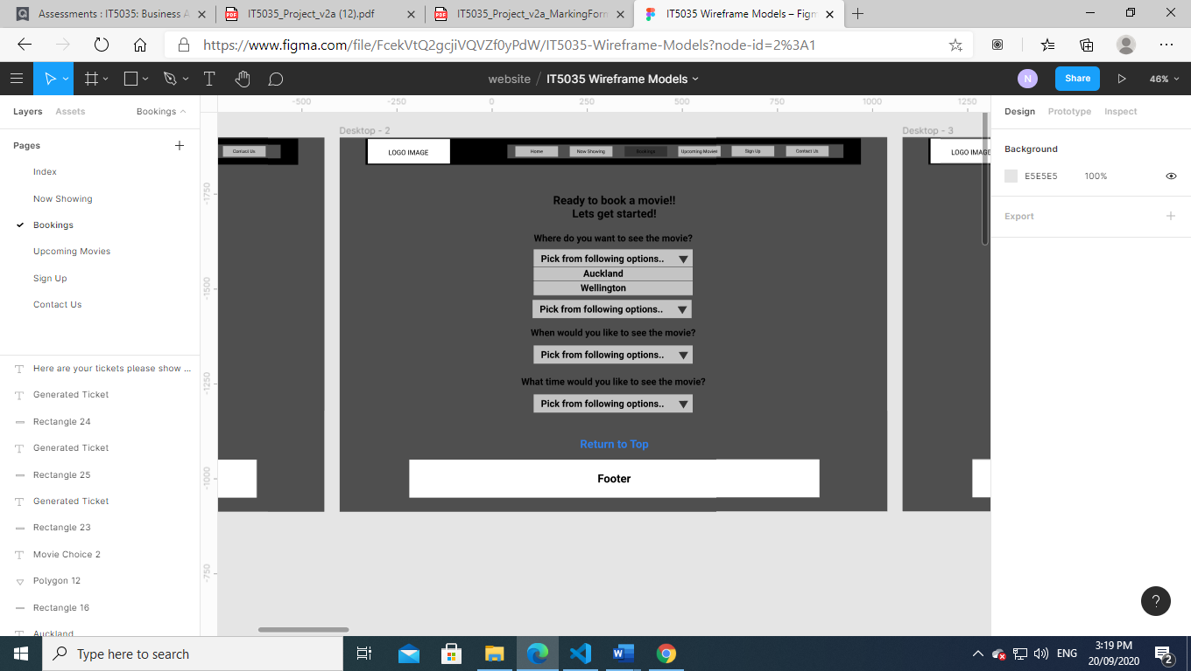

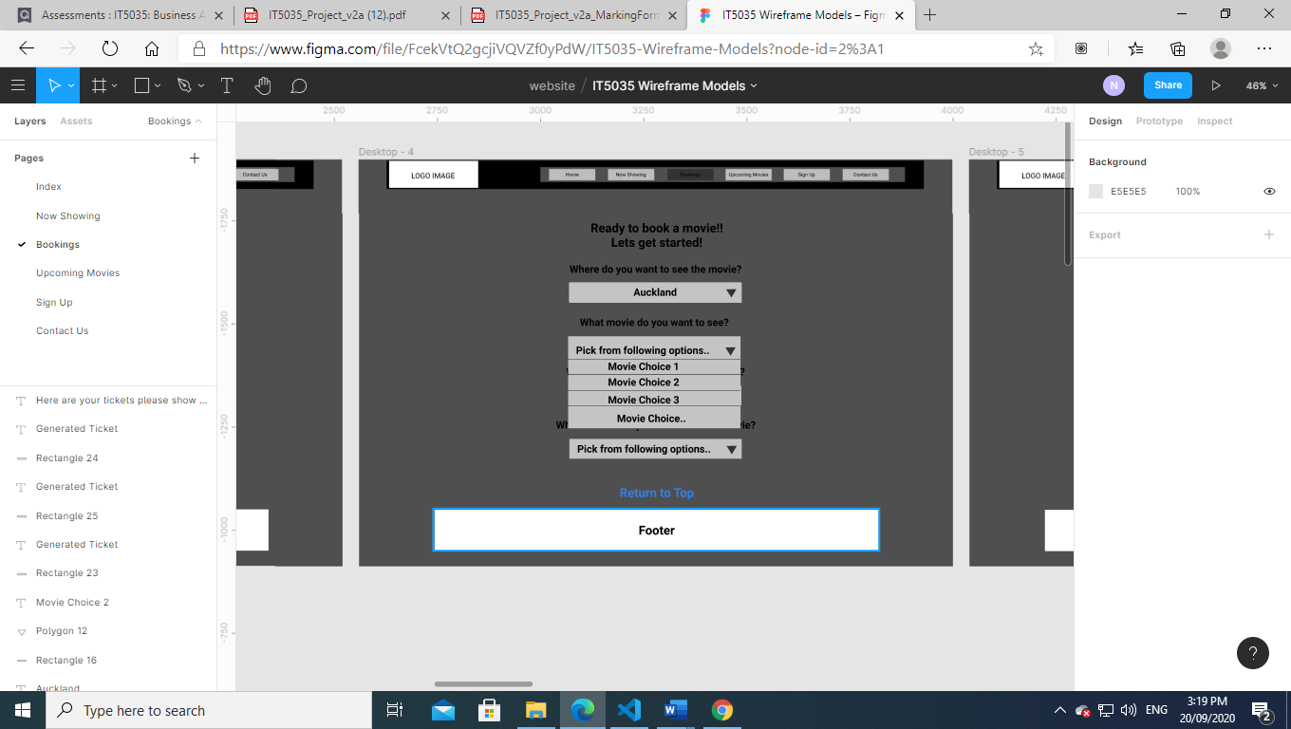

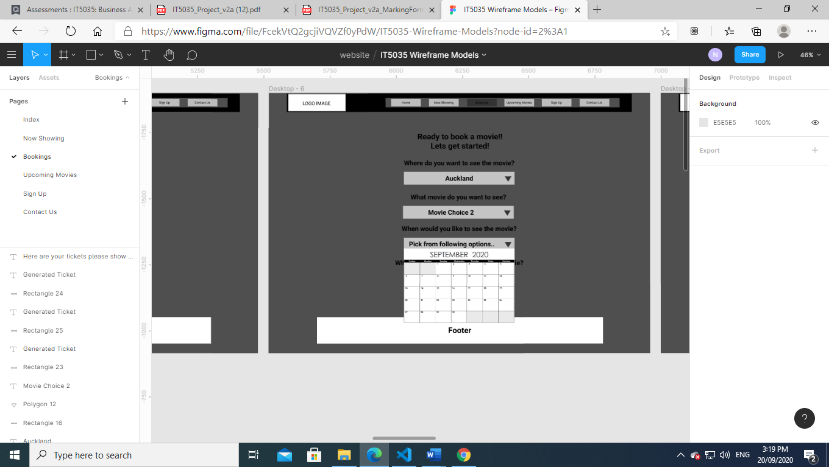

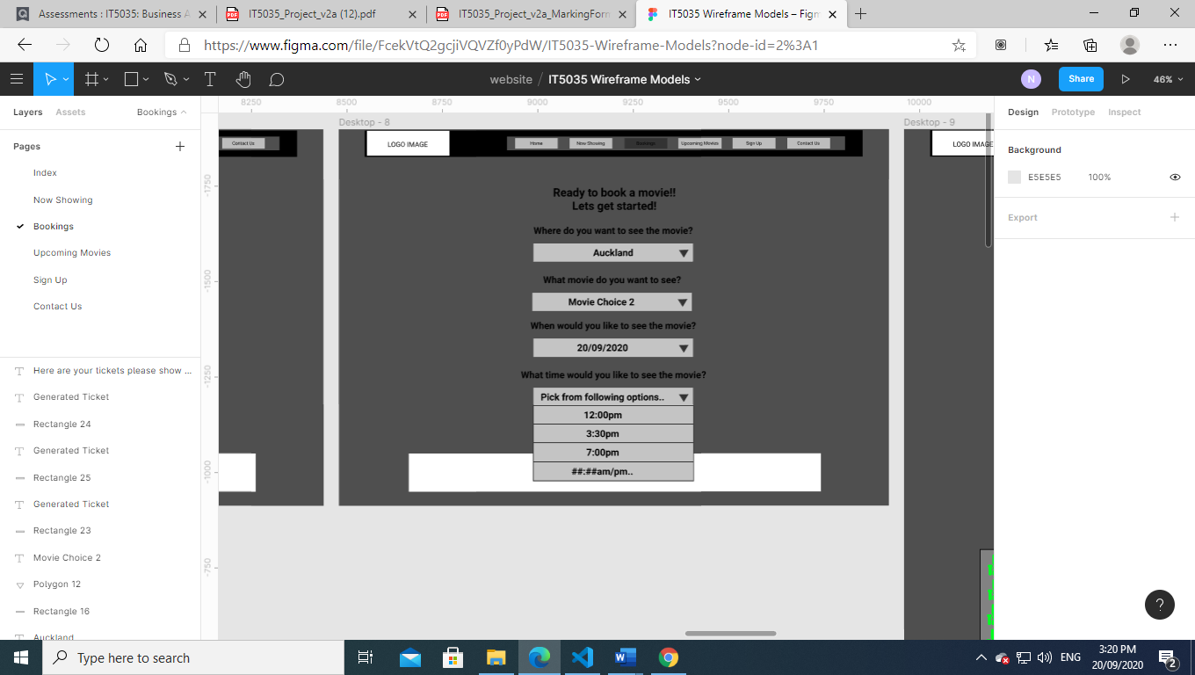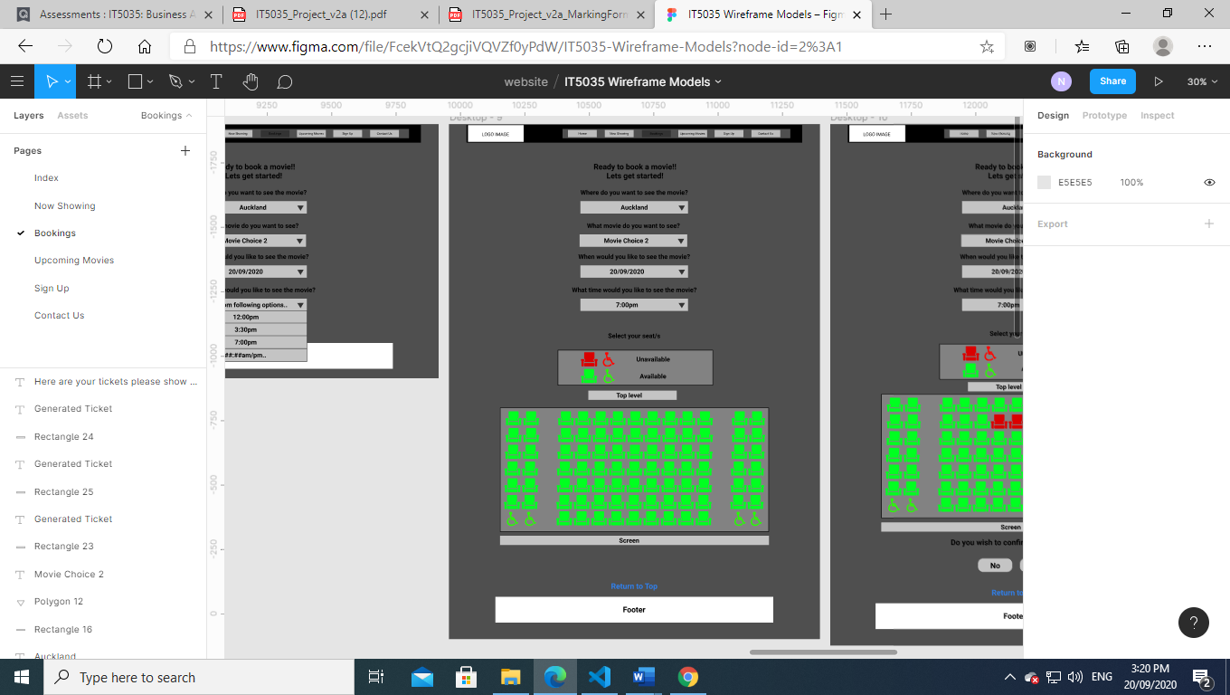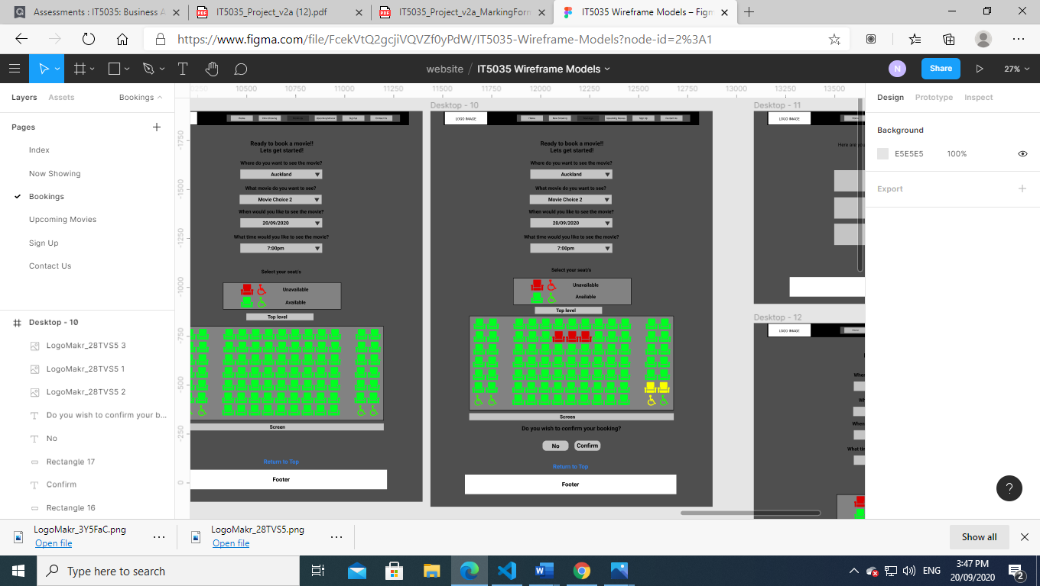

Once all fields are selected a react component will appear allowing the user to select the seat choice. Seats coloured red will be unavailable and green available, selected seats will change colour to orange to indicate to the user of their current selection

Selected seats can be unselected and change back to their original color green, while red will not be clickable or change color

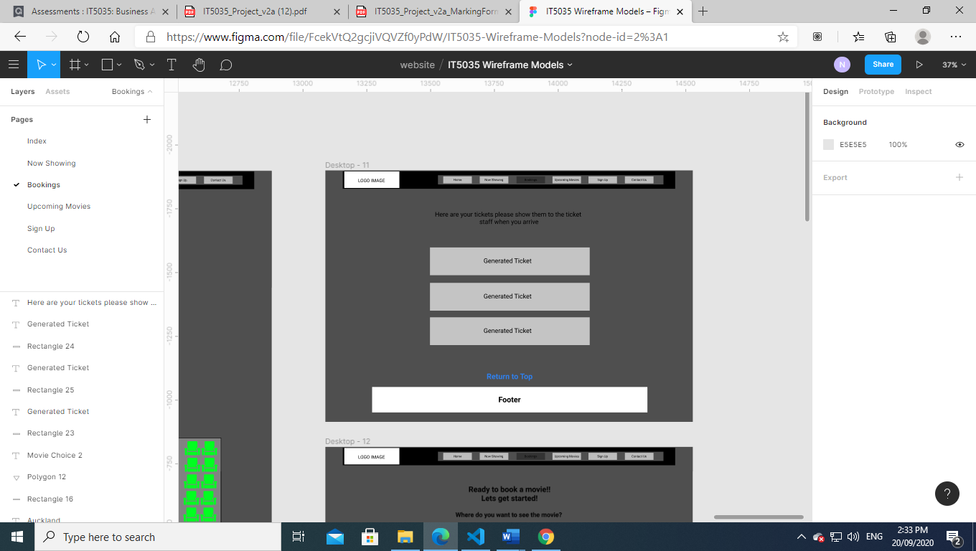 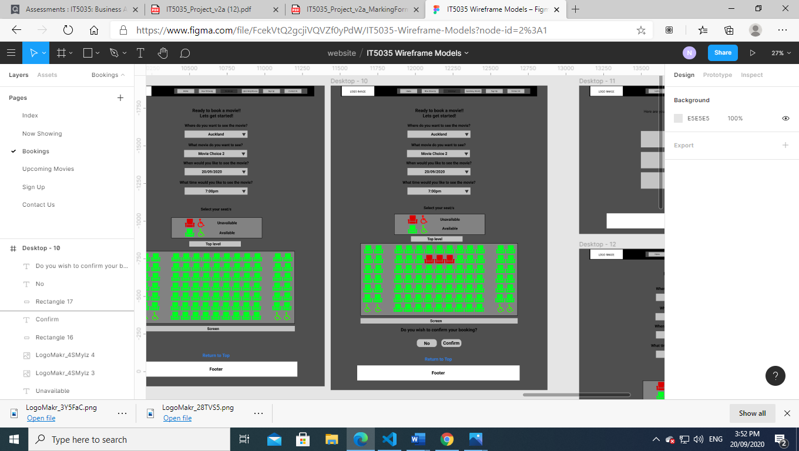

If cancel is pressed instead of confirm the selected tickets will be unselected and original state returned, if confirm is clicked all options will disappear rendering individual tickets (more detail on ticket design is further on in this document)

## **iPad Mini –Portrait 768px wide**

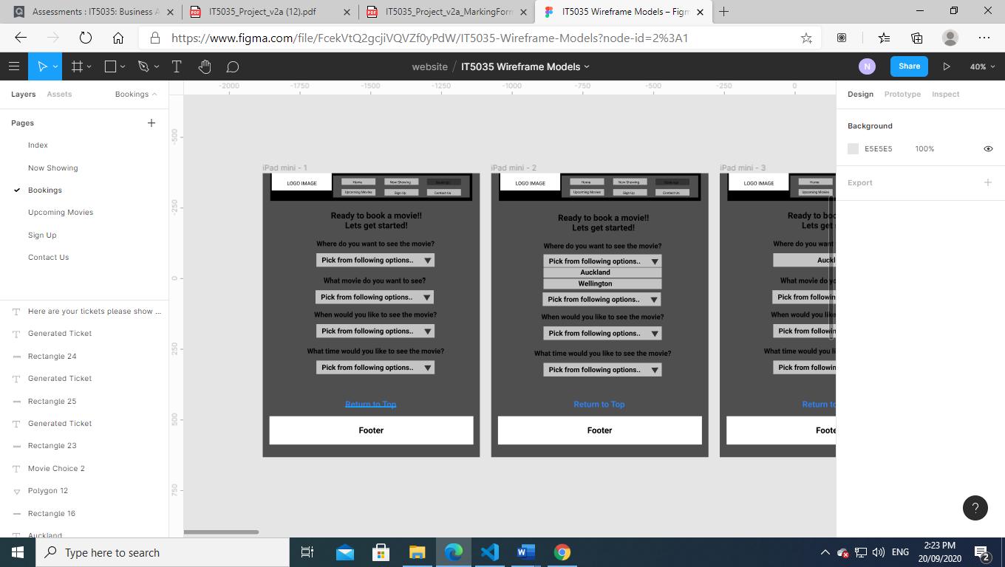

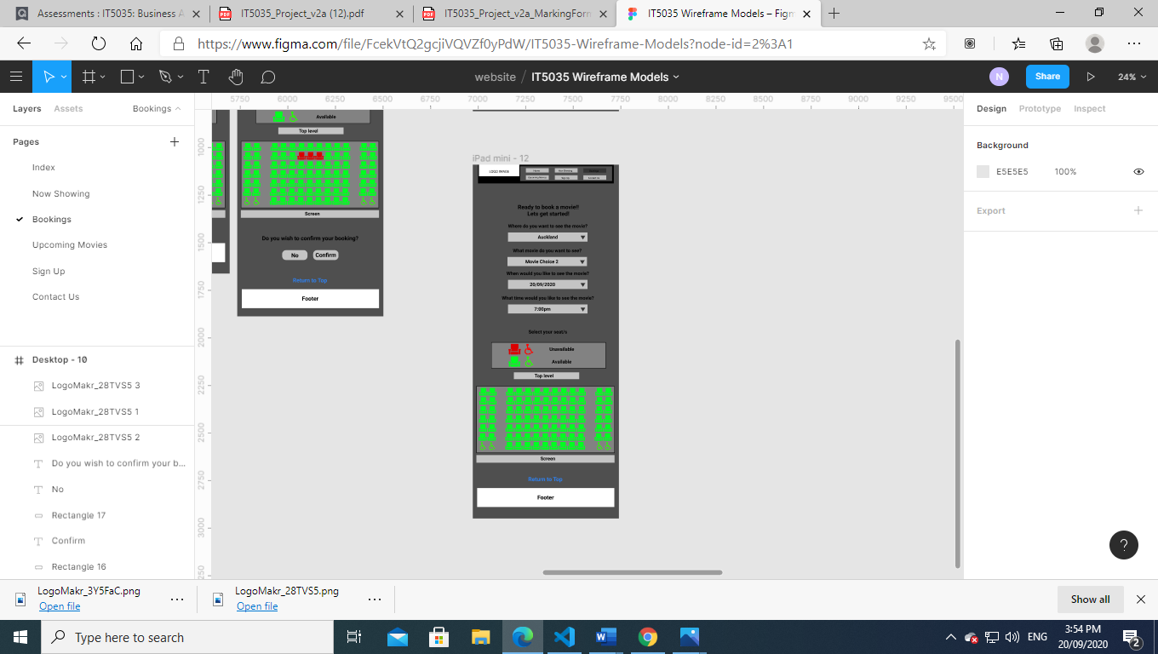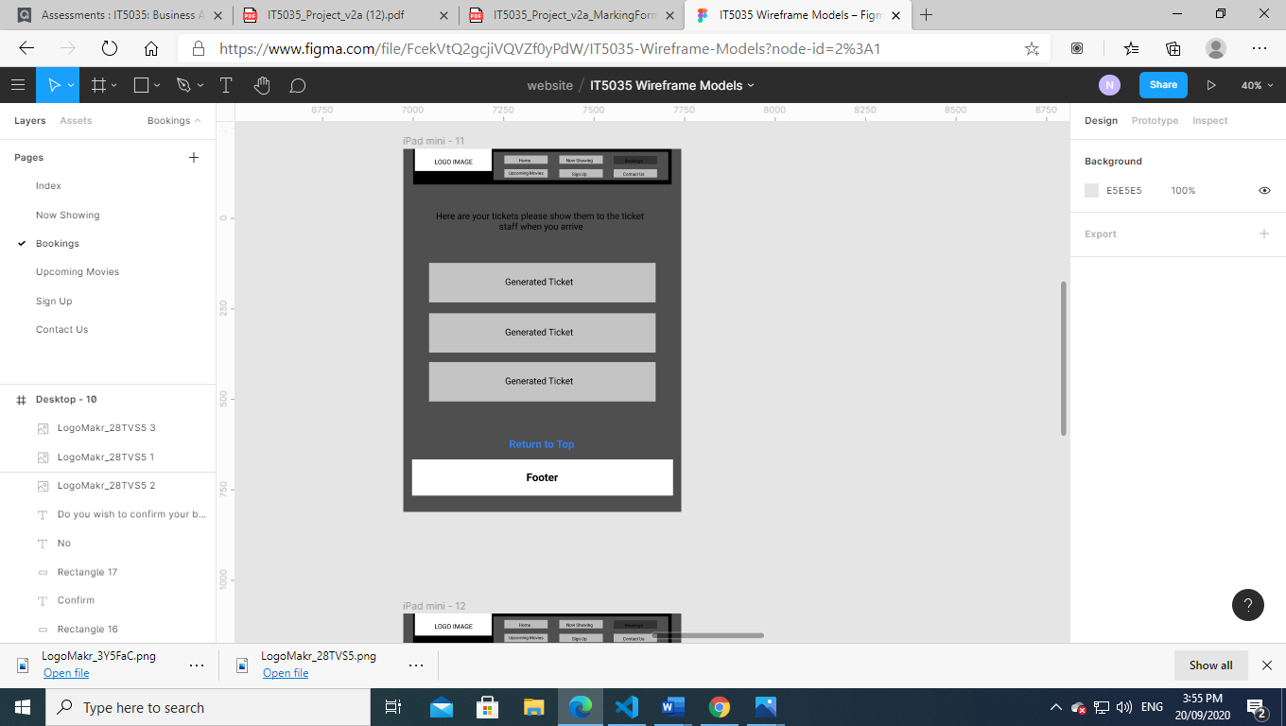

The seat selection will still to all fit in the current dimensions of the iPad as well as the tickets only the menu needs to adjust

## **Android**

**Portrait view 360px wide**

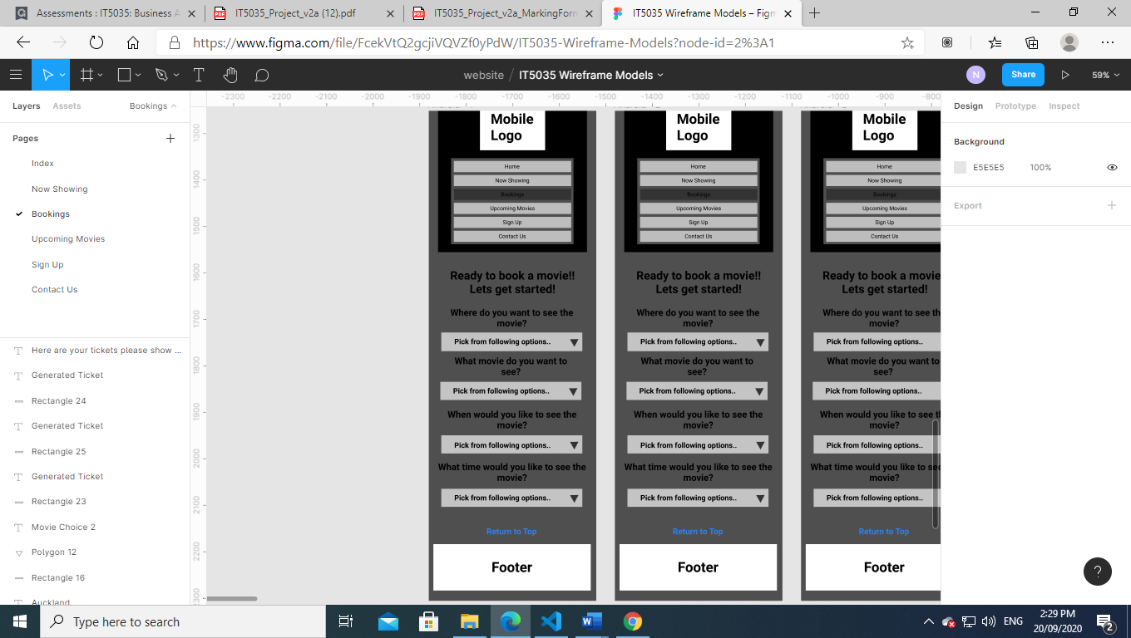

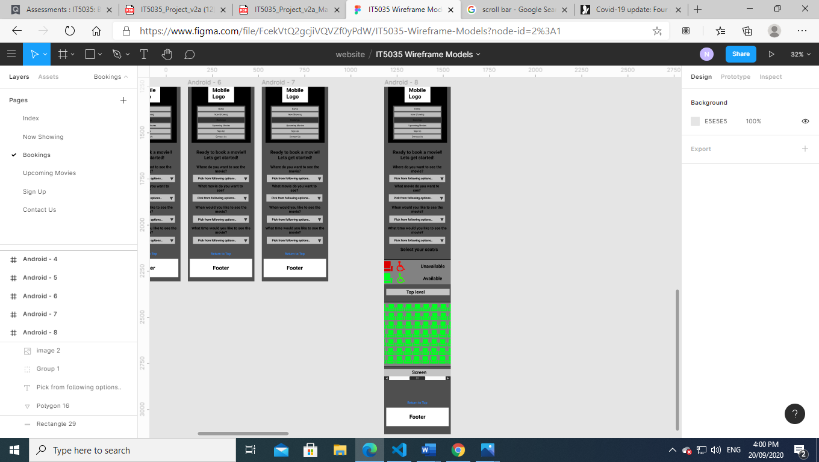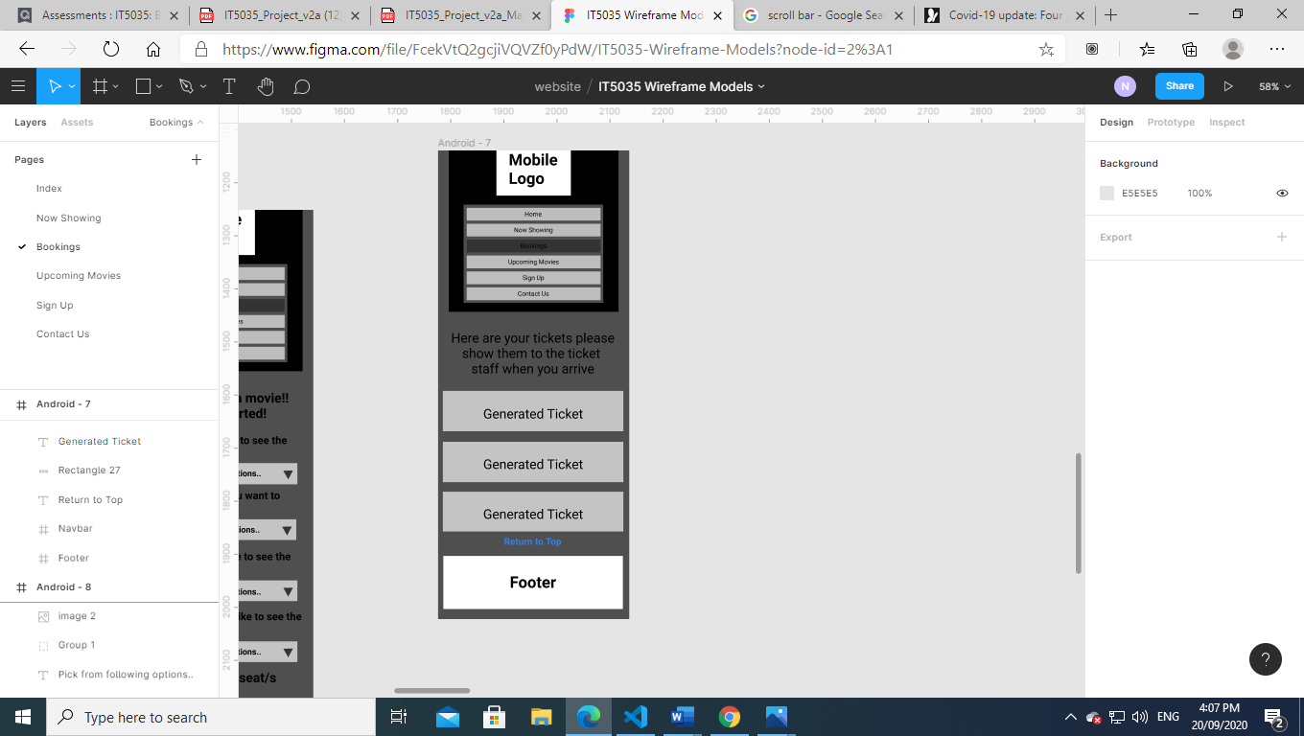

In the android size the seat selection will become scrollable as the number of seats reduced to a size to accommodate the screen width will become too small and selection difficult. However the rest of the other content will be able to scale down in size to fit the screen width

# **Additional Design Content**

## **Icons Made**

 

Figure 1 Icons retrieved from <https://logomakr.com/4ENsrf>



Figure 2 Icons retrieved from <https://logomakr.com/6FOhBp>

## **Ticket layout Template**

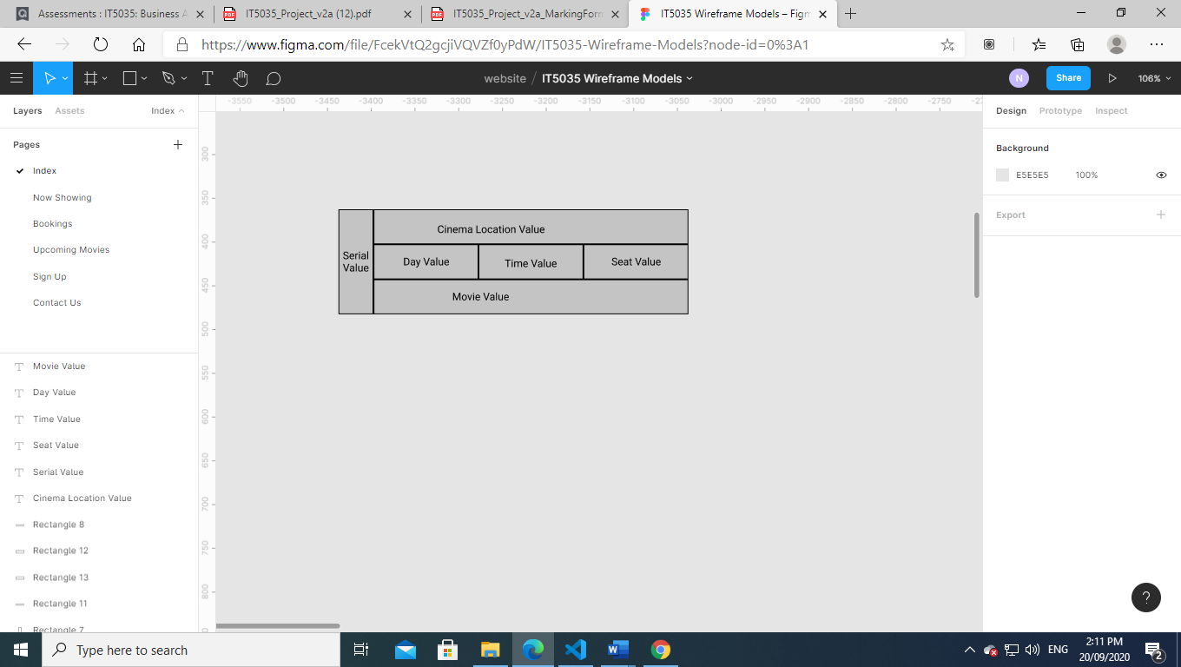

Figure 3 Movie Ticket Generated via site App

Serial Value will be automatically generated on rendering and will be a combination of the seat value(which will have a row letter and seat number) and a combination of numbers from the Day value(2 from the year and 2 from the day)