Nicholas Richard Harding

[Email address]

Project Documentation

*System Design and UI Design Document Attached in separate files.*

Responsive and interactive client-side web development

Project 1

Task 2

Test Plan

Interactive design tests

1. Test page in Windows Edge, Google Chrome and Mozilla Firefox – test at different sizes to see if the CSS kicks in and responds to display pages in correct format
2. Test site on Samsung S9
3. Test form submissions
   1. In the booking forms users will be unable to input text into the drop down selections
   2. Date displays a clickable calendar to pick dates and only accepts present and future dates
   3. Sunday is not a valid date and should alert the user when they try to input or select that day, it should not allow it in the form.
   4. Movie times can’t be selected till previous form inputs are filled out it should also notify the user what needs to fill in still by highlighting input boarders with red then fading out on clicking those forms
4. Test Select Seating component
   1. The select seating component should only render once all inputs are filled out and the check availability button is clicked
   2. The Math.floor(Math.Random(2)) should initiate and render different color seats to simulate already selected seats
   3. Unavailable seats should not be clickable and be red
   4. Available seats should render as green and be clickable
   5. On clicking seats it should change seat color to yellow showing the user it is selected
   6. The selected seats should still be clickable and change to green showing cancelation of that selection
   7. It should append only selected seats to an array for storing users selected seats and remove seats if they change seat choice
   8. On the cancel button it should clear all selected seats As the seats chosen and form values can be changed before confirmation an confirm alert was decided as a better option
   9. On confirm button click it should render tickets chosen render no tickets if no seats selected
   10. On confirm all previously mounted components should unmount safely and not done by removing the containers they are rendered to
5. Ticket Component Creation
   1. When tickets are rendered they are rendered to current page and all previous components and web content bellow the navbar and before the footer should disappear
   2. Tickets values are placed inside the ticket and in correct locations
   3. Ticket serial should produce a value composition of two year values from date indexed at 0 and 1, then seat value containing row number and date values indexed at 9 and 8 then seat number (code snippet bellow)

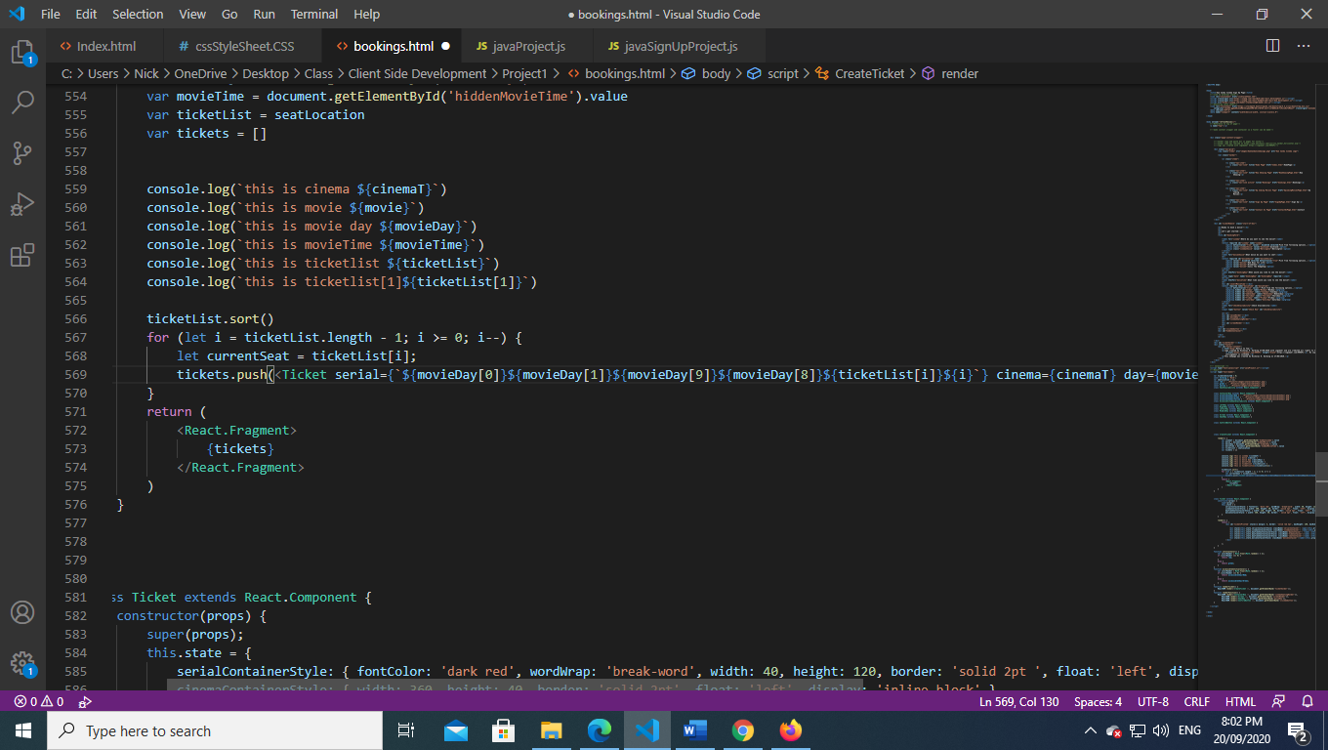

* 1. The ticket layout should correspond to the UI Design Document
  2. Page refresh will reset entire page and rendered tickets unmounted and return to being default booking page

1. Sign Up page Form
   1. In first and last name input it should only take text value and non numeric
   2. Gender radio buttons will only accept one gender and not the other, it must also have one of them selected on form submission
   3. Phone inputs should follow the pattern of ##-###-#### and consist of numbers
   4. Email inputs should follow the email pattern
   5. On submission all inputs are checked and validated, it should alert the user if values are missing or don’t follow patterns and highlight those fields and focus on them or return to the top
   6. If all values are ok it should prompt a confirm box showing their inputs and asking them if they are correct and if cancel is pressed no form submission is completed
   7. If all values are correct it should innerHTML the old thank you page into the sign up page instead of directing the user to a new page and remove the all sign up inputs and buttons
2. When the pages containing forms are refreshed or onload should clear old values in variables

The testing methods I will use are:

* Directly using the site and testing it in how it is expected to handle with correct values and clicks etc.
* Direct testing in trying to break the web side application by doing unexpected changes order flow
* Lots of console logs in various areas checking that I’m getting expected values
* Create a test button to render components like the seat selecting to test its functionality of the component on submission it will be taken out of the site and source code posted here
* Having a live site to test on other devices such as the Samsung S9 and an iPhone 6
* <!--seating test button-->
* <button onclick="renderFunction()">PRESS ME</button>

        function renderFunction() {

                ReactDOM.render(<ContainerRow />, document.getElementById('cinemaSeatingHolder')),

                ReactDOM.render(<Screen />, document.getElementById('screenRender')),

                ReactDOM.render(<SeatKey />, document.getElementById('movieKey')),

                ReactDOM.render(<ConfirmButton />, document.getElementById('clickmebutton'));

        }