 

VLSI Project

Phase 1

Submitted to:

Eng. Abdulrahman Mohamed Ibrahim

Submitted by:

Ahmed Magdy Sec: 1 BN: 5

Mohamed Ibrahim Sec: 2 BN: 12

Omar Tarek Sec: 2 BN: 7

Mohamed Abobakr Sec: 2 BN: 13

**DESIGN**

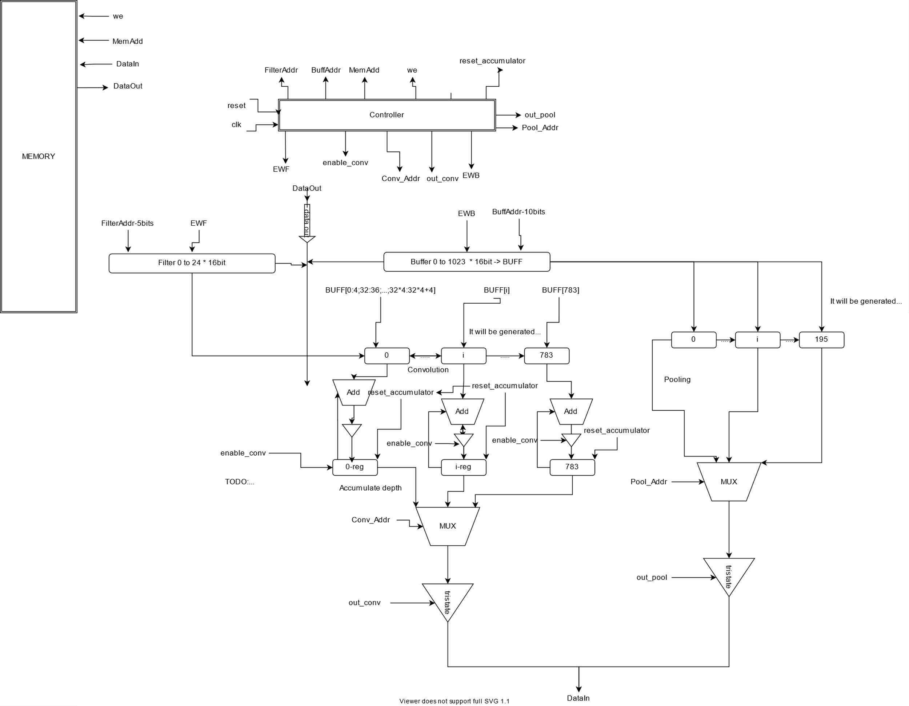

State Machine

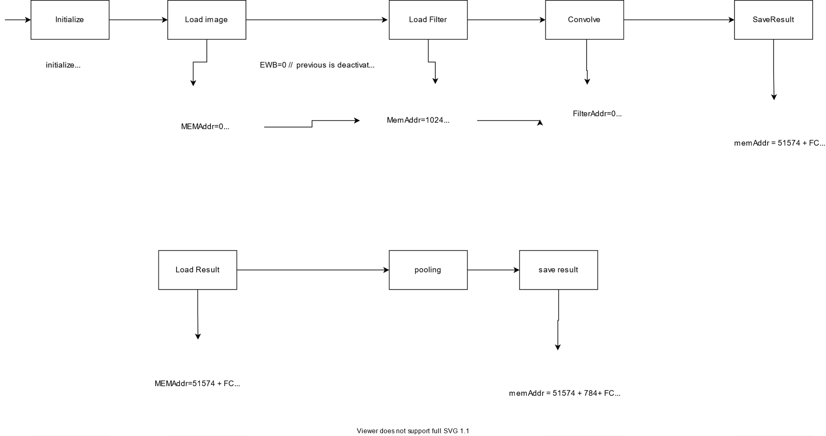

Scenario and Steps:

1. Start when signal “start” becomes 1.
2. Initiate starting address of input and filter and size, number of layers, depth.
3. Determine if layer is convolution or pooling.
4. If layer is convolution:
   1. Read input.
   2. Read filter.
   3. Convolute.
   4. Save intermediate result.
   5. Repeat again till all filters in this layer is finished.
5. If layer is pooling:
   1. Read input.
   2. Pooling.
   3. Save intermediate result.
   4. Repeat again for all inputs in layer.
6. When all layers are finished done signal becomes ‘1’ and now data is ready to be delivered to FC-sub team.

Assumptions:

1. Input passed IO team the number of layers say N then N-bits determine if layer is convolution or pooling.
   1. 0 for convolution
   2. 1 for pooling
2. Image is saved in the beginning of ram (i.e. Address = 0).
3. All other filter inputs are directly after the image.
4. Window size of all filters are 5.
5. Pooling 2*2.